Download and install .NET sdk:-

<https://dotnet.microsoft.com/download>

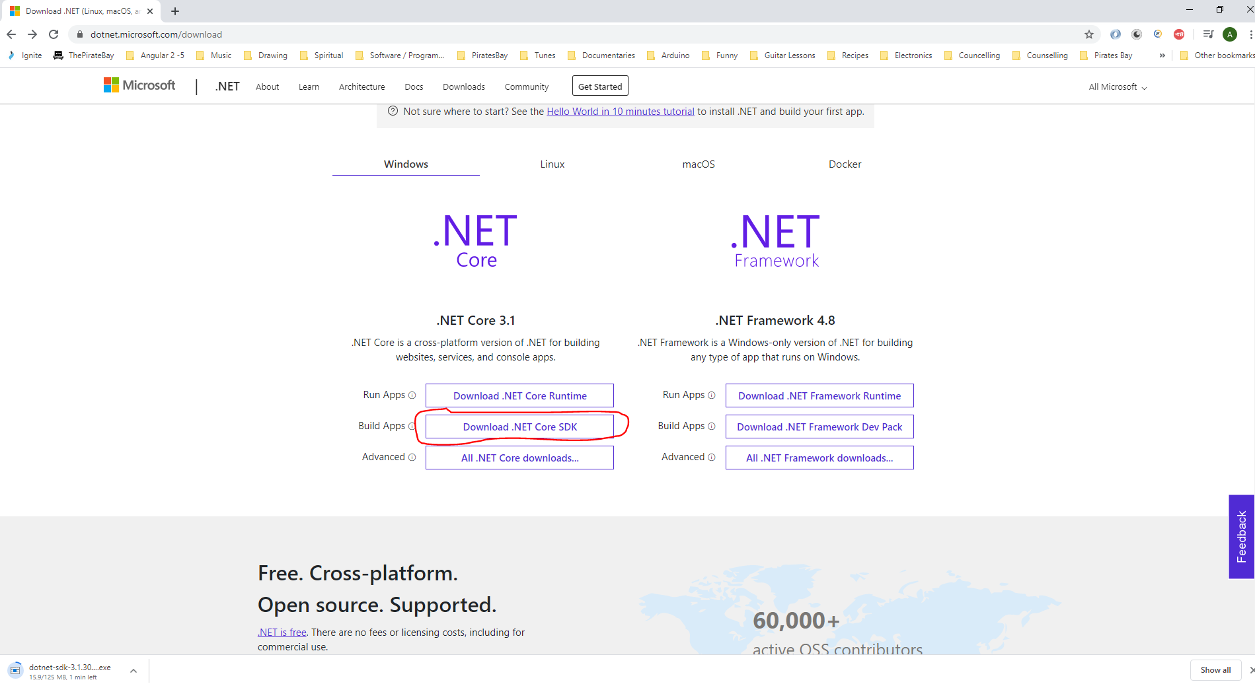

**Setup VSCode:-**

Search extensions for:-

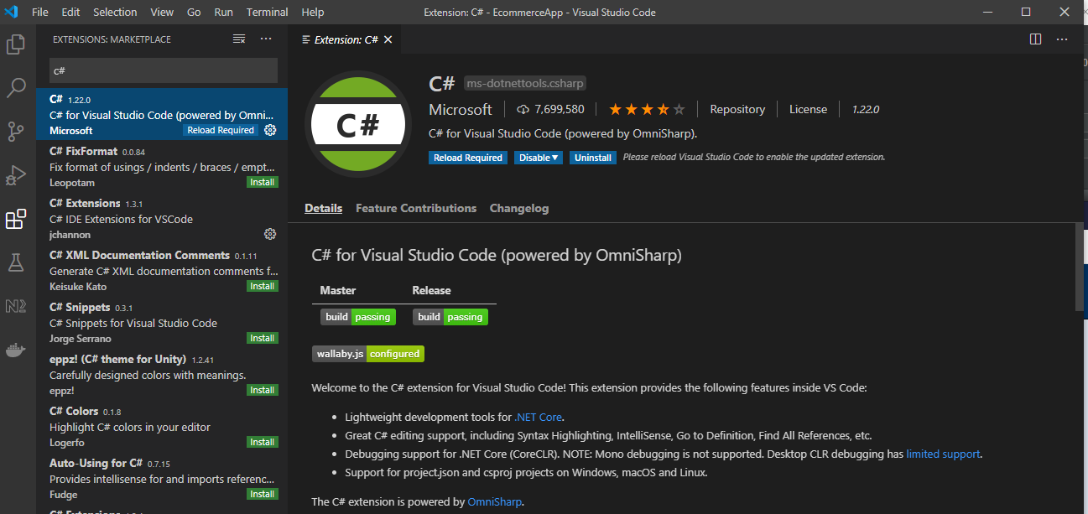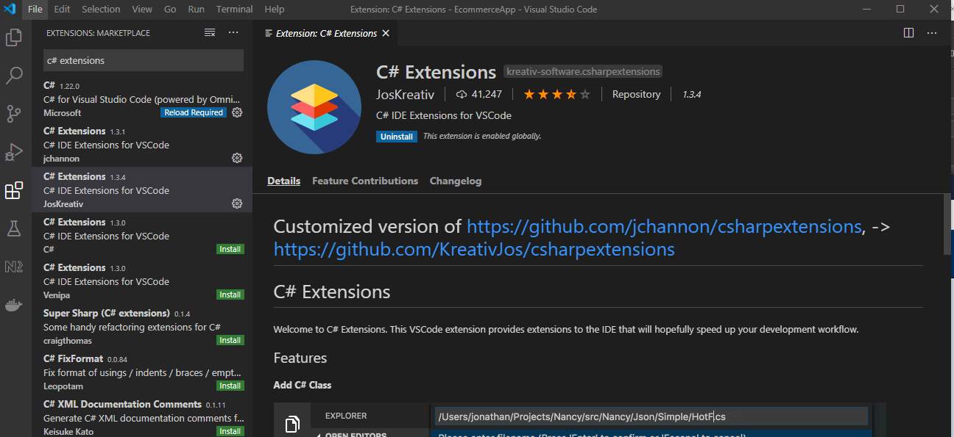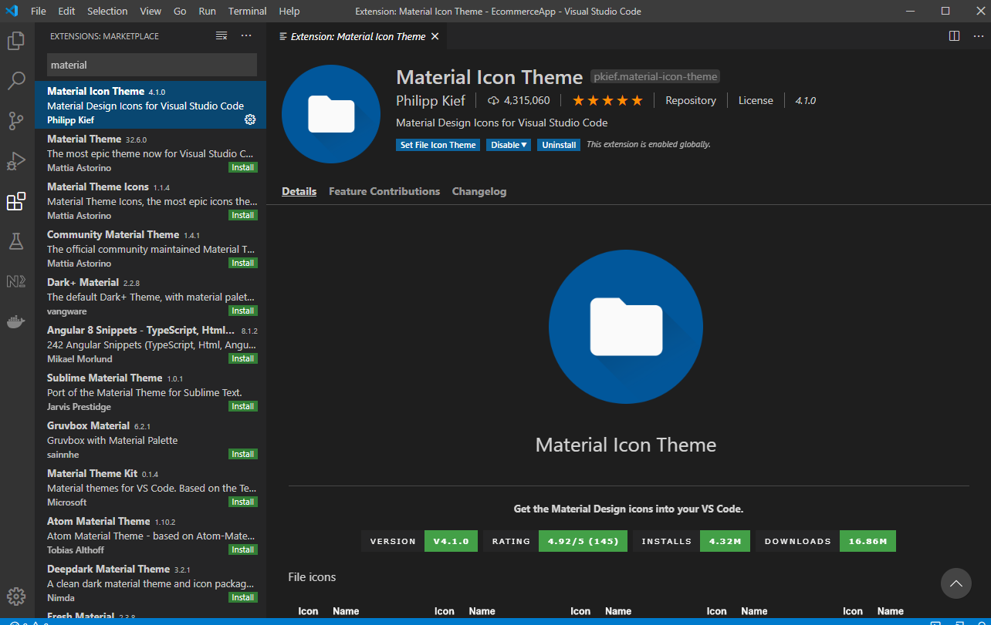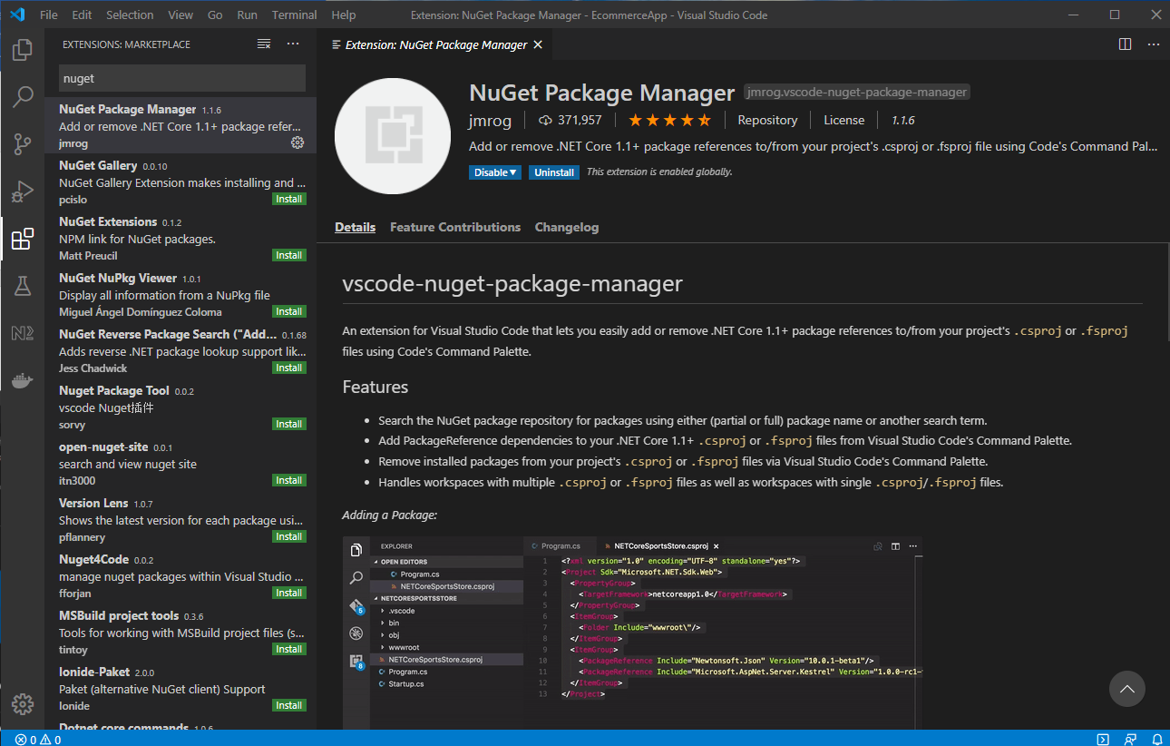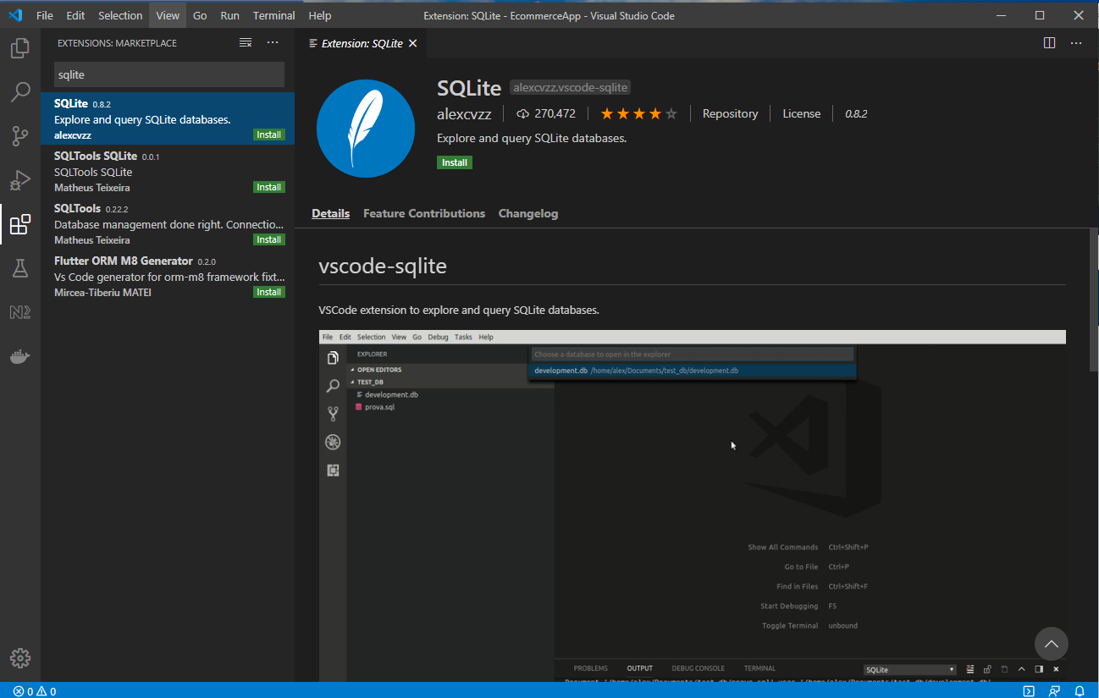

<https://github.com/trycatchlearn/skinet>

<https://github.com/TryCatchLearn/Skinet/commits/master>

**Create API**

In VSCode terminal type:-

*dotnet new sln*

*dotnet new webapi -o API*

*dotnet sln add API*

The above creates the following:-

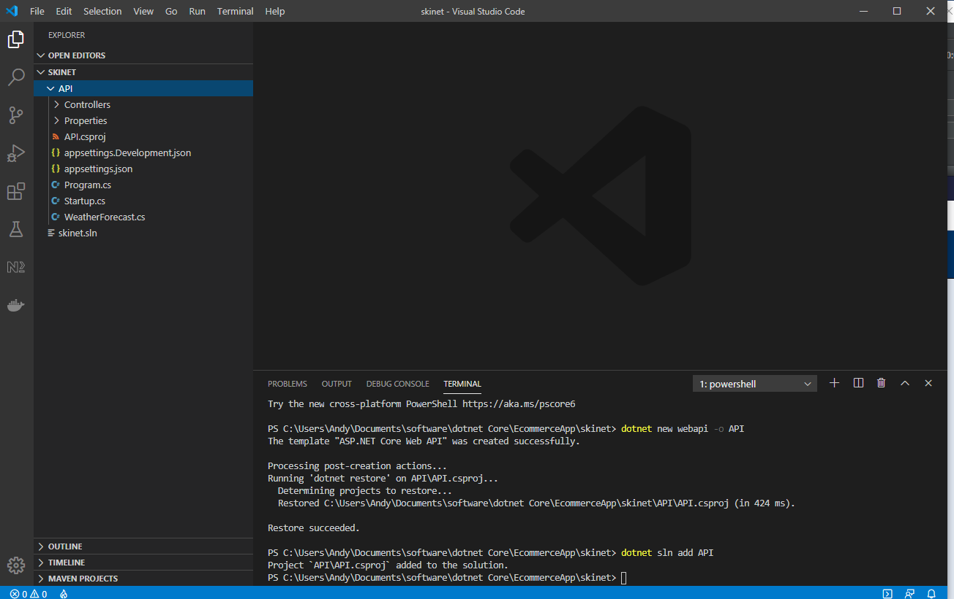

Add .vscode folder and content, by pressing:-

[ctrl] + [SHIFT] + p

Generate Assets for Build and Debug

When this popup appears click yes:-

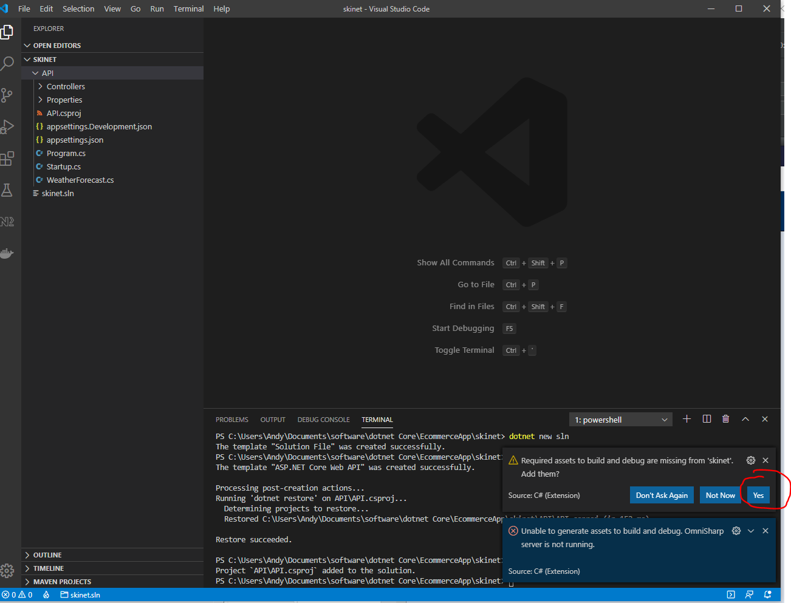

**Run project:-**

Cd into API folder and type:-

dotnet run

Use Postman to test API:-

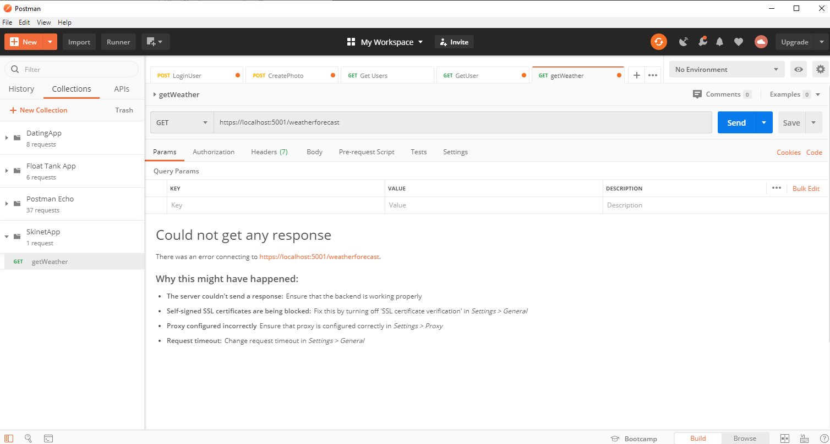

We don’t get a response because Postman by default does not trust self signed certificates. So in Postman go to settings:-

File -> Settings

Then turn this off:-

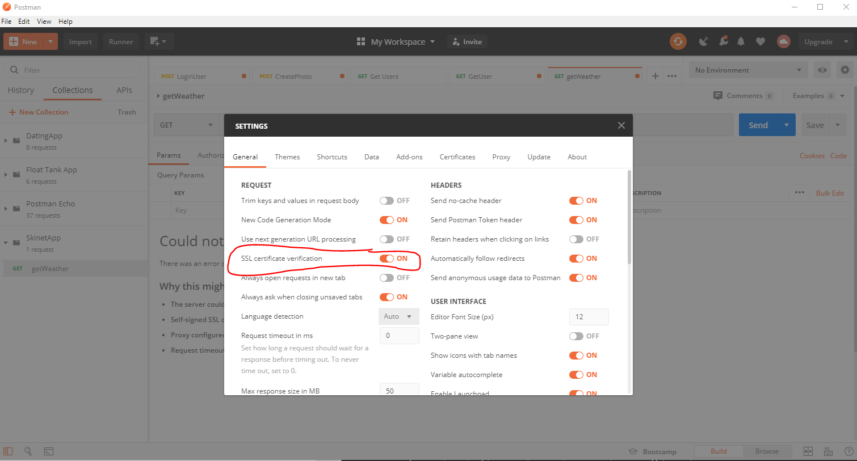

Now click ‘Send’ again. This time you get this:-

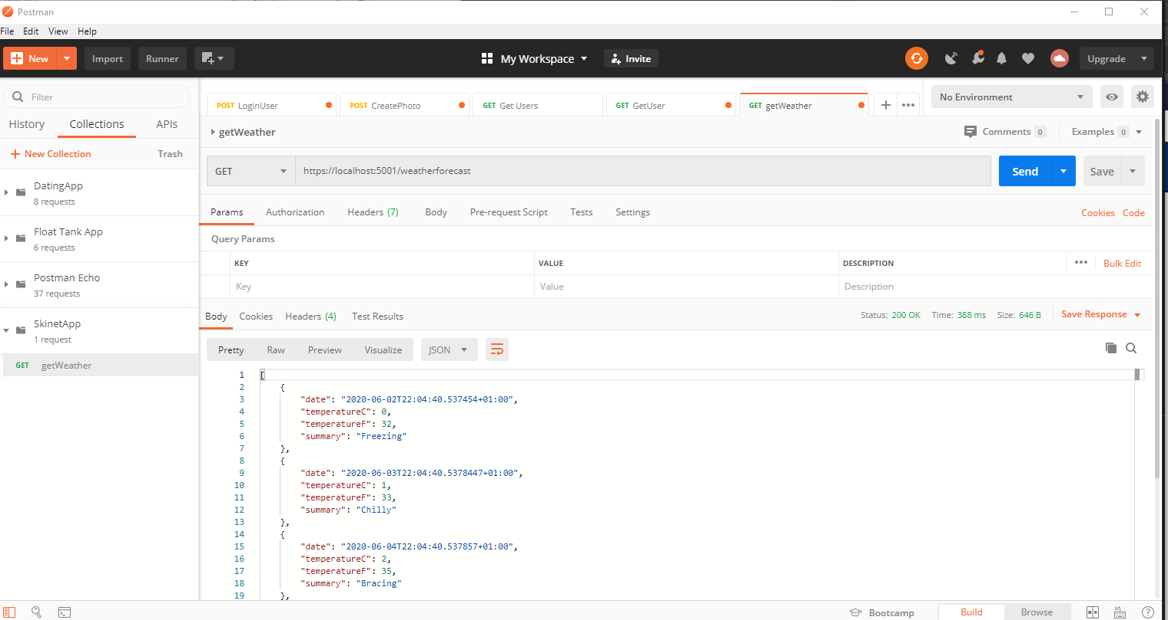

You can check to see if you have a valid certificate by type this:-

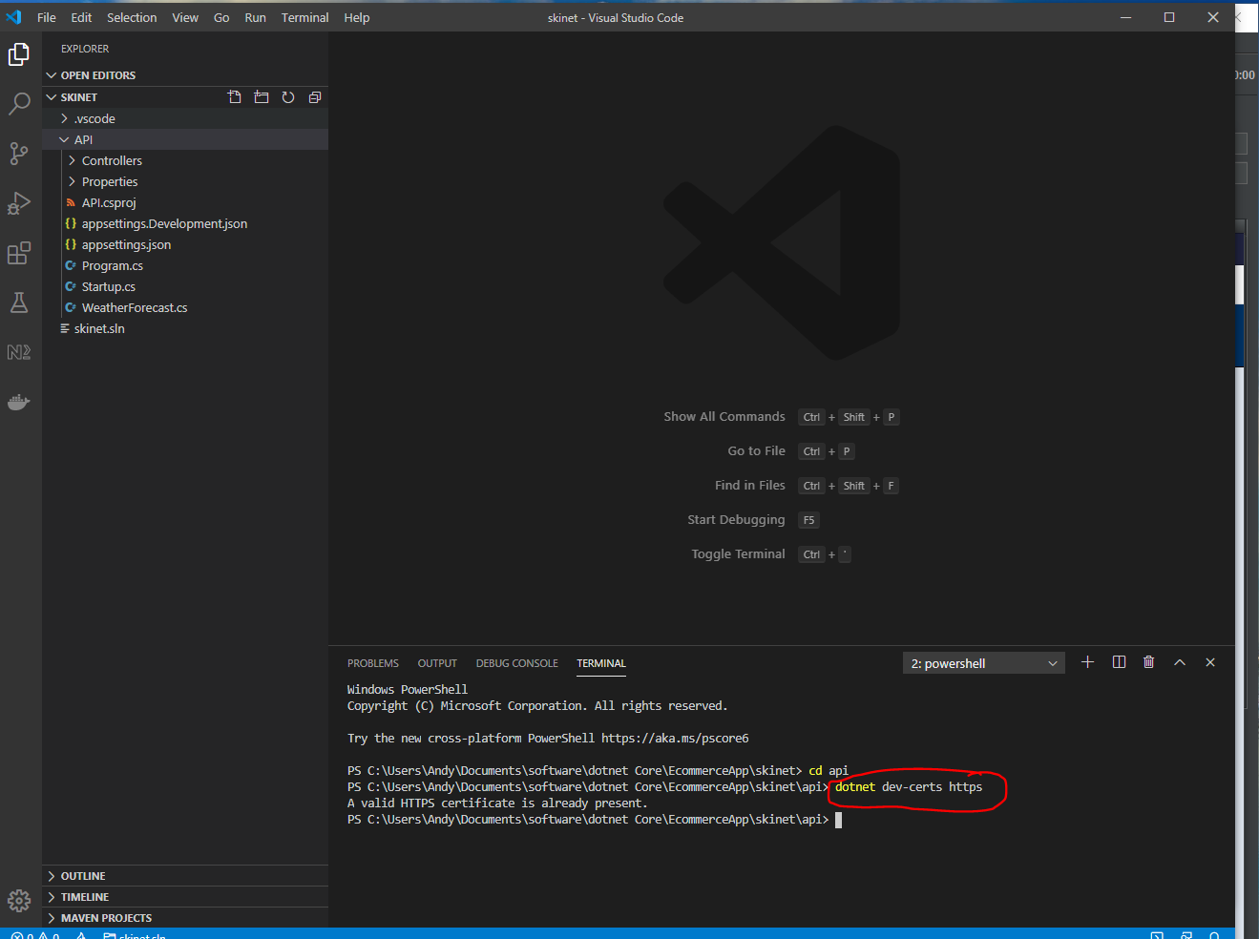

You can run this command to all trust of the certificate:-

dotnet dev-certs https -t

**Create a new controller:-**

Create a new C# class under the ‘Controllers’ folder:-

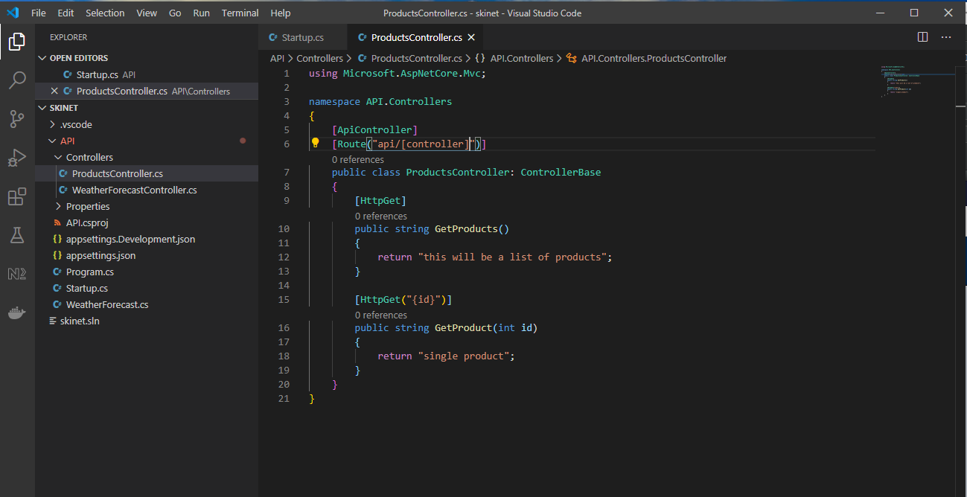

Use the following command to run the api and see automatic updates when you change your code:-

*dotnet watch run*

Test new controller in Postman:-

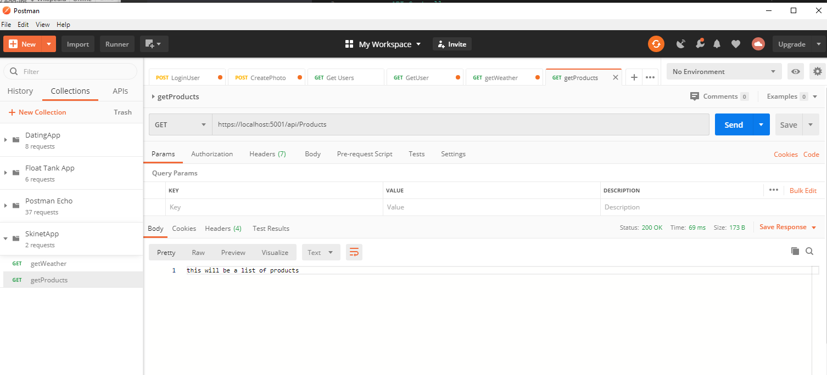

Also,

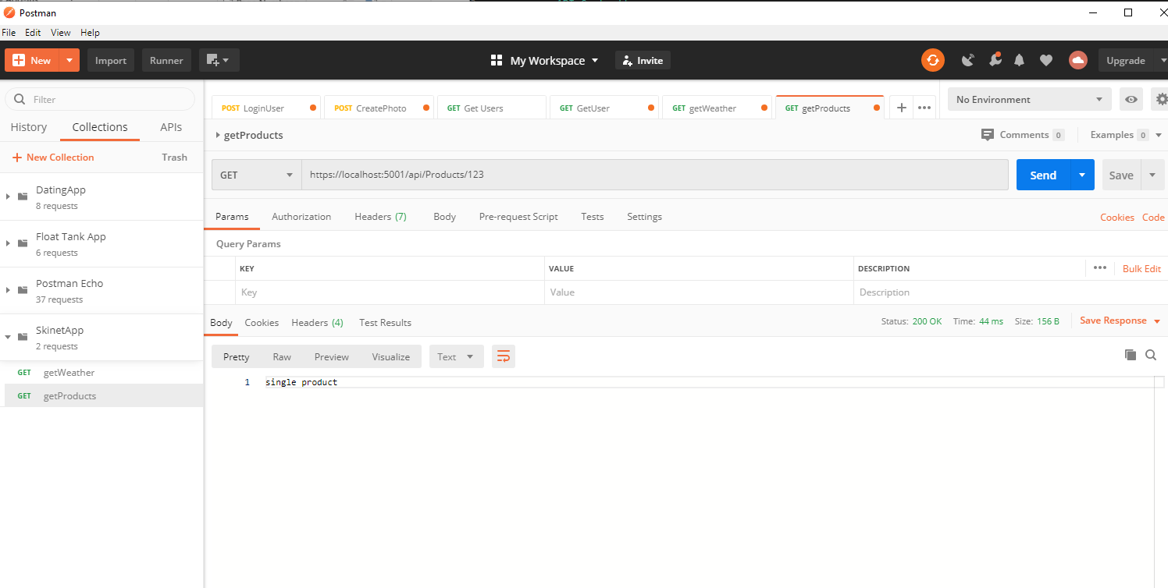

**Create a Database**

Add Entity class first:-

Create a new folder under ‘API’ called ‘Entities’ and create a new ‘C# class’ called ‘Product’ in the folder:-

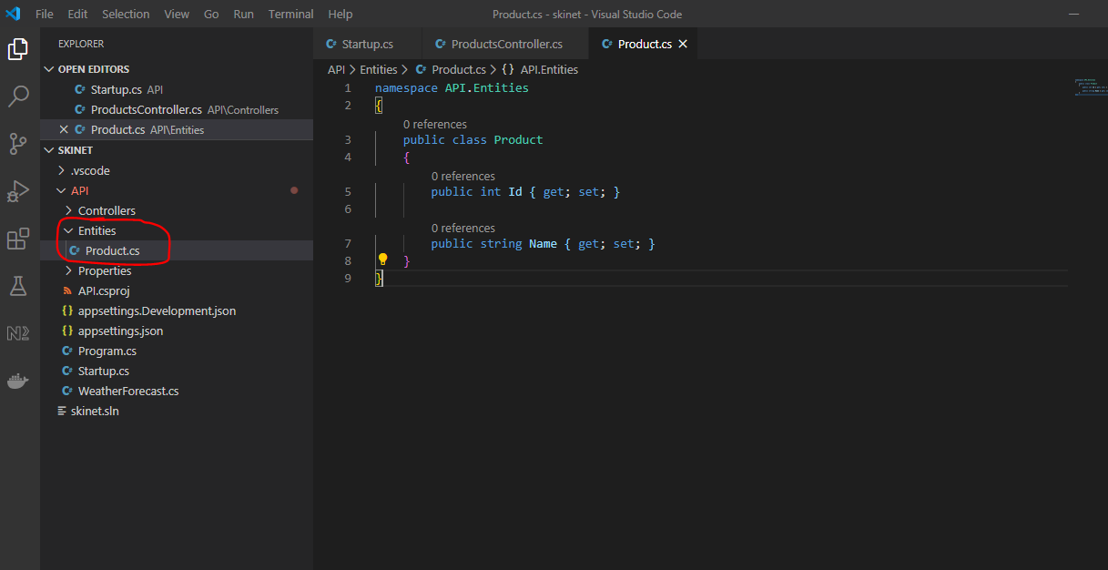

Add ‘Entity Framework’ into the application as a package using Nuget package manager:-

First get the version of dotnet runtime SDK running on your machine:-

In VSCode terminal type:-

dotnet --info

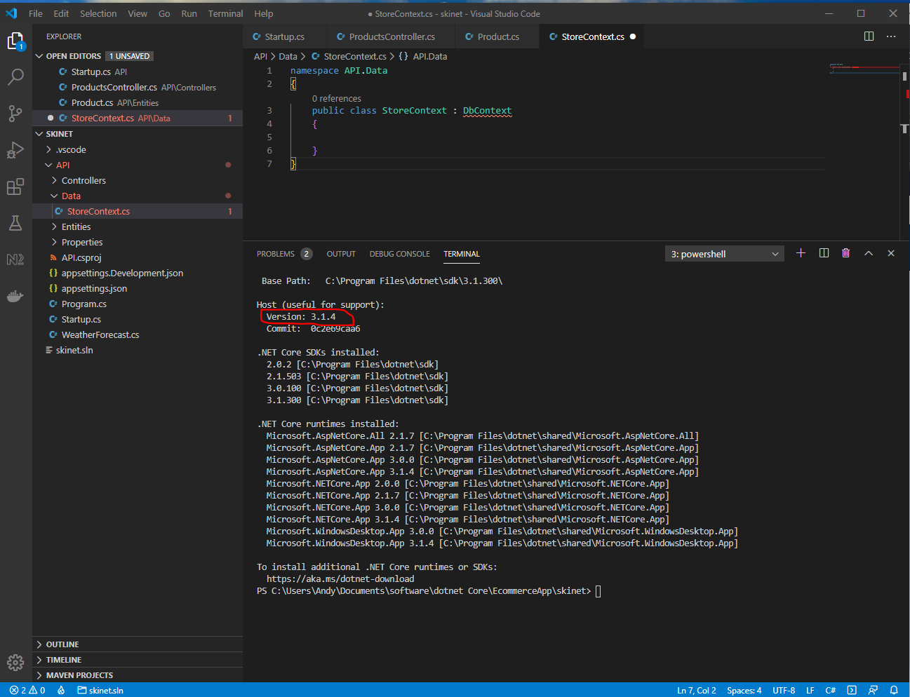

Look at the ‘Host (useful for support): version 3.1.4’ section. This is the version you need to use for the following part when installing Entity Framework. So you need to install **3.1.4.** See the following:-

[ctrl] + [shift] + p

nuget

Microsoft.EntityFrameworkCore

**3.1.4**

Now add a second package:-

[ctrl] + [shift] + p

nuget

Microsoft.EntityFrameworkCore.sqlite

**3.1.4**

Then click the ‘restore’ when the popup appears or type the following into the VSCode terminal:-

dotnet restore

Create a new folder under ‘API’ called ‘Data, and then create a new class in this folder called ‘StoreContext’:-

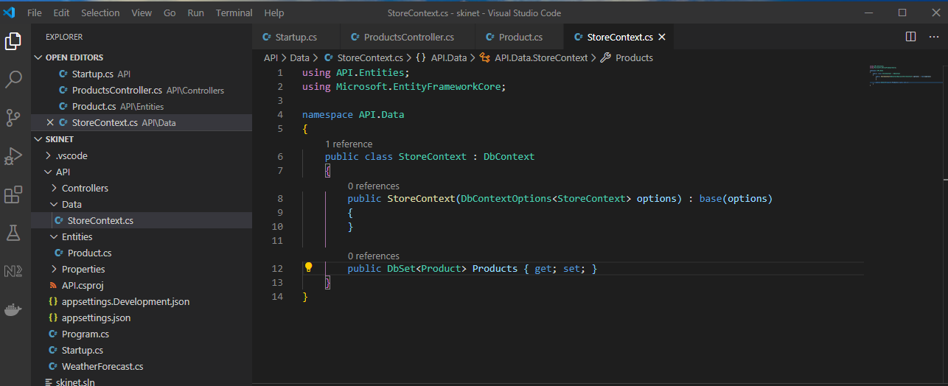

Add connection string:-

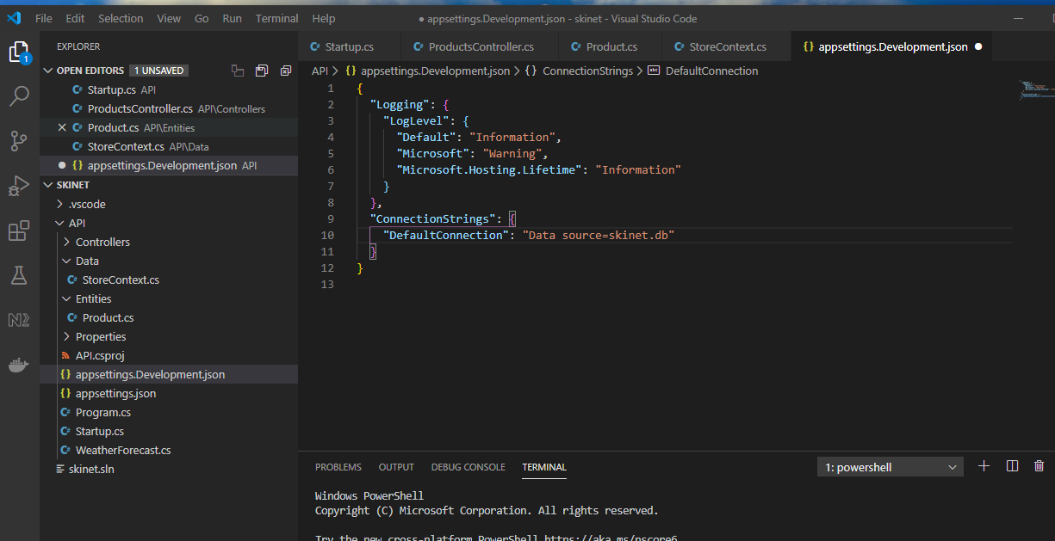

Now, go to File -> Preferences -> Settings

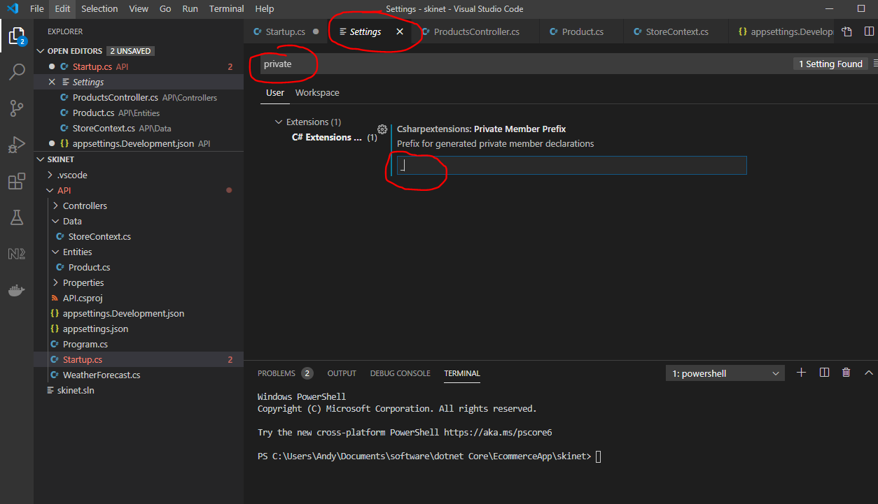

And uncheck this:-

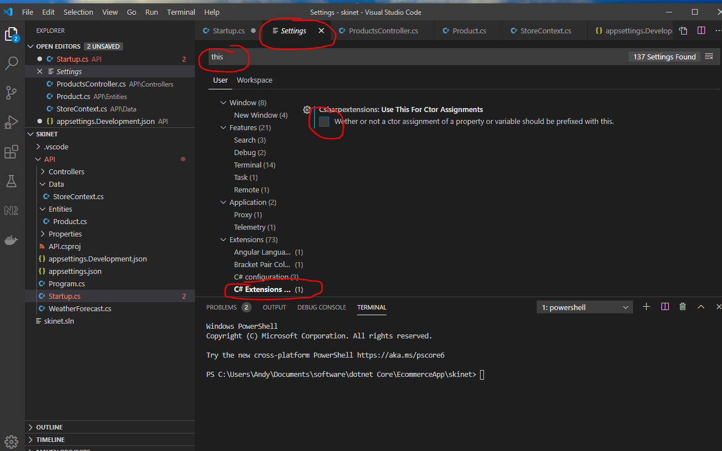

Then add this:-

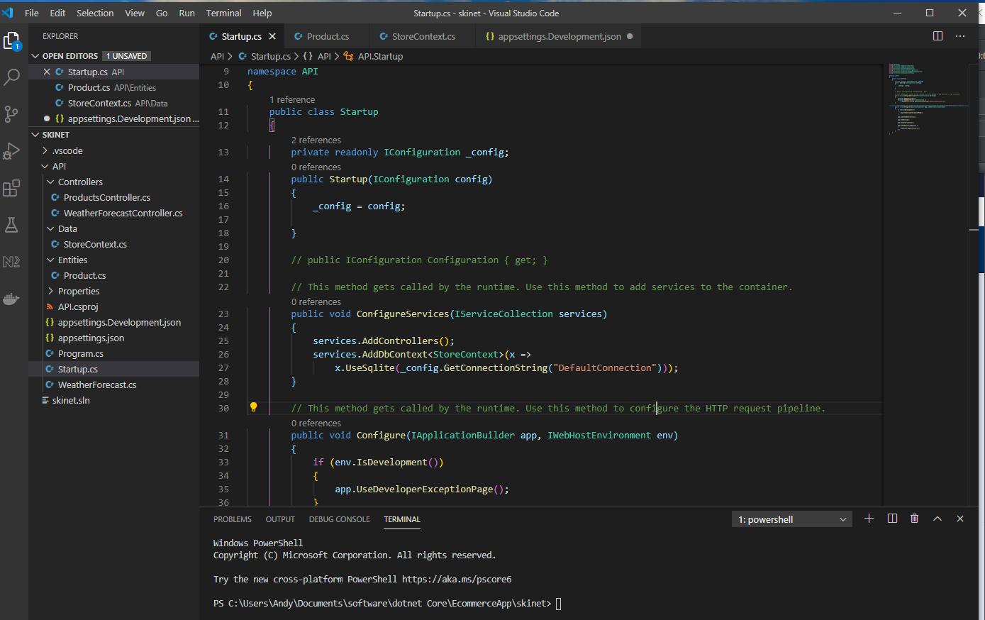

**Generate Database Tables:-**

Stop API server – [ctrl] + c

Get the SDK version, by entering:-

*dotnet --info*

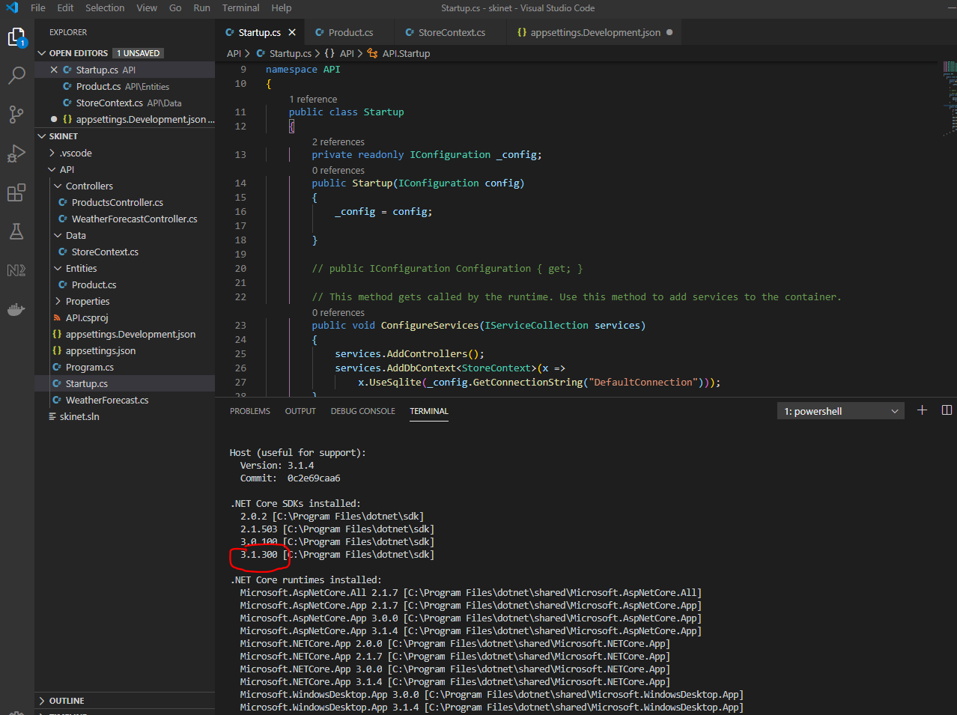

Then enter:-

*dotnet tool install --global dotnet-ef --version 3.1.300*

Generate a migration using the terminal:-

*dotnet ef migrations add IntialCreate -o Data/Migrations*

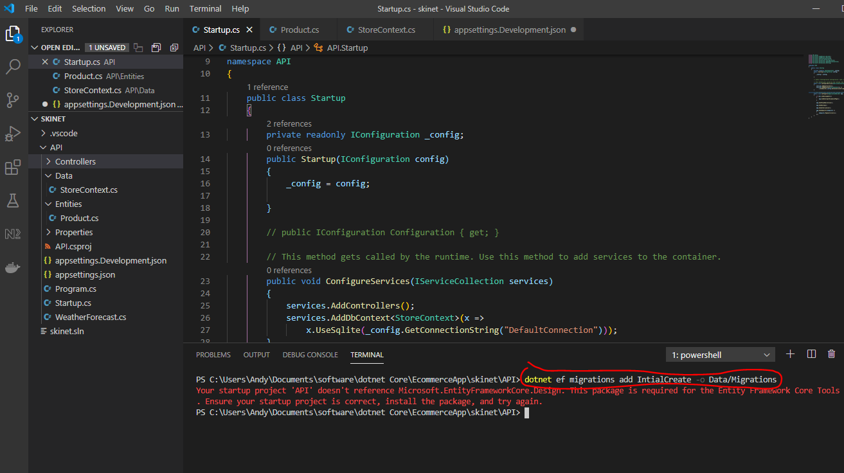

See error above. To round this:-

[ctrl] + [shift] + p

nuget

Microsoft.EntityFrameworkCore.Design

‘Host (useful for support): version 3.1.4’ section

Then re-run in the terminal:-

*dotnet ef migrations add IntialCreate -o Data/Migrations*

Note:- You can update ef core tools to:-

dotnet tool update --global dotnet-ef --version 3.1.0

This creates this:-

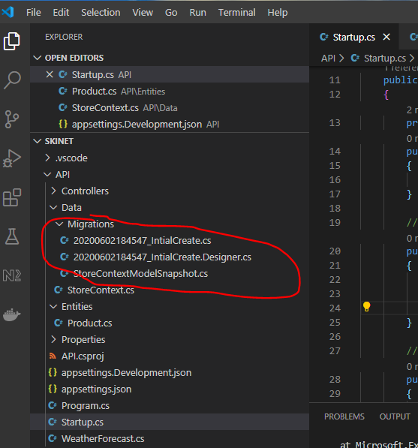

Look at this file:-

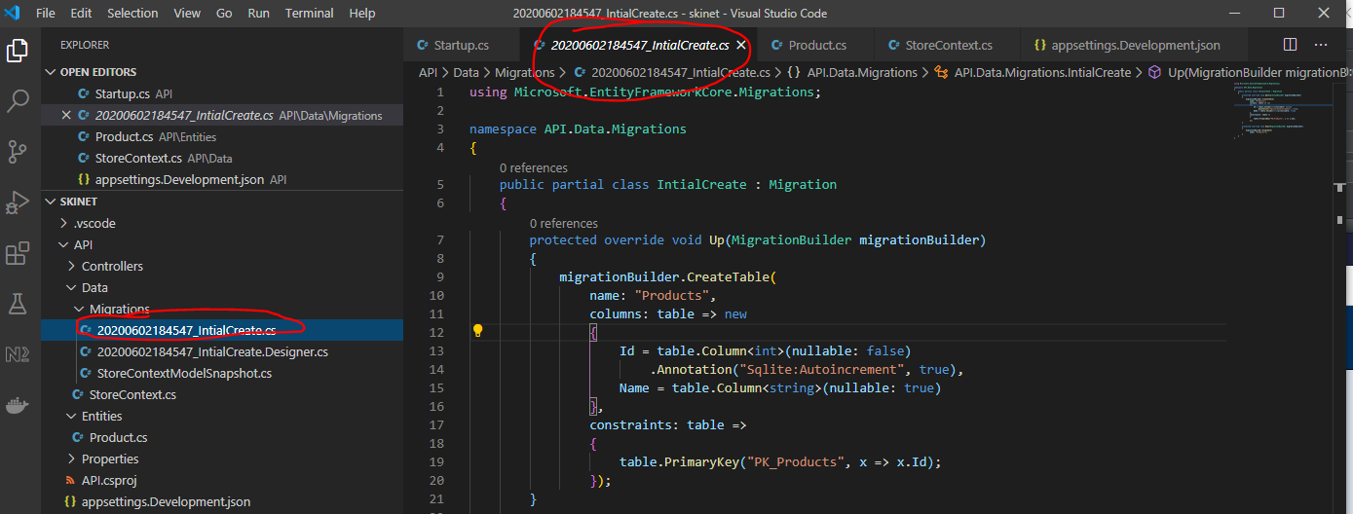

**Create the Database using the migration**

In the terminal enter:-

dotnet ef database update

See the database has been created here:-

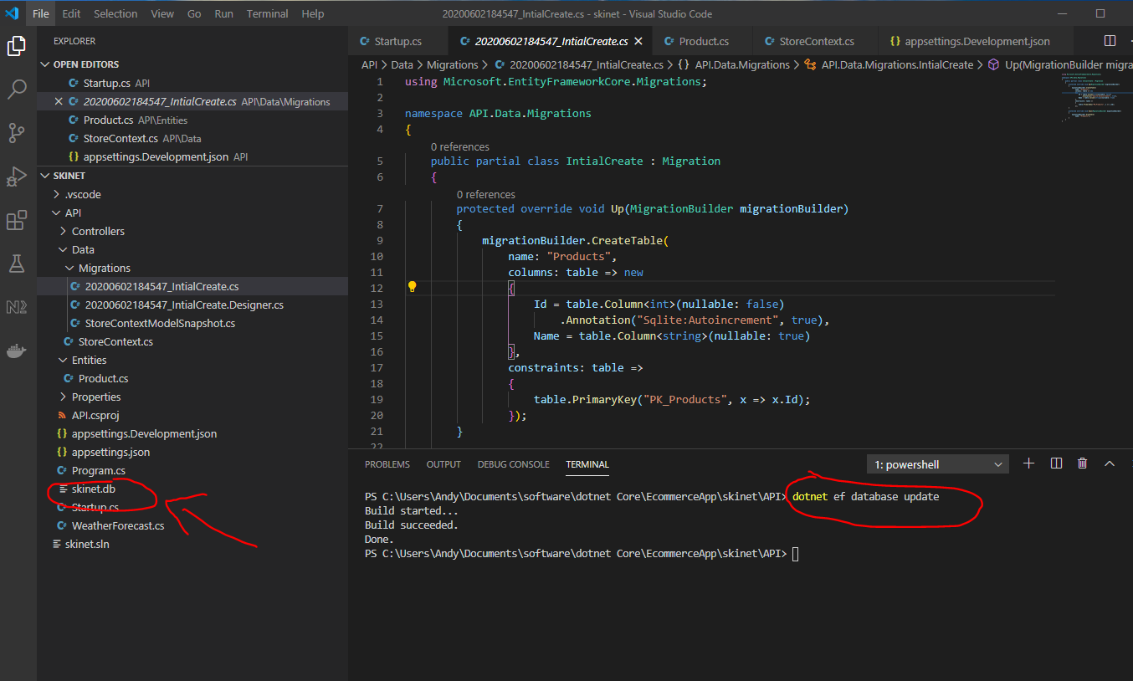

Now, use Sqlite to view the database:-

[ctrl] + [short] + p

Sqlite: Open Database

Skinet.db

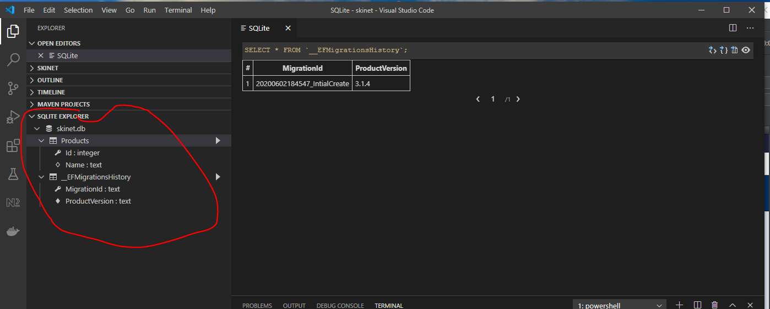

And

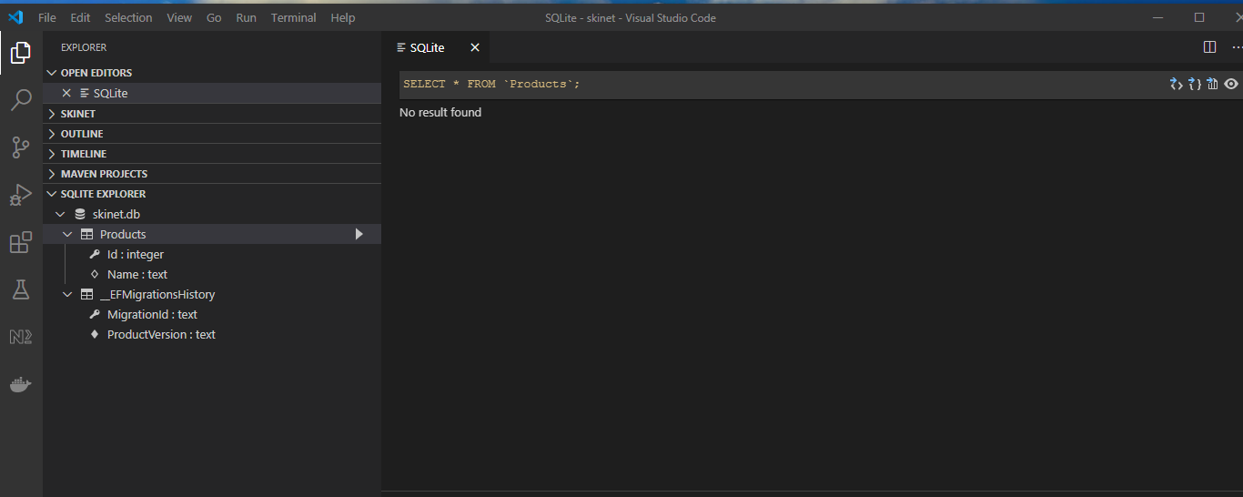

Add a few products into the products table:-

Right click products table and select ‘New Query [insert]’:-

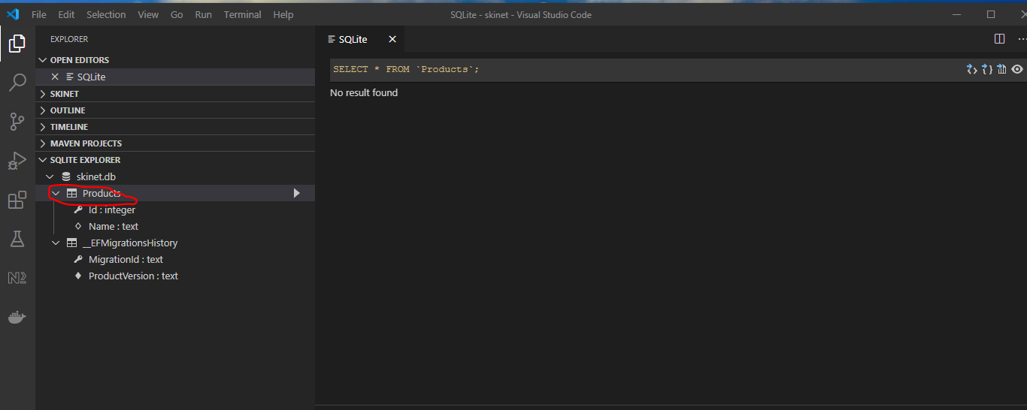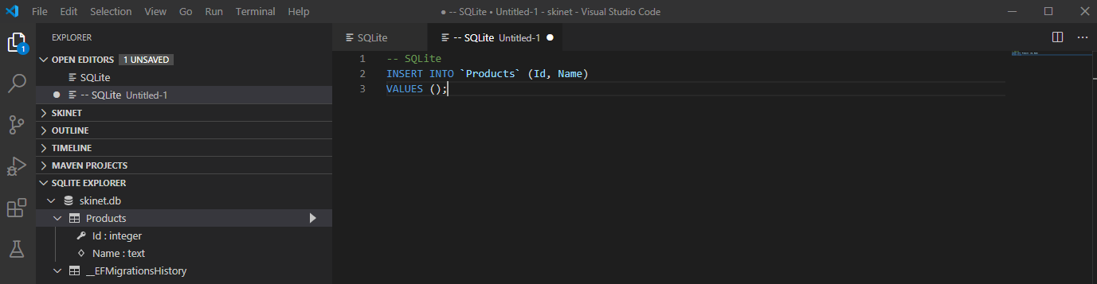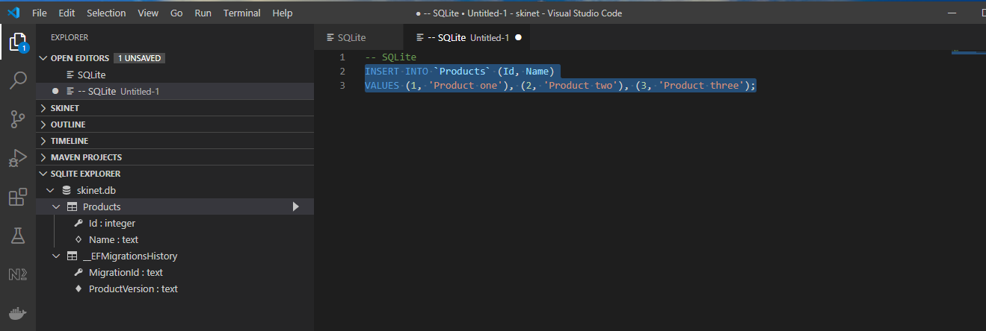

Select all the query and right click it and select ‘Run Query’.

Now see products:-

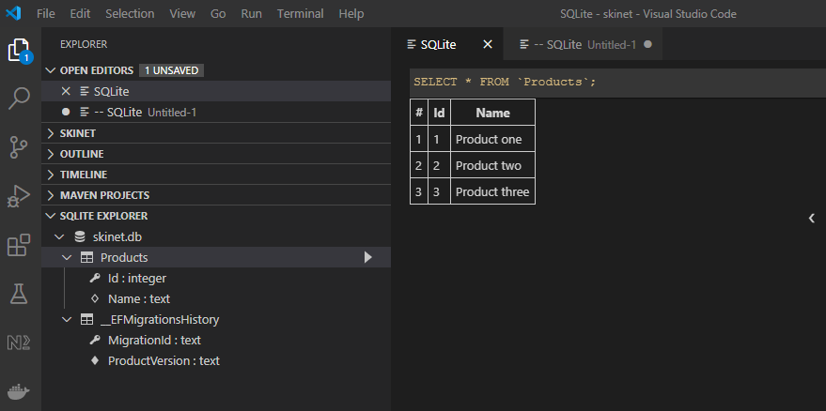

**Read data from the database**

Go to the controllers folder and open the ProductController.

Generate a constructor by [ctrl] + . over the class name:-

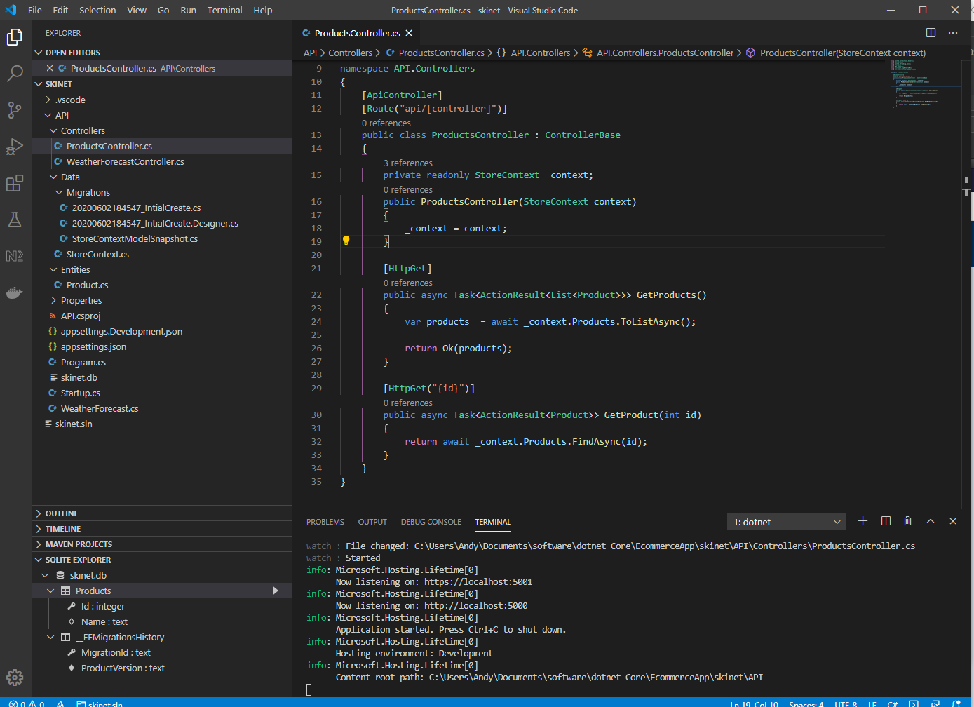

Use Postman to test this:-

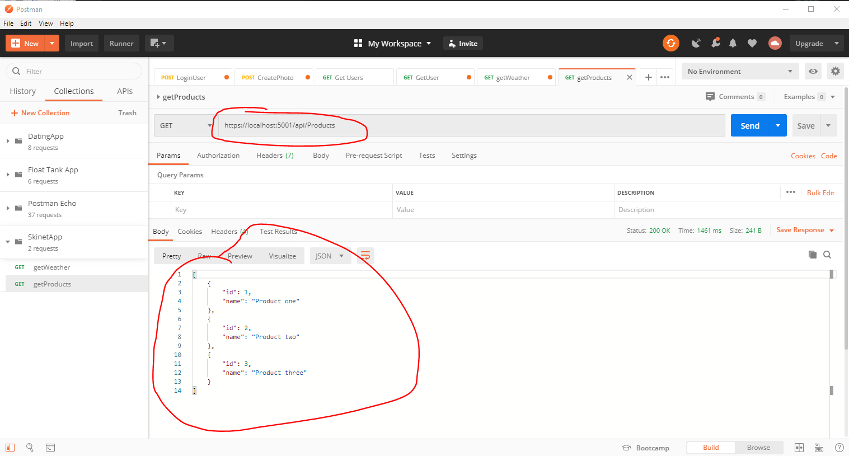

**Postman Collections**

See variable for <https://localhost:5001> it is called ‘url’:-

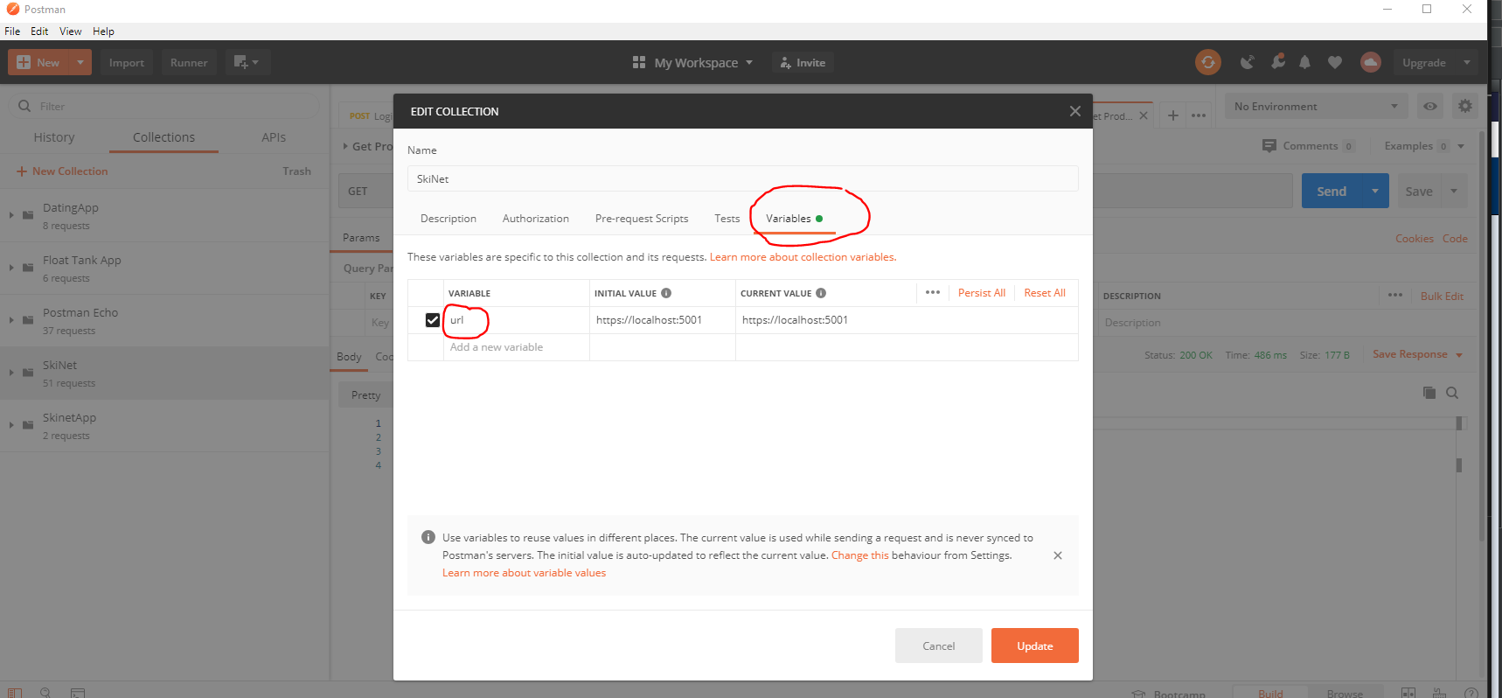

Now use ‘url’ in your requests:-

Change this:-

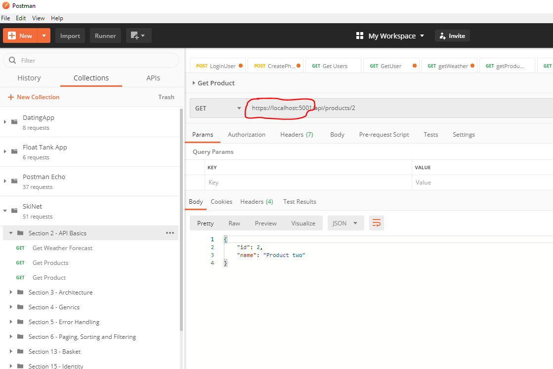

To this:-

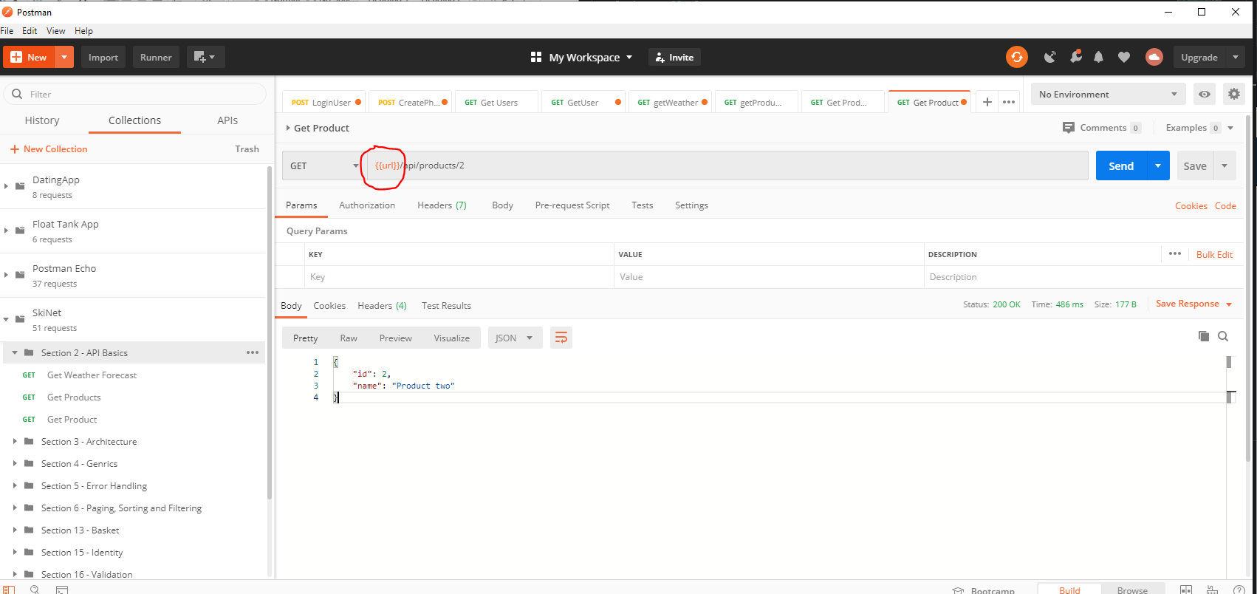

**Create an additional Project**

In the terminal create a class library project:-

dotnet new classlib -o Core

In the terminal create another class library project:-

dotnet new classlib -o Infrastructure

Now add this two projects to the solution:-

dotnet sln add Core/

dotnet sln add Infrastructure/

Now, setup dependencies. API has a dependency on the Infrastructure project:-

cd API

dotnet add reference ../Infrastructure

This adds this:-

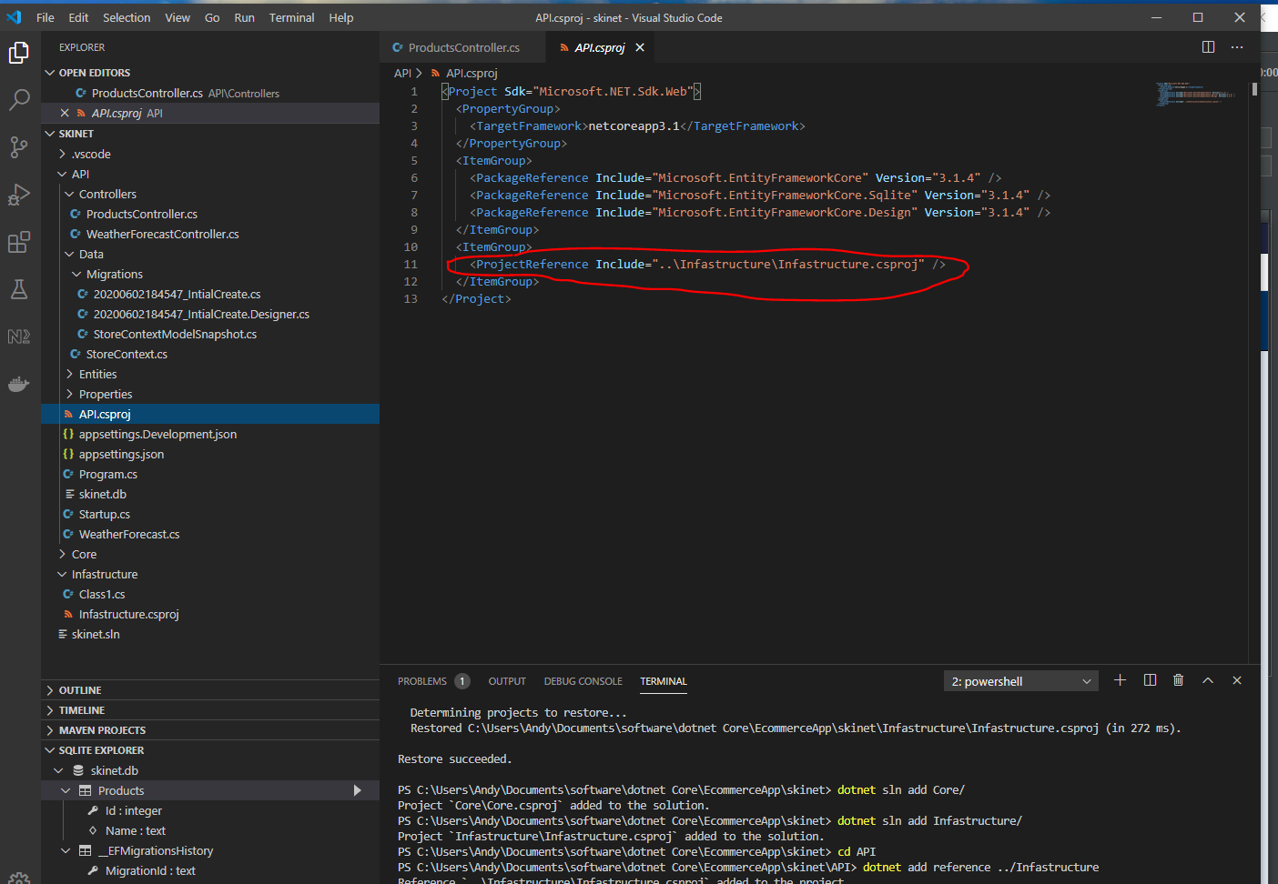

Now add this dependency in the ‘Infrastructure’ project to the ‘Core’ project:-

cd ..

cd Infrastructure

dotnet add reference ../Core

Now physically move the ‘Entities’ folder into the ‘Core’ folder:-

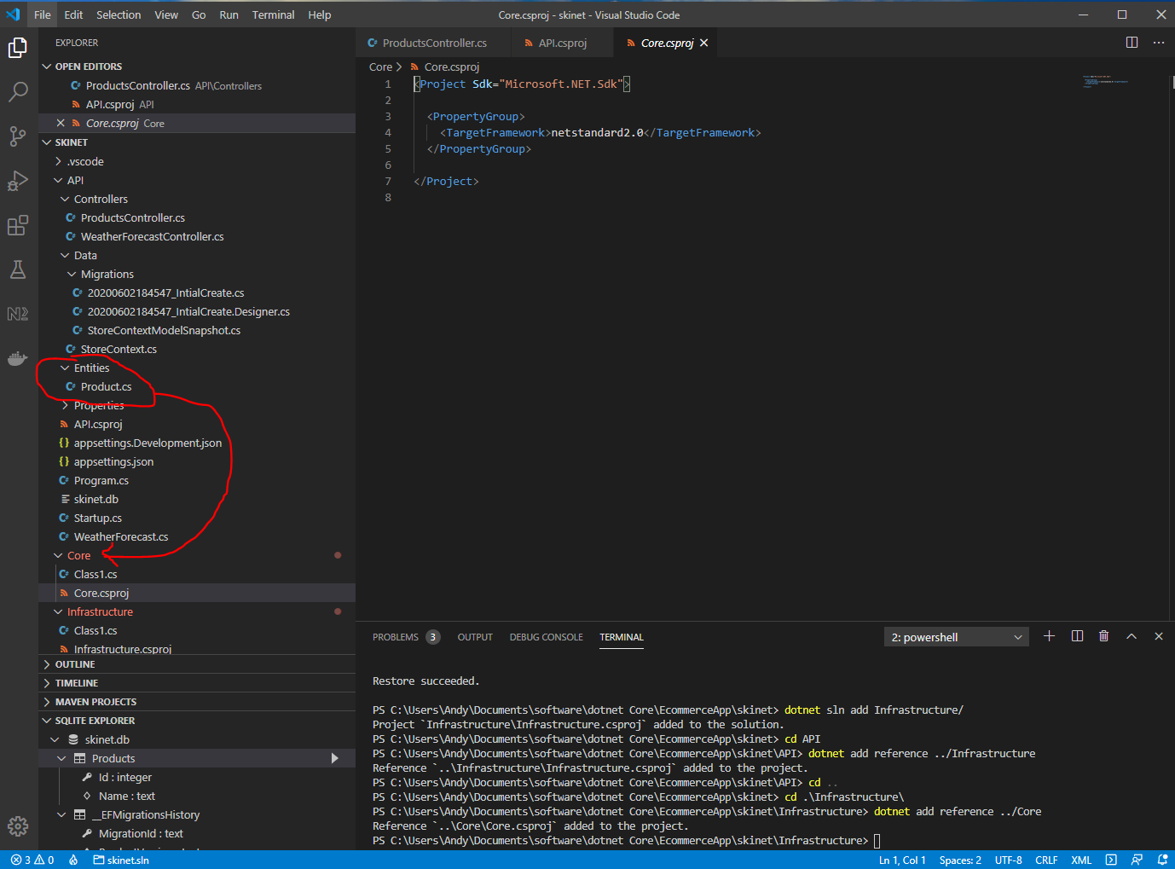

Now, move the ‘Data’ folder into the ‘Infrastructure’ folder:-

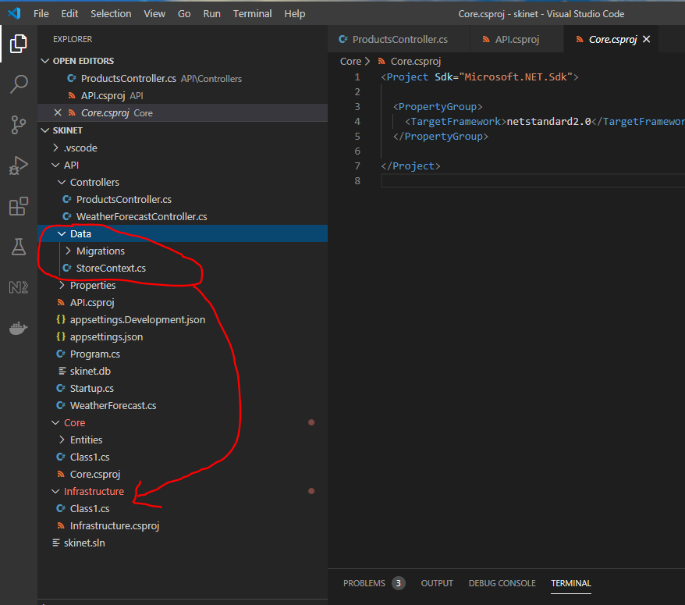

Now type the following into the terminal:-

*dotnet restore*

Now correct the namespaces:-

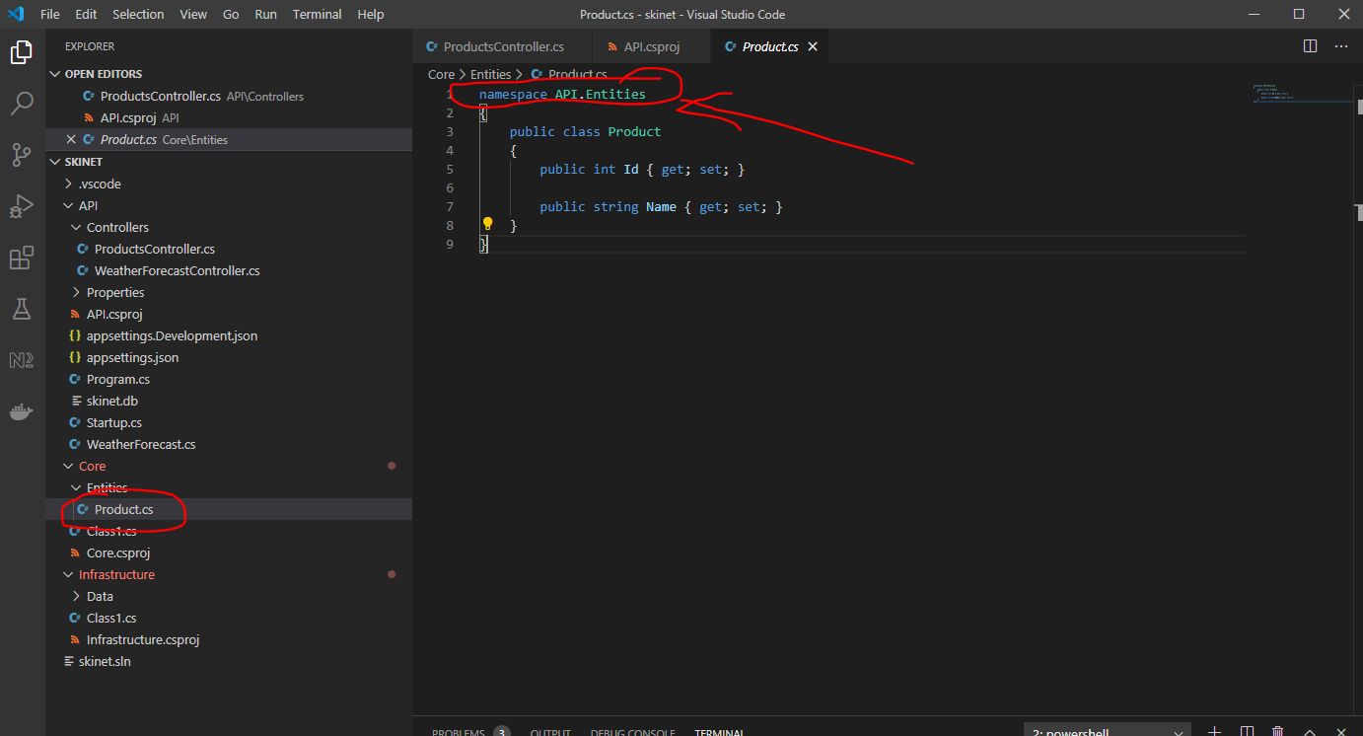

Change to:-

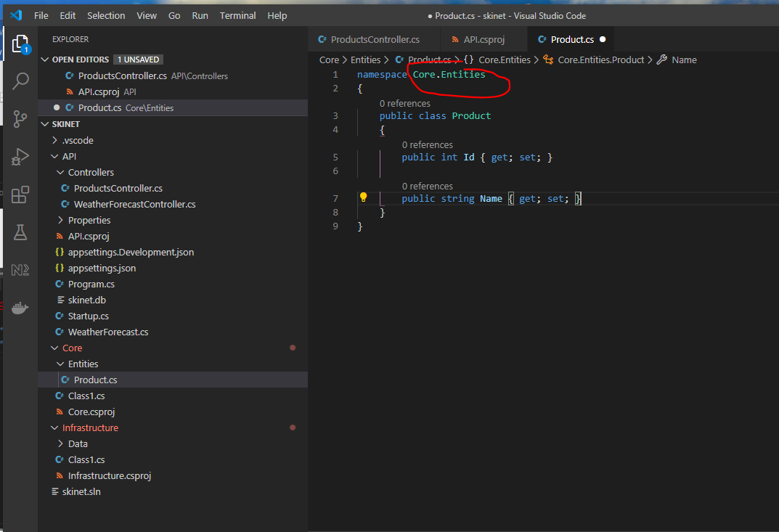

And check this too:-

Copy these from here:-

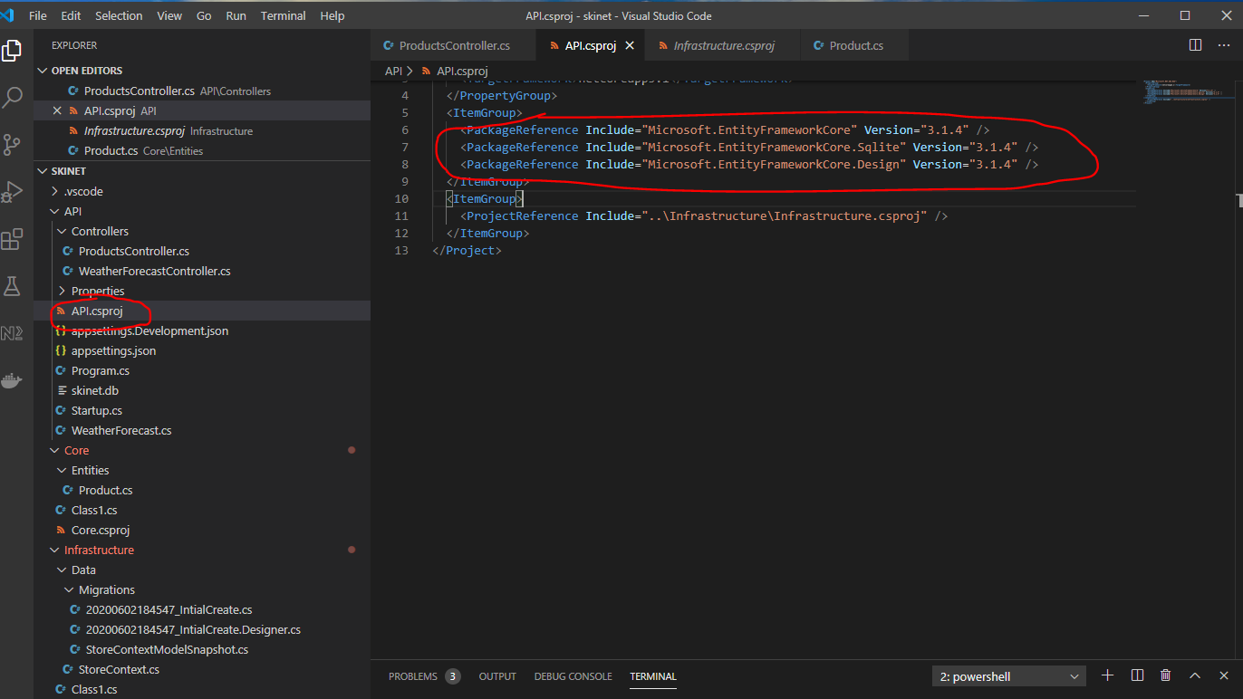

And paste here:-

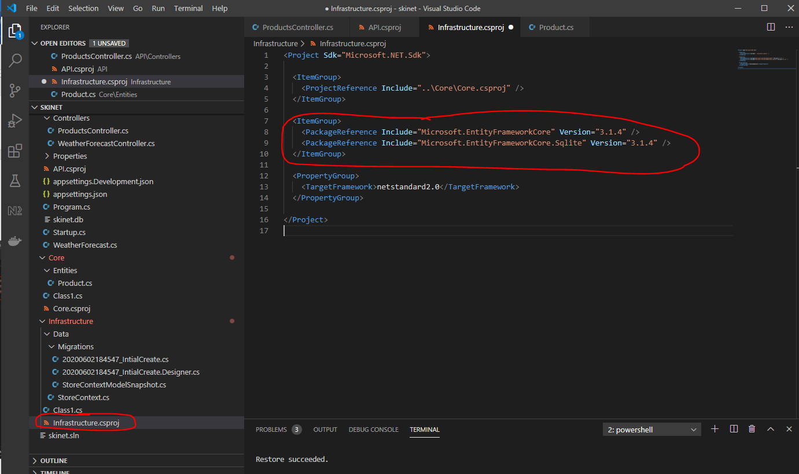

Remove these two from here:-

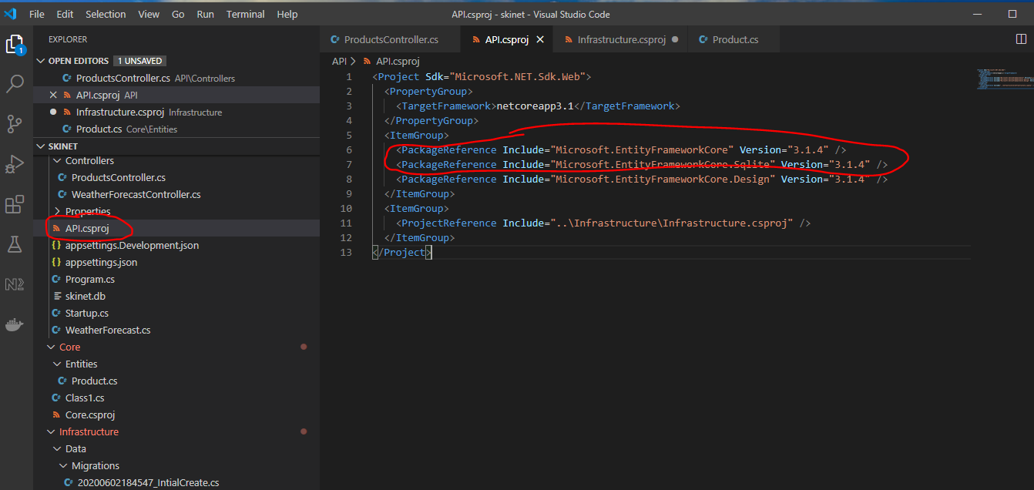

So you now have:-

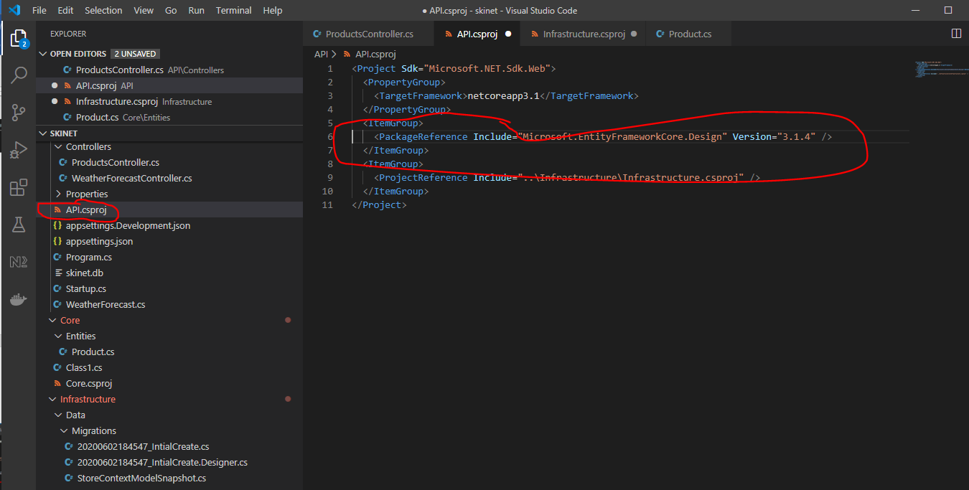

Correct these too:-

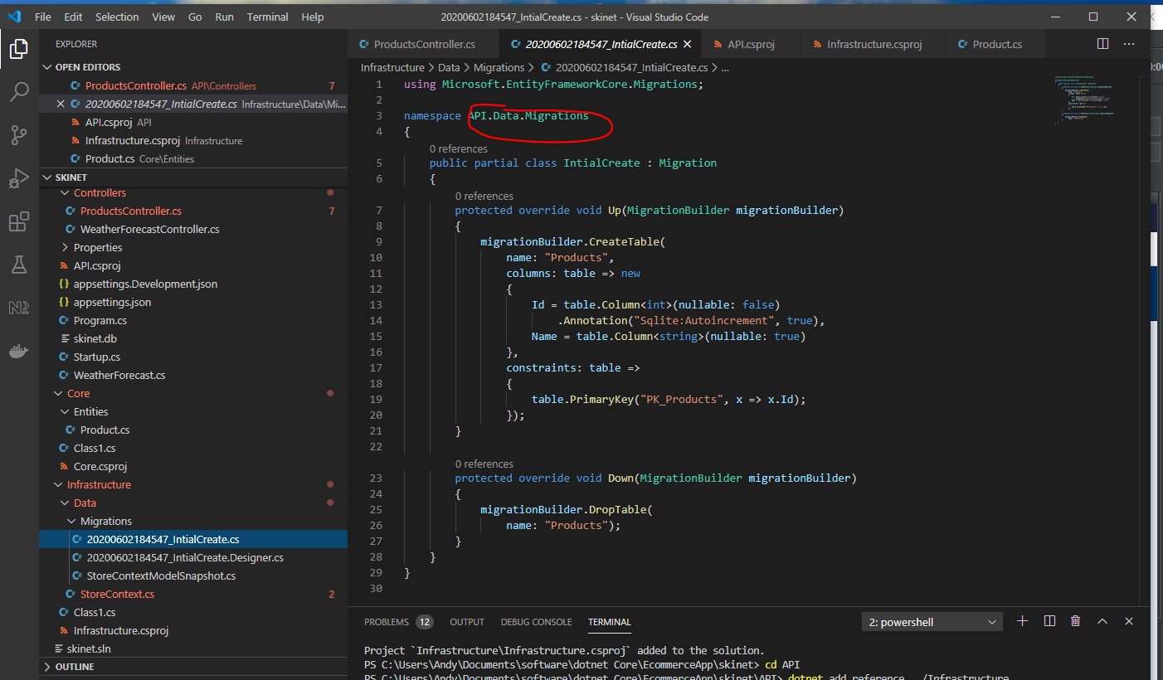

Change to:-

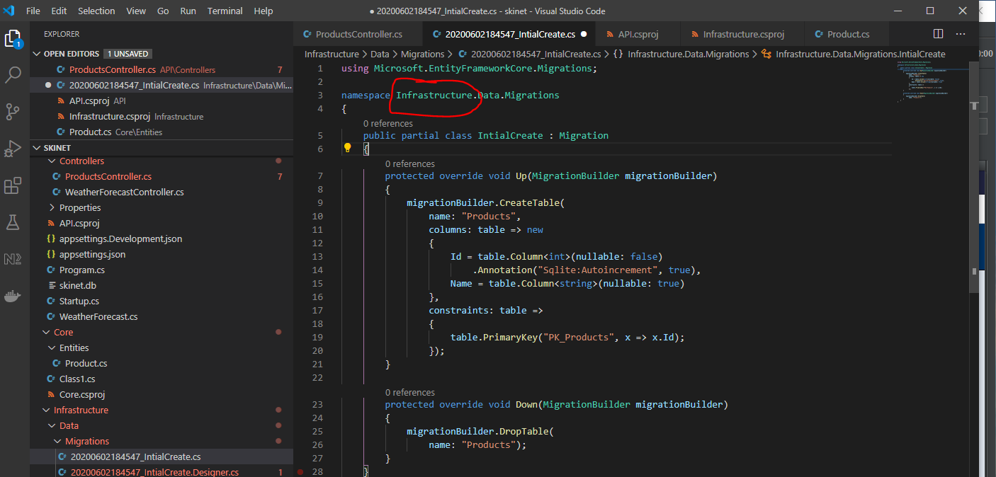

And this too:-

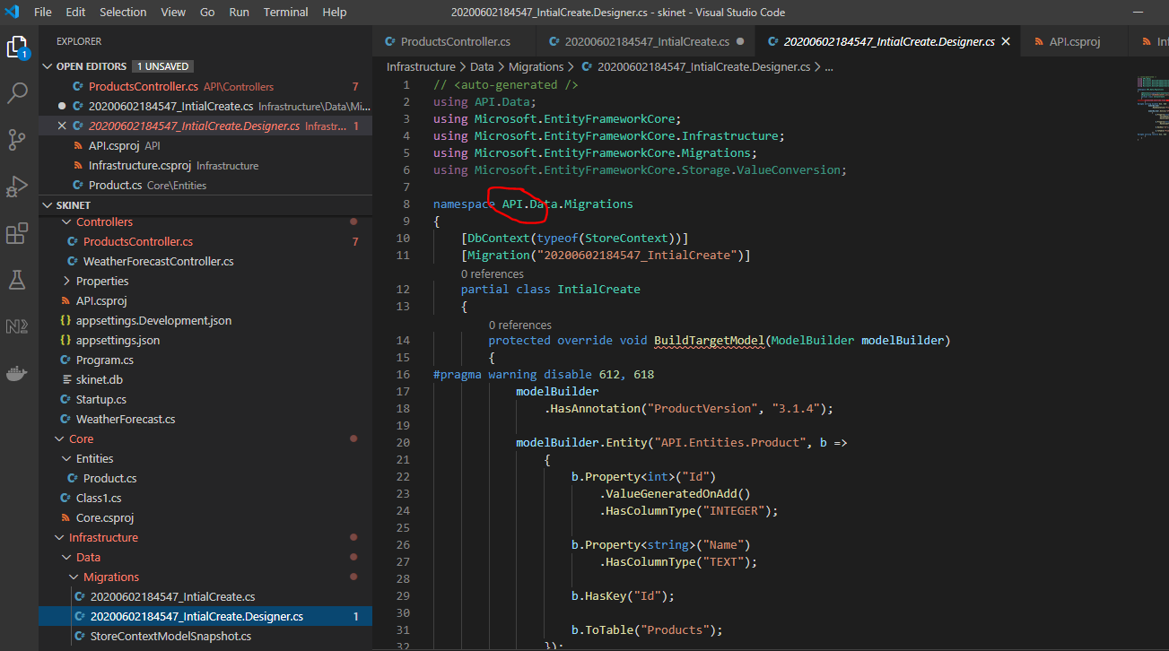

Change to:-

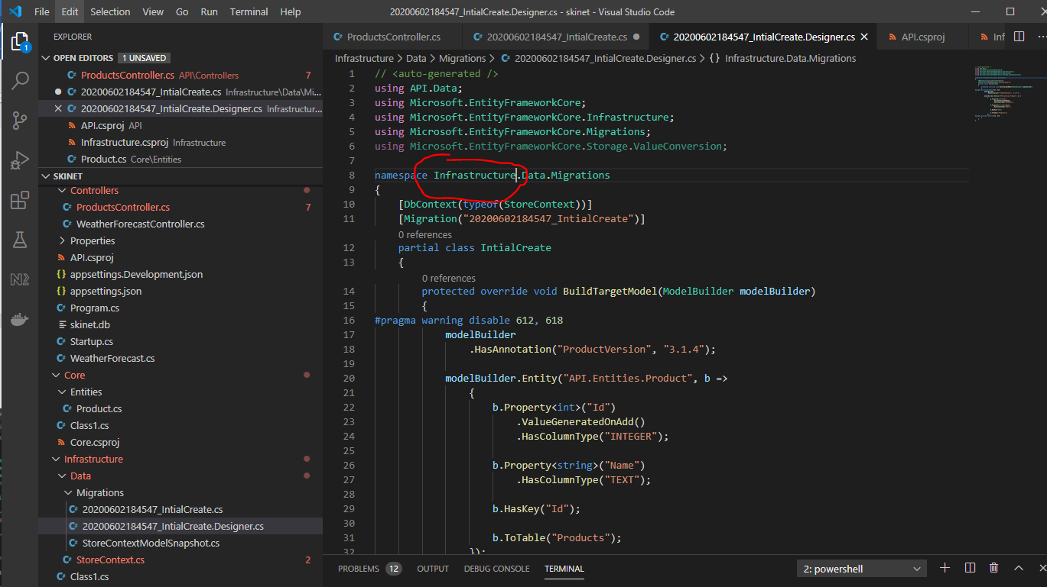

And this too:-

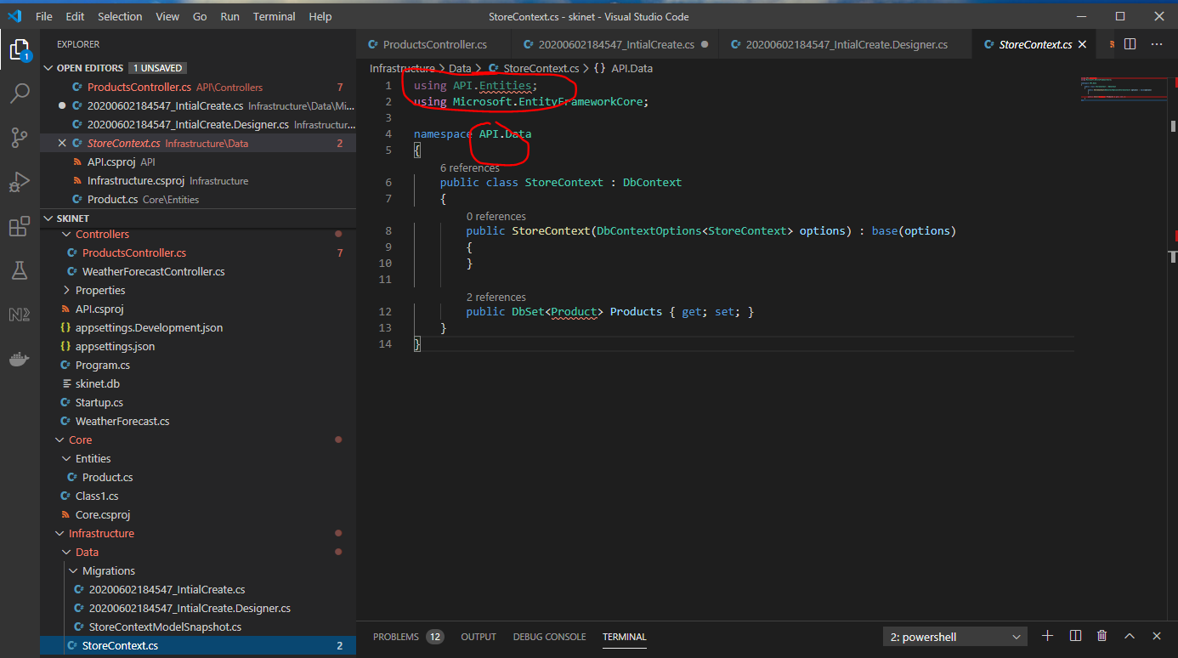

Change to:-

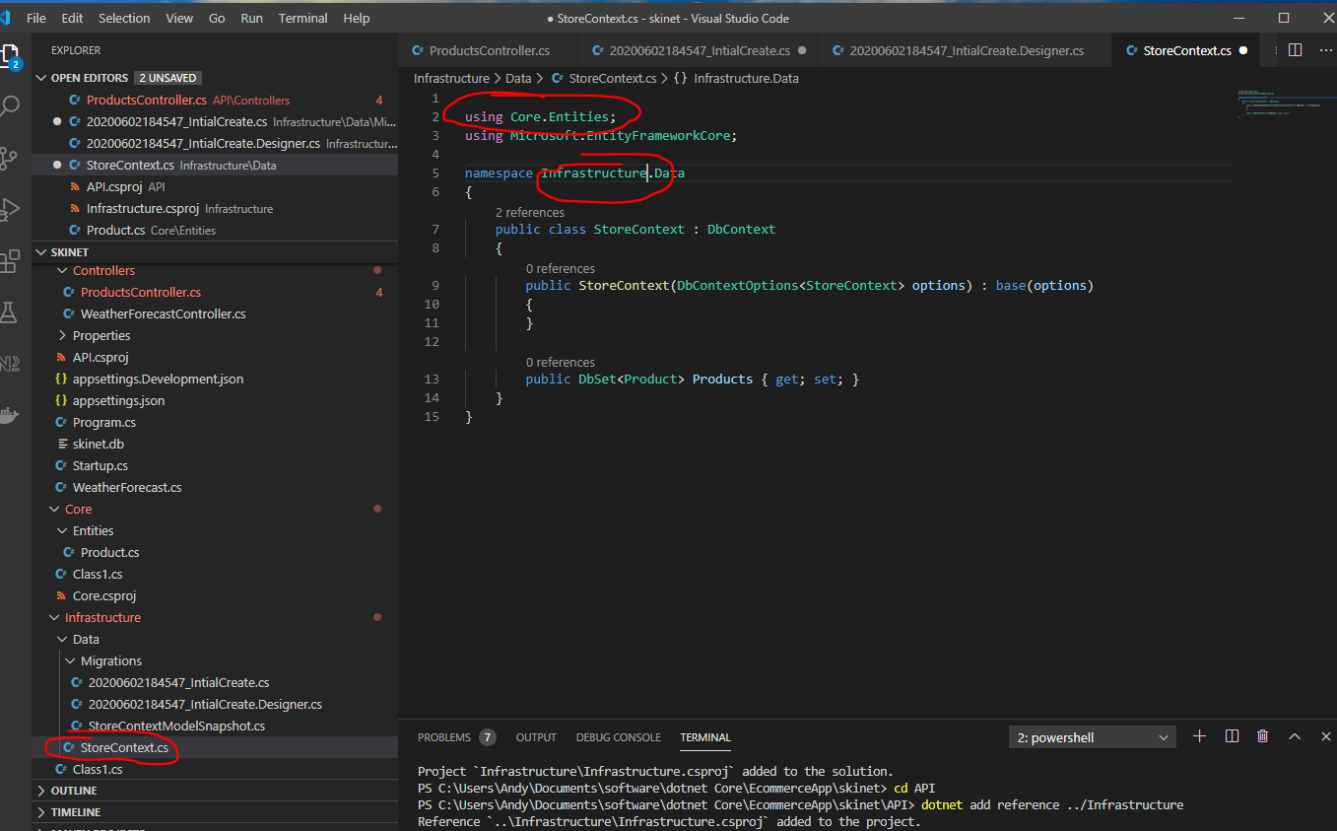

And these too:-

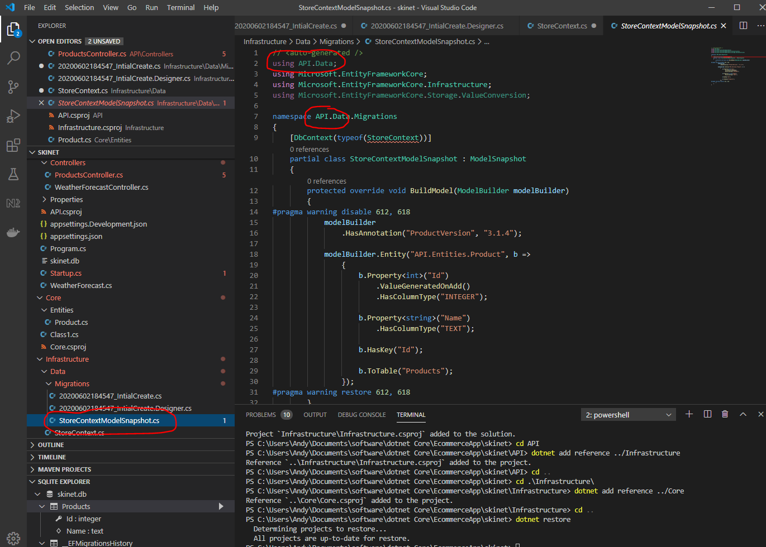

Change to:-

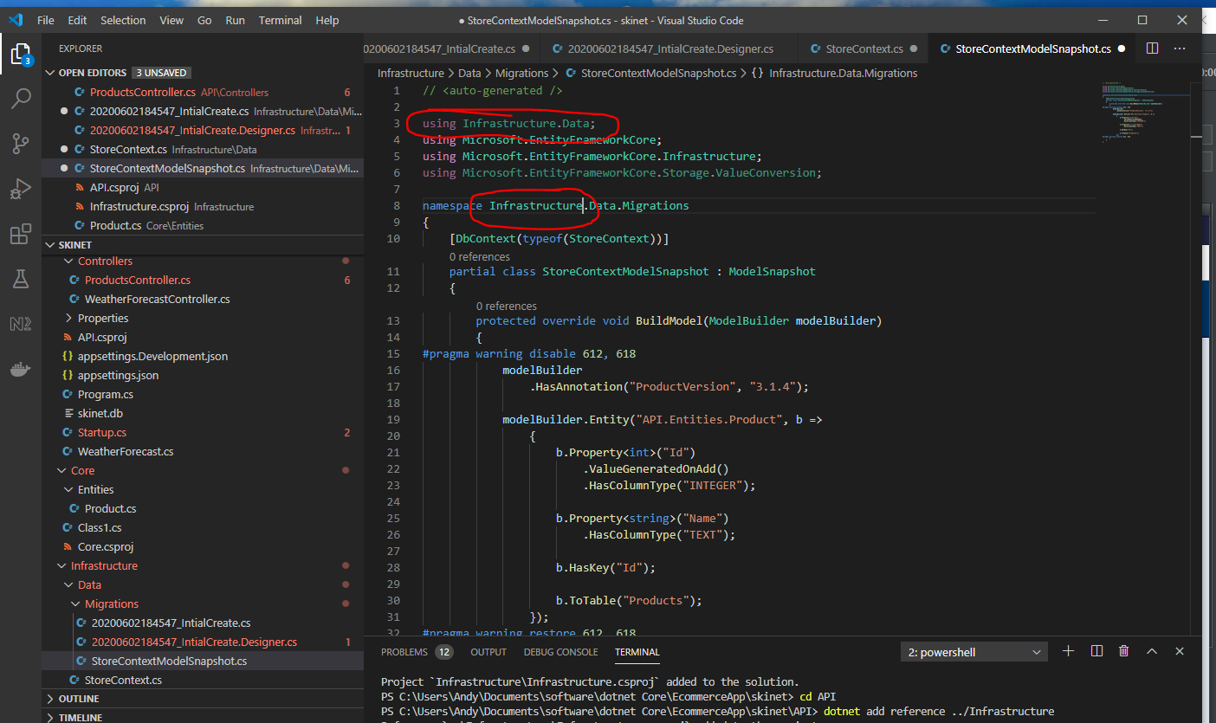

And this too:-

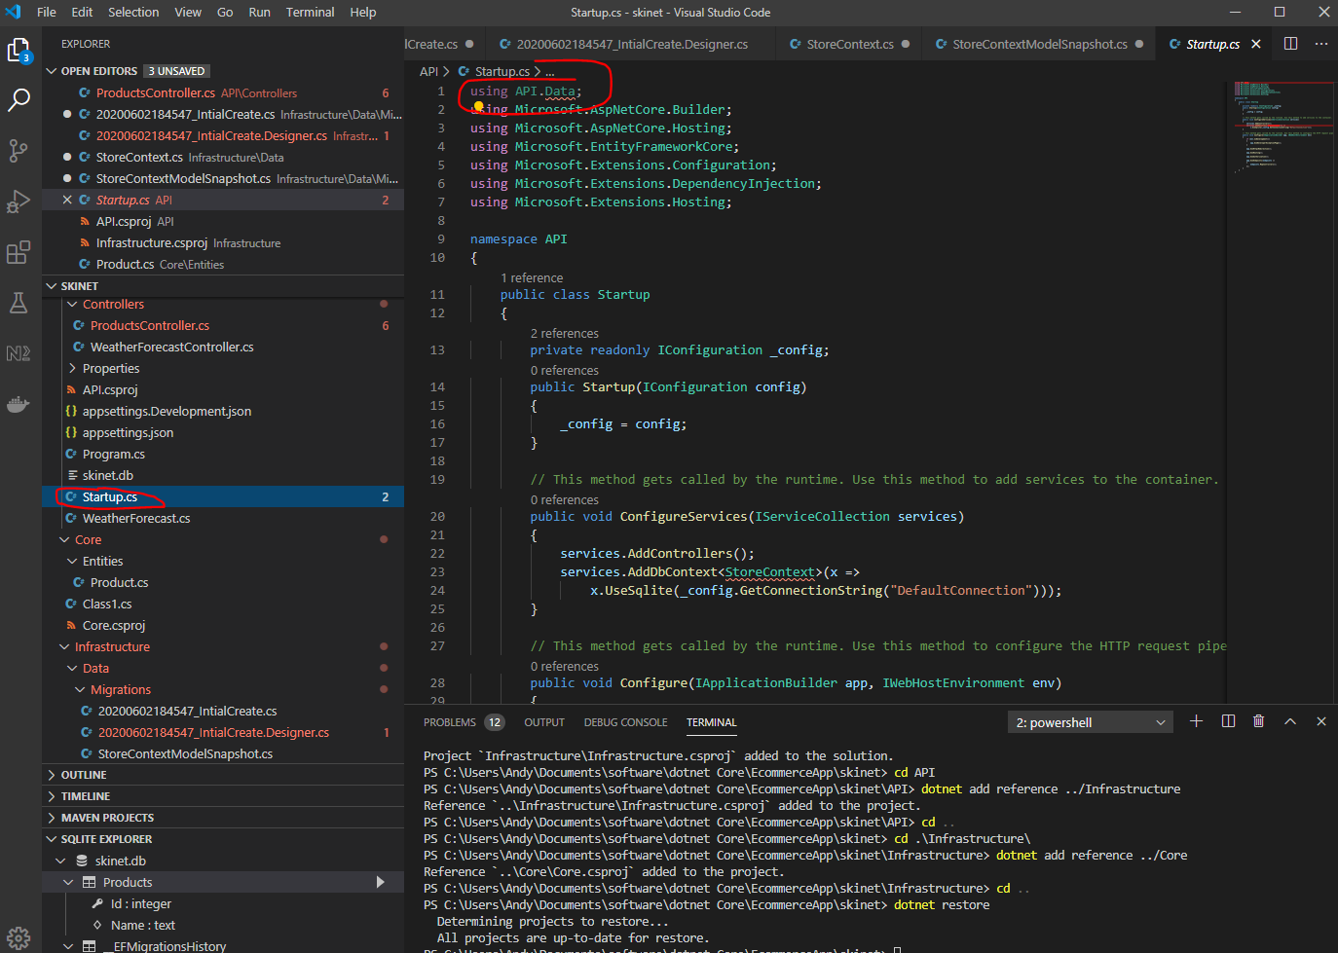

Change to:-

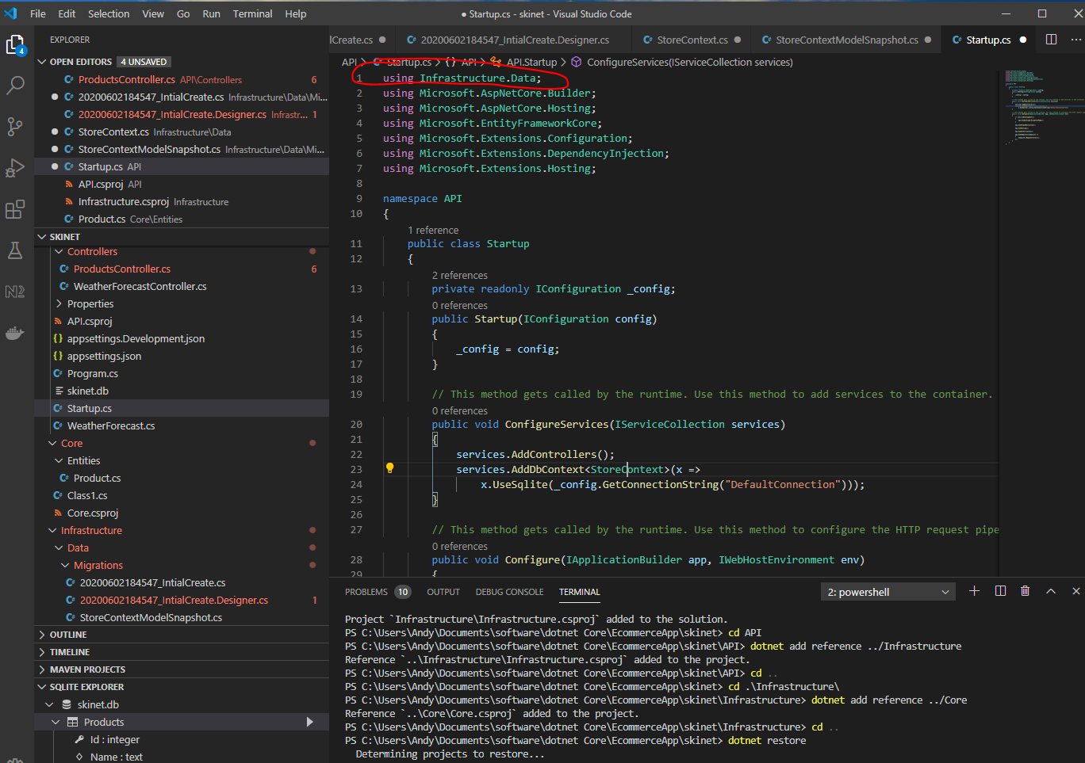

Also tehse:-

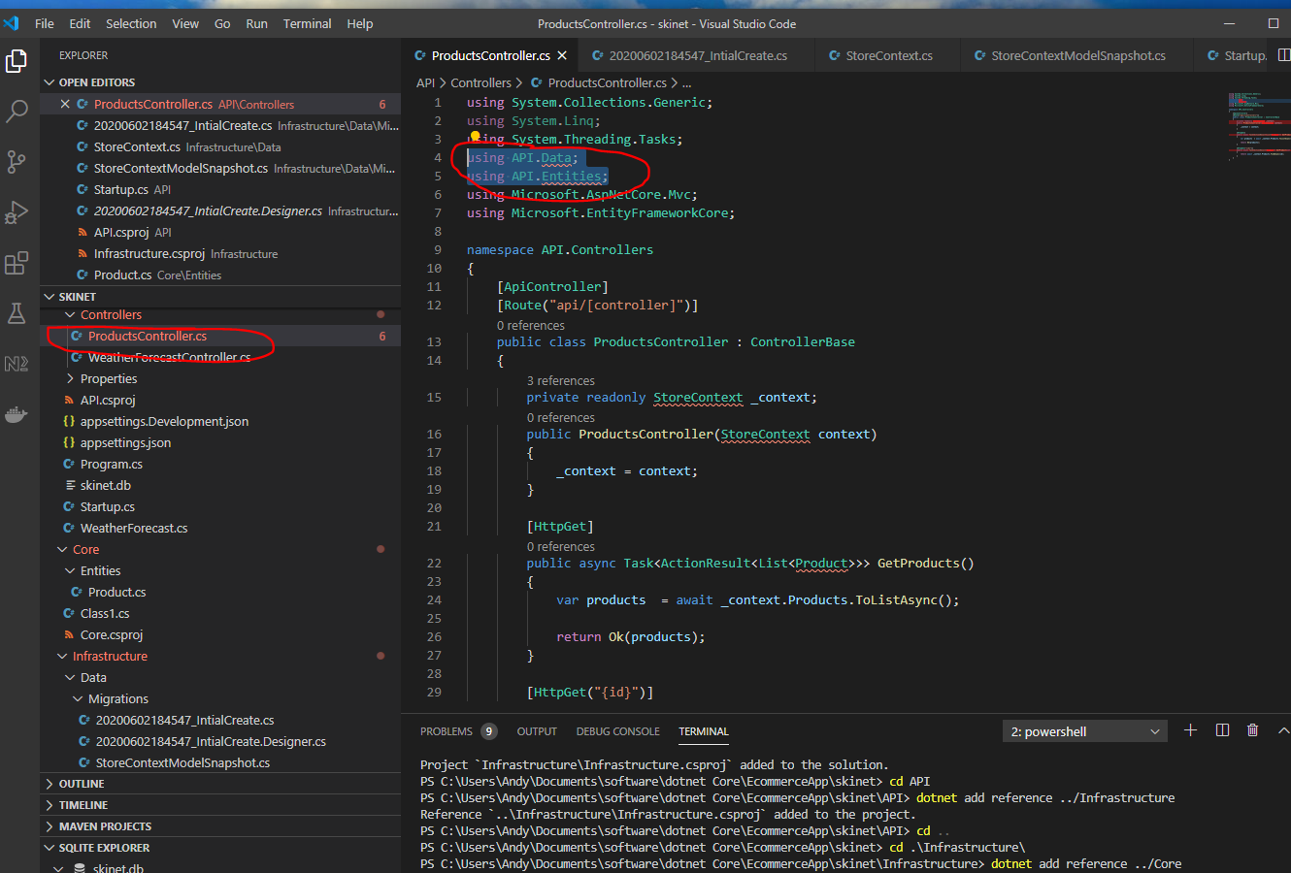

Change to:-

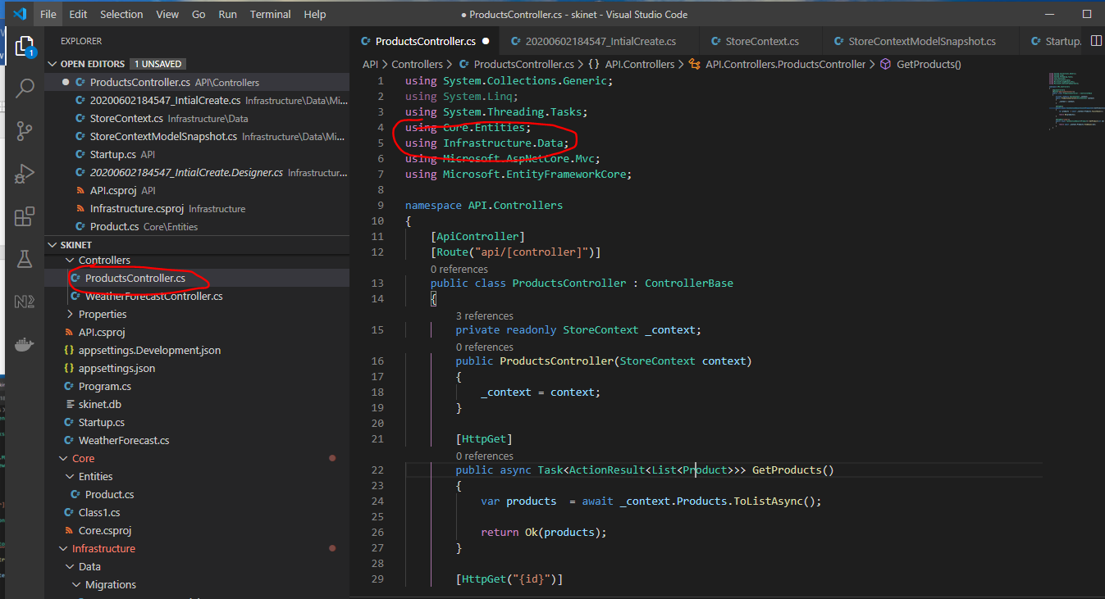

Now in the terminal type:-

*dotnet build*

To hide files in your solution you can go to –

File -> Preferences -> Settings

Type ‘exclude’:-

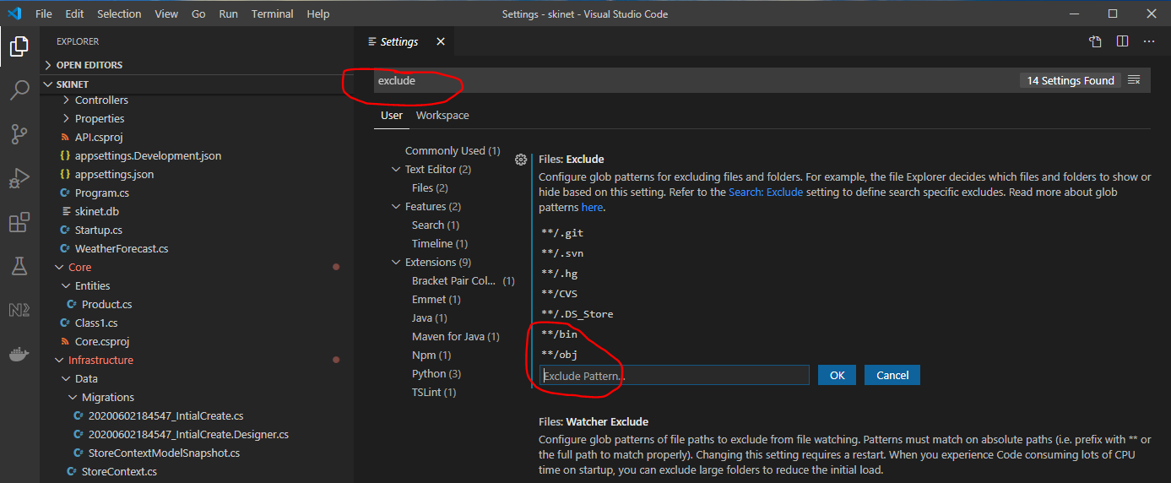

**Upload to Git:-**

Initialise your project as Git project. At the root of your project in VSCode type:-

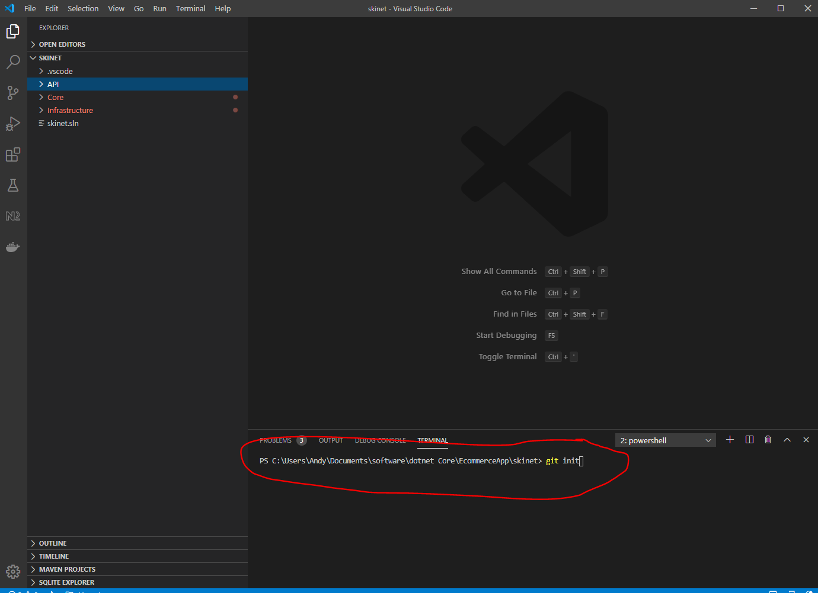

*git init*

Now see all the files ready to upload to Git:-

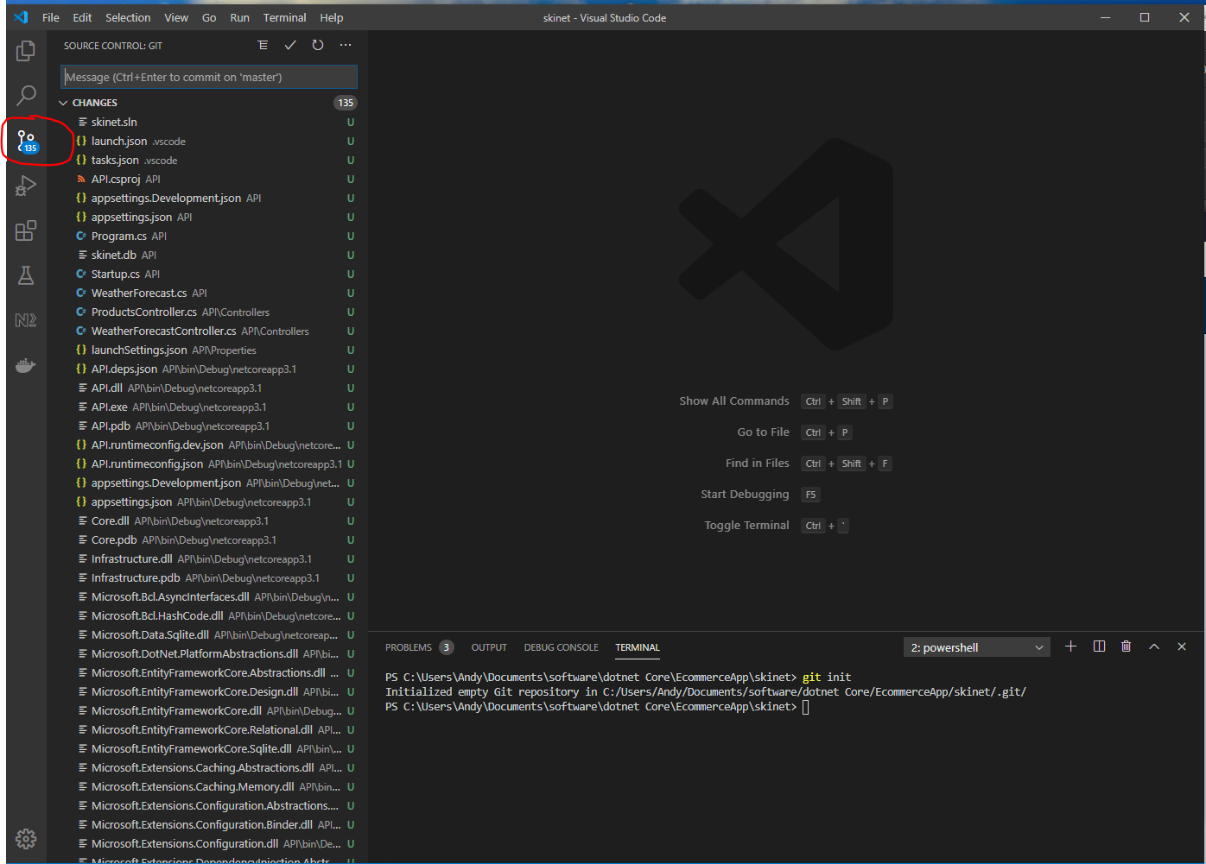

Add a new ‘gitignore’ file to the solution to contain a list of file types that will not be uploaded to Git:-

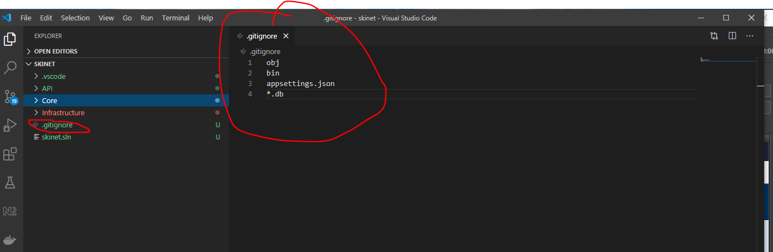

In the VSCode terminal enter:-

*git add .*

*git commit -m “Initial Commit”*

Go to GitHub account:-

<https://github.com/divine-moment-of-truth>

Create a new repo:-

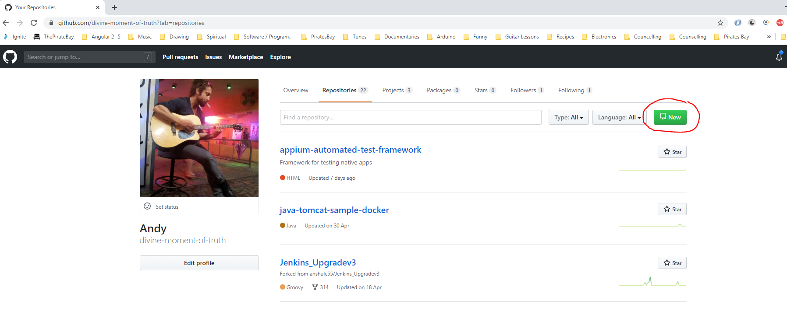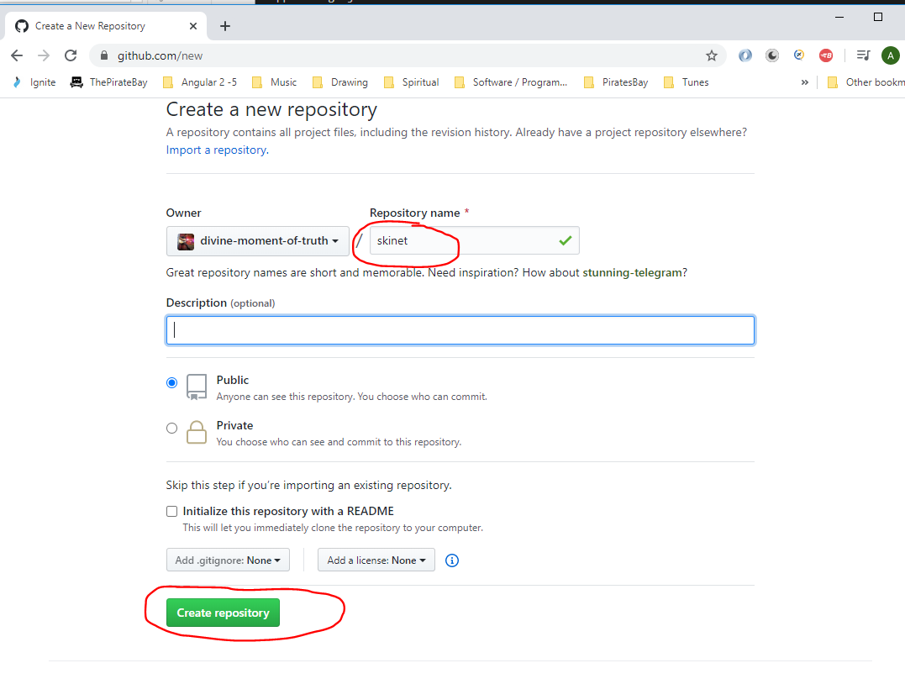

This gives you this:-

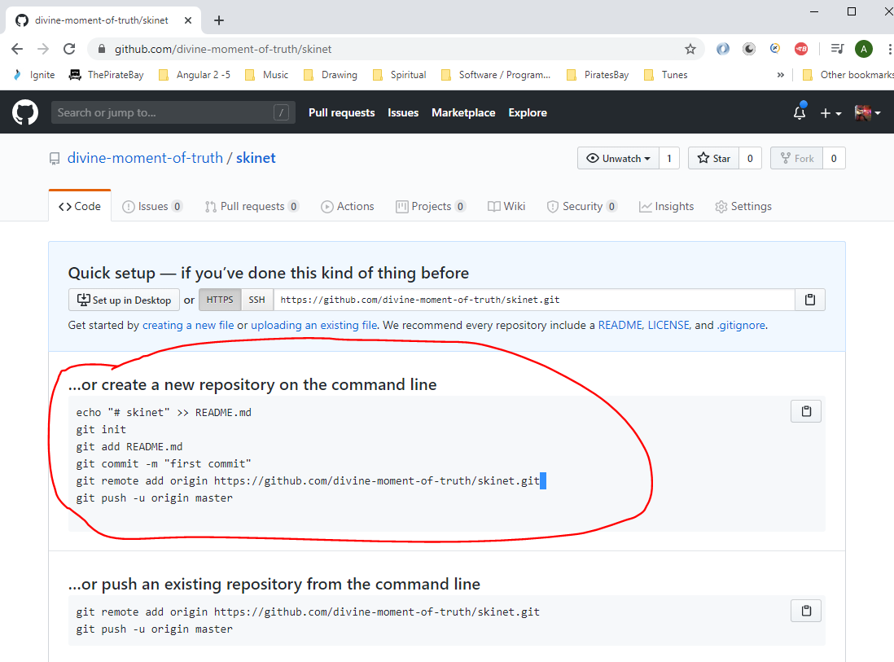

Copy the line:-

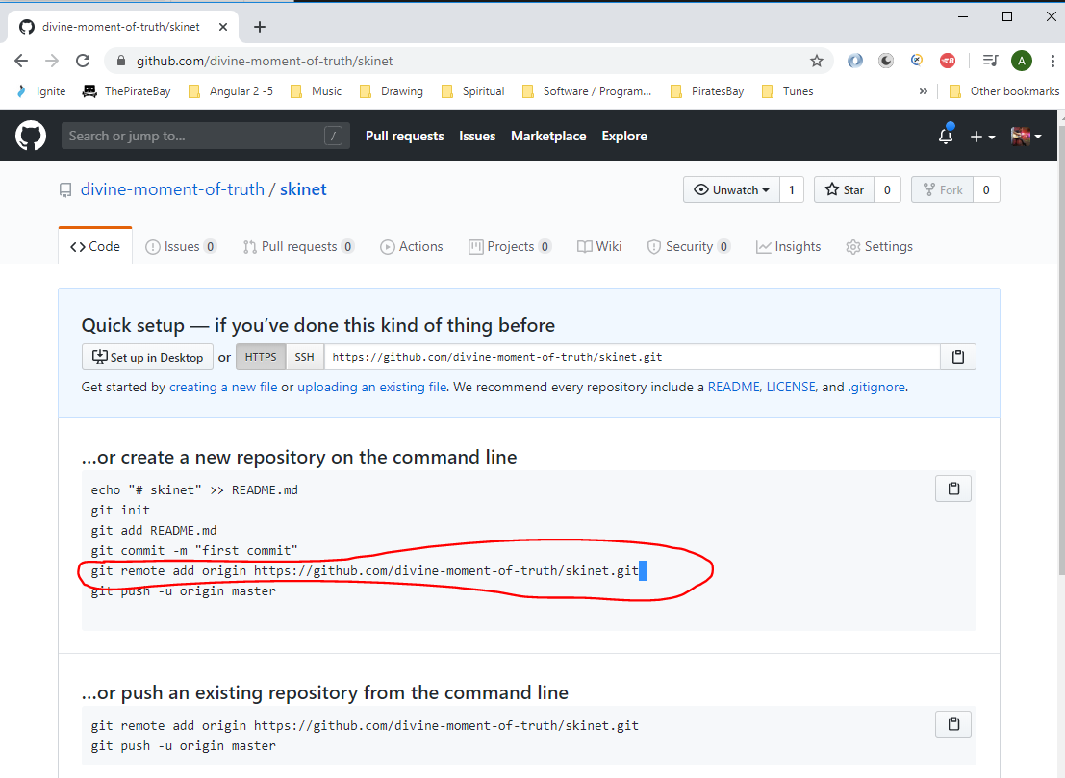

In the VSCode terminal enter:-

git remote add origin https://github.com/divine-moment-of-truth/skinet.git

git push -u origin master

Your code is now uploaded to GitHub

**Application Architecture**

We now have 3 projects:-

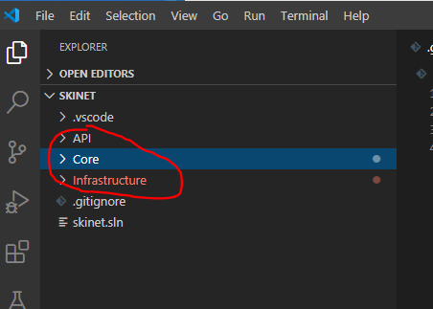

API

Core

Infrastructure

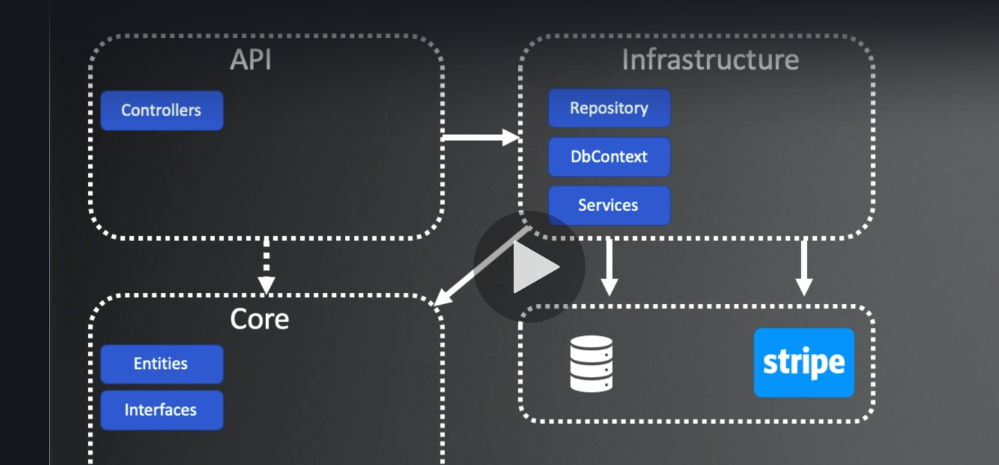

**Repository Pattern**

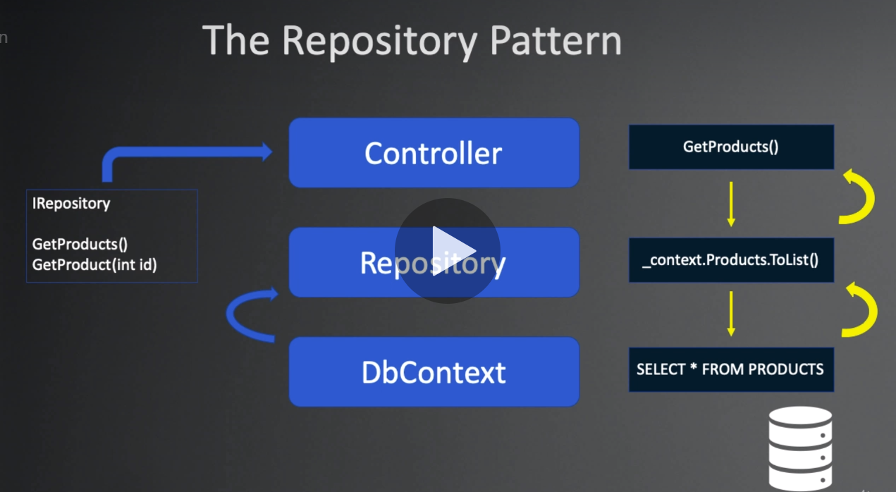

Create a Repo:-

Create an interface in ‘Core’.

Create a folder under ‘Core’ called ‘Interfaces’:-

Create an Interface called ‘IProductRepository in the ‘Interface’ folder:-

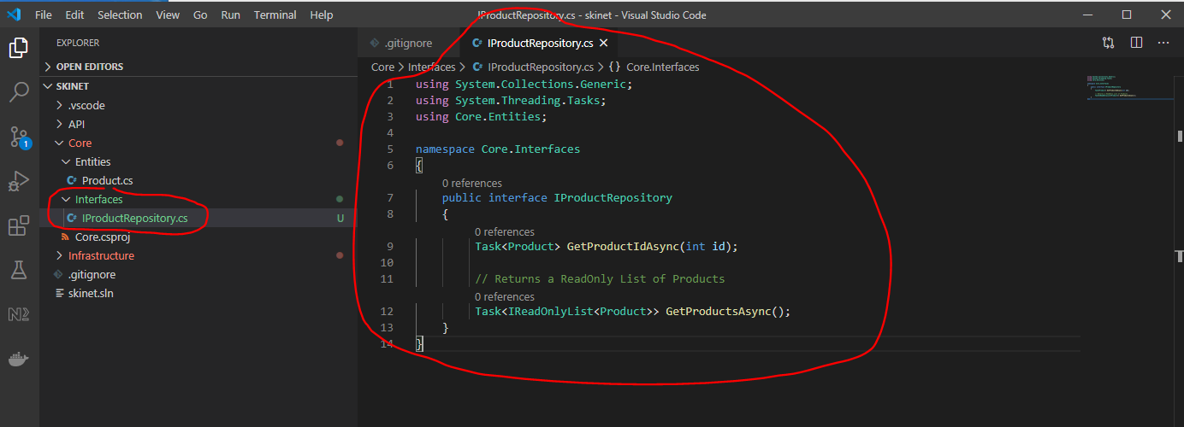

Create a new class in ‘Infrastructure/Data’ to implement the interface:-

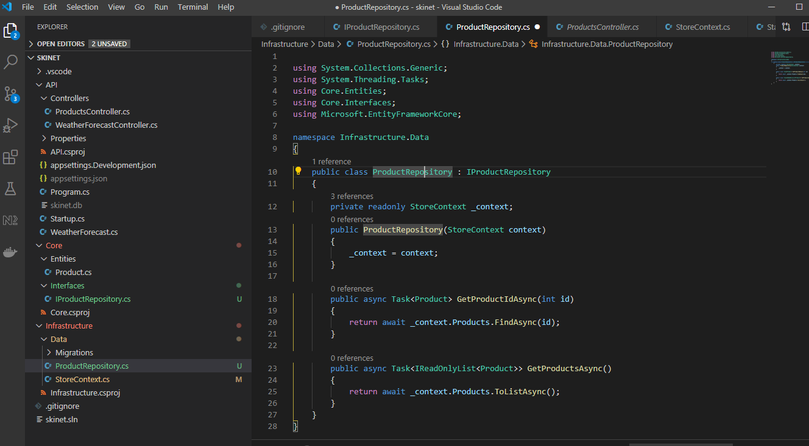

We want this class to be injectable into other classes (controller classes) we need to add this as a service in the ‘startup.cs’ class:-

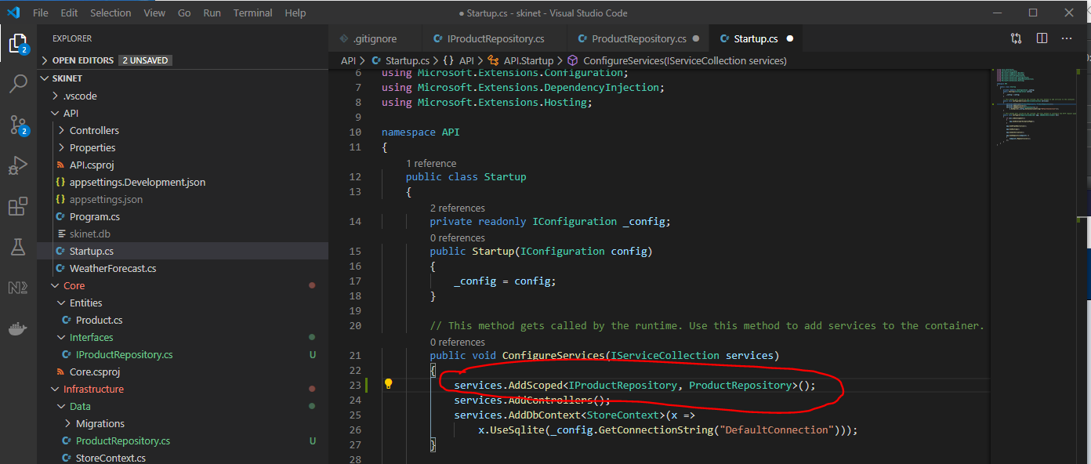

Remove the following from ProductsController.cs:-

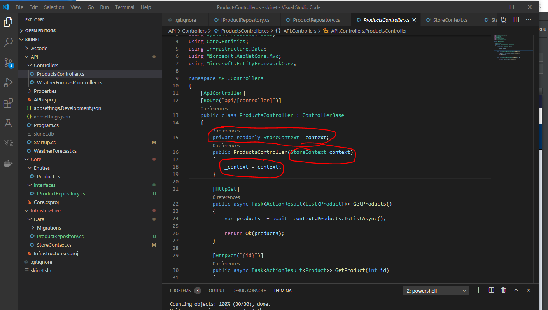

Show now be like this:-

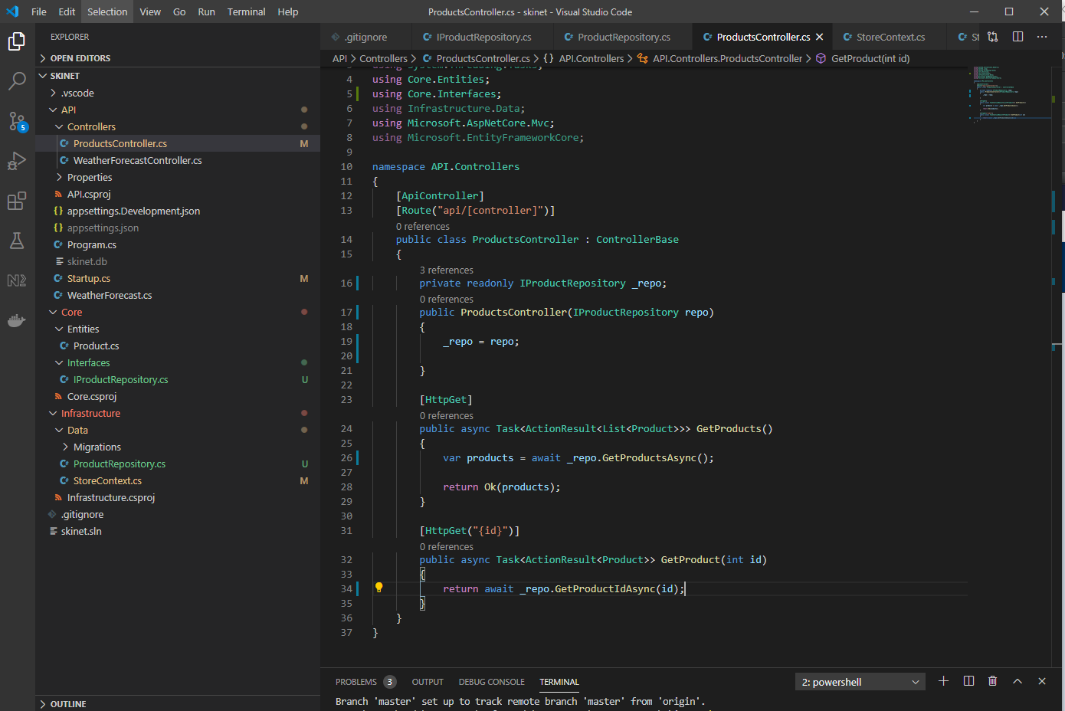

Test changes in Postman:-

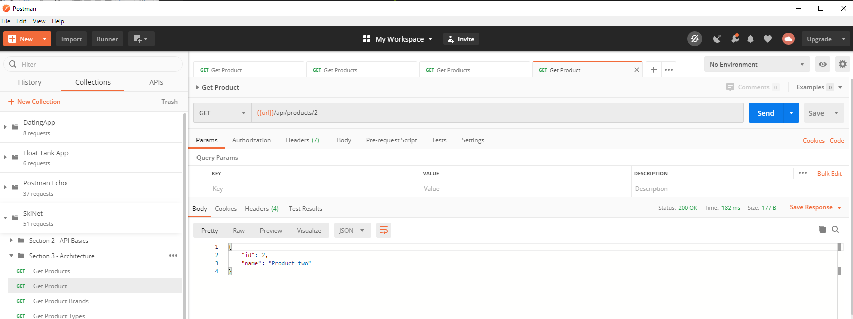

**Create a Base Entity Class**

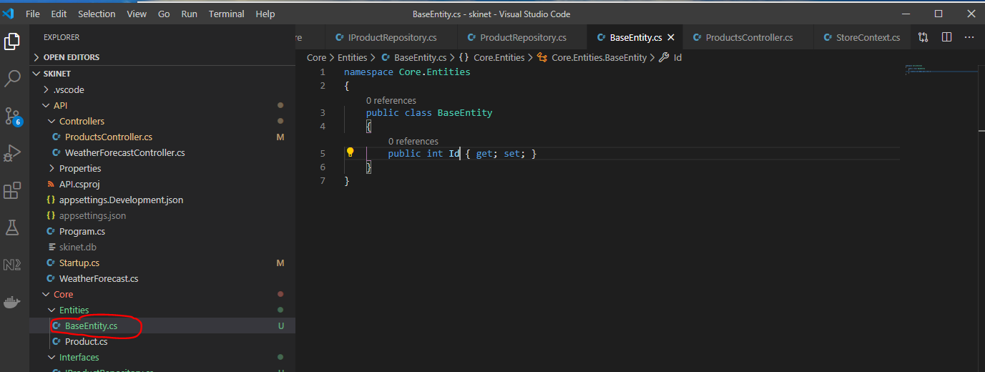

Now make ‘Product.cs’ class entity inherit from the ‘BaseEntity.cs’ class:-

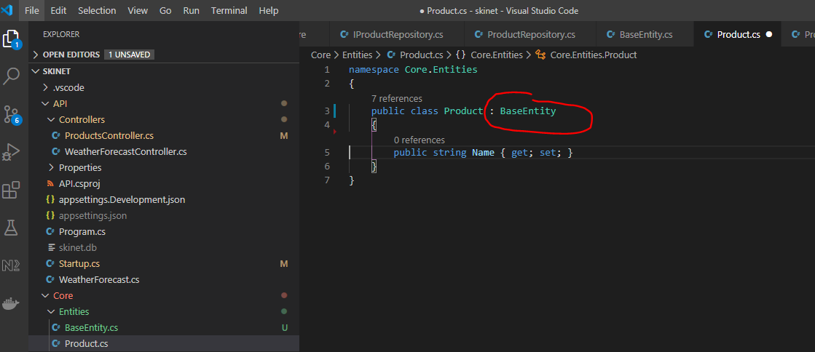

Add new properties to ‘Product class:-

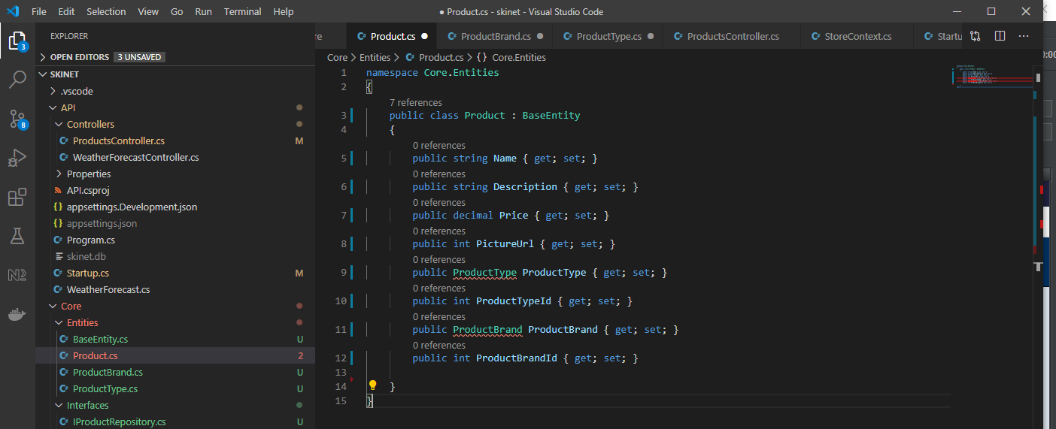

Create two new classes:-

ProductBrand

ProductType

Both inherit from ‘BaseEntity’ class:-

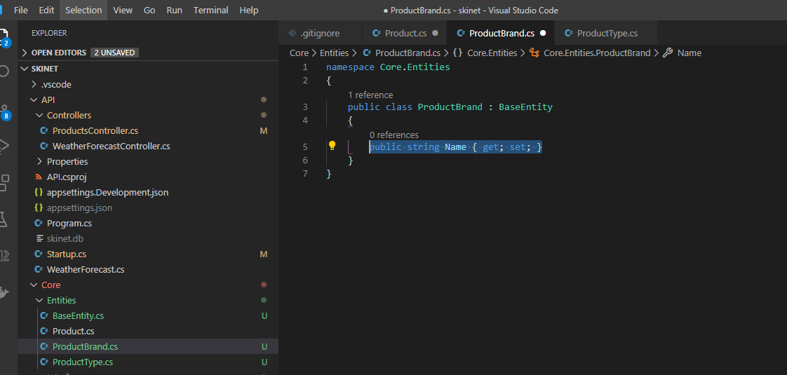

And

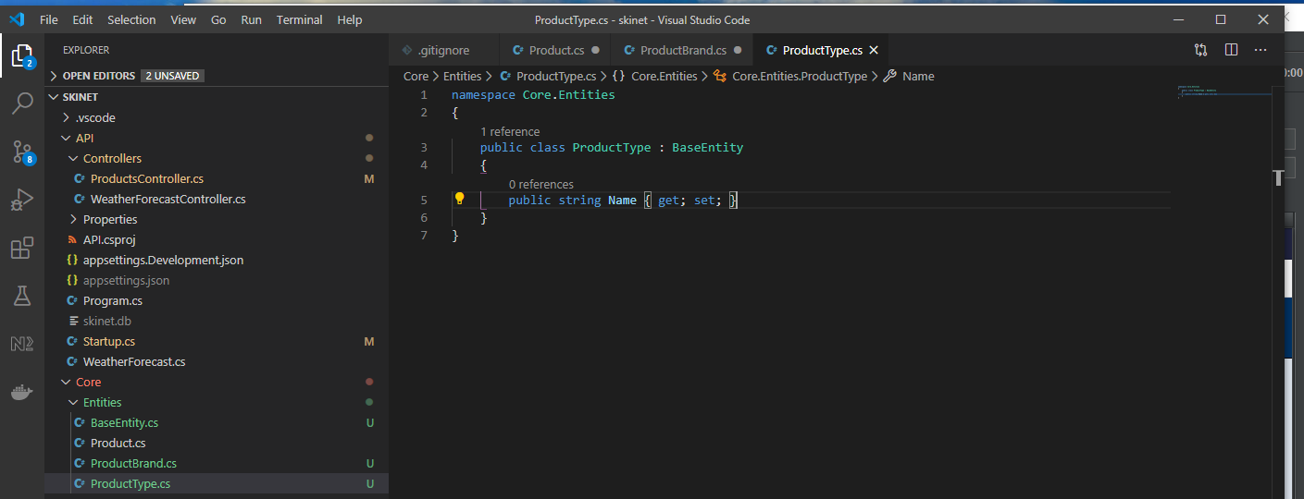

Now, update ‘StoreContext’ with new classes:-

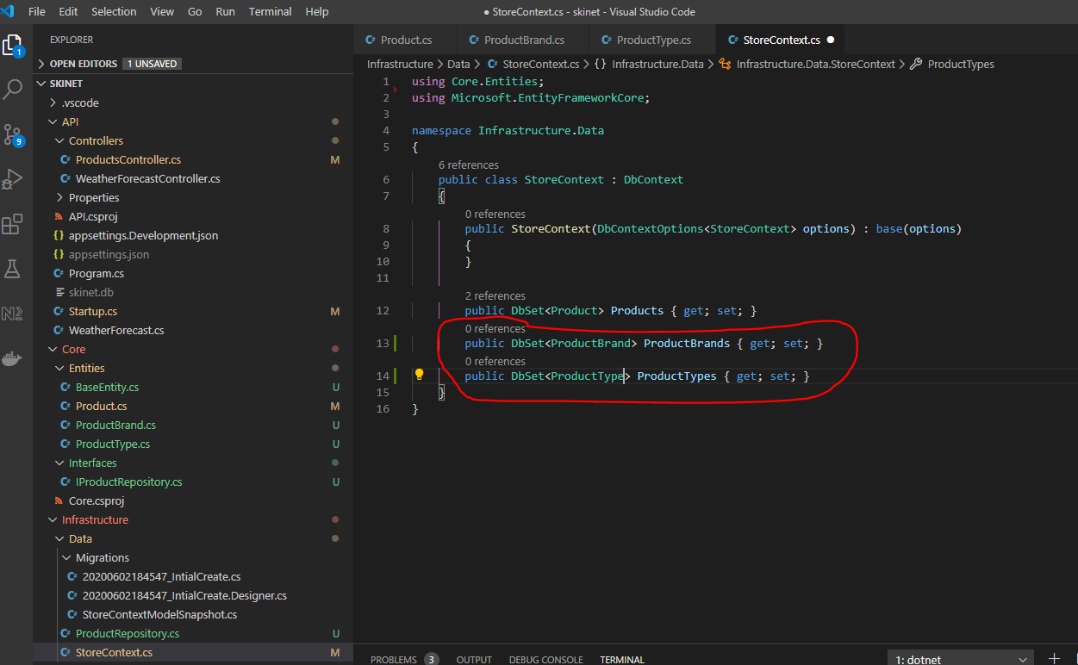

**Create a migration for the above change**

Stop API server in VSCode terminal:-

***[CTRL] + c***

Delete the preciously created migration via VSCode terminal (you will need to be at the rout of the solution to run this command i.e. ‘skinet’):-

***dotnet ef database drop -p Infrastructure -s API***

-s - this is the project name where the startup.cs class is i.e. API

-p - this is the project name where database migration exists i.e. Infrastructure

***dotnet ef migrations remove -p Infrastructure -s API***

Create new migration:-

***dotnet ef migrations add InitialCreate -p Infrastructure -s API -o Data/Migrations***

-o - this is the output location i.e. create the migrations here – ‘Data/Migrations’

This creates this:-

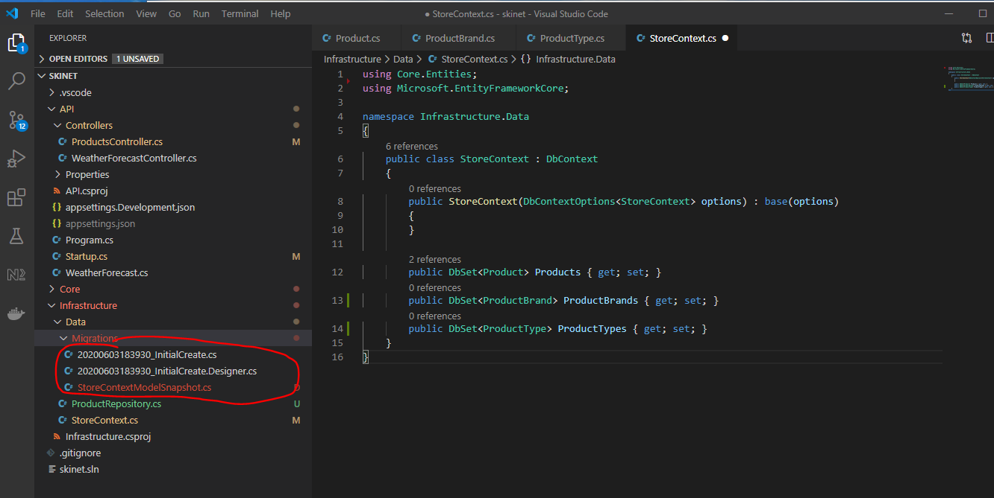

**Fine tuning / configuring Migrations**

Create a new folder under the ‘Data’ folder called ‘Config’, then create a new class in this folder called ‘ProductConfiguration’:-

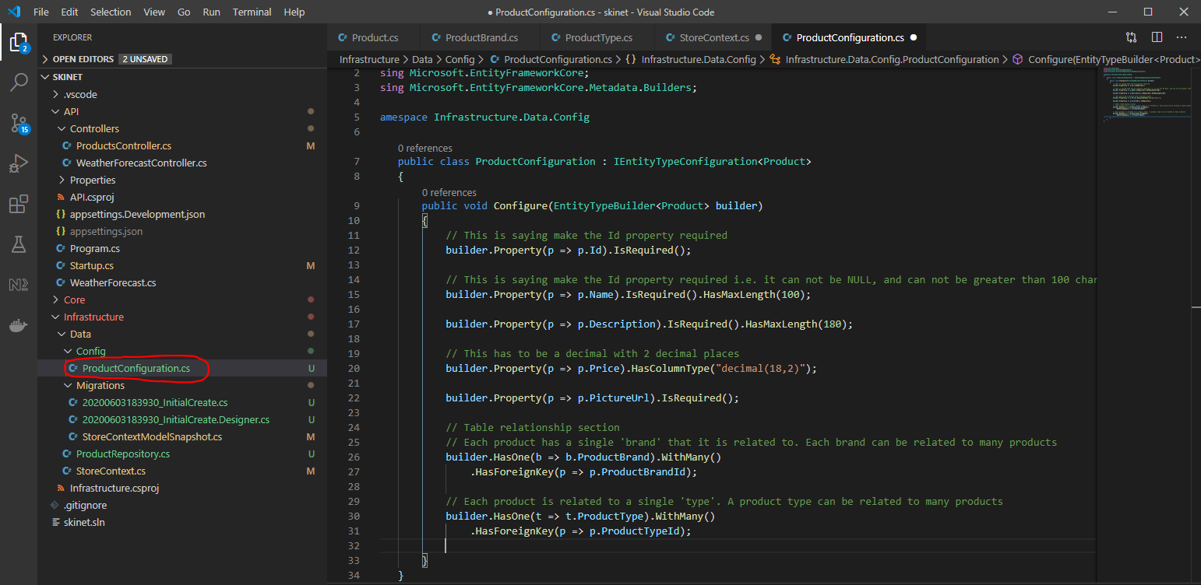

Now update the ‘StoreContext’ class:-

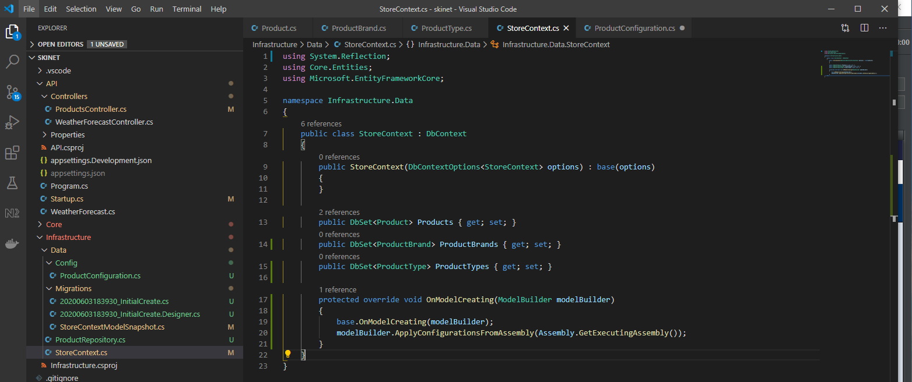

Now remove previously created migrations (enter the following into VSCode):-

***dotnet ef migrations remove -p Infrastructure -s API***

Now create a new migration:-

***dotnet ef migrations add InitialCreate -p Infrastructure -s API -o Data/Migrations***

See changes in migration file:-

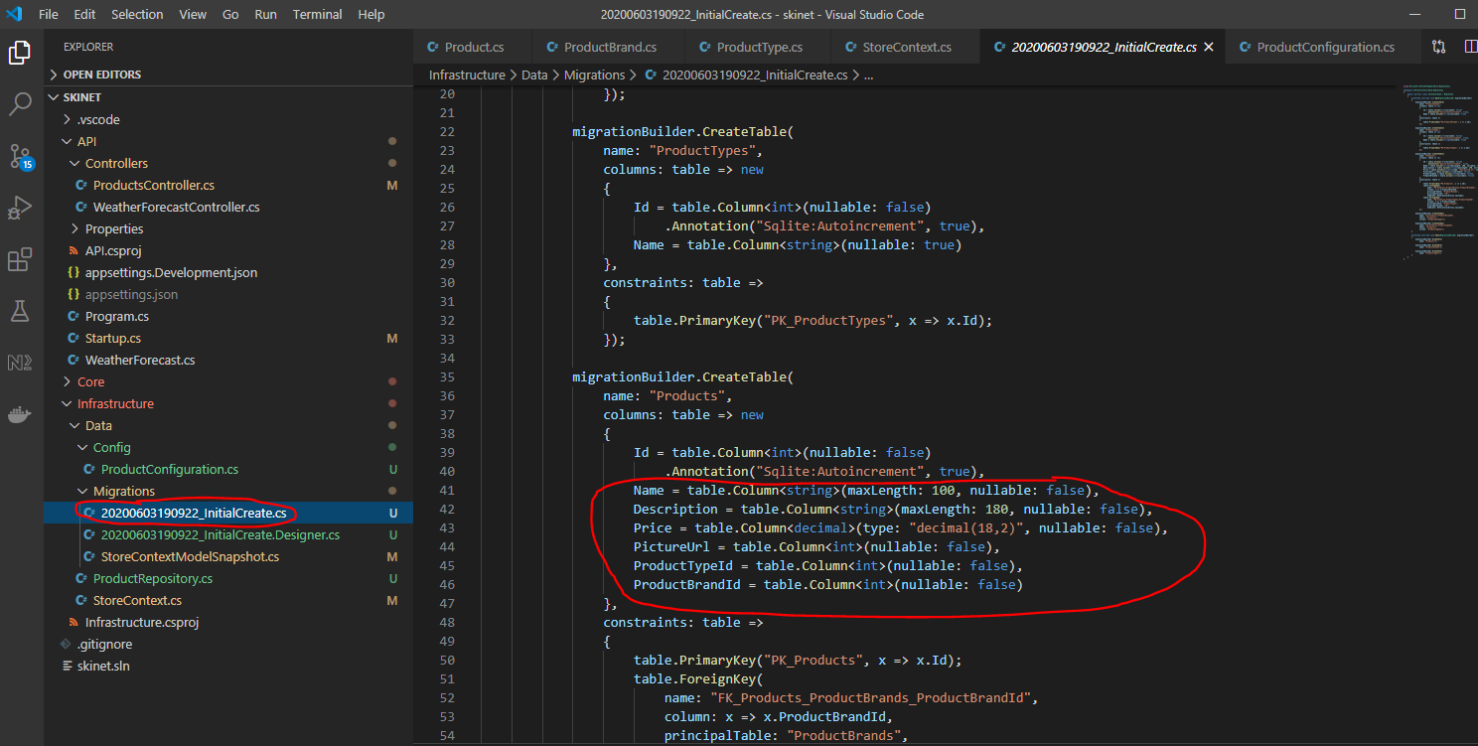

**Apply the Migration and Create the Database**

Go to ‘Programs.cs’ file:-

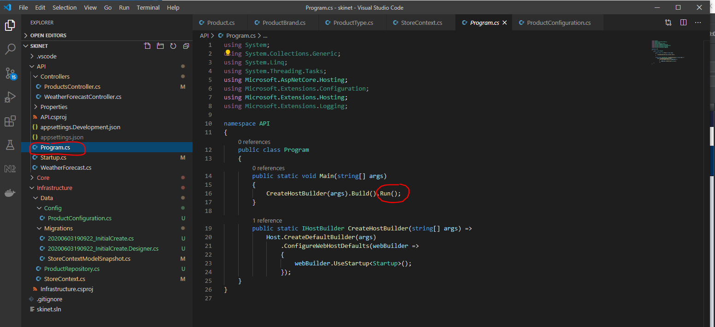

Remove ‘.Run()’.

Now add all this code:-

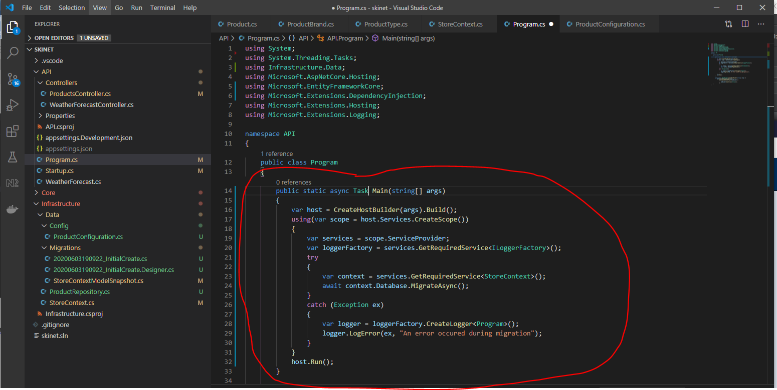

Restart API via VSCode terminal:-

*cd API*

*dotnet watch run*

Now, right click ‘skinet.db’ database in VSCode EXPLORER and select ‘Close database’

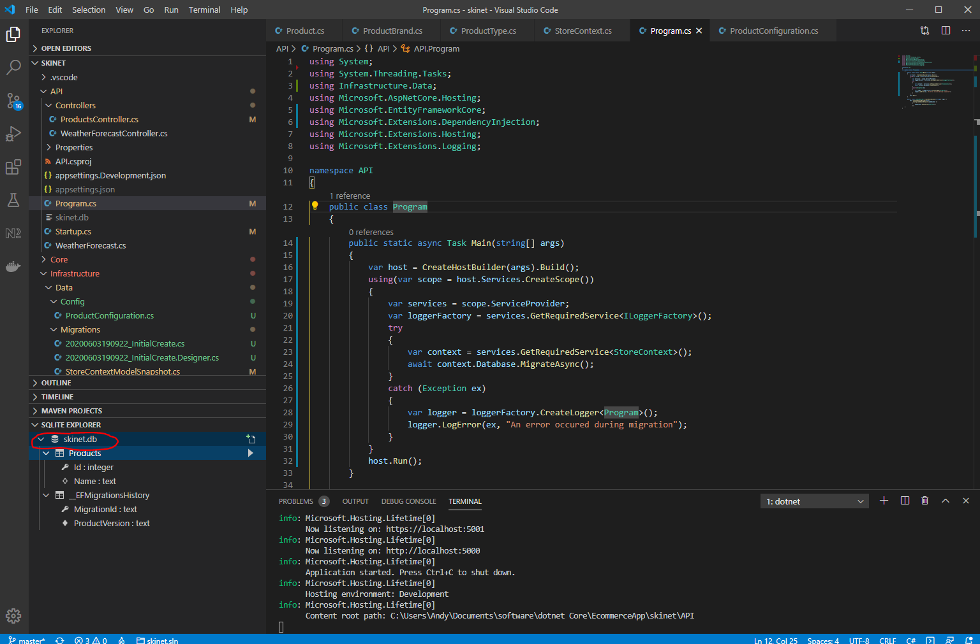

The press:-

[ctrl] + [shift] + p

SQLite: Open database

skinet.db

Now see the 3 database tables:-

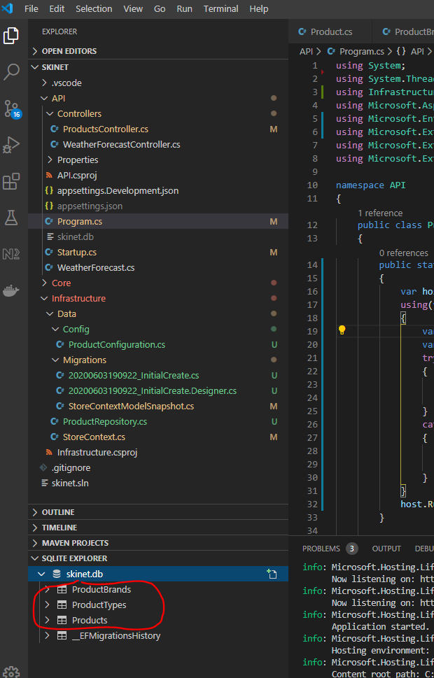

**Seeding Data into Database Tables**

Data can be found in this folder:-

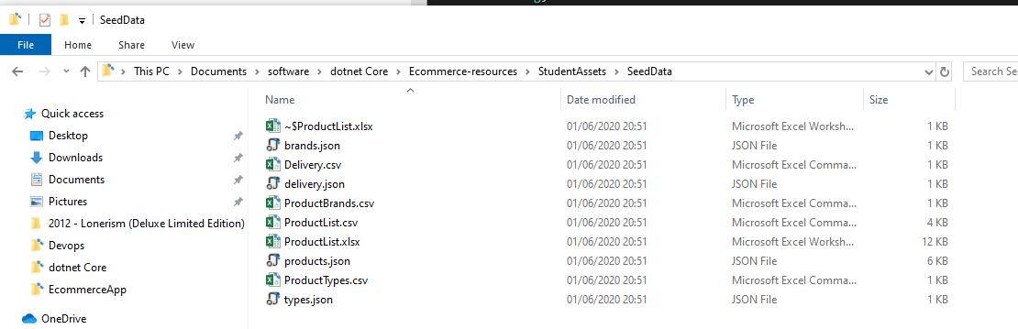

Use a .csv to JSON file converter online:-

<https://csvjson.com/csv2json>

Open this file in notepad:-

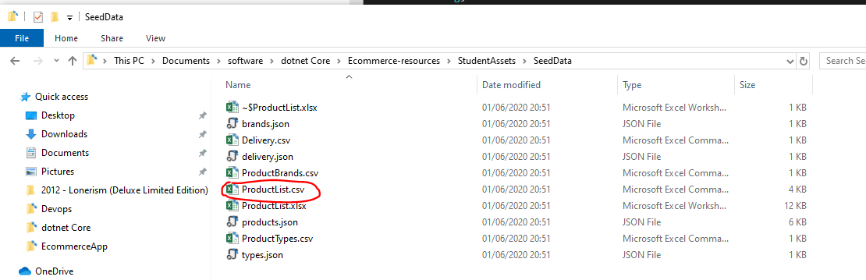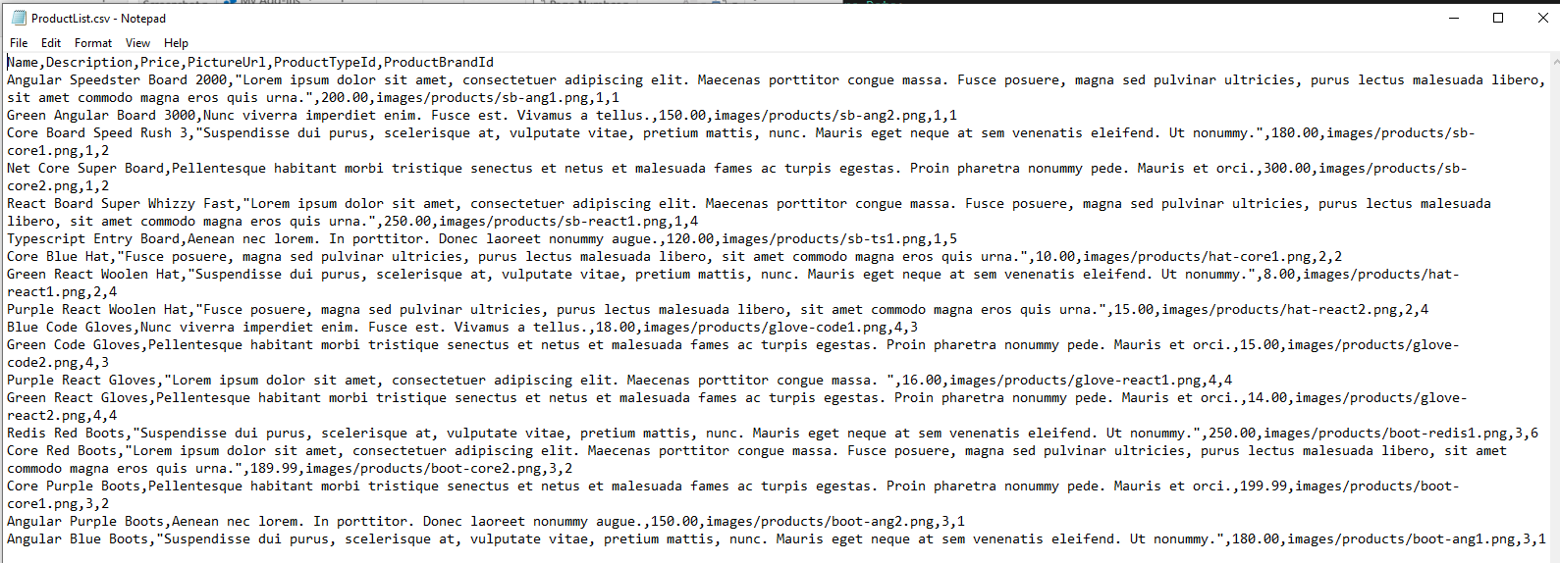

Copy content and paste into website:-

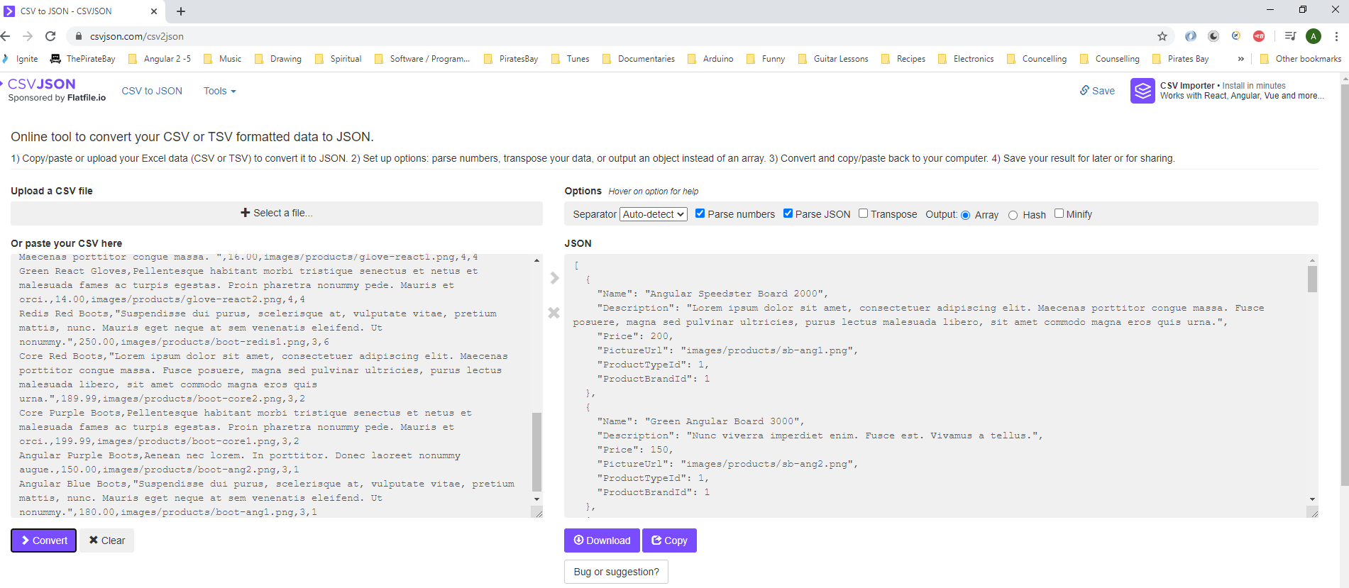

The JSON output is what we will be using to get the data into our database.

Copy these files and paste into your project:-

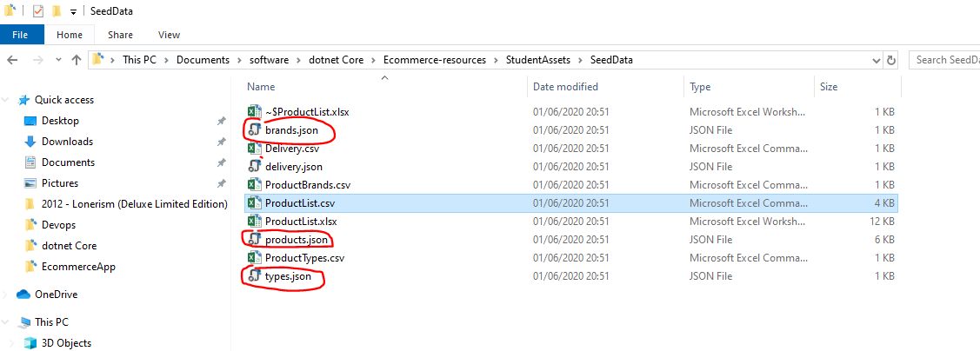

Create a new folder in VSCode solution for putting the above file into:-

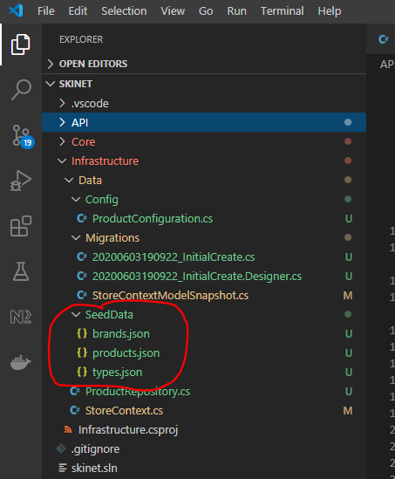

Create a new class for seeding data within the ‘Data’ folder:-

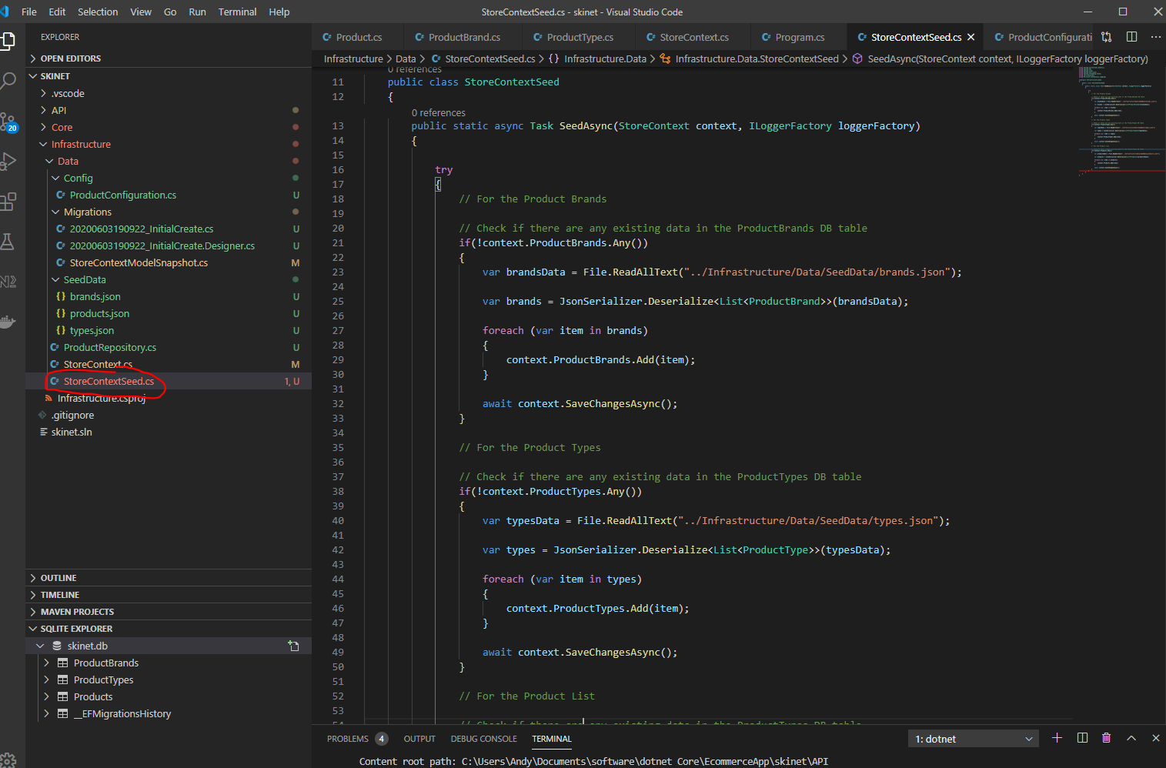

Now, update the ‘Program.cs’ class file:-

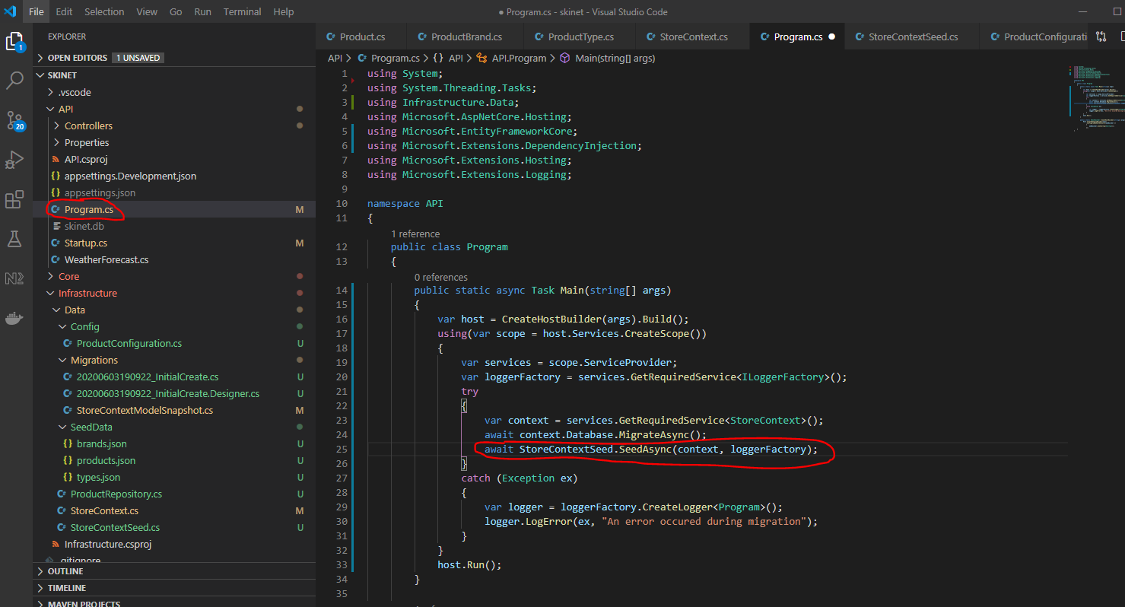

Stop then restart the API:-

[ctrl} + c

donet watch run

NOTE:- At this point I found an erro when running my API. One of my product properties had been configured incorrectly i.e. I had set ‘PictureUrl’ as an INT, where is should have been a STRING. So overcome the problem I had to do this:-

***[CTRL] + c***

Delete the preciously created migration via VSCode terminal (you will need to be at the rout of the solution to run this command i.e. ‘skinet’):-

***dotnet ef database drop -p Infrastructure -s API***

***dotnet ef migrations remove -p Infrastructure -s API***

Create new migration:-

***dotnet ef migrations add InitialCreate -p Infrastructure -s API -o Data/Migrations***

cd API

dotnet watch run

Now I can see my database tables populated with data:-

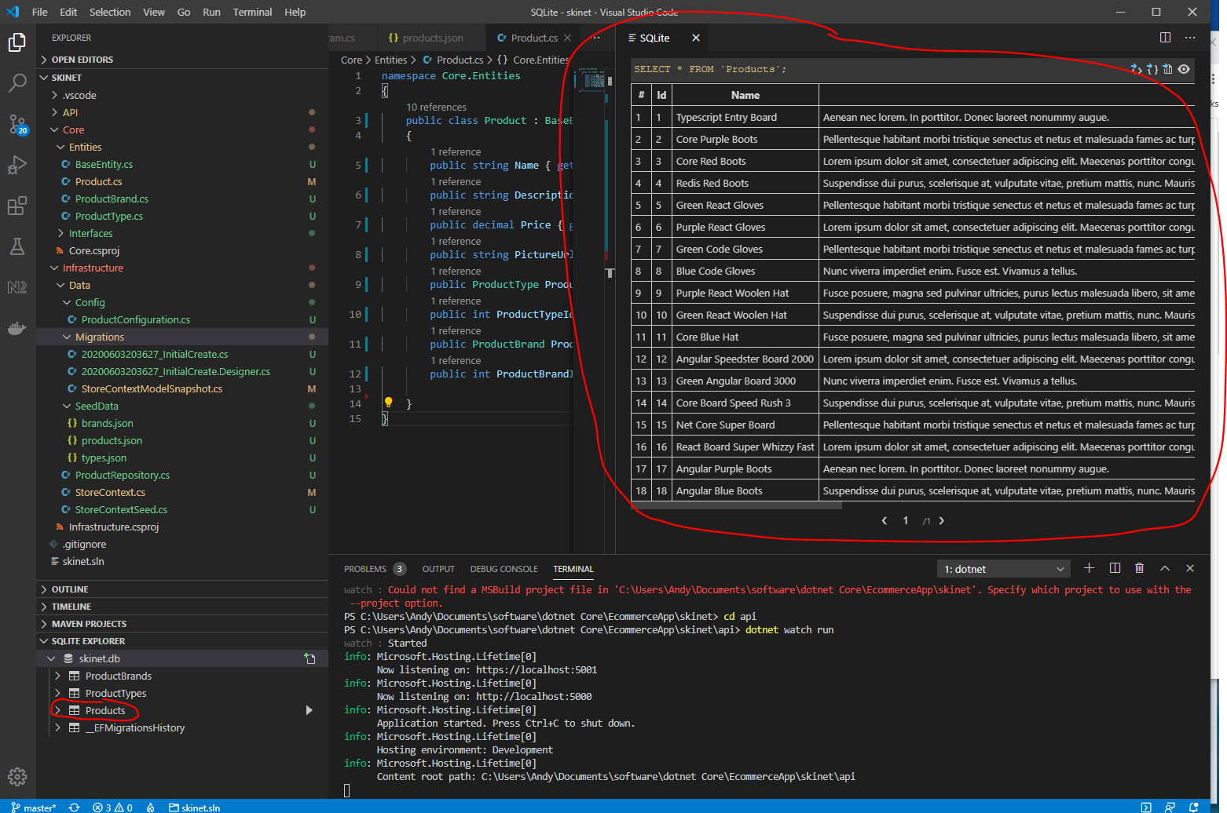

**Add code to add brand and type data**

Update the ‘IProductRepository’ interface to include the other two data types:-

* BrandName
* ProductType

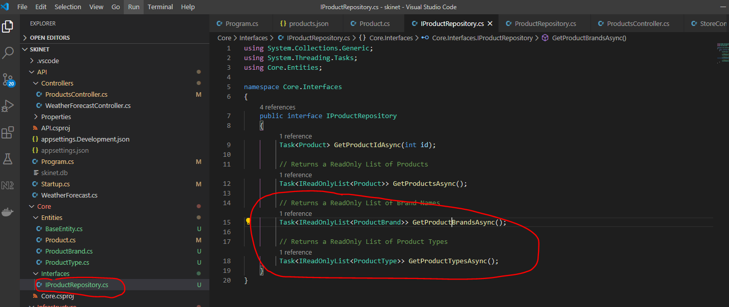

Now update the ‘ProductRepository’ class:-

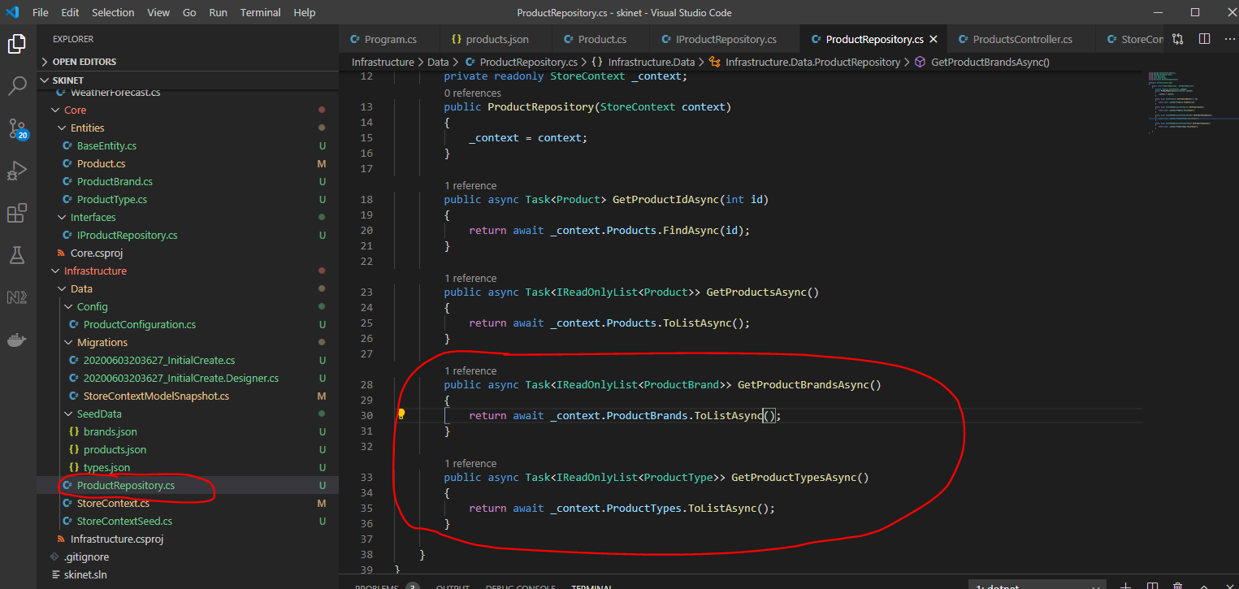

Now update the ‘ProductController’ class:-

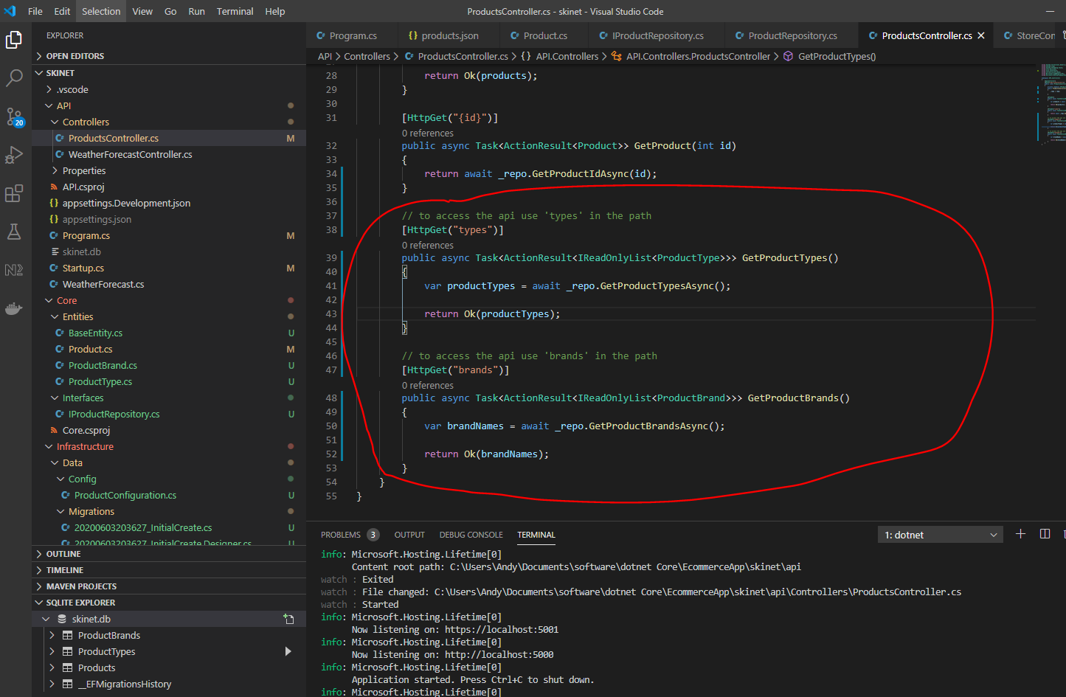

Now test using postman:-

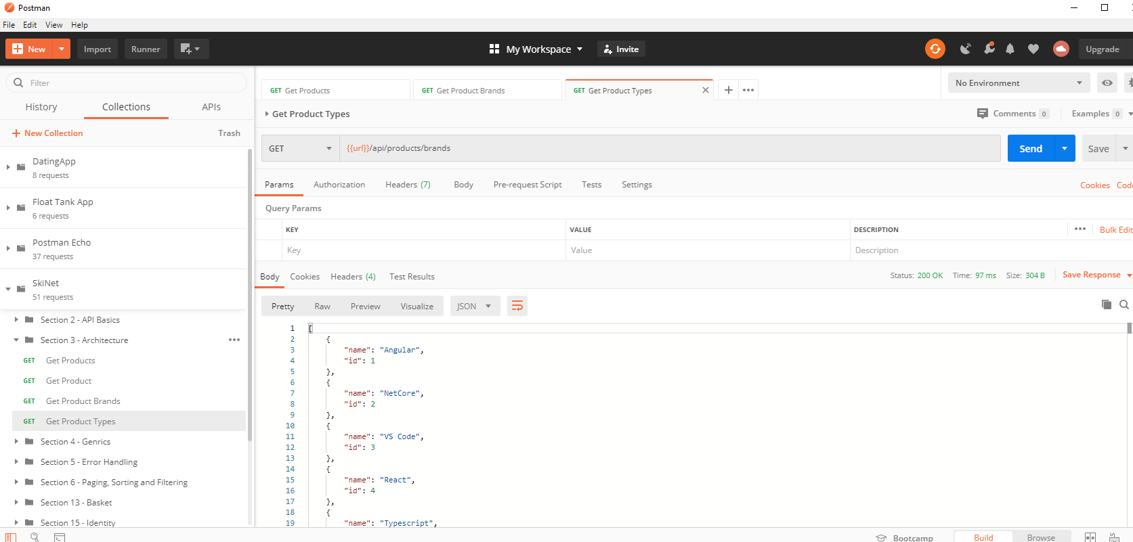

And

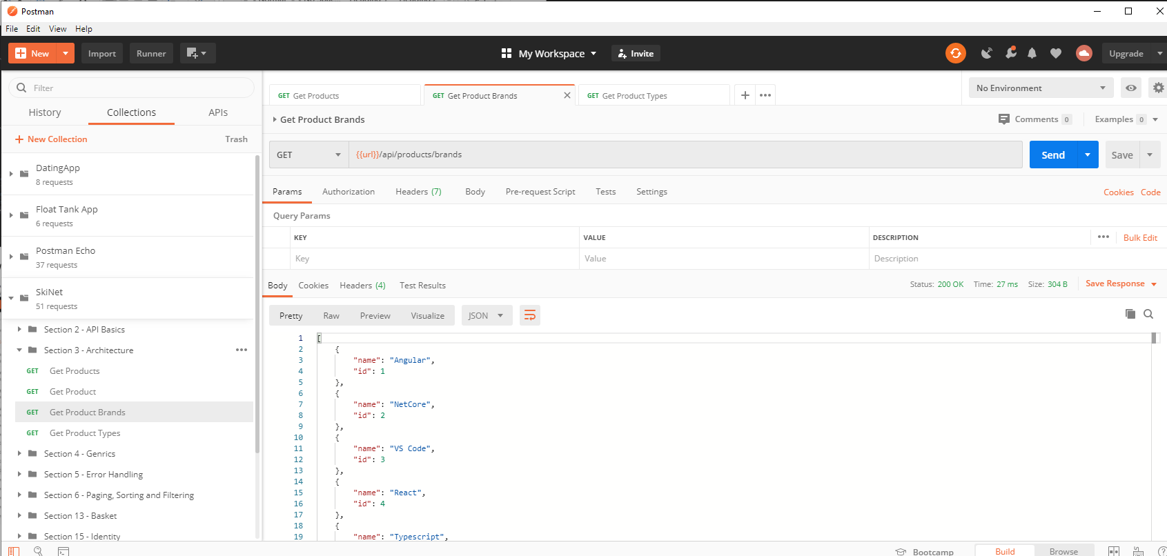

Next problem is when getting products the ‘productType’ and ‘productBrand’ items are shown as ‘null’:-

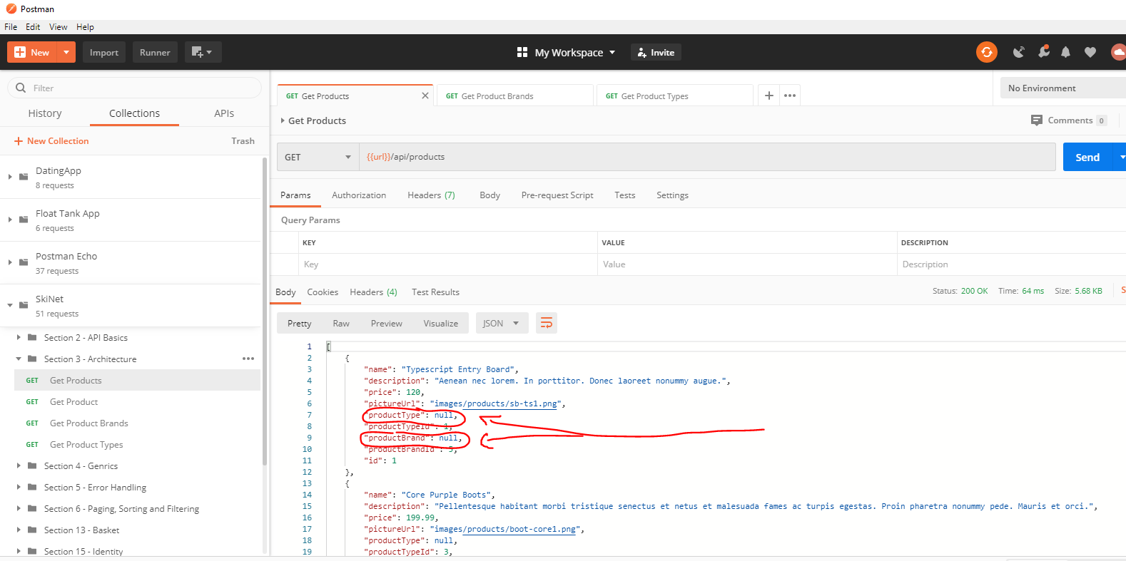

Go to the ‘ProductRepository.cs’ file a look at the ‘GetProductsAsync’ methos as this is where product data is retrieved from the database:-

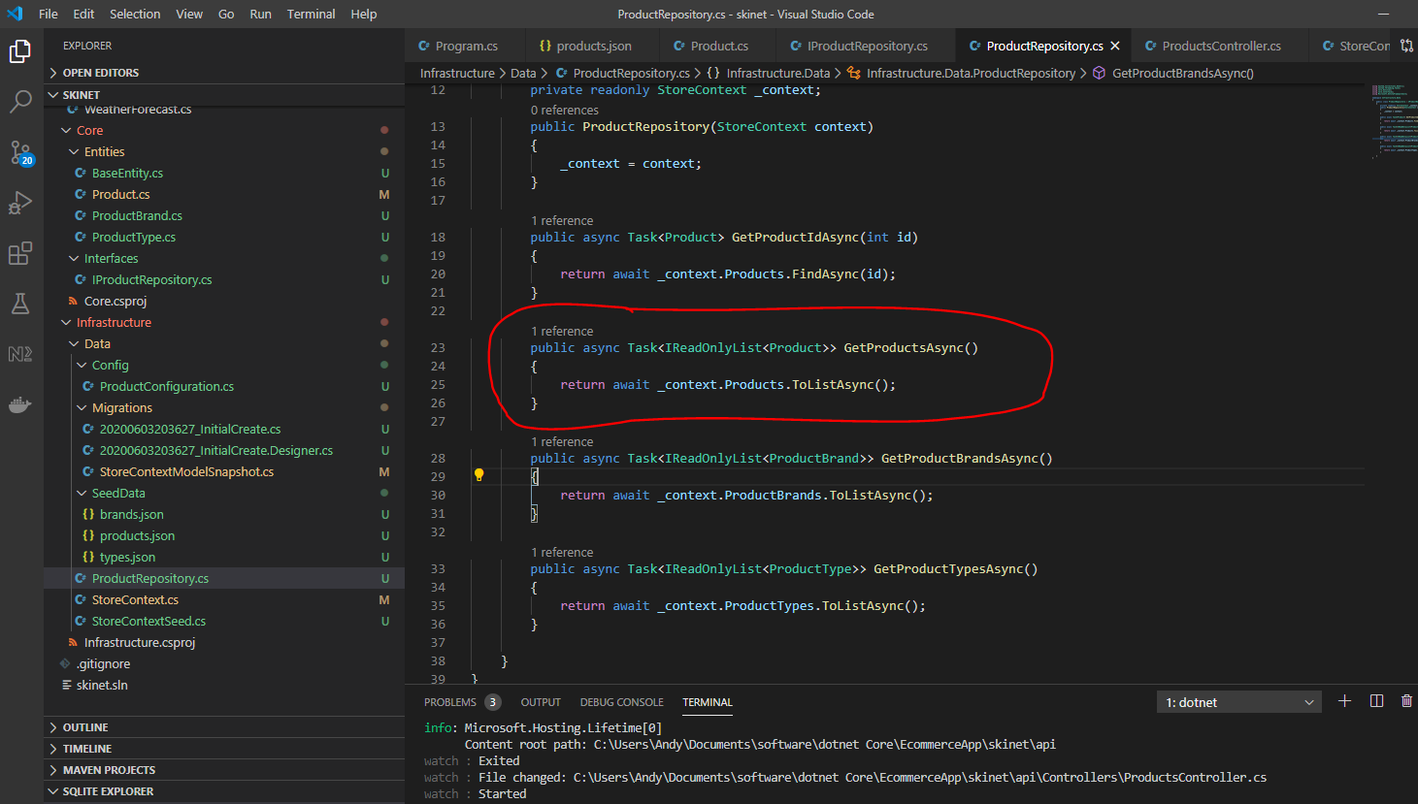

You need to tell it to get the brand name and product type data here, so add this:-

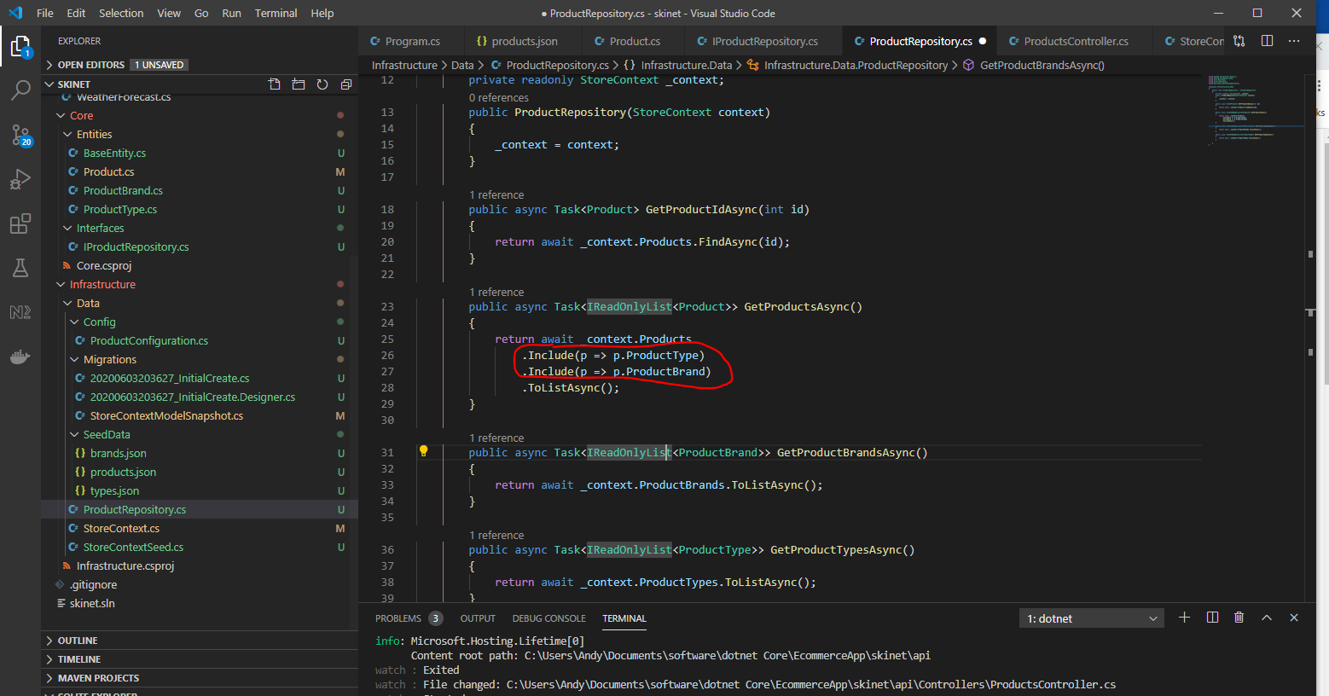

Also, add this:-

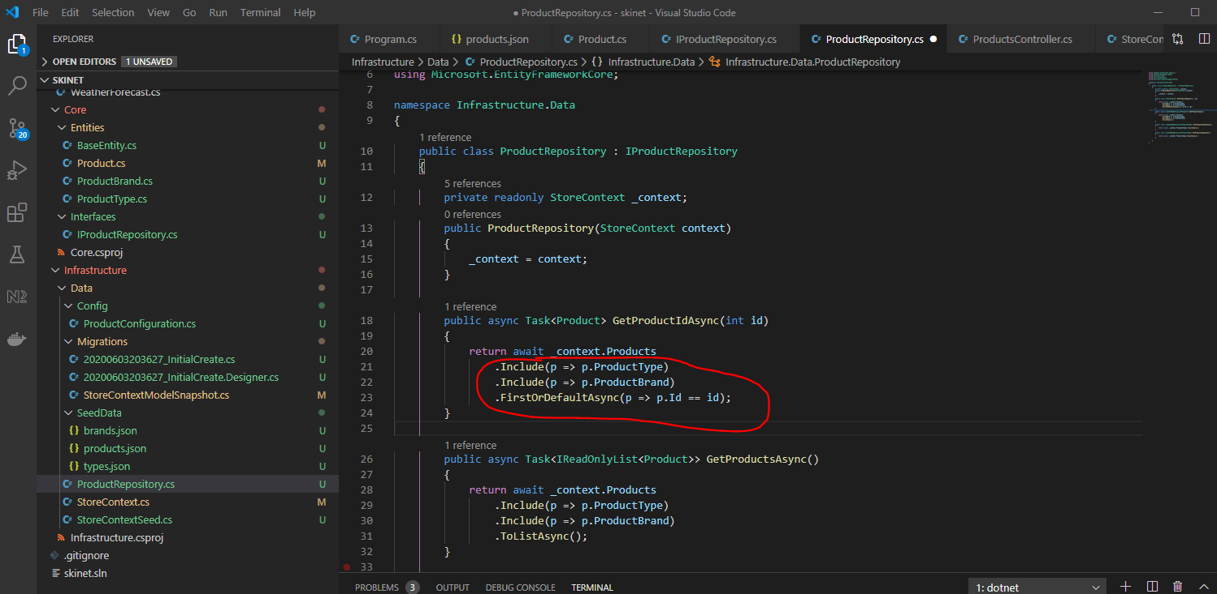

Now test in Postman:-

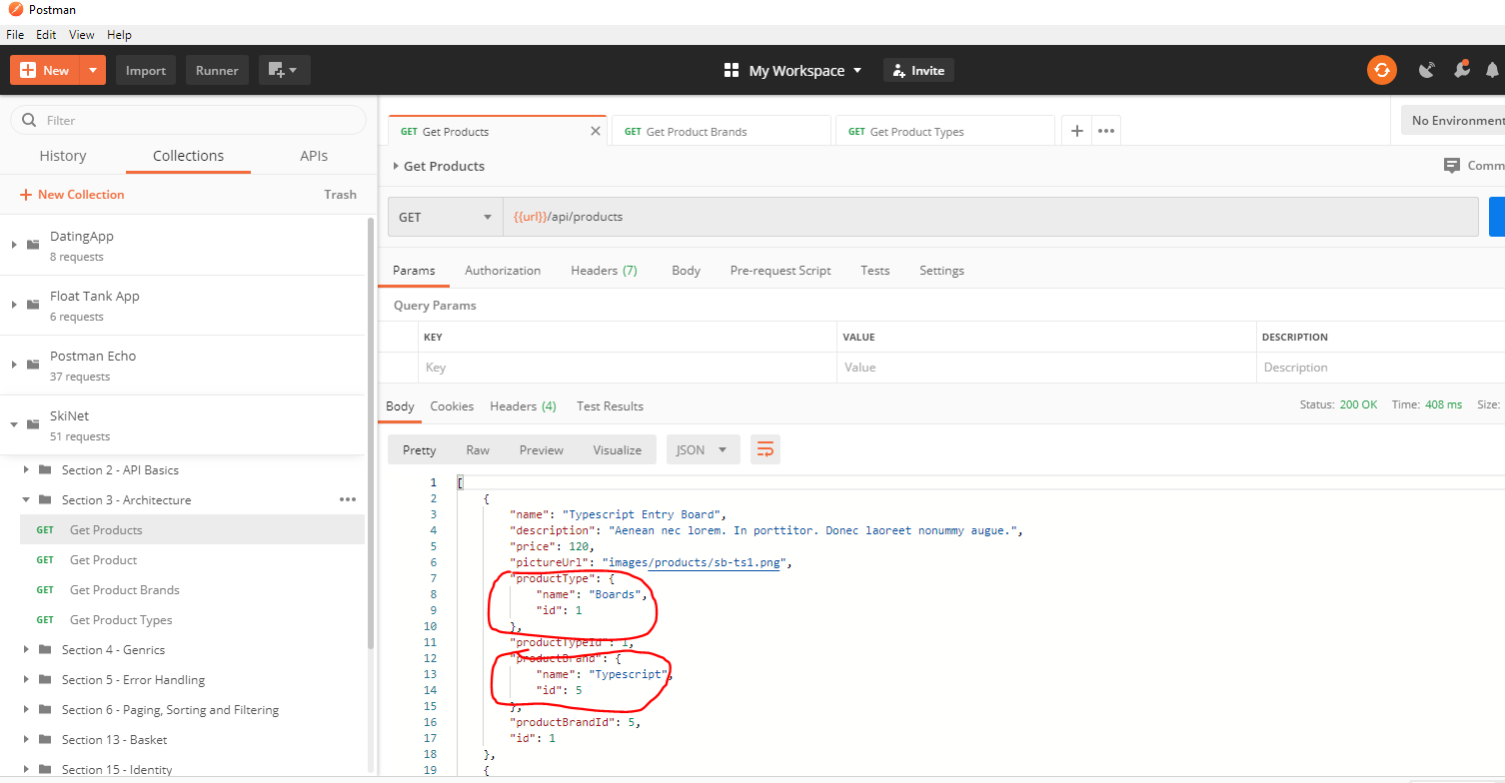

Now see that ‘productType’ and ‘productBrand’ data is present.

Upload all changes to GitHub:-

In VSCode terminal enter:-

git add .

git commit -m “Added repos for Brand Names and Product Types”

git push origin master

**Generic Repository**

Notice that these 2 methods are all doing a very similar thing (except for the ‘include’ parts):-

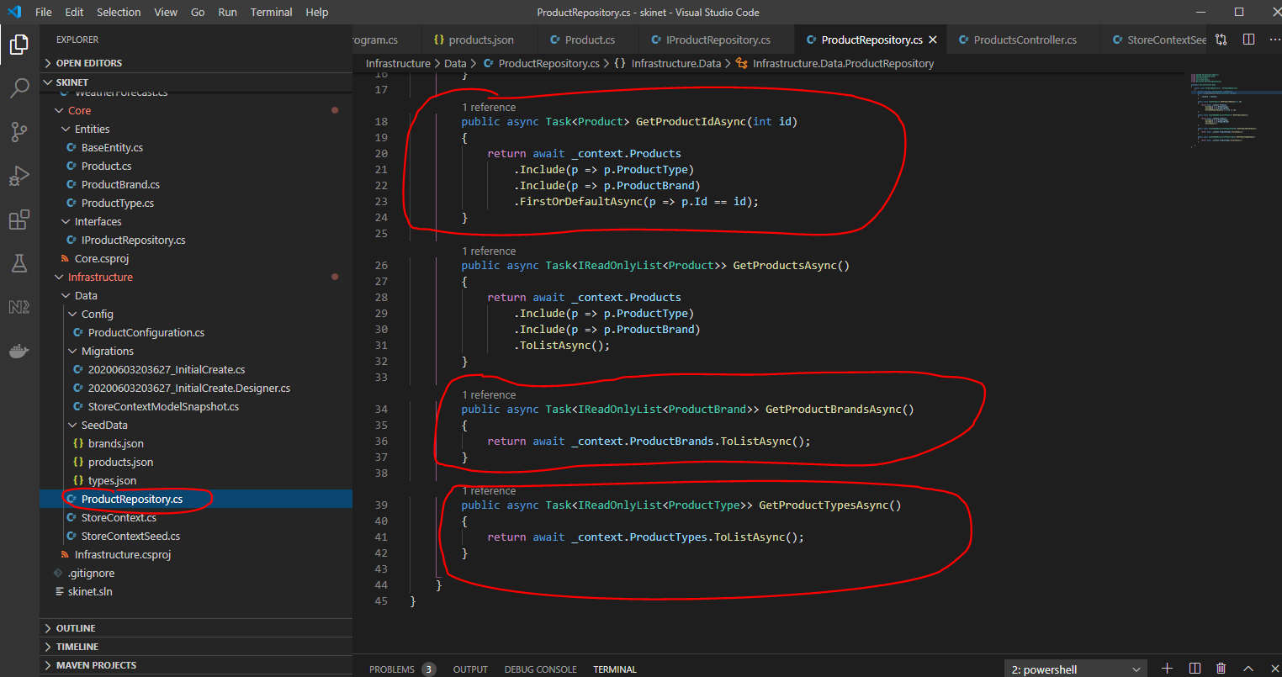

So replace the 4 interface methods here:-

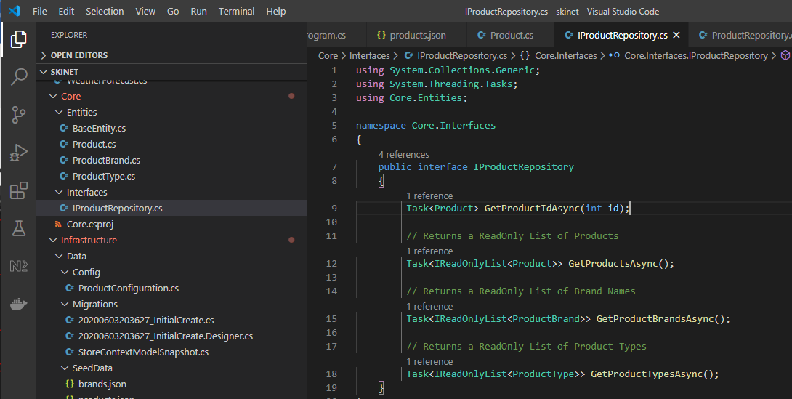

First, create a new interface called ‘IGenericRepository’ here:-

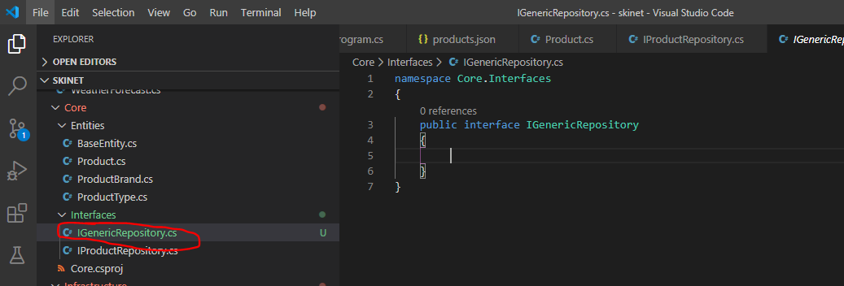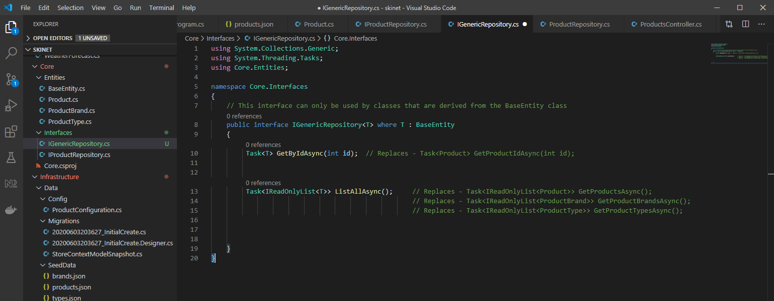

Now create a class in the class to implement the interface in the ‘Infrastructure/Data’ folder:-

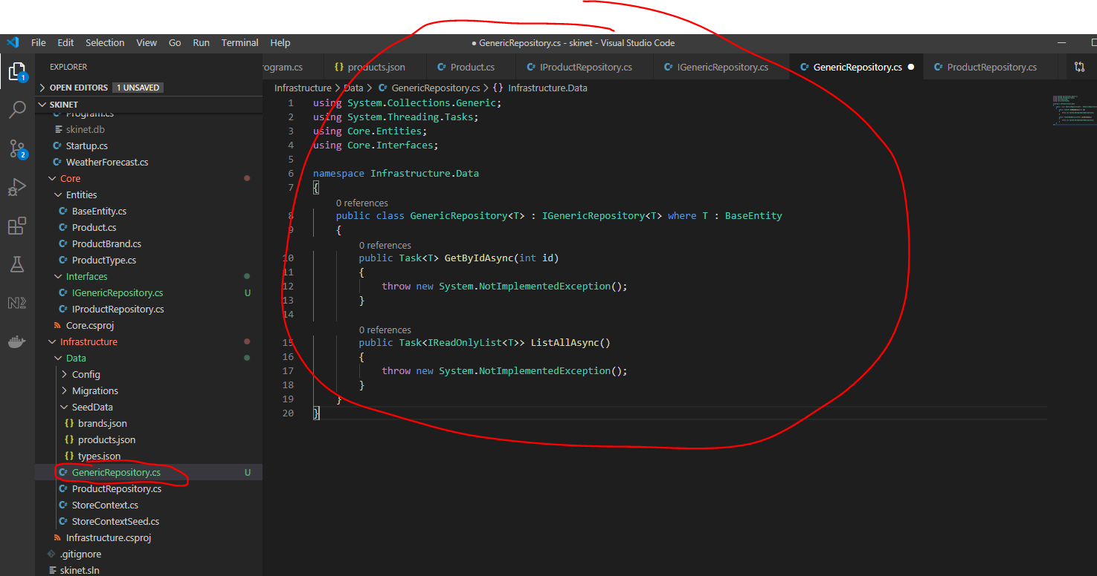

We will add implementation to the above methods after adding the above class to the ‘startup.cs’ class:-

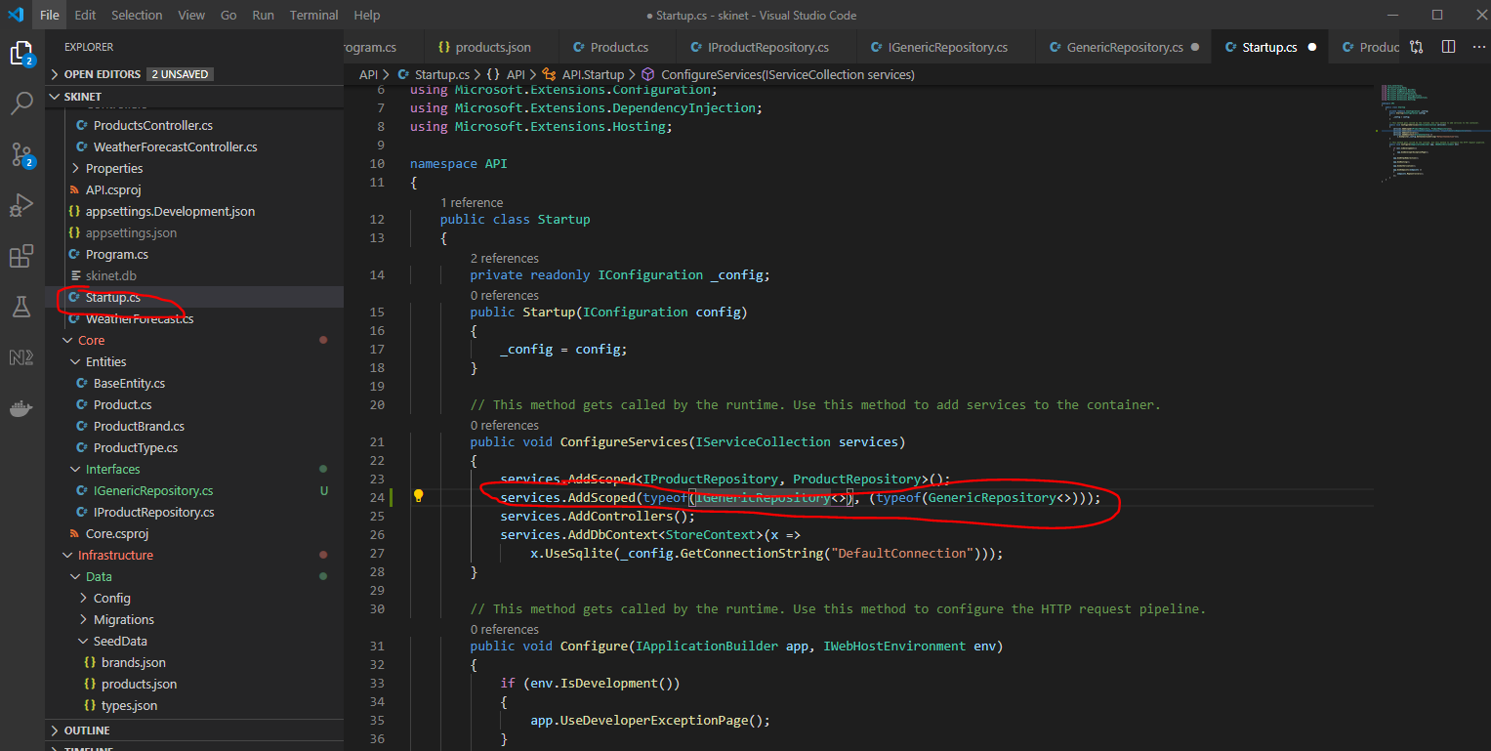

Finish updating the ‘GenericRepository’ now:-

Add a constructor and add implementation of the methods:-

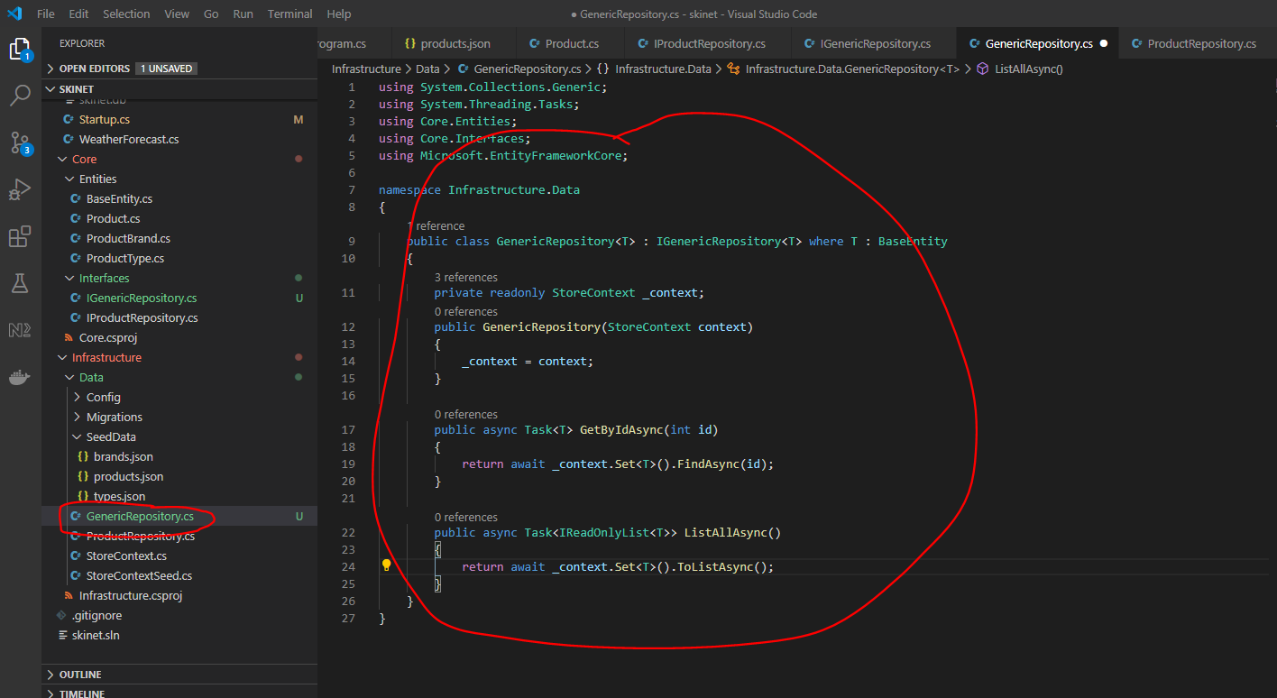

Now go to the product controller and remove this:-

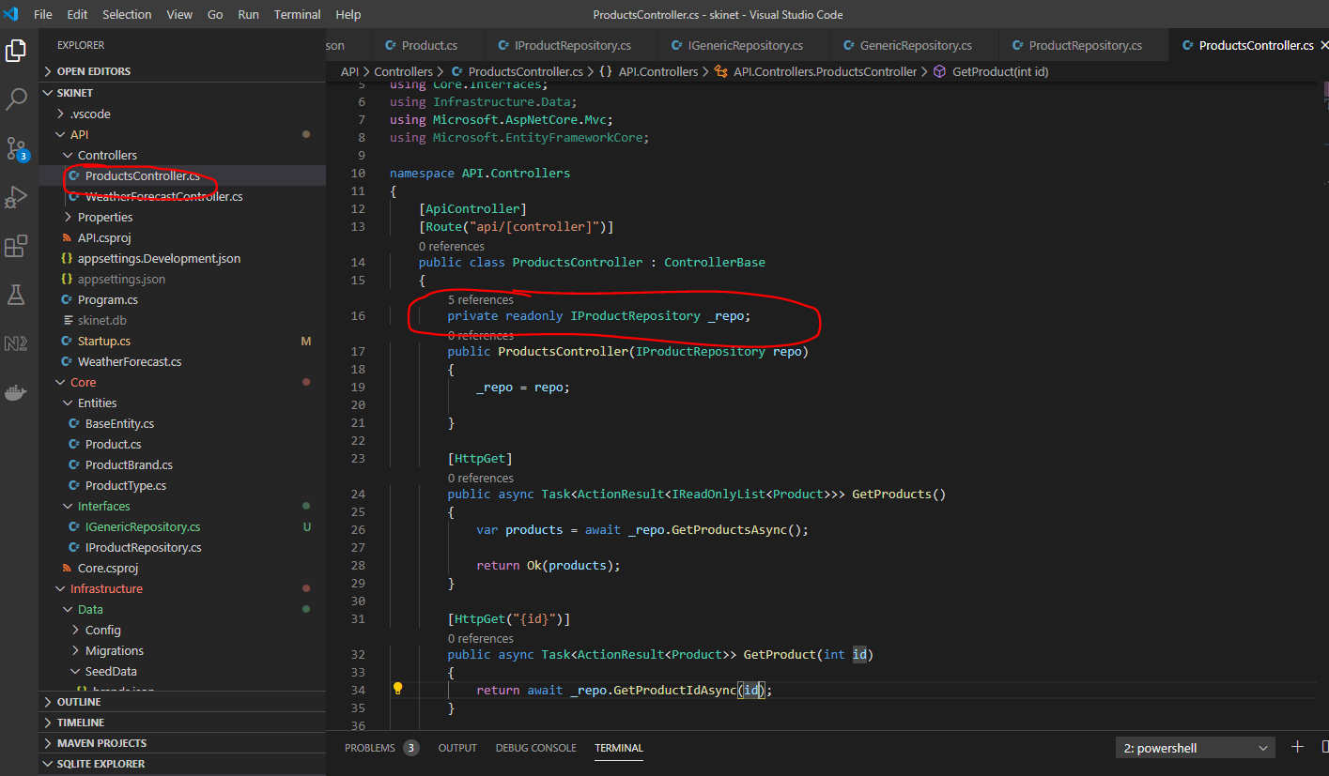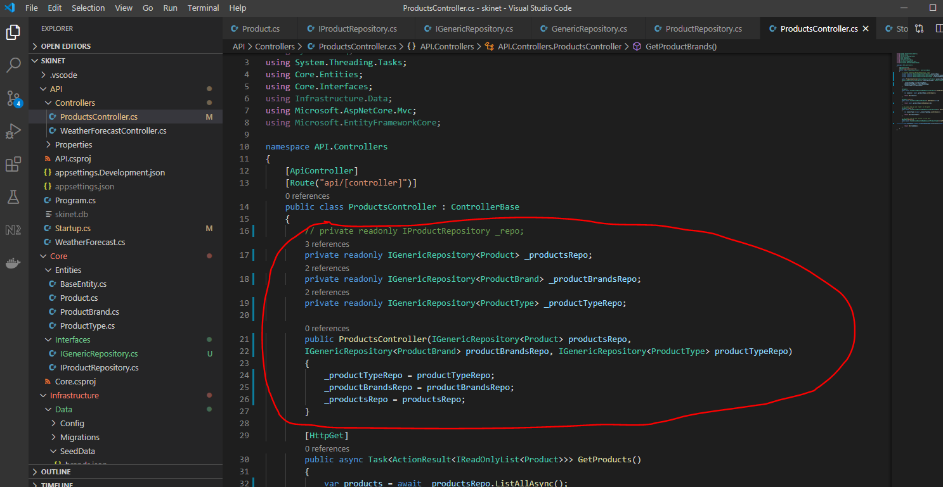

using System.Collections.Generic;

using System.Linq;

using System.Threading.Tasks;

using Core.Entities;

using Core.Interfaces;

using Infrastructure.Data;

using Microsoft.AspNetCore.Mvc;

using Microsoft.EntityFrameworkCore;

namespace API.Controllers

{

    [ApiController]

    [Route("api/[controller]")]

    public class ProductsController : ControllerBase

    {

        // private readonly IProductRepository _repo;

        private readonly IGenericRepository<Product> _productsRepo;

        private readonly IGenericRepository<ProductBrand> _productBrandsRepo;

        private readonly IGenericRepository<ProductType> _productTypeRepo;

        public ProductsController(IGenericRepository<Product> productsRepo,

        IGenericRepository<ProductBrand> productBrandsRepo, IGenericRepository<ProductType> productTypeRepo)

        {

            _productTypeRepo = productTypeRepo;

            _productBrandsRepo = productBrandsRepo;

            _productsRepo = productsRepo;

        }

        [HttpGet]

        public async Task<ActionResult<IReadOnlyList<Product>>> GetProducts()

        {

            var products = await _productsRepo.ListAllAsync();

            return Ok(products);

        }

        [HttpGet("{id}")]

        public async Task<ActionResult<Product>> GetProduct(int id)

        {

            return await _productsRepo.GetByIdAsync(id);

        }

        // to access the api use 'types' in the path

        [HttpGet("types")]

        public async Task<ActionResult<IReadOnlyList<ProductType>>> GetProductTypes()

        {

            var productTypes = await _productTypeRepo.ListAllAsync();

            return Ok(productTypes);

        }

        // to access the api use 'brands' in the path

        [HttpGet("brands")]

        public async Task<ActionResult<IReadOnlyList<ProductBrand>>> GetProductBrands()

        {

            var brandNames = await _productBrandsRepo.ListAllAsync();

            return Ok(brandNames);

        }

    }

}

If you now use Postman to test what you have done you will realise that the GetProducts method is now return ‘null’ for ‘productType’ and ‘brandType’:-

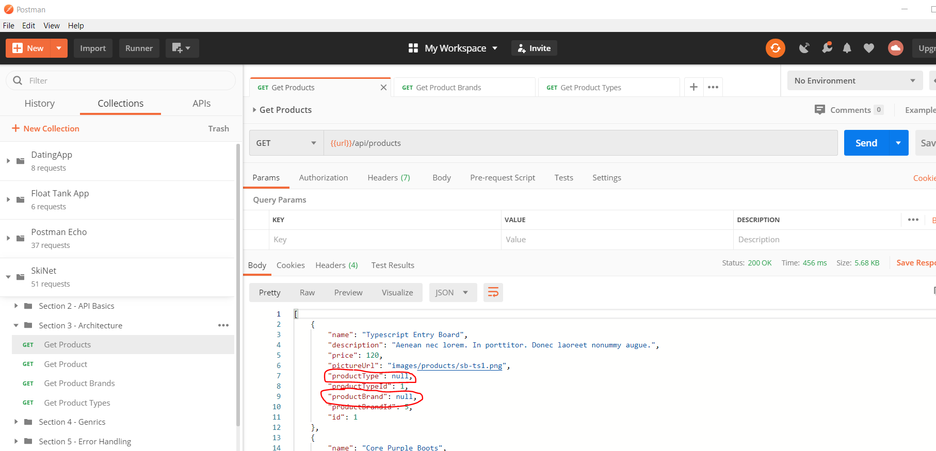

To overcome this use the ‘Specification Pattern’.

**Specification Pattern**

This is all to replace this section:-

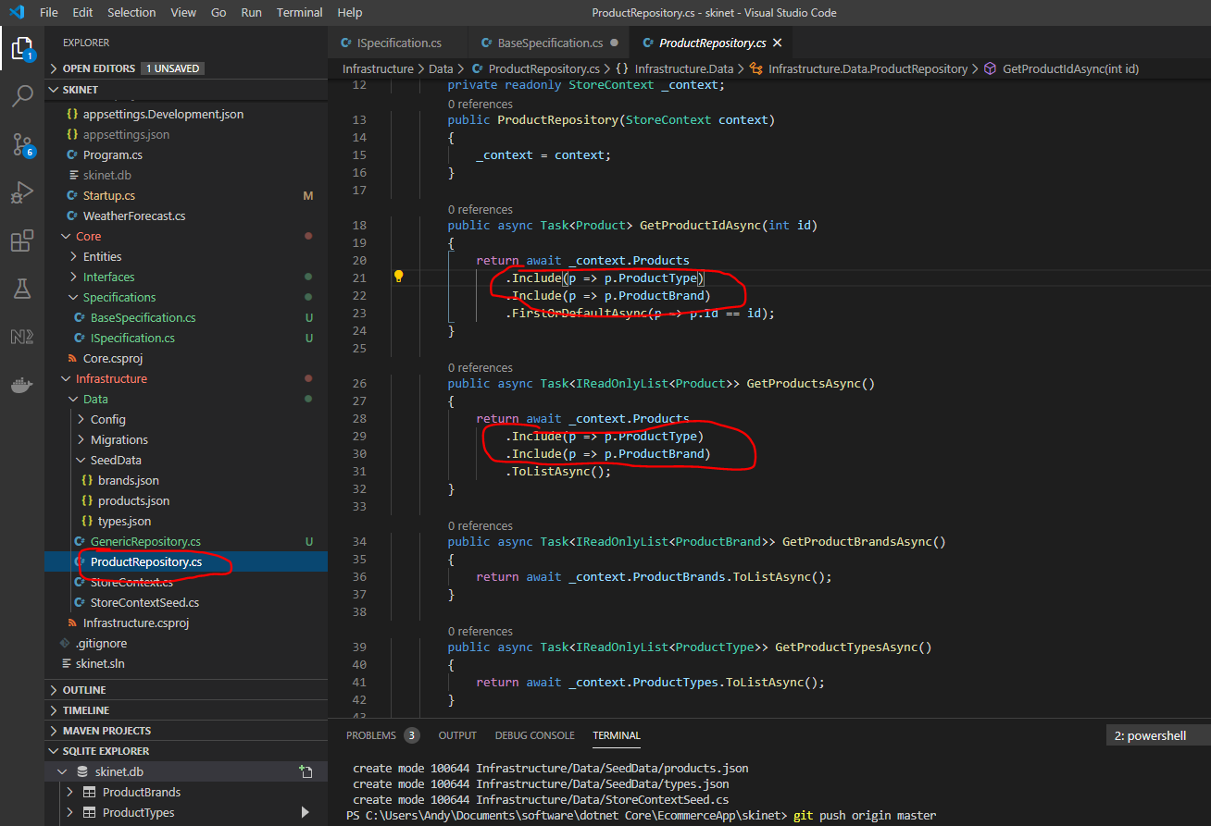

Create a new folder under ‘Core’ called ‘Specifications’. The create a new interface in this folder called ‘ISpecification’:-

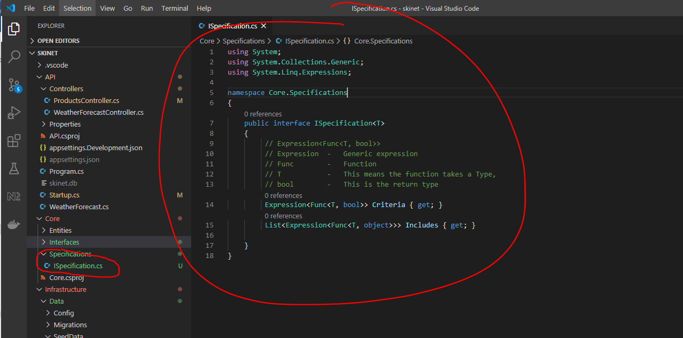

In the ‘Specifications’ folder create a new class called ‘BaseSpecification’:-

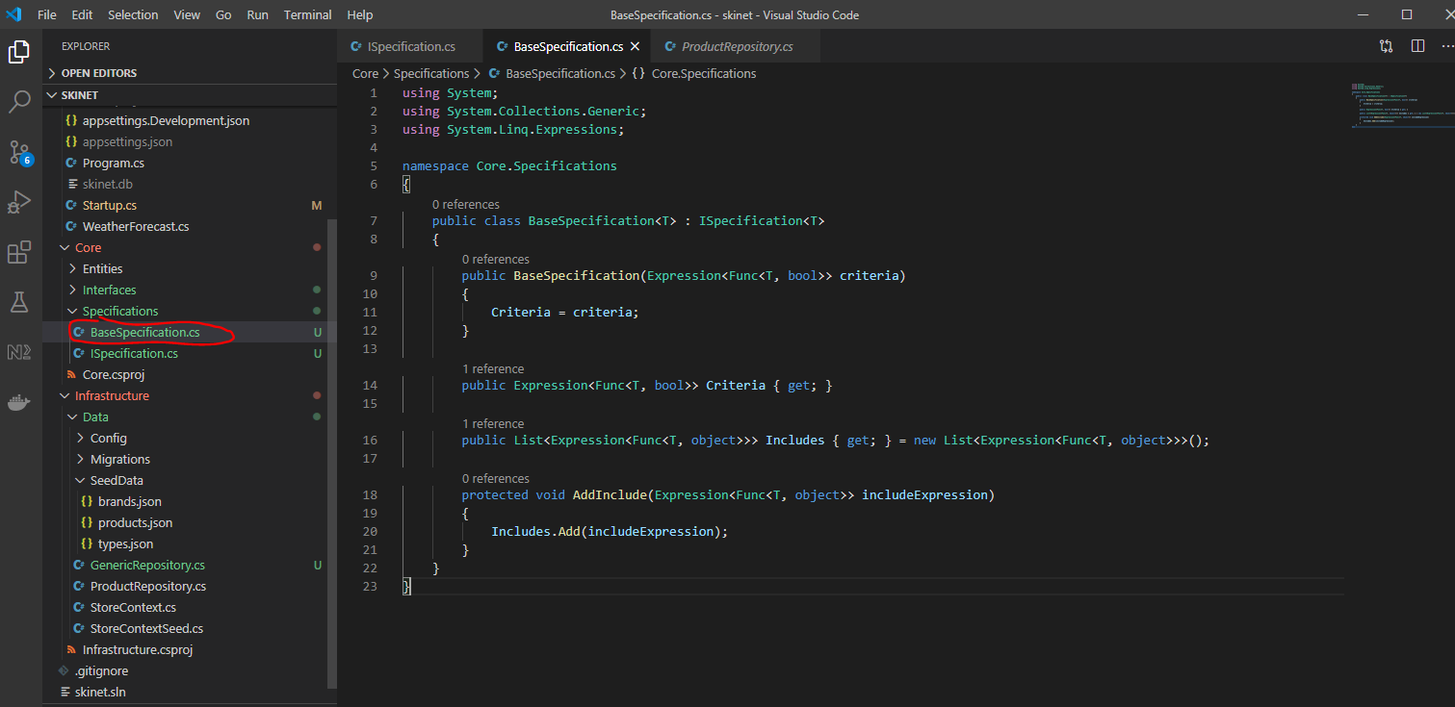

This inherits from the above interface.

The List of expressions are used to run on the database context to return products.

Now create a specification evaluator class in the ‘Infrastructure/Data’ folder:-

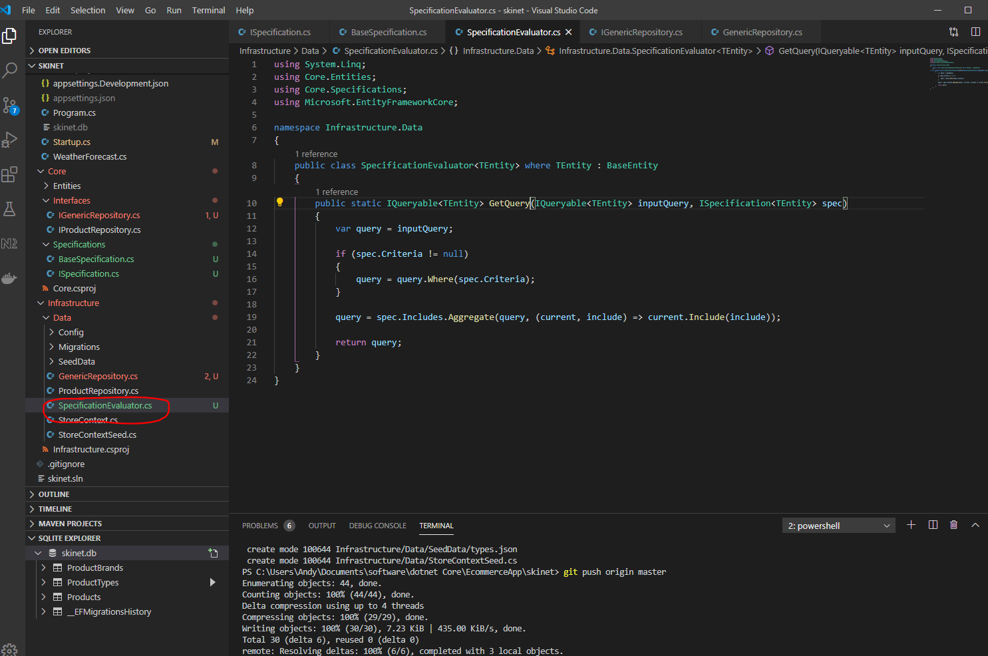

Add two additional methods to the IGenericRepository interface:-

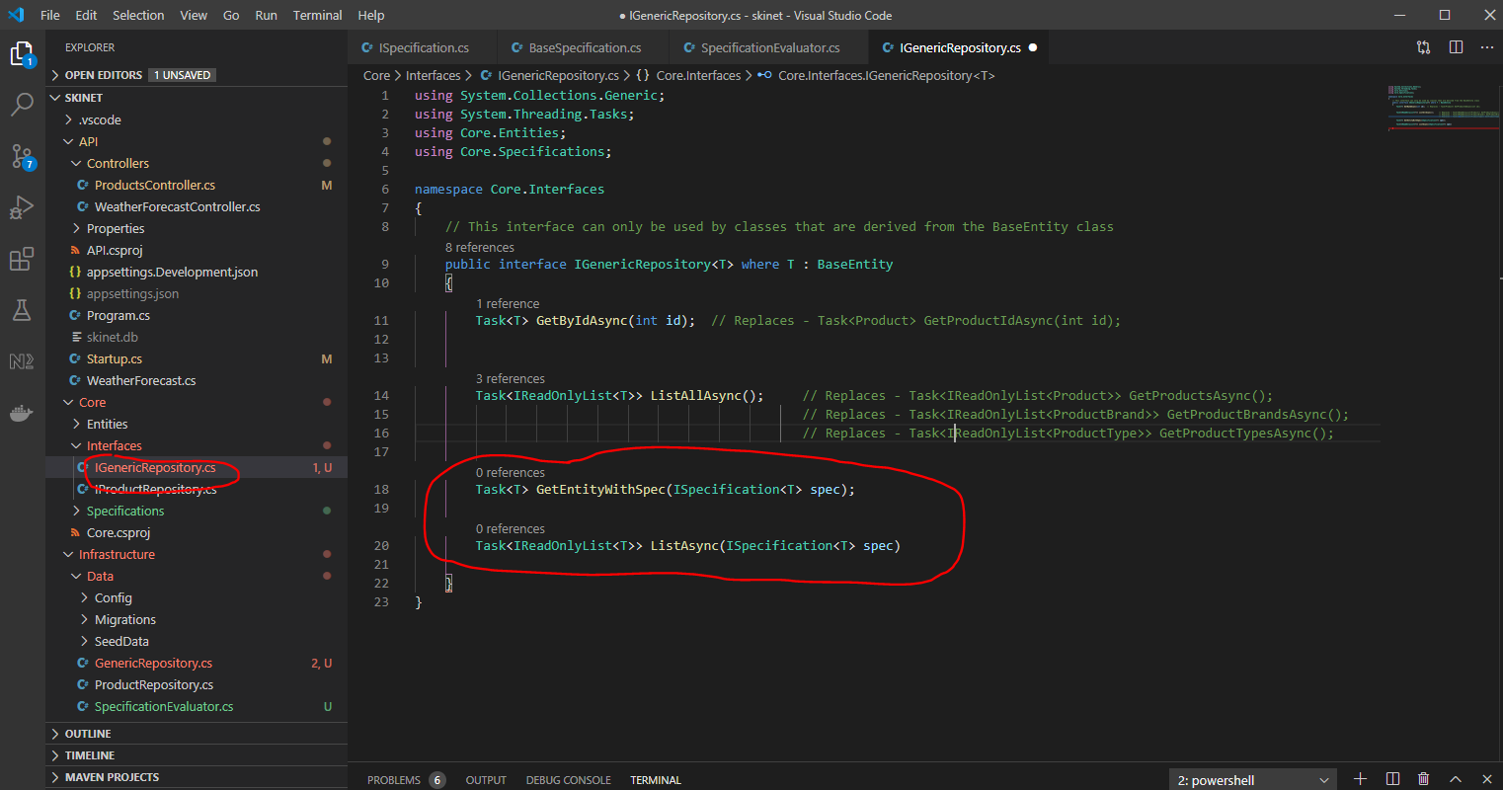

Now, go to the ‘GenericRepository.cs’ class and implement the two above methods:_

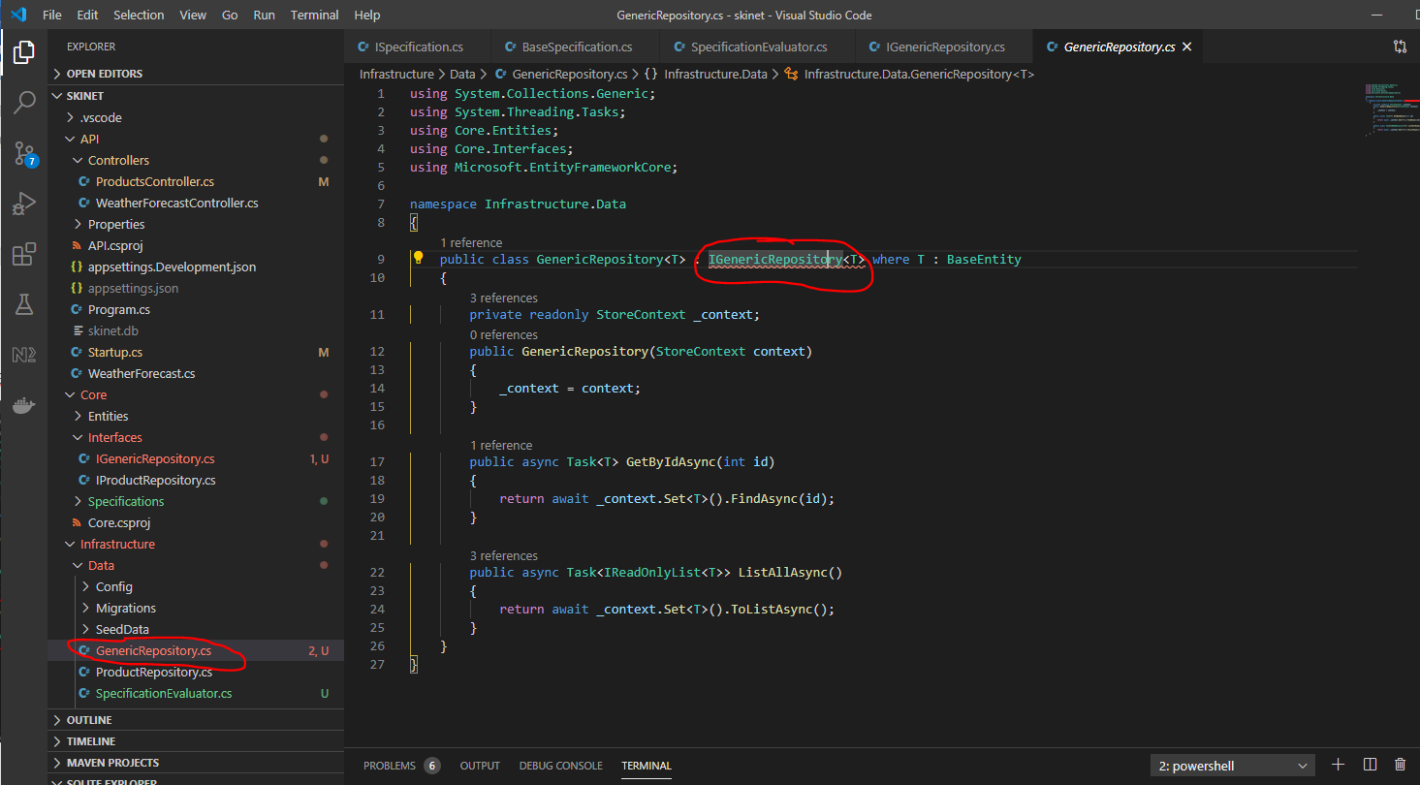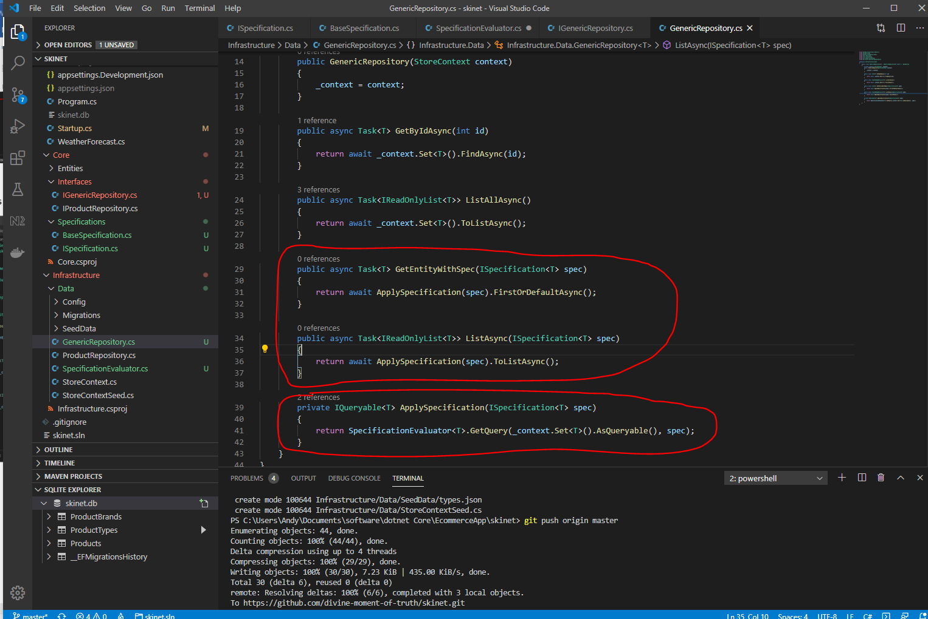

Now, update the ProductsController.cs class to use the new generics:-

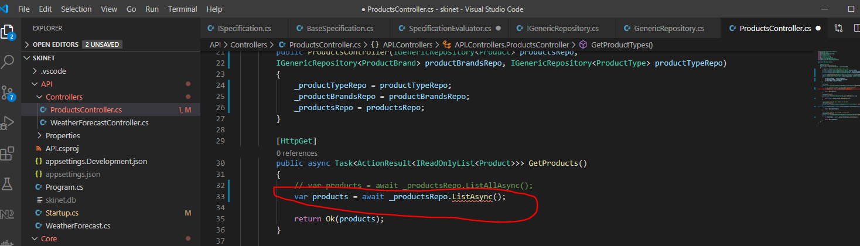

Create new specification classes here:-

ProductsWithTypesAndBrandsSpecification.cs

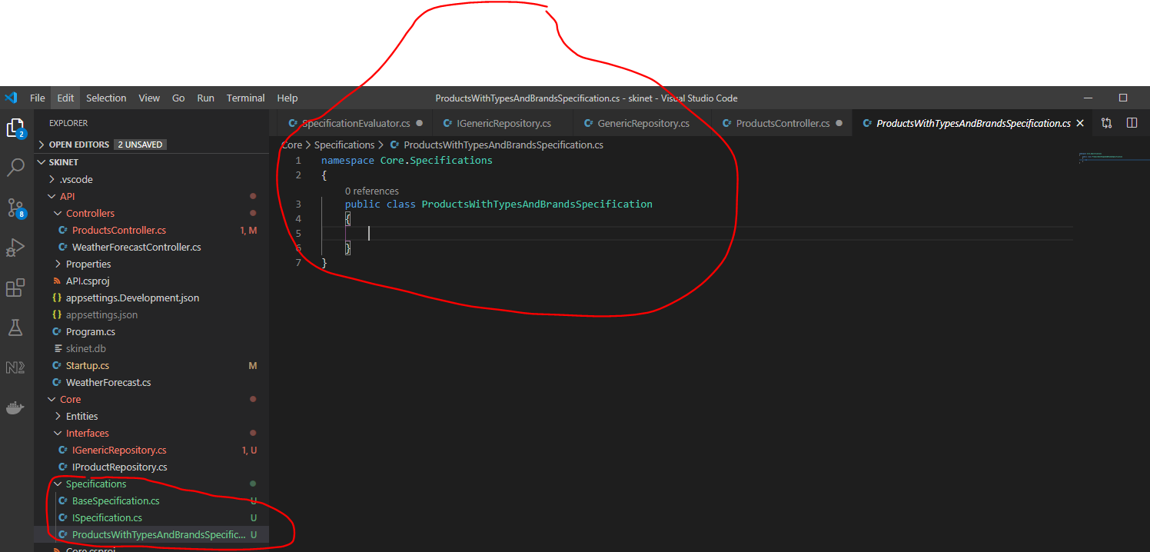

Create a parameterless constructor in the ‘BaseSpecification’ class:-

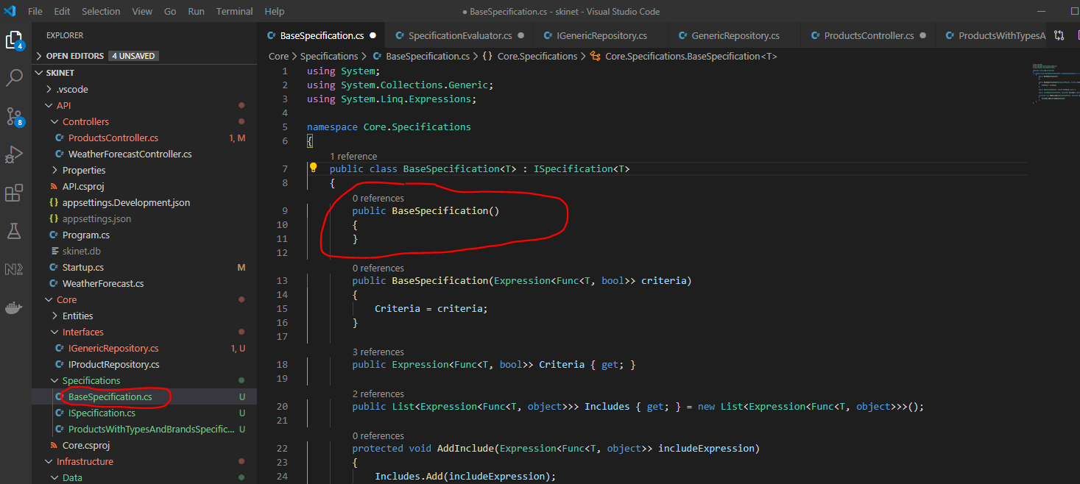

Then, add this method to the ‘ProductsWithTypesAndBrandsSpecification’ class:-

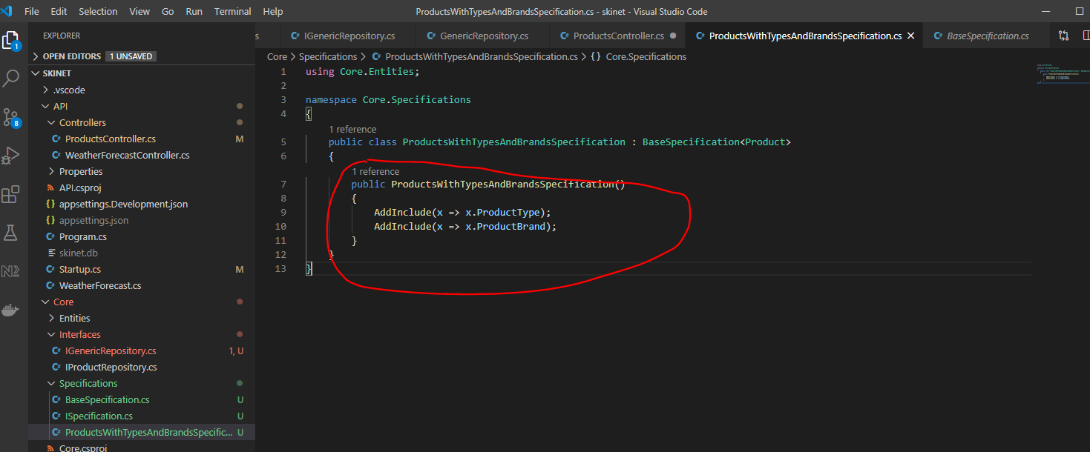

Then update the ‘ProductsController’:-

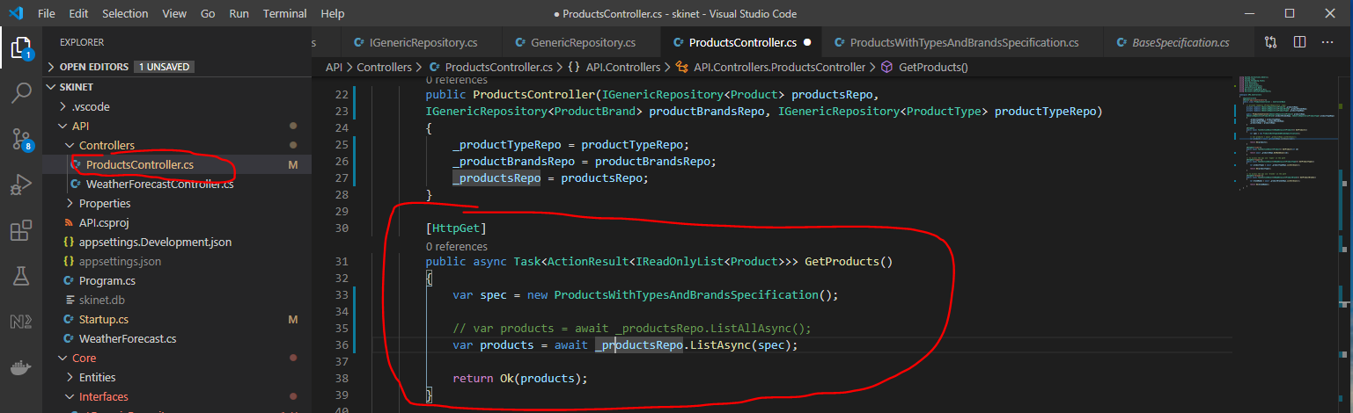

Now do a similar thing for the ‘ProductController.cs’ method – GetProduct()

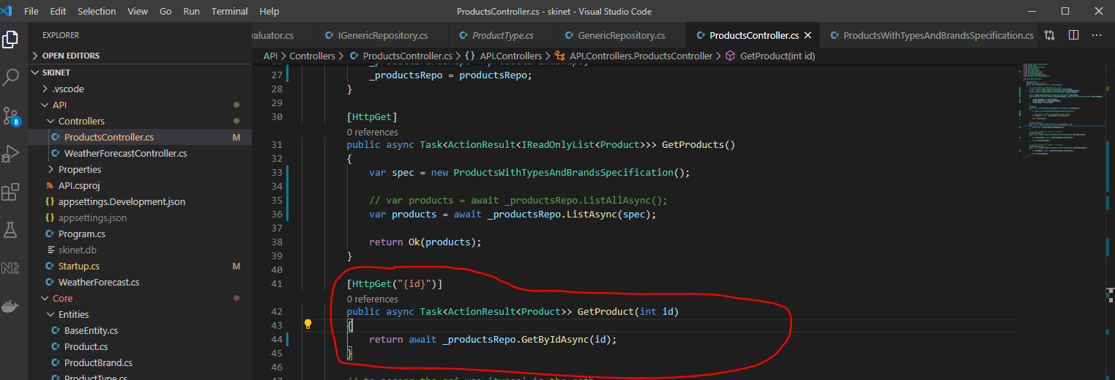

Update the ‘ProductsWithTypesAndBrandsSpecification’ class:-

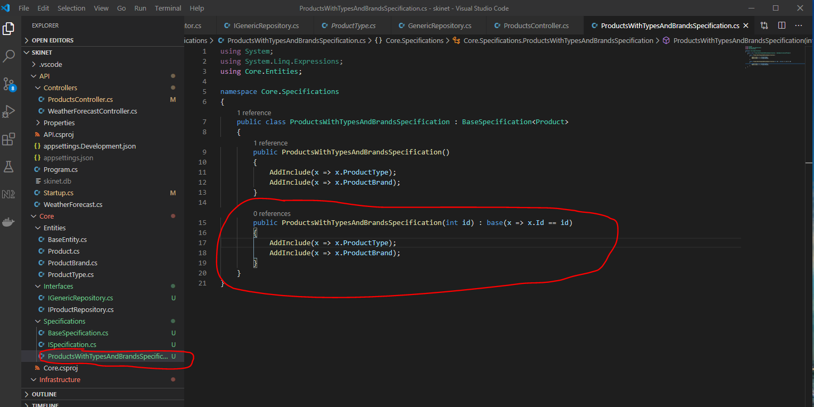

Now, update the Products controller:-

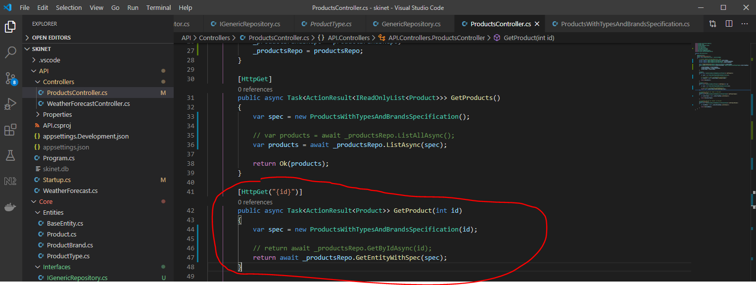

Now, to make sense of everything covered here using generics we will use the debugger:-

Step 1:-

Product controller. When this url is hit:-

{{url}}/api/products/3

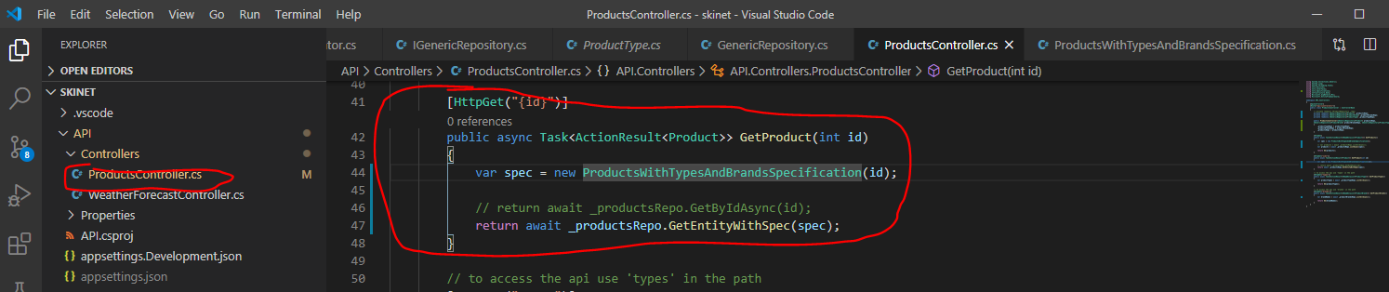

First a new spec is created:-

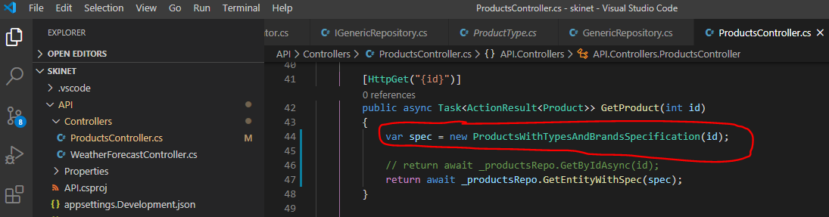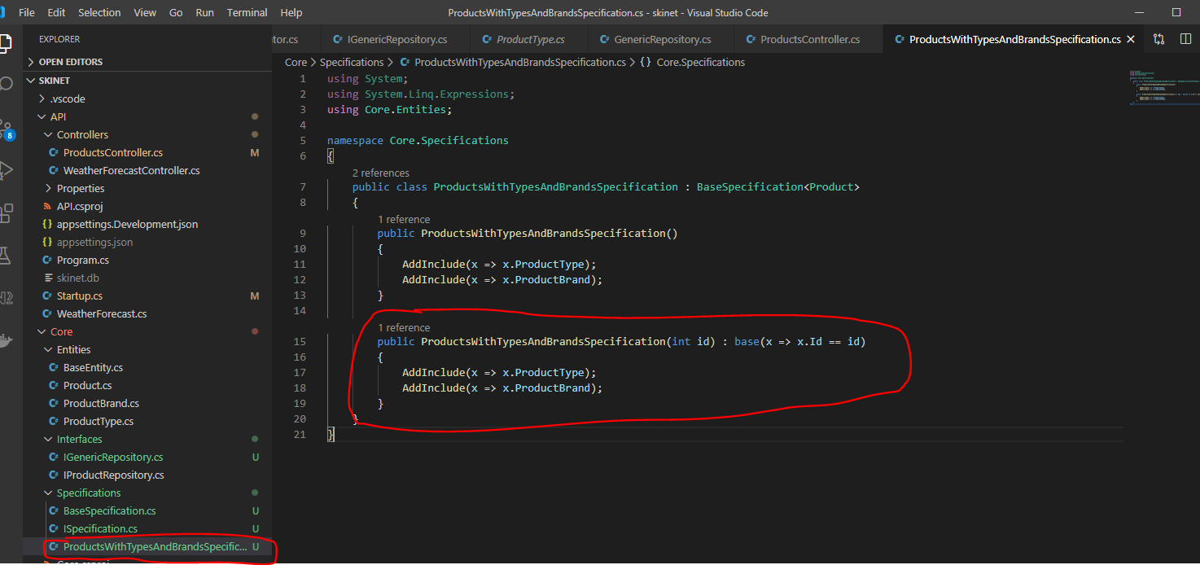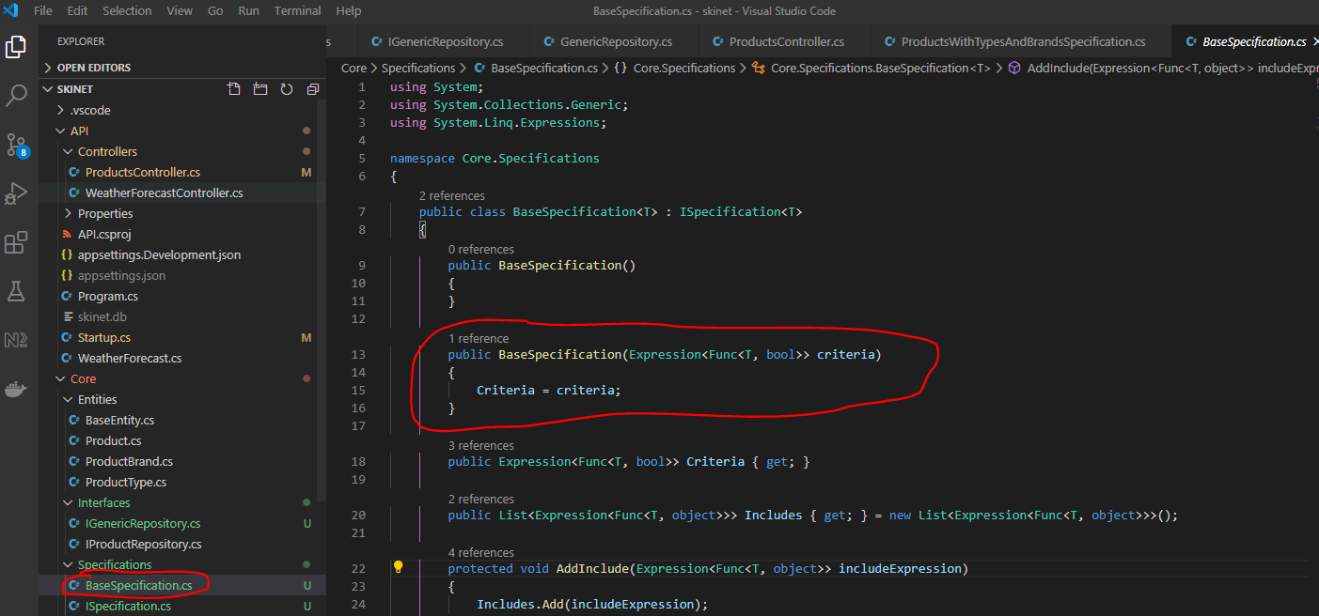

So ‘Criteria’ = the expression we pass i.e. x => x.Id == id

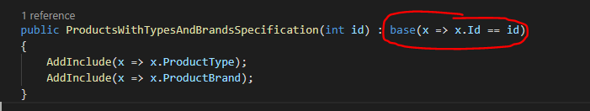

The next step in the ProductController class GetProduct method is:-

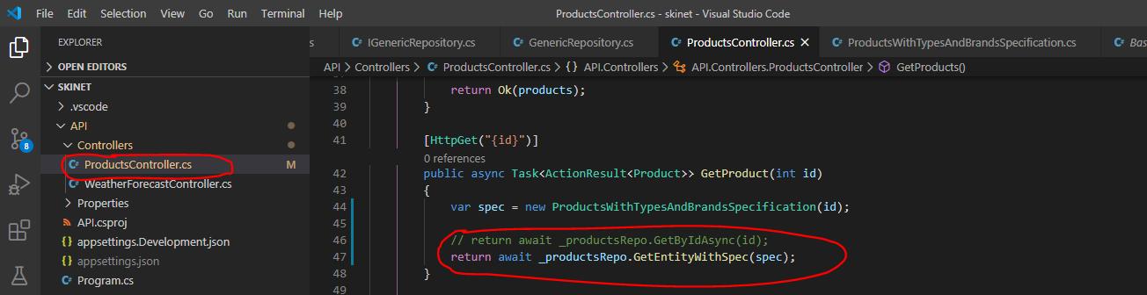

_productsRepo is of type GenericRepository. The GenericRepository has this method – ‘GetEntityWithSpec’:-

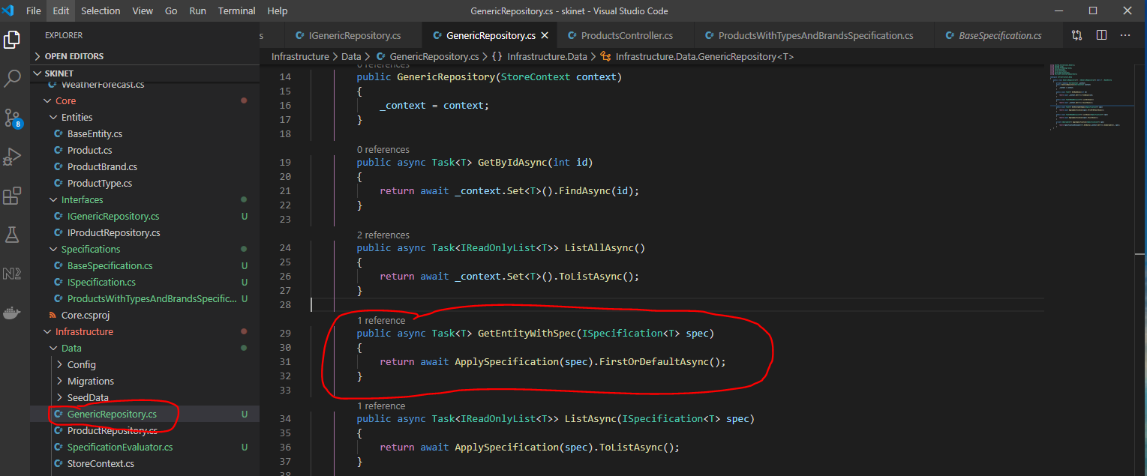

return await ApplySpecification(spec).FirstOrDefaultAsync();

the spec is passed to the ApplySpecification() method:-

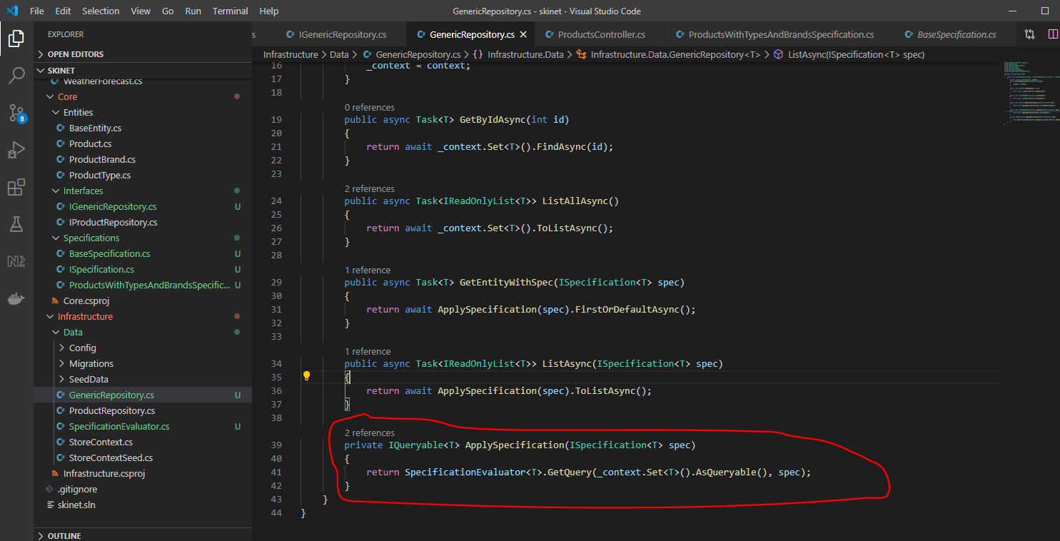

SpecificationEvaluator has a method called ‘GetQuery’. To this method we are passing the DbSet of type ‘Product’ and the specification (spec):-

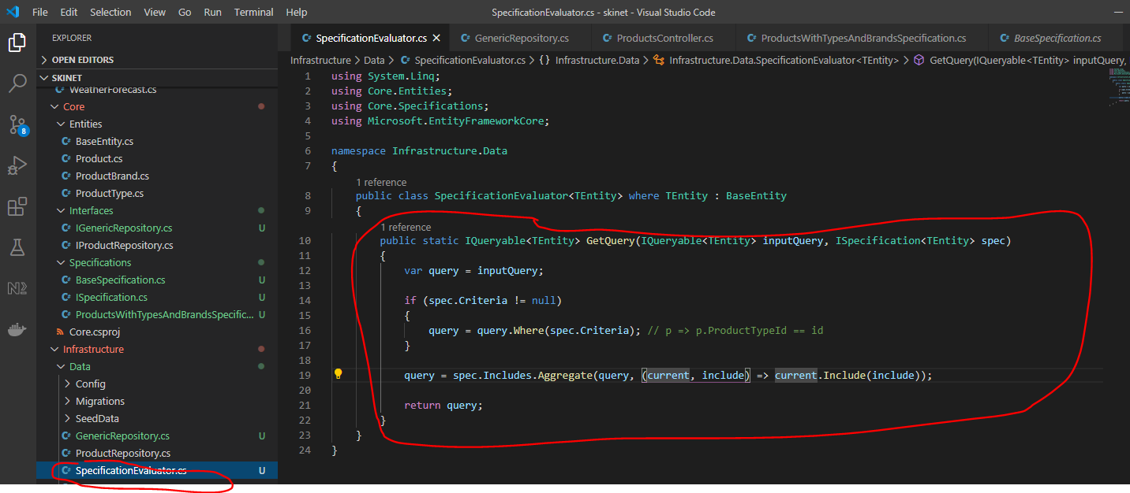

Because we have sent a DbSet (in the variable – inputQuery) we can run ‘Where’ method on it, see:-

var query = inputQuery;

query = query.Where(spec.Criteria)

Note:- spec is equal to this - x => x.Id == id or x => x.Id == 2

Then, this part:-

query = spec.Includes.Aggregate(query, (current, include) => current.Include(include));

which also includes the ‘include’ section i.e. this:-

            AddInclude(x => x.ProductType);

            AddInclude(x => x.ProductBrand);

So now this returns an IQueryable back to this:-

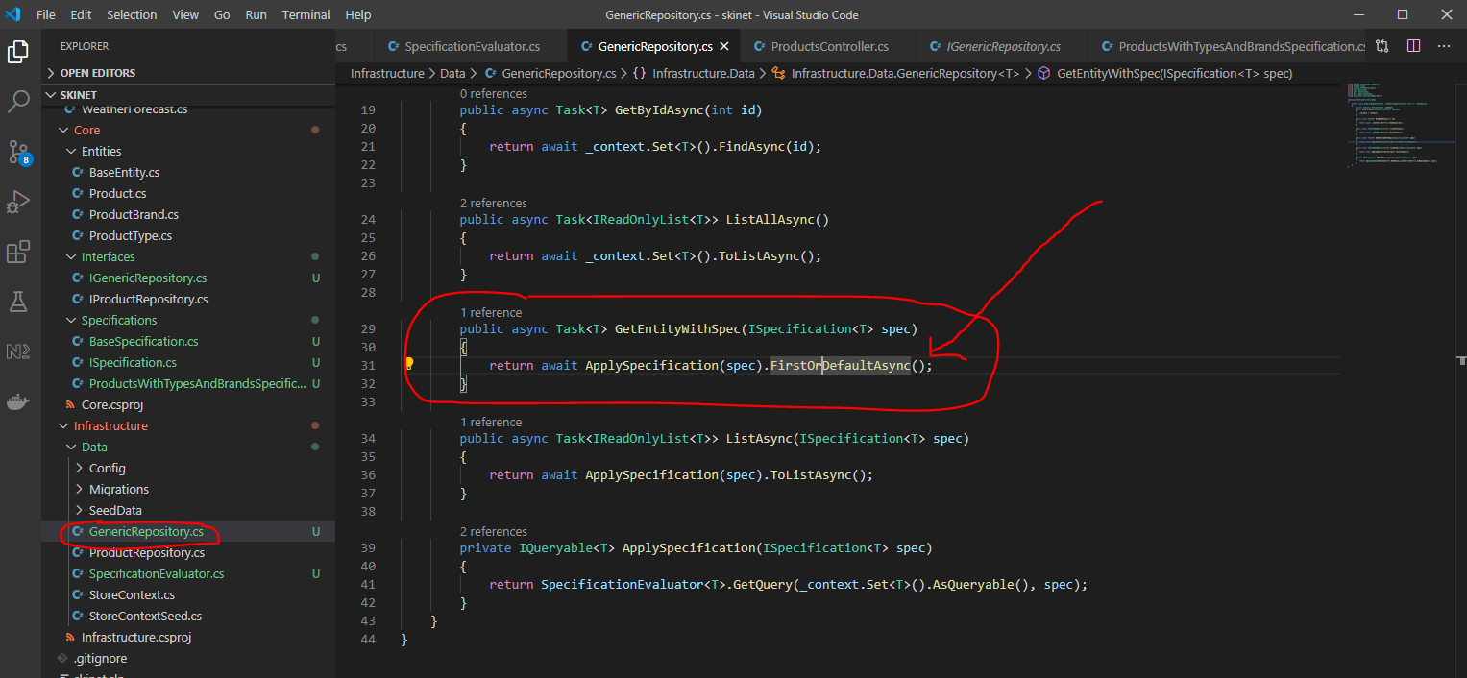

FirstOrDefaultAsync();

FirstOrDefaultAsyn() - this is where the actual query is ran against the database.

No use the debugger to see what is happening:-

Add a break point here:-

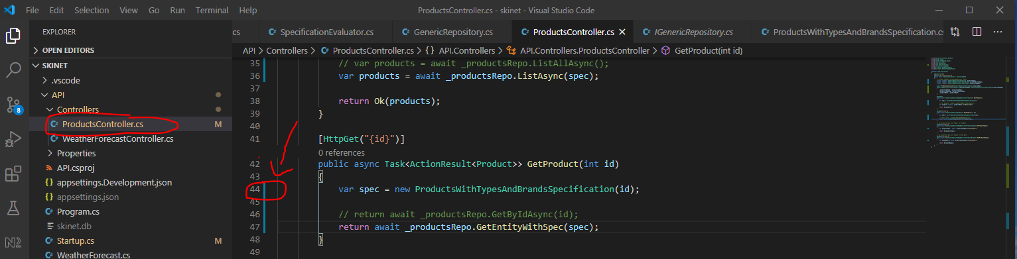

Click this:-

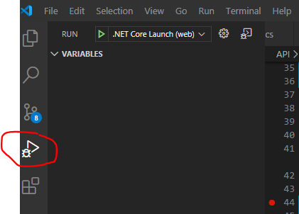

Click this drop down and select ‘.Net Core Attach’ option.

Ensure that this section appears in the ‘launch.json’ file:-

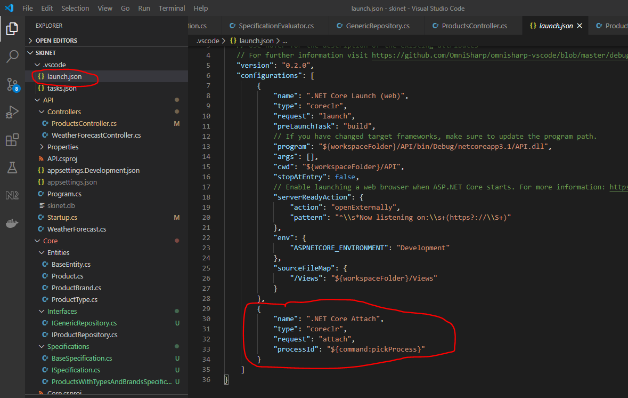

If the above does not exist you can create it by doing this:-

Press [ctrl] + [shift] + p

Start to type generate and click this:-

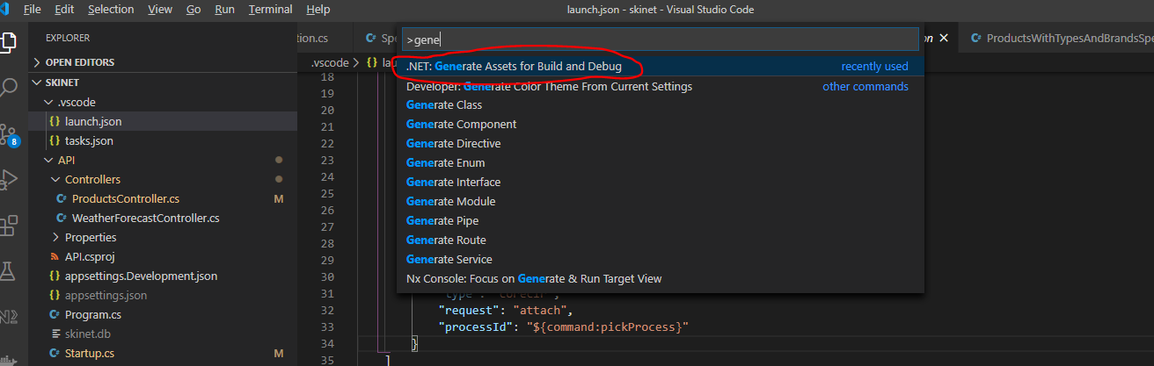

Now, back to the debugging. Click the play button:-

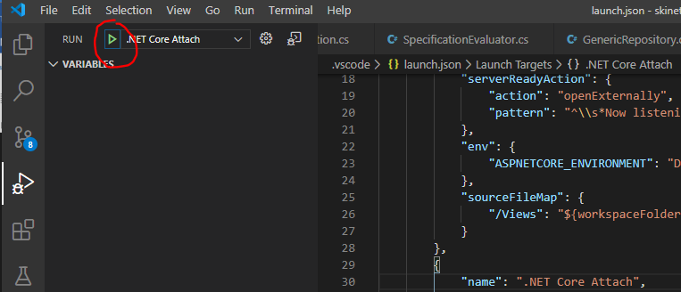

Search for ‘API’ and select this:-

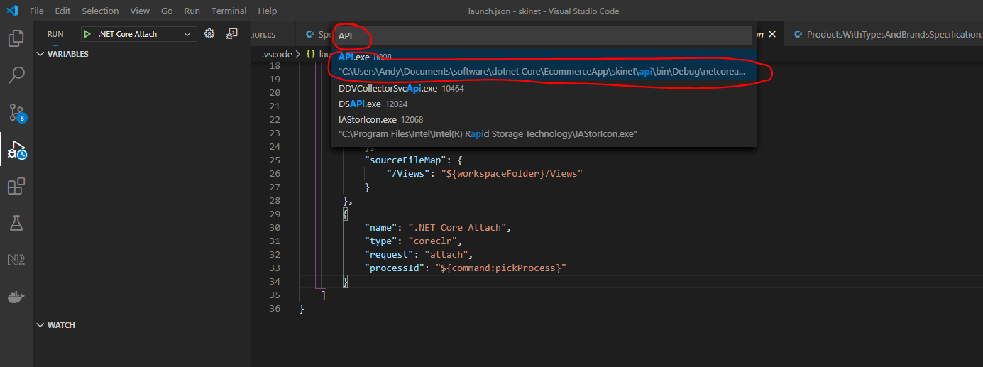

Now in Postman click on this:-

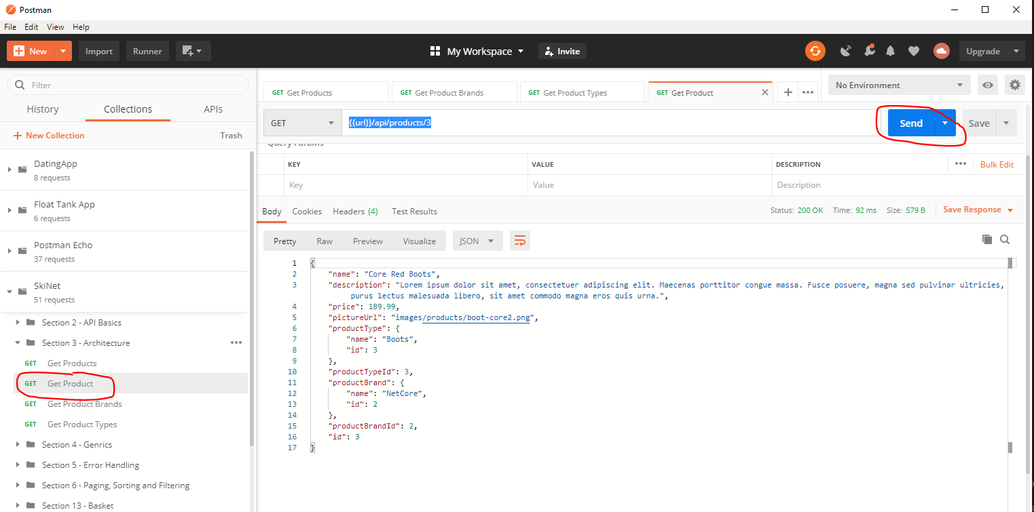

See that break point has been hit:-

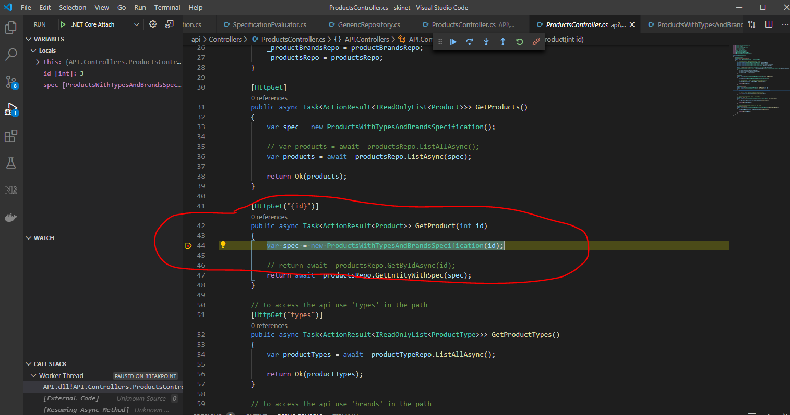

Use this to step through code:-

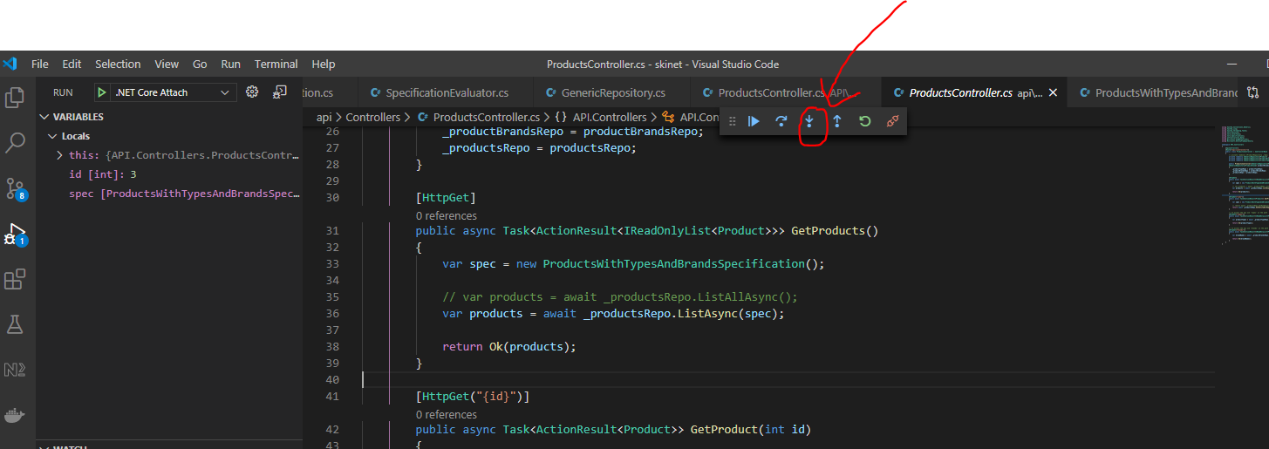

Now use the step over button:-

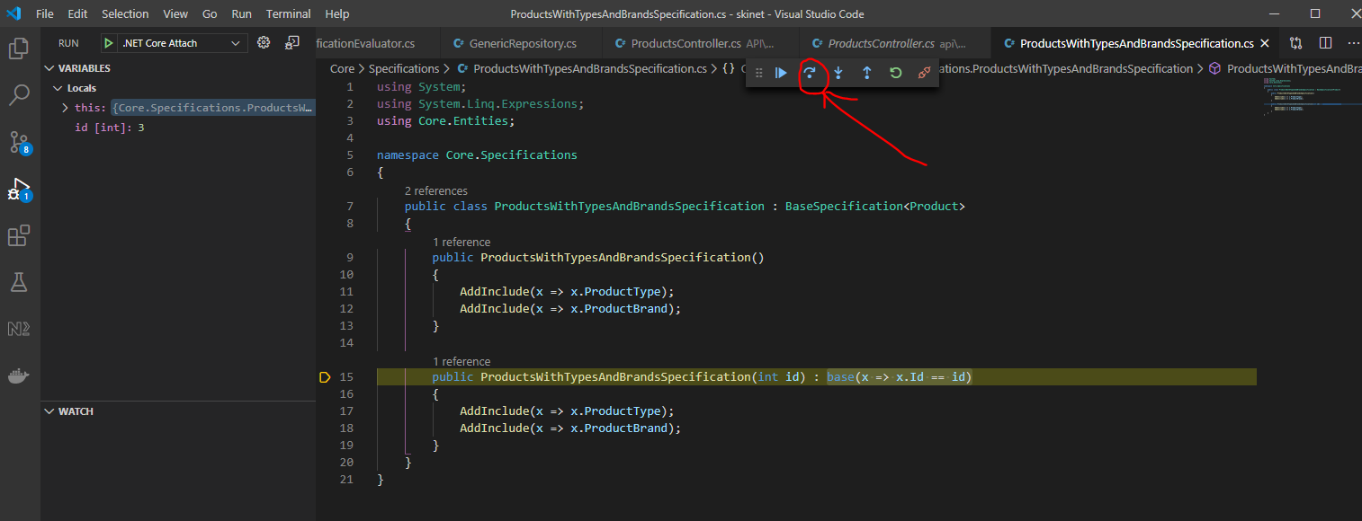

Now, look what we have in the ‘spec’ variable:-

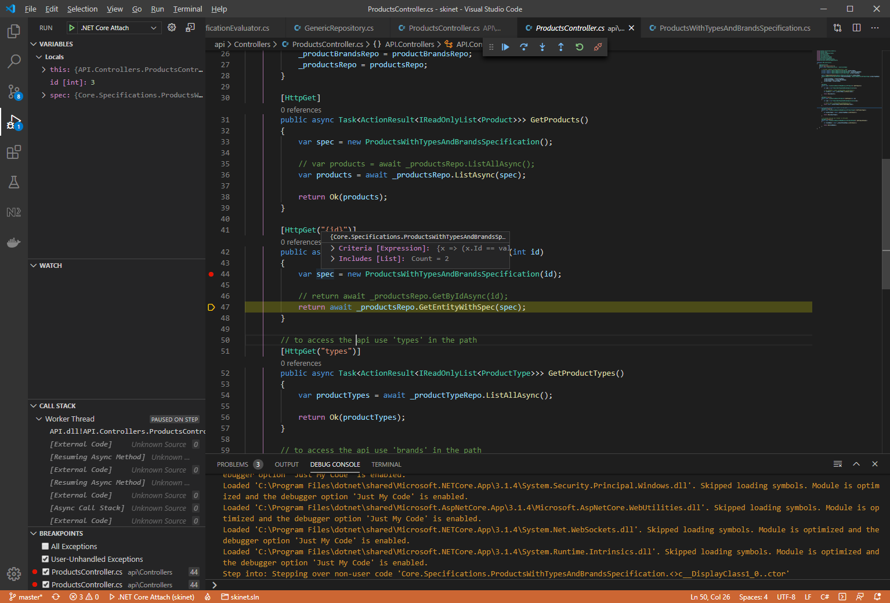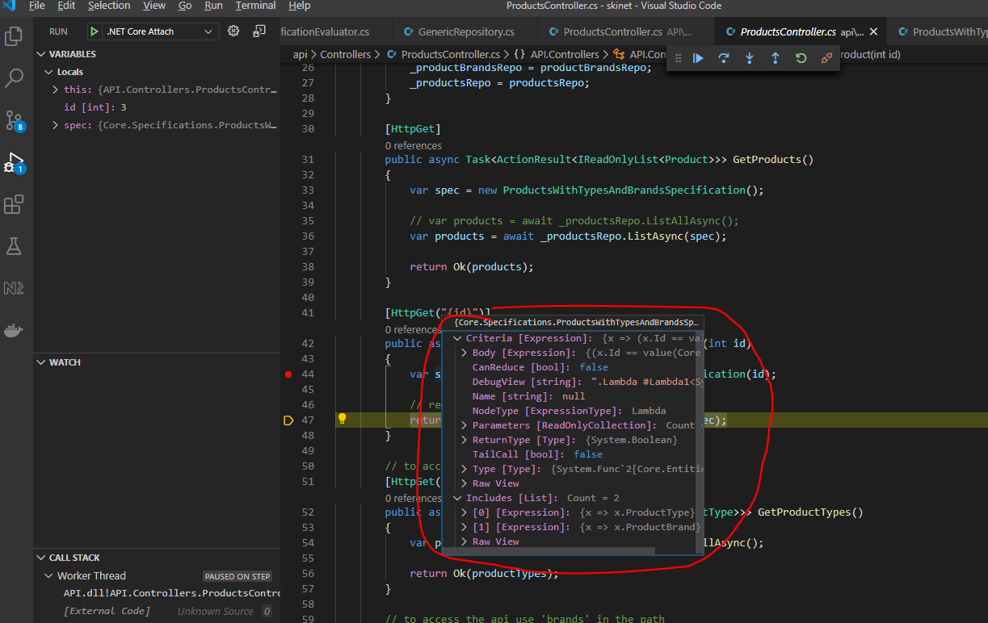

You can also see the content of ‘spec’ here:-

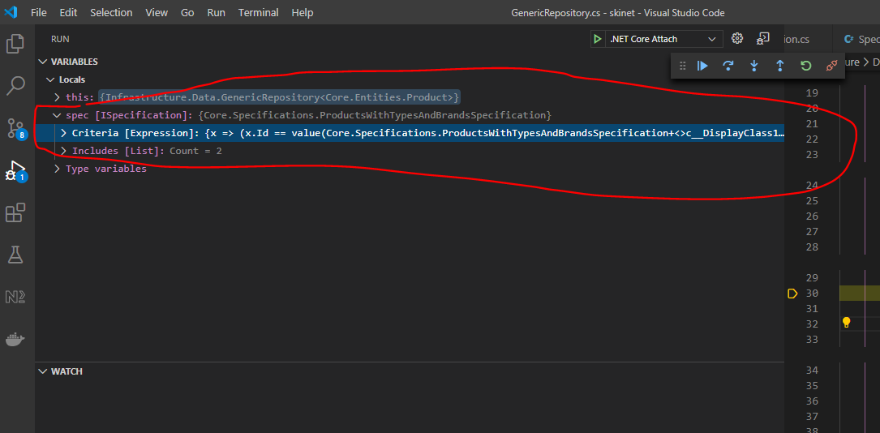

Click step inside button to take you here:-

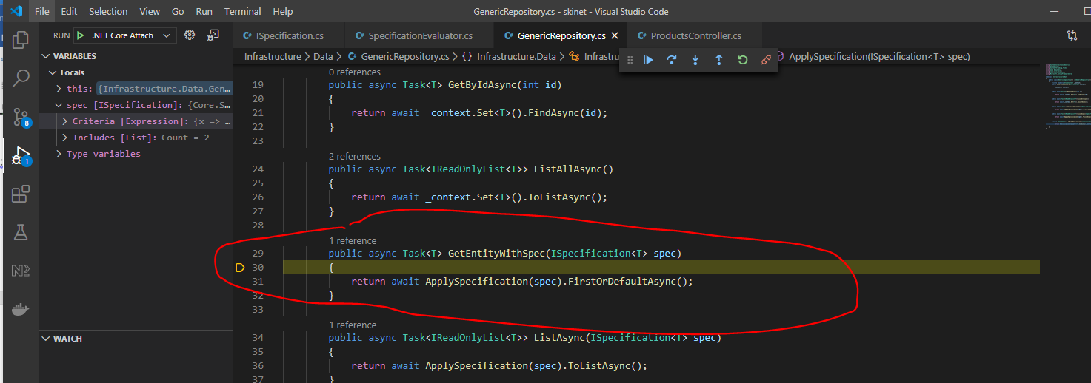

Step into here:-

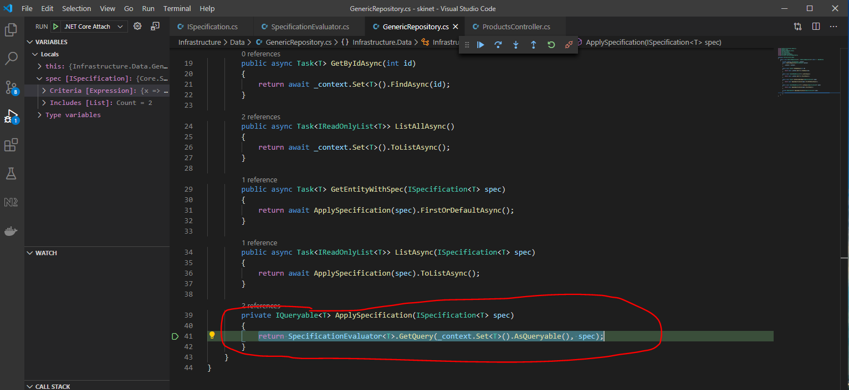

Then step in again:-

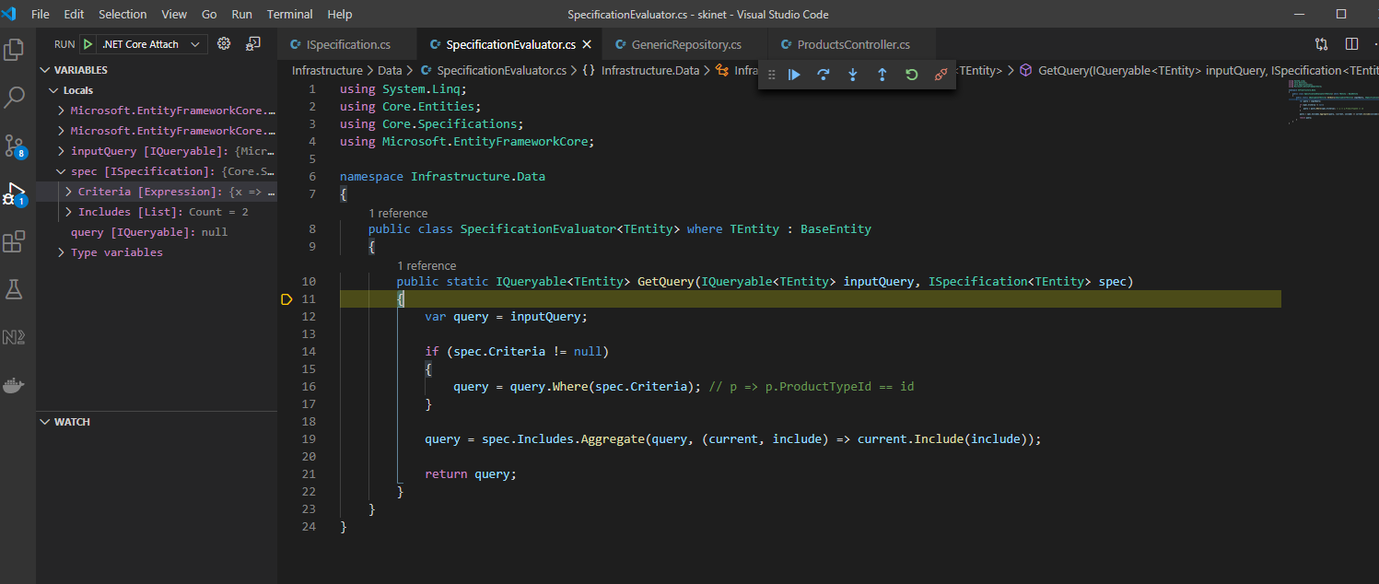

The above is building up the query i.e. it add the x => x.Id == id query to the include queries i.e. these two:-

x => x.ProductType

x => x.ProductBrand

Then the built up query is ran against the database here:-

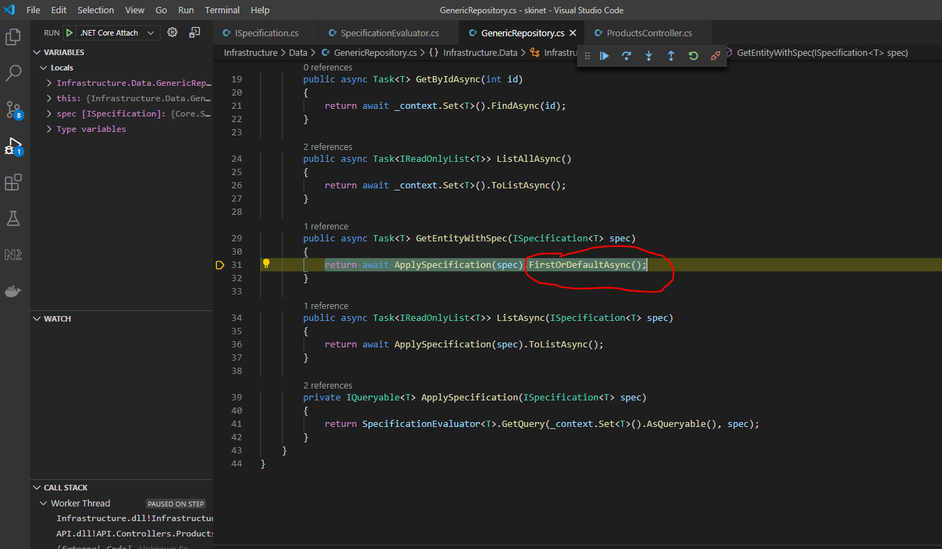

And returns the product object matching the id.

**Shaping data sent back from the Database**

This is used for the following situation:-

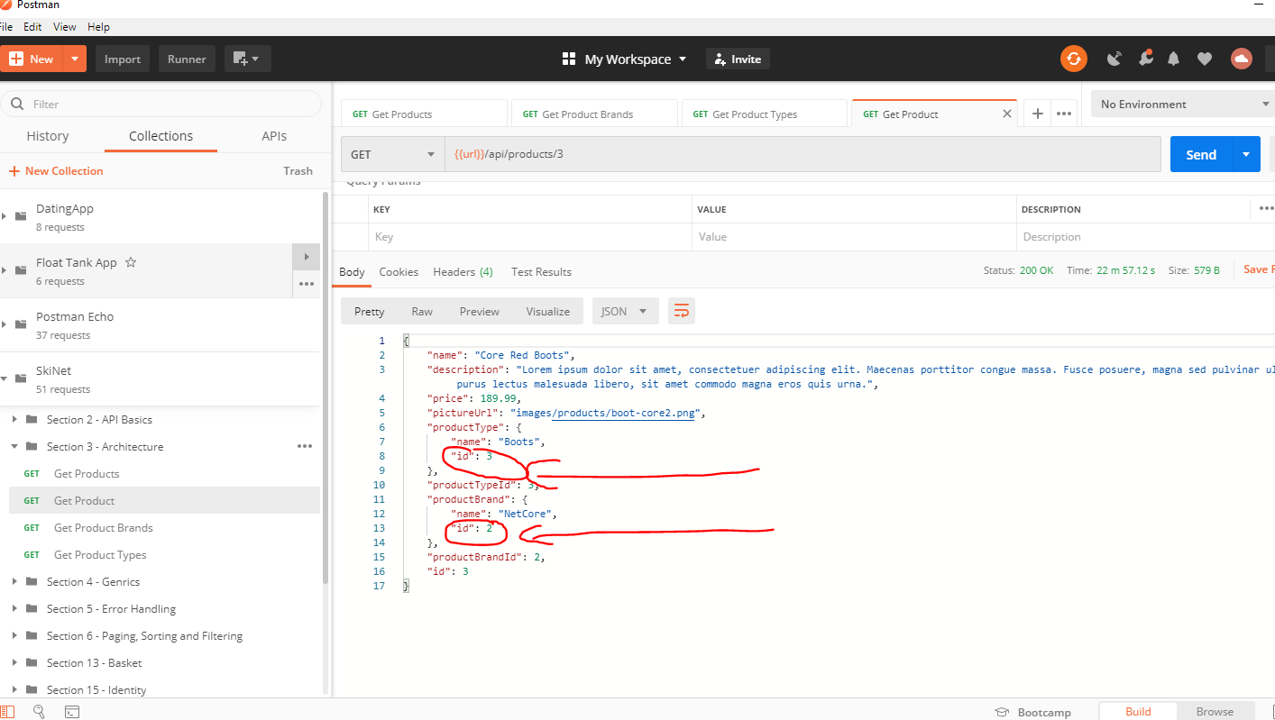

See the product object returned contains some data we don’t really need i.e. the ‘productBrand’ id and the ‘productType’ id.

So, we create a DTO (Data Transfer Object). Create a folder under ‘API’ called ‘Dtos’, then create a class in this folder called ‘ProductToReturnDto’:-

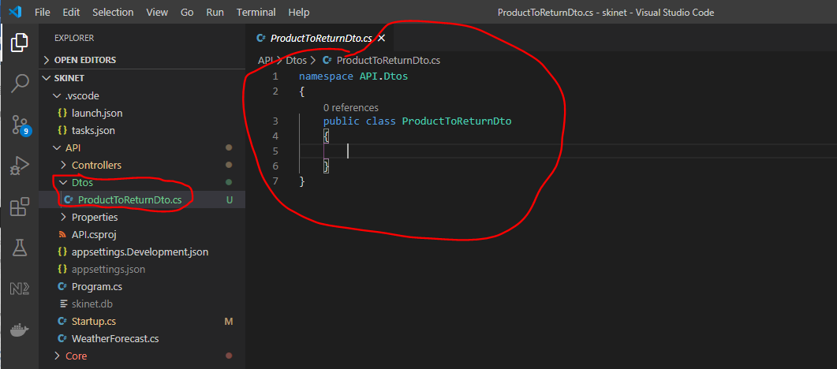

Copy all properties from the product entity class:-

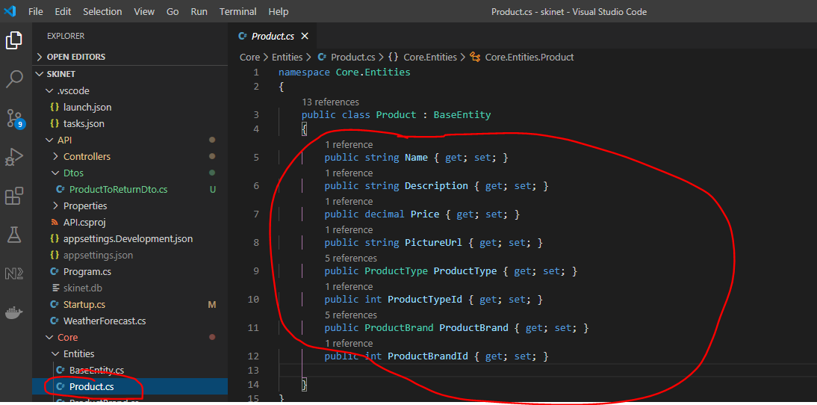

Add this:-

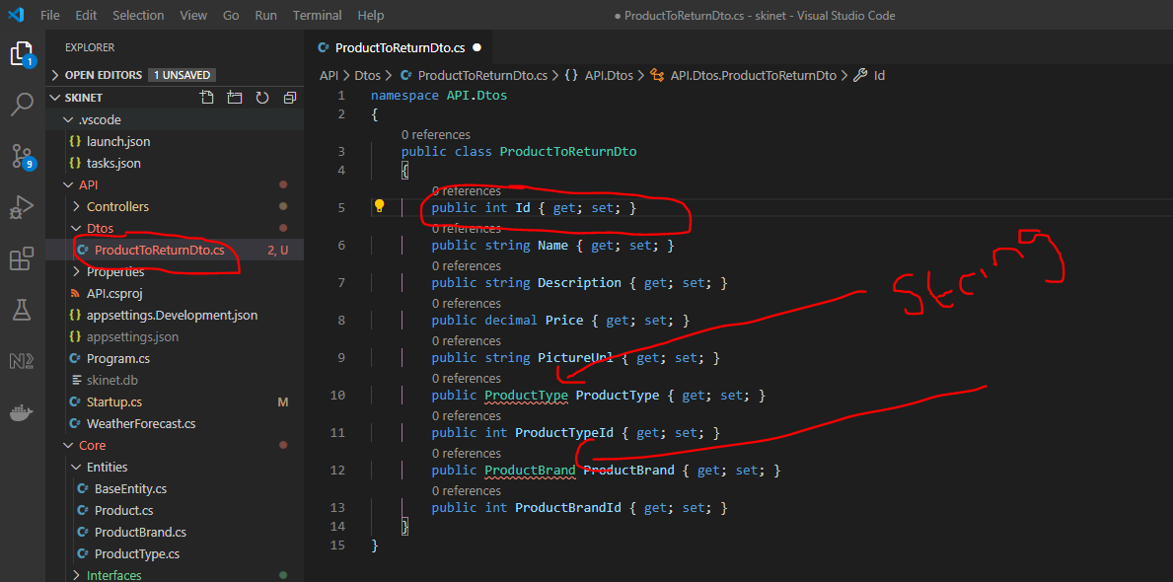

Change the two above to strings and remove these two properties:-

        public int ProductTypeId { get; set; }

        public int ProductBrandId { get; set; }

This will leave the following properties:-

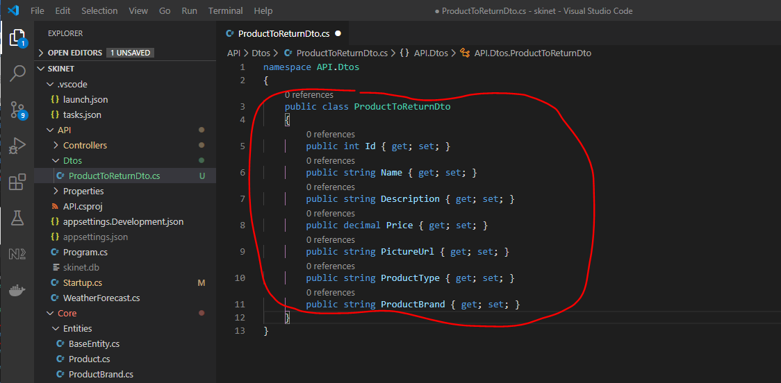

Now, change the ‘ProductController’:-

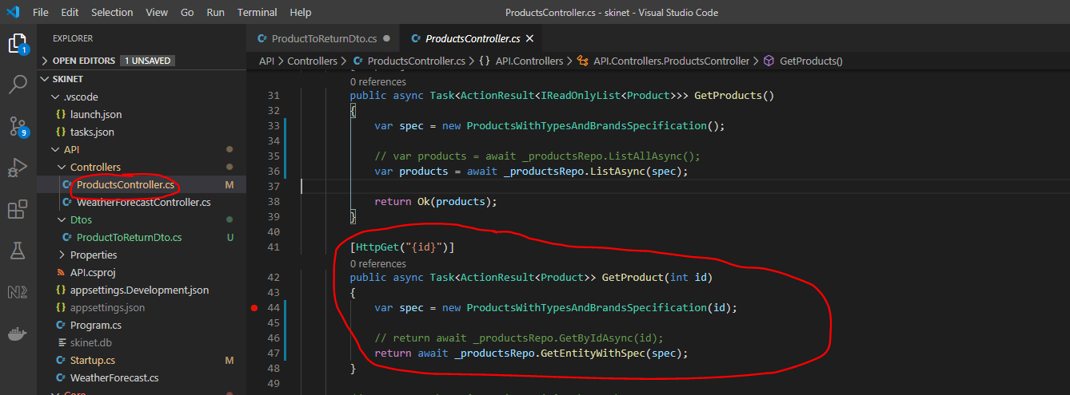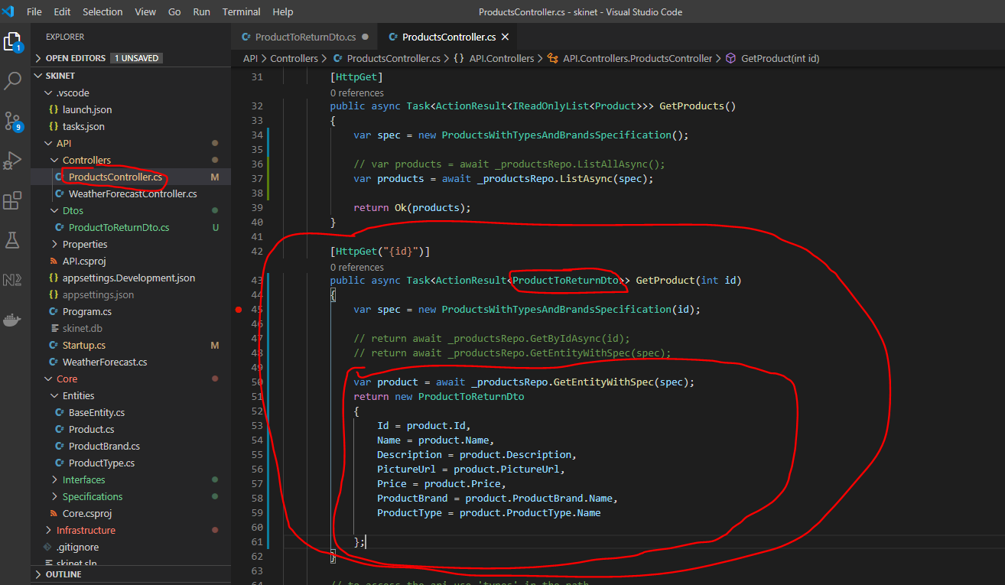

Also, update this:-

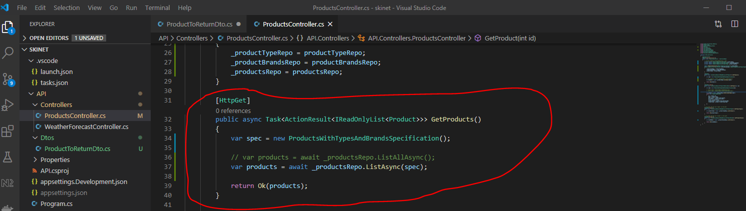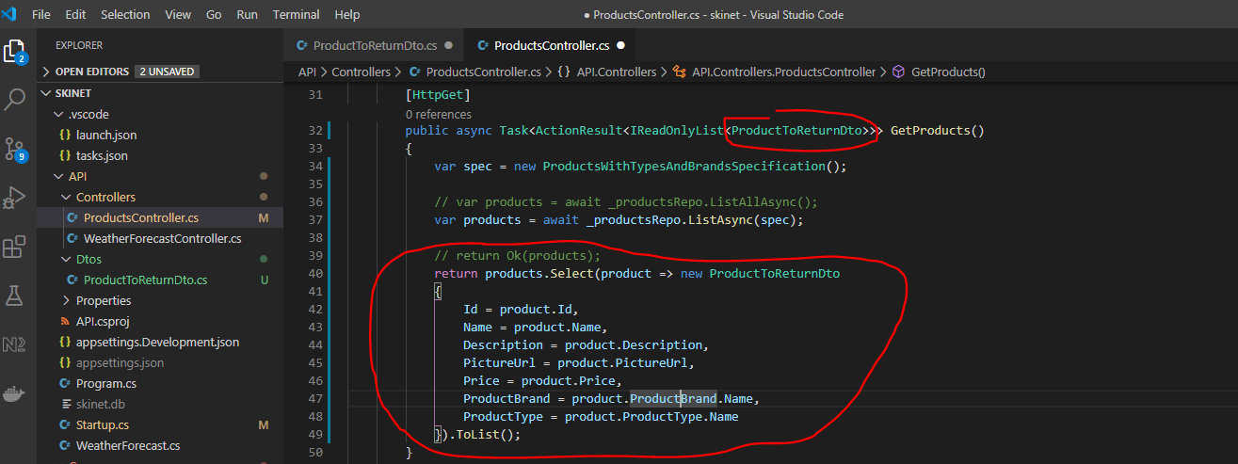

**Adding Automapper to the API Project**

Open up Nuget package manager:-

[shit] + [ctrl] + p

nuget

AutoMapper.Extensions.MicrosoftDependencyInjection

7.0.0

{root}/API/API.csproj

Now, create a new folder under API called ‘Helpers’. Create a class in that folder called ‘MappingProfiles’:-

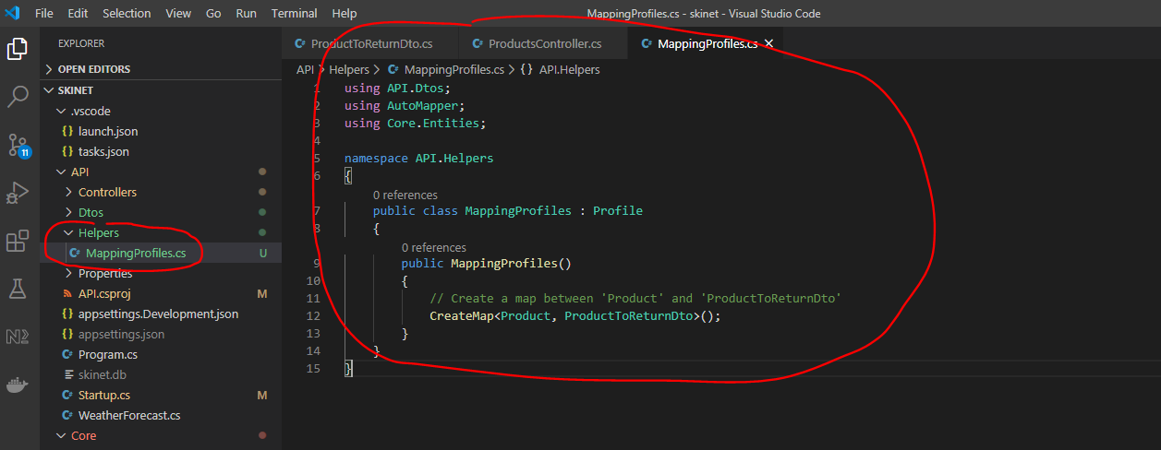

Add AutoMapper as a service in the ‘startup.cs’ class:-

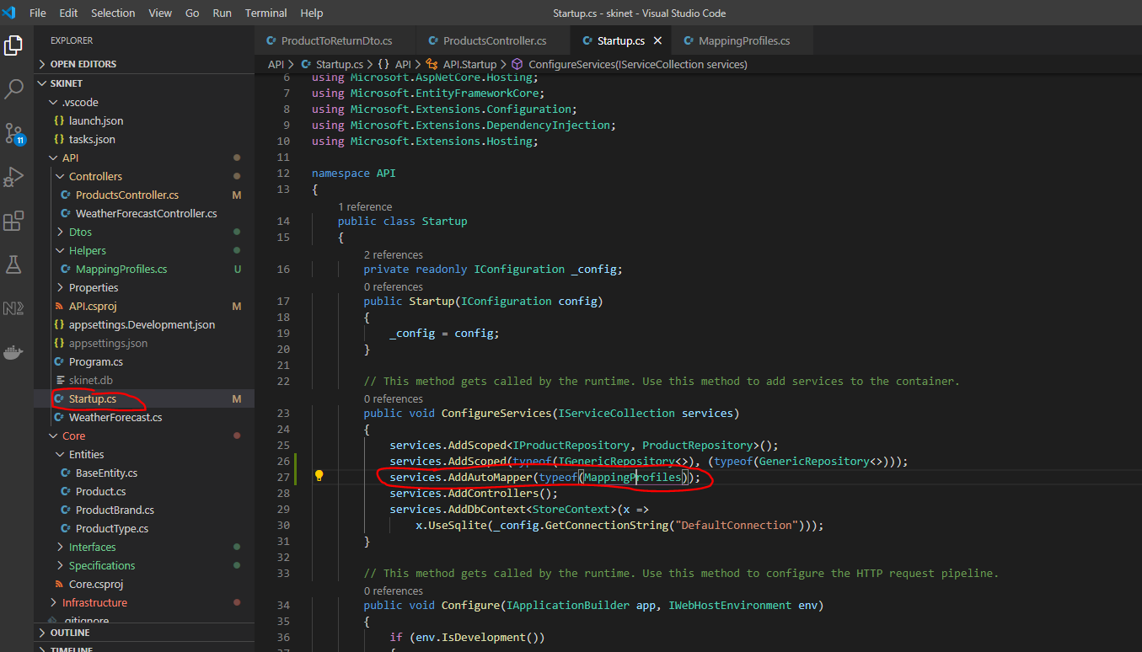

Now change the ‘ProductController’ class to make use of the AutoMapper:-

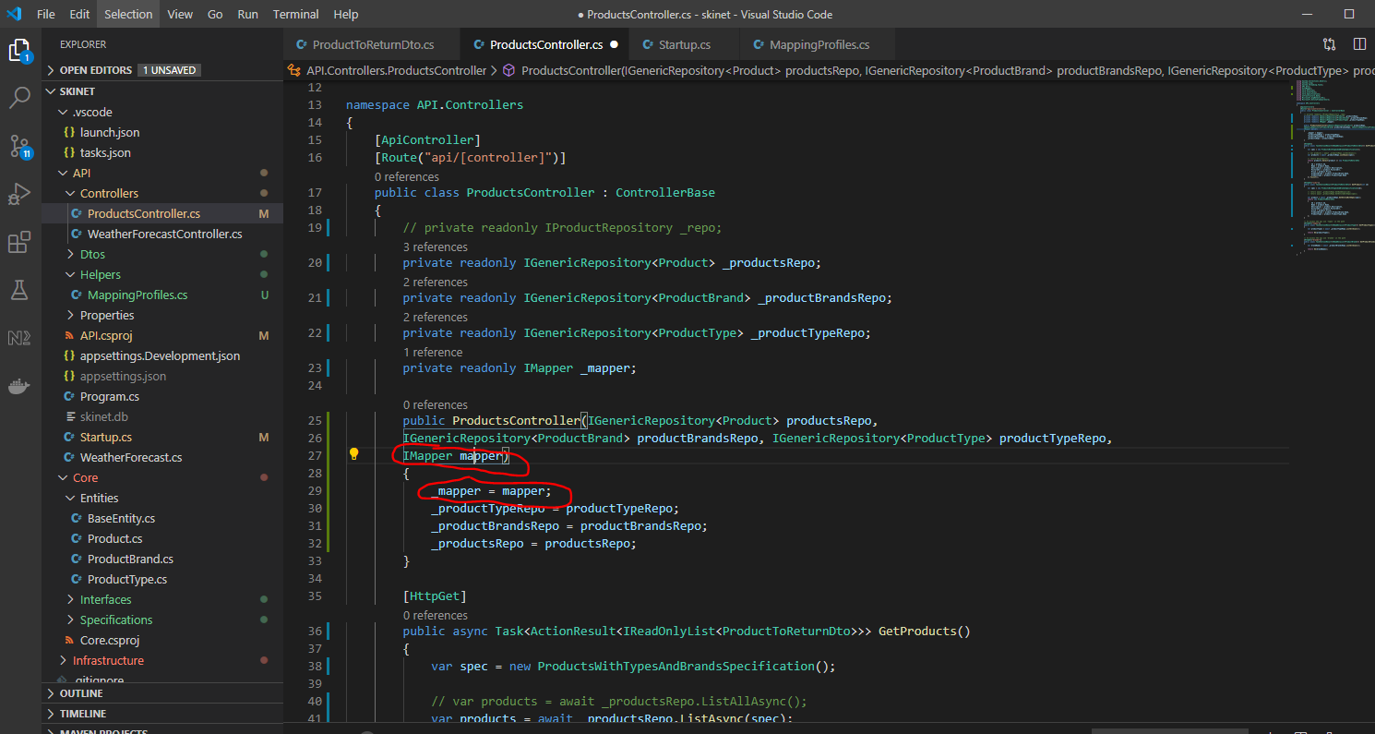

Add this:-

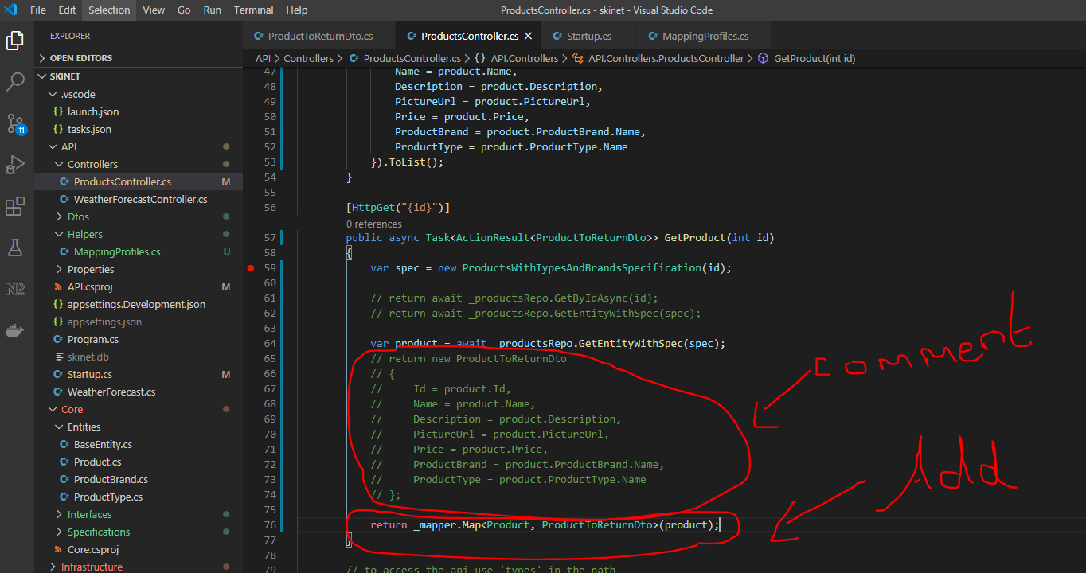

Use Postman to test this:-

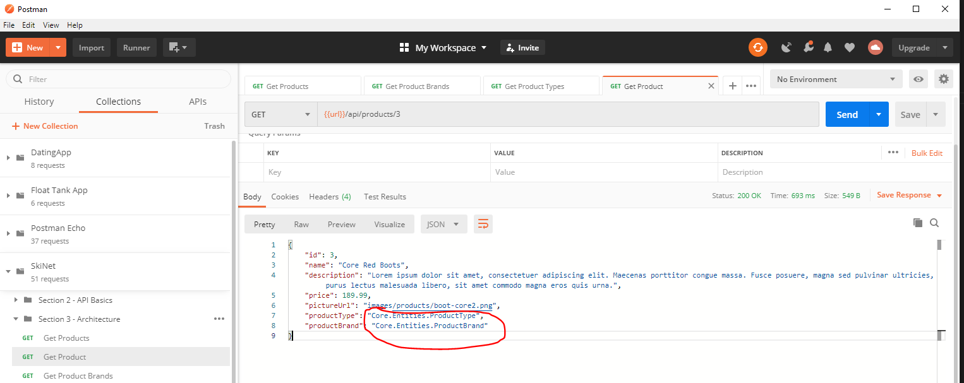

See the productType and productBrand have now got a problem (above). This is because these properties have different types between the ‘Product’ and ‘ProductToReturnDto’ classes:-

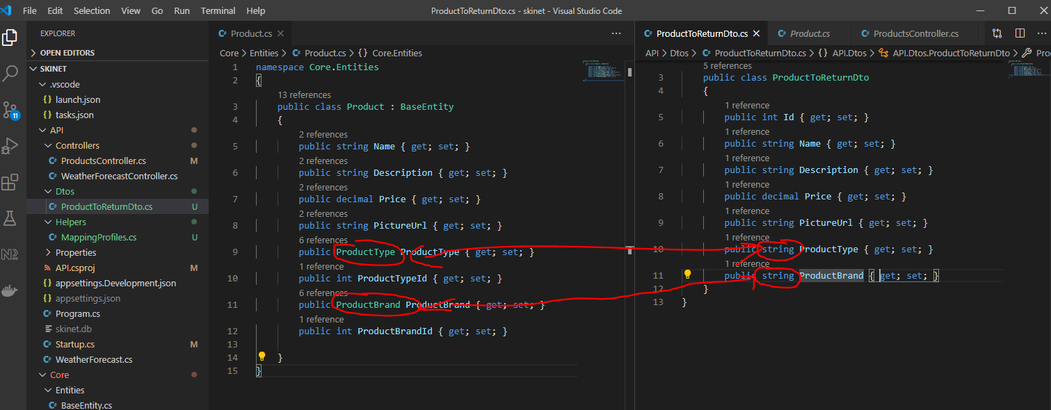

So tell AutoMapper about these two above properties. Go to MappingProfiles class:-

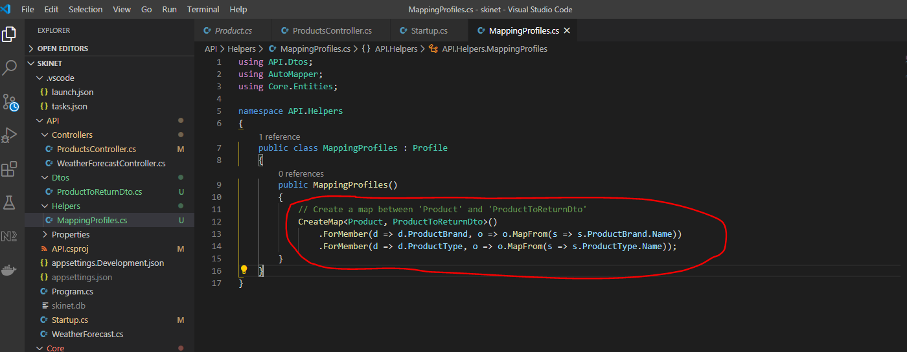

Now change the ProductsController class and change the ‘GetProducts()’ method:-

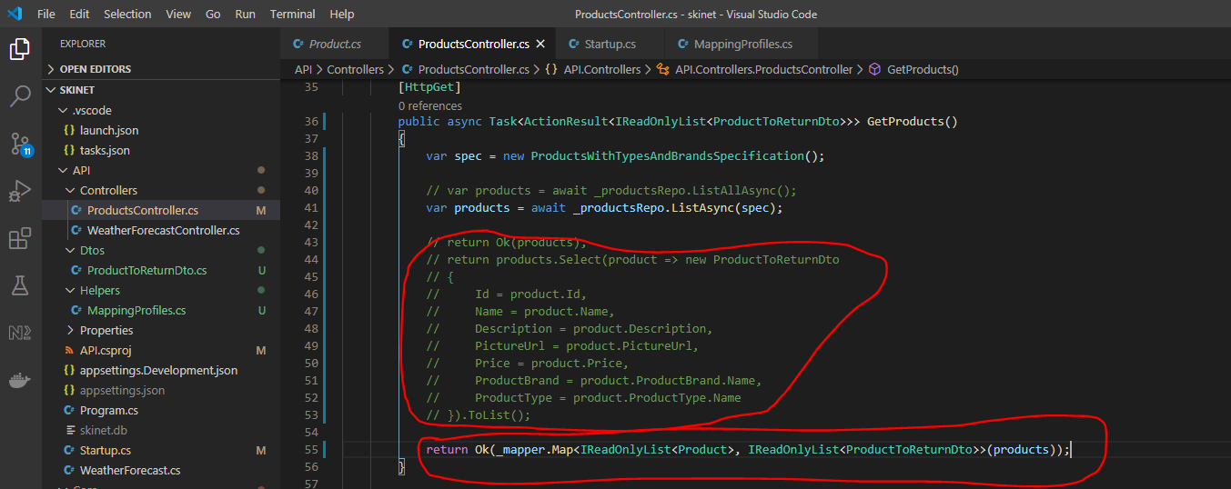

Use Postman to test again:-

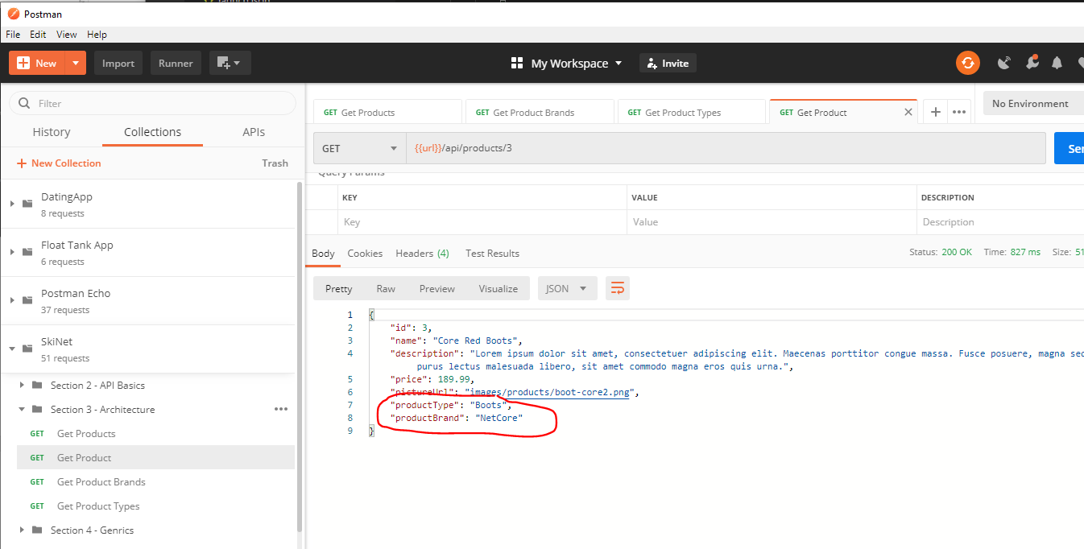

See fields are now correct.

Now, sort out the ‘pictureUrl’ property. Add the full address to the url:-

Add a property to the ‘appsettings.Development.json’ fole:-

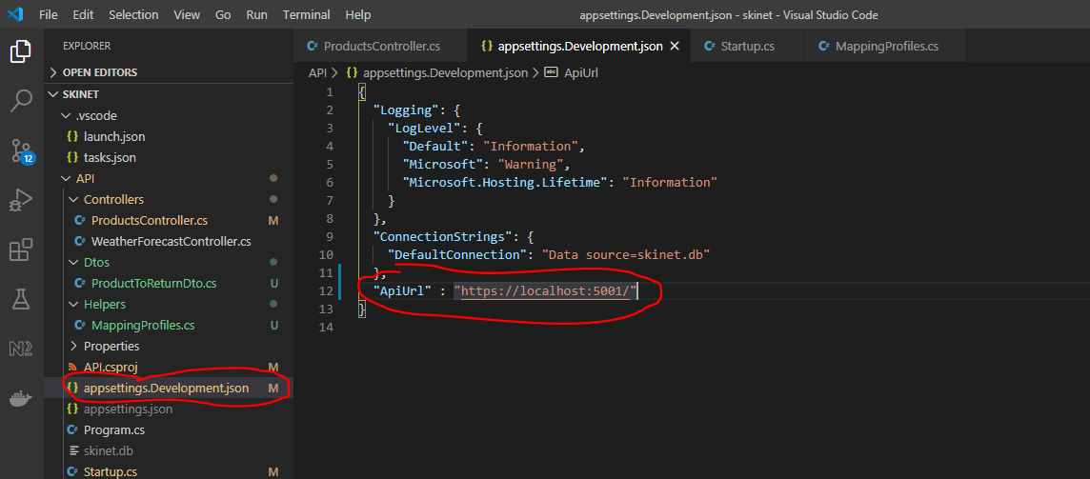

Create a new class under the ‘Helpers’ class:-

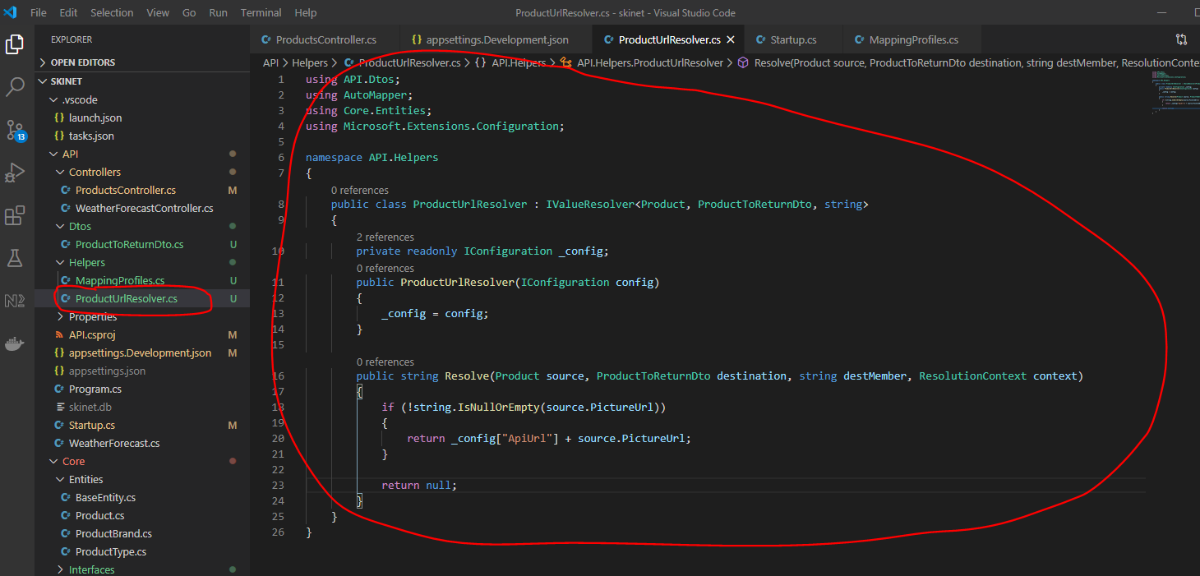

Now use this in the MappingProfiles class:-

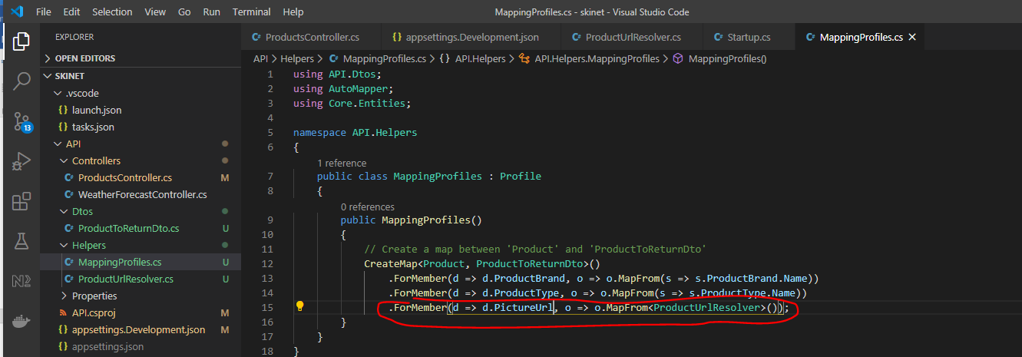

Now, test in Postman. See the full url address:-

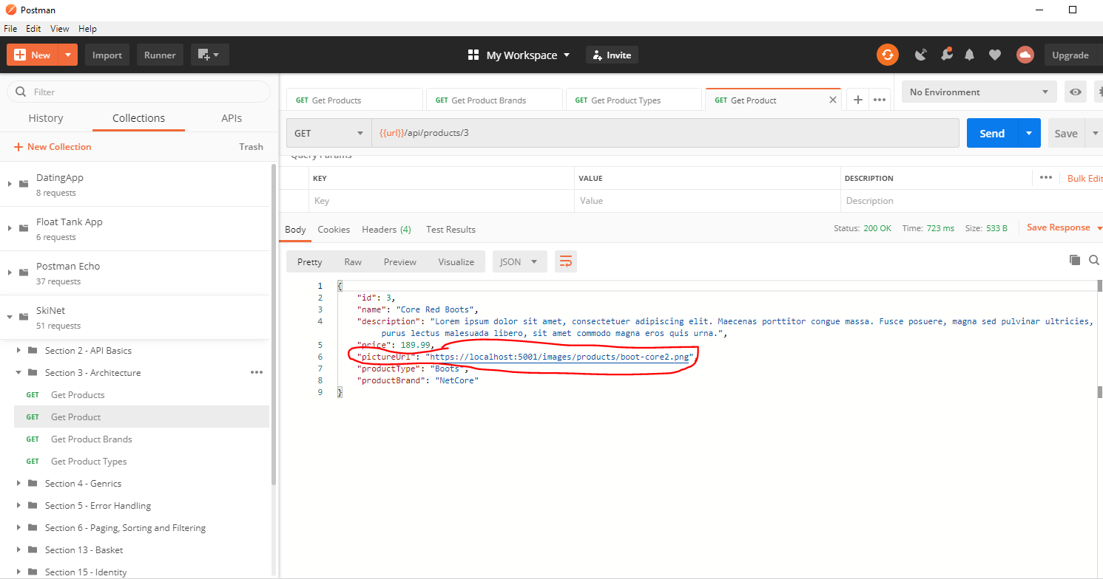

Add images into the API folder in a new folder called ‘wwwroot’:-

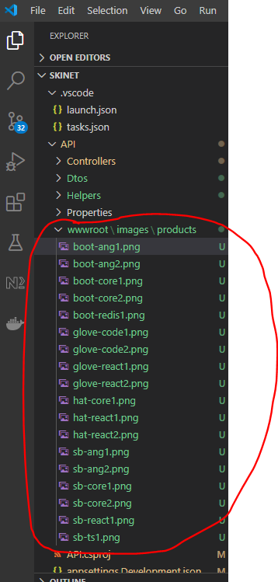

Configure the API to serve static images. Go to ‘startup.cs’ class and add this as middleware:-

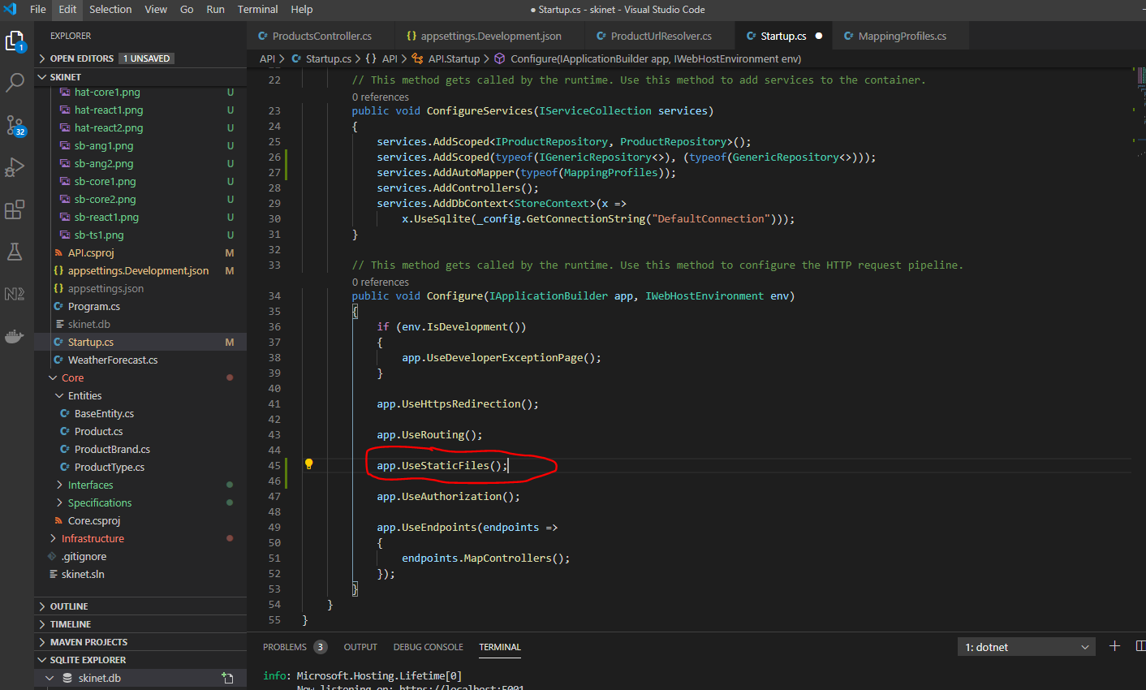

Ordering is important here.

Commit changes to GitHub:-

git add .

git commit –m “Addition of generics”

git push origin master

**Error Handling**

Create a new base controller class:-

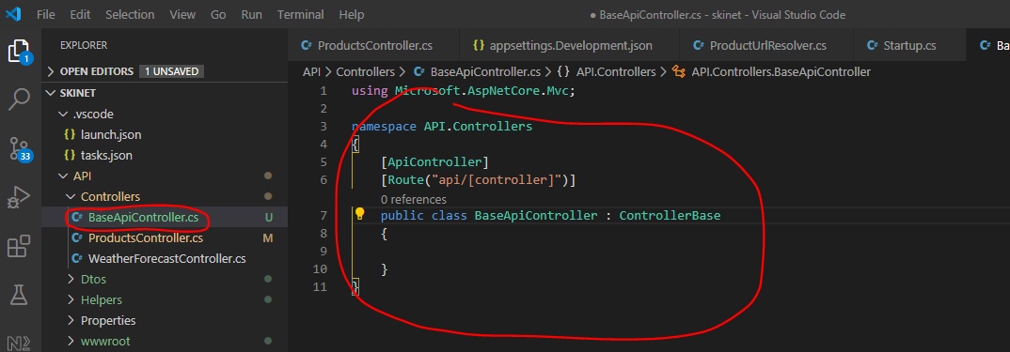

Update ‘ProductController:-

Remove this section:-

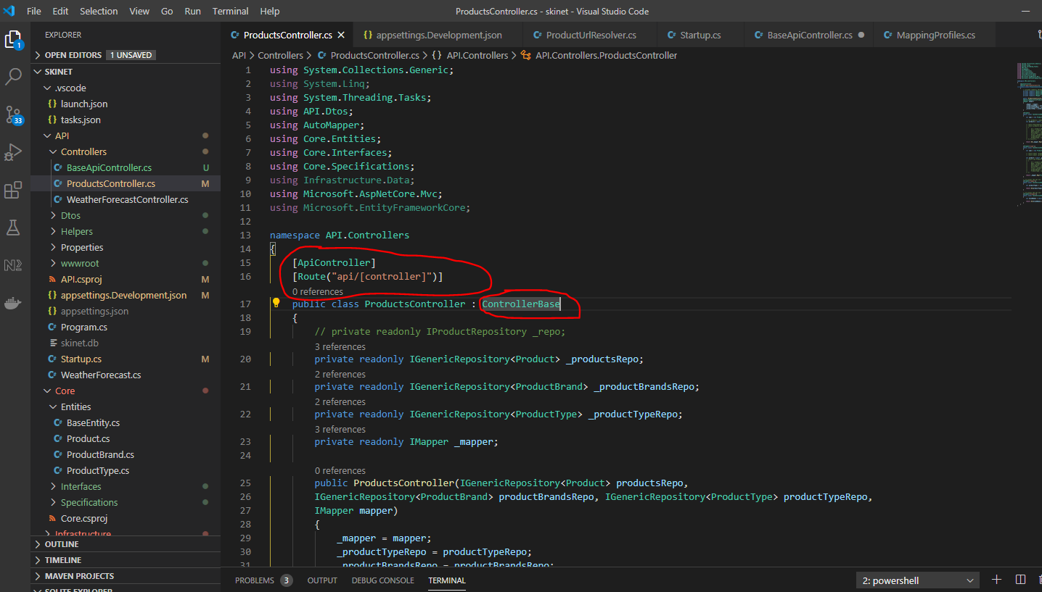

Giving this:-

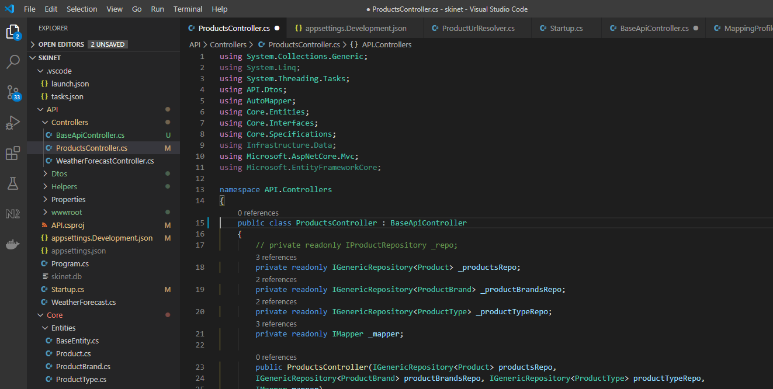

Create a new controller:-

BuggyController.cs

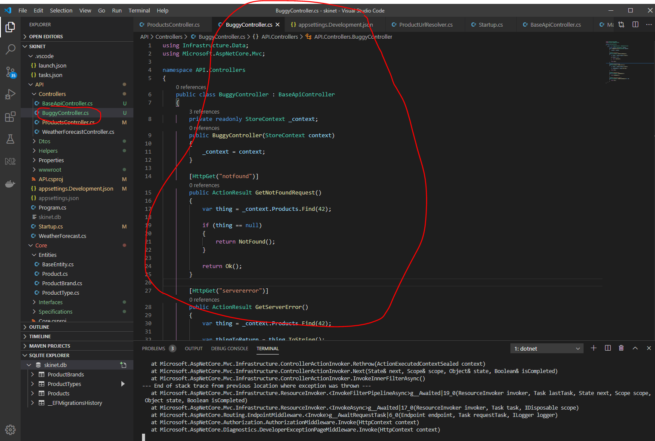

Restart the API server after adding or making changes to controllers.

Create a new folder under ‘API’ and a class in it called ‘ApiResponse’:-

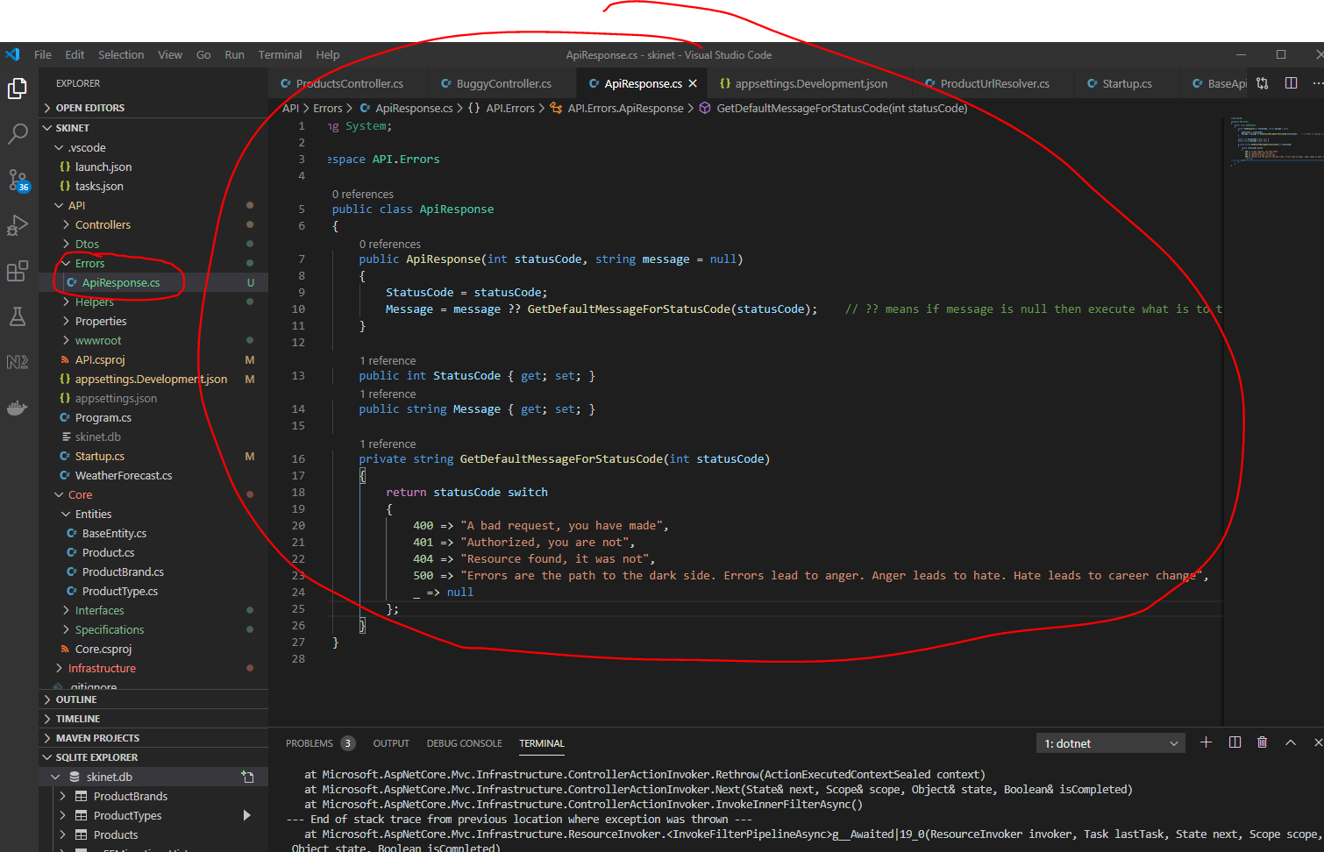

Now, update the ‘BuggyController’ class:-

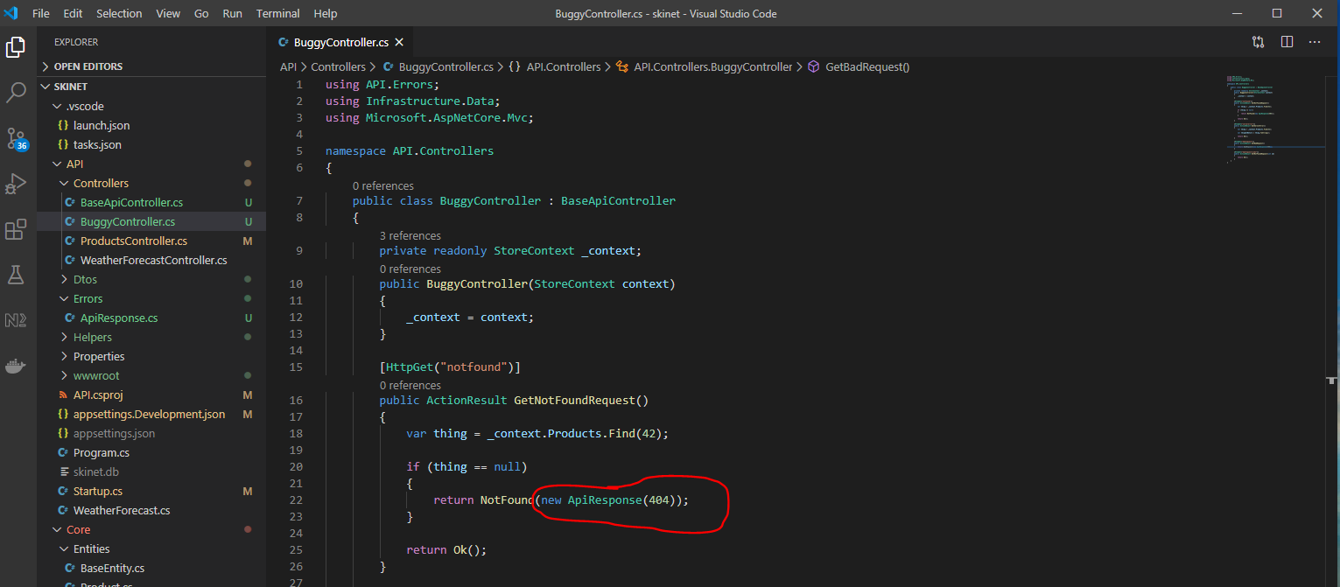

Create a new controller called ‘ErrorController’:-

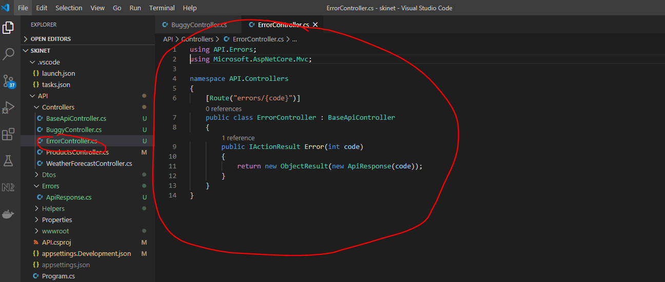

Add this to the exception handling middleware section in ‘startup.cs’ class:-

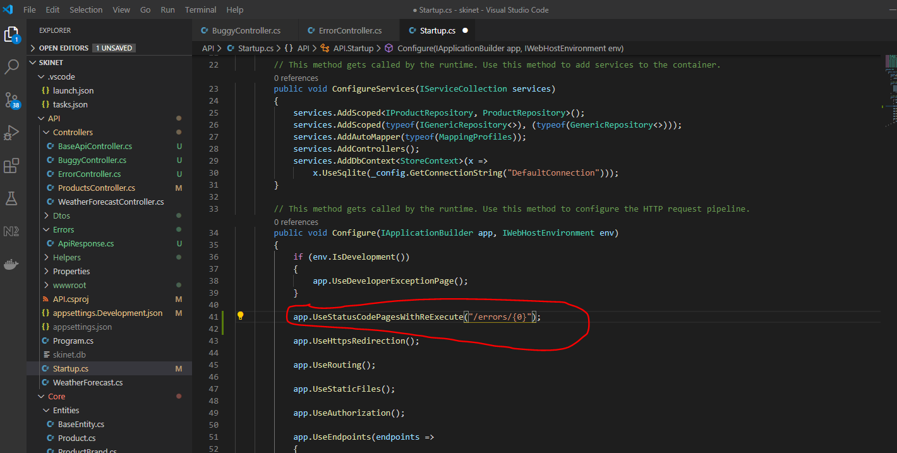

Create a new class in the ‘Errors’ folder:-

ApiException.cs

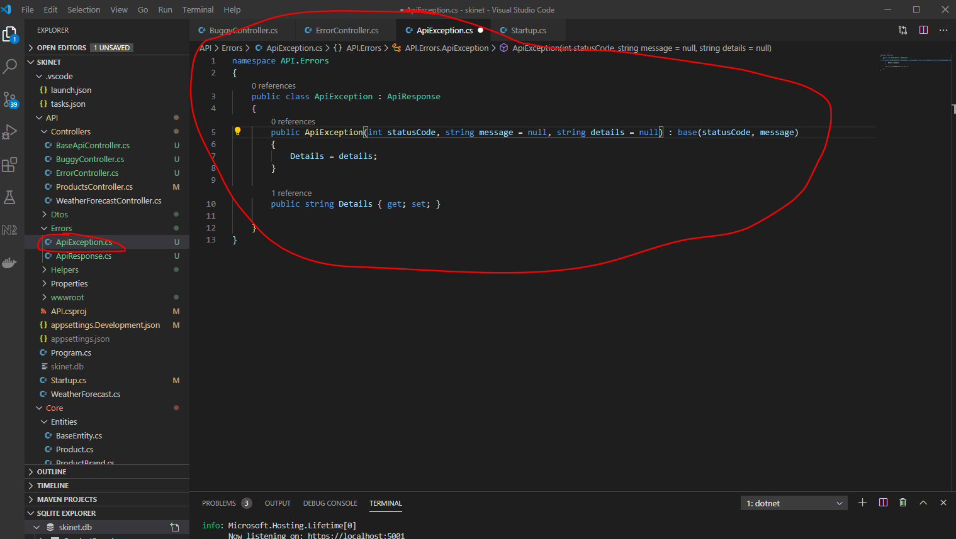

Create a new folder in the ‘API’ folder called ‘Middleware’. Create a class in this folder called ‘ExceptionMiddleware’.

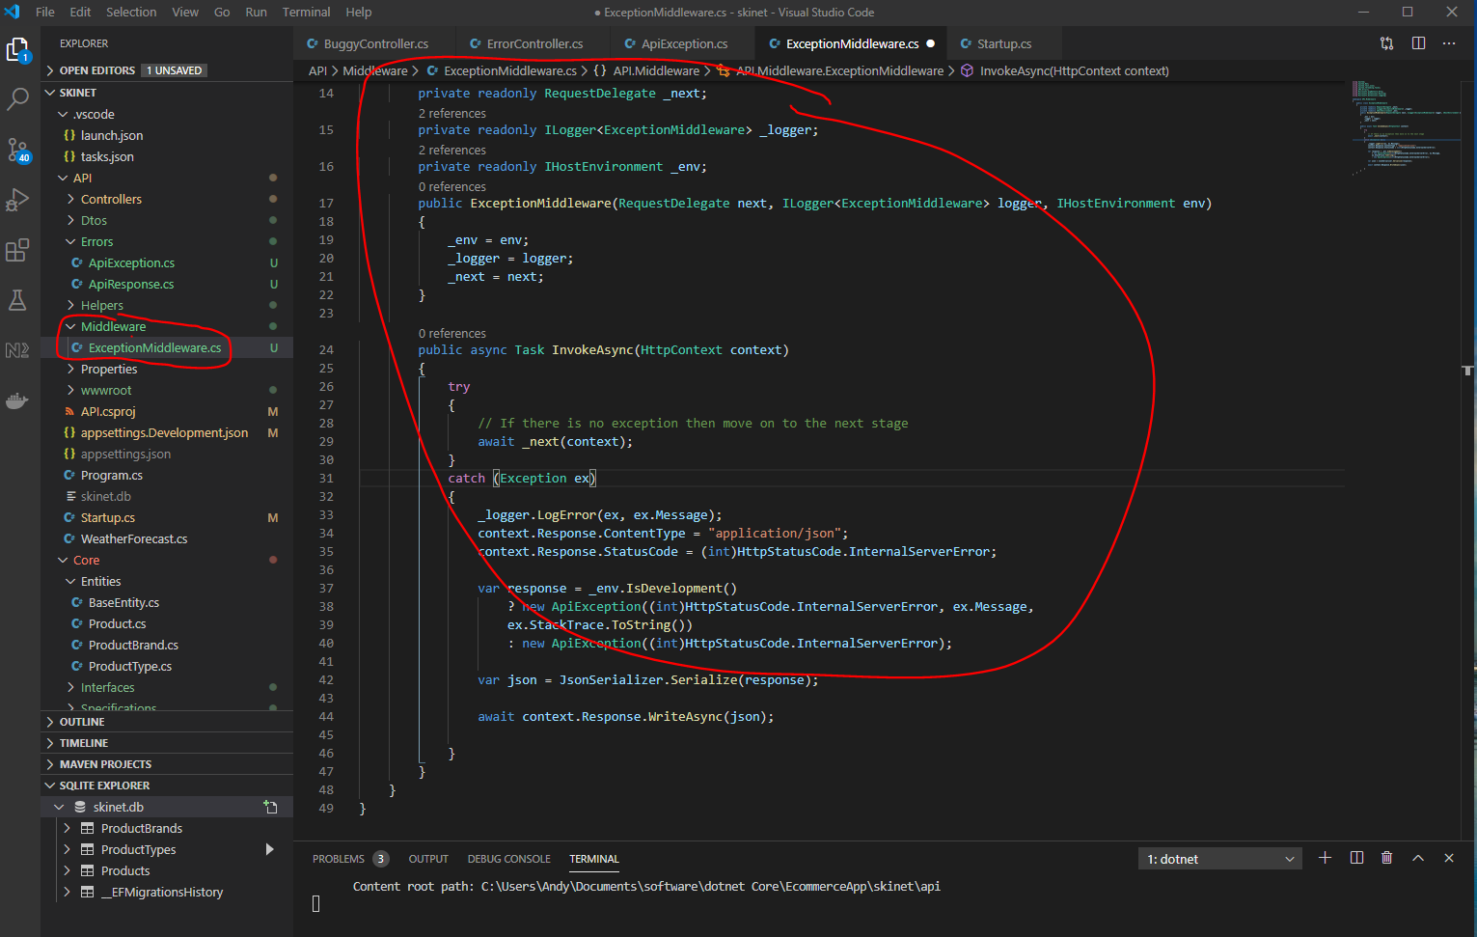

Now, update the middleware section in ‘startup.cs’. Remove this section:-

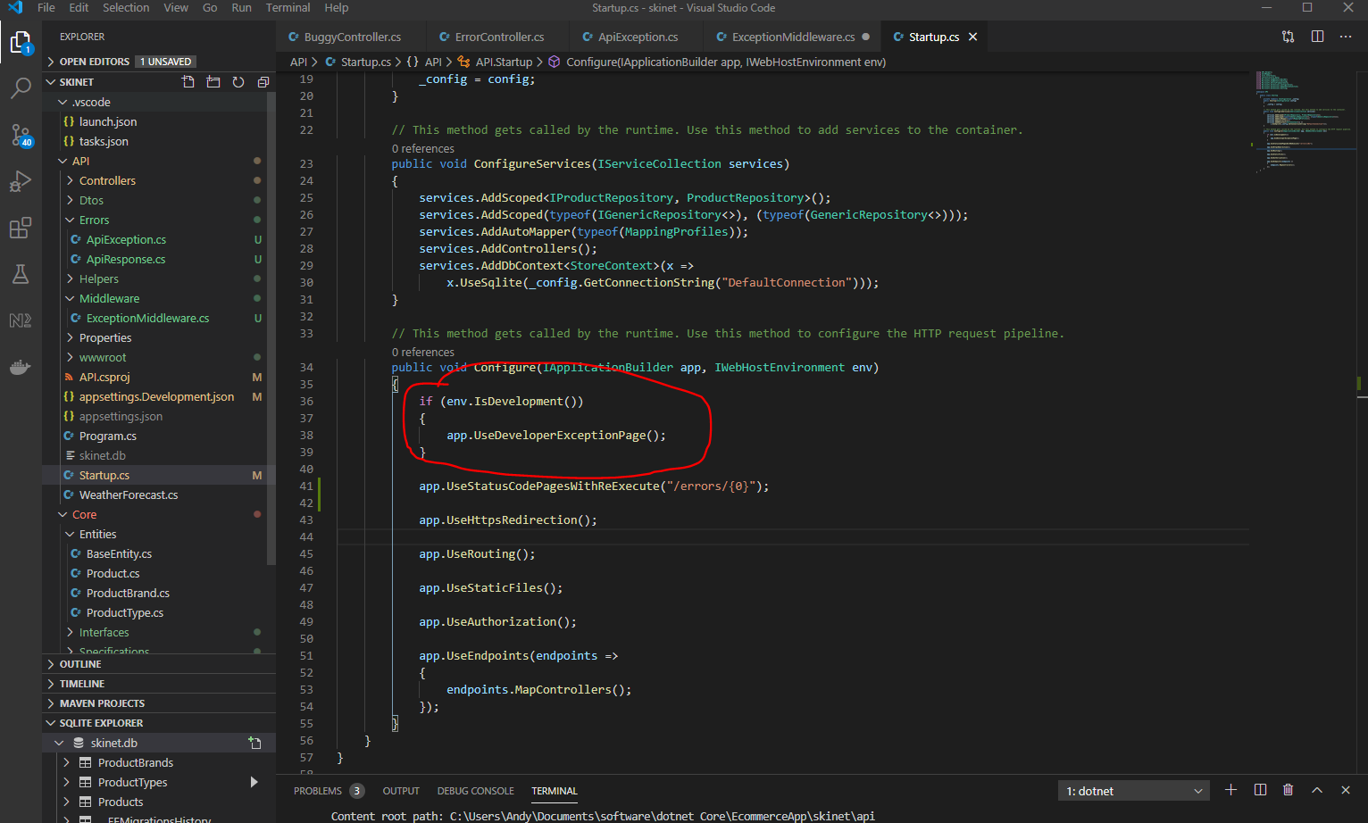

Replace with this:-

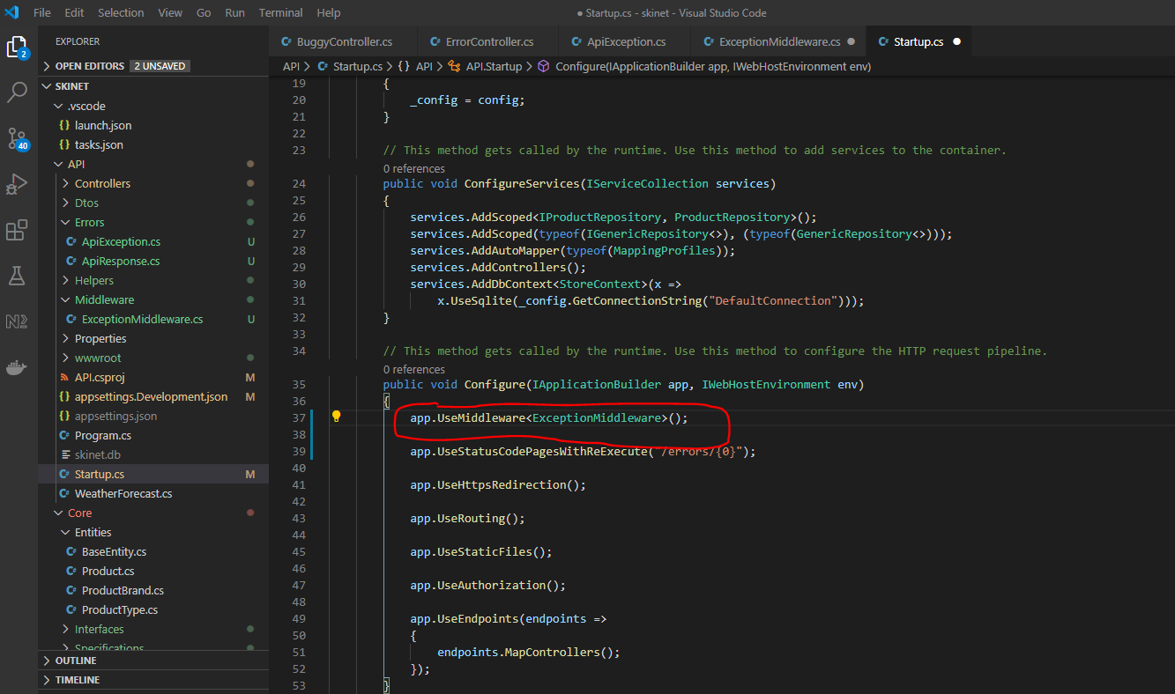

Now, test the exception using Postman:-

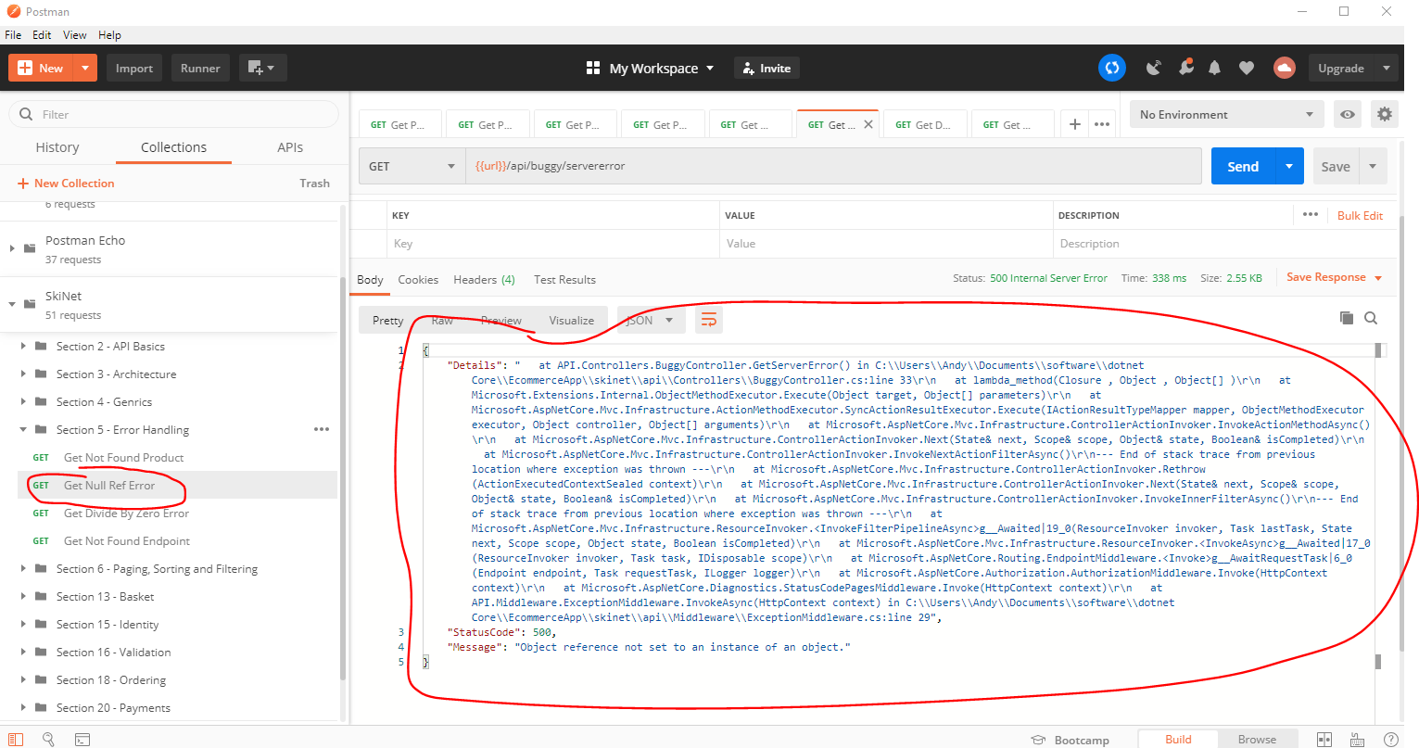

Change json message response to be in camel case. Go to ‘ExceptionMiddleware’ class:-

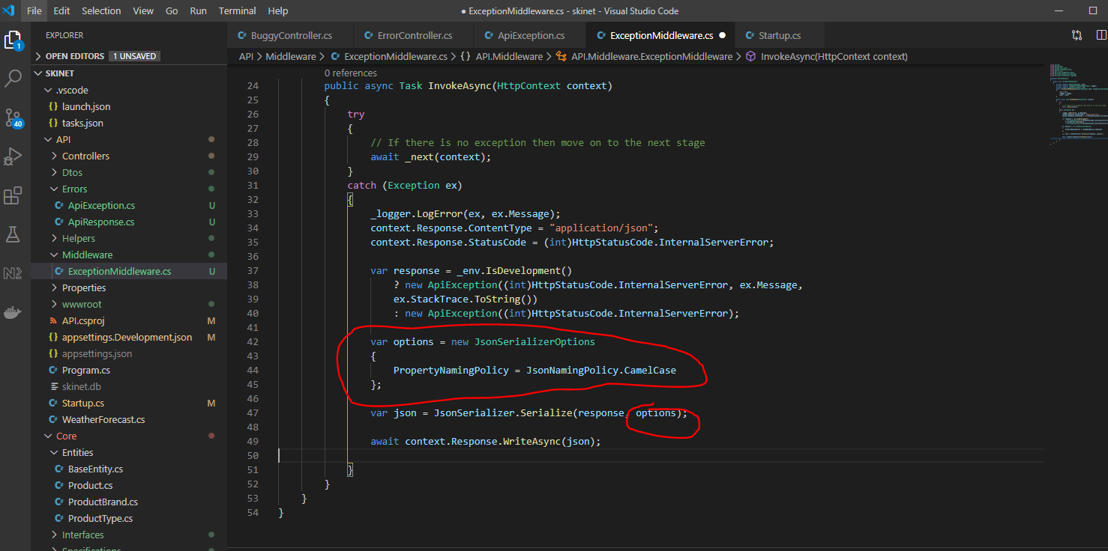

Now improve the validation error message response:-

Create a new class in the ‘Errors’ folder called ‘ApiValidationErrorResponse’.

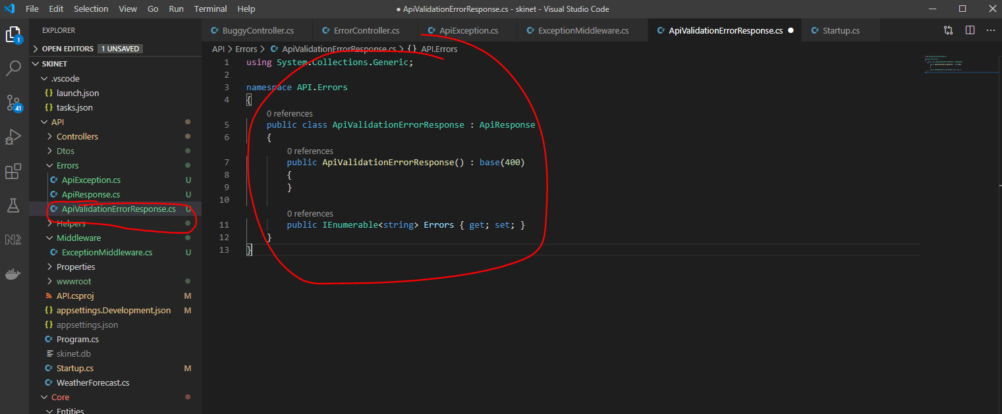

Now, add the service to the statup.cs class:-

Note:- It needs to go below ‘services.AddControllers()’:-

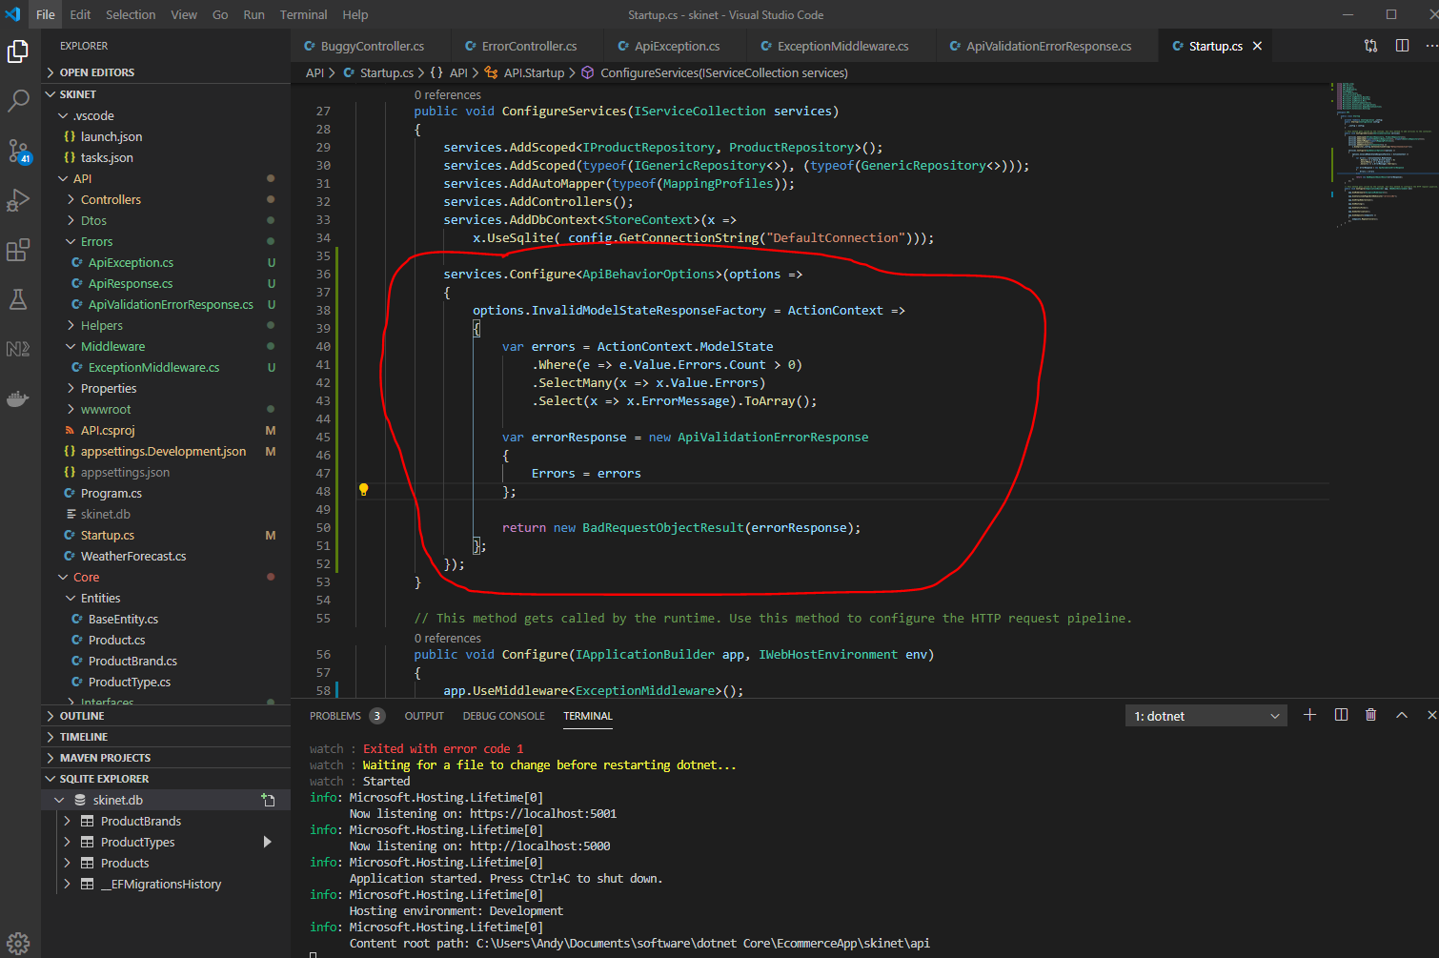

**Use Swagger to document API responses**

Add nuget package:-

[ctrl] + [shift] + p

nuget

Swashbuckle.AspNetCore.SwaggerGen

5.4.1 - latest version

{root}/API/API.csproj

and

Swashbuckle.AspNetCore.SwaggerUI

5.0.0 - latest version

{root}/API/API.csproj

Now, add a new service to the ‘startup.cs’ class:-

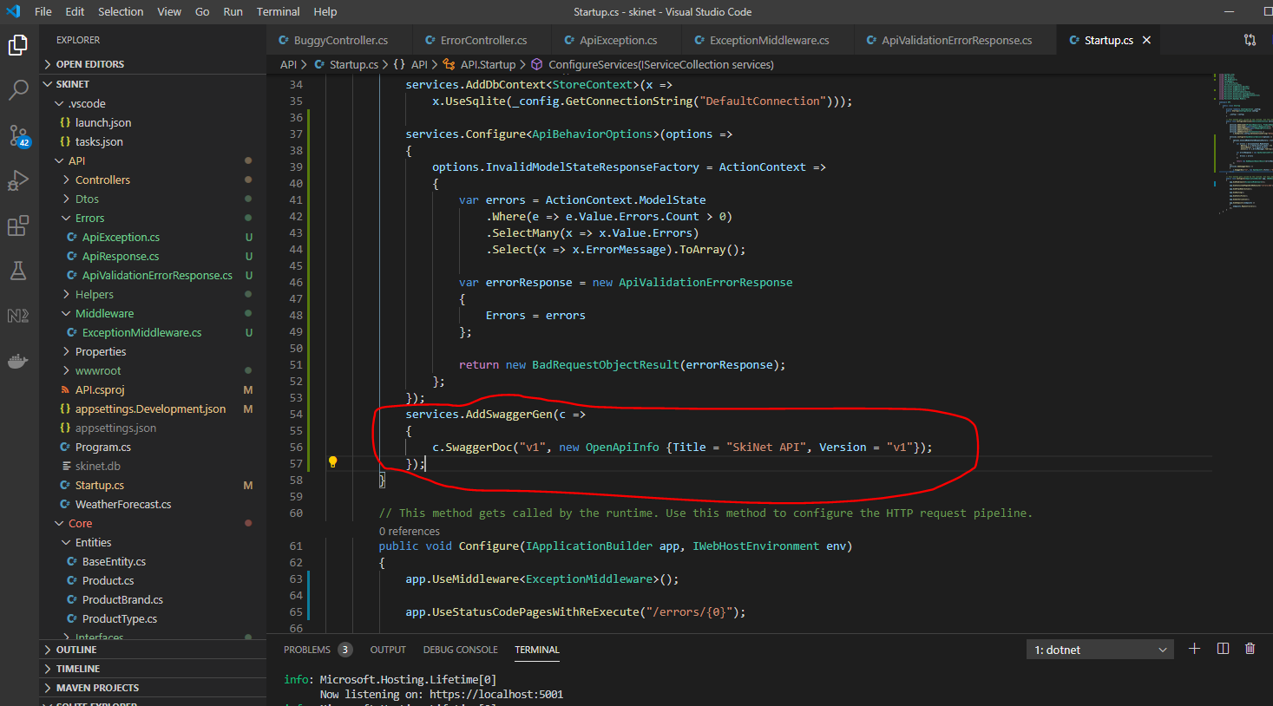

Add the service to the middleware section of the ‘startup.cs’ class:-

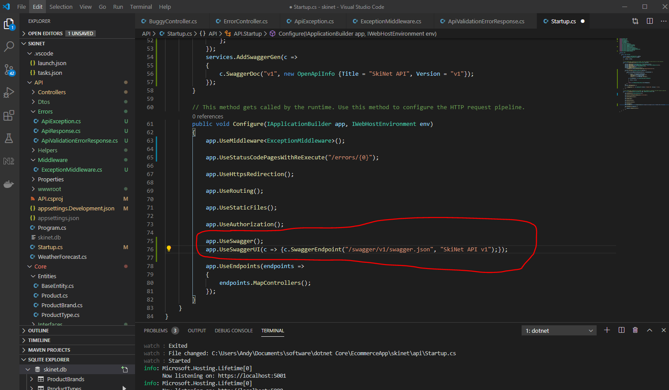

Test in a browser:-

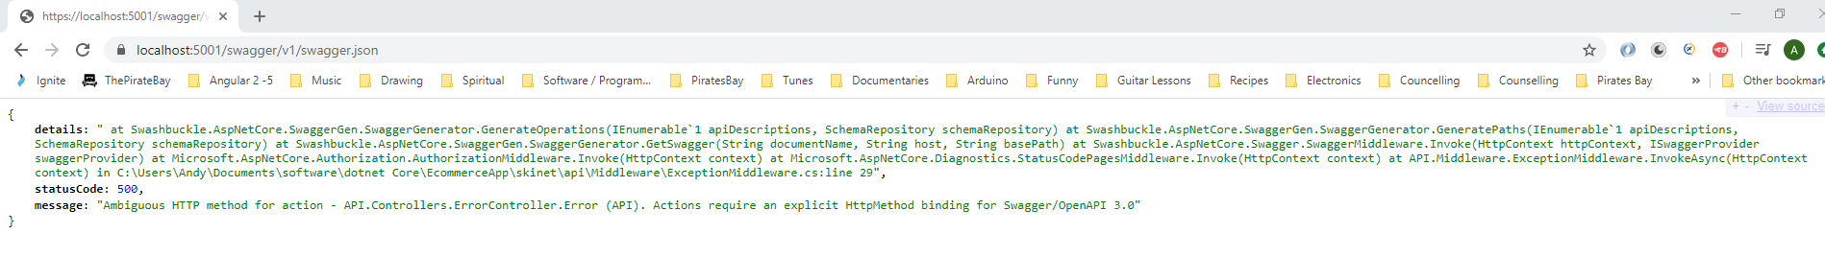

Also,

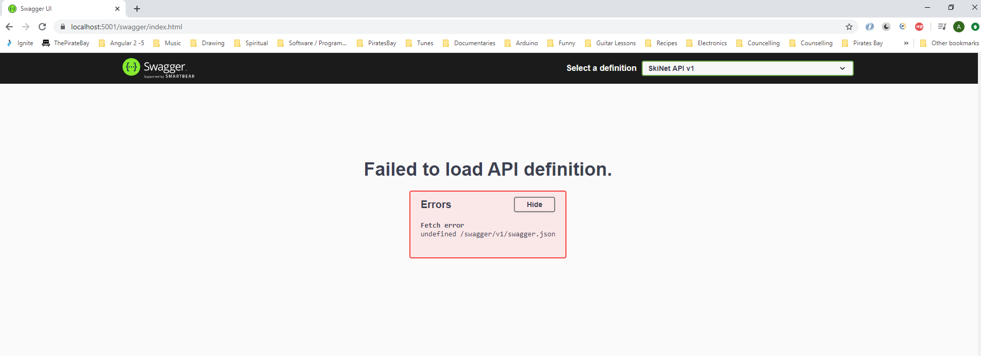

To get rid of the above error add the following to the ‘ErrorController’ class:-

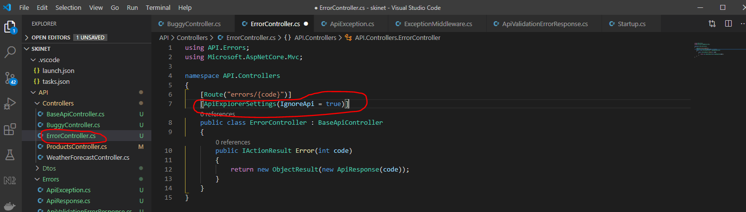

Refresh browse:-

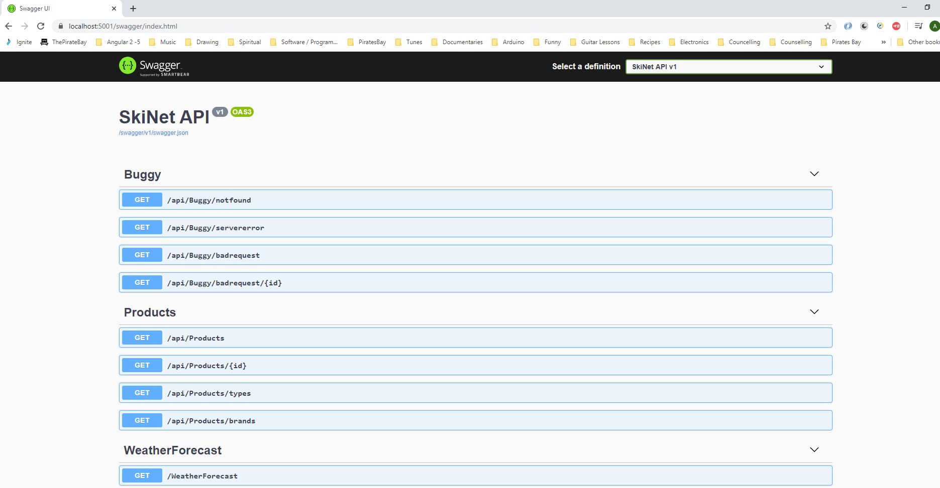

We do not what to see the ‘WeatherForecastController’ in the swagger page:-

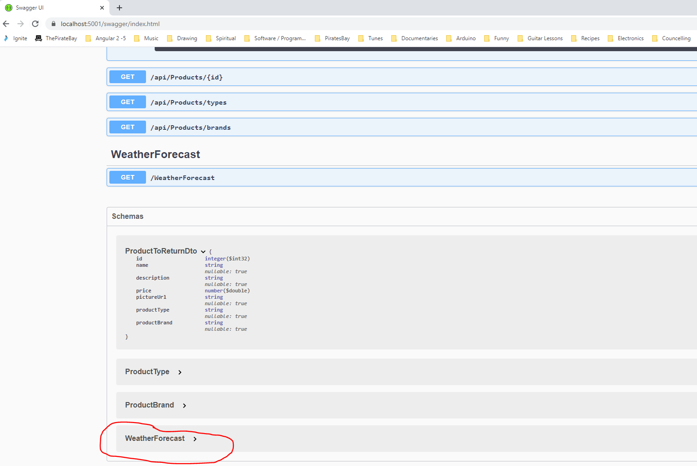

Add this to the WeatherController:-

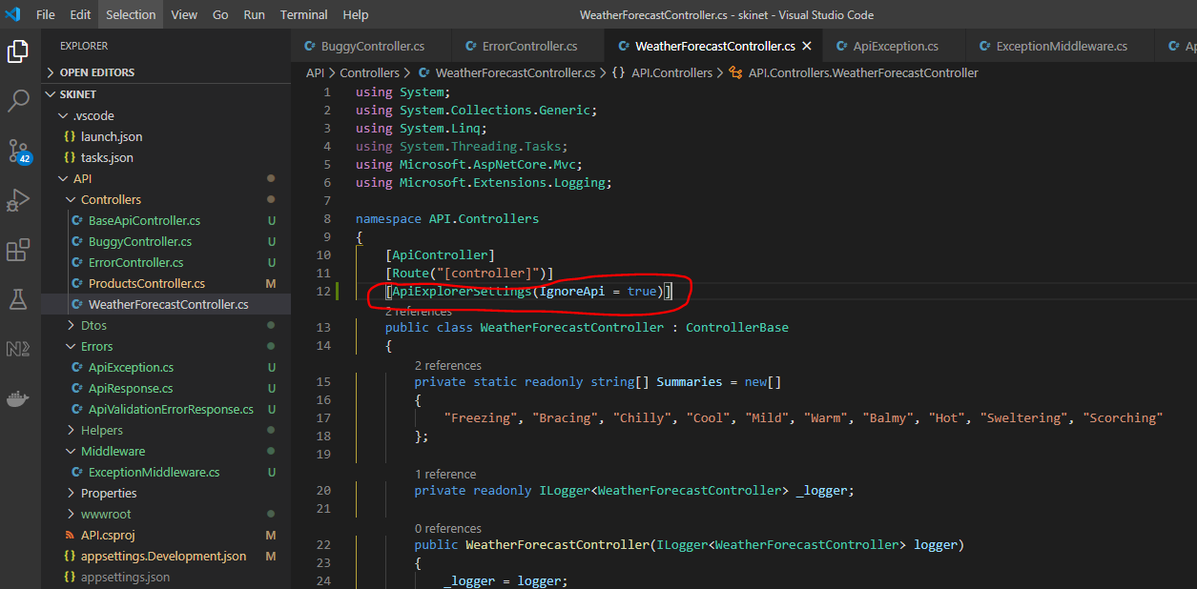

Improve Swagger documentation now e.g. add details to explain that if a user enters an id for a product that does not exist then an error code is returned. So update the ‘ProductController’ class:-

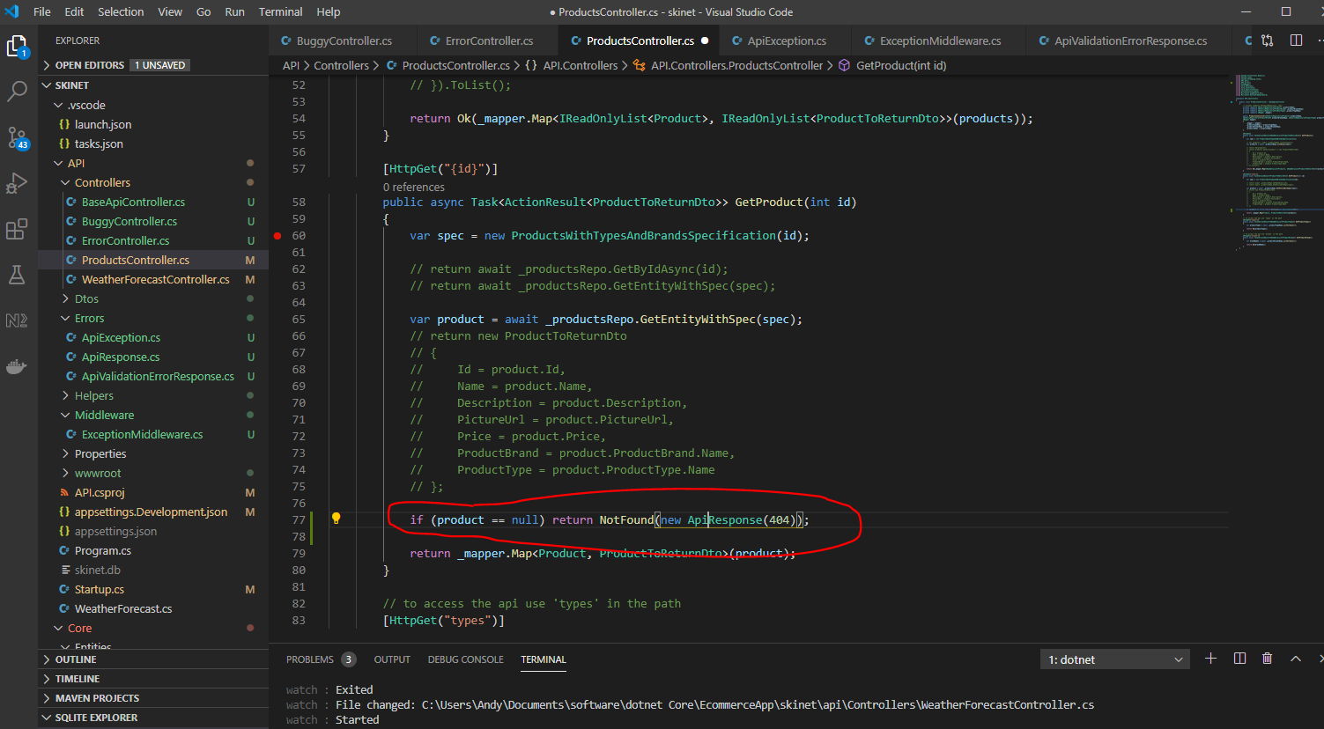

Test change in Swagger:-

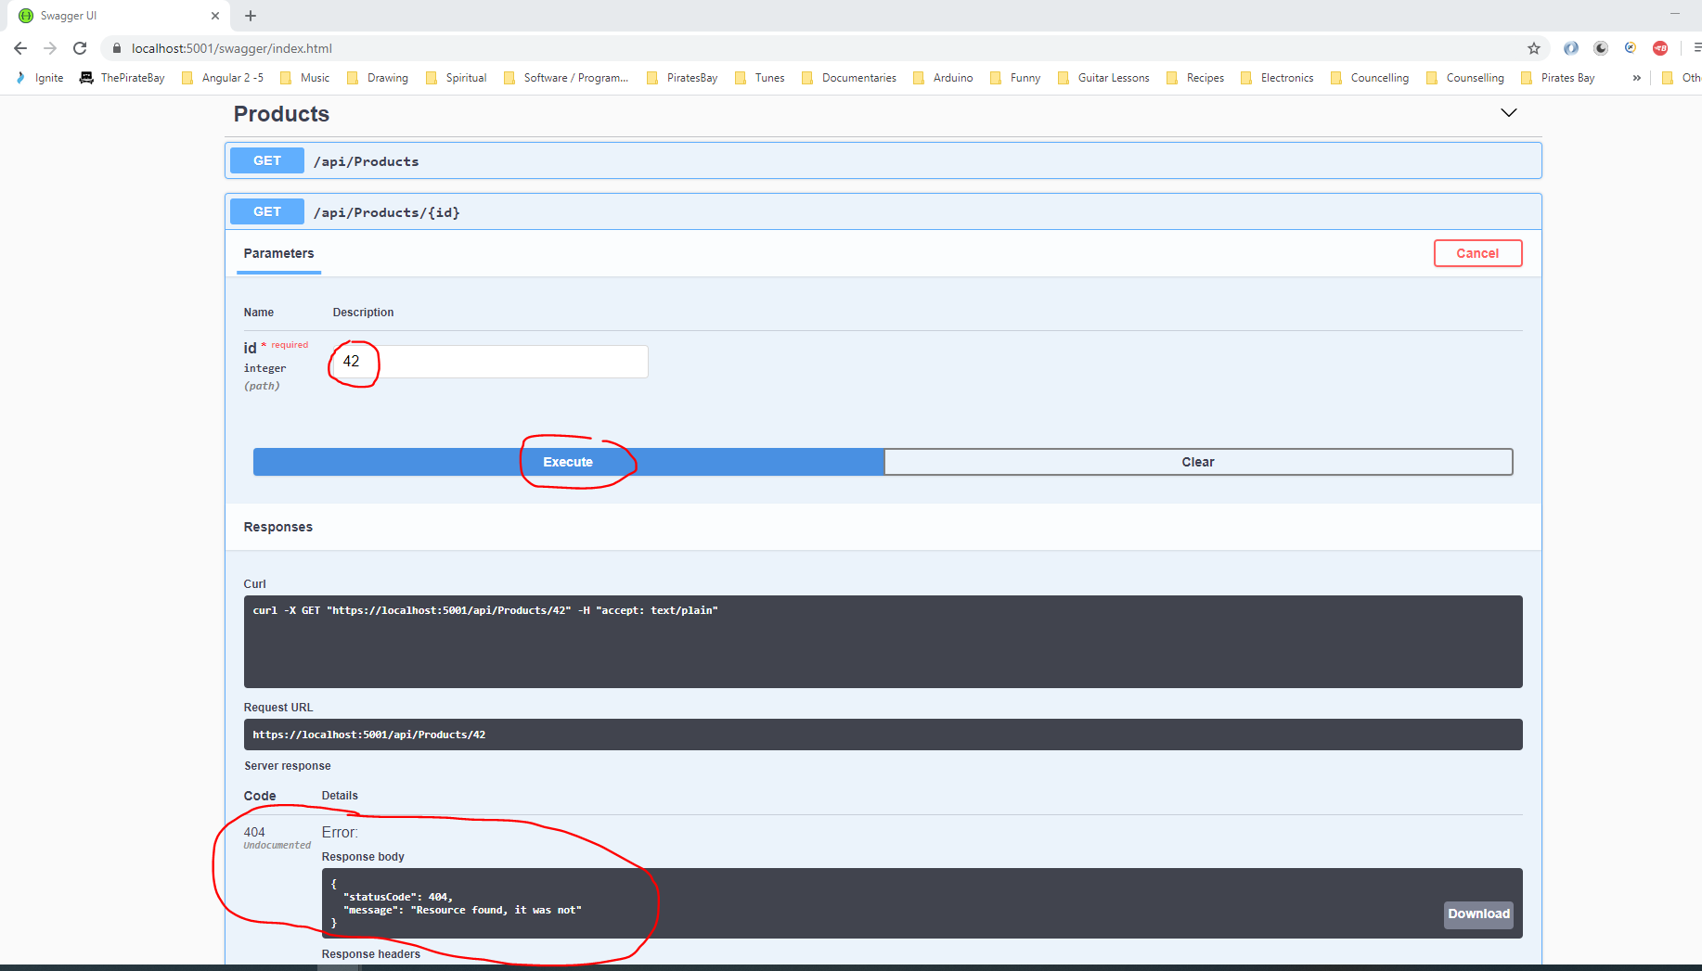

Add further attributes to product controller class:-

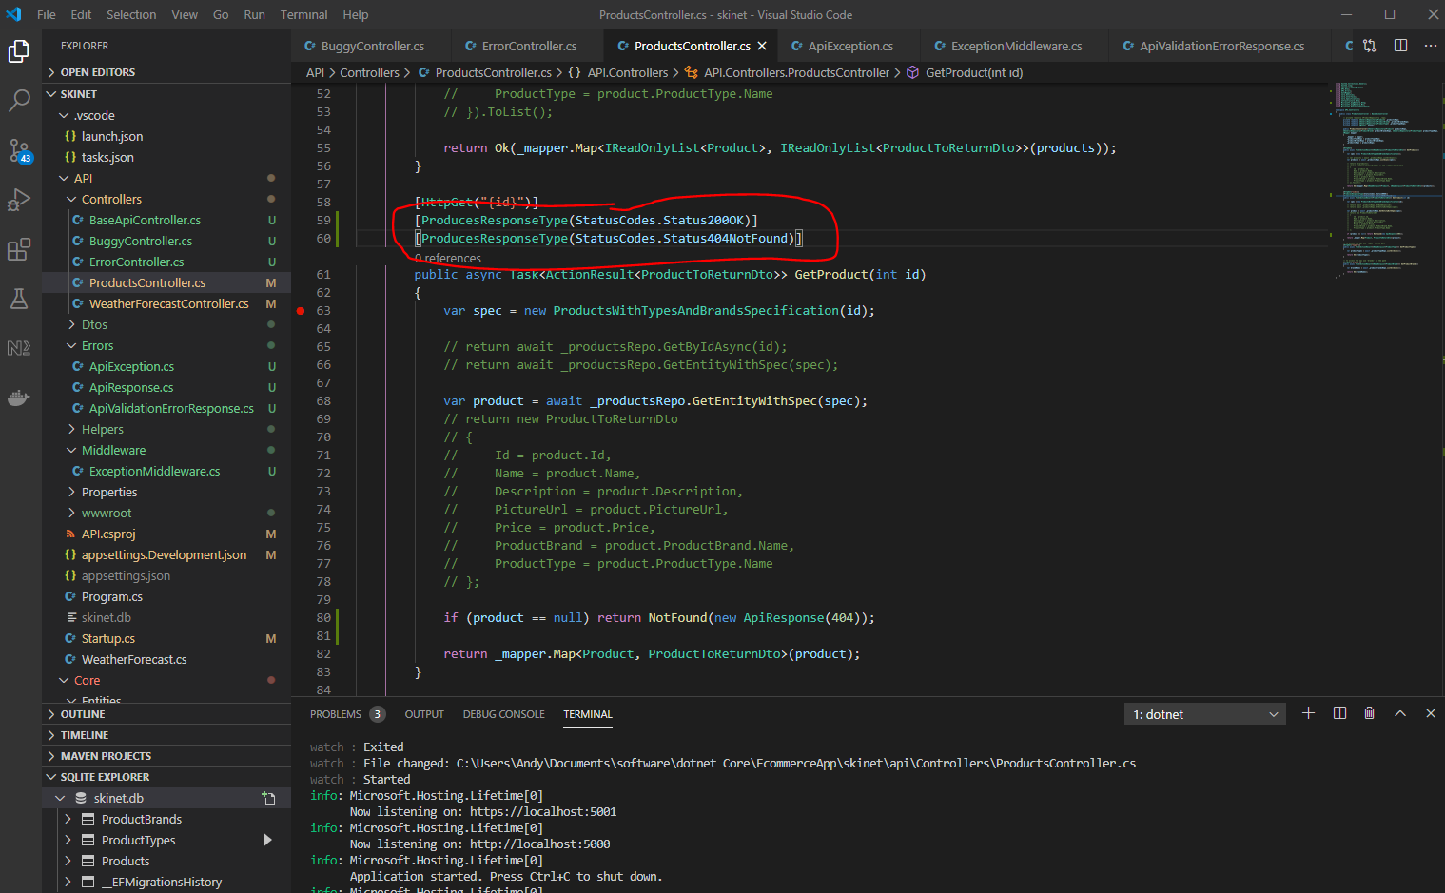

Now, see Swagger page:-

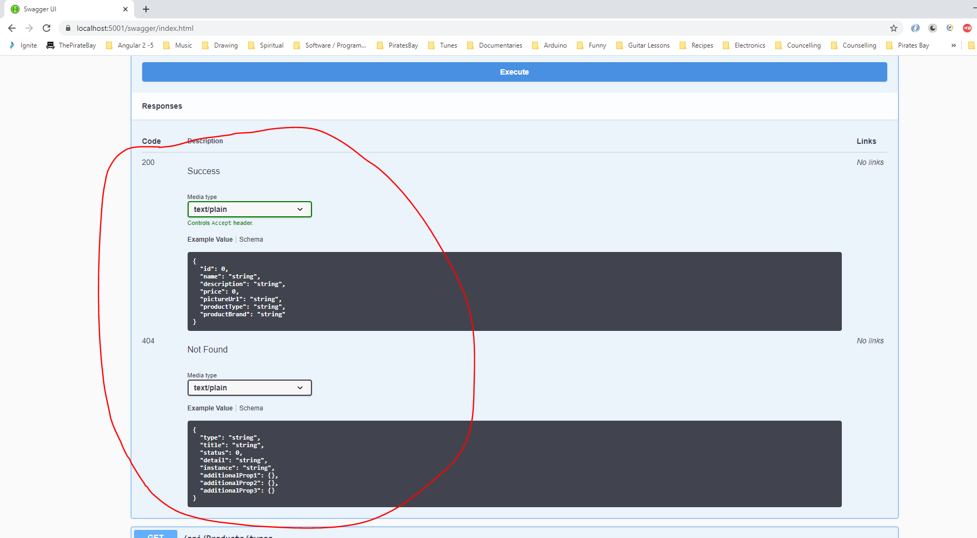

Notice that this isn’t quite right:-

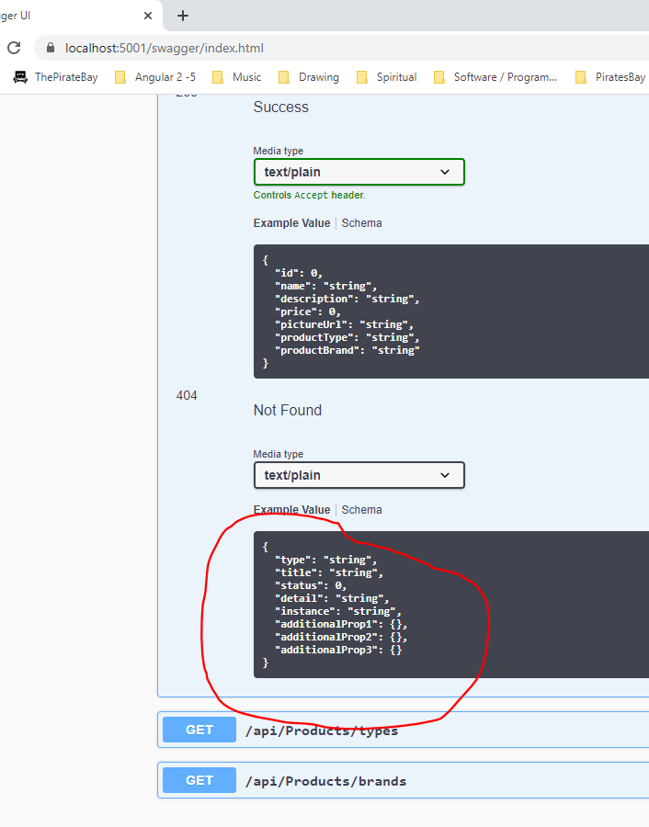

Add this to the ProductController class:-

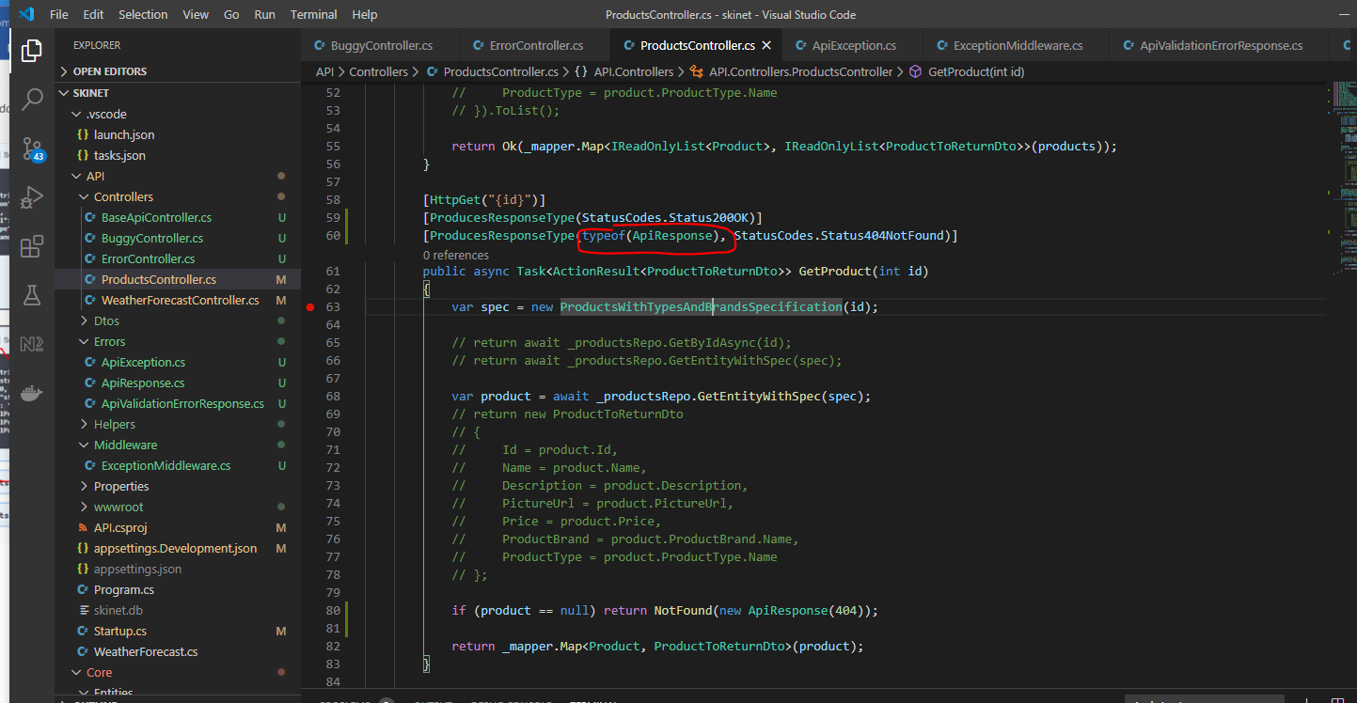

Now, see the correct message response:-

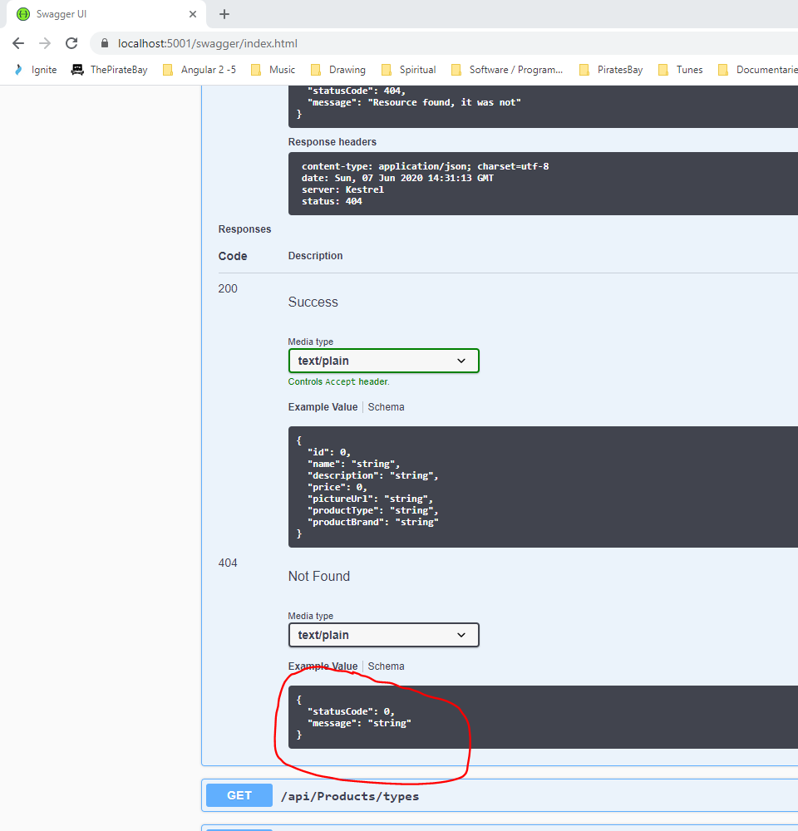

Now, clean up the ‘startup’ class:-

Create a new folder under ‘API’ called ‘Extensions’, and create a class in this folder called ‘ApplicationServicesExtensions’:-

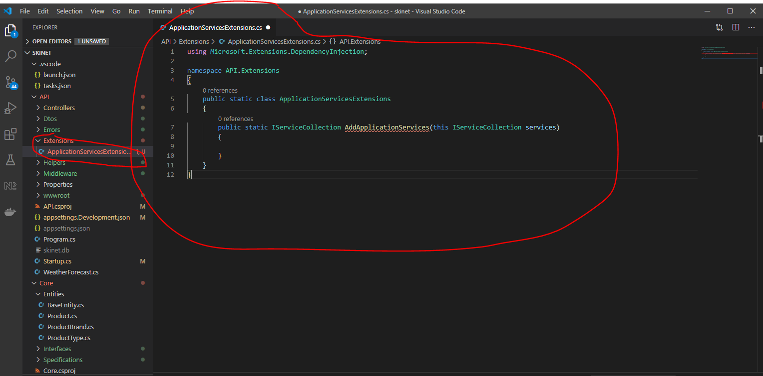

Now cut services from the ‘startup.cs’ class:-

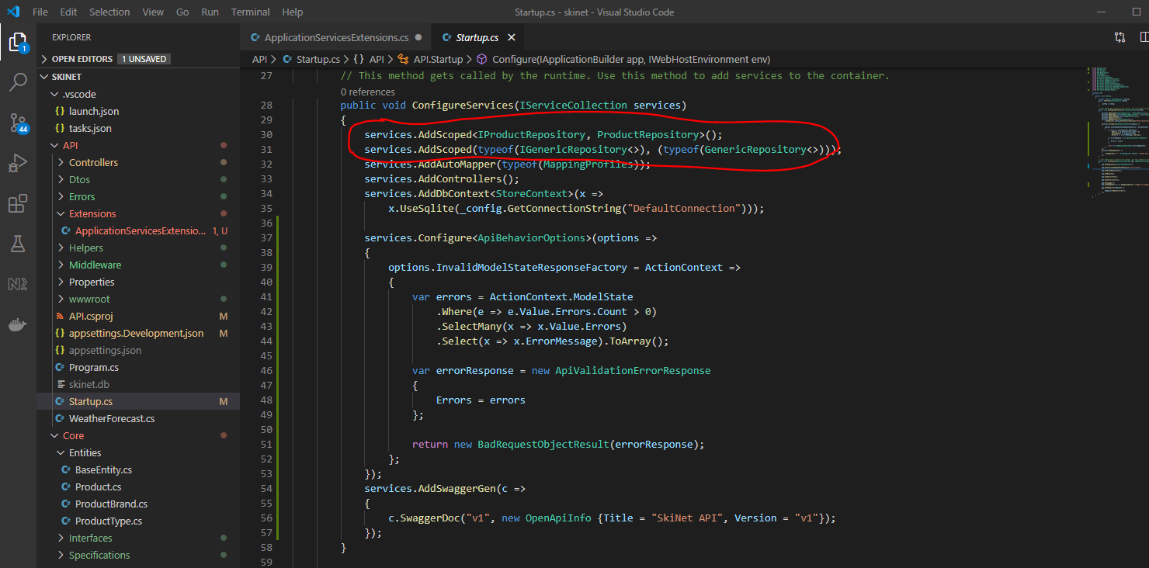

And,

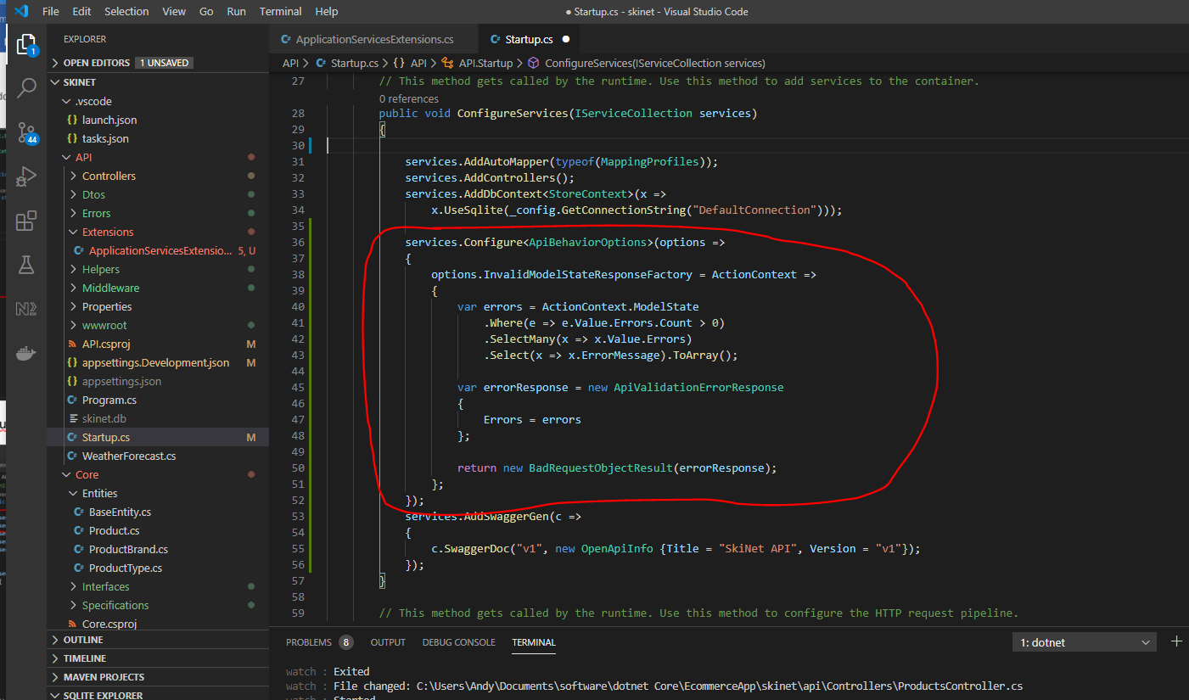

Add them to the ‘ApplicationServicesExtensions’ class:-

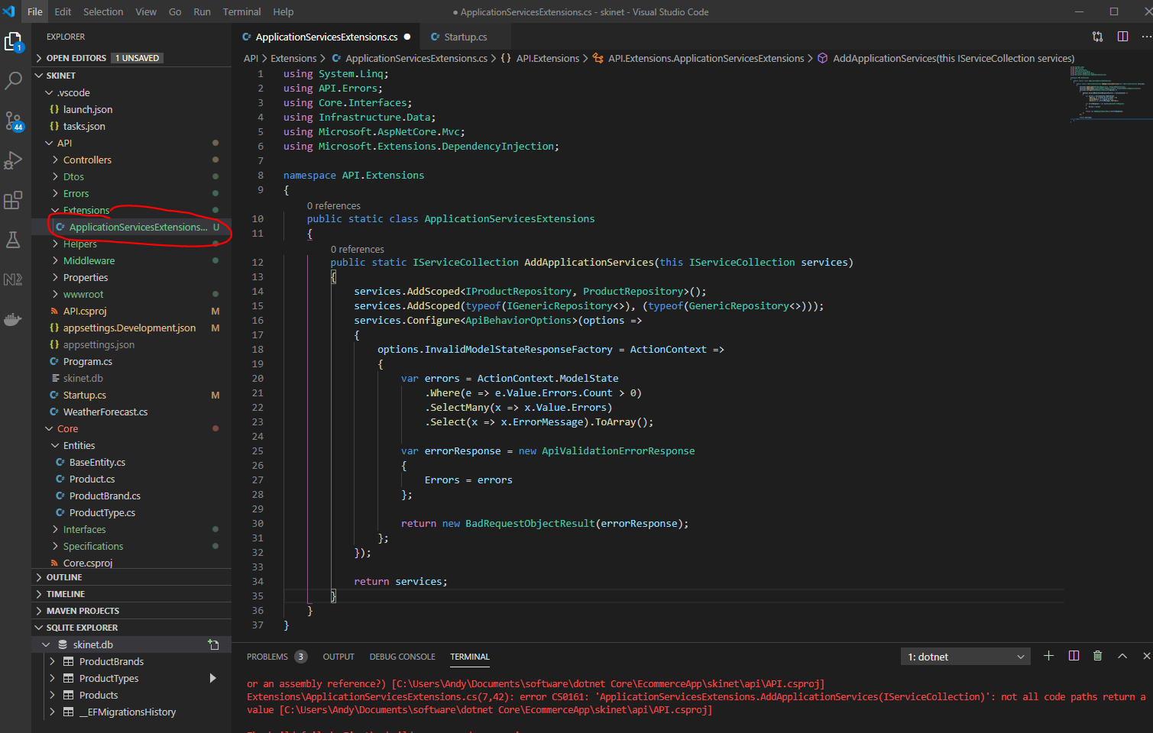

Now, add this line in the ‘startup.cs’ class:-

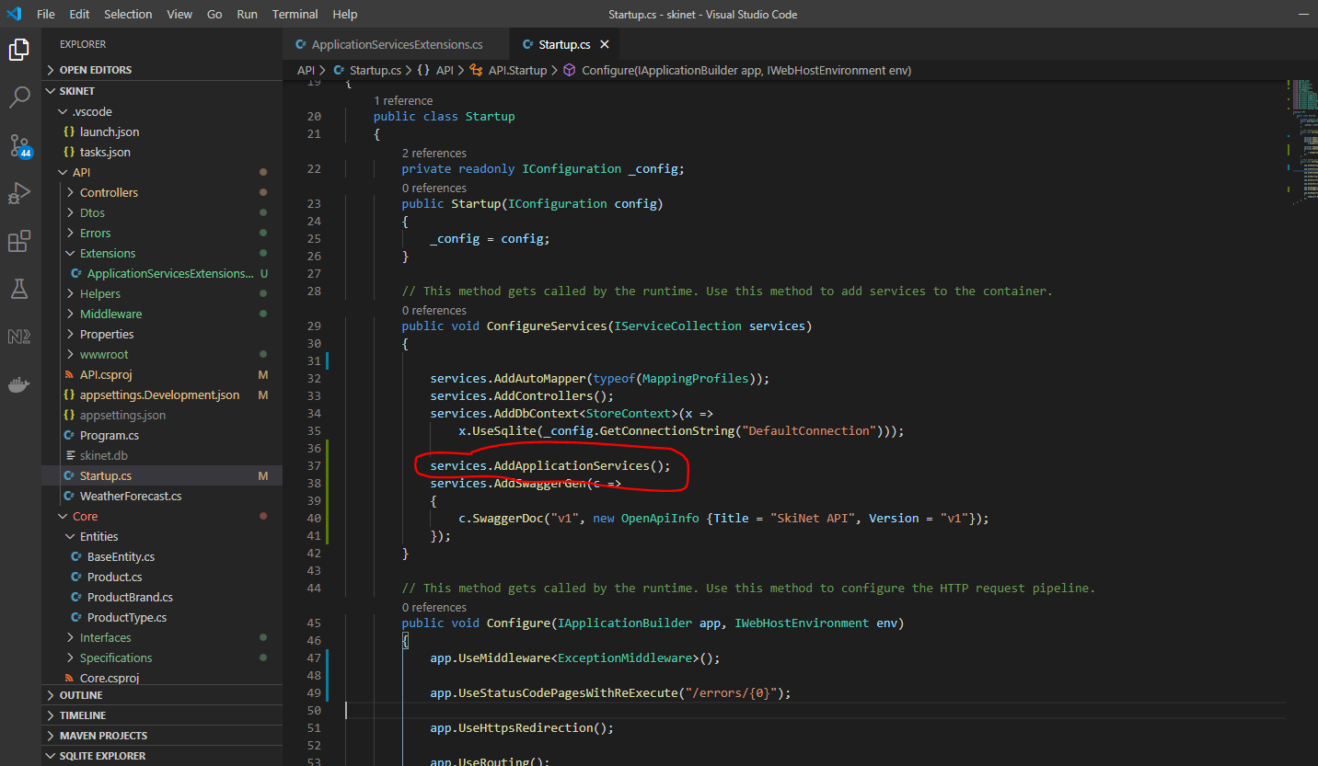

Now, create a new extension class for the Swagger service and middleware called ‘SwaggerServiceExtensions’:-

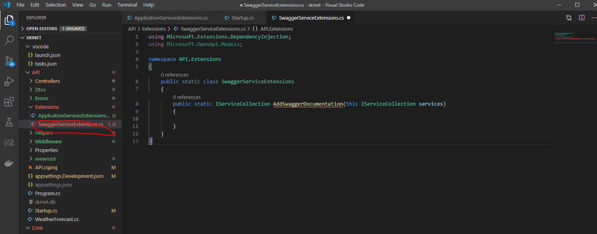

Cut swagger service from ‘startup.cs’ class:-

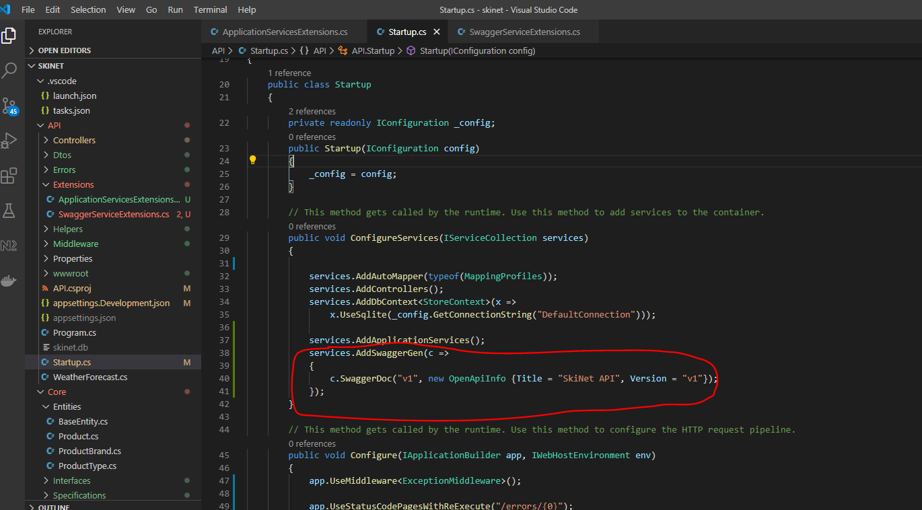

Paste here:-

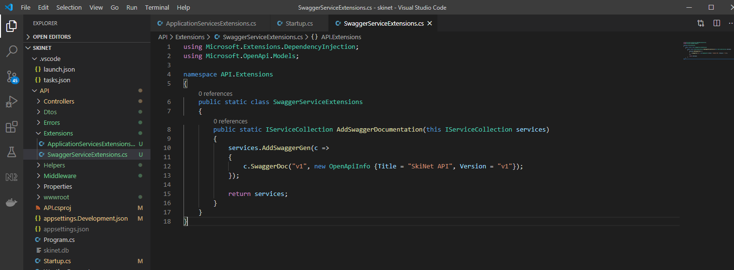

Now add the middleware section to the class. Add a new static method to the class:-

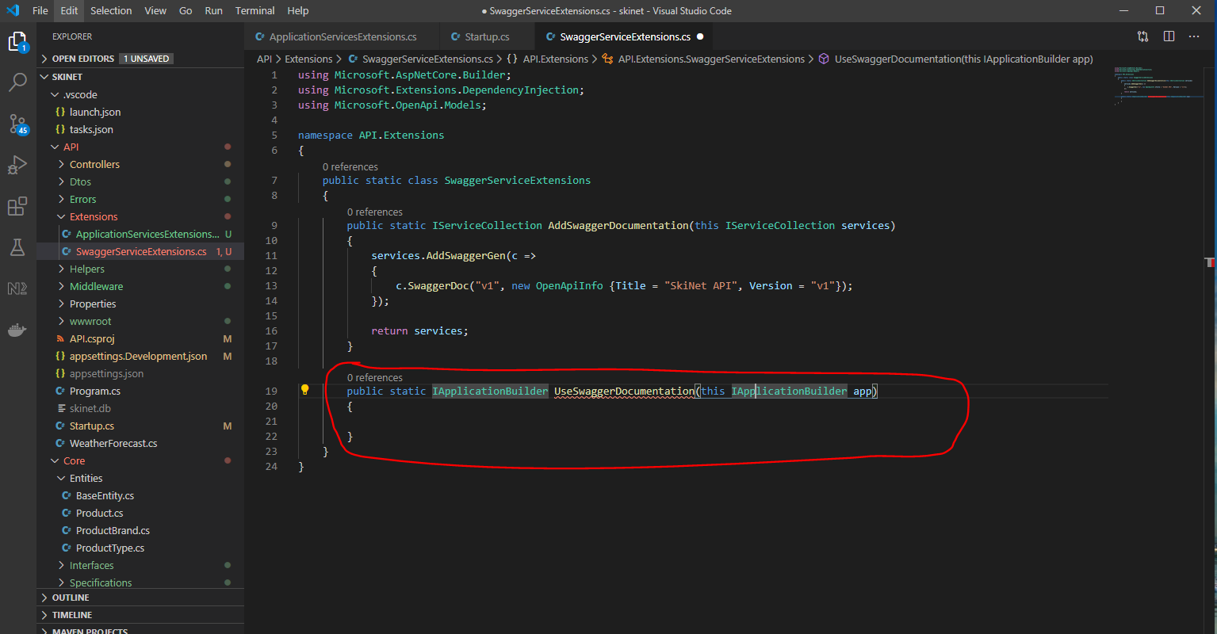

Cut these sections from the startup.cs class:-

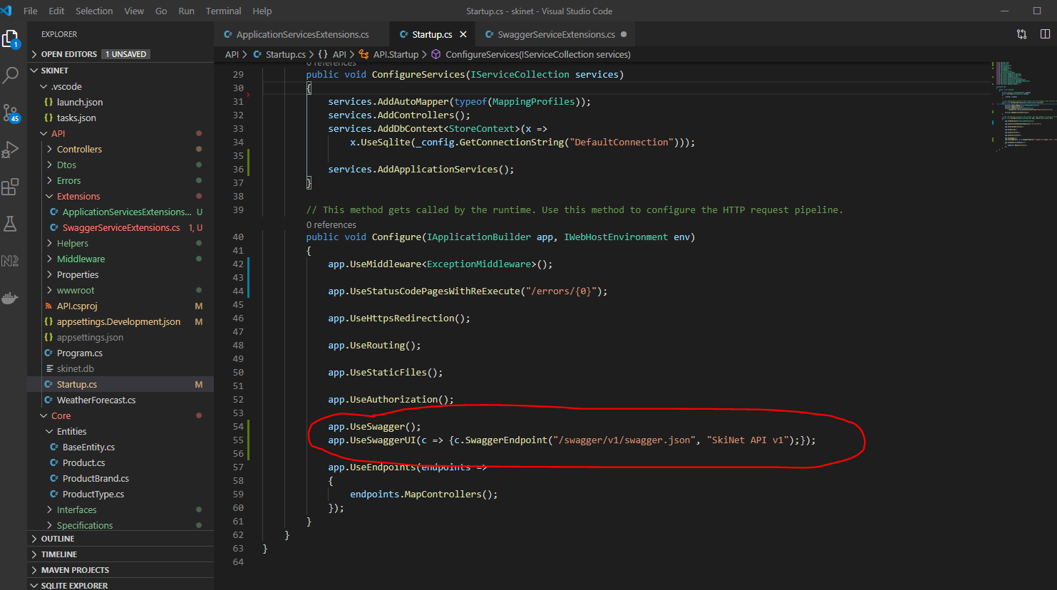

Paste here:-

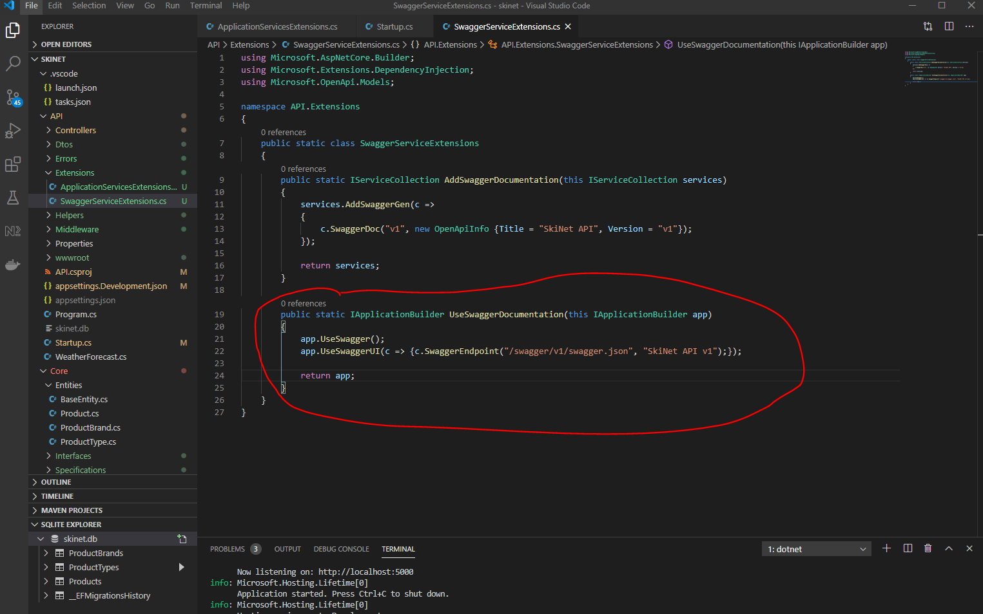

Now add a section into the ‘startup.cs’ class:-

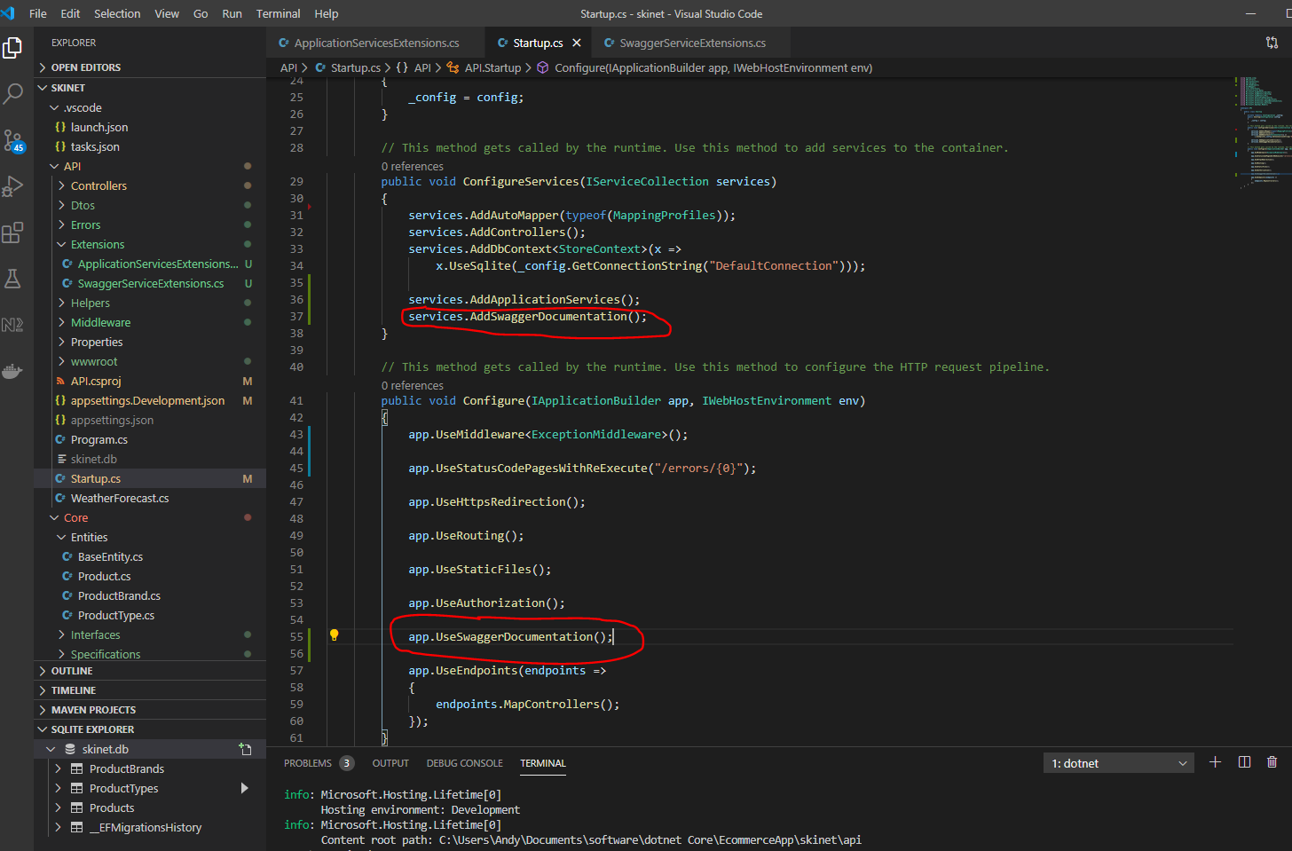

Commit all changes to Git:-

git add .

git commit -m “Add exception handling”

git push origin master

**Adding API Sorting, Search, Filtering and Paging**

Go to the ISpecification interface and add two new properties:-

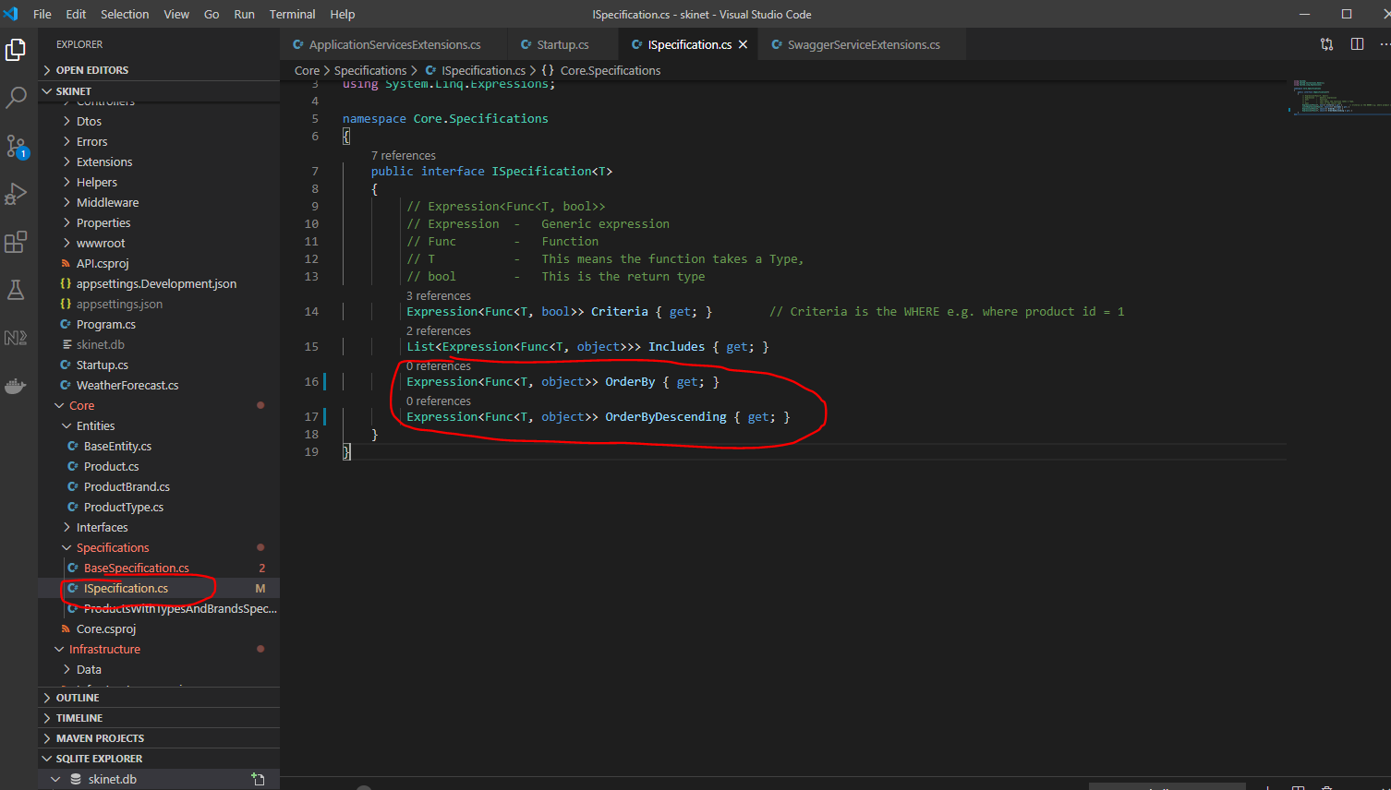

Now update the ‘BaseSpecification‘, because it inherits from ISpecification interface:-

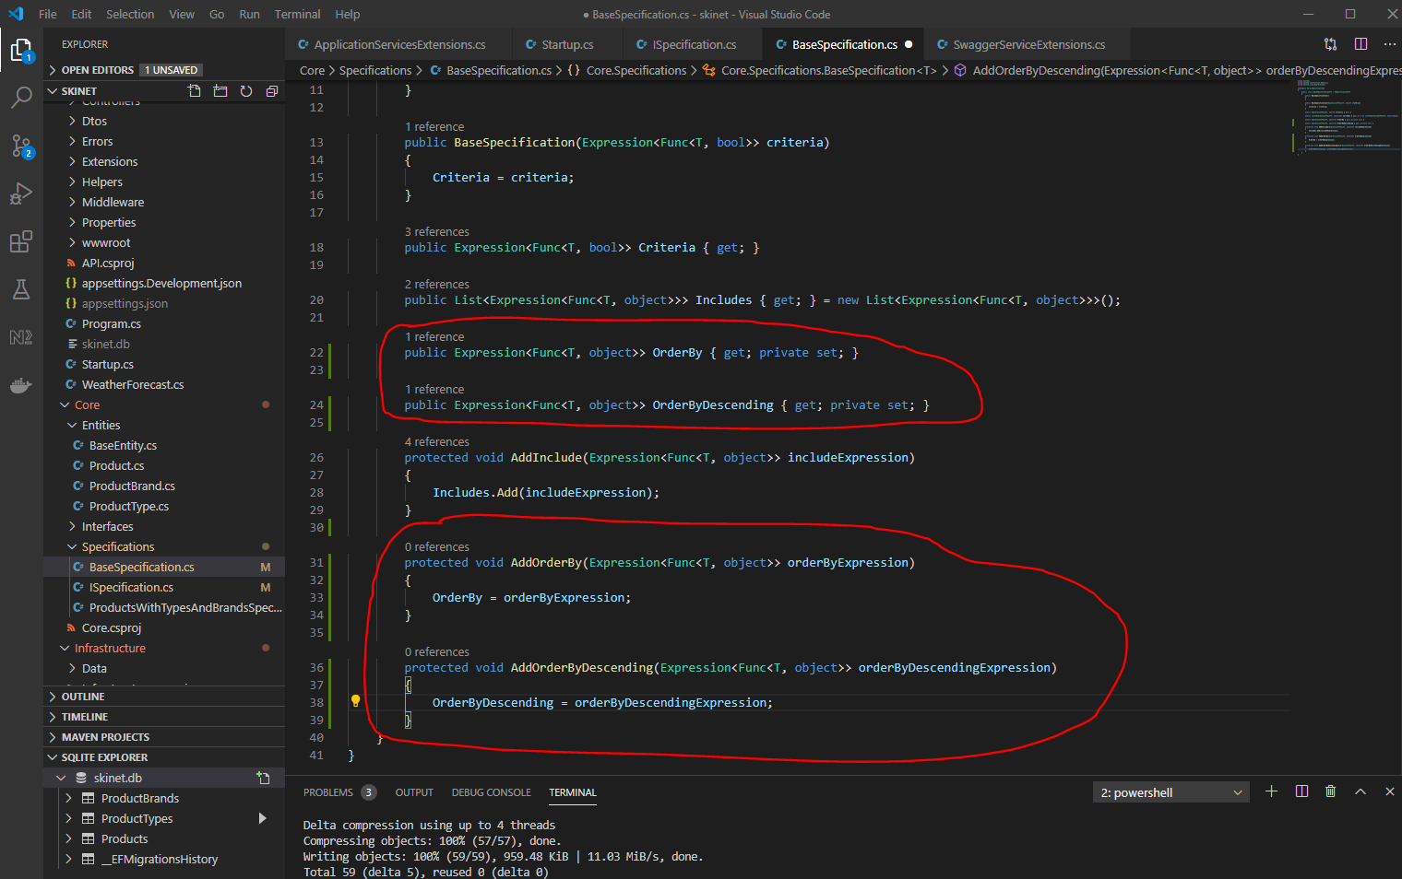

Update ‘SpecificationEvaulator’ class:-

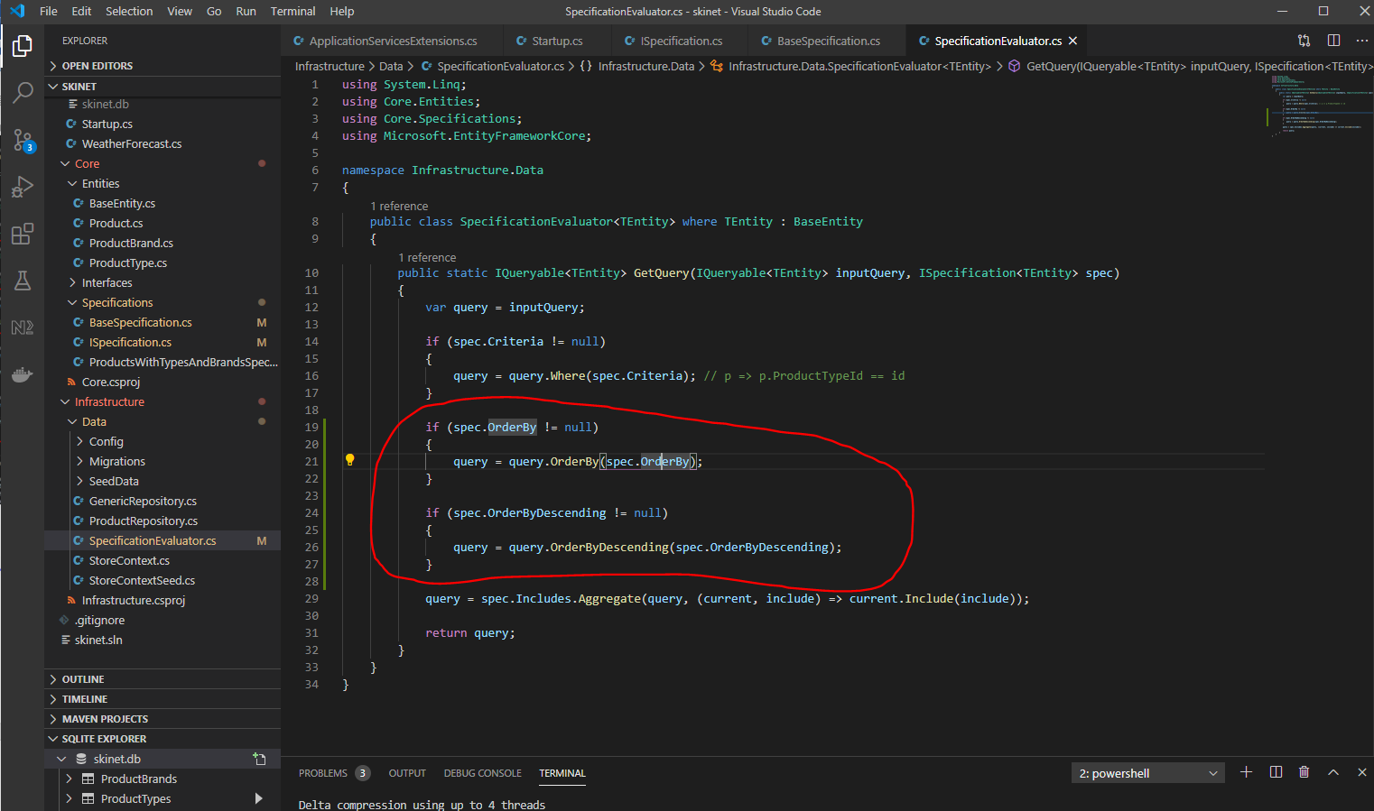

Now, update the ‘ProductController’ class:-

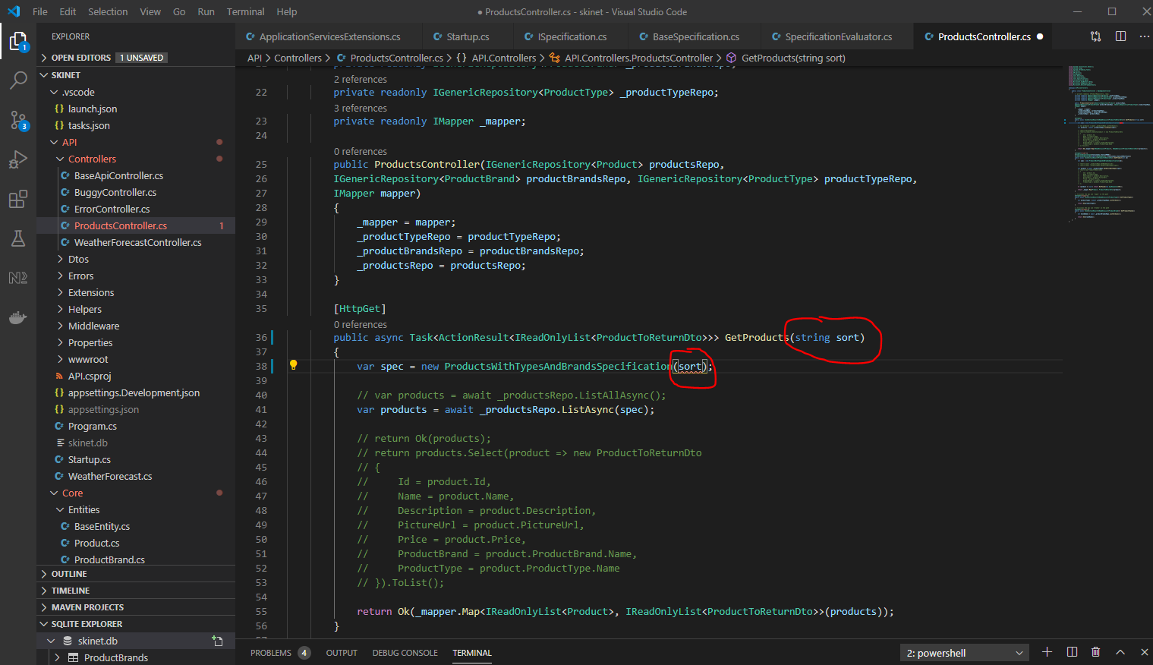

Now, update the ‘ProductsWithTypesAndBrandsSpecification’ class

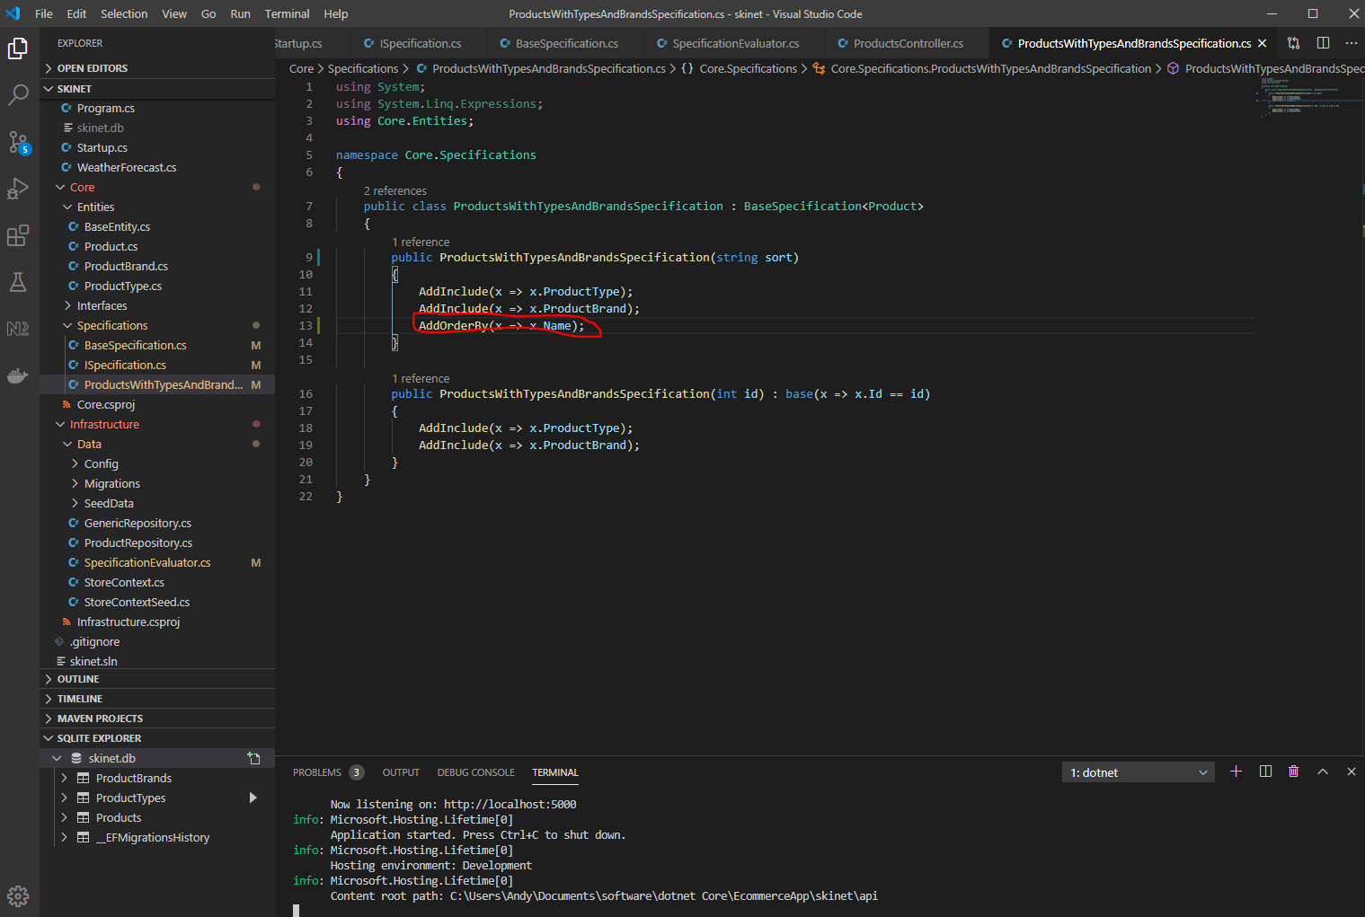

Now change the above to check to see what the value of ‘sort’ is so that you can order by the specified column, add a switch statement:-

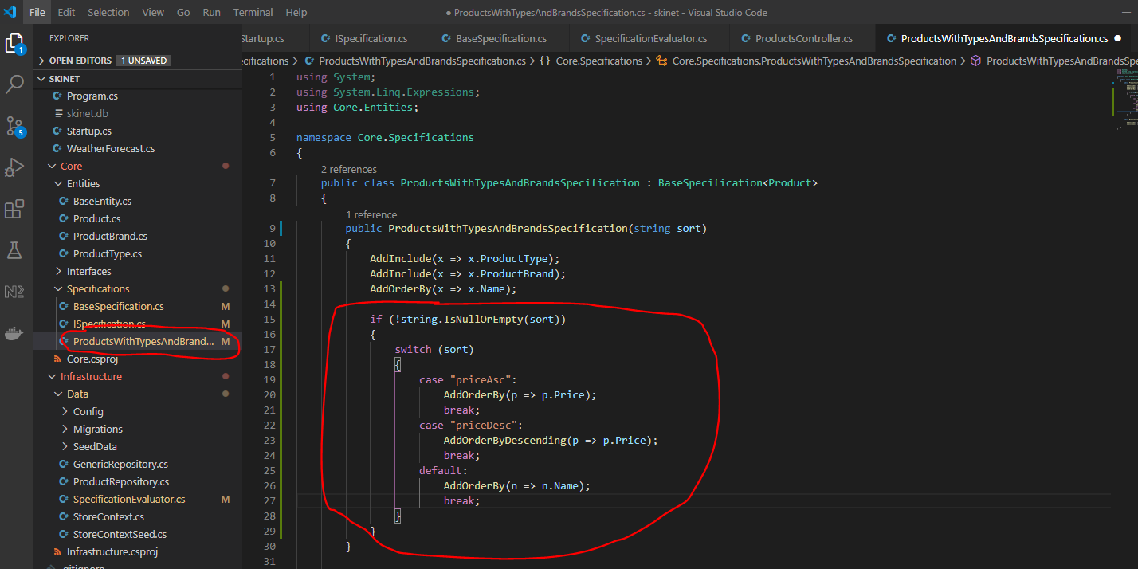

Use Postman to test this:-

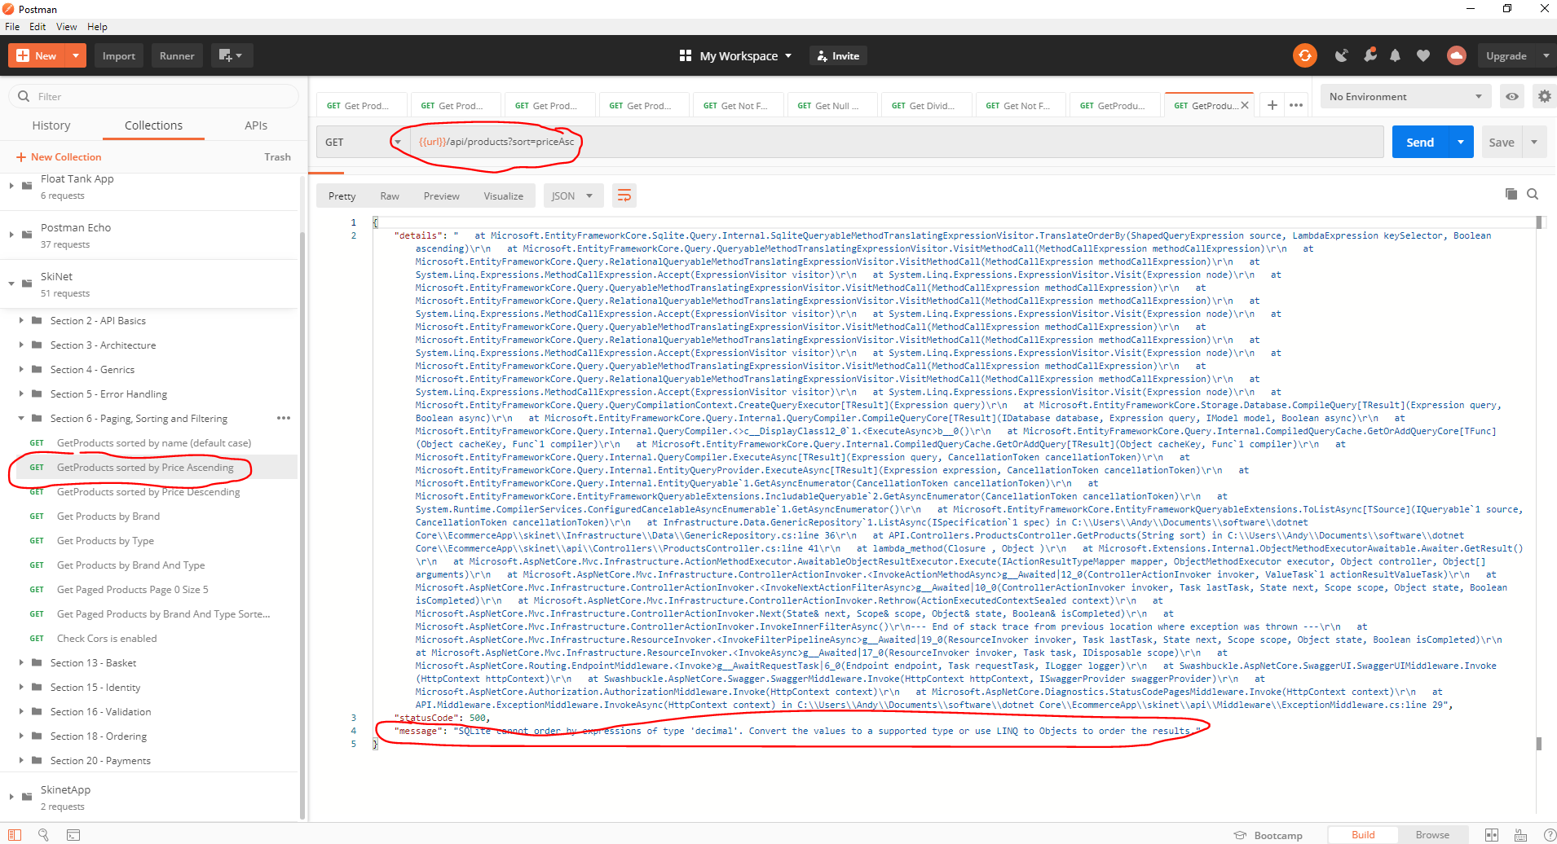

See above error message. This is caused by SQLite not supporting decimal numbers. To get around this:-

Go to StoreContext class and convert the decimal into a double:-

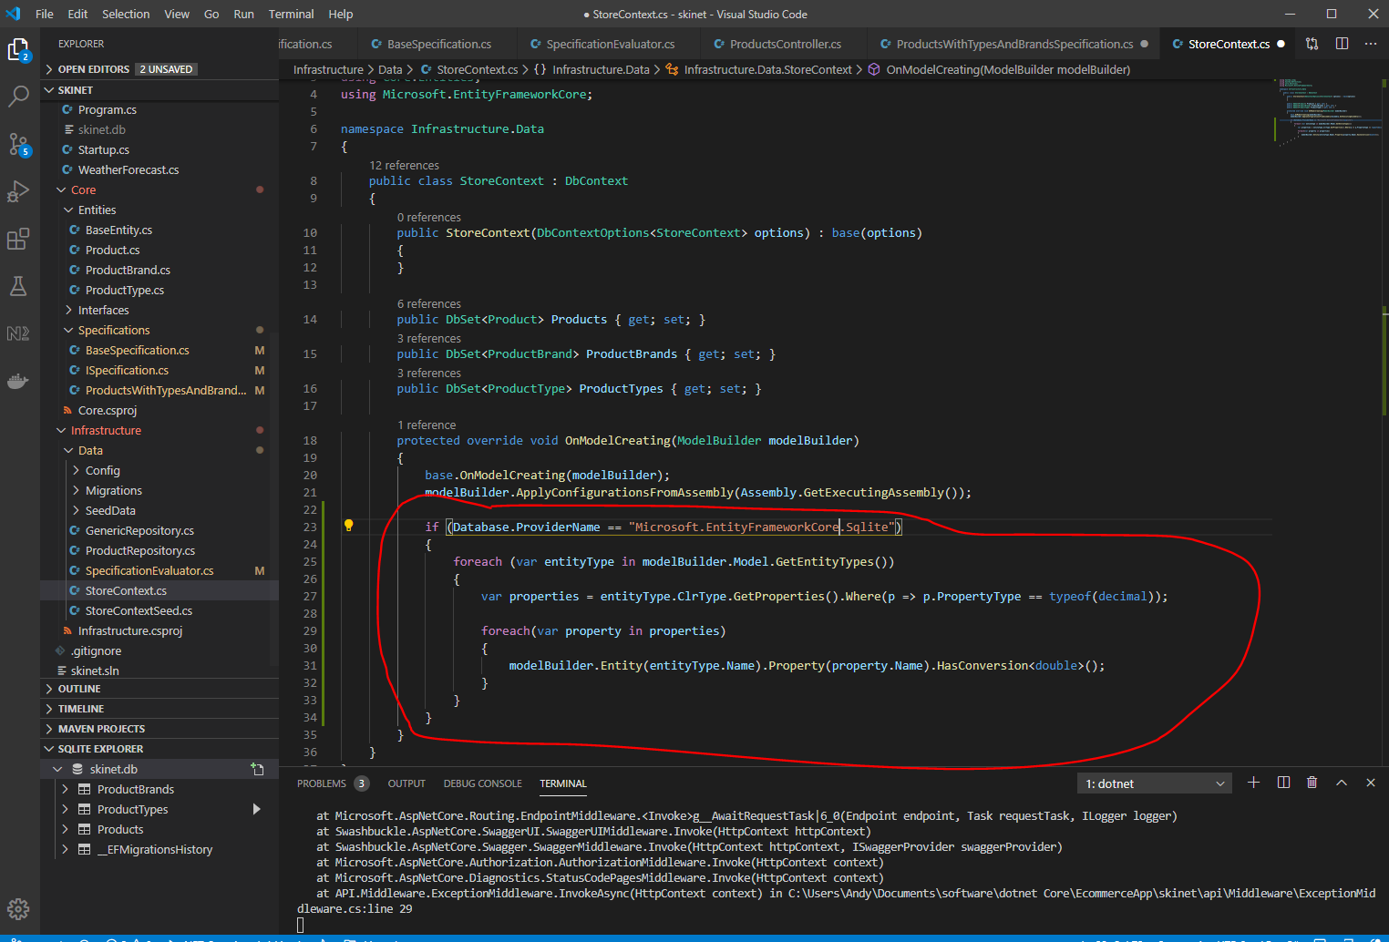

Test in Postman again:-

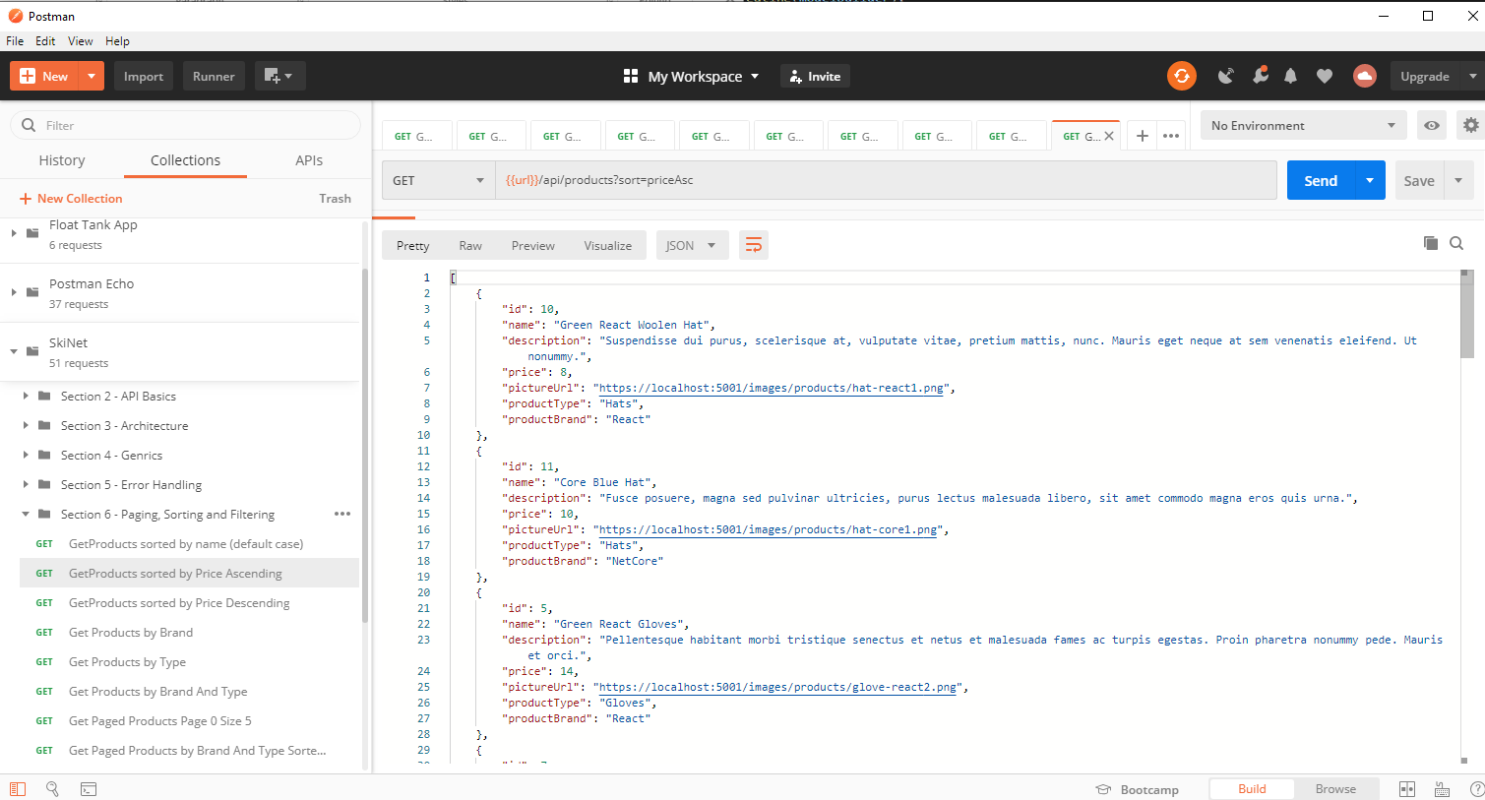

See error has gone away.

**Add filtering**

Add some optional parameters to the ProductController ‘GetProducts’ method:-

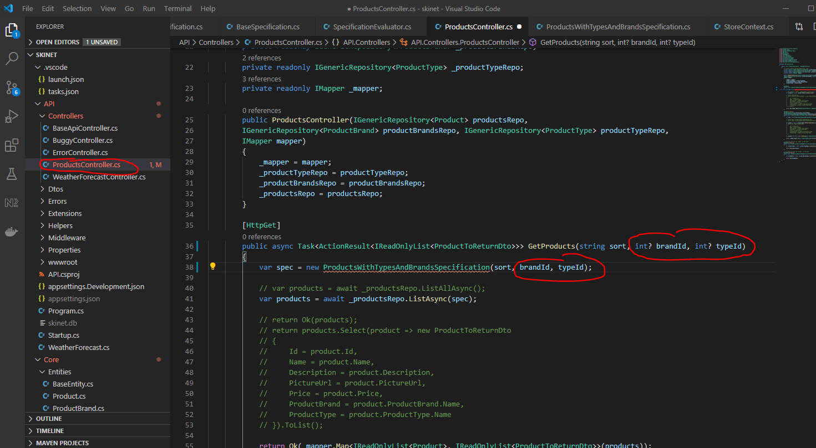

Now, update the ‘ProductsWithTypesAndBrandsSpecification’ class:-

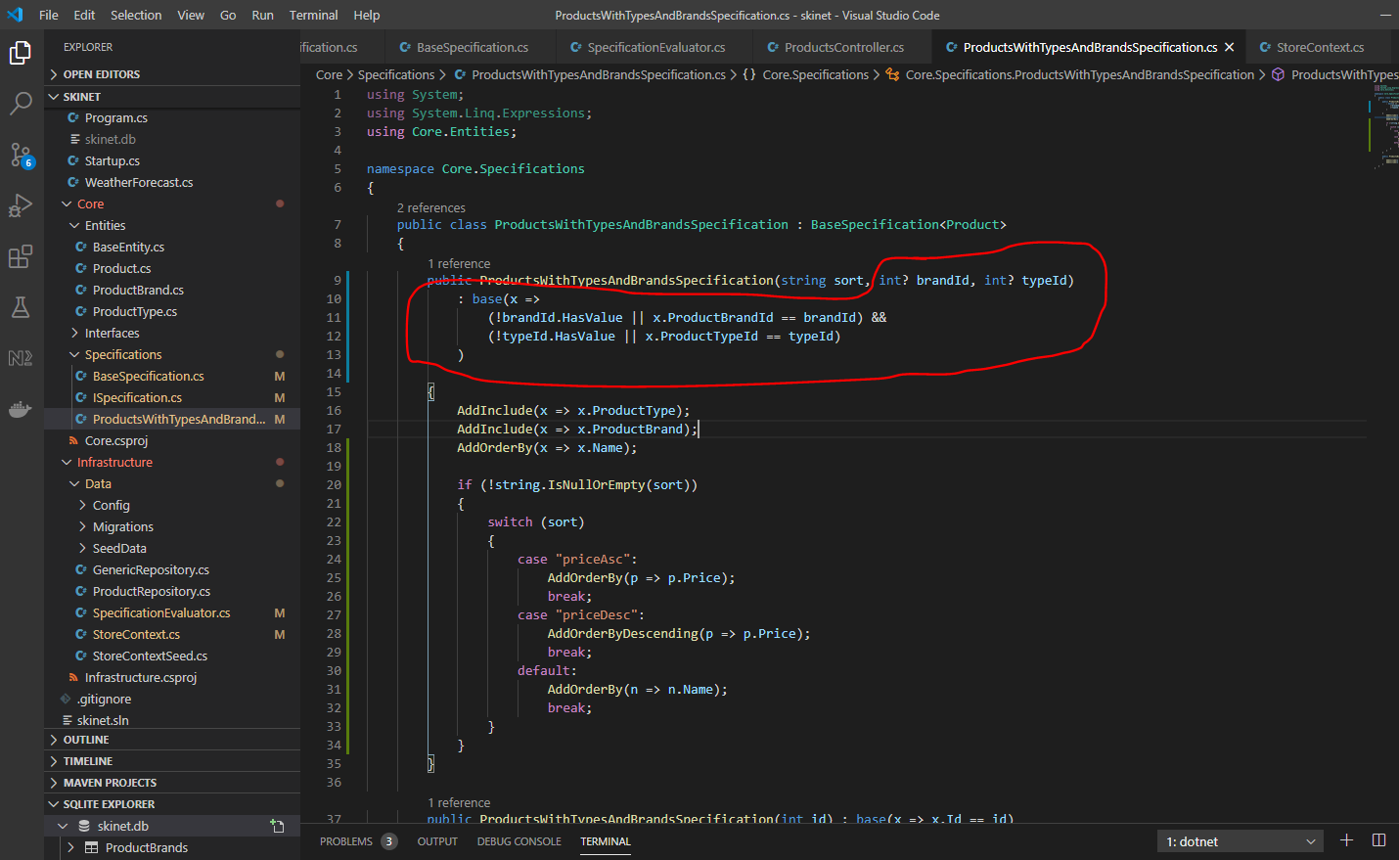

(!typeId.HasValue || x.ProductTypeId == typeId)

This above means that if typeId has a value then perform this part – x.ProductTypeId == typeId

(!brandId.HasValue || x.ProductBrandId == brandId)

This above means that if brandId has a value then perform this part – x.ProductBrandId == brandId

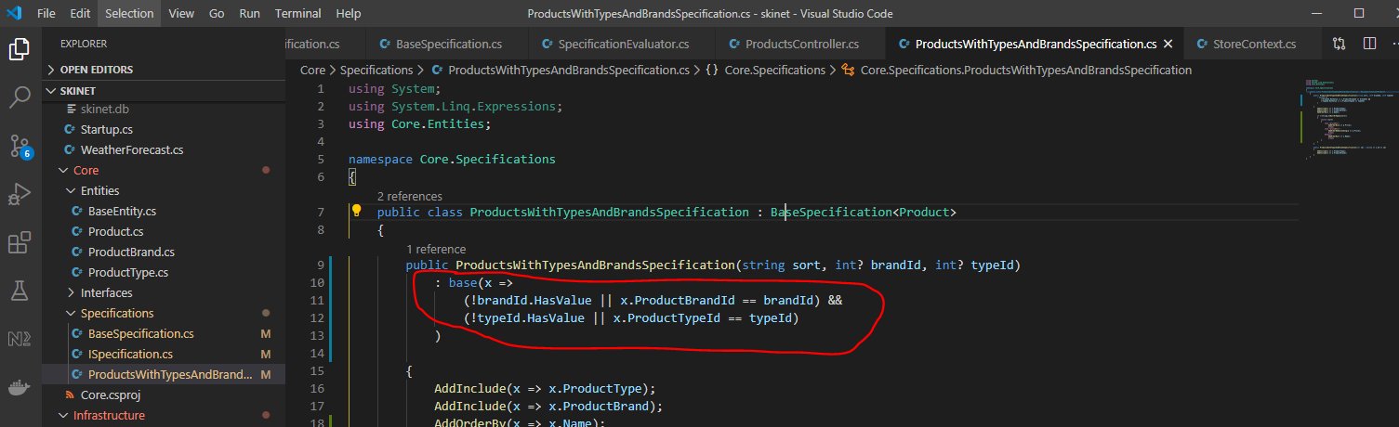

The above part means add this into the constructor i.e. add the expressions into the ‘Criteria’ variable to perform the ‘Where’ query.

Test in Postman:-

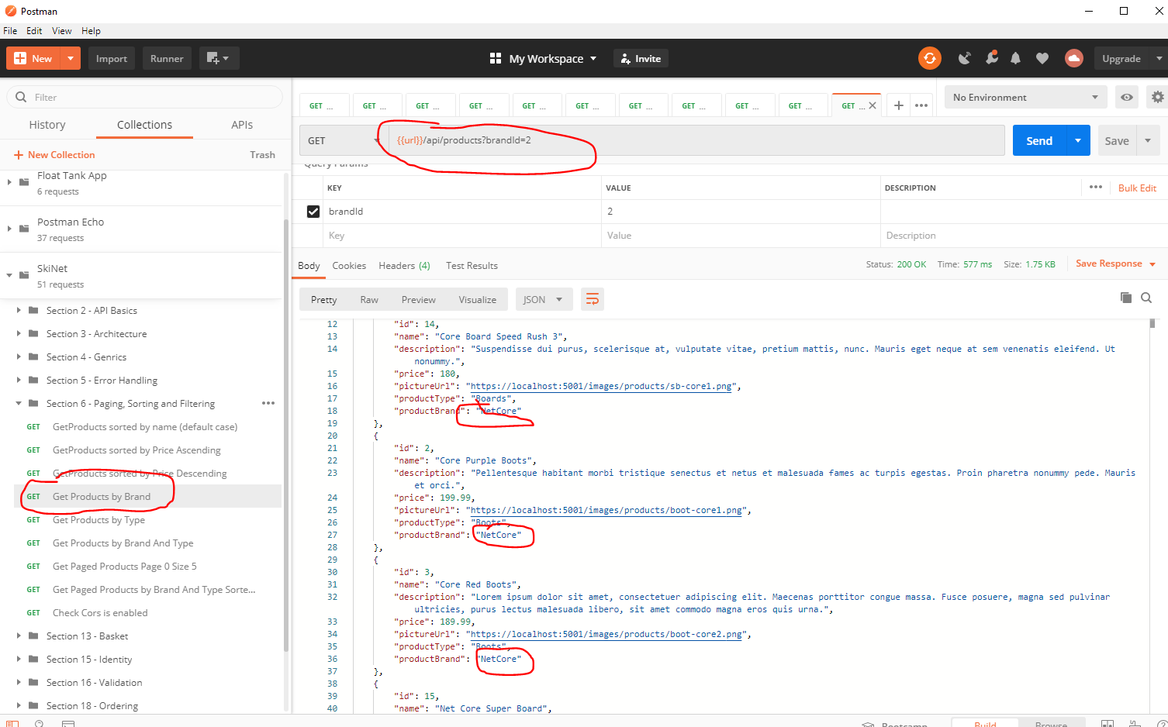

And:-

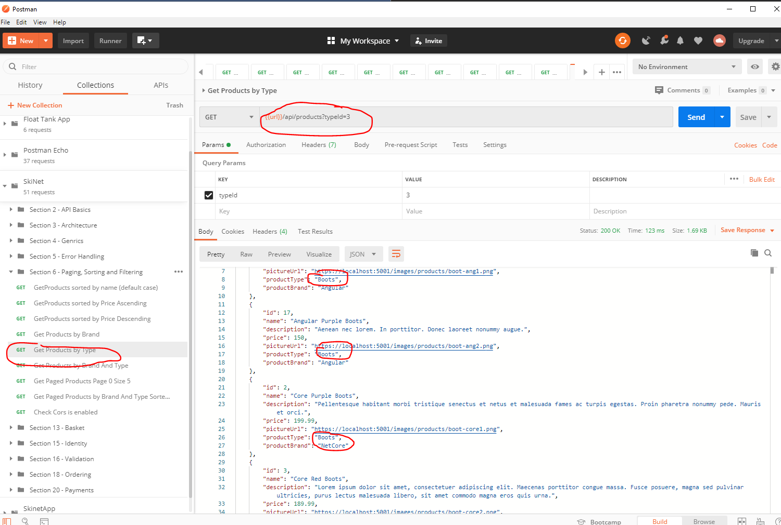

And:-

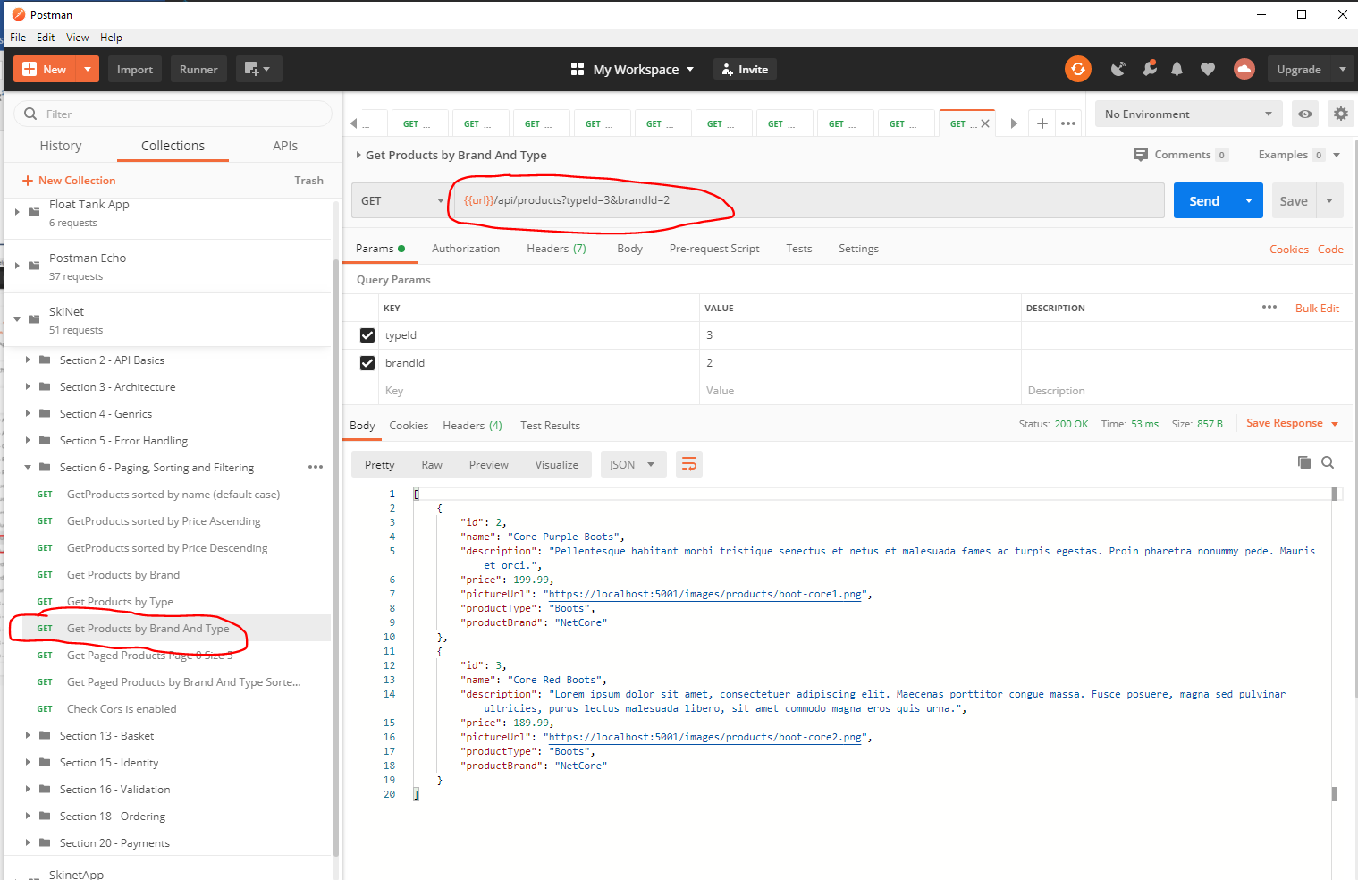

**Pagination**

Add some new properties to the ISpecification interface:-

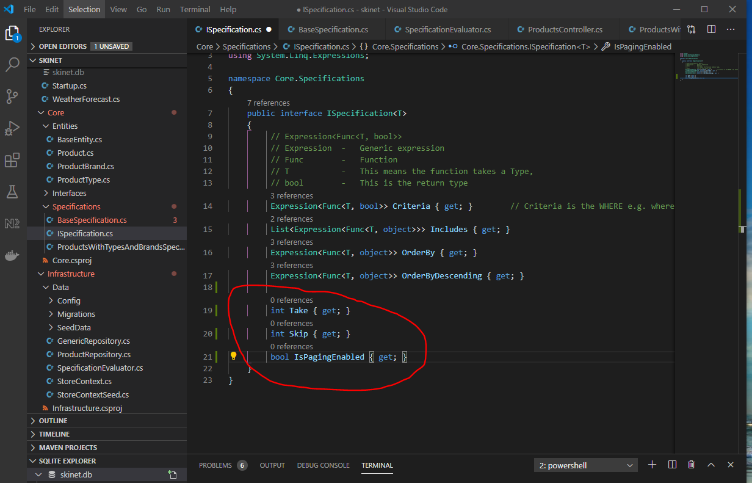

How the above properties are used:-

You would use ‘Take’ to select e.g. 5 products for the first page and ‘Skip’ none. For the second page you would ‘Take’ another 5 products, but you would skip the first 5 because they are being displayed on the first page. For the 3rd page you ‘Take’ 5 products, and ‘Skip’ 10 because the first 5 are displayed on the first page, the next 5 are displayed on page 2 etc.

Now go to the ‘BaseSpecification’ class and implement the above 3 new properties:-

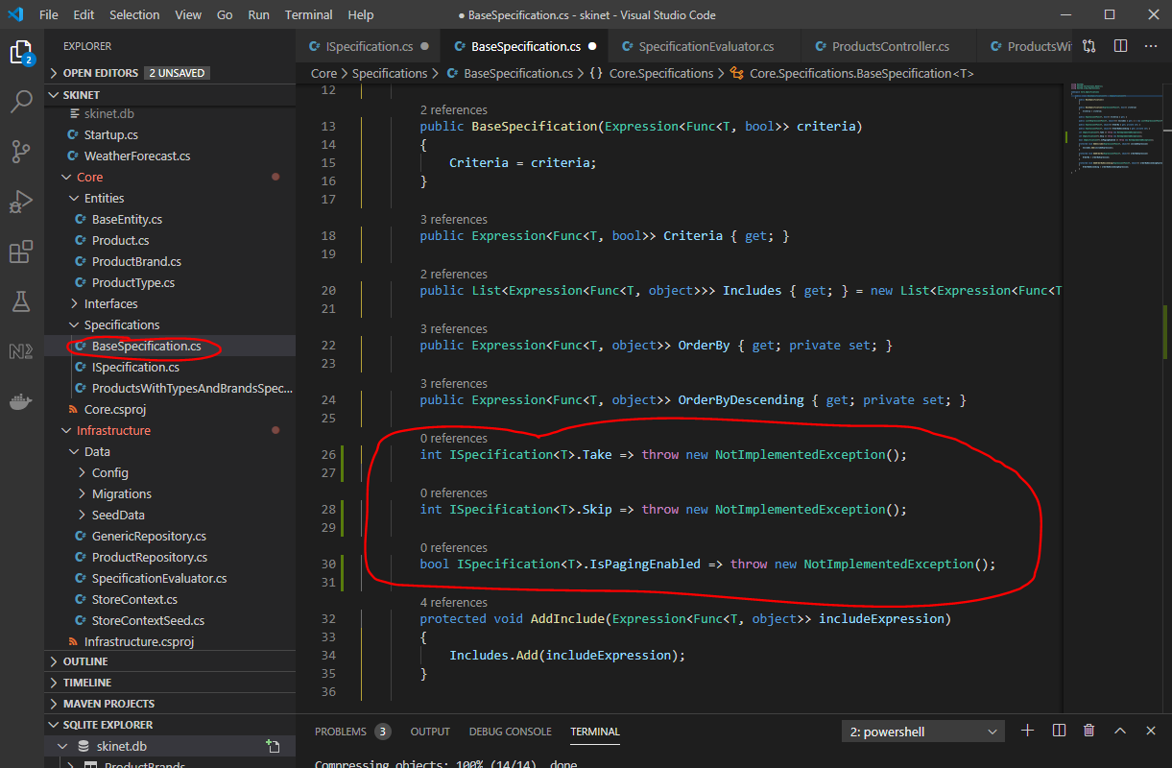

Change them to:-

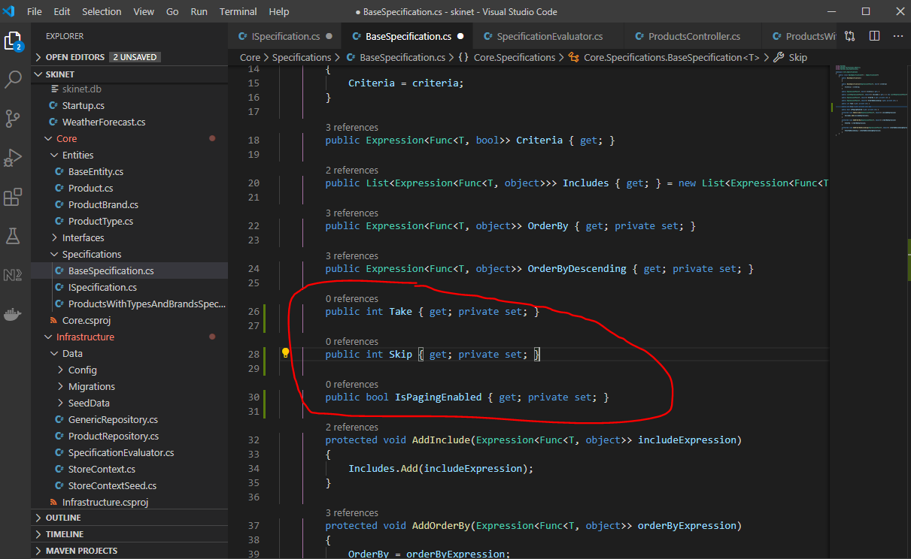

Create a new method:-

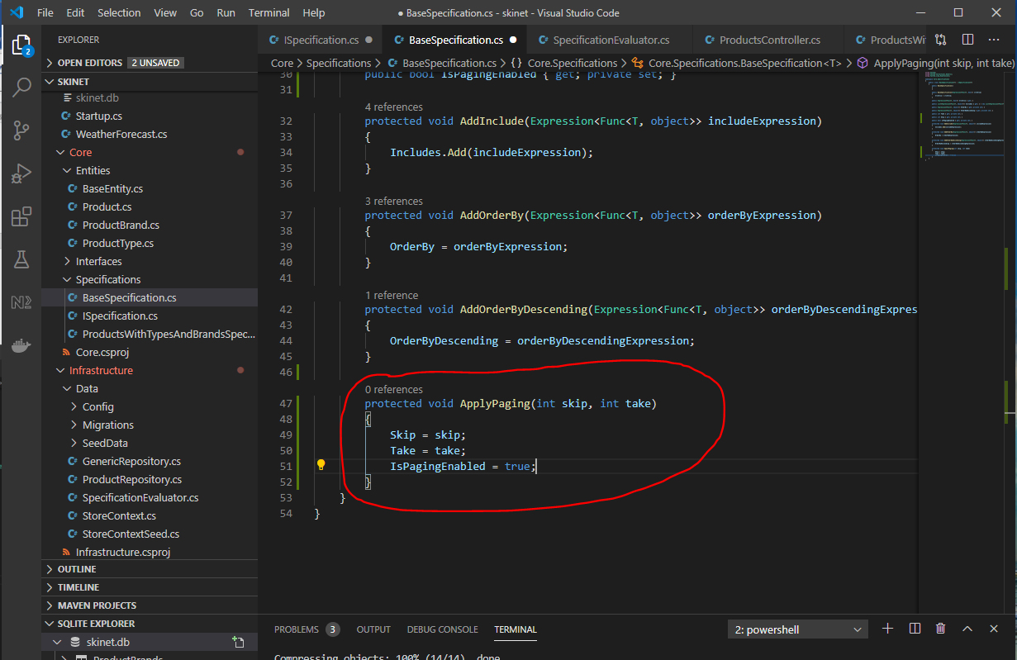

Now, update the SpecificationEvaluator class and add this method to be performed on the database:-

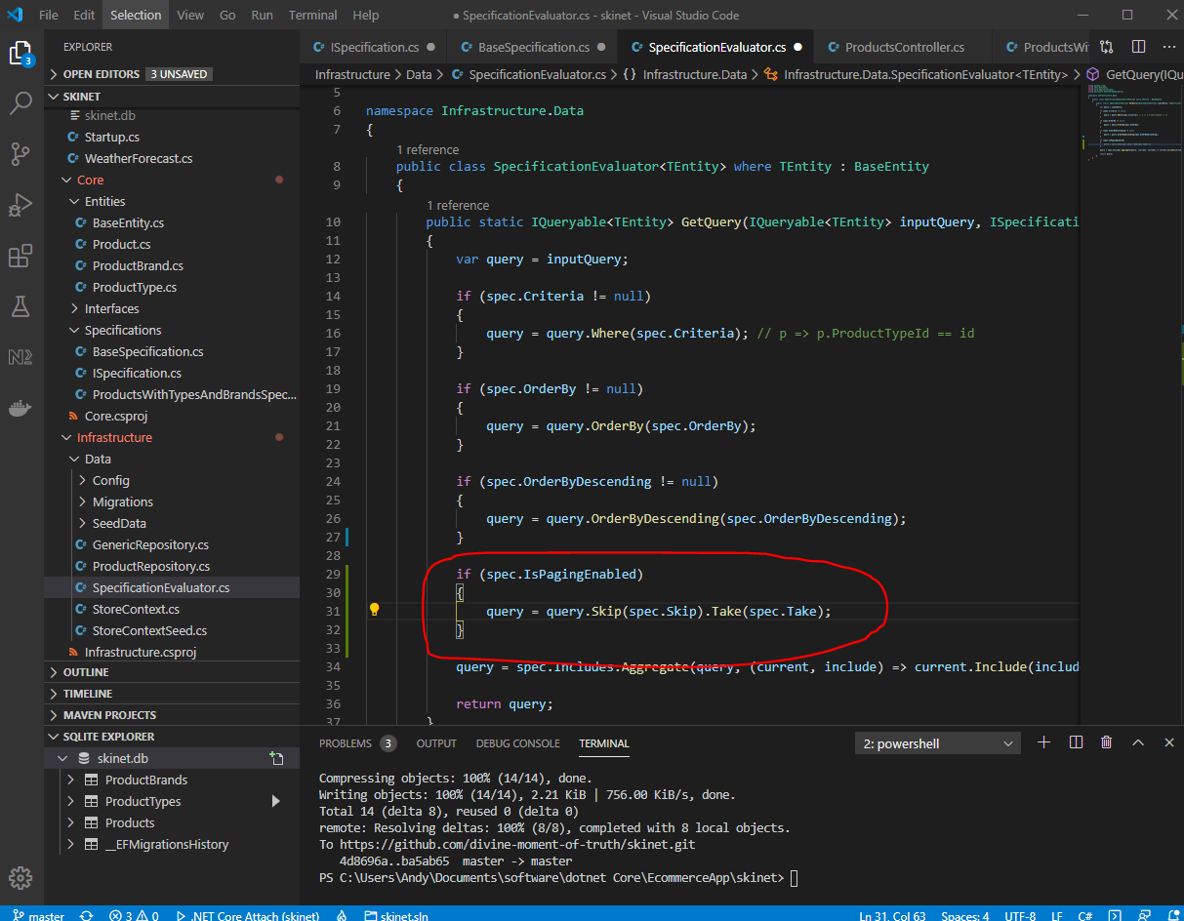

‘Skip’ and ‘Take’ in the above are Linq methods.

We now need to update the ‘ProductController’ to use the paging stuff. Rather than adding yet more parameters to the ‘GetProducts’ method:-

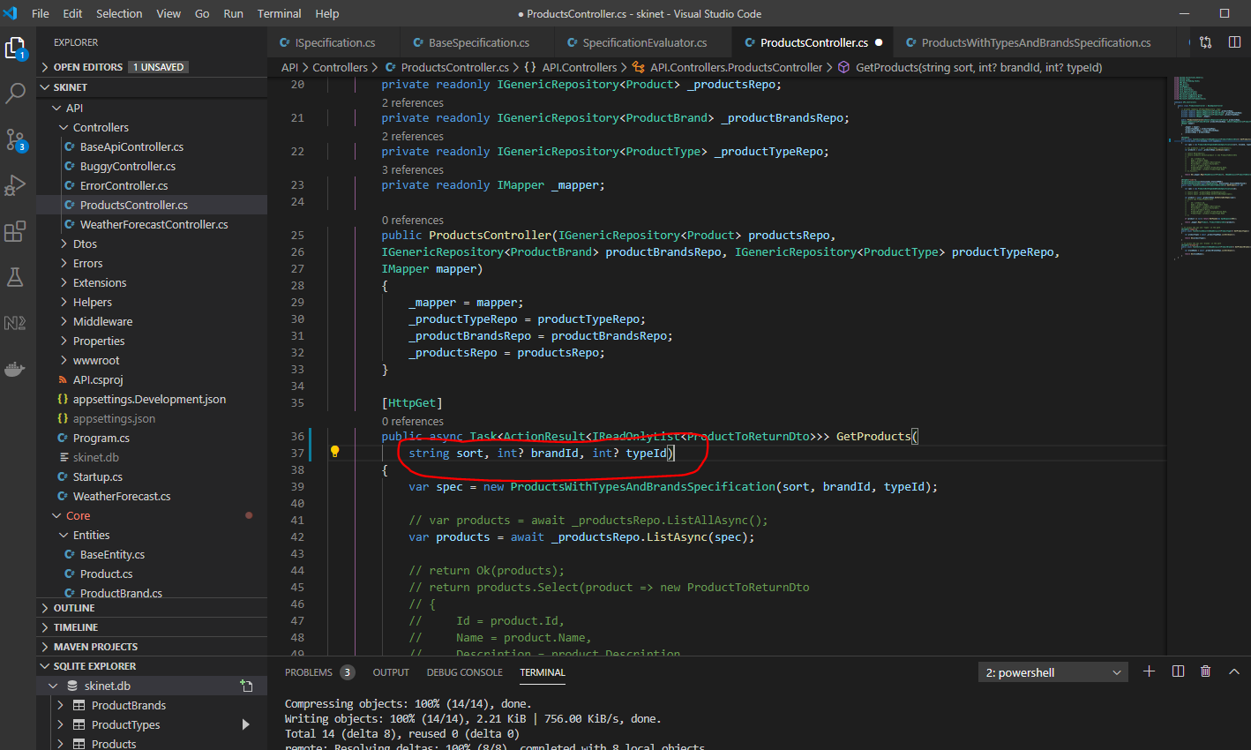

So, create a new class in – ‘Core/Specifications’:-

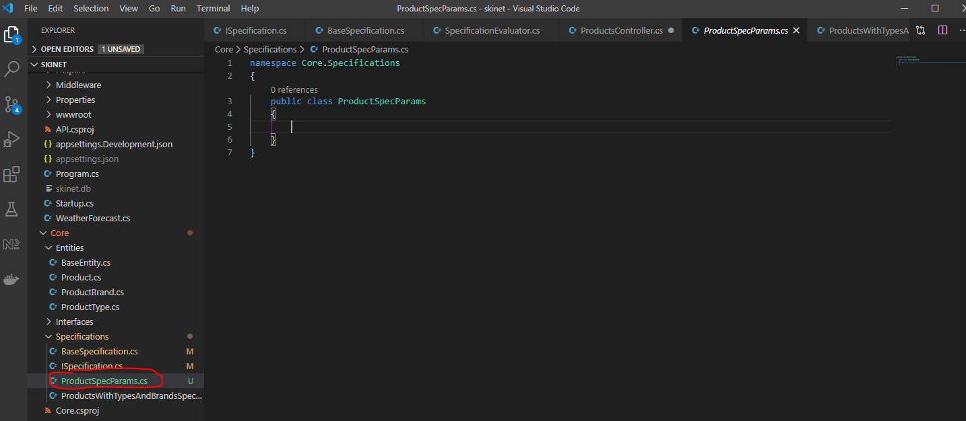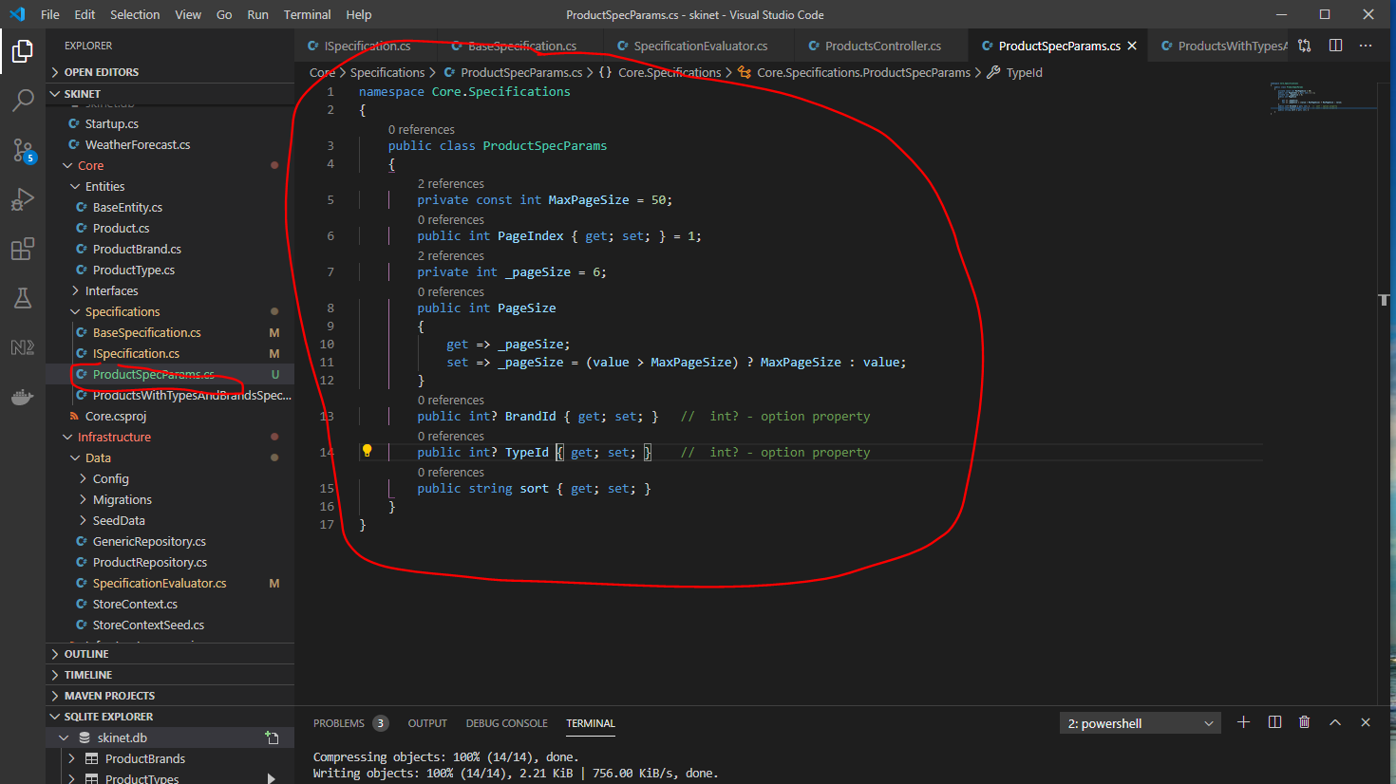

Now, back to the ‘ProductsController’ update the GetProdcuts method:-

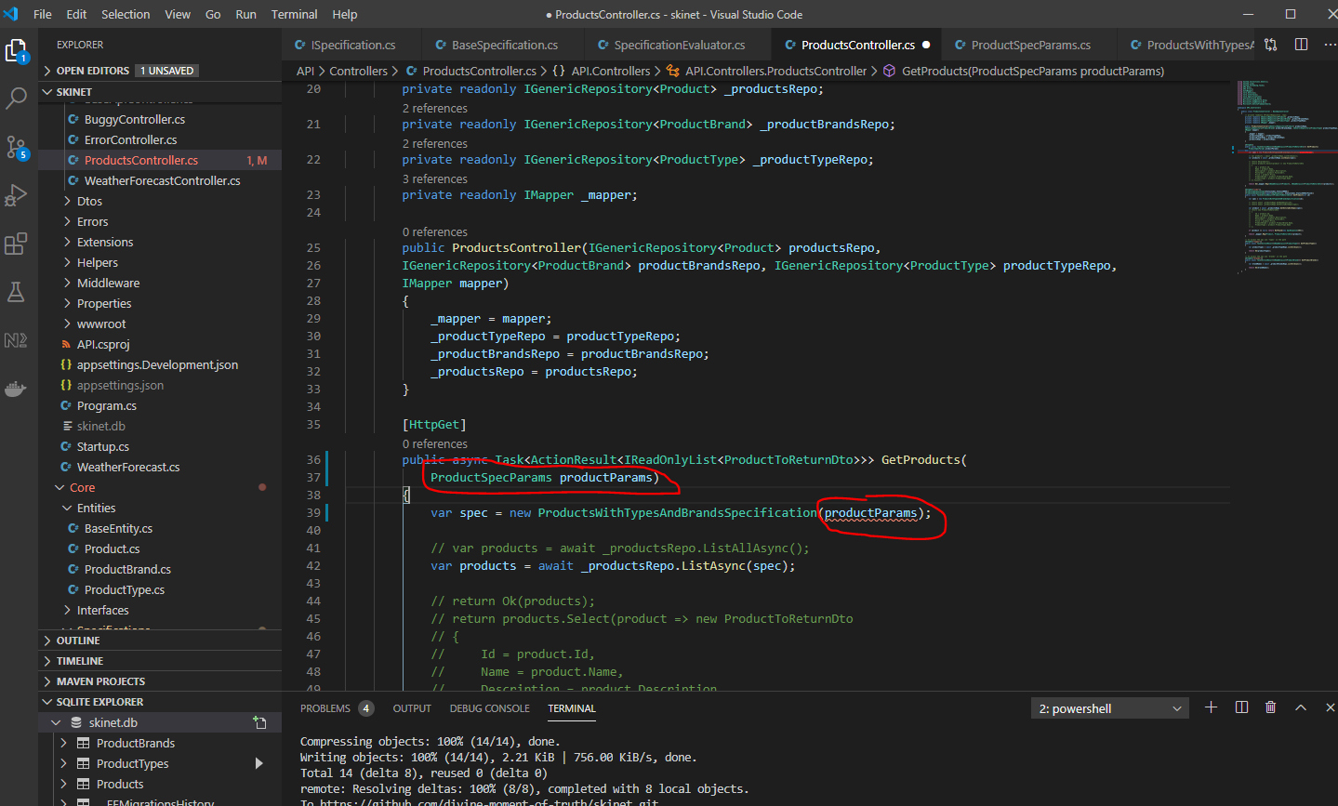

The ‘ProductsWithTypesAndBrandsSpecification’ class will need updating niw:-

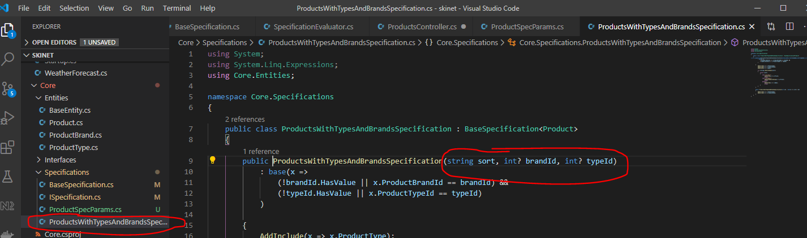

Change to:-

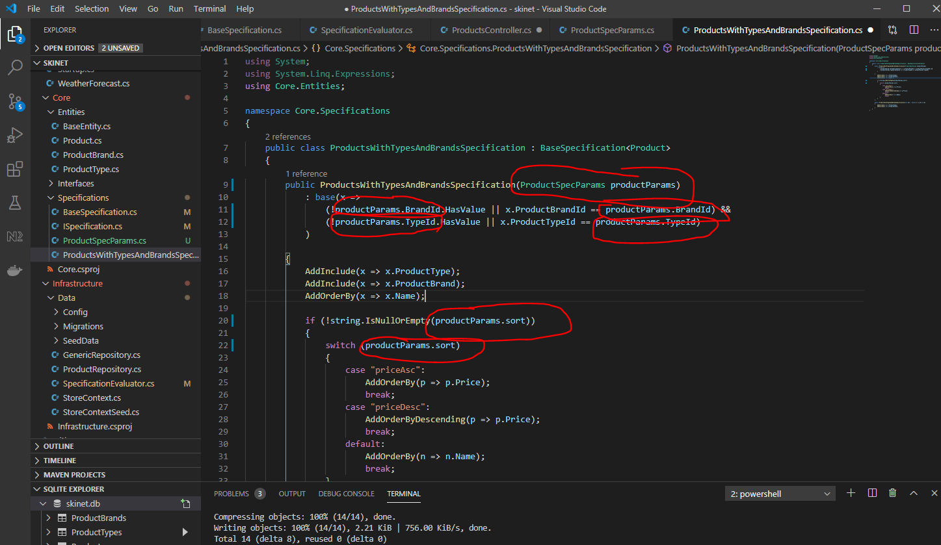

Now, test API using Postman to make sure nothing is broken.

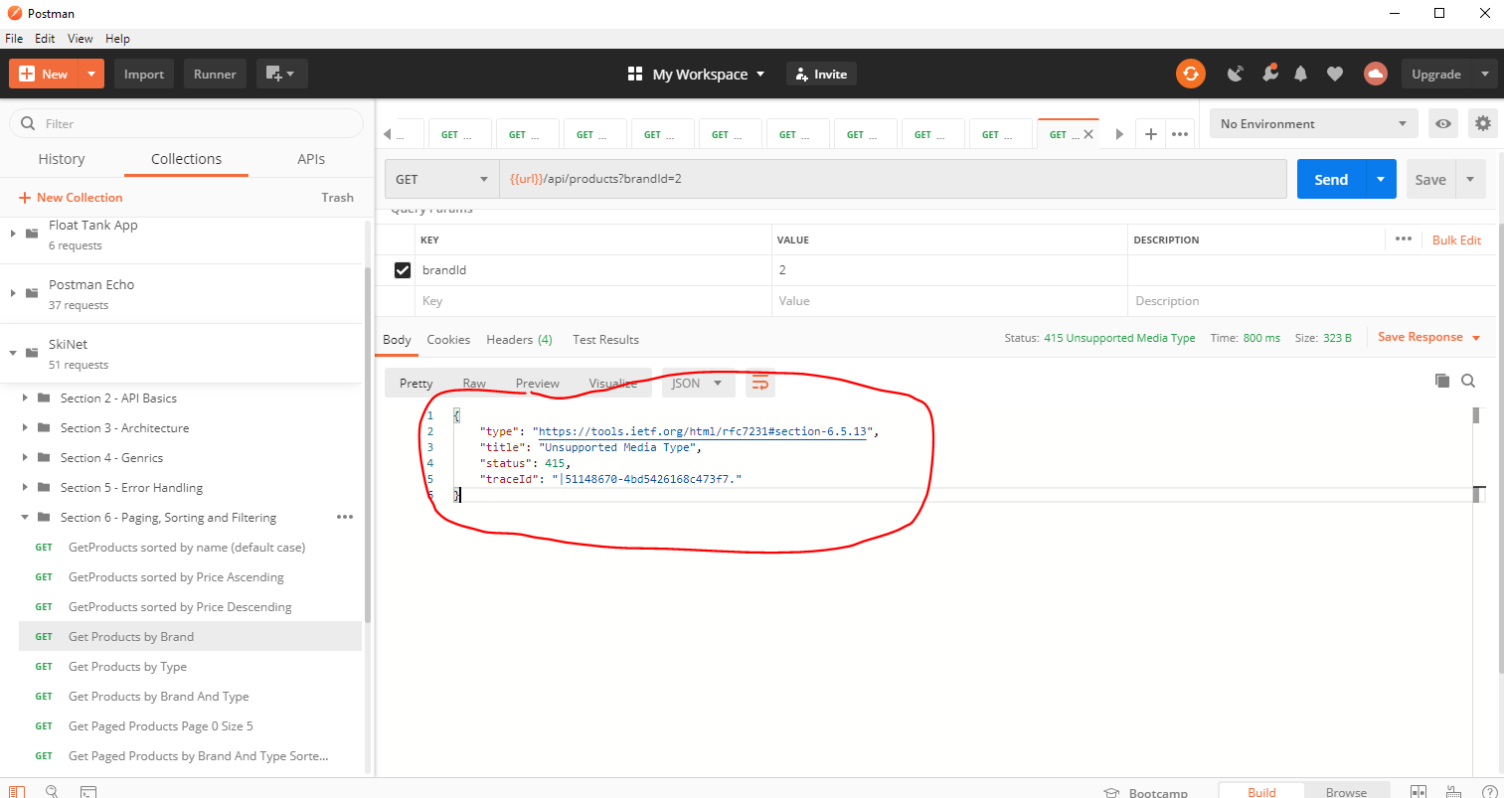

See error above. To correct this you need to add this:-

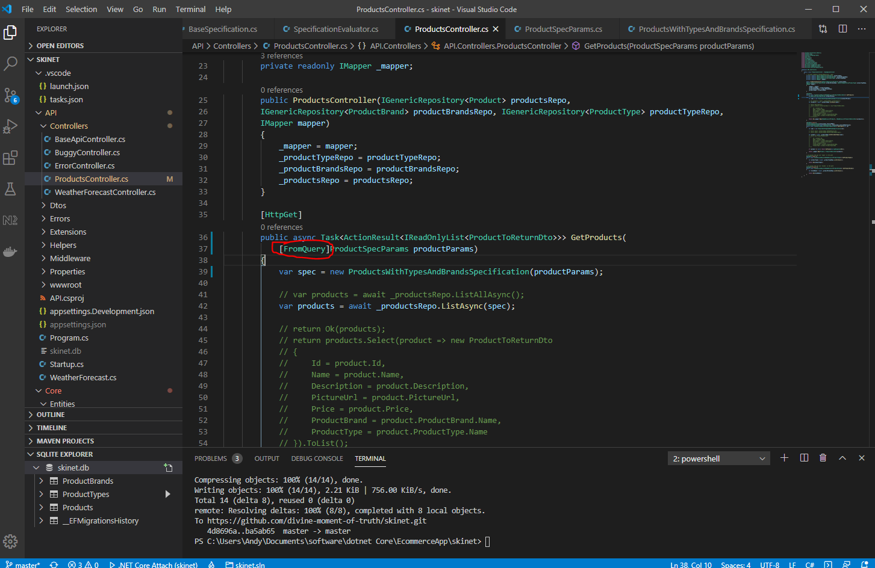

Now add the paging to the ‘ProductsWithTypesAndBrandsSpecification’ class:-

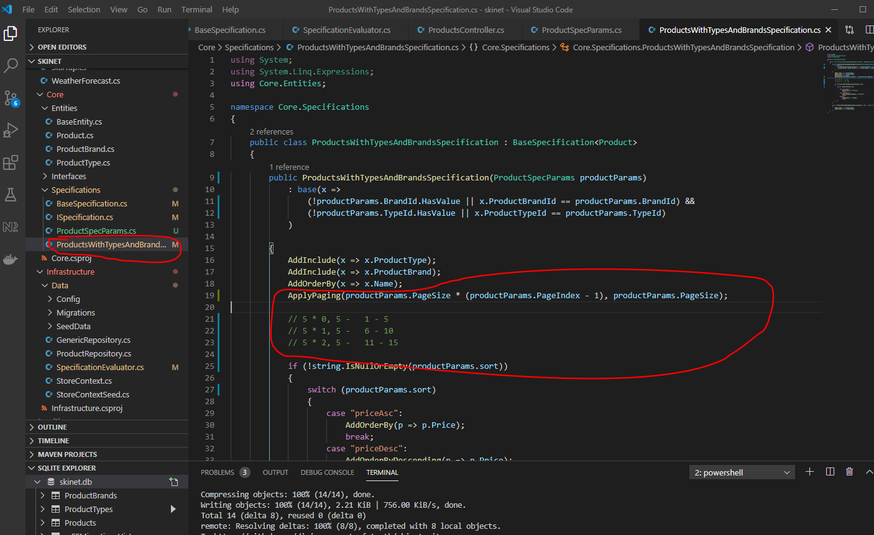

Now create a pagination class in the ‘Helpers’ folder:-

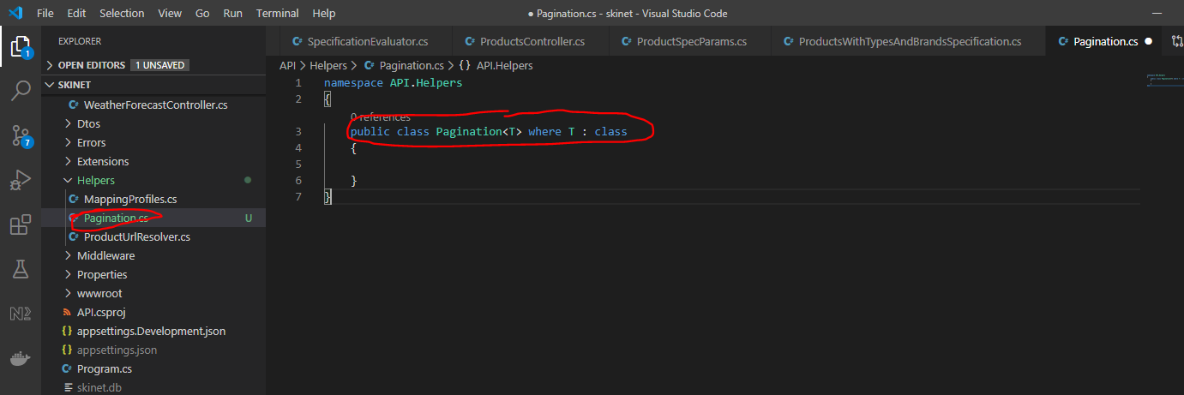

This means that the class is generic and it is constrained so that the T has to be of type = class.

Add these properties:-

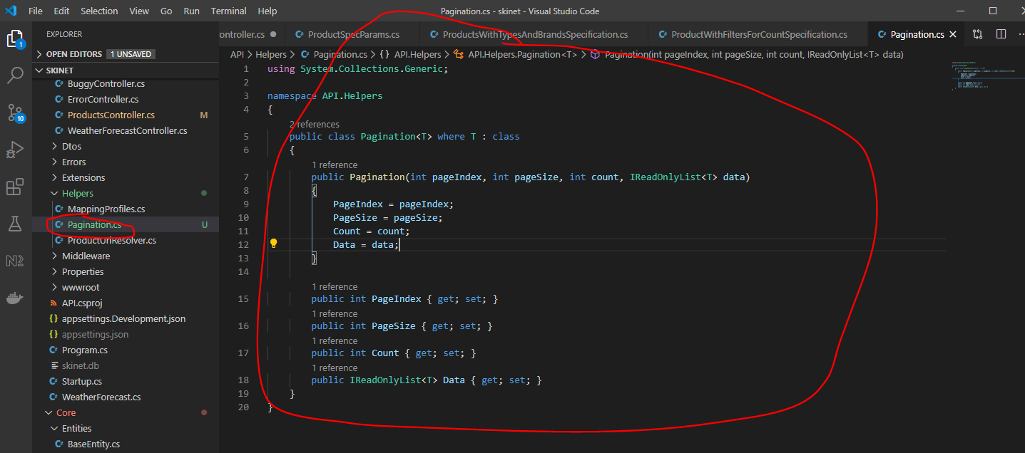

Now add new members to the ‘IGenericRepository’ interface. We need a method to count the number of returned items:-

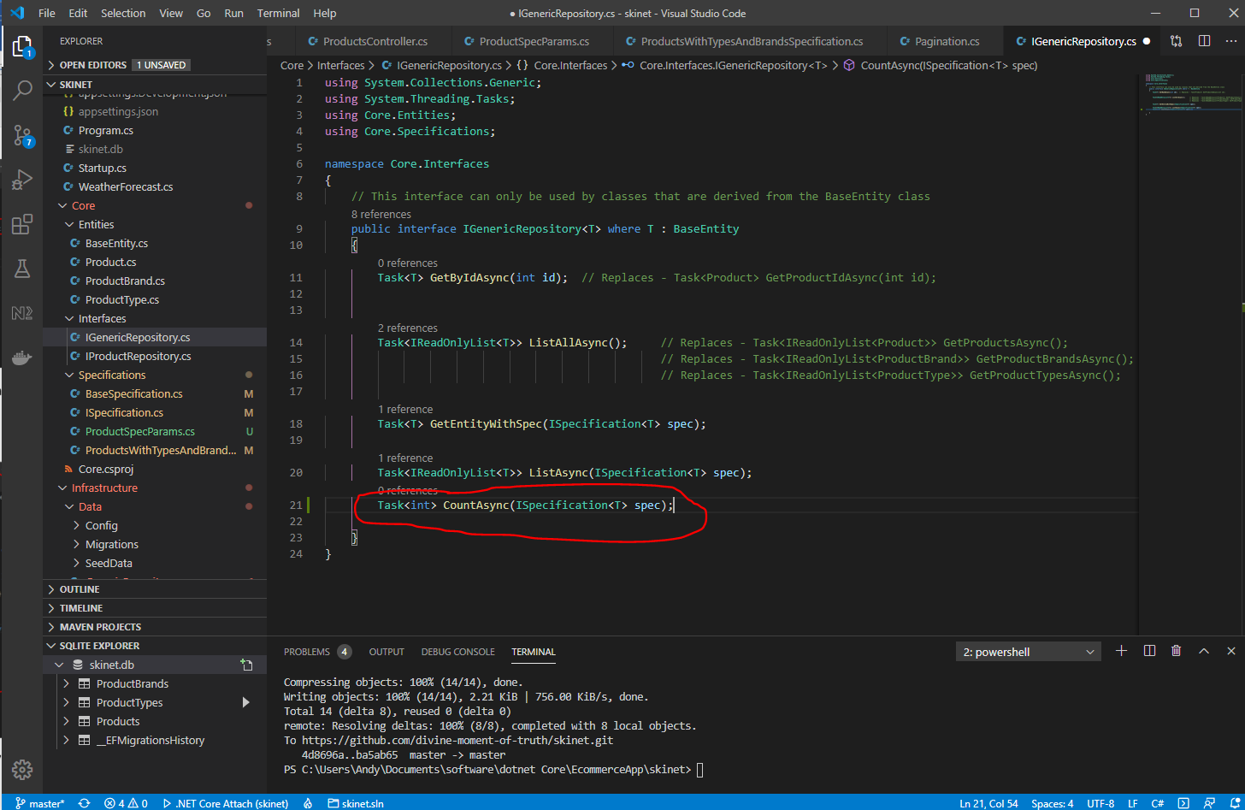

Update ‘GenericRespository’ class now i.e. provide implementation for the method added to the IGenericRepository interface:-

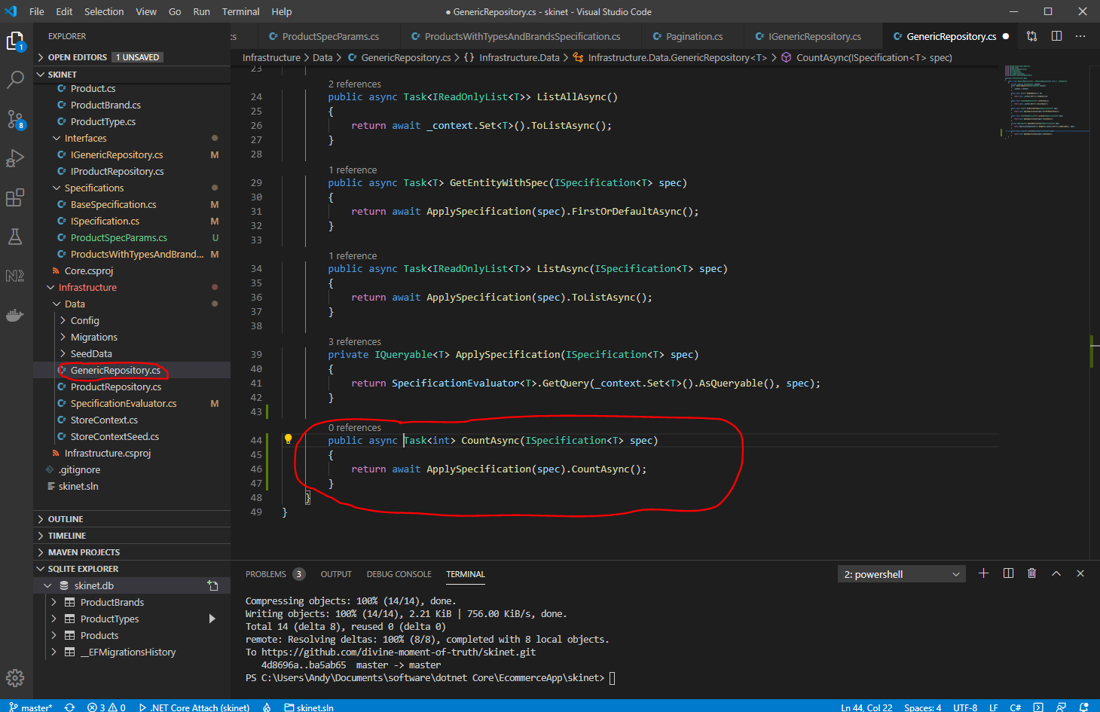

Create another class now under ‘Specifications’ folder called ‘ProductWithFiltersForCountSpecification’:-

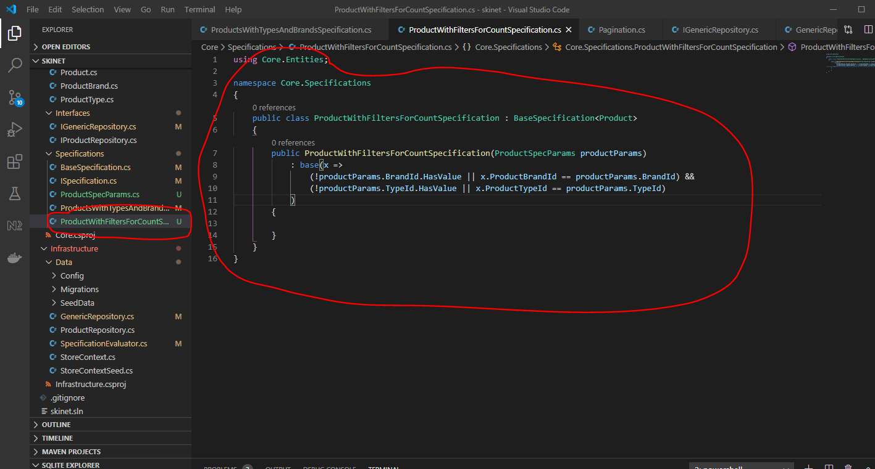

Now change the ‘ProductController’ ‘GetProducts’ method. Change the return type from the ‘GetProducts()’ method:-

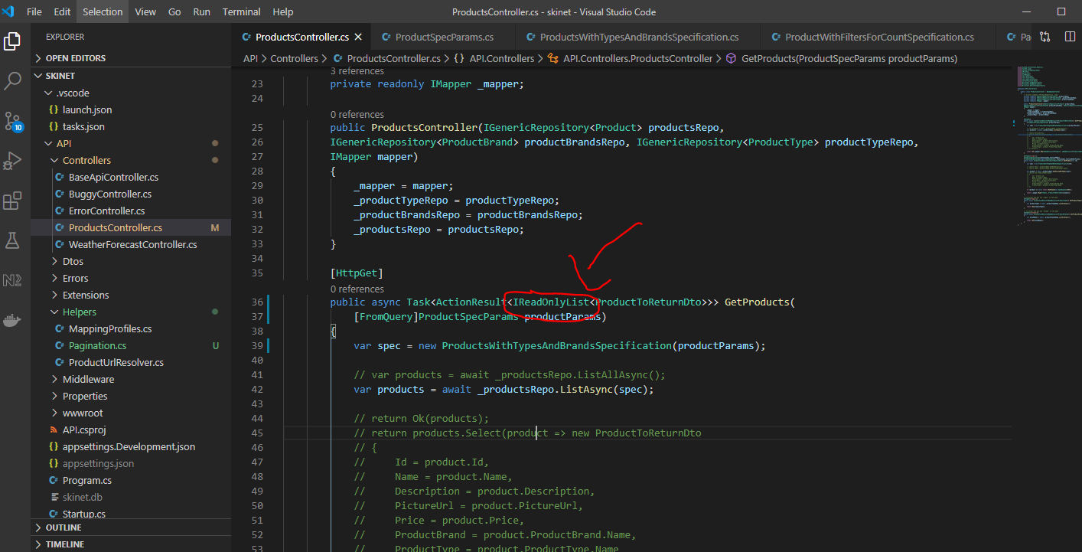

Change the above to the ‘Pagination’ object type:-

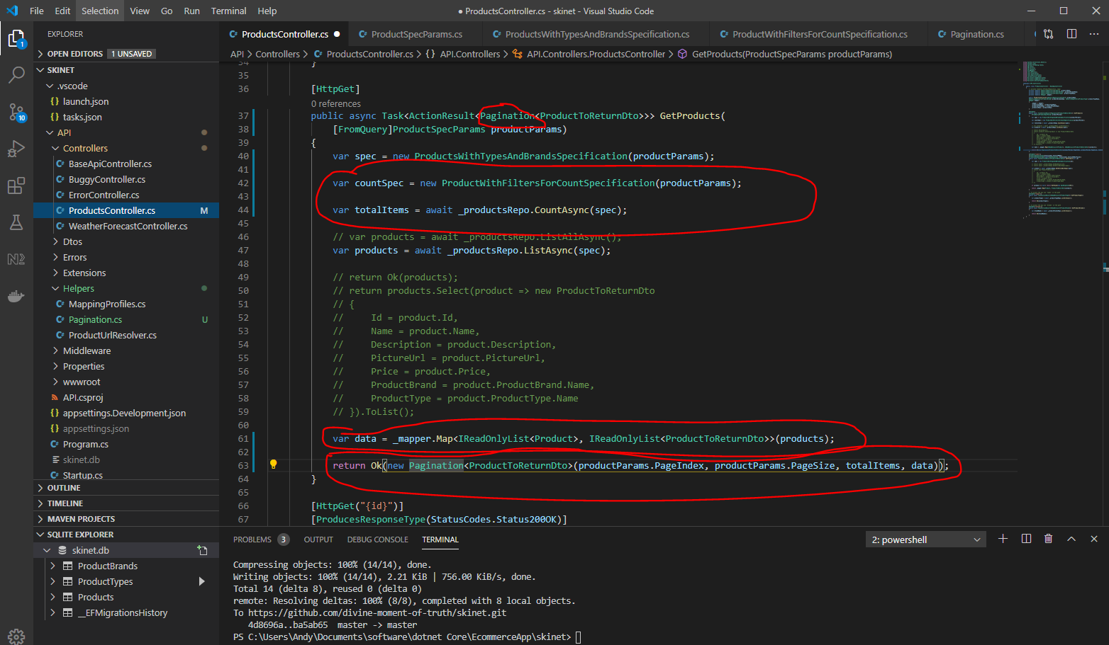

Test in Postman:-

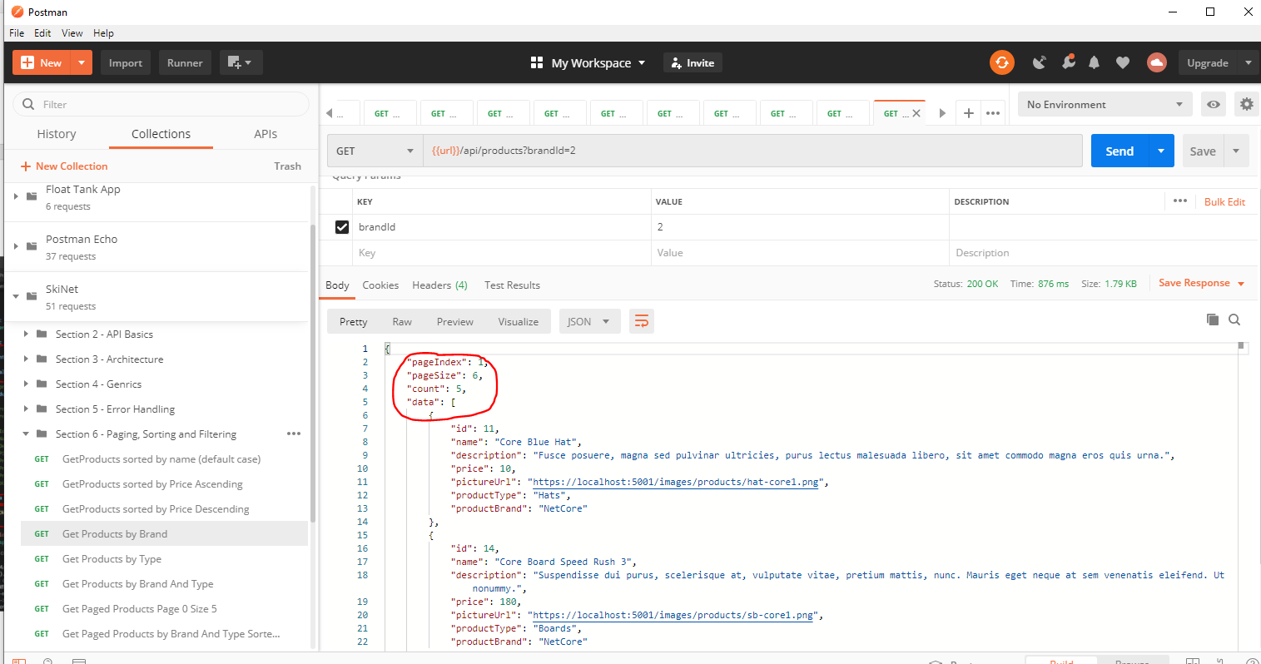

You can see the ‘pageIndex, pageSize, count and data sections now.

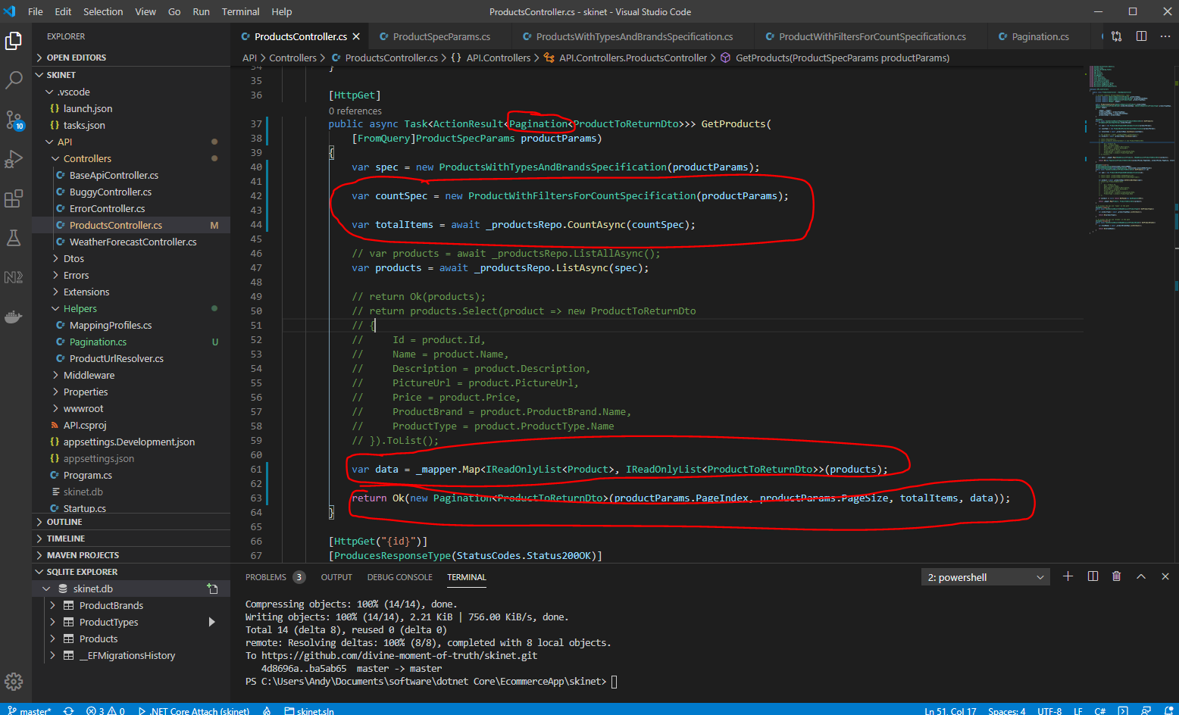

**Implementing Search Facility**

Add a new property to the ‘ProductSpecParams’ class:-

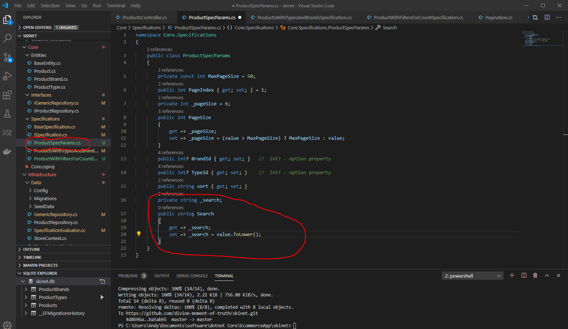

Add an additional criteria to the ‘ProductsWithTypesAndBrandsSpecification’ class:-

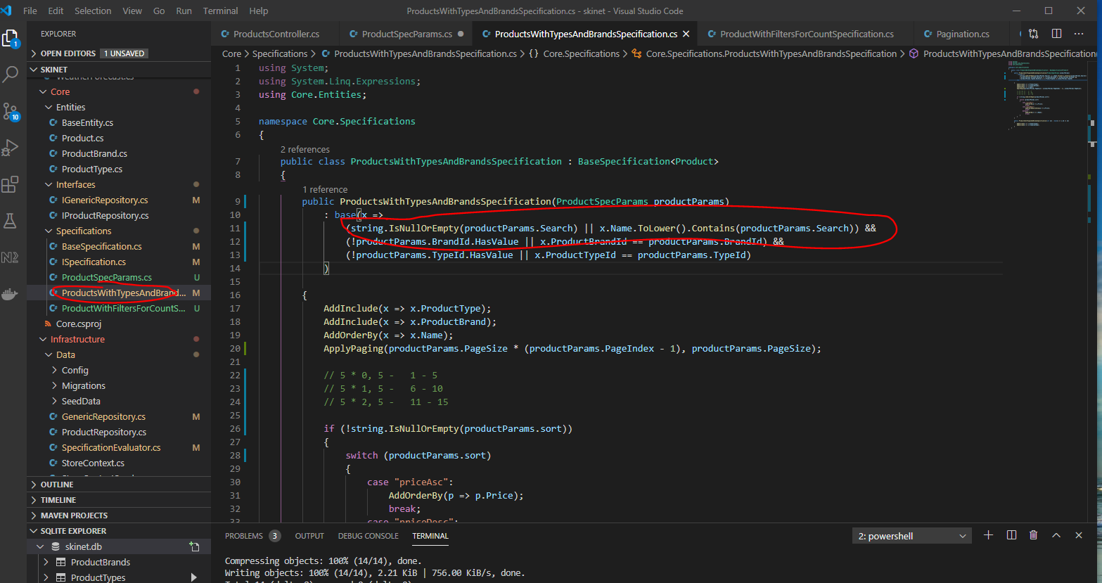

This line tests to see if the string (productParams.Search) is empty OR else (i.e. if it is not) then do this - x.Name.ToLower().Contains(productParams.Search))

Copy this line and paste it into the ‘ProductWithFiltersForCountSpecification’ class too:-

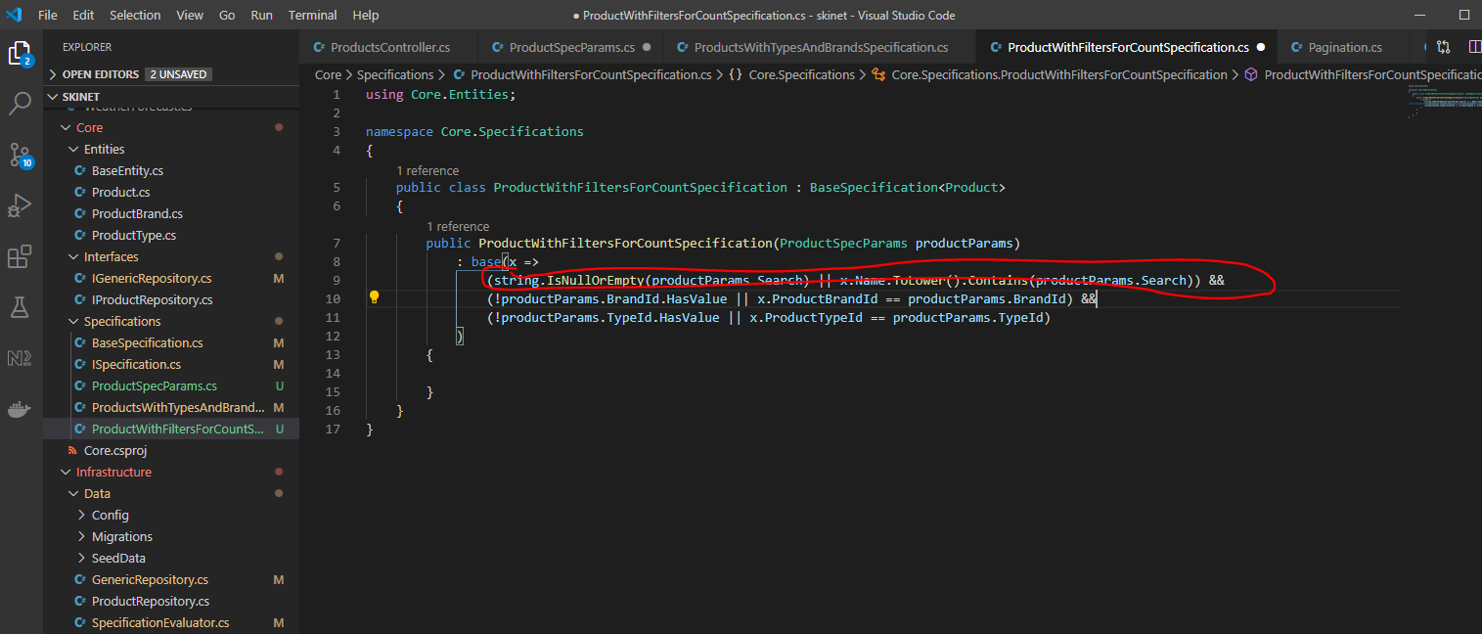

Now, test in Postman:-

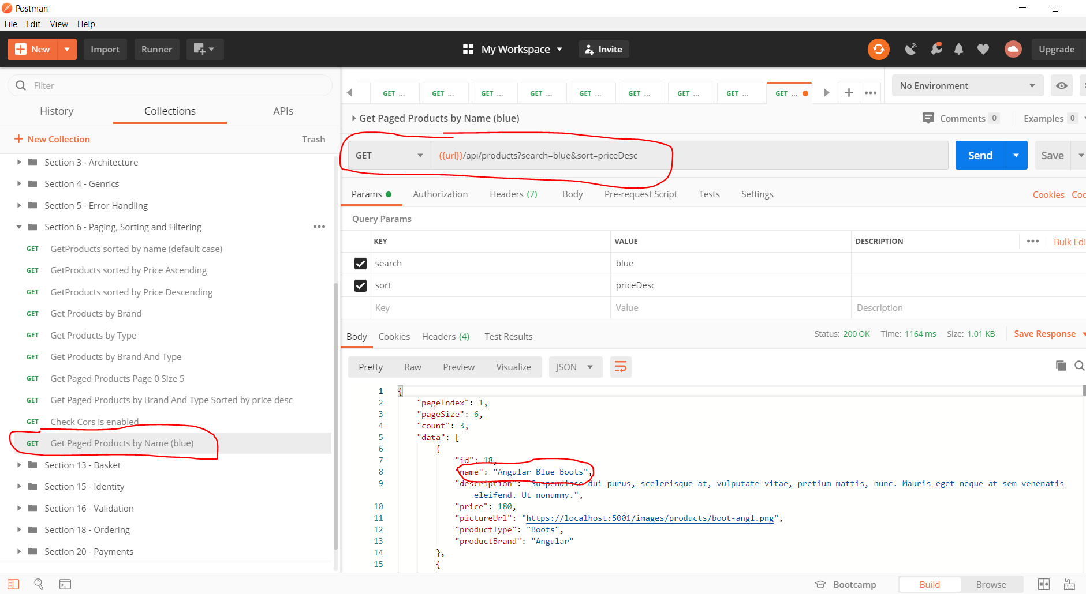

**Add CORS support to API**

Add entry into ‘startup.cs’ class:-

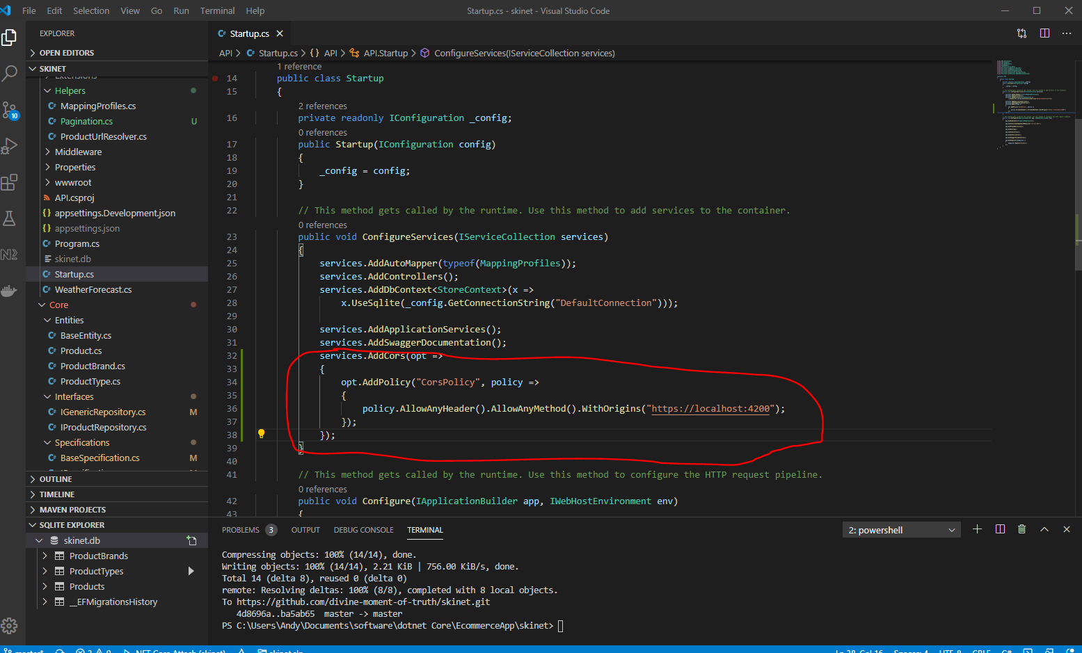

Also, add middleware section to ‘startup.cs’:-

**Frontend/Client side Implementation**

[1] Use Angular 9 for this project.

[2] Install NodeJS 12.x.x

[3] Install NVM - NVMmeans that you can have many different versions of NodeJS installed. NVM allows you to switch between different versions of NodeJS installed on your machine. NVM can be downloaded from here:-

<https://github.com/coreybutler/nvm-windows/releases>

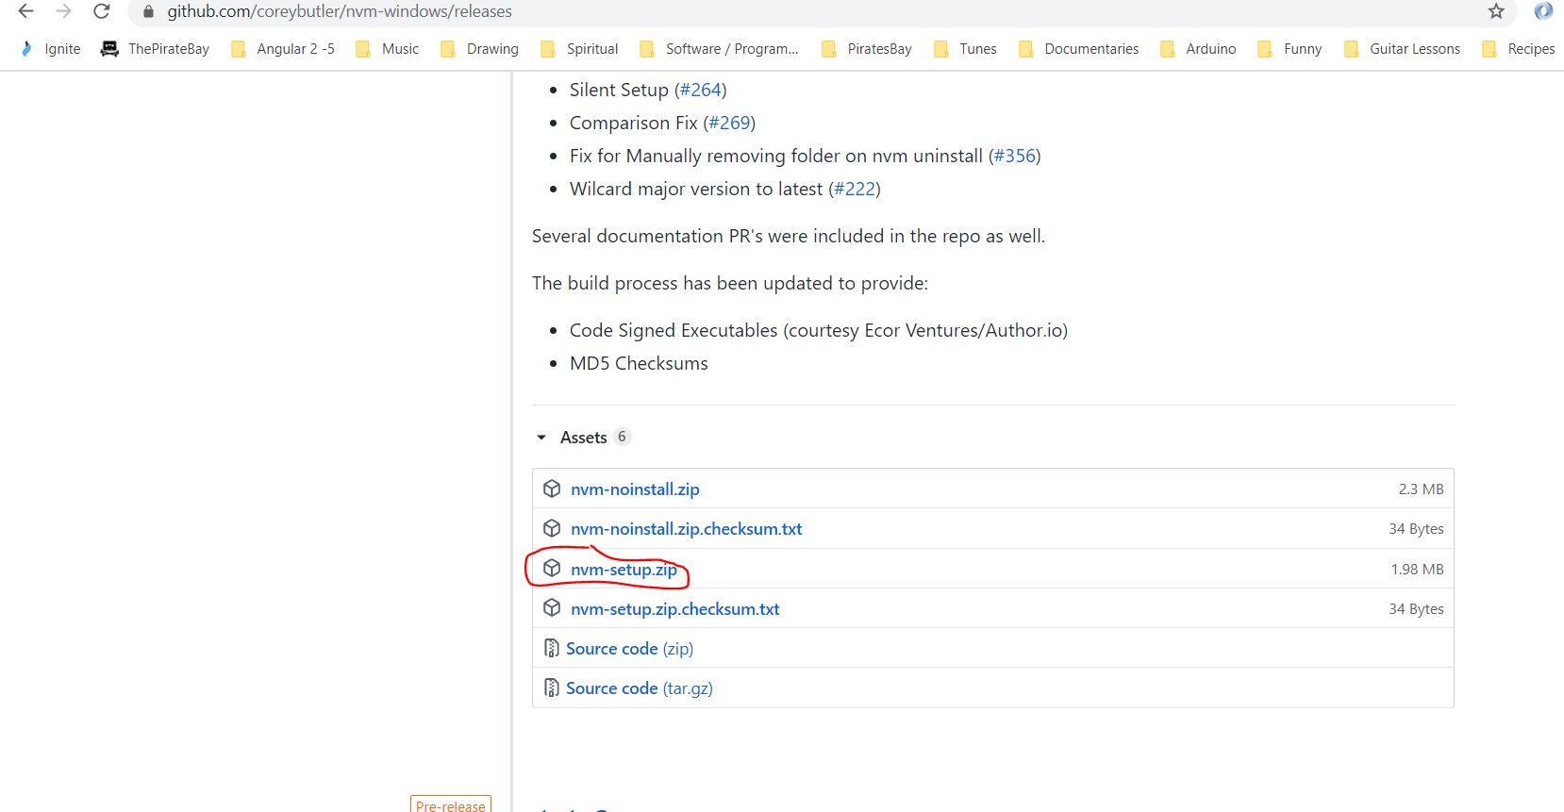

When downloaded, unzip and run setup.

When NVM is installed you can use the command line to switch between different version of NodeJS by typing:-

nvm use 10.16.3

[4] Install Angular CLI. In the Terminal type:-

npm install -g @angular/cli

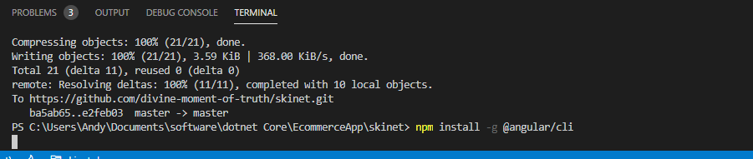

[5] Create Angular project:-

ng new client

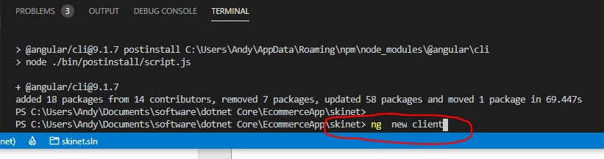

Y - Yes to angular routing

SCSS

Angular ‘Client’ project has been created:-

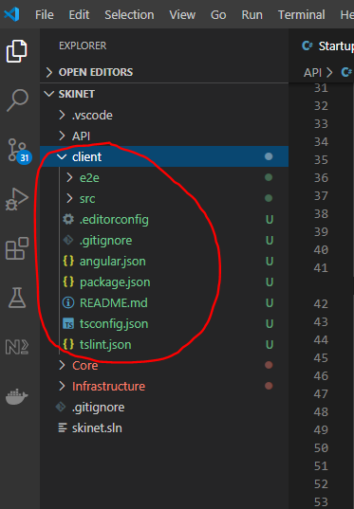

You might have to install Python2.7 if you get errors. Download and install here:-

C:\Python27\

Add location to environment variables:-

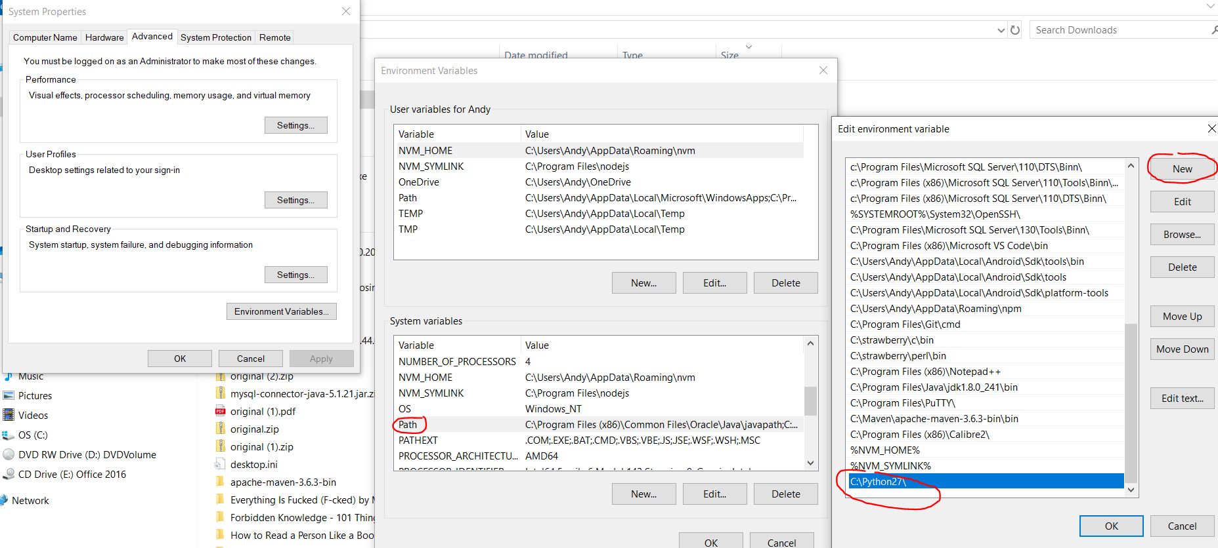

Enter this into the terminal ensure that angular cli version 9 is installed:-

ng version

if and older version is installed type:-

npm install -g @angular/cli@latest

and

npm install @angular/cli@latest

**Https self-signed certificates**

Used for clients entering credit card details into browser:-

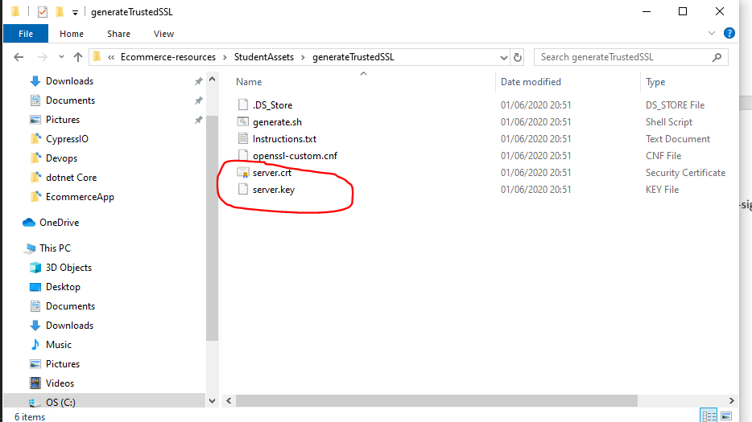

Copy the two above files. Paste here:-

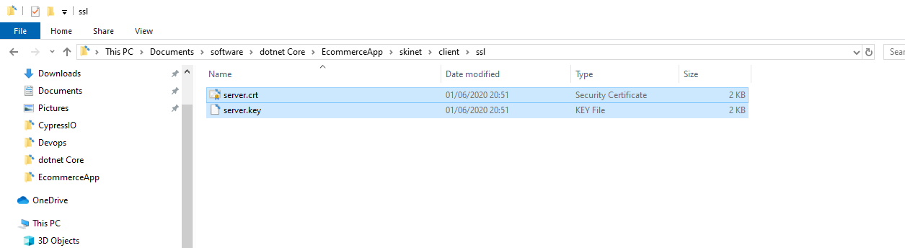

Use these instructions for installing the certificate on Windows 10:-

Windows 10

1. Double click on the certificate (server.crt)

2. Click on the button “Install Certificate …”

3. Select whether you want to store it on user level or on machine level

4. Click “Next”

5. Select “Place all certificates in the following store”

6. Click “Browse”

7. Select “Trusted Root Certification Authorities”

8. Click “Ok”

9. Click “Next”

10. Click “Finish”

If you get a prompt, click “Yes”

OSX instructions can be found here:-

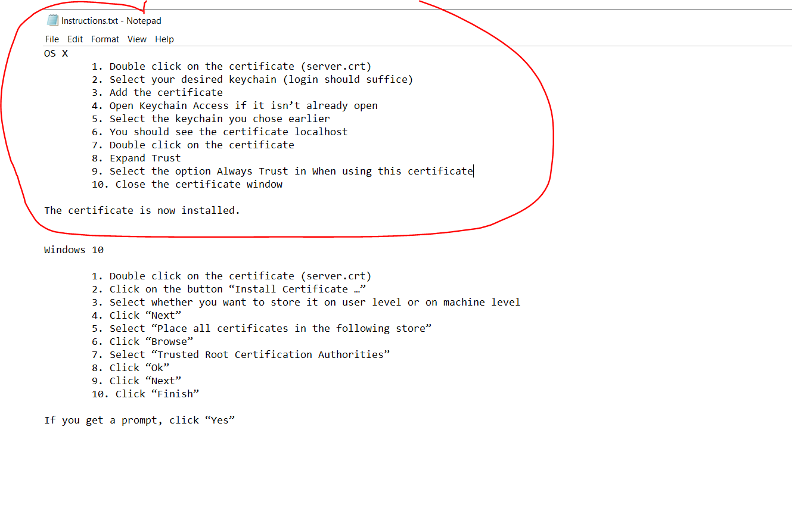

Now update the ‘angular.json’ file. Add these three lines:-

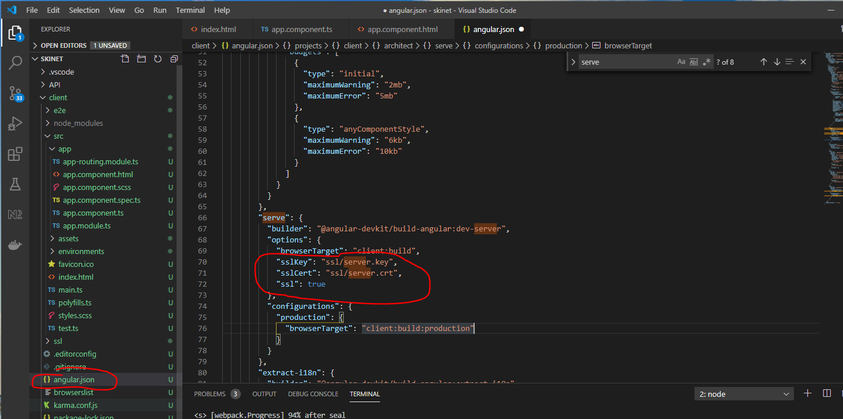

Stop the angular server:-

[ctrl] + c

Then restart:-

ng serve

Now, open a browser and go to the https address:-

<https://localhost:4200/>

See padlock:-

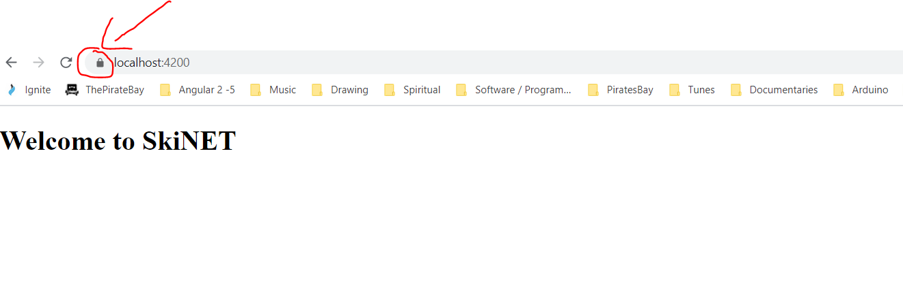

Angular app is running on https.

**Add Styling Framework – Bootstrap**

Add NGX-bootstrap:-

<https://valor-software.com/ngx-bootstrap/#/documentation#getting-started>

Copy this:-

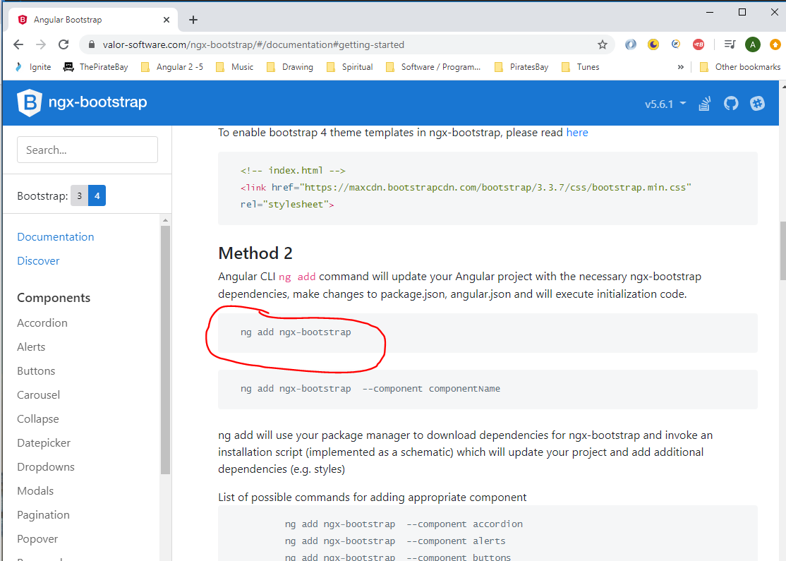

cd into ‘client’ folder:-

***cd client***

***ng add ngx-bootstrap***

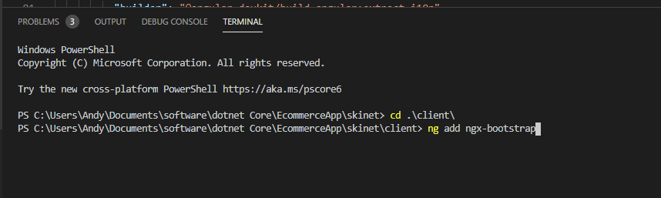

Add an icon set:-

***npm install font-awesome***

Now, add locate the path of the ‘fot-awesome.css file:-

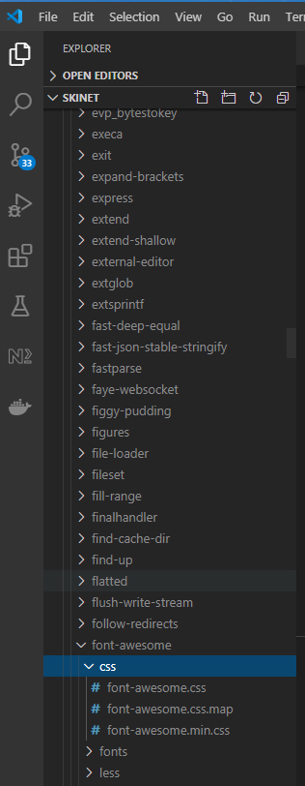

Add this path to the ‘angular.json’ file:-

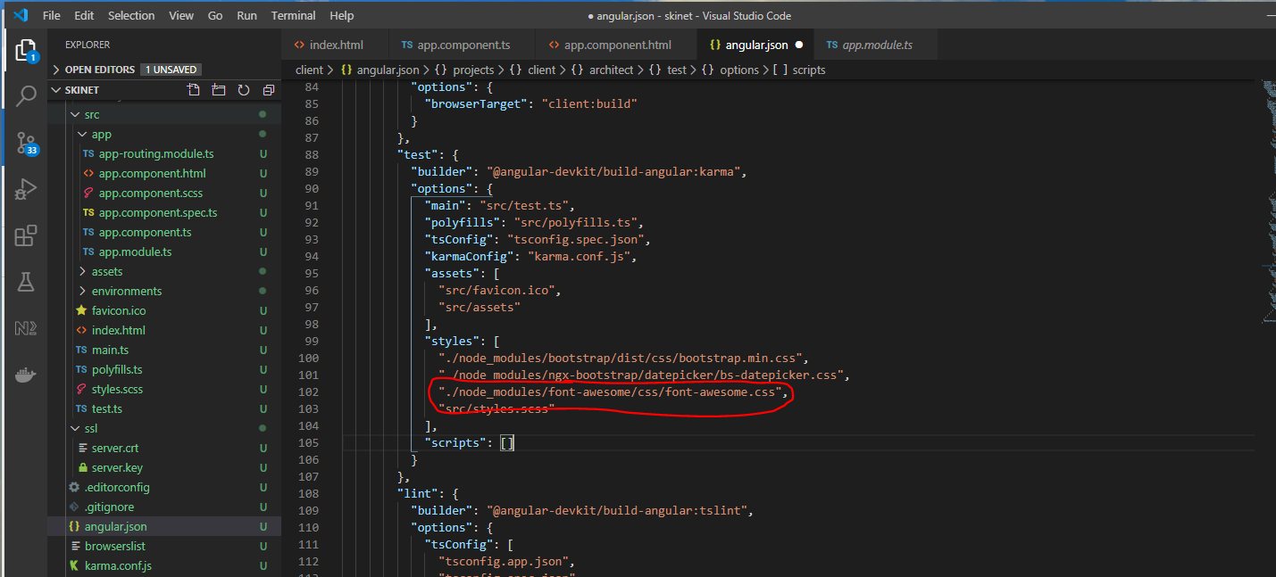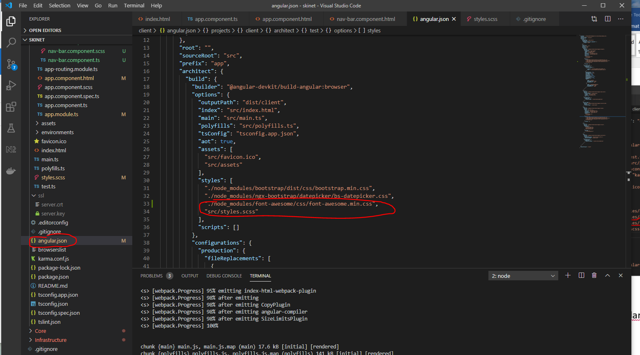

Any time you make any changes to ‘angular.json’ you will need to stop and start the angular server:-

***[ctrl] + c***

***ng serve***

In the ‘.gitignore’ file in the ‘client’ folder add the ‘ssl’ files because you would not want to upload these to GitHub:-

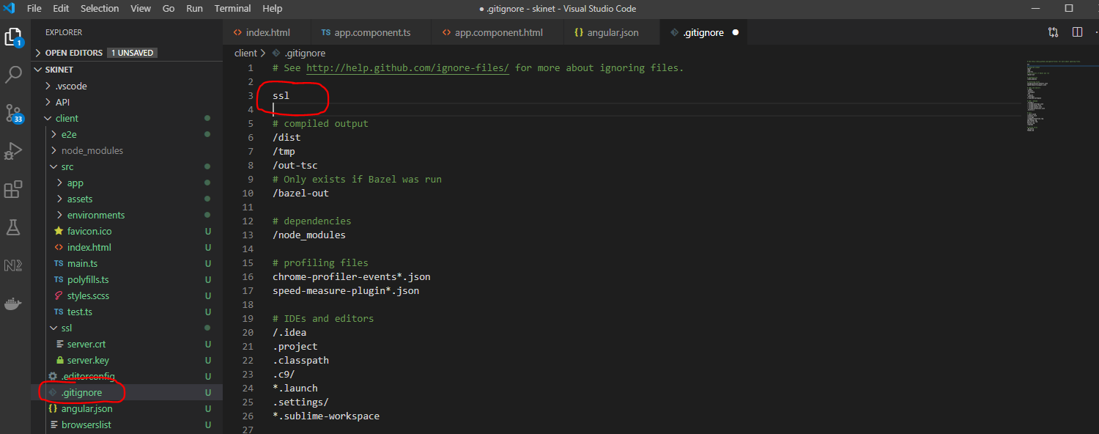

Commit all changes to GitHub:-

git add .

git commit -m “Addition of Angular client files”

git push origin master

**Add Extensions to make Angular Easier**

Add these:-

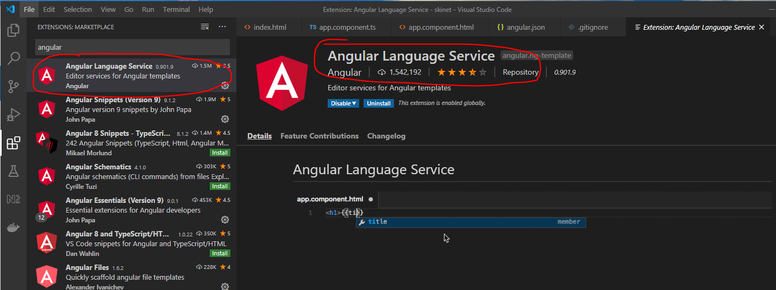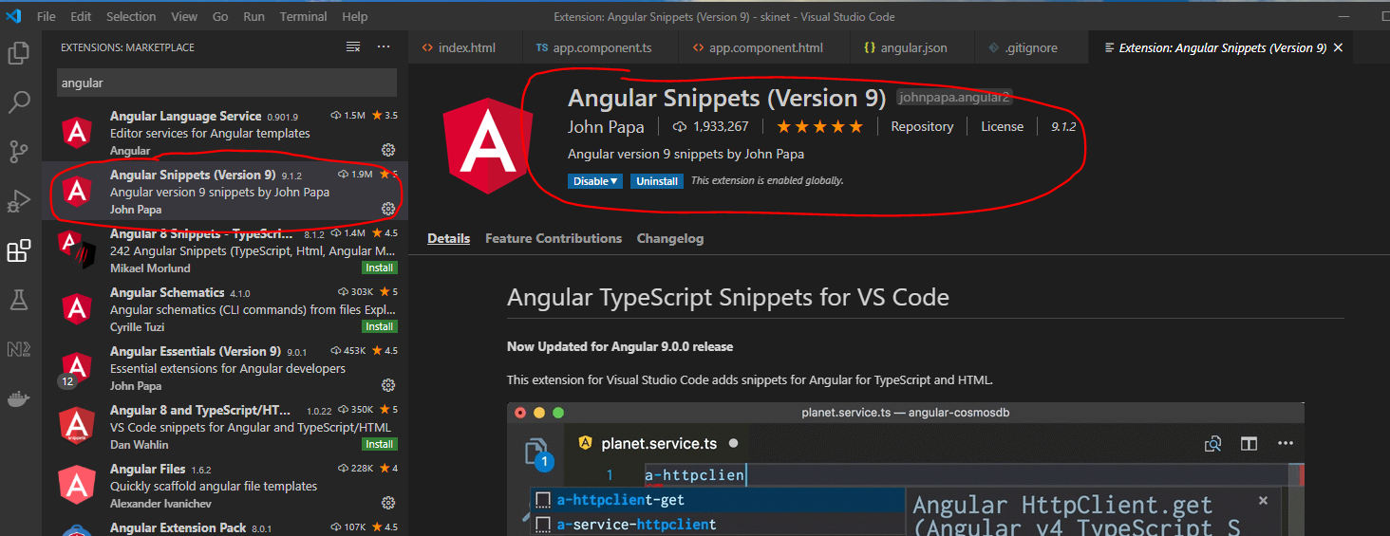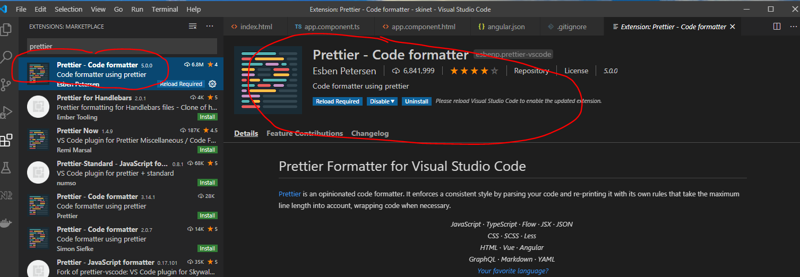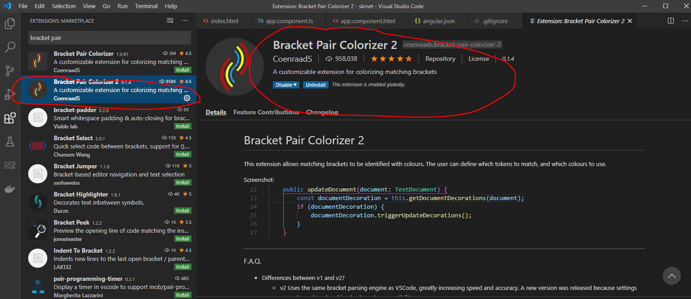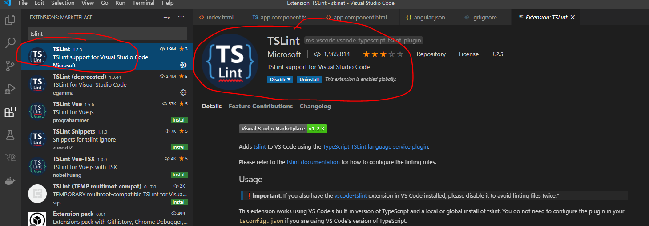

**Create Components**

Create Navbar component:-

cd into ‘client/src/app’:-

***cd client/src/app***

***ng g c nav-bar --skip-tests***

Now go to Bootstrap website and find a suitable navbar:-

[https://getbootstrap.com/docs/4.5/examples/](https://getbootstrap.com/docs/4.5/examples/pricing/)

This one looks good:-

<https://getbootstrap.com/docs/4.5/examples/pricing/>

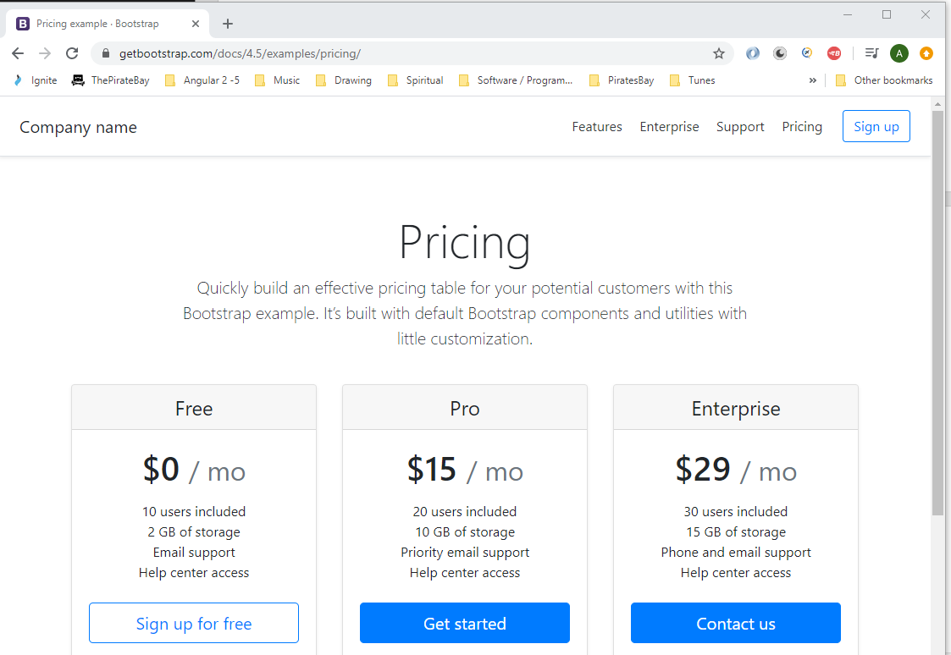

F12 to enter devTools and copy this section:-

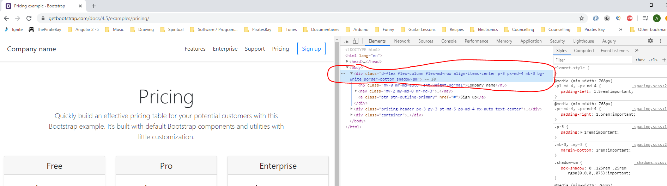

Right click the section and select ‘Copy -> Copy element’

Paste here:-

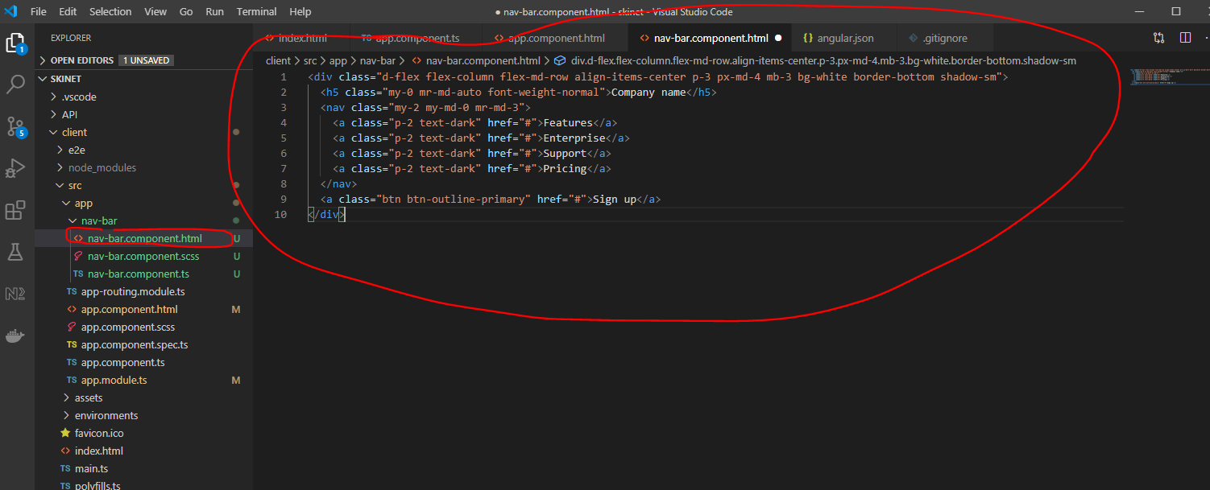

This looks like this:-

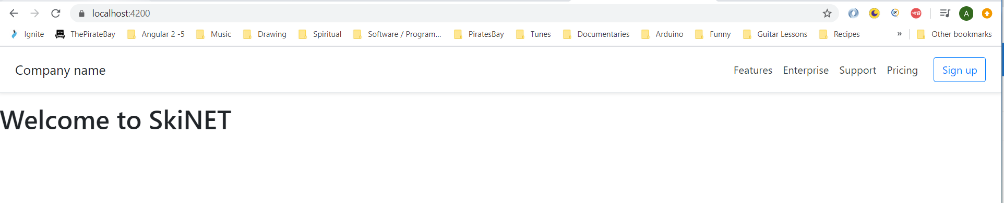

Make adjustments to this:-

<div class="d-flex flex-column flex-md-row align-items-center justify-content-between p-3 px-md-4

mb-3 bg-white border-bottom shadow-sm fixed-top">

  <img src="/assets/images/logo.png" style="max-height: 70px;" alt="logo">

  <nav class="my-2 my-md-0 mr-md-3 text-uppercase" style="font-size: larger;">

    <a class="p-2 text-dark" href="#">Home</a>

    <a class="p-2 text-dark" href="#">Shop</a>

    <a class="p-2 text-dark" href="#">Contact</a>

  </nav>

  <div class="d-flex align-items-center">

    <a class="position-relative">

      <i class="fa fa-shopping-cart fa-2x mr-5 text-dark"></i>

      <div class="cart-no">5</div>

    </a>

    <a class="btn btn-outline-secondary mr-2">Login</a>

    <a class="btn btn-outline-secondary mr-3">Sign up</a>

  </div>

</div>

Add image into app ‘assets’ folder:-

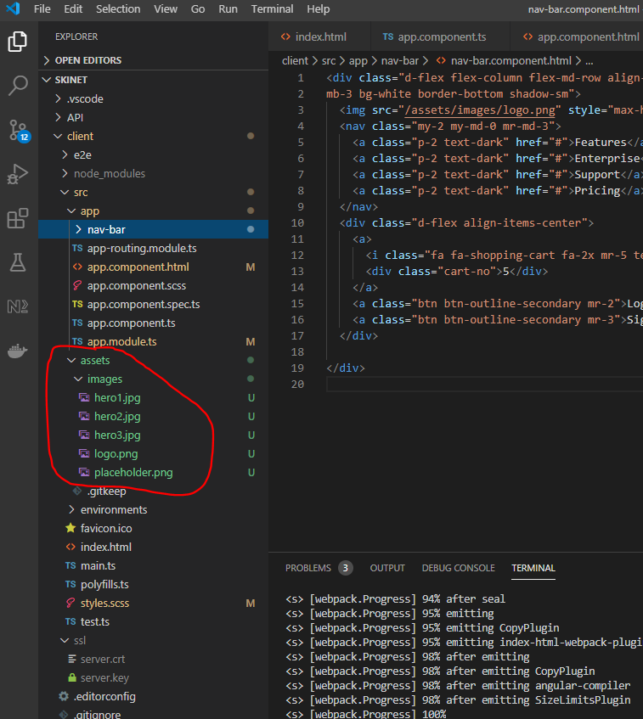

Learn Flex-box system:-

<https://flexboxfroggy.com/>

Add this to the ‘app.module.ts’ file:-

HttpClientModule

**Create an interface for the product object**

Open swagger and copy this:-

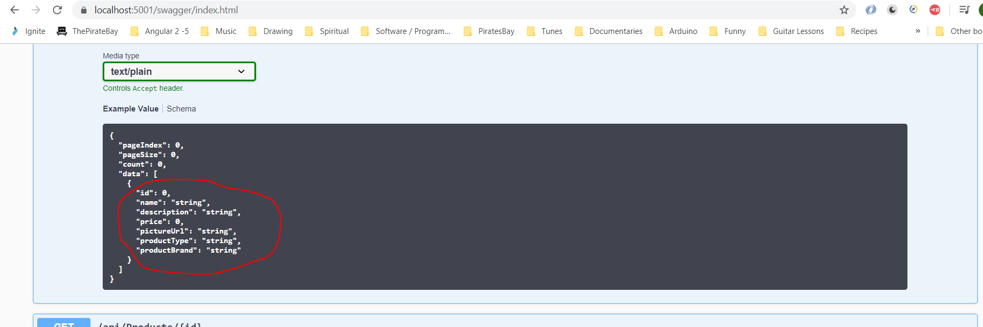

**"id": 0,**

**"name": "string",**

**"description": "string",**

**"price": 0,**

**"pictureUrl": "string",**

**"productType": "string",**

**"productBrand": "string"**

Use this website:-

<http://www.jsontots.com/>

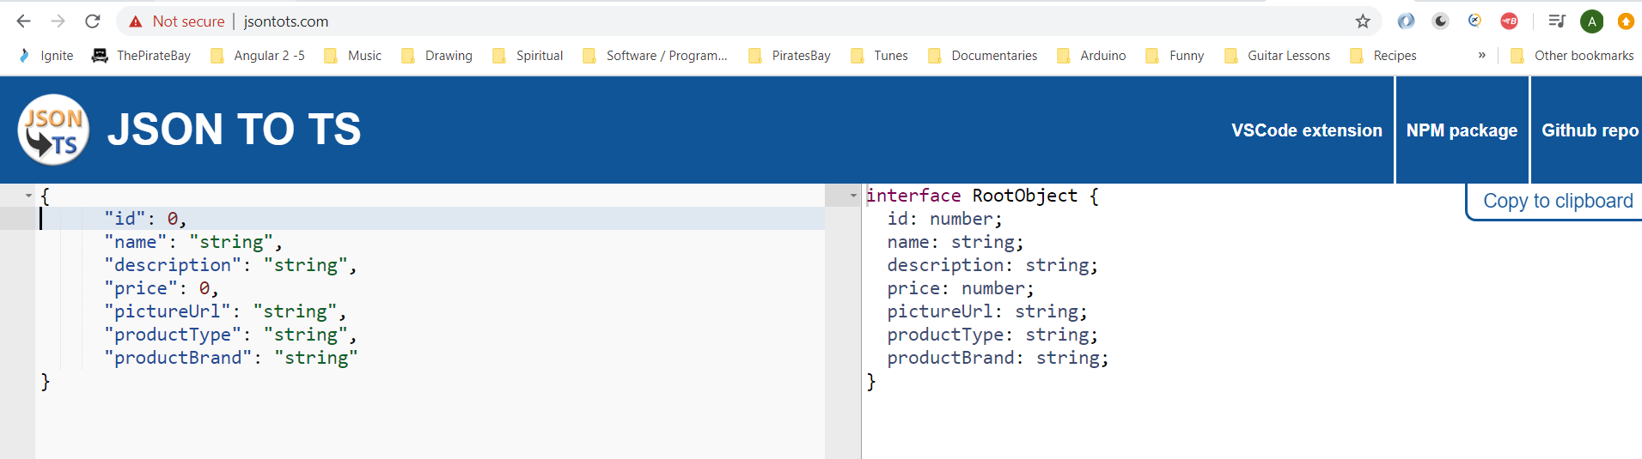

Copy the interface from the right hand side.

Create this folder and interface:-

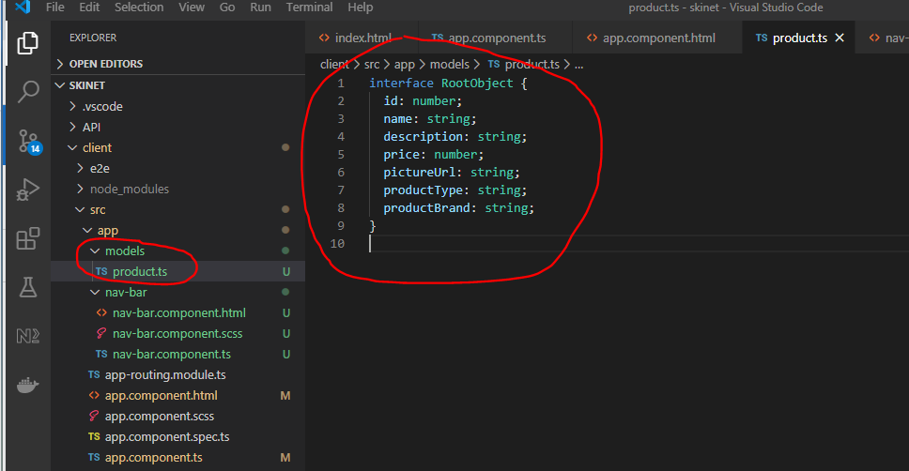

Change Interface to ‘IProduct’ and make it exportable it:-

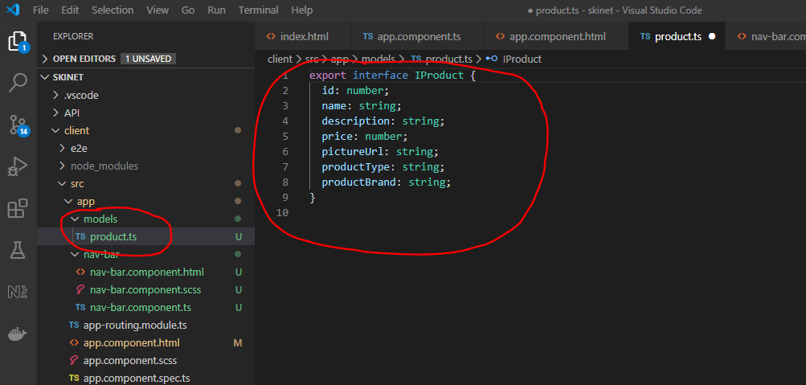

Now, add this:-

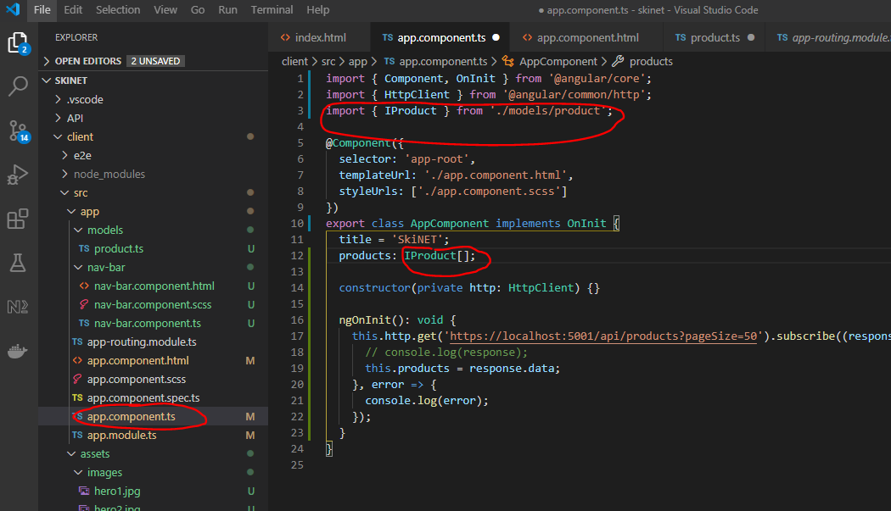

Copy this:-

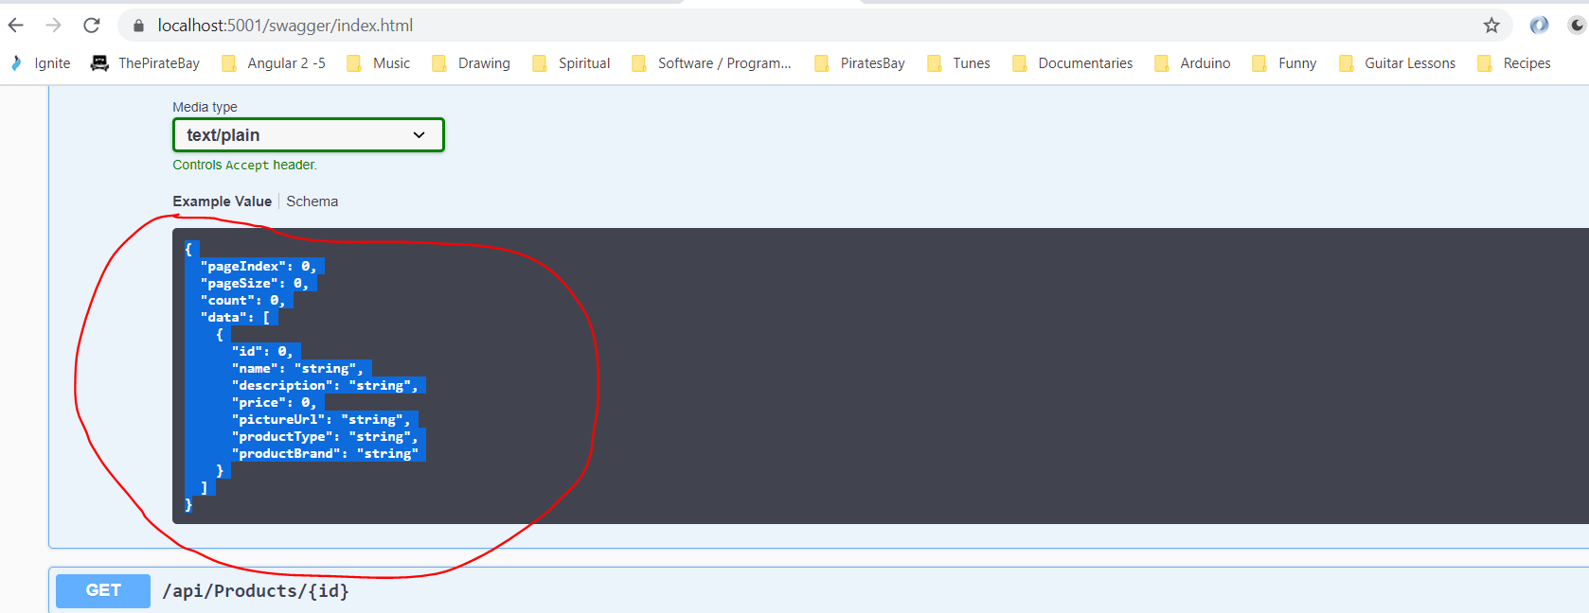

Paste here:-

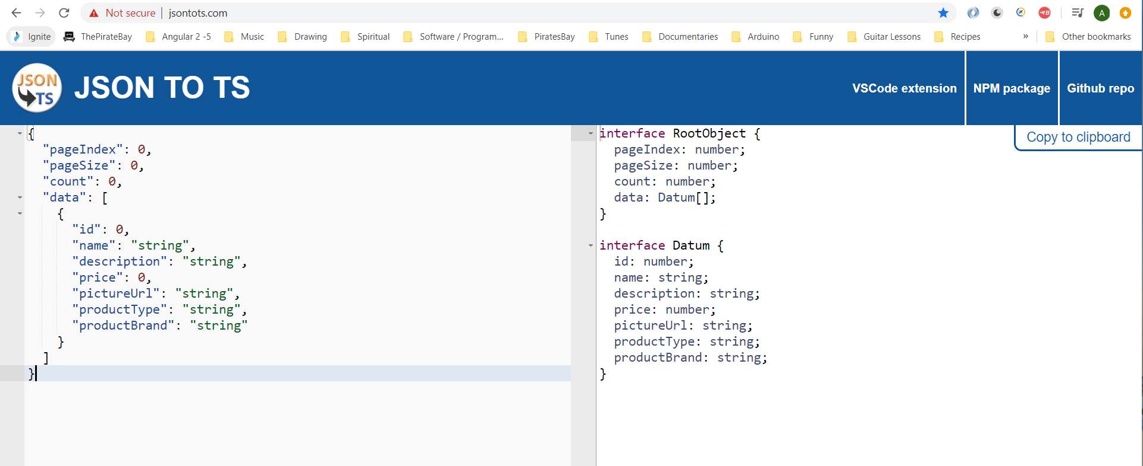

Copy this part:-

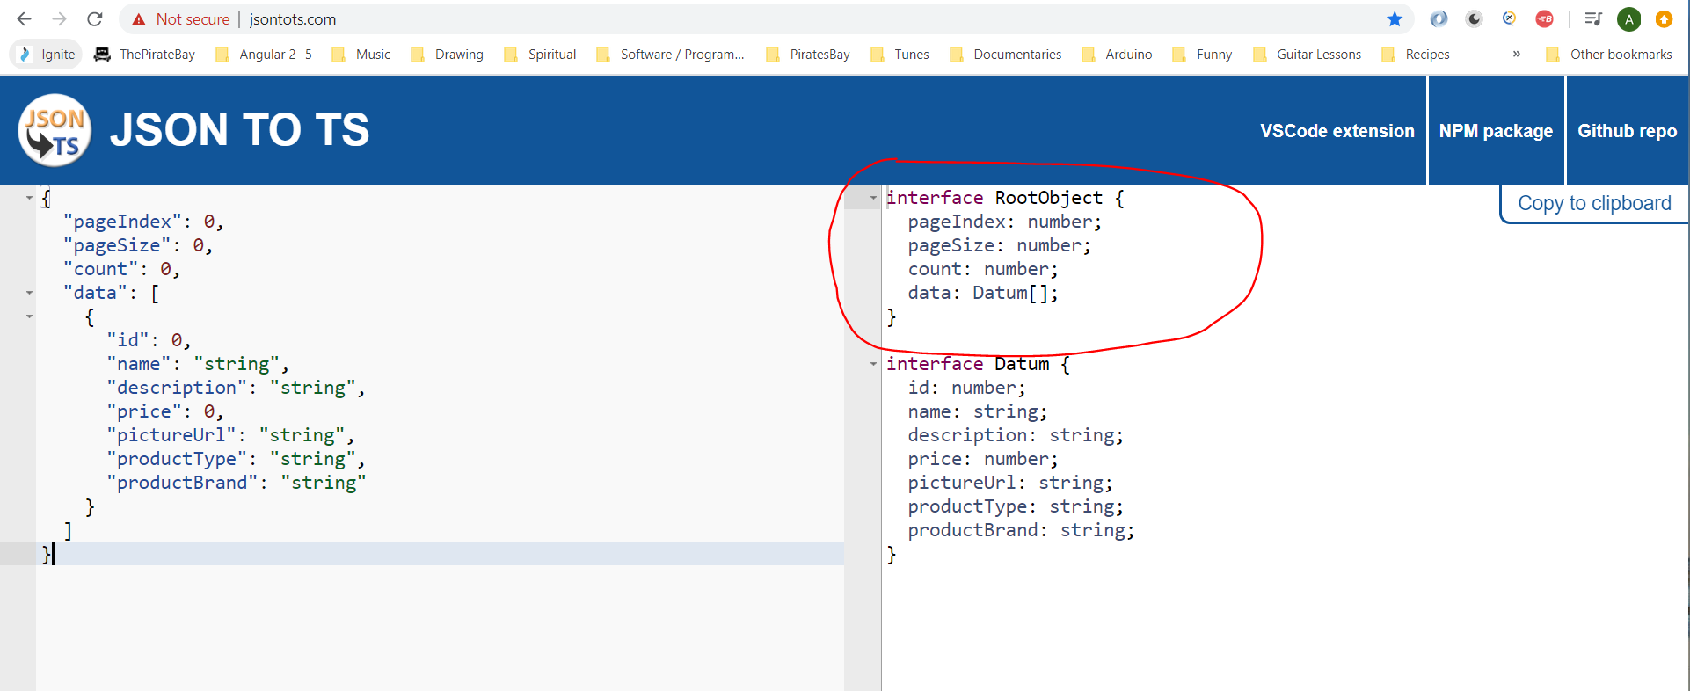

Create a new interface:-

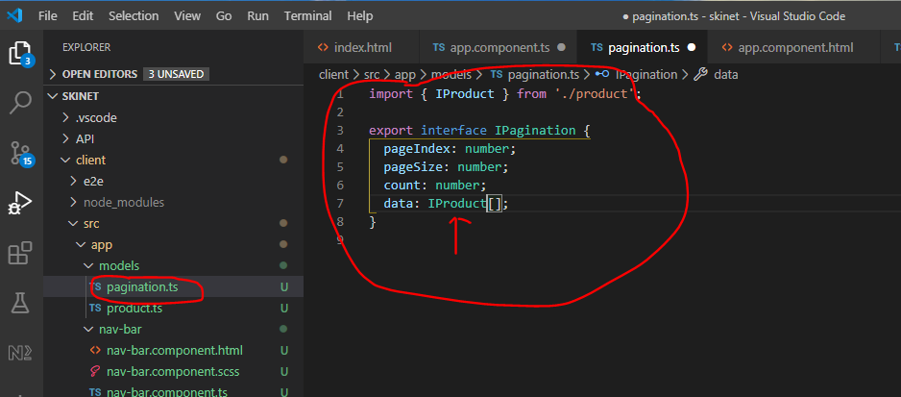

Now update this:-

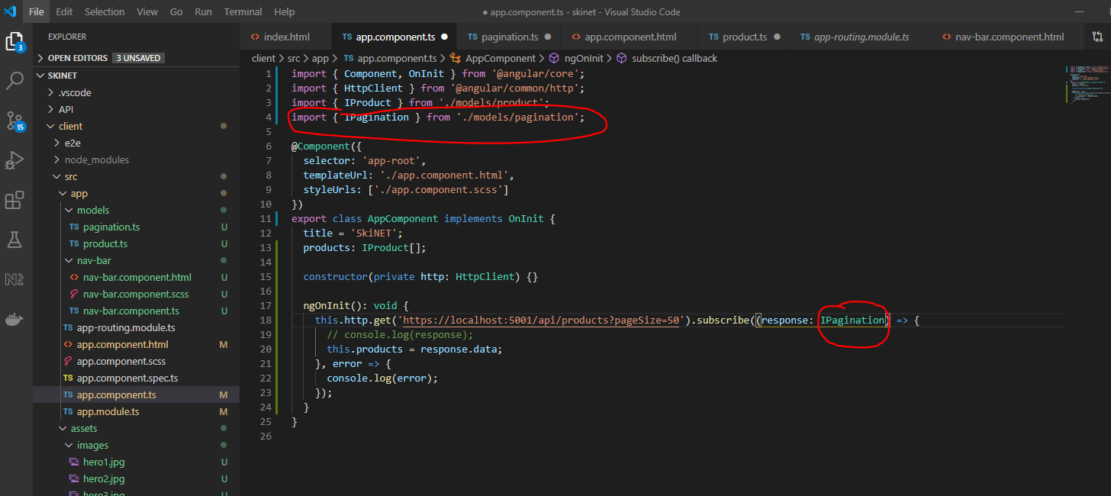

**Building the UI**

Create a module called ‘core’ here:-

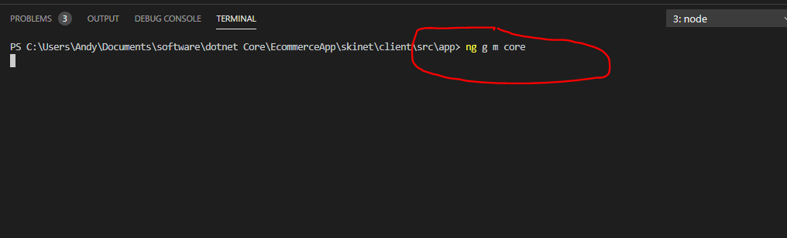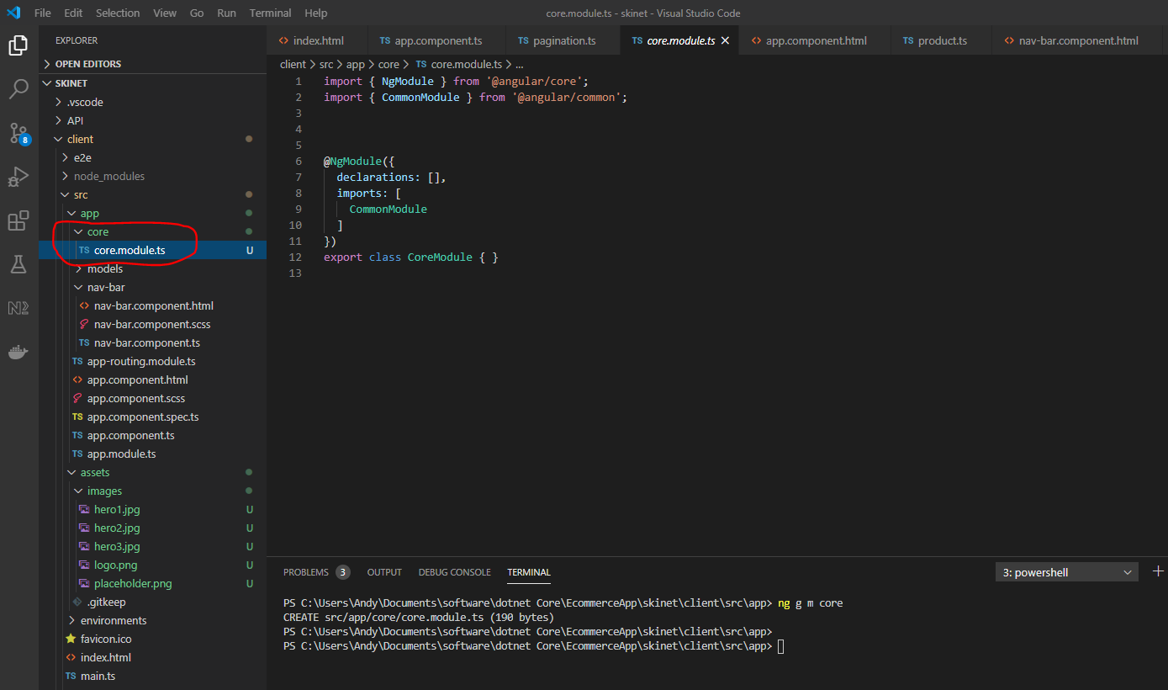

Create two more modules:-

shared

shop

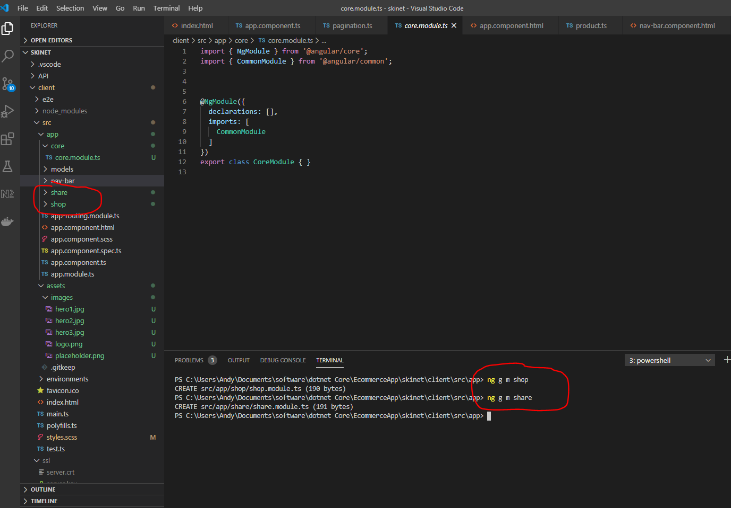

Change directory into ‘shop’ module folder and create a new component called ‘shop’ without creating another folder called ‘shop’ and with no test files:-

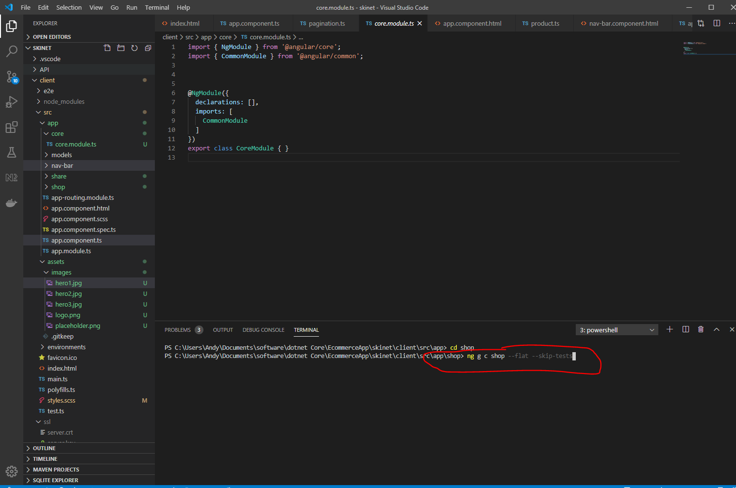

ng g c shop --flat --skip-tests

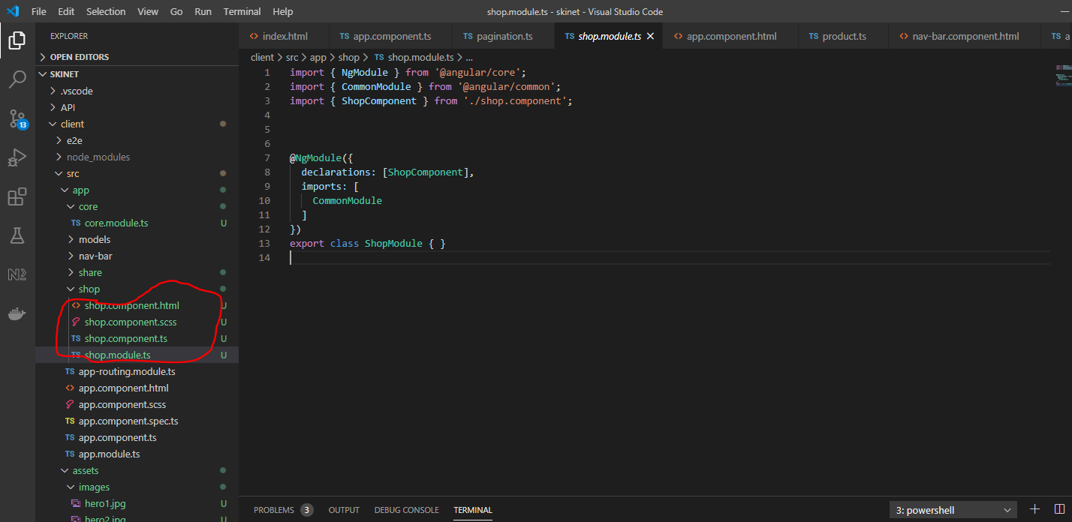

Create a service within the shop folder:-

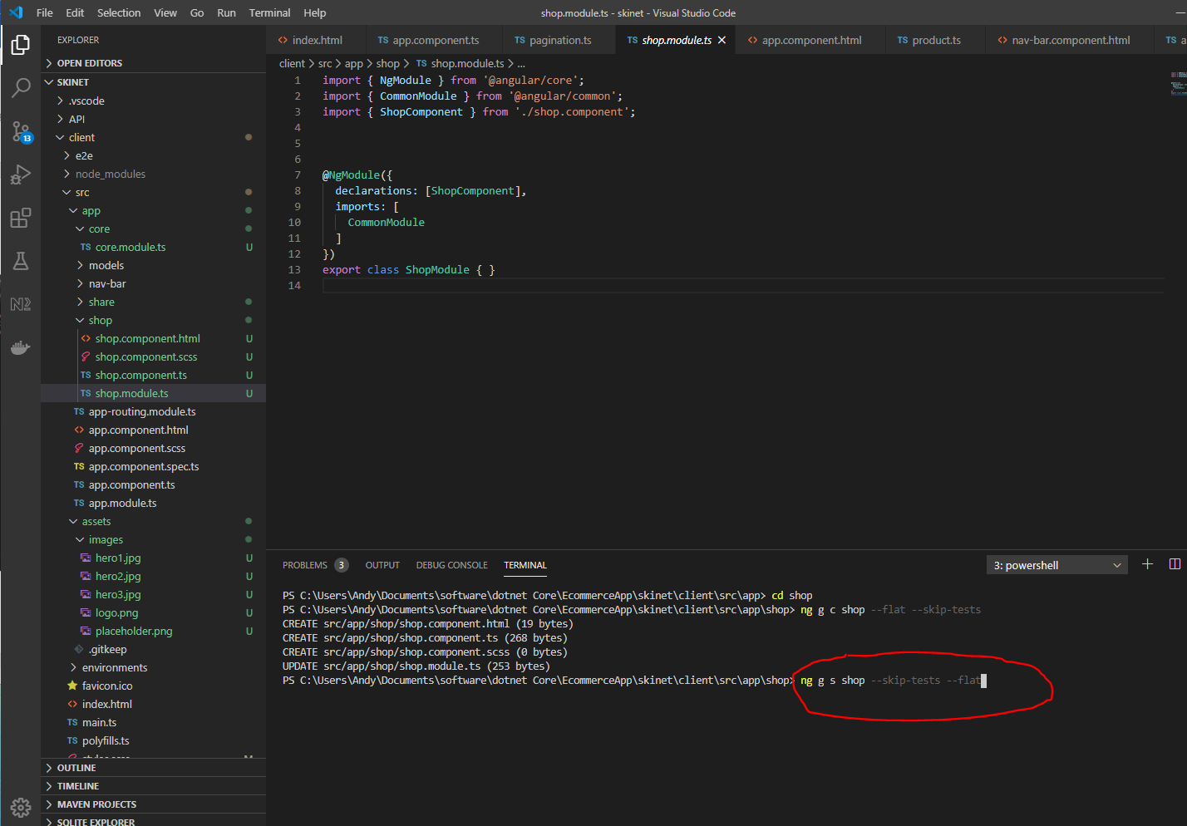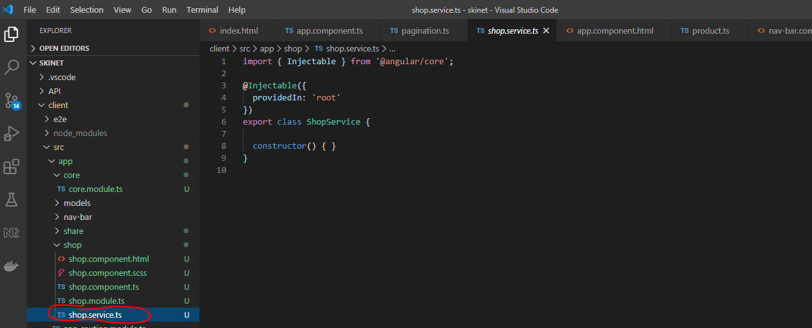

Now create a routing module in the ‘shop’ folder:-

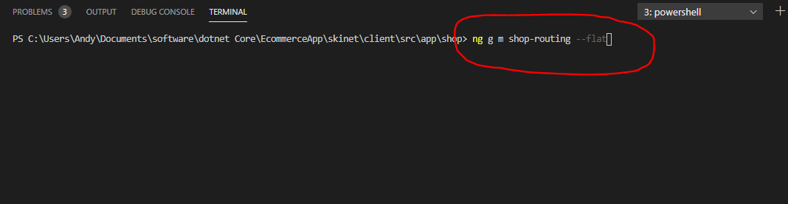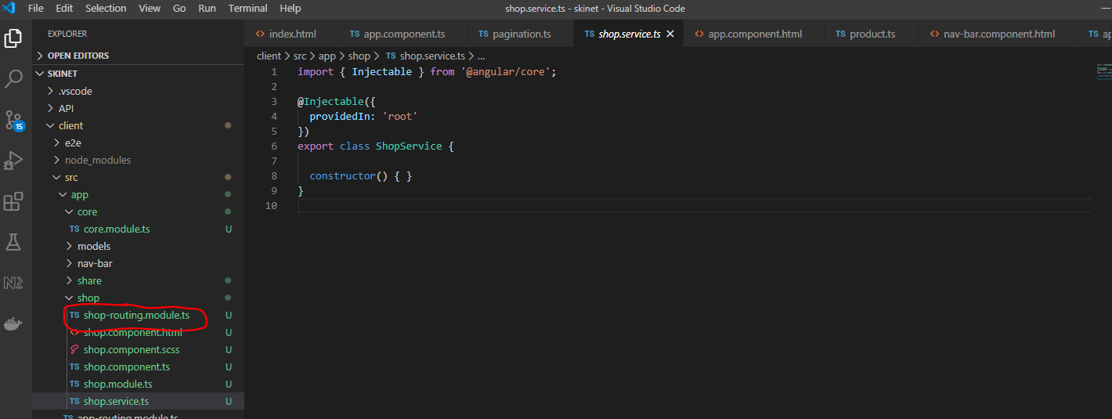

Core Module:-

This is used for singletons. So move ‘nav-bar’ component folder inside of the ‘core’ folder:-

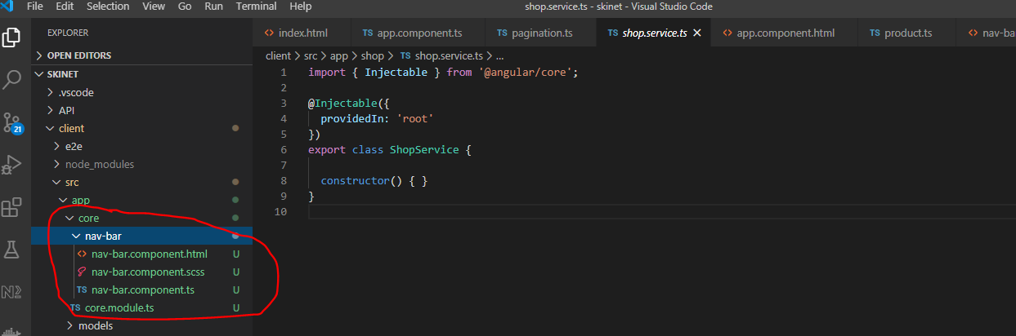

Add this to core.module.ts:-

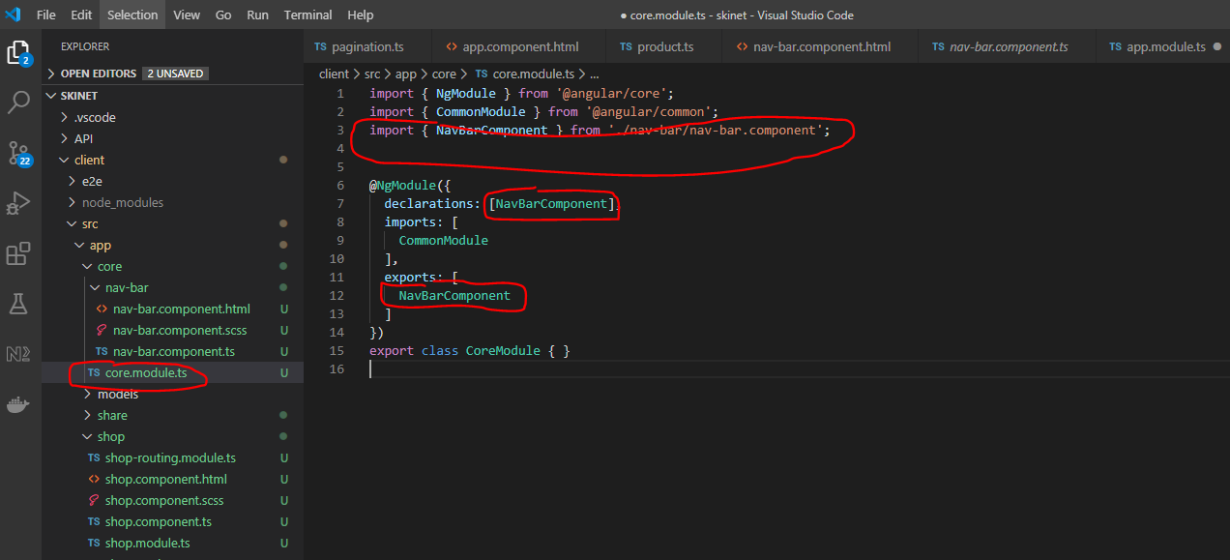

Remove reference to NavBarComponent from ‘app.module.ts’.

Now, move the ‘models’ folder into the ‘shared’ folder:-

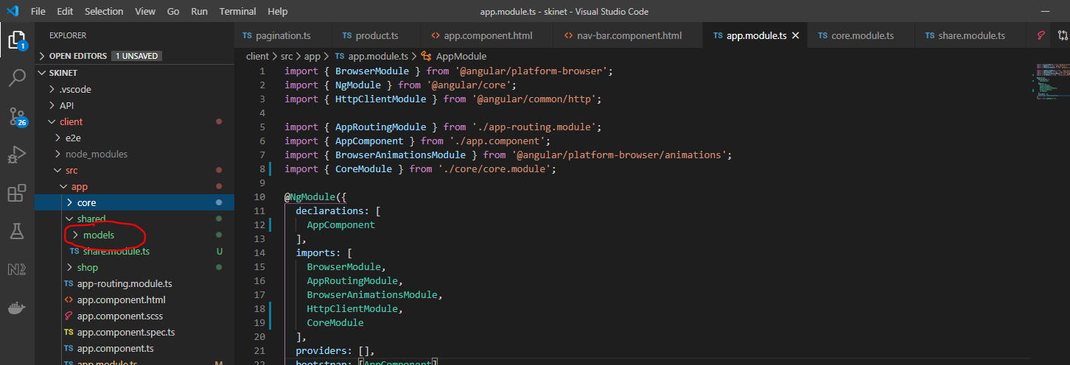

**Angular Services**

Angular services are singletons. That means they are always available. They are never destroyed.

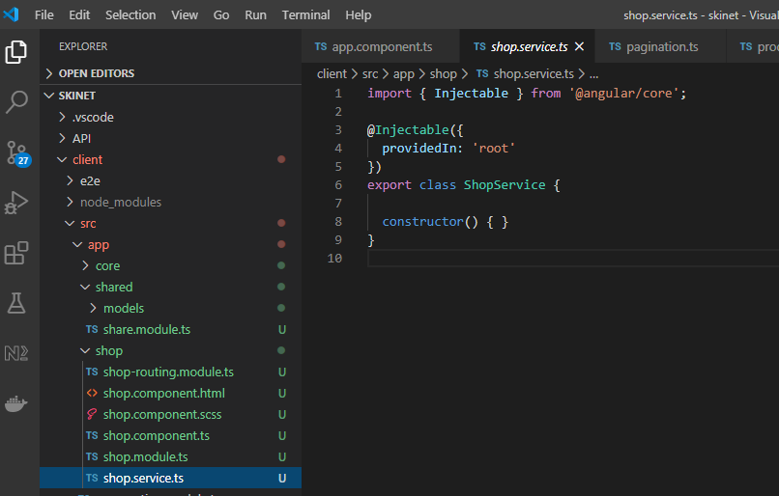

Add this:-

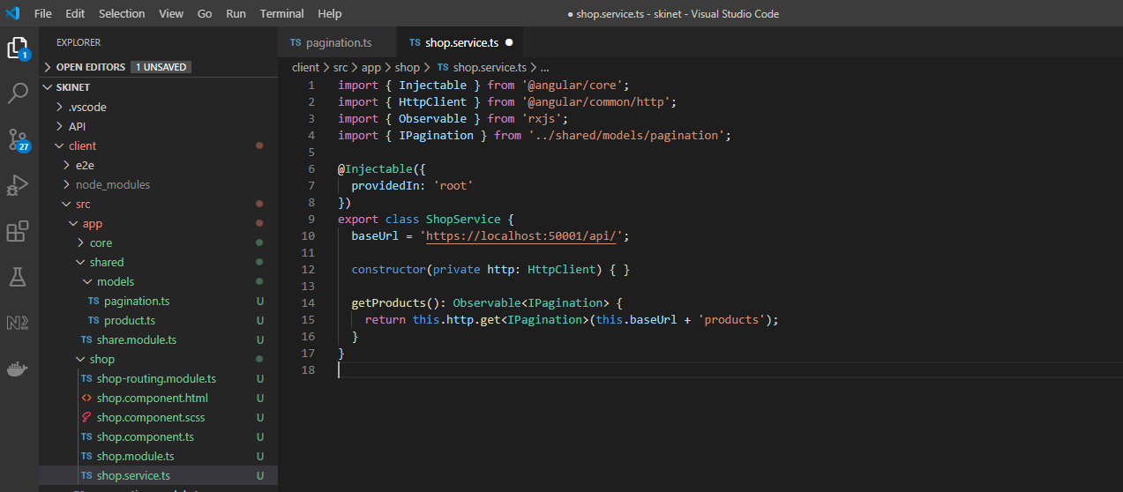

Consume the ShopService in the ShopComponent:-

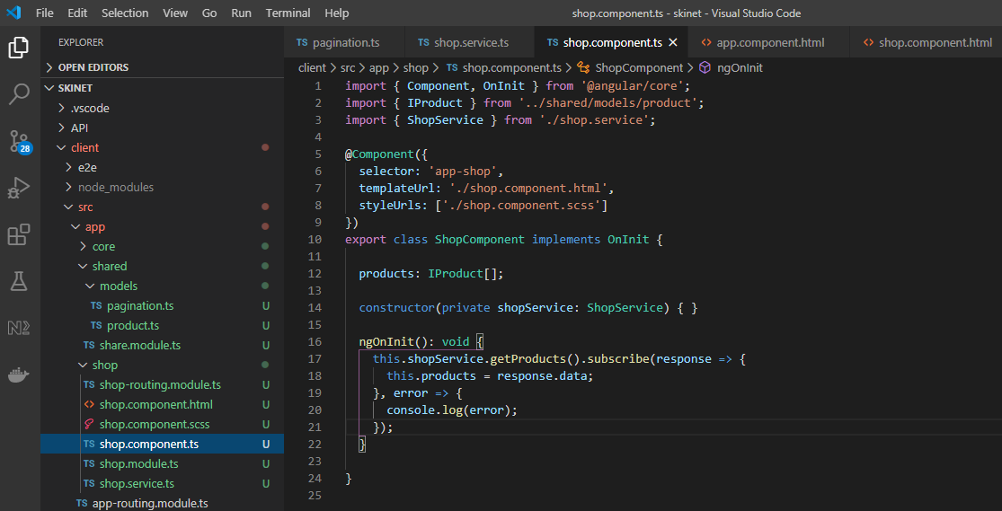

Add this html to the shopcomponent:-

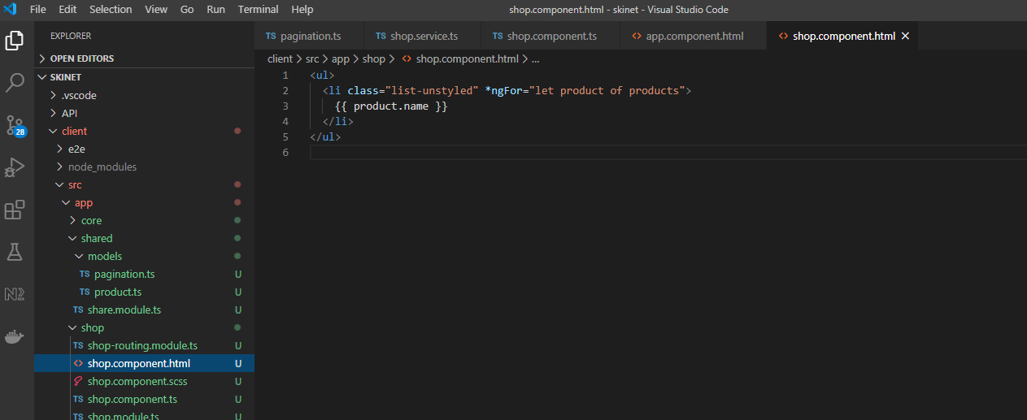

Add shopModule to app.module:-

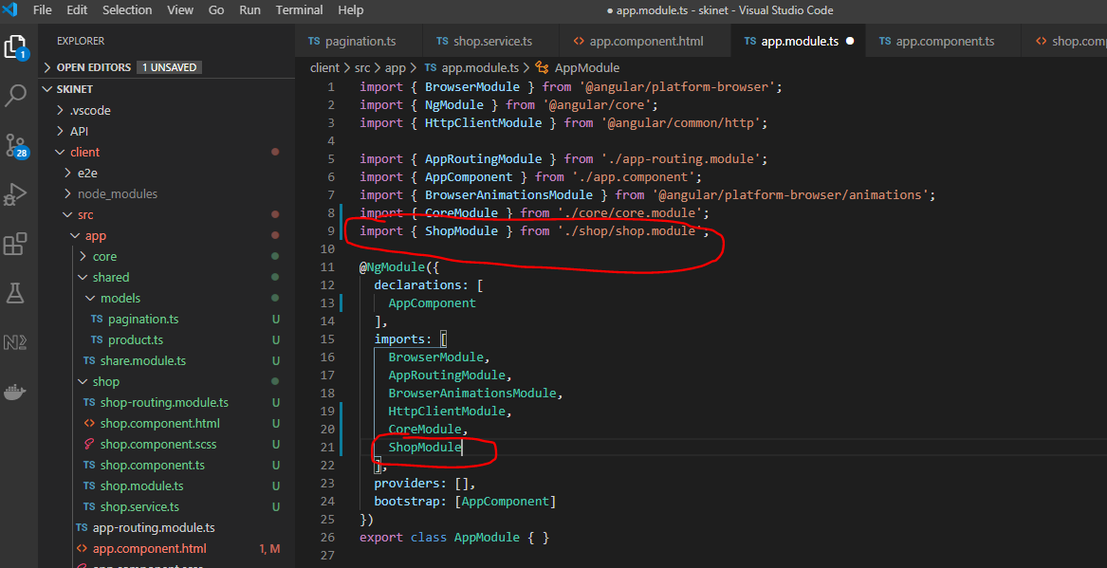

Export the shop.component from the shop.module:-

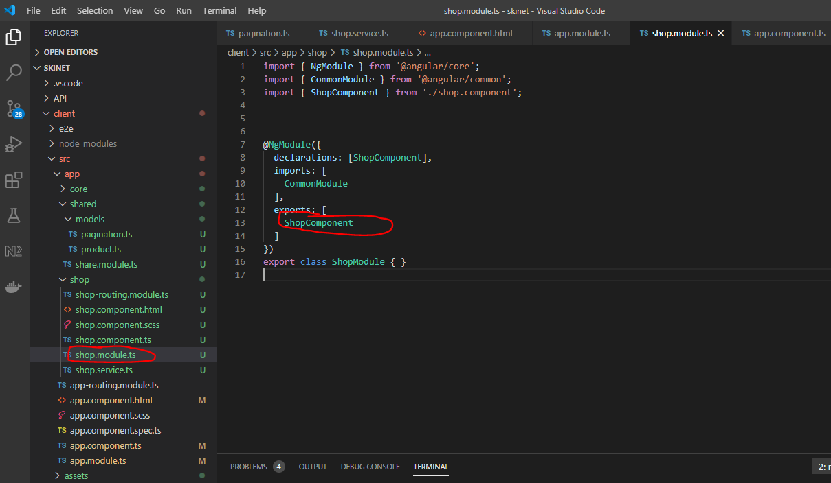

See products now appearing on page:-

**Create Website Layout**

Go to Bootstrap:-

<https://getbootstrap.com/docs/4.5/examples/album/>

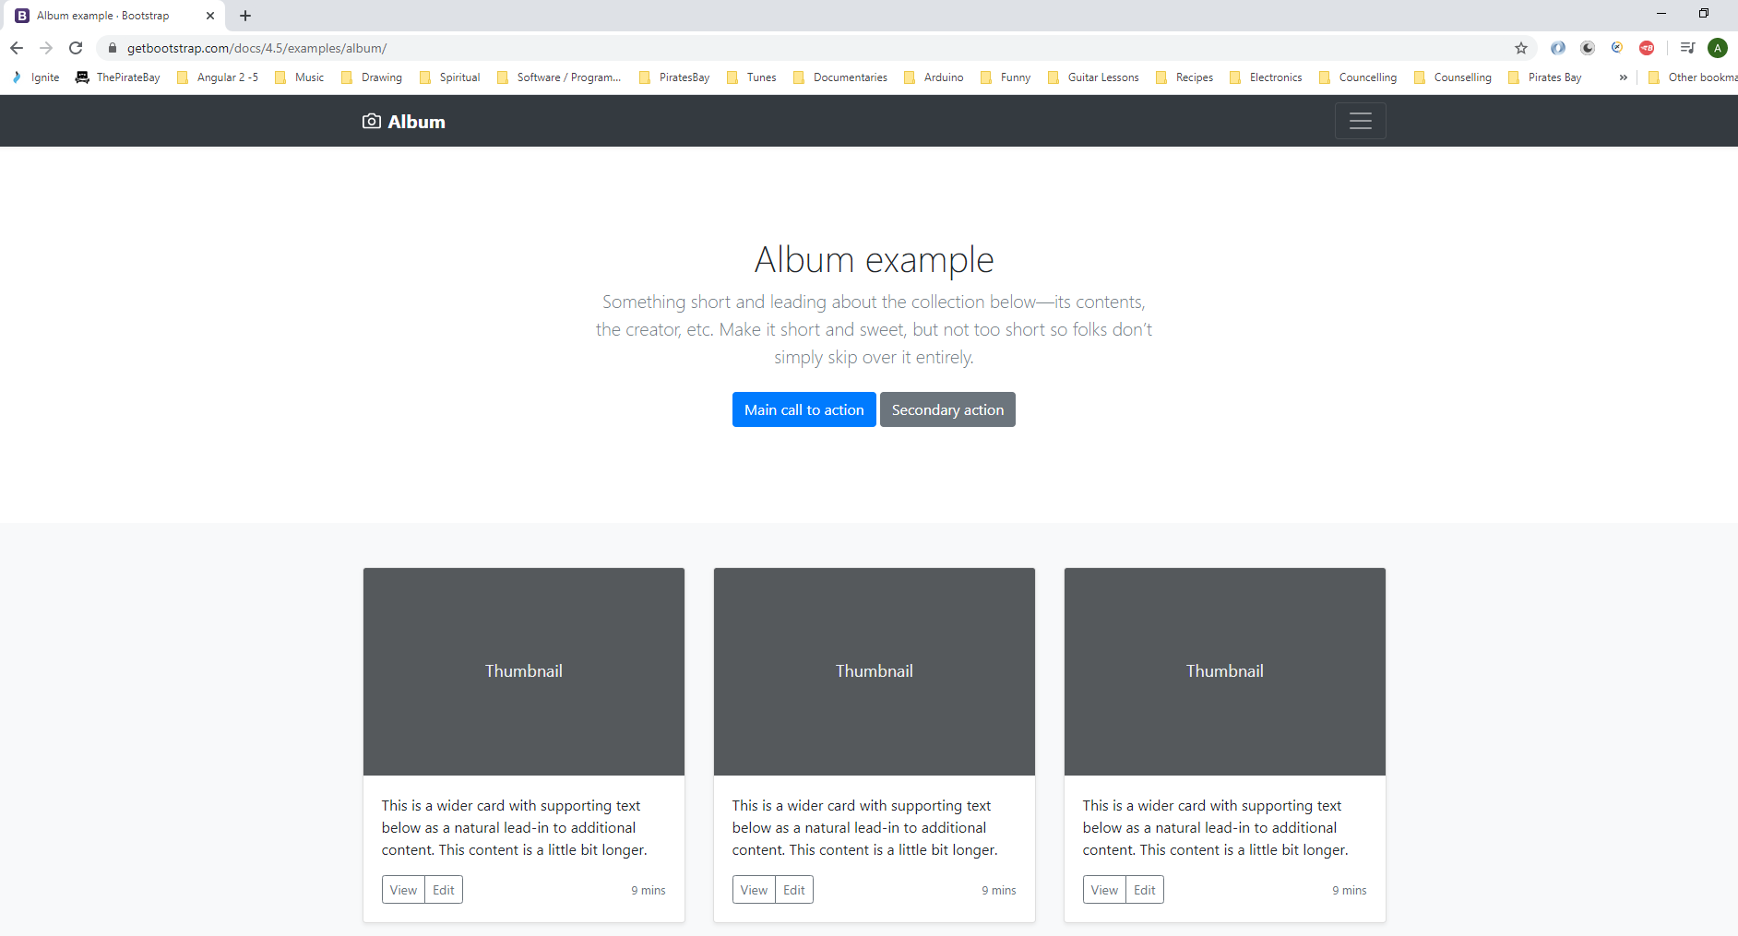

Copy from here i.e. right click the highlighted section below and choose ‘Copy element’:-

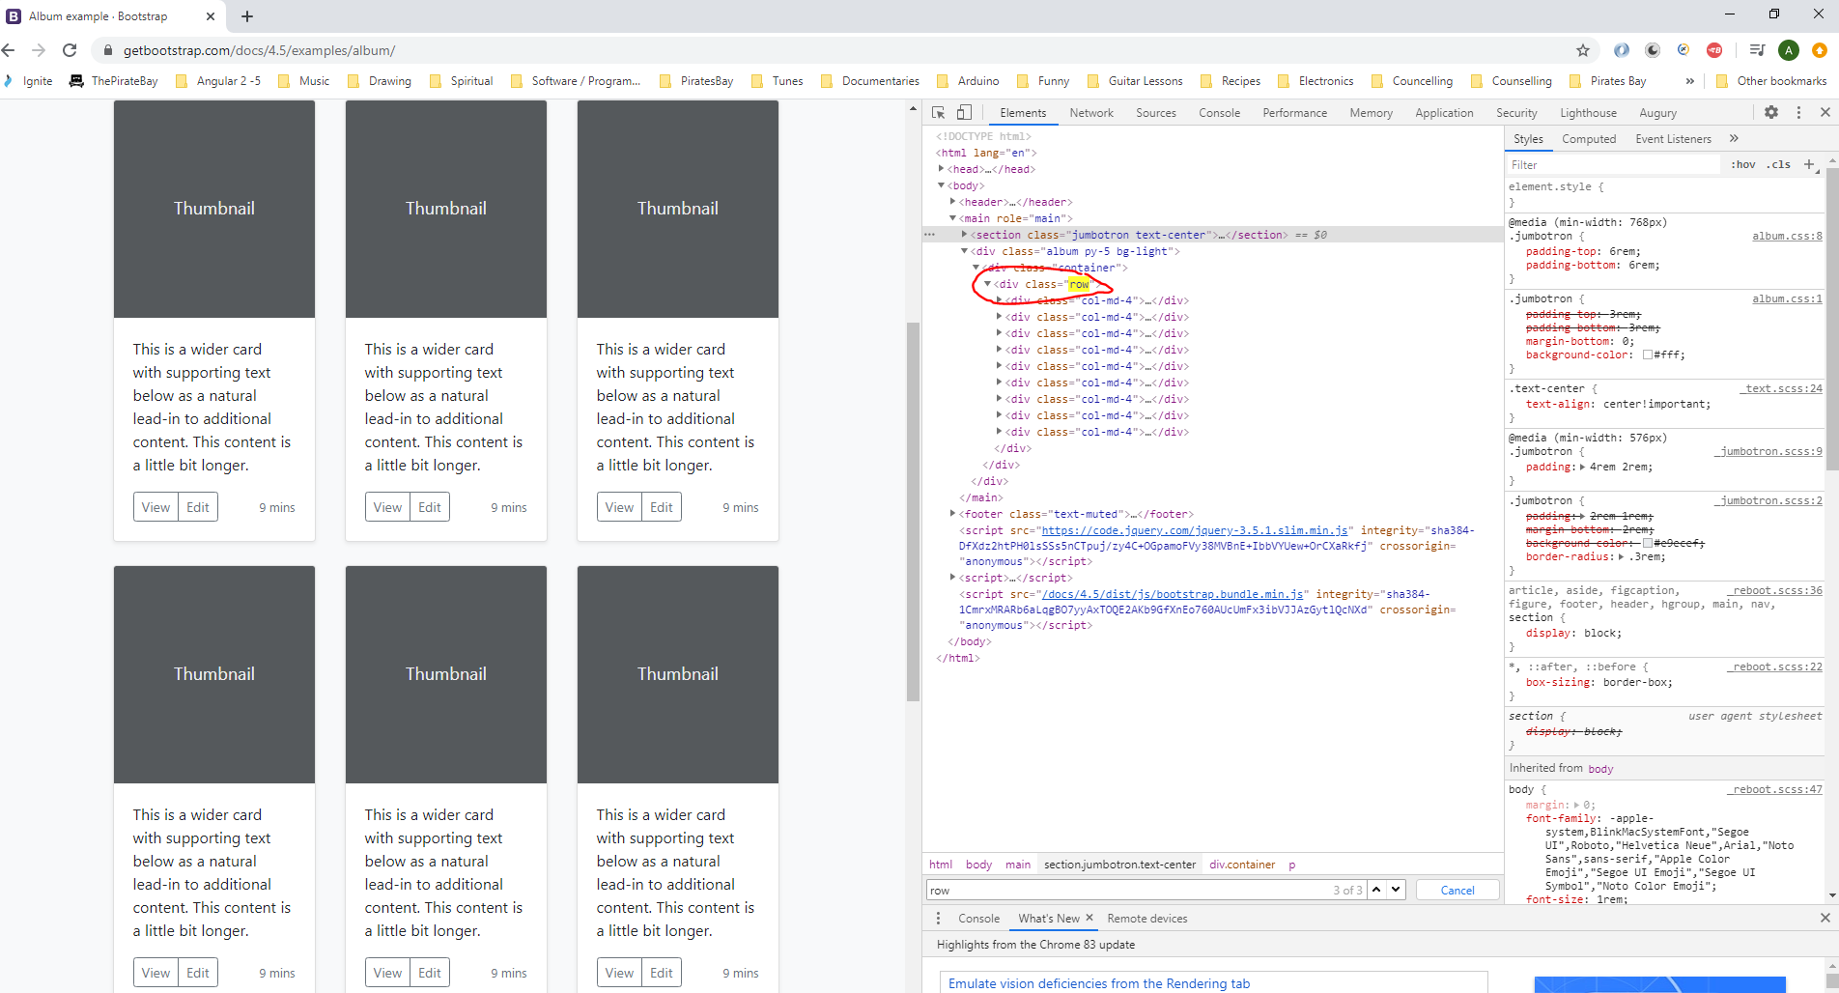

Paste here:-

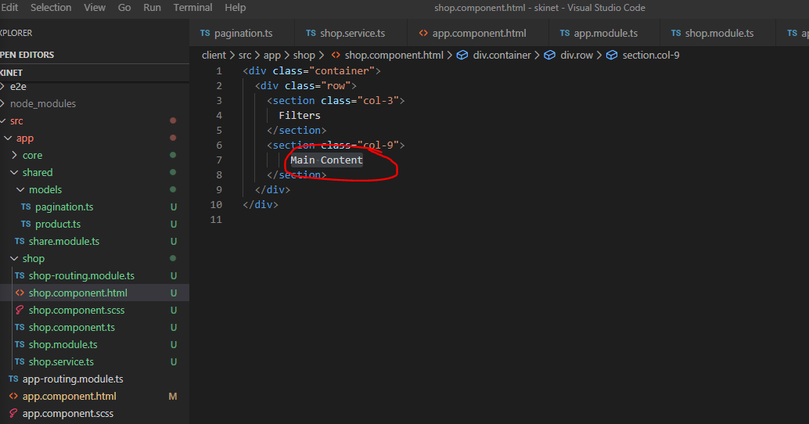

Now website looks like this:-

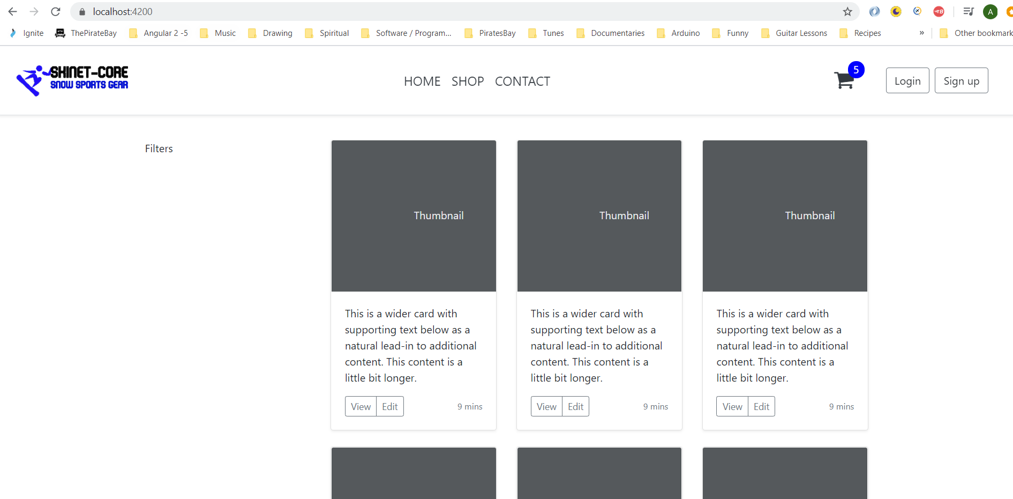

Now go here:-

<https://getbootstrap.com/docs/4.5/components/list-group/>

Copy this:-

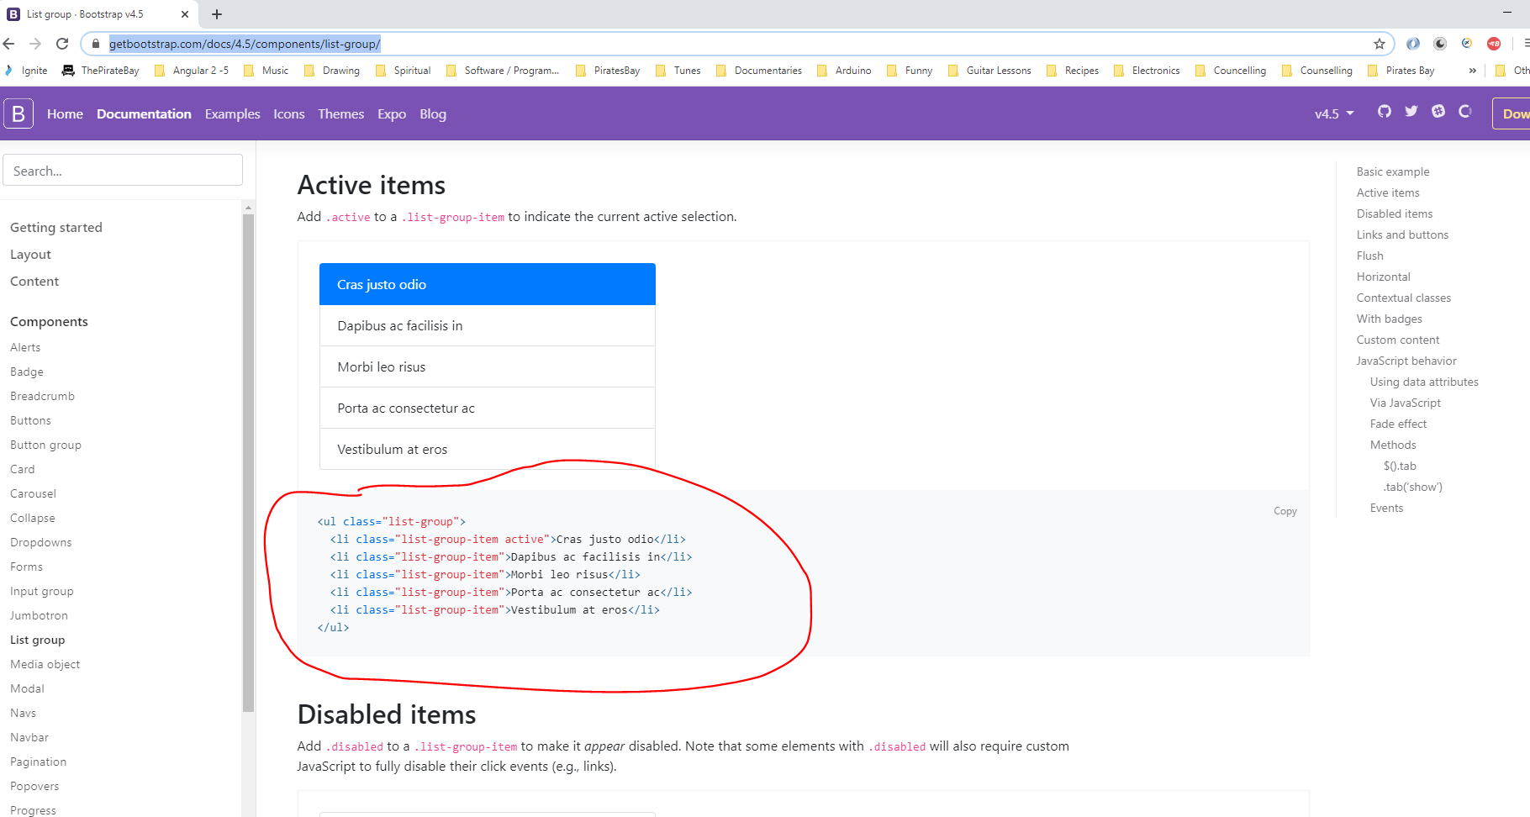

Paste here:-

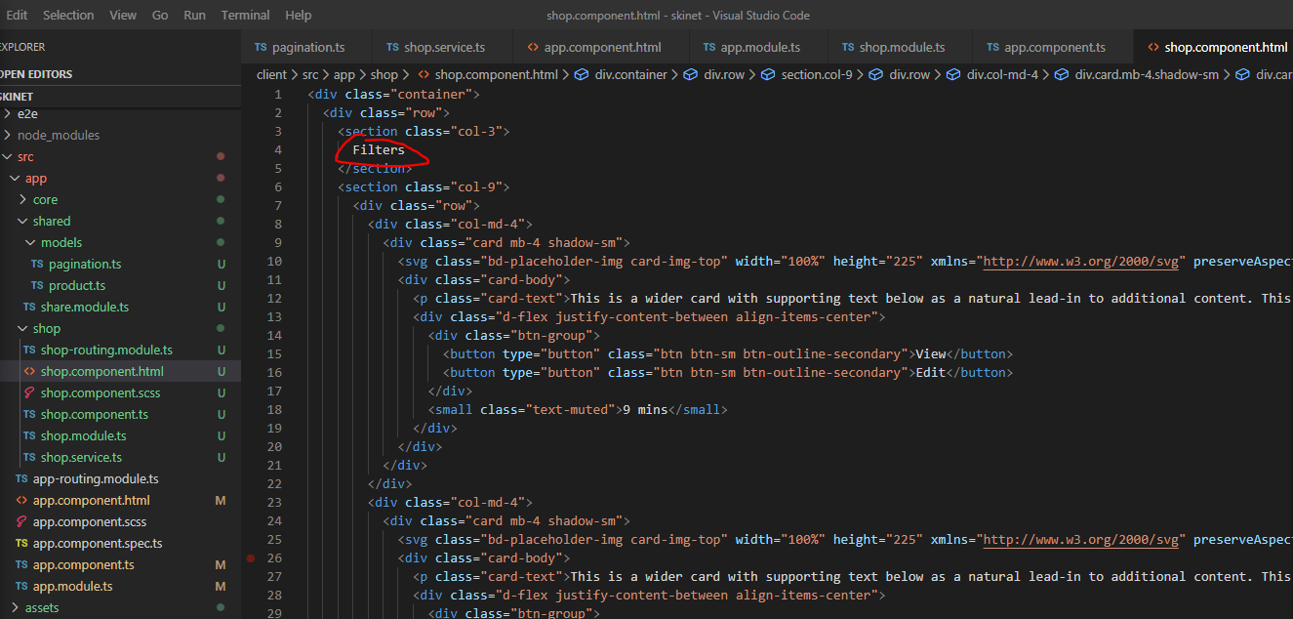

mt-2 = margin top of 2

ml-3 - margin left of 3

my-2 - margin at the top and bottom of 2

mr-2 - margin right of 2

mb-2 - margin at the bottom of 2

pb-2 - padding at the bottom of 2

Create a new component to contain all the products i.e. these sections:-

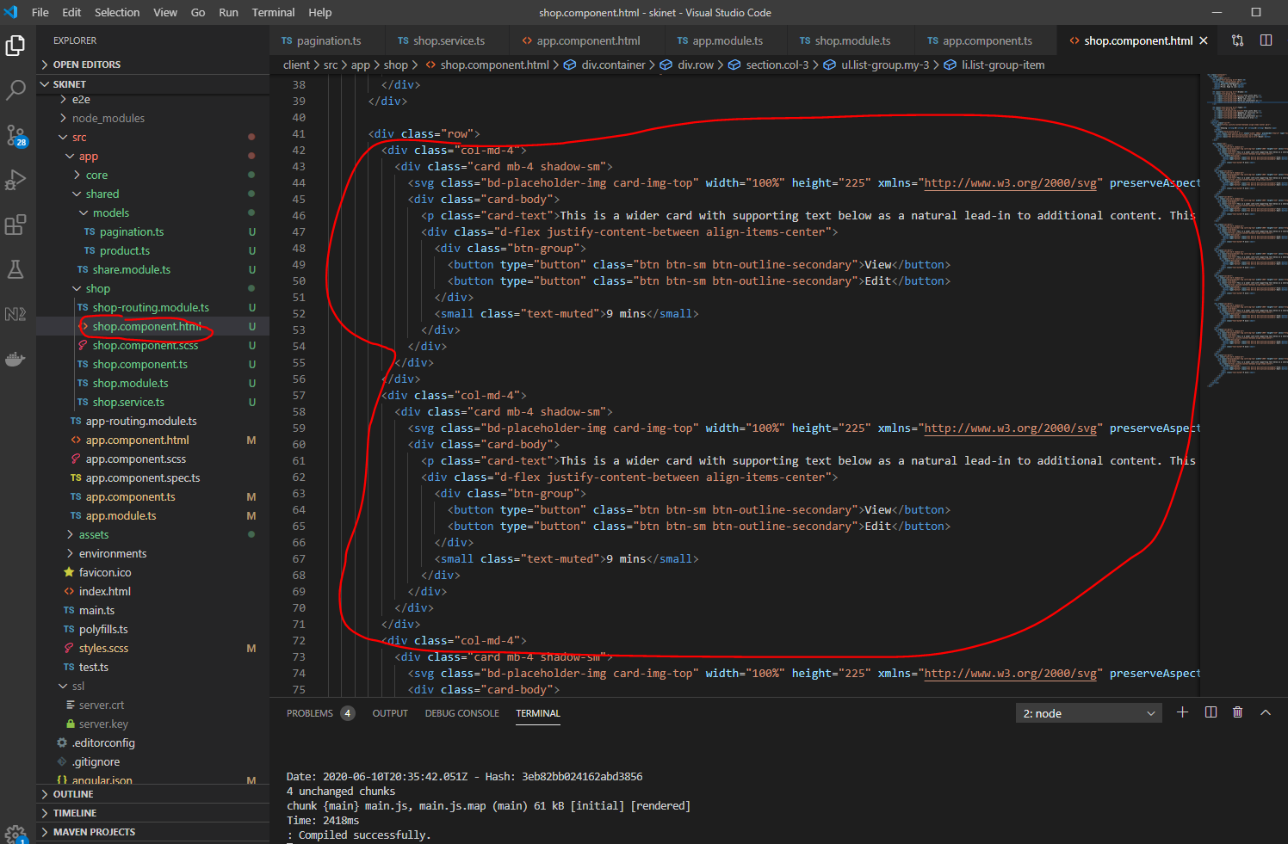

Create product-list component:-

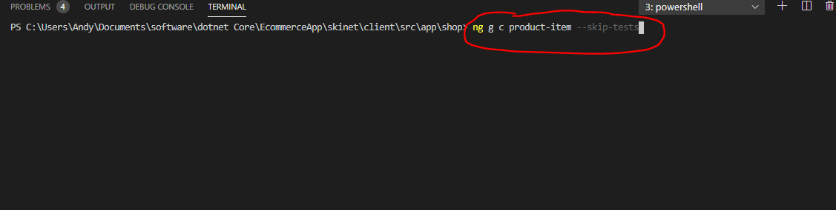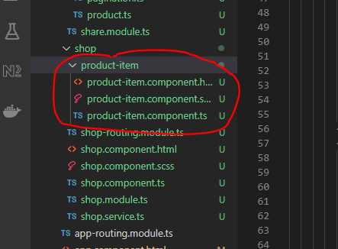

Change shop component to this:-

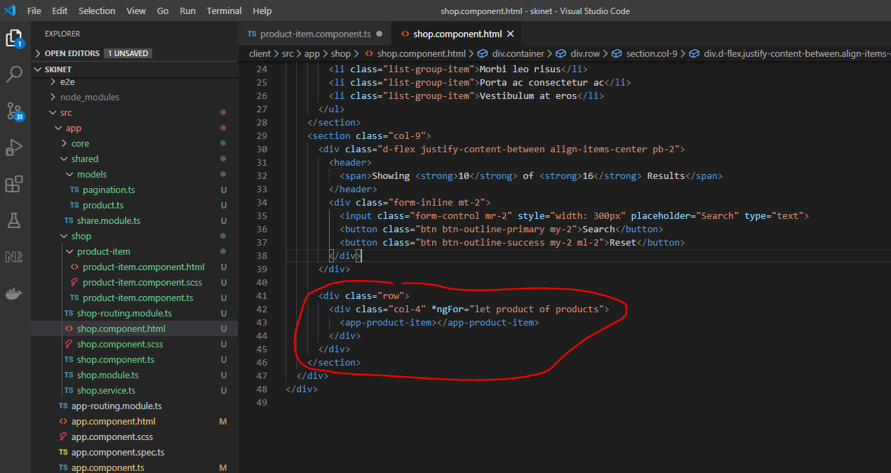

We are going to pass down the product object down to the child component (product-list.component.ts):-

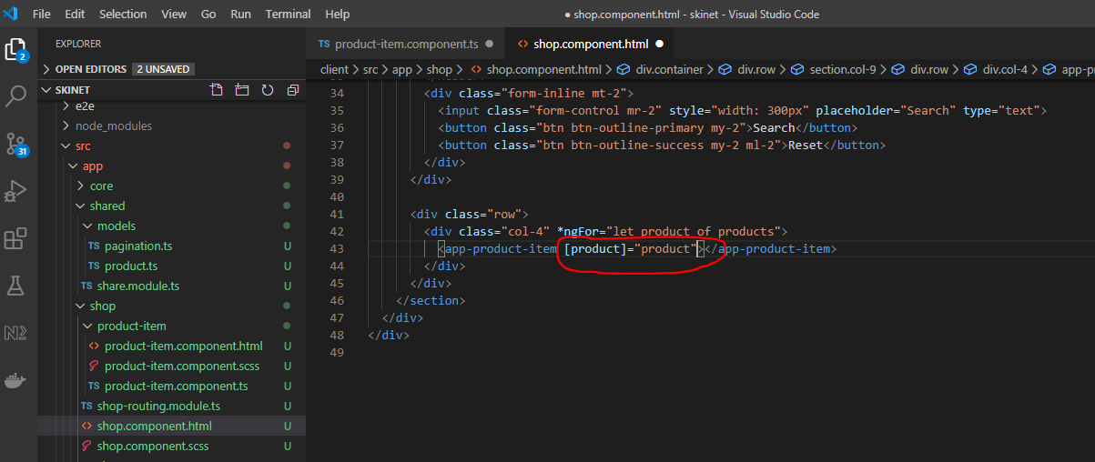

[product] - is the input product in the ‘product-list.component.ts’ component

product - is the product from “let product of products”

Actually, to make clearer change:-

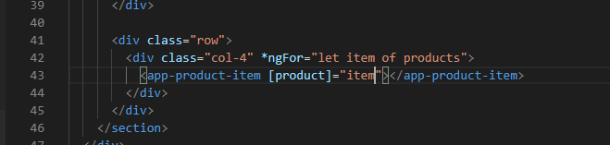

Now clean up the ‘product-list.component.ts’ component:-

h-100 - all card will have a height of 100

**Sort out Filtering**

Create two new interfaces in the ‘models’ folder for ‘Brands’ and ‘ProductTypes’:-

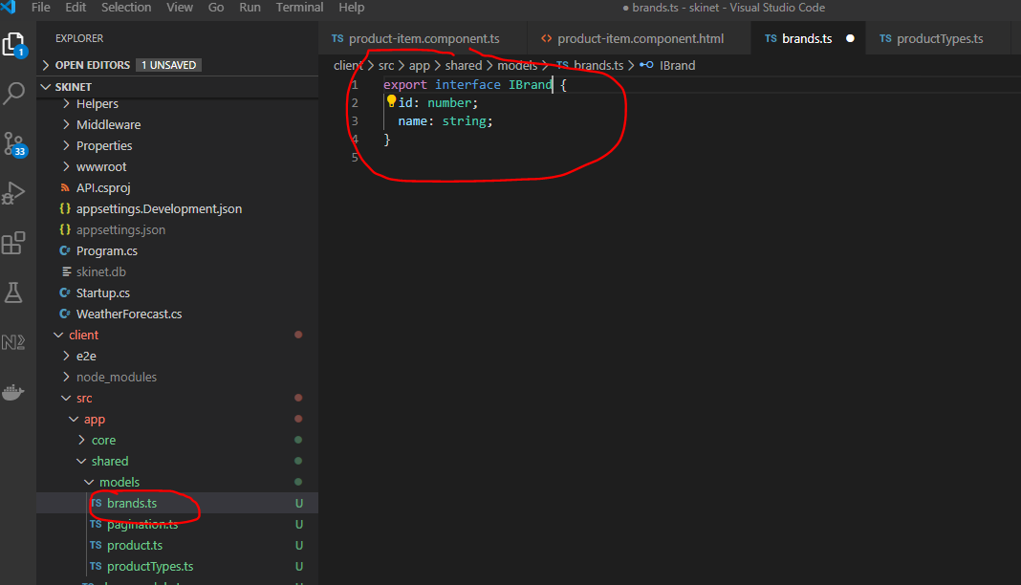

And

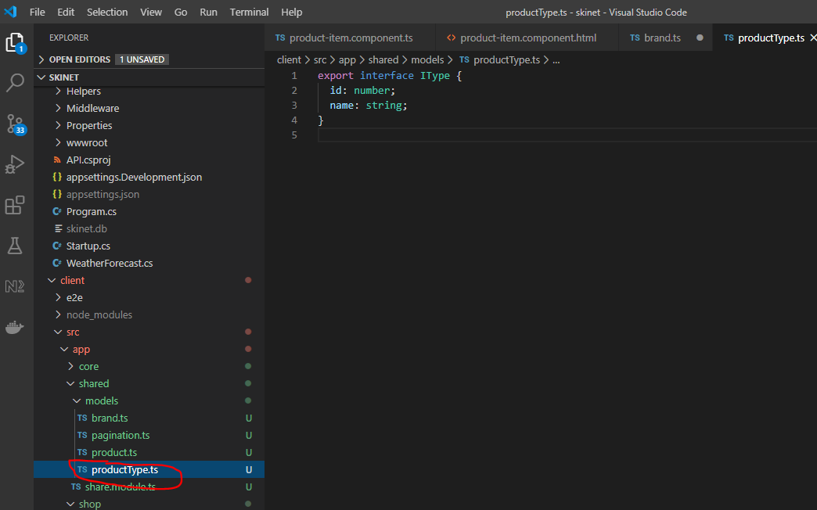

Add methods in the shop service now:-

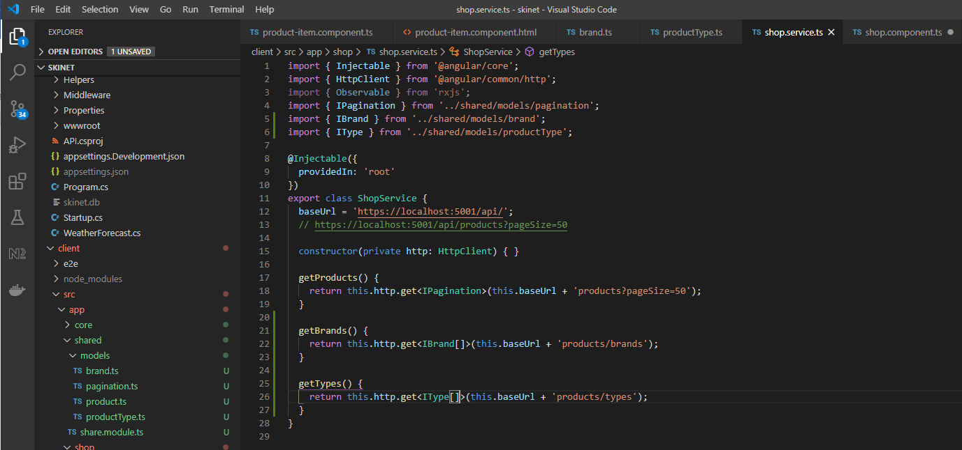

Update shop component:-

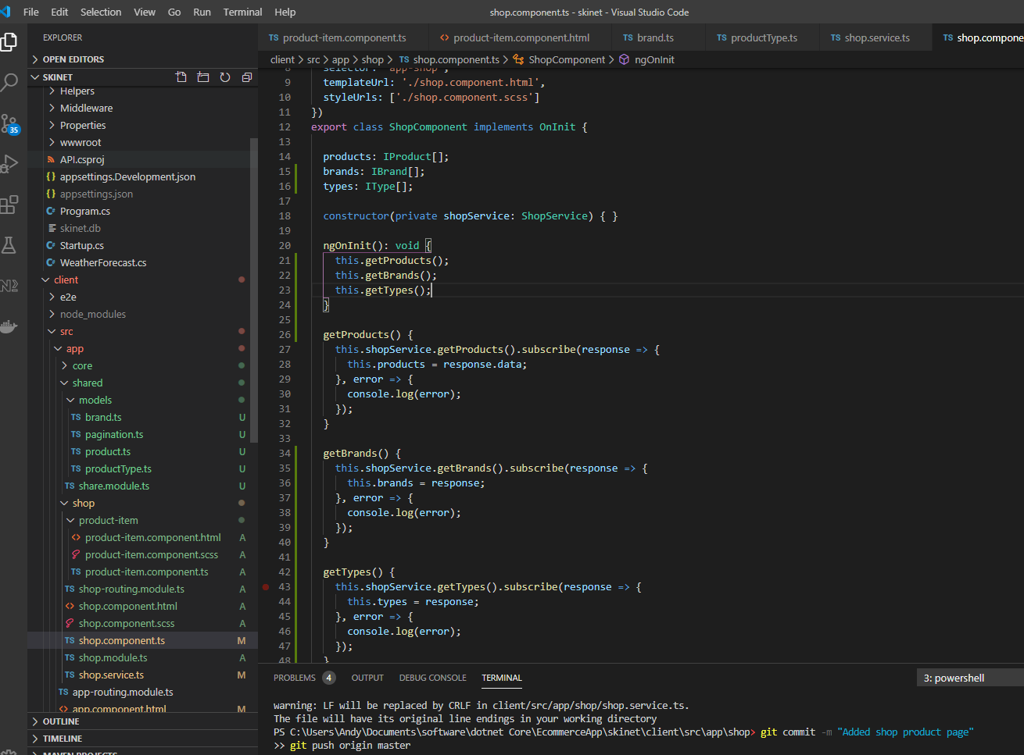

Now update html:-

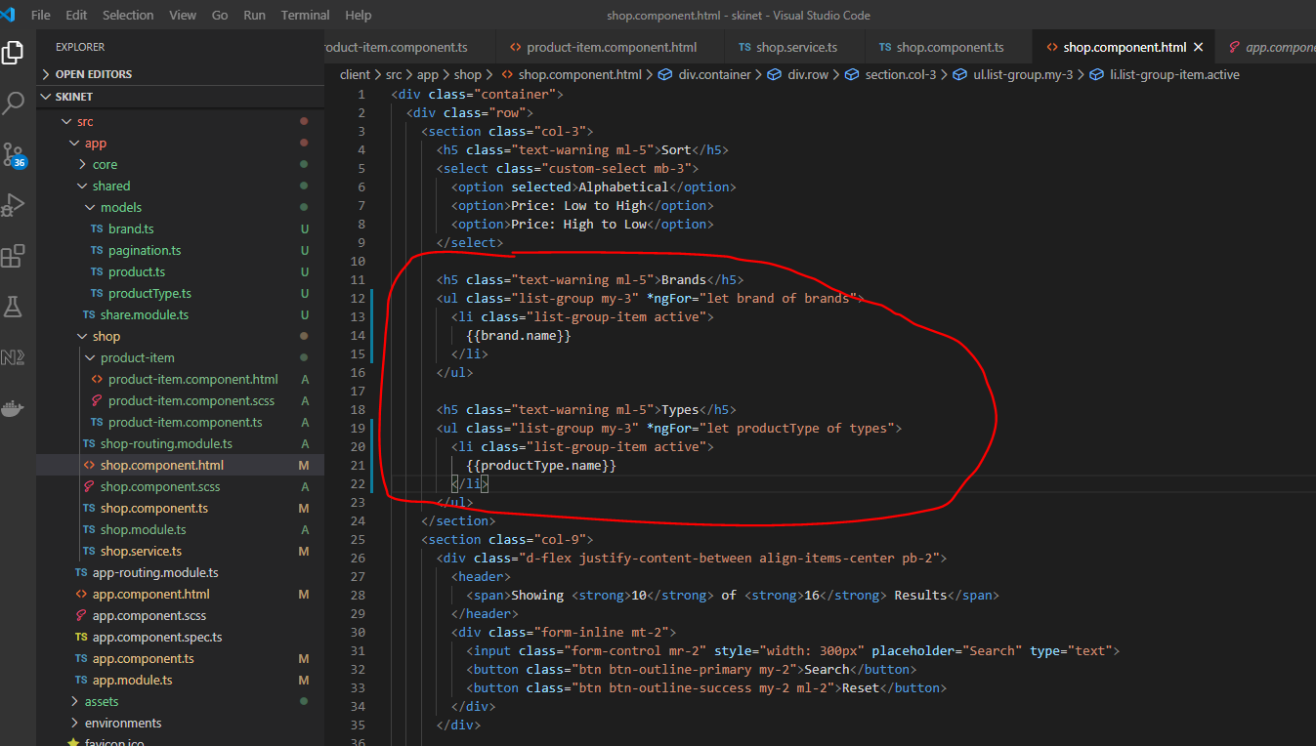

Update service to this:-

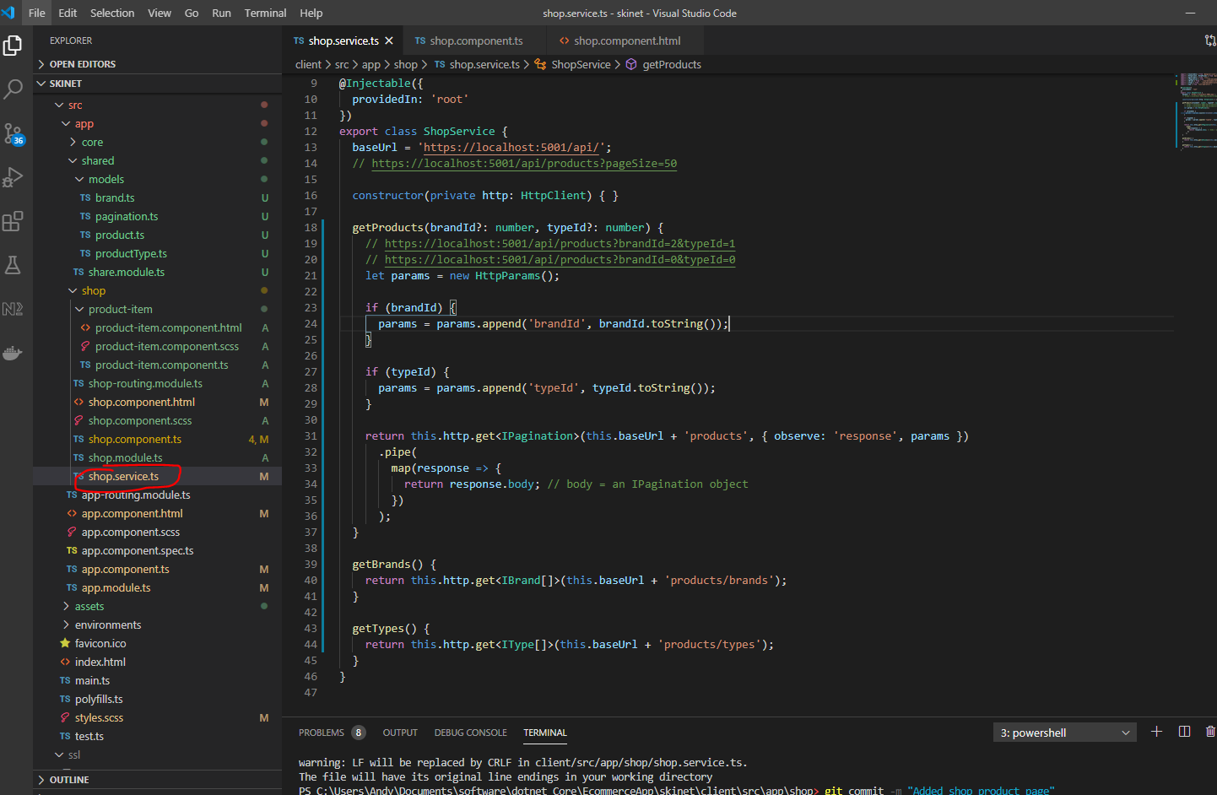

Update shop component:-

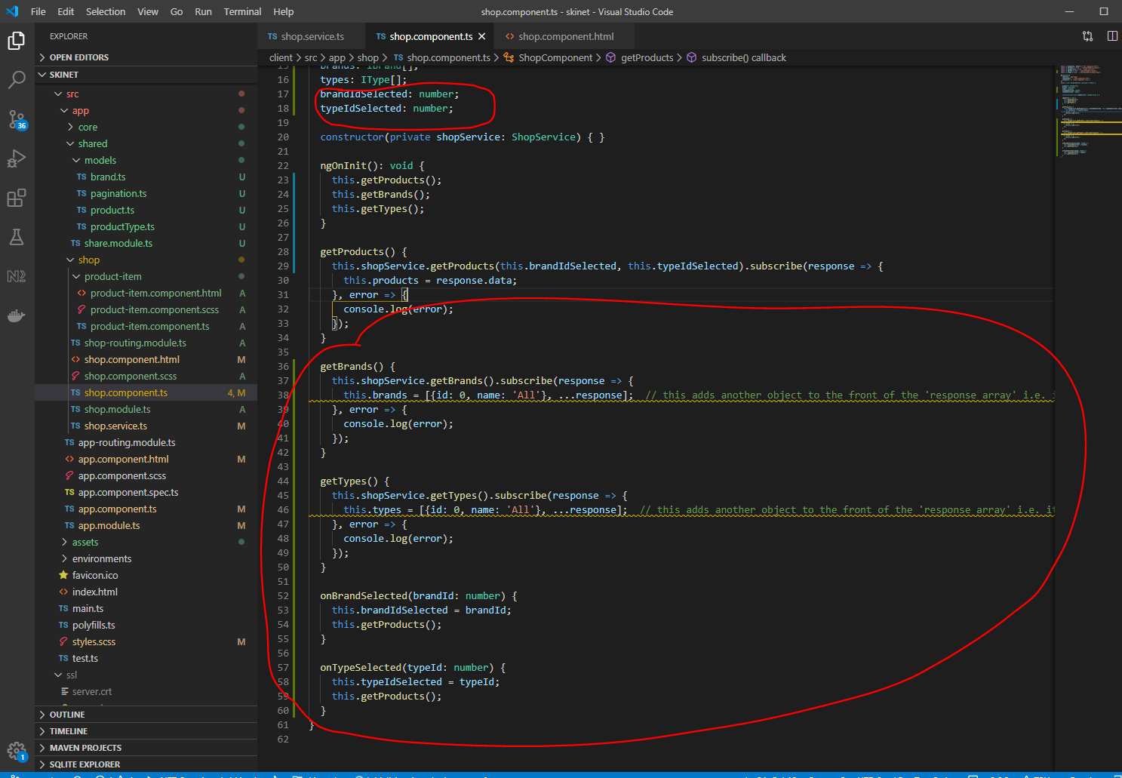

Add filter html:-

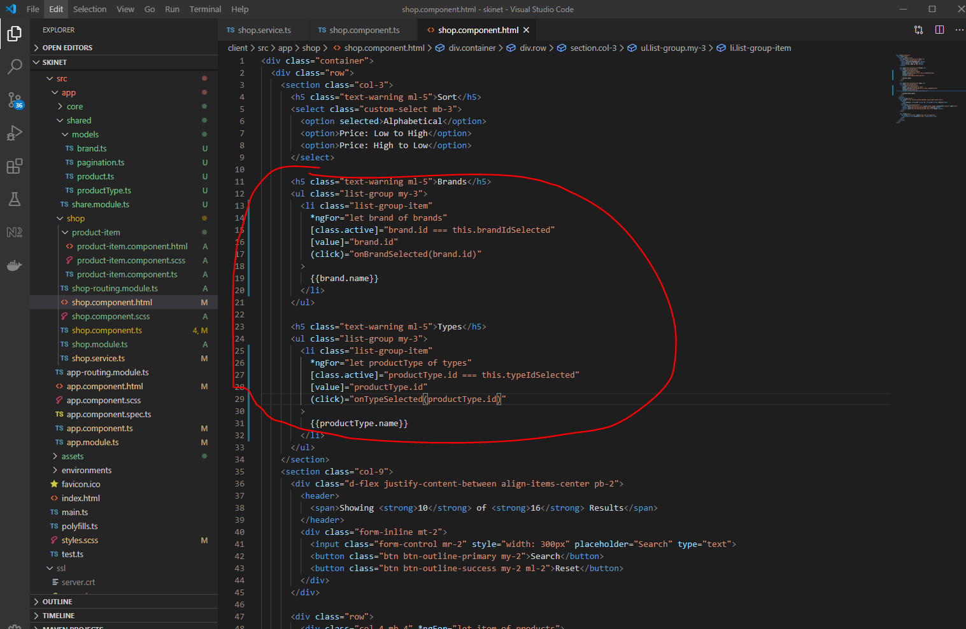

**Sort Functionality**

Add these properties:-

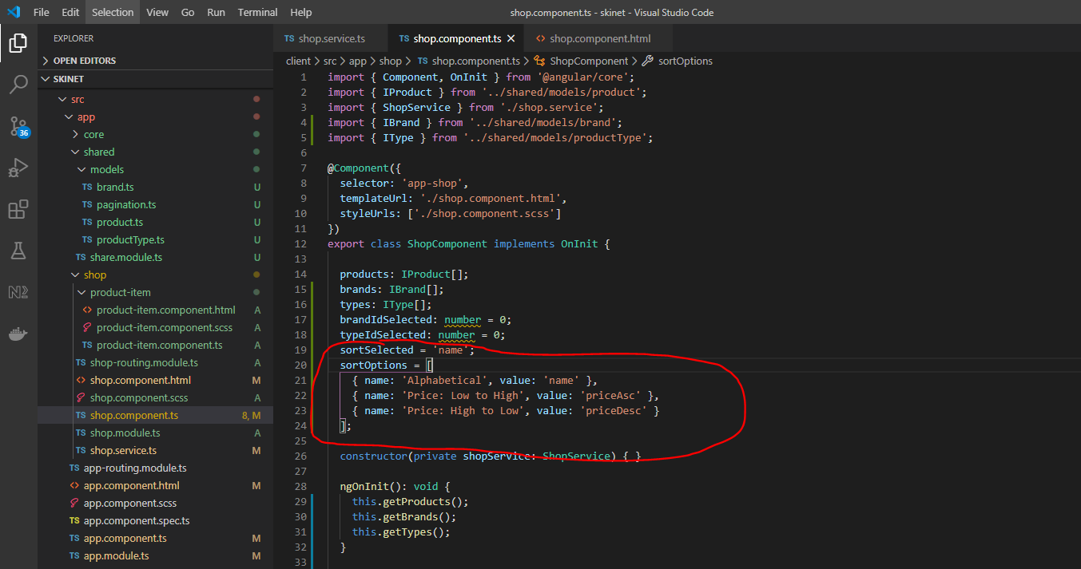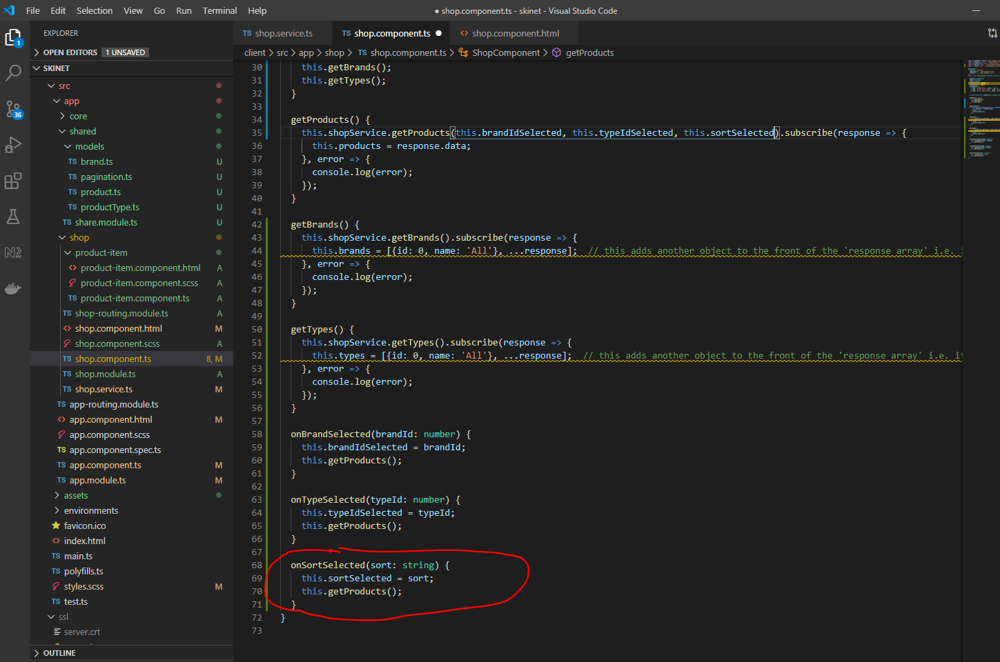

Update shop service:-

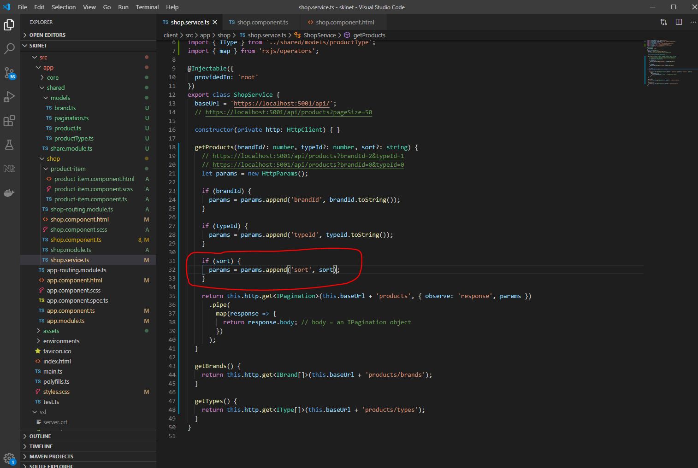

Update shop component html:-

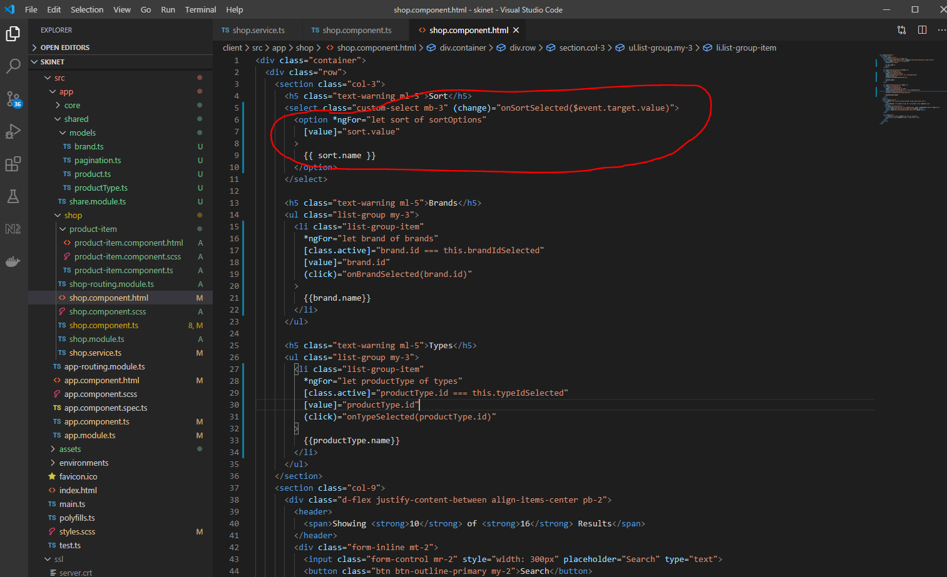

**Pagination**

Go to this webpage:-

<https://valor-software.com/ngx-bootstrap/#/pagination>

Import this:-

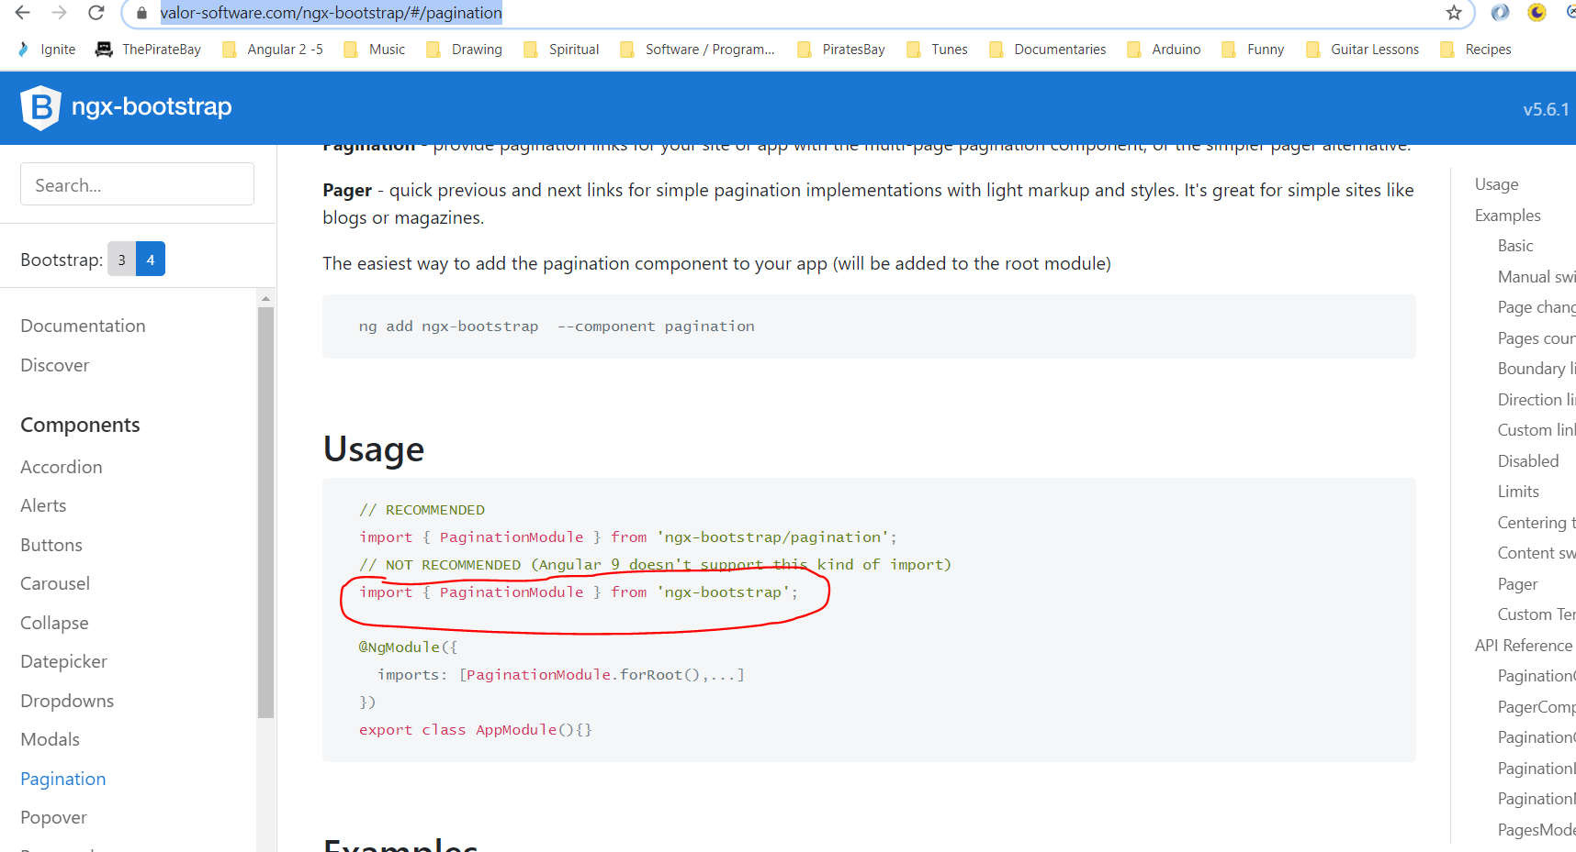

Add this to the ‘shared’ folder ‘shared.module.ts’:-

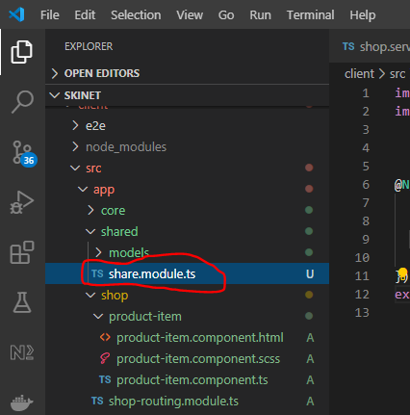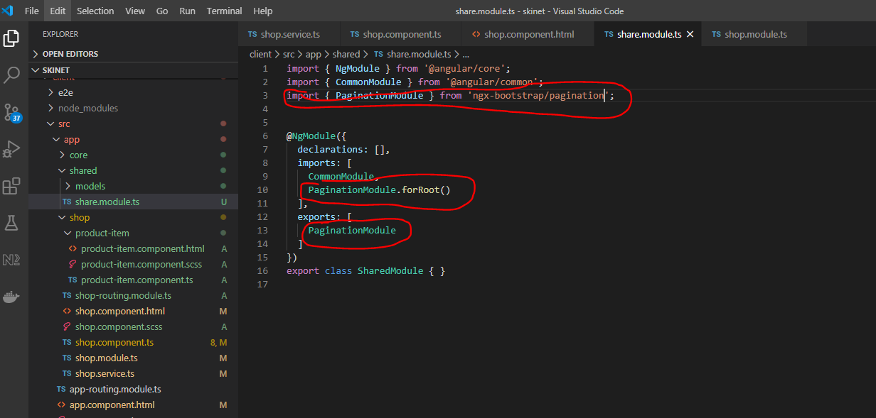

Now add reference to shared.module to the shop.module:-

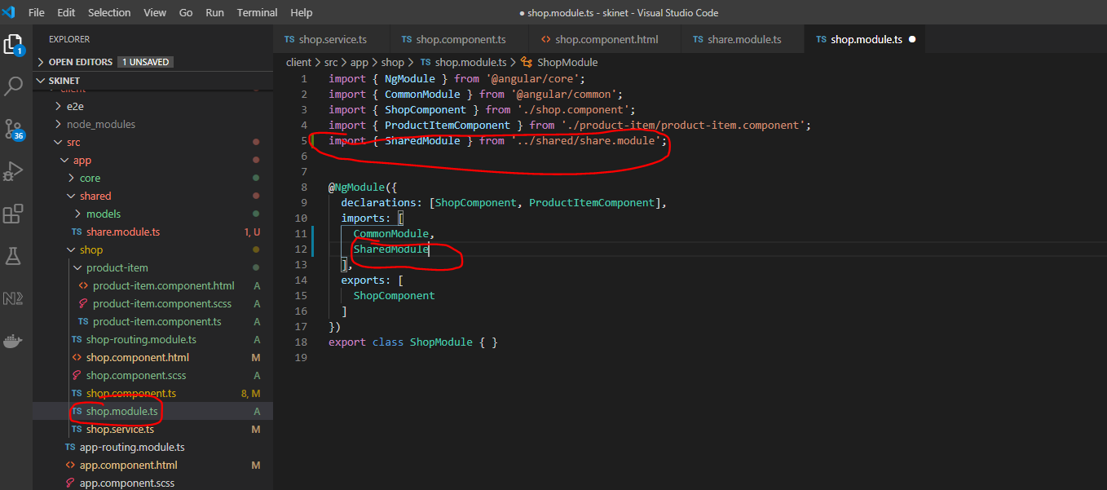

Use this:-

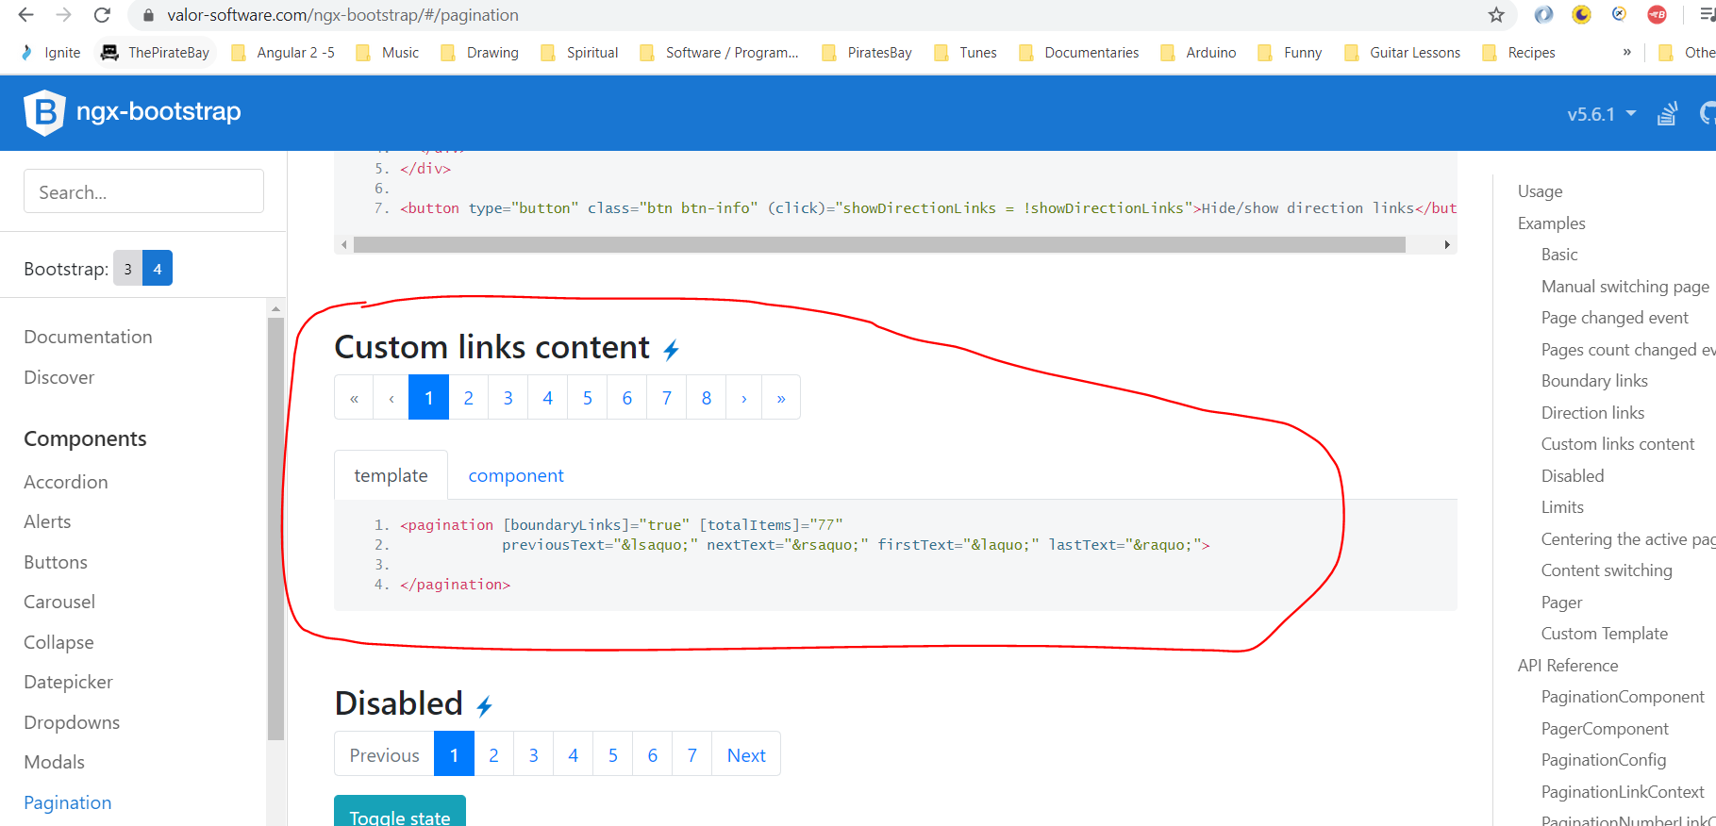

Paste here:-

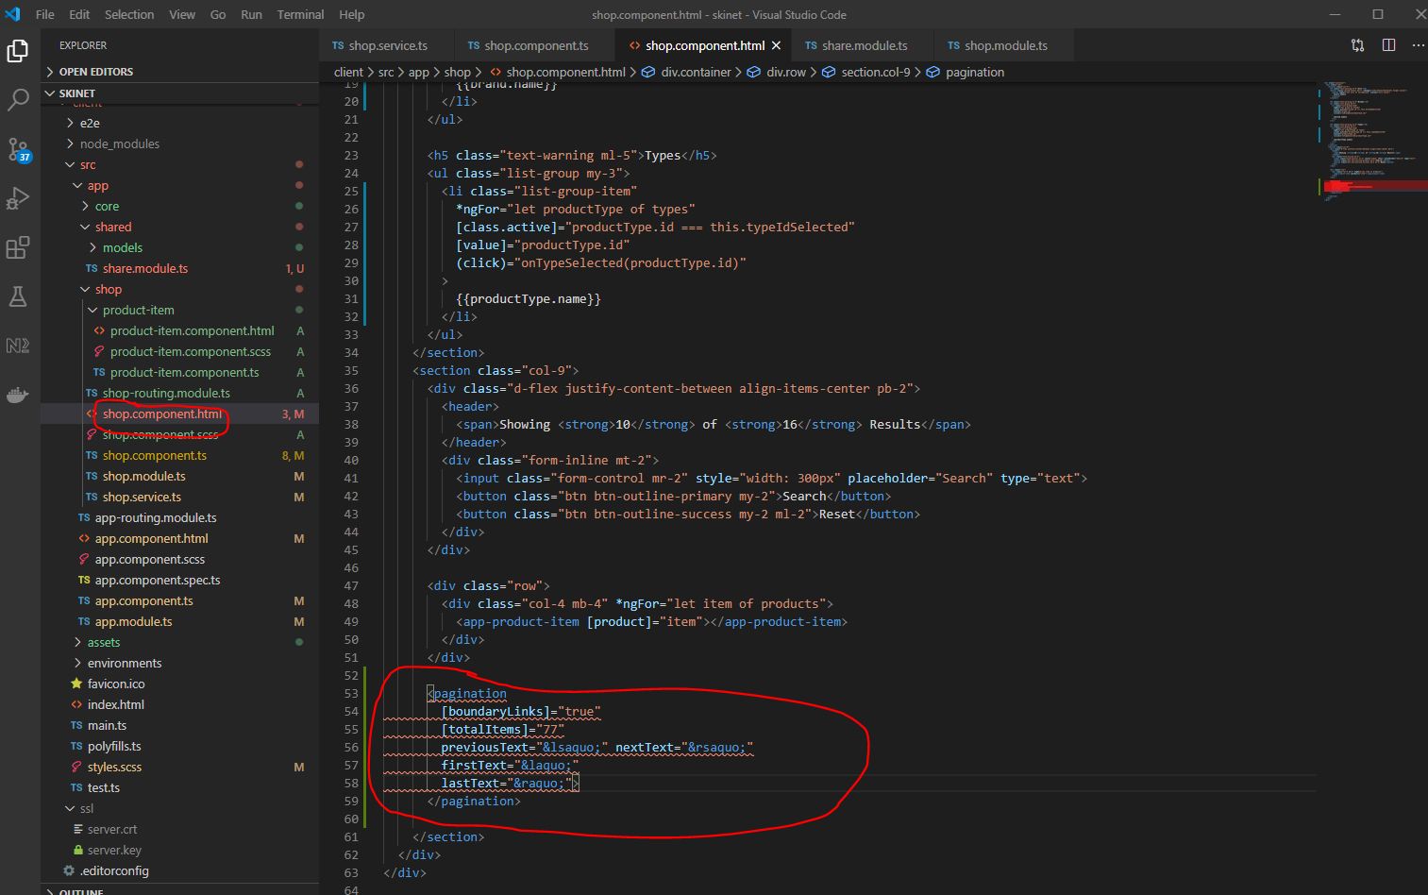

Tidy up using Flex Box:-

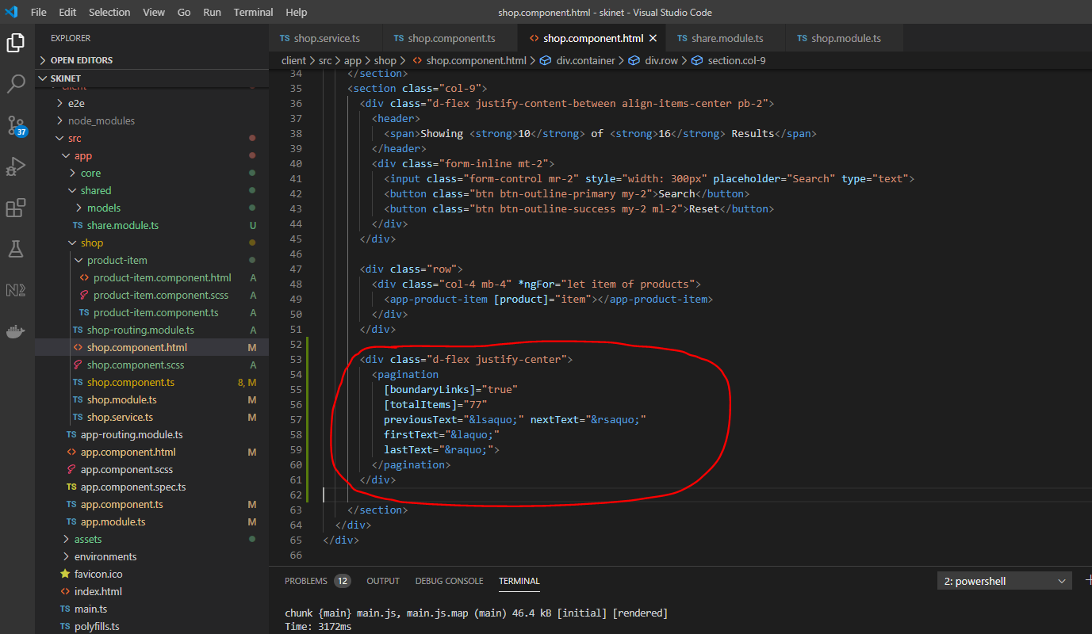

Create a new ‘shopParams’ class and remove the following properties from the shop component:-

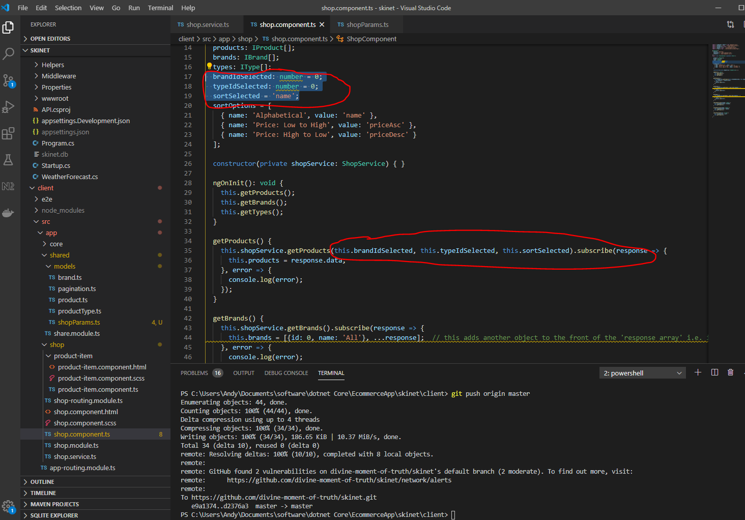

ParamsClass:-

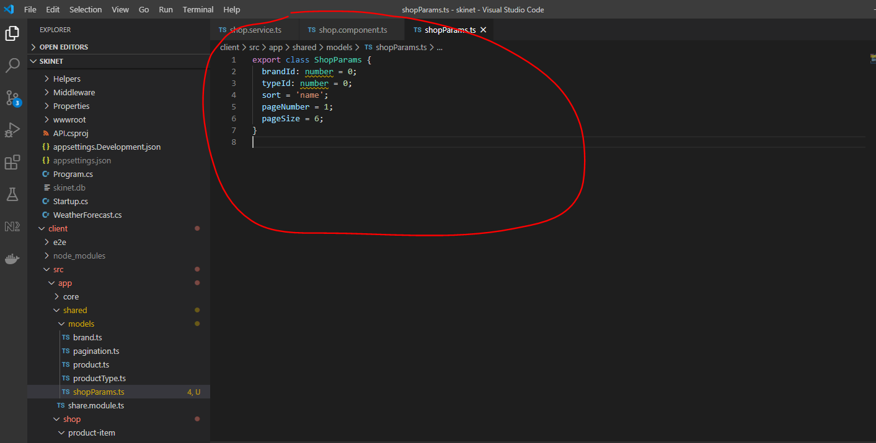

Now update the shop service and shop component:-

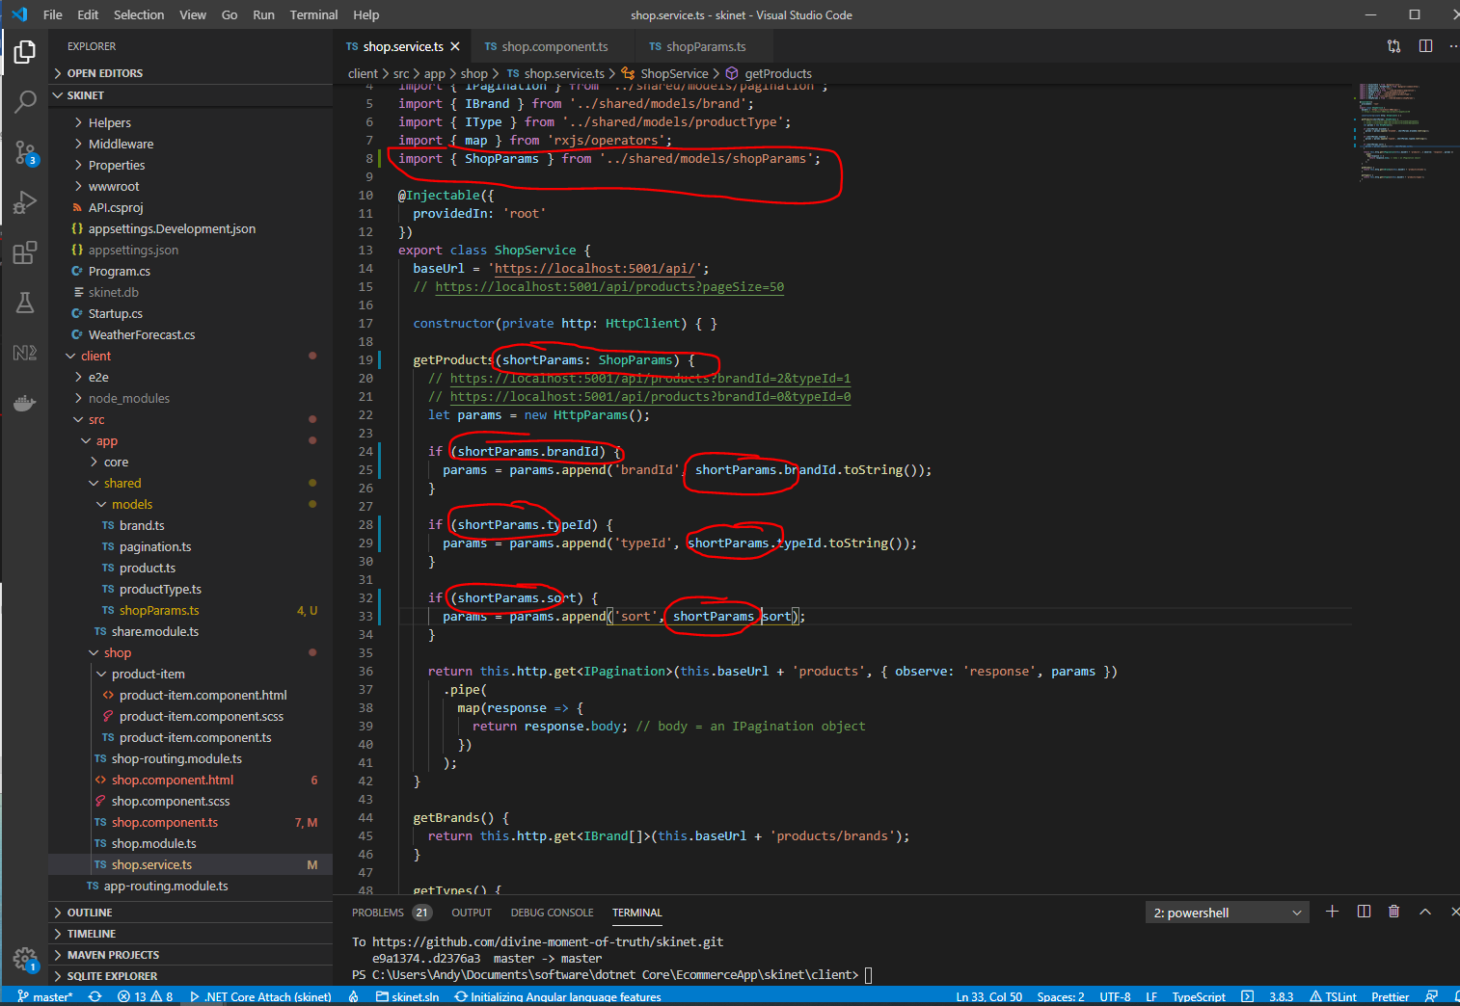

And

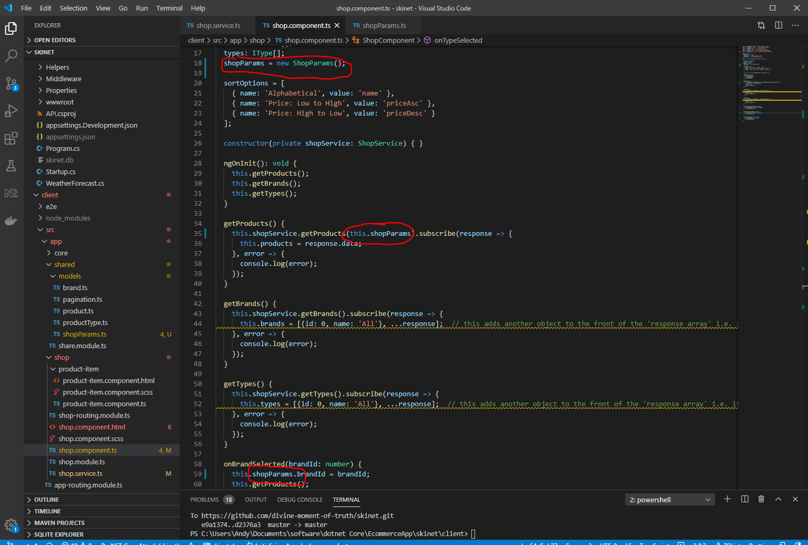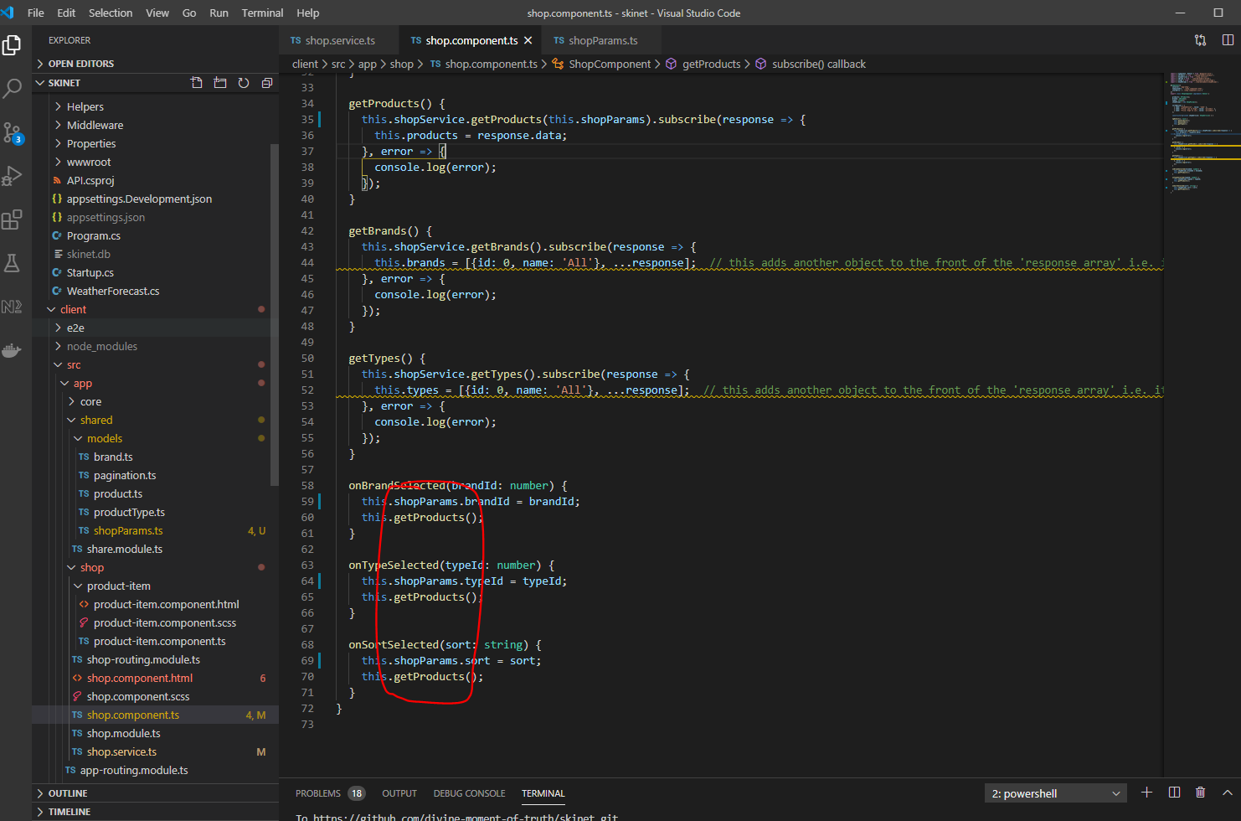

Also, update HTML:-

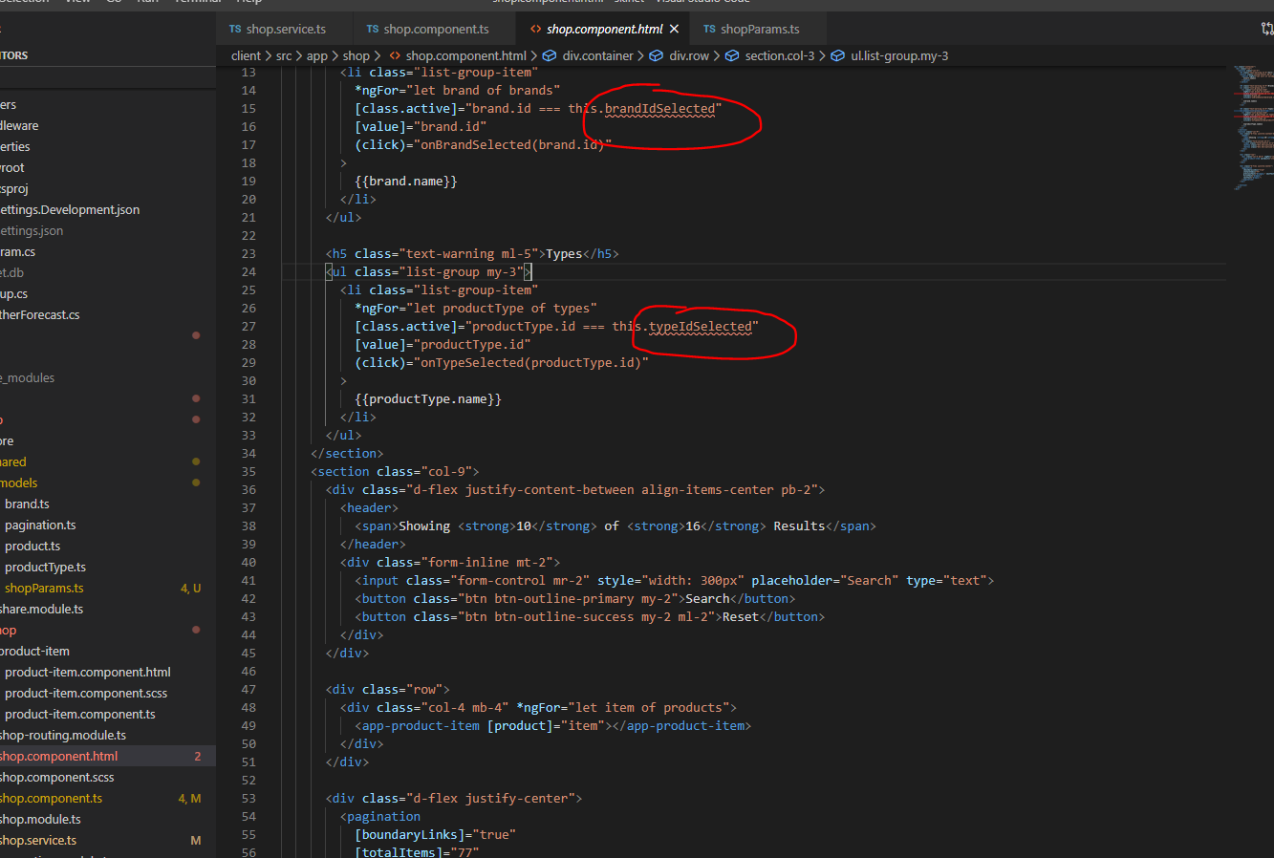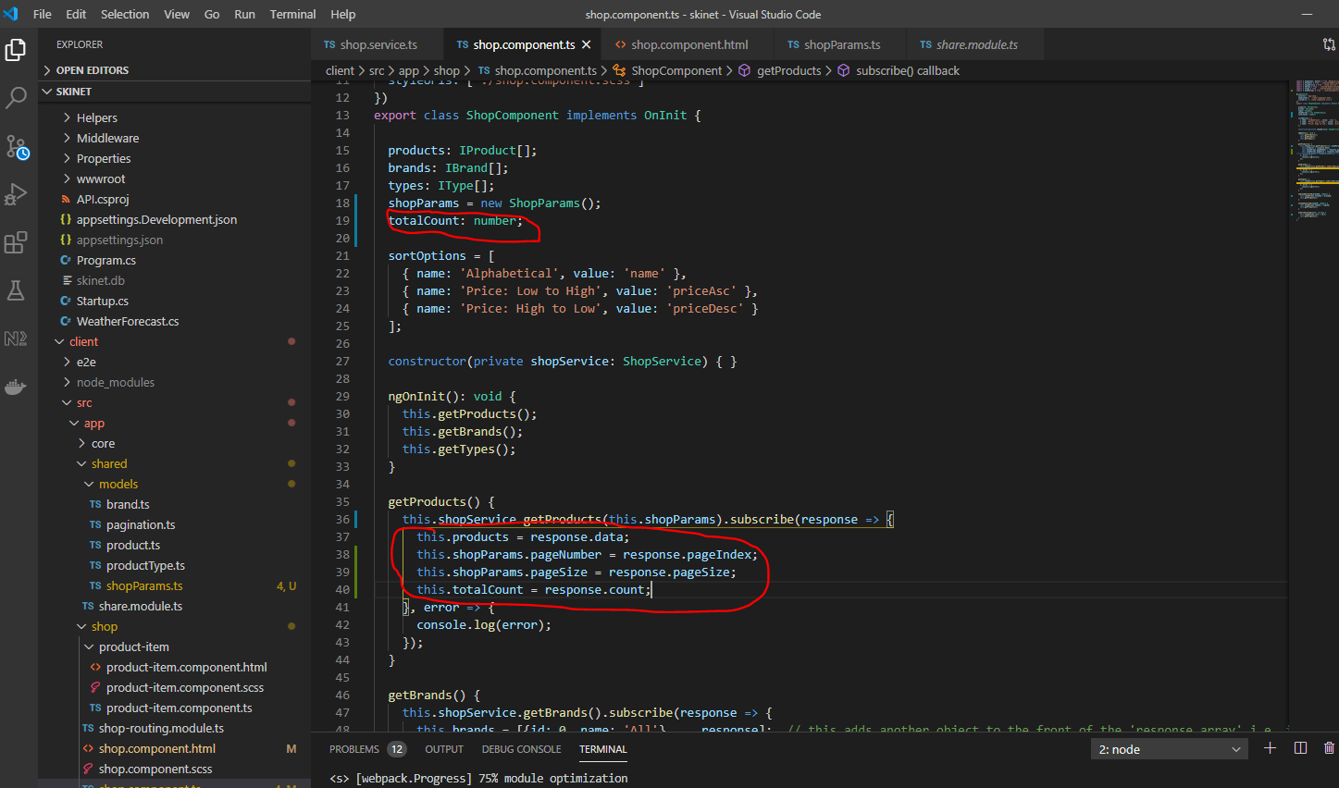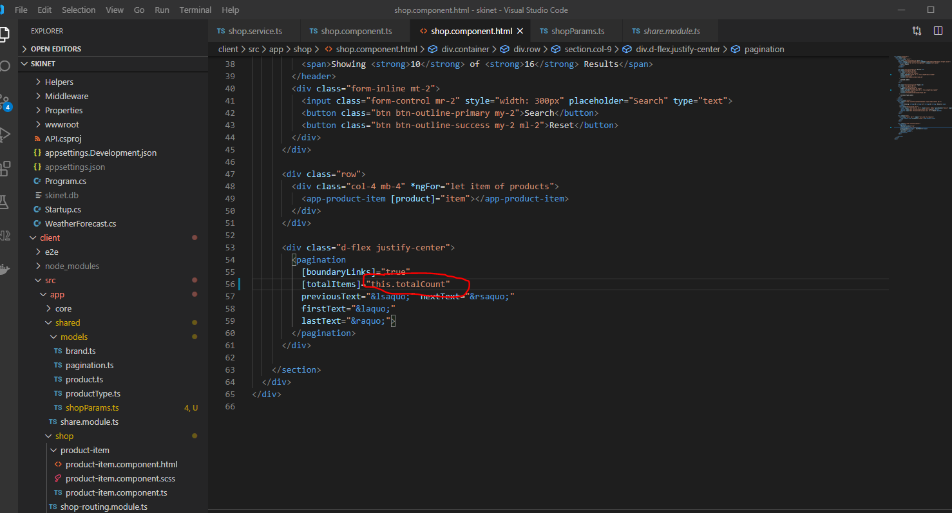

**Add the pagination component into the shared folder so that it can be used else where**

**Split into two components:-**

**page-header**

**Create a folder called ‘component’ under ‘share’ folder:-**

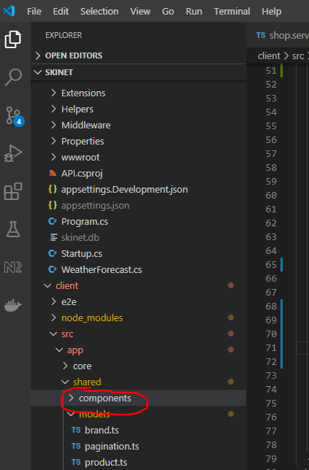

In the terminal cd in to the above folder then type:-

ng g c paging-header --skip-tests

Now cut and paste this header section from the shop component:-

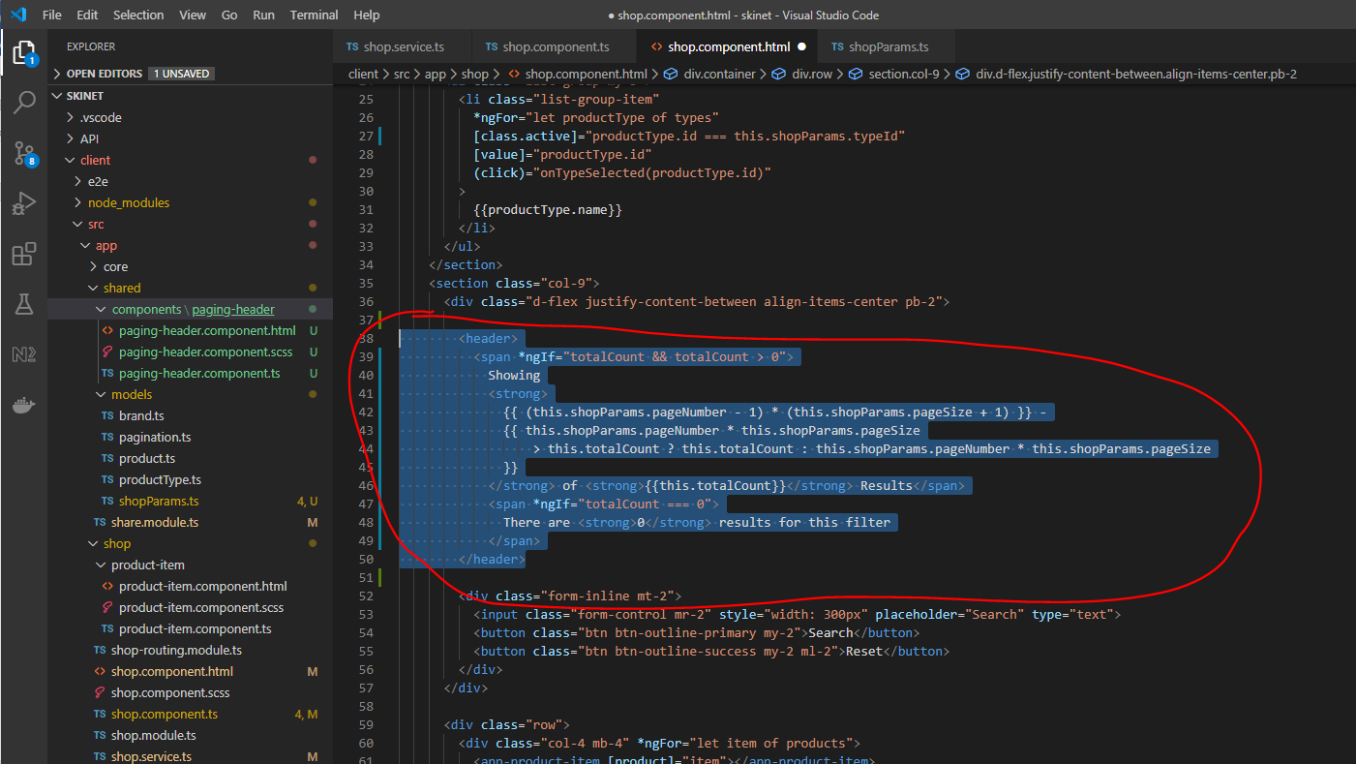

Paste here:-

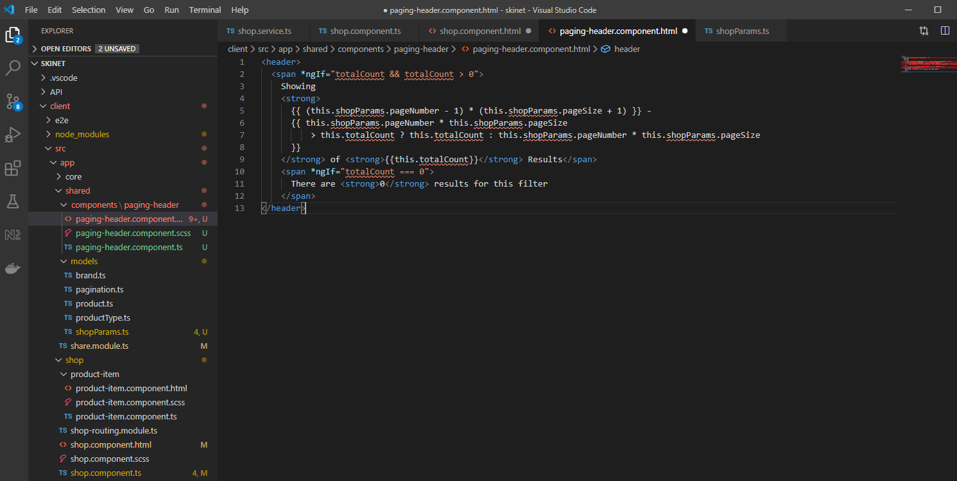

Get rid of red squiggles:-

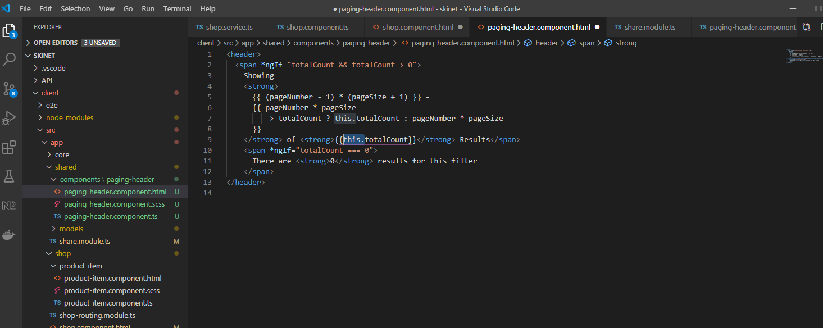

Add @Input’s to component:-

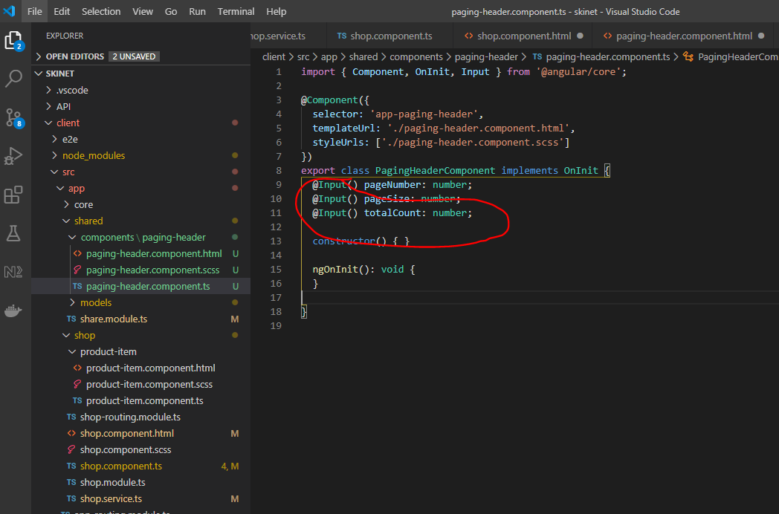

Export new component in ‘shared.comdule.ts’:-

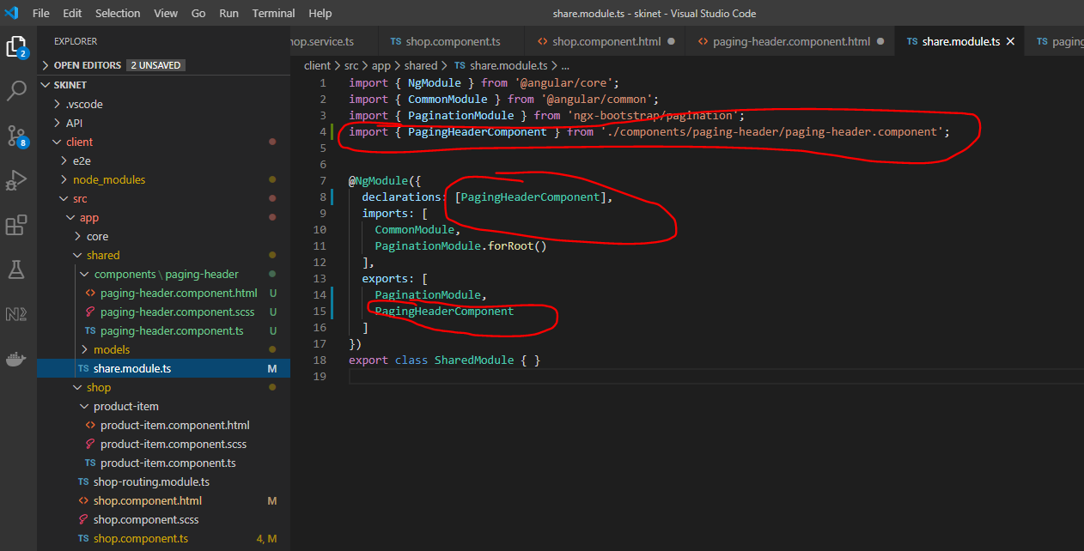

Import in ‘shop.module.ts’:-

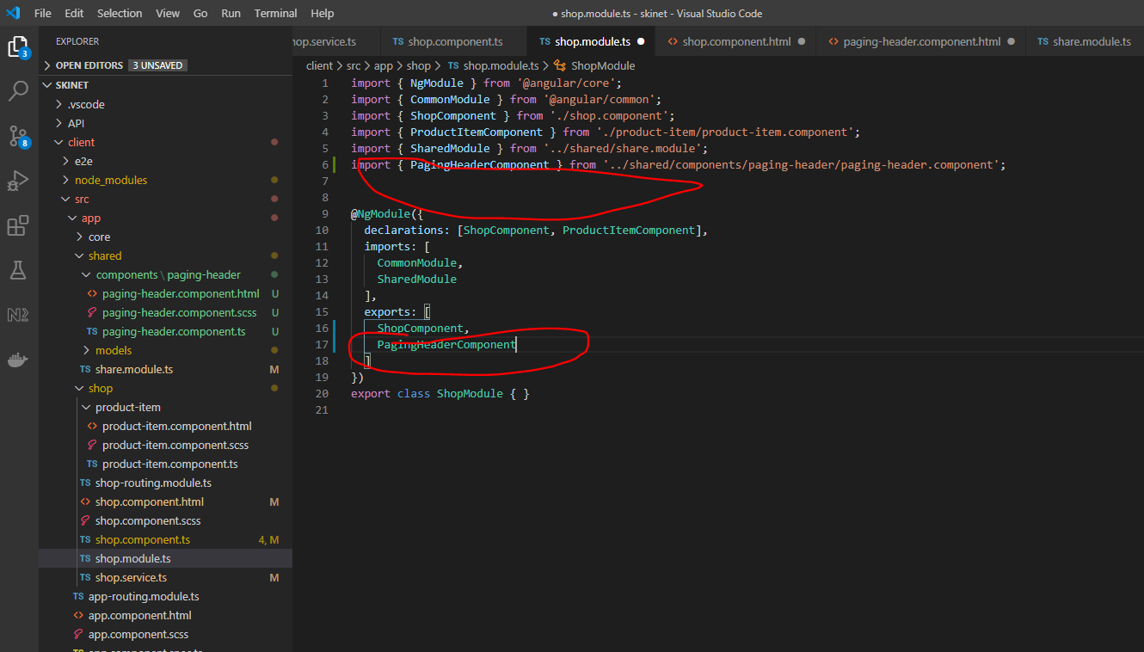

In the shop.component.ts add this:-

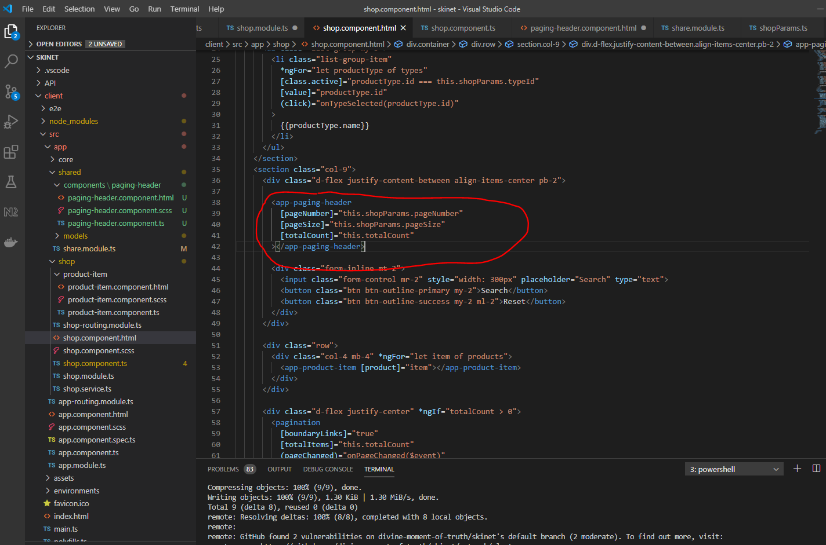

sNow, create a new component for the pagination content/bottom section:-

in the terminal type:-

ng g c pager --skip-tests

Now, export this new component from the ‘shared.module.ts’:-

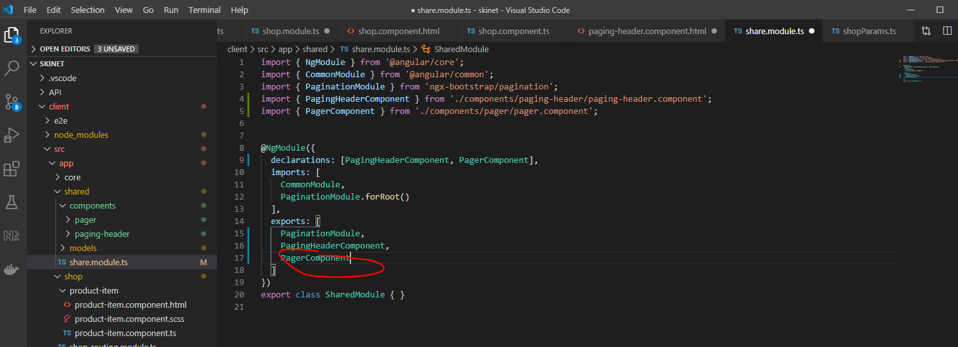

Cut this section from the shop component:-

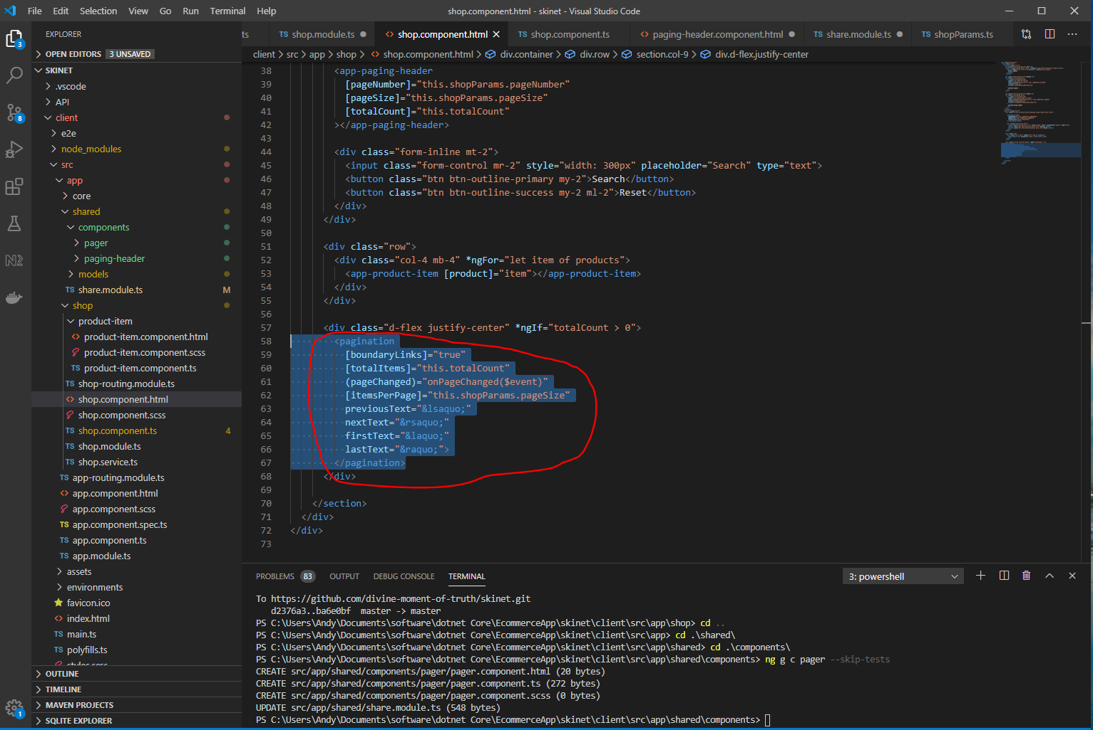

Paste, here:-

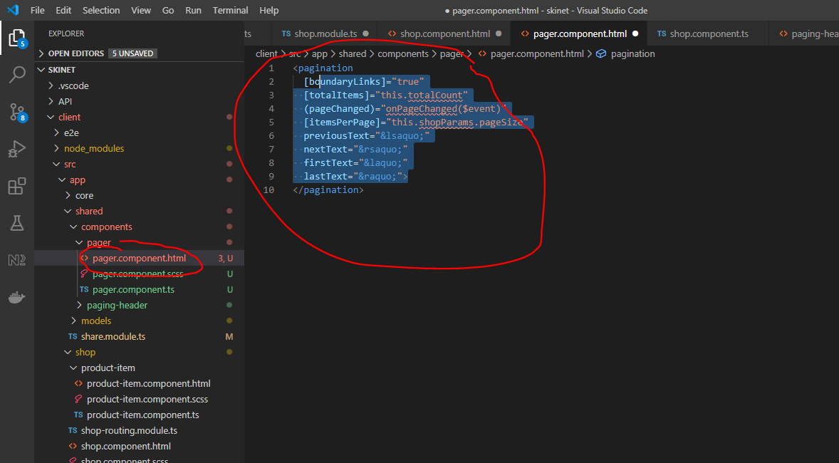

Add this:-

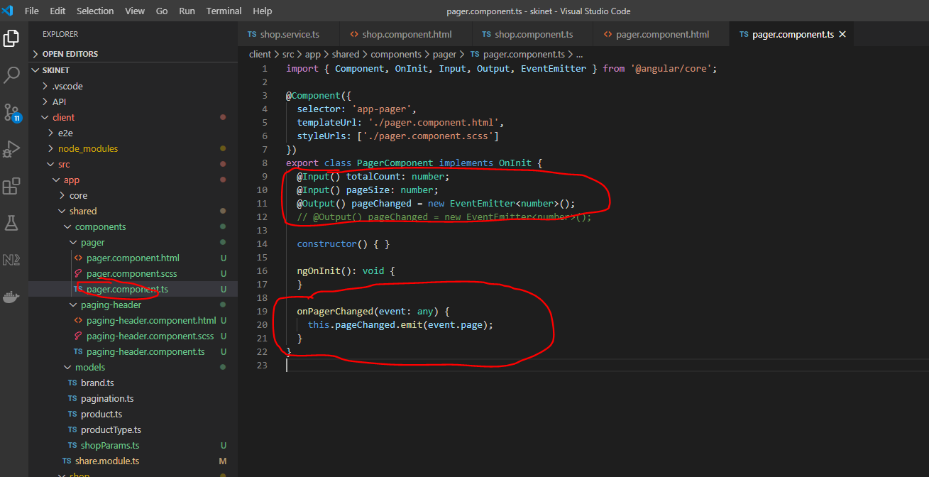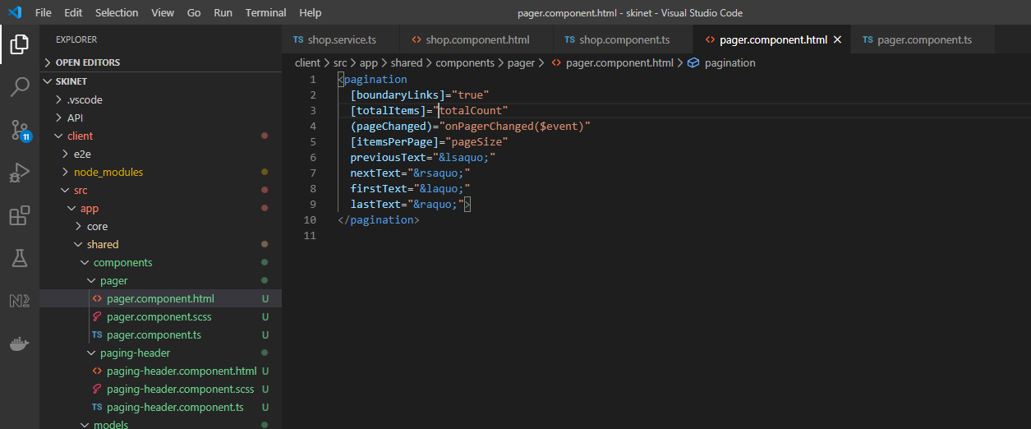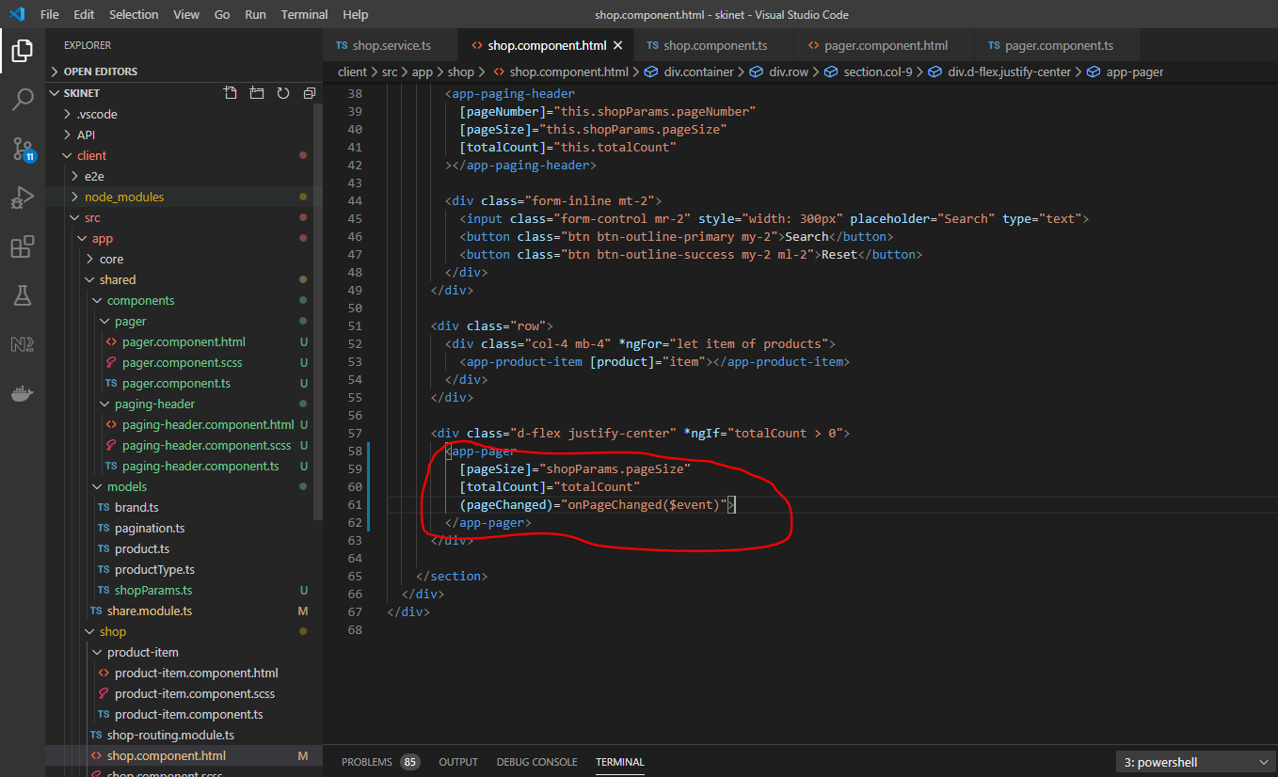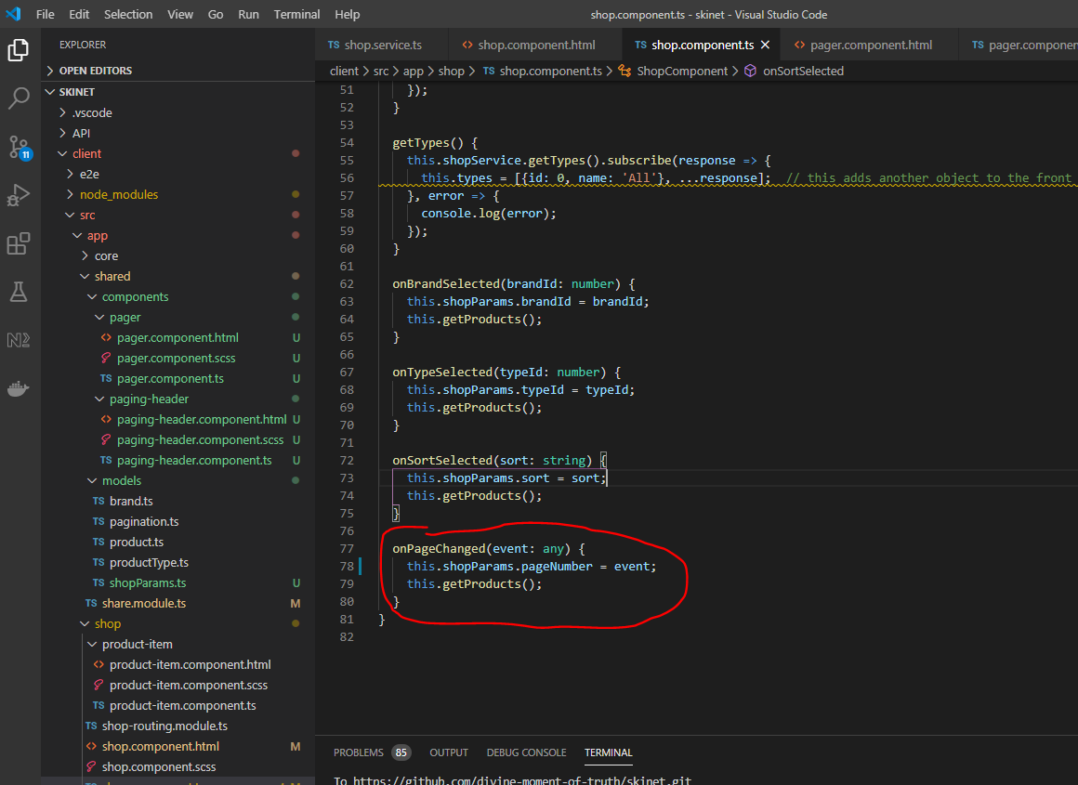

**Search Component**

Add this:-

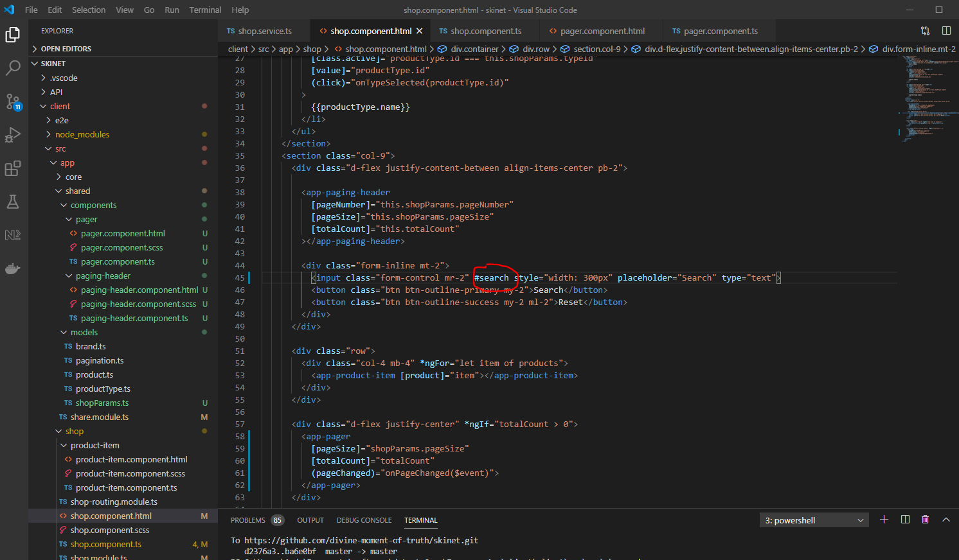

Add this to the .ts component:-

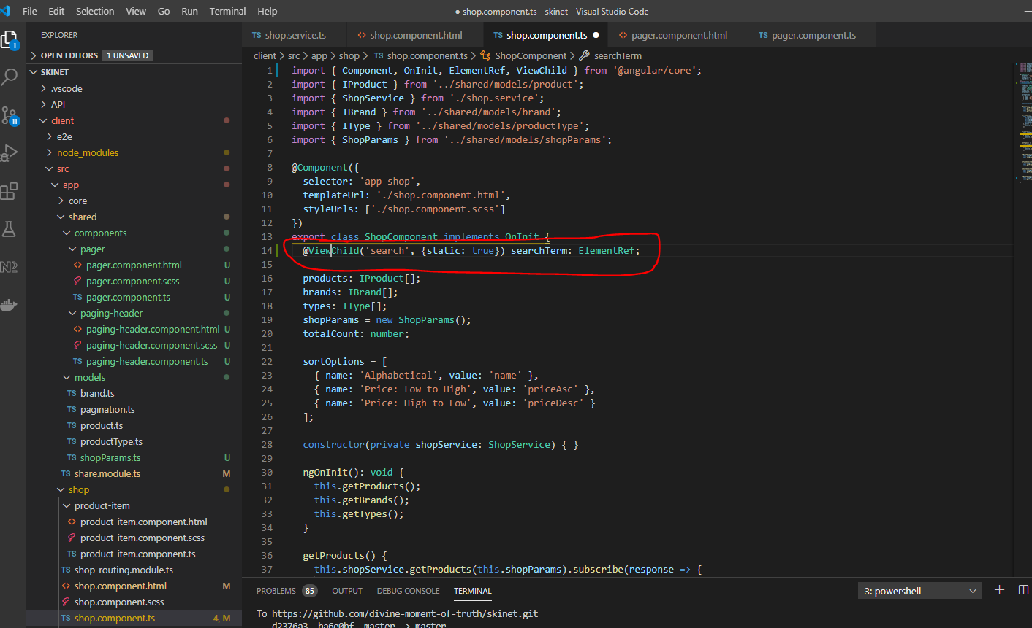

{static: true} - this means that the element will always be present i.e. it is not dependent on any *ngIf statements

Add a new property to the ‘ShopParams’ class:-

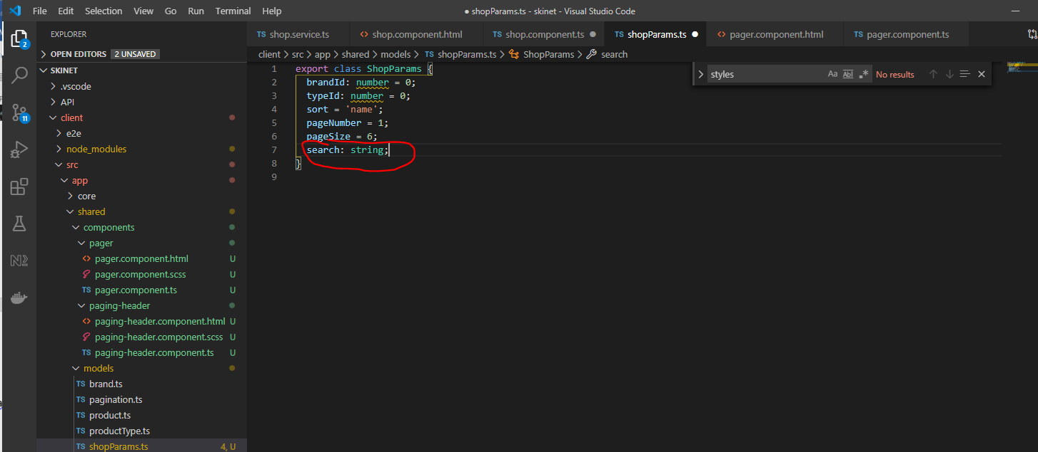

Add these methods to the shop component:-

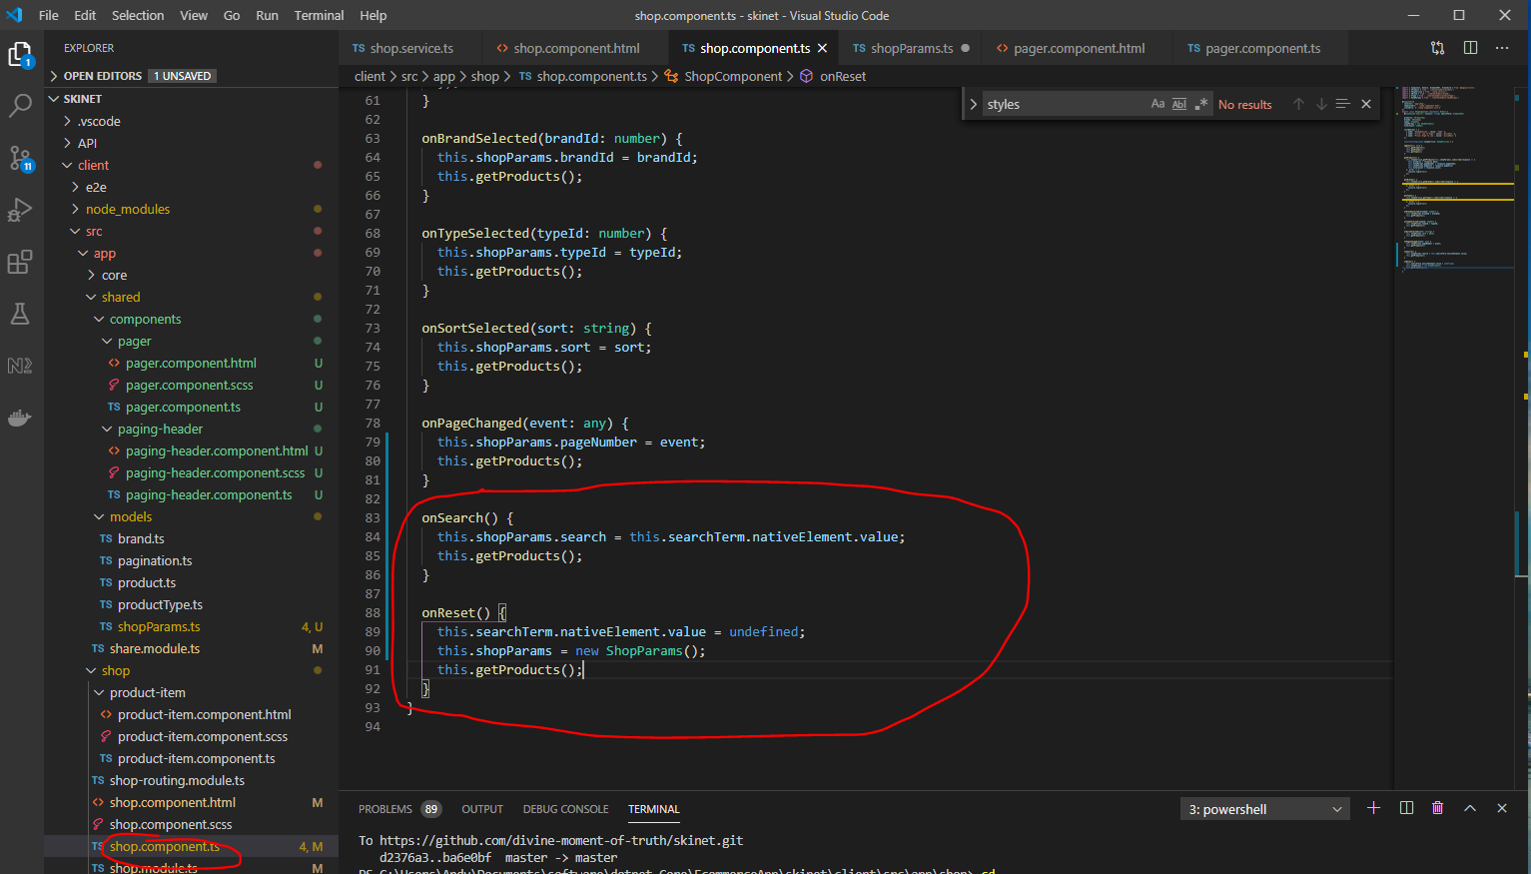

this.shopParams = new ShopParams();

The above line resets the shopParams class to the default values.

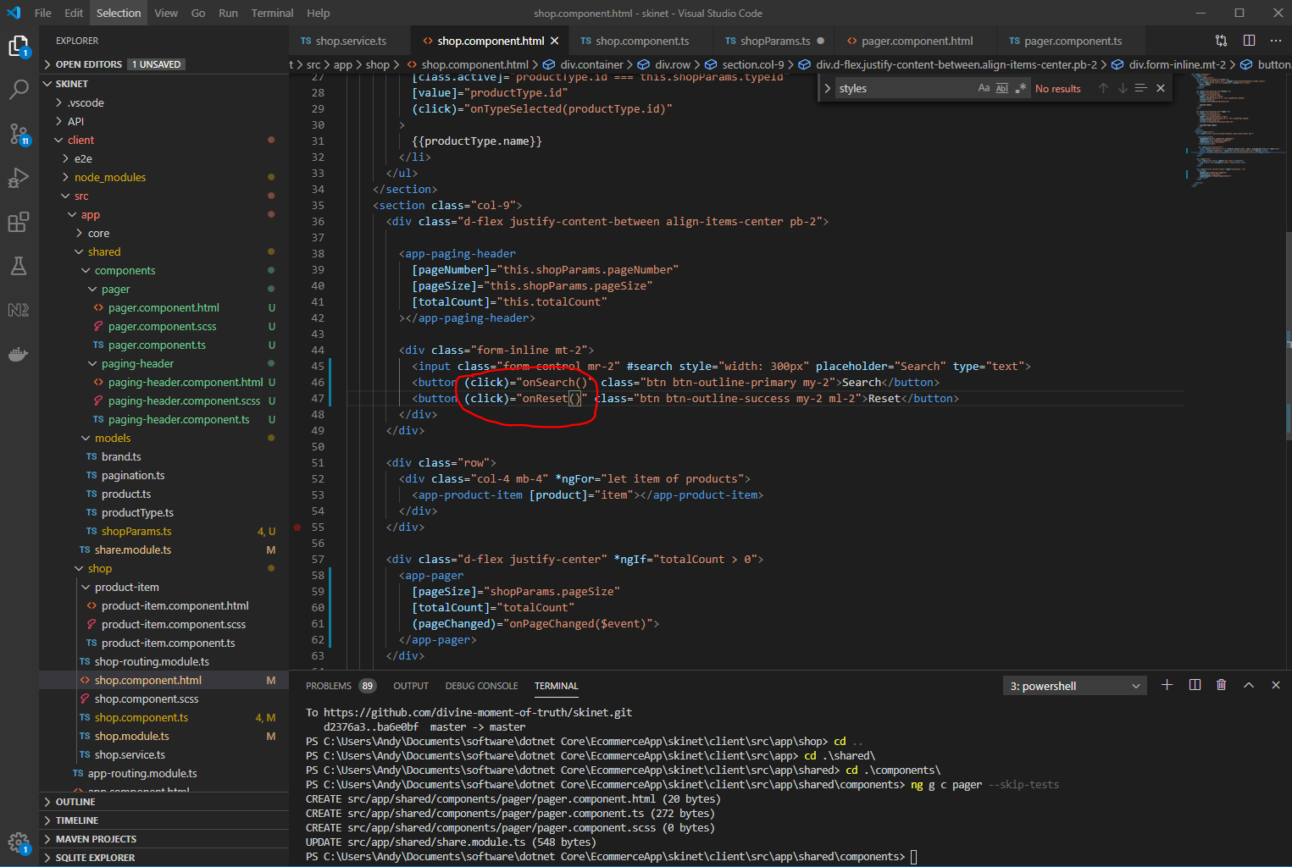

Also, add this to the shop service:-

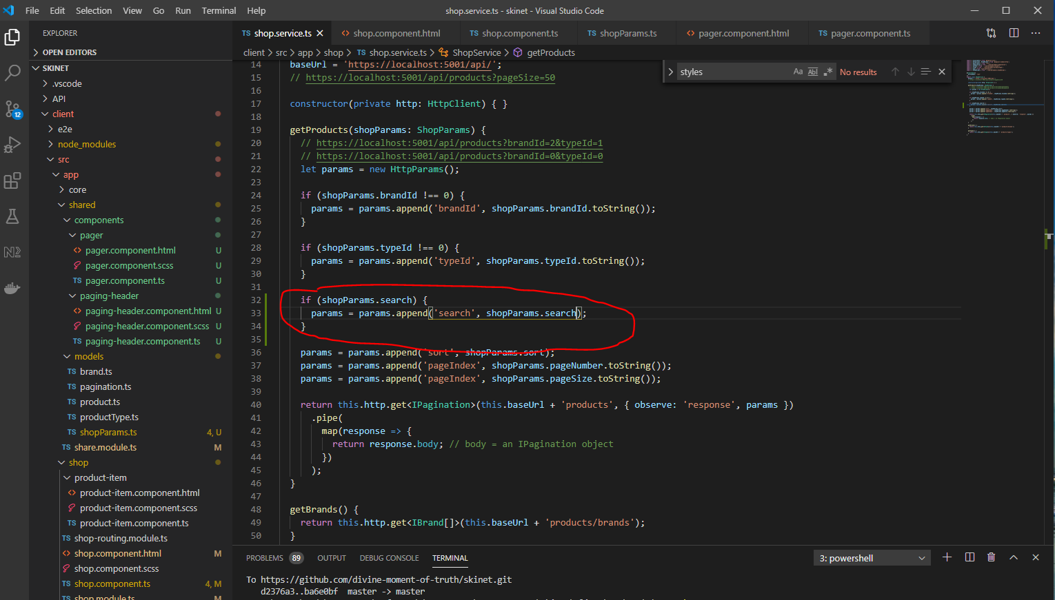

To make search happen without having to click on ‘Search’ button i.e. you can enter text into the search box then just press [Enter] add this code:-

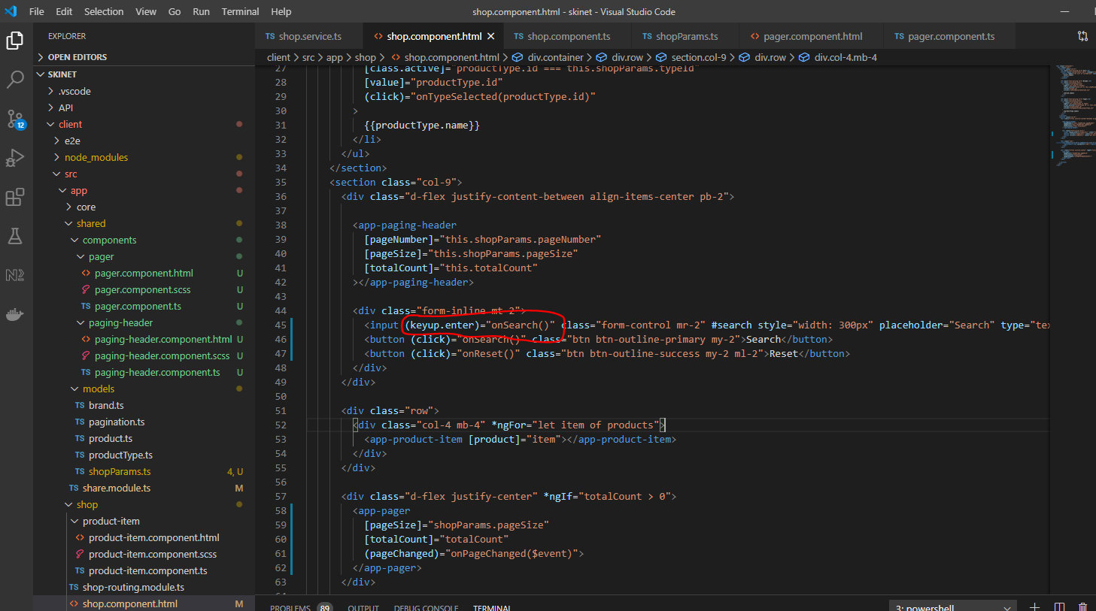

Resolve bug:-

The bug is this:-

Click on page 2 or 3 then click on ‘Boots’ under the ‘Types’ section:-

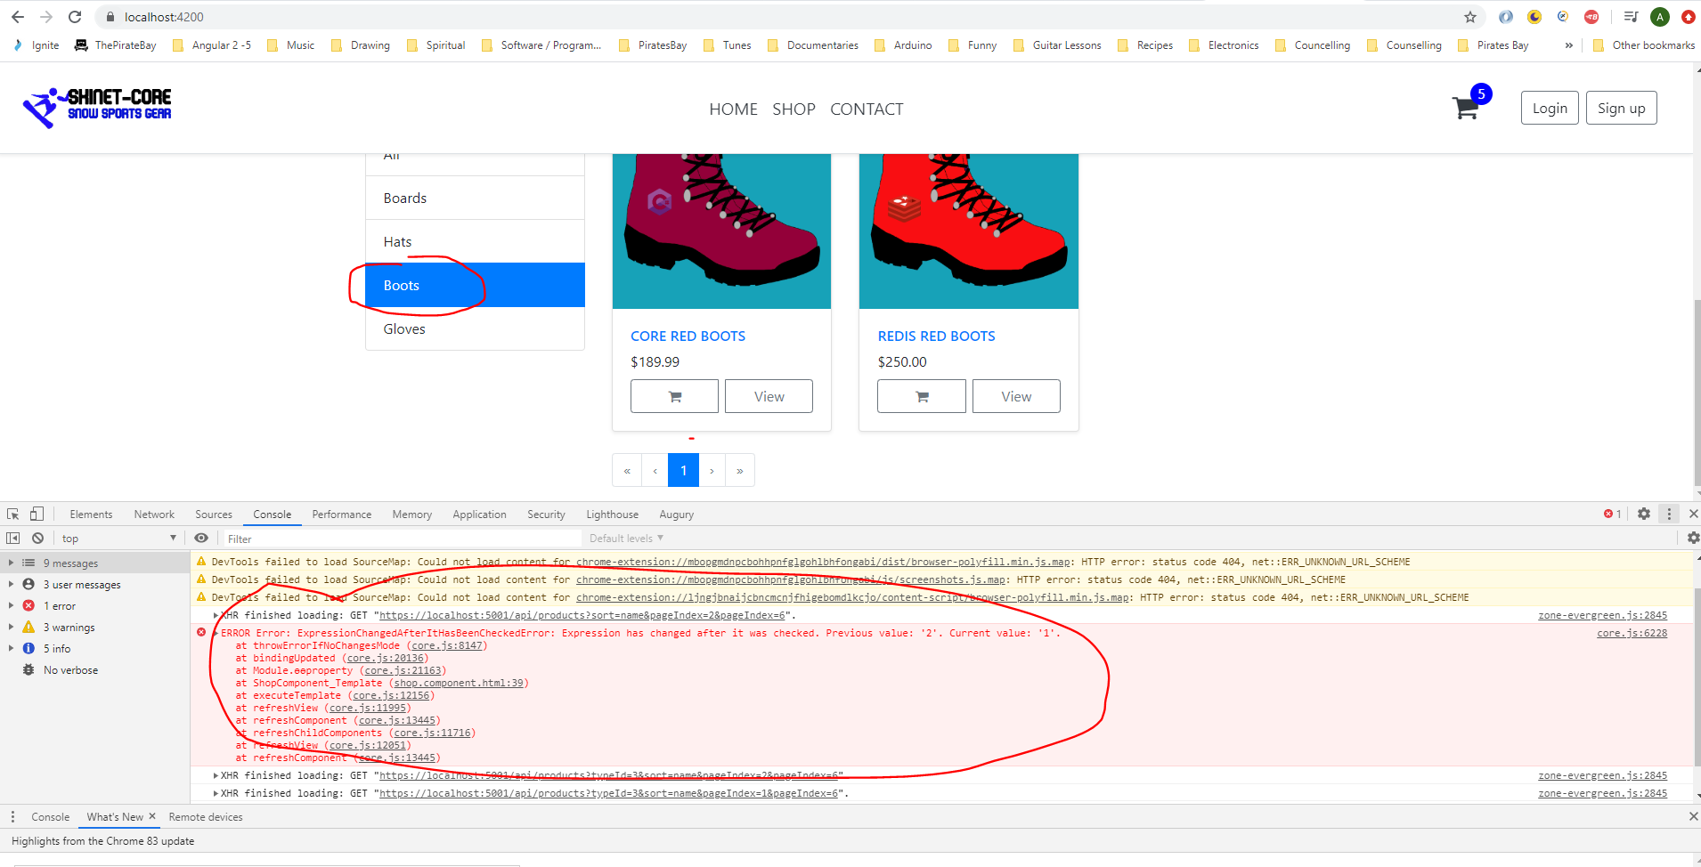

This is because you need to reset the page number back to 1 every time you do a filter search. So you need to reset to 1 as follows:-

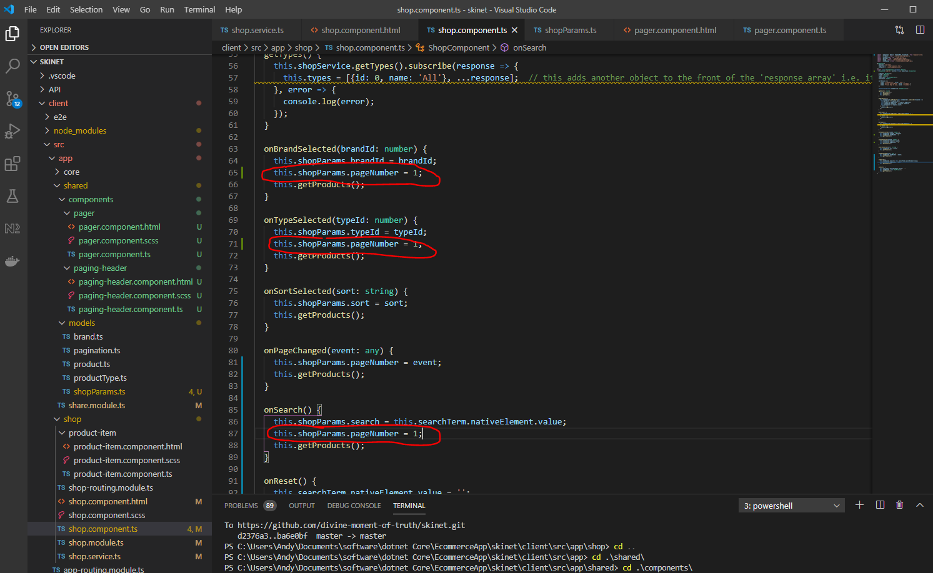

Also, observe this problem:-

Open devtools.

Go to the Network tab.

Click the clear button.

In the app click on the page 2 pagination tab.

Click on the ‘Boots’ button under the ‘Types’ filter section.

Notice on the Network tab that there are two identical request messages going to the server:-

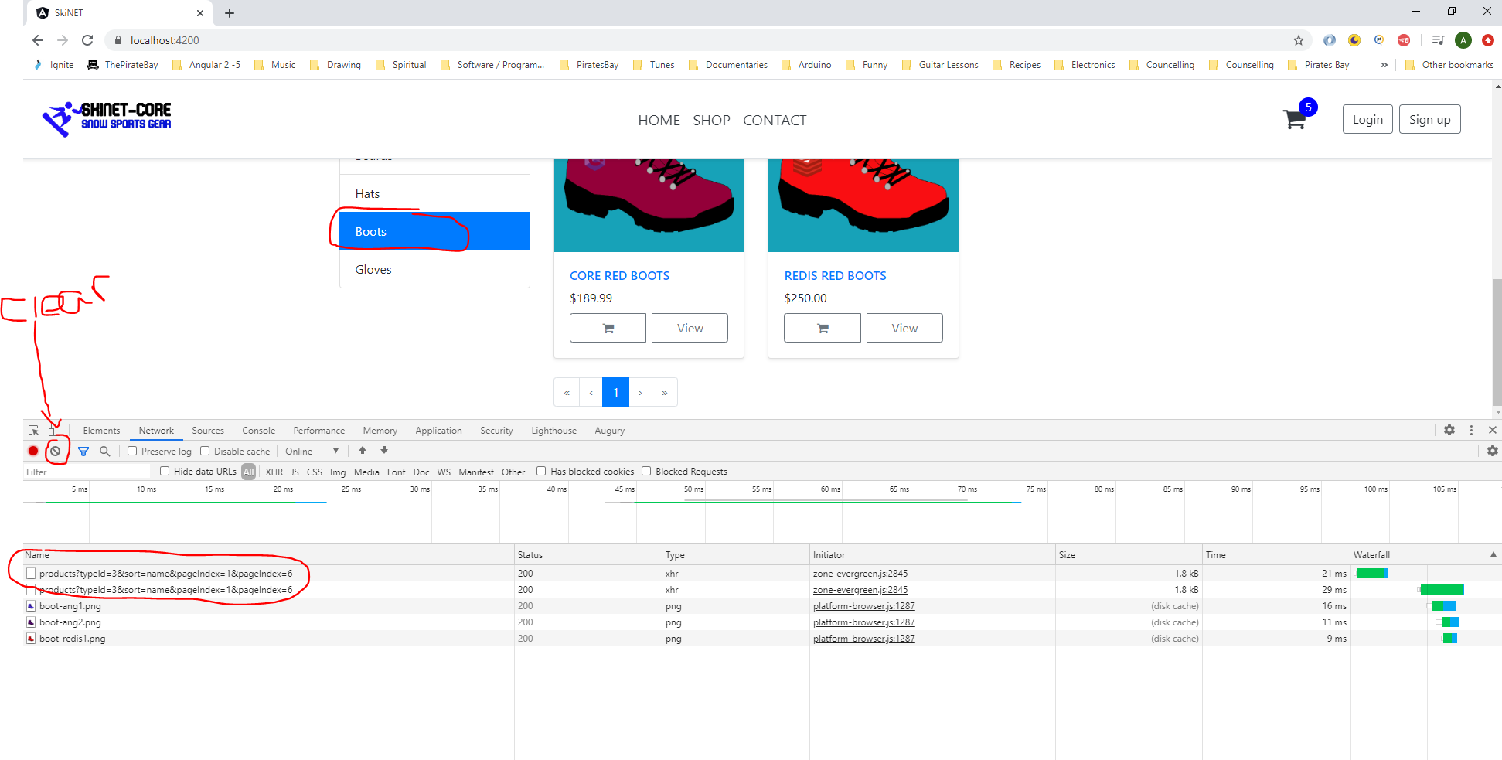

This is because when you click on a filter this gets triggered:-

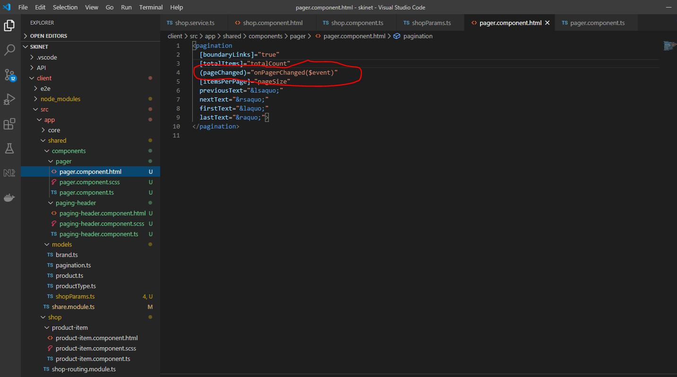

Which causes this to get triggered:-

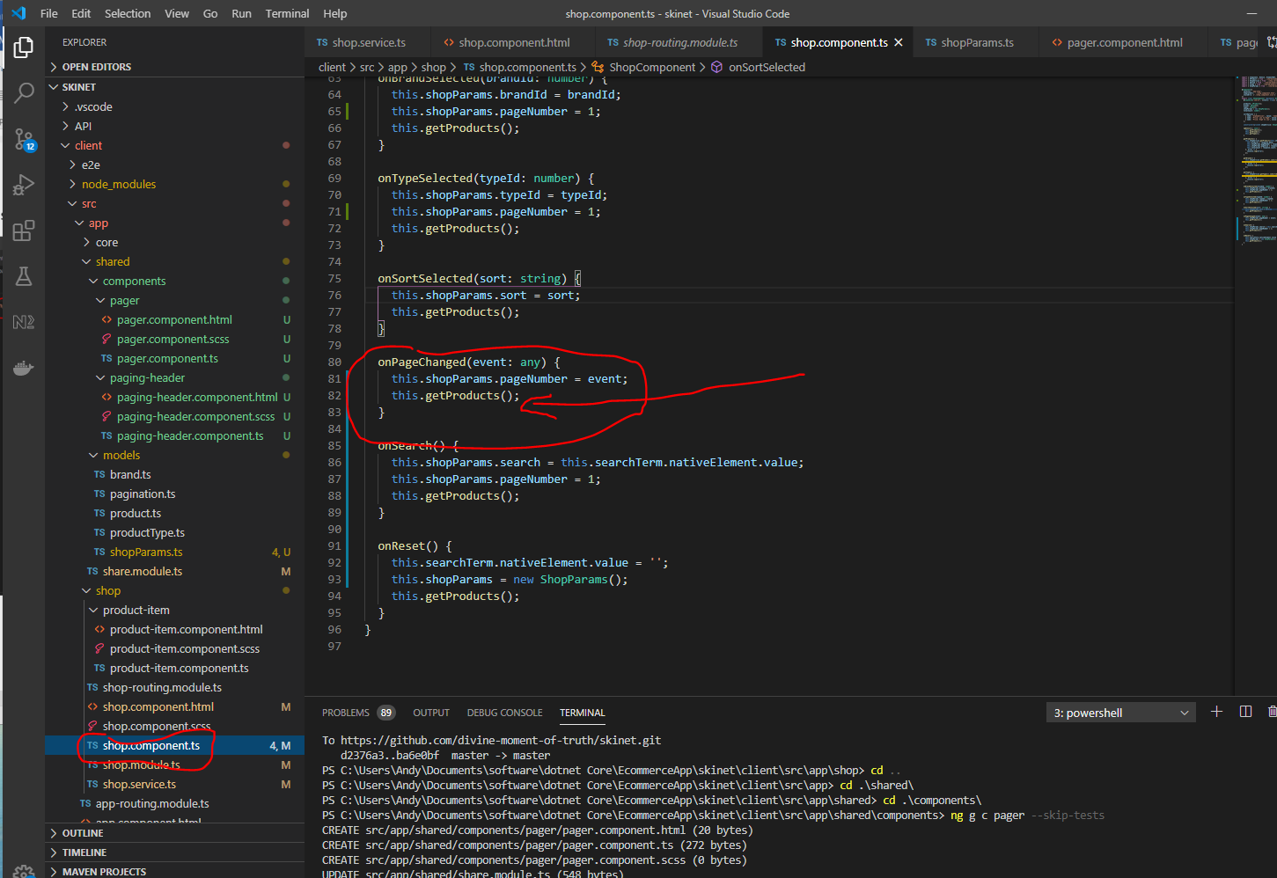

So at the same time you are changing one of the filters e.g. onBrandSelected() gets triggered too:-

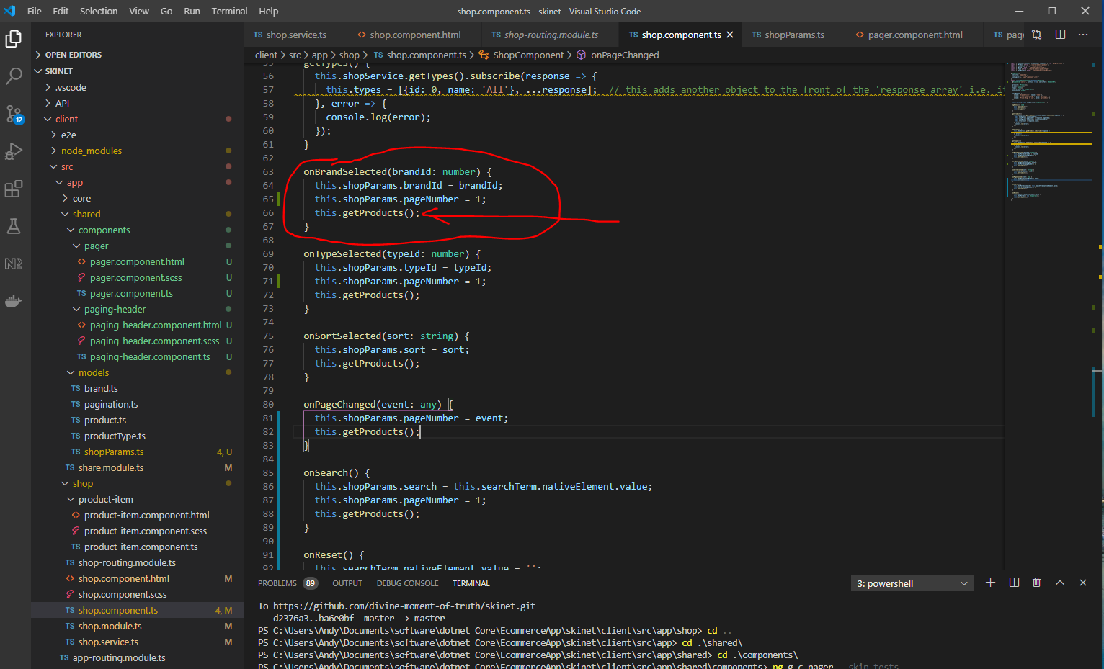

Can you see that ‘getProducts()’ method is being called twice.

So to overcome this problem do this:-

So you do not want to be getting called if you are just clicking on one of the filters:-

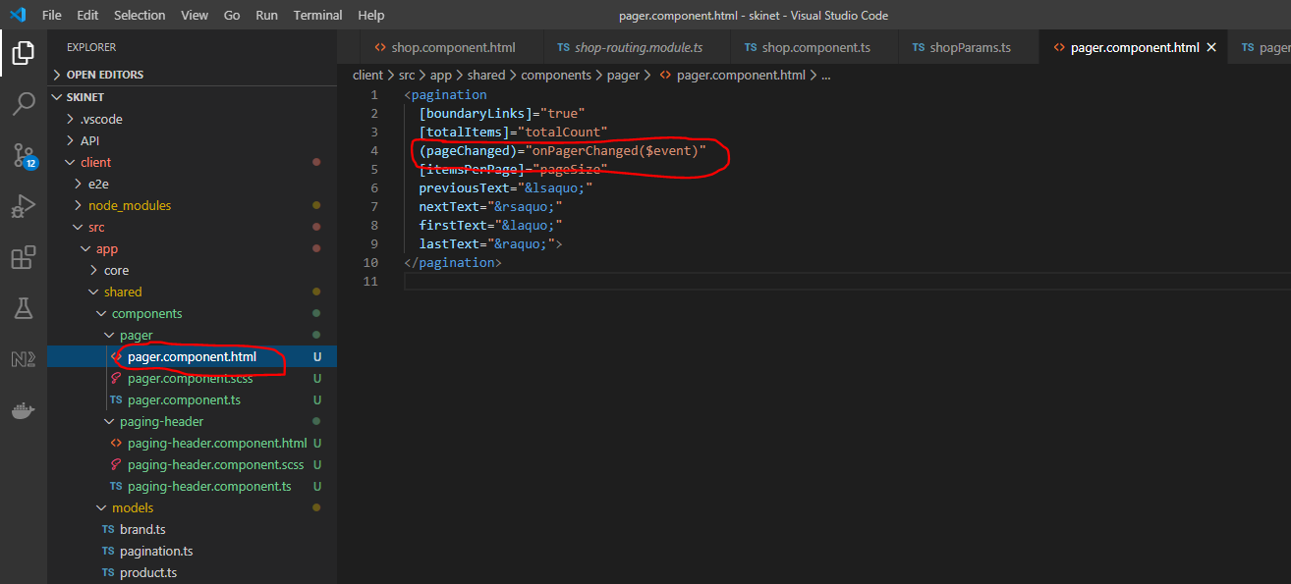

Add and iff to the ‘onPageChanged()’ method so that you can test to see if the page number has changed, if the page number has changed then call the ‘getProducts()’ method:-

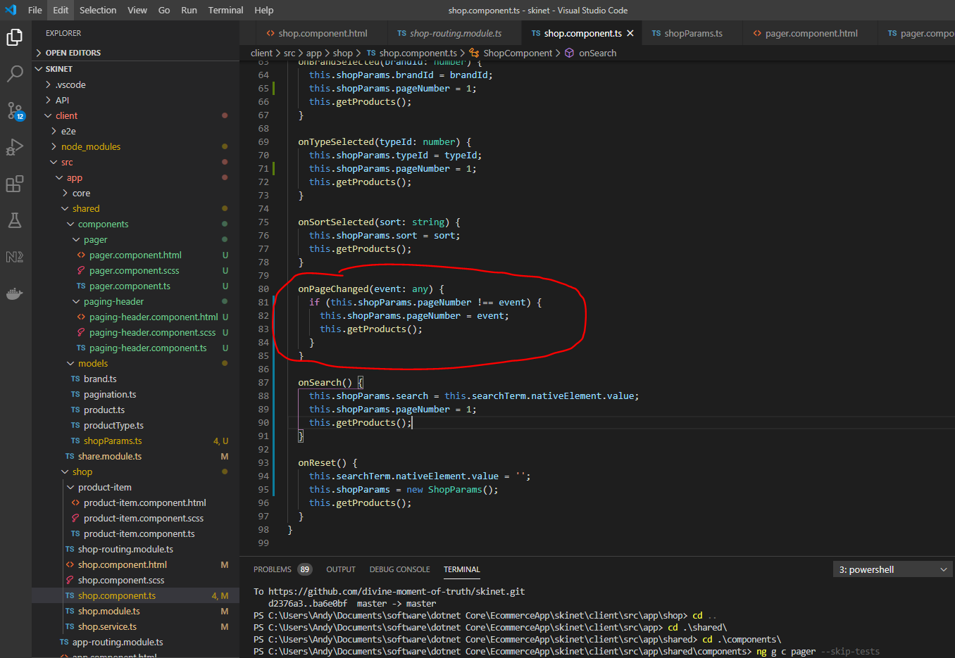

**Add Routing**

In app folder create a ‘home’ module:-

***ng g m home***

cd into the ‘home’ folder and create a home component:-

***ng g c home --skip-tests -flat***

Create a product detail component in the ‘shop’ folder:-

***ng g c product-details --skip-tests***

Export the home component from the home.module:-

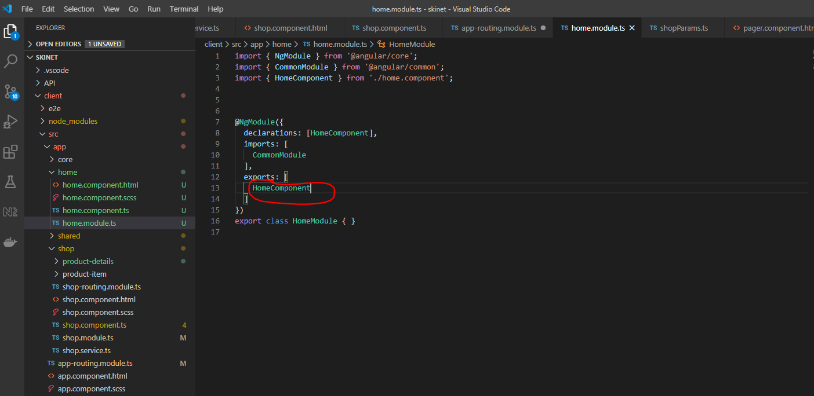

Add Home the ‘home.module’ to the ‘app.module’ file:-

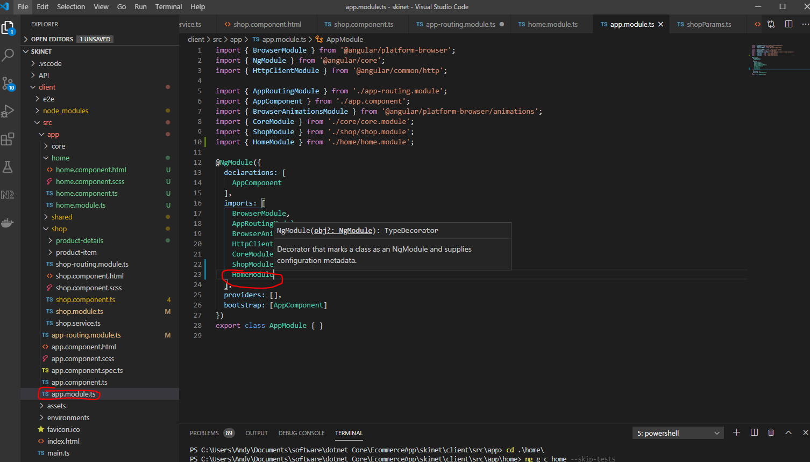

Now update the ‘app.component.html’ file:-

Remove this and replace:-

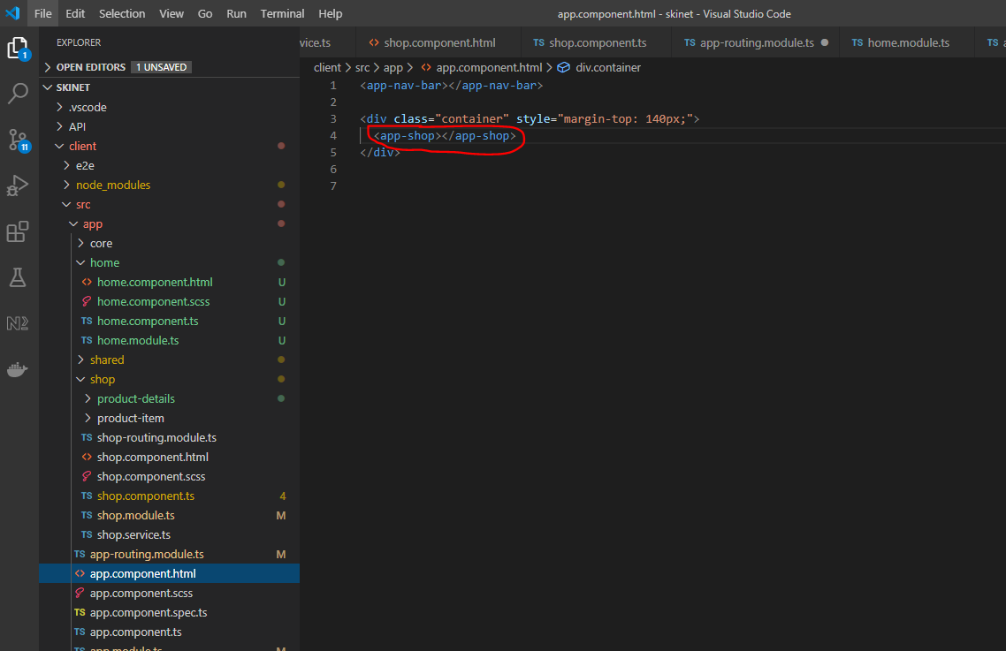

Replace with this:-

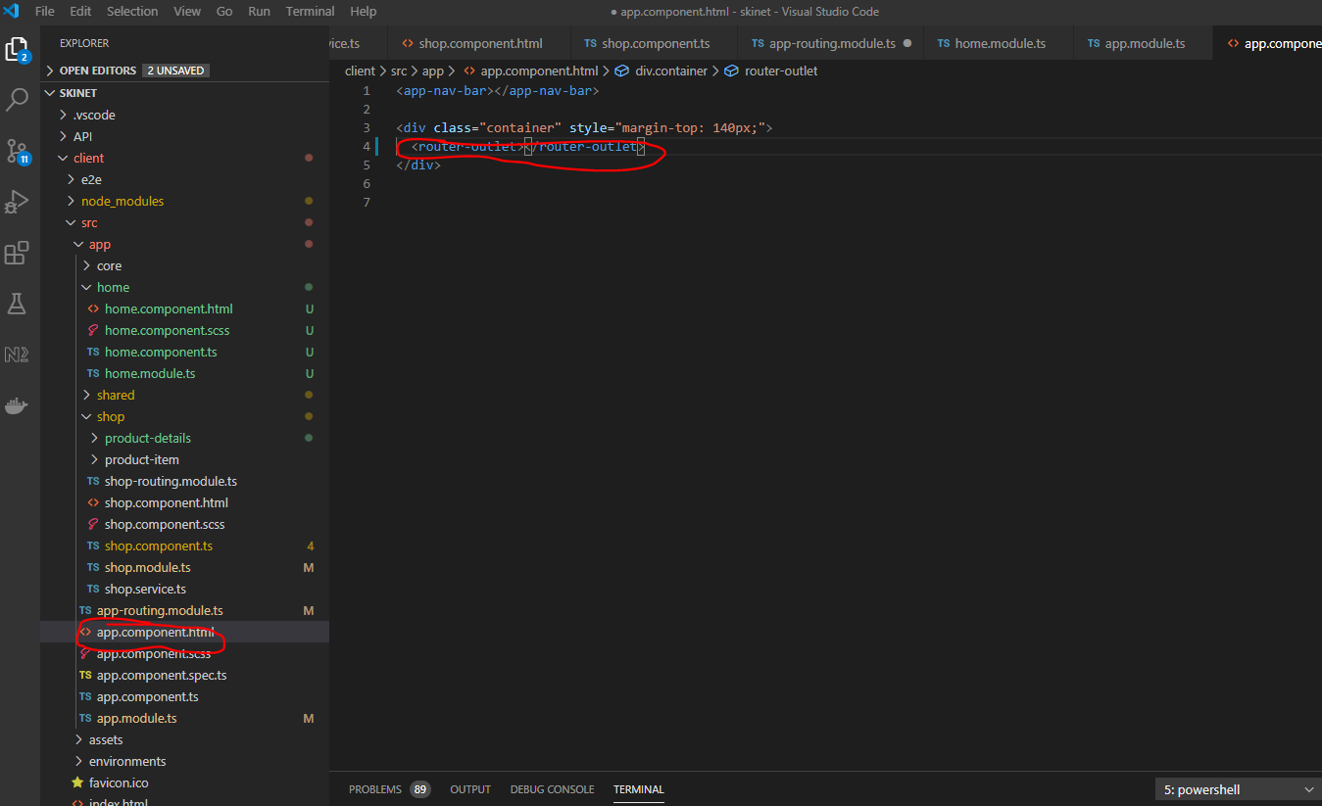

Update navbar:-

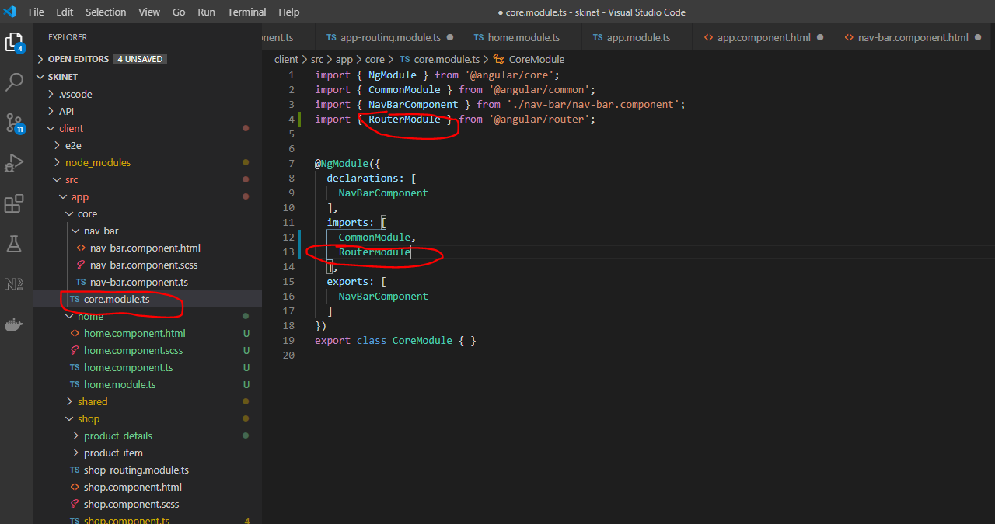

Html:-

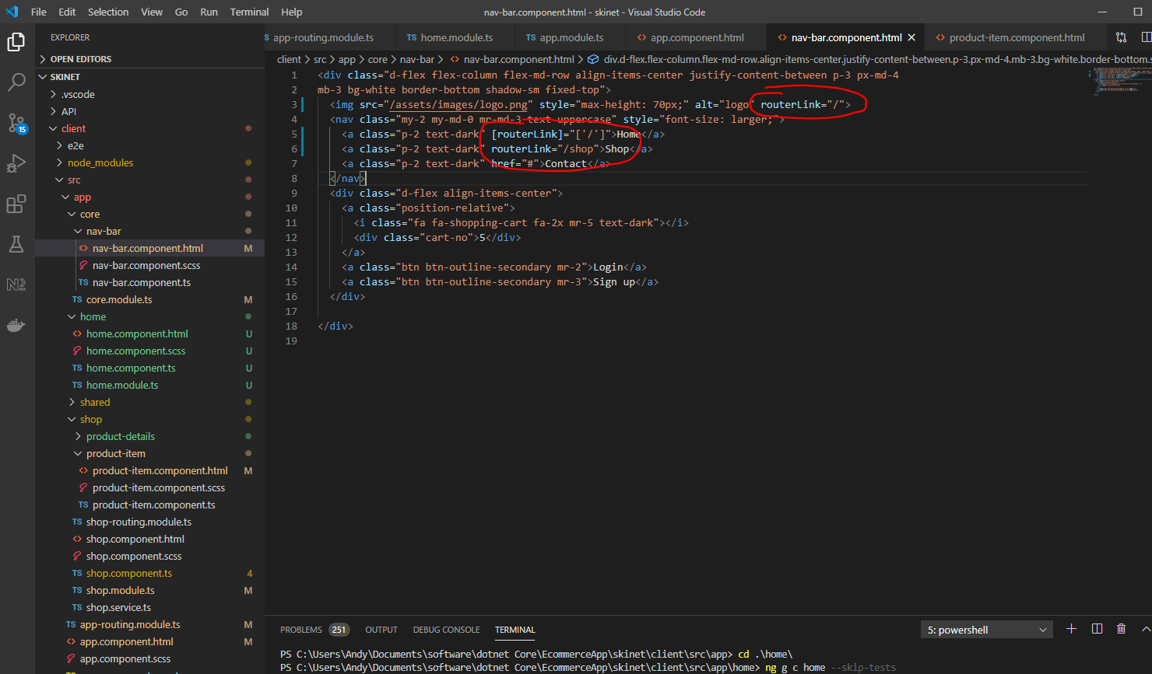

Also, update shop.module.ts:-

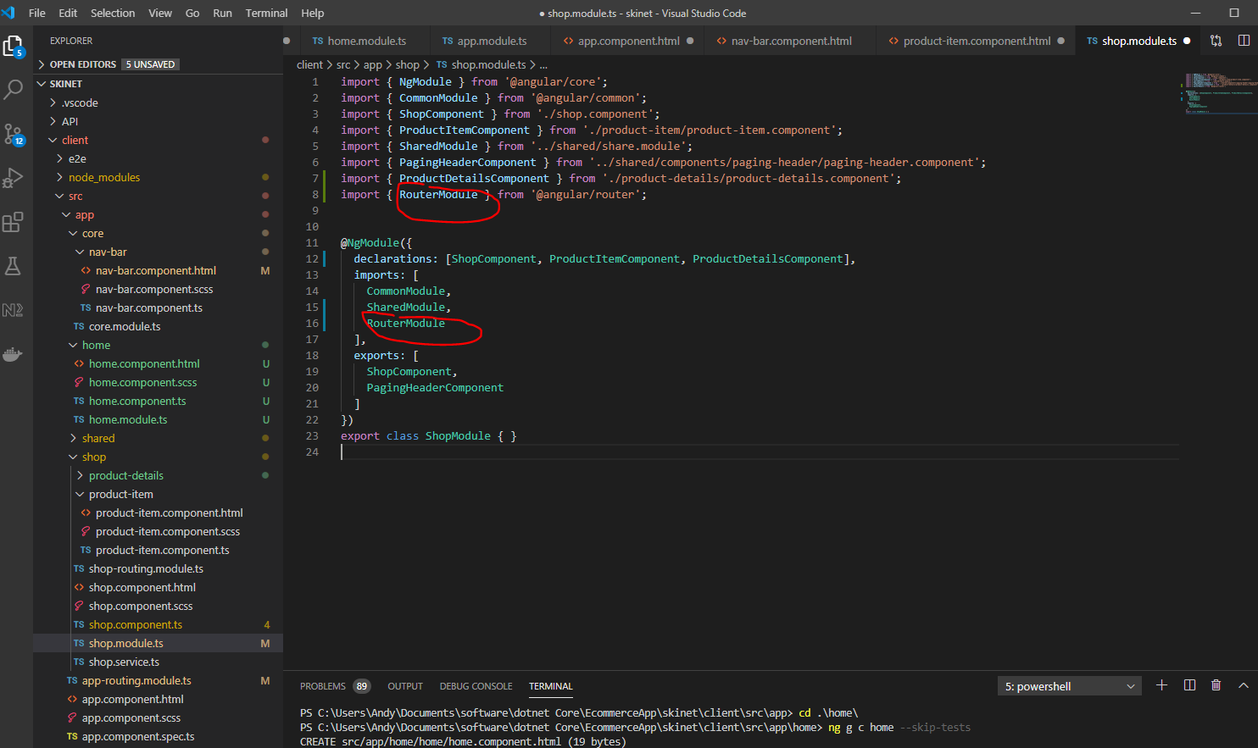

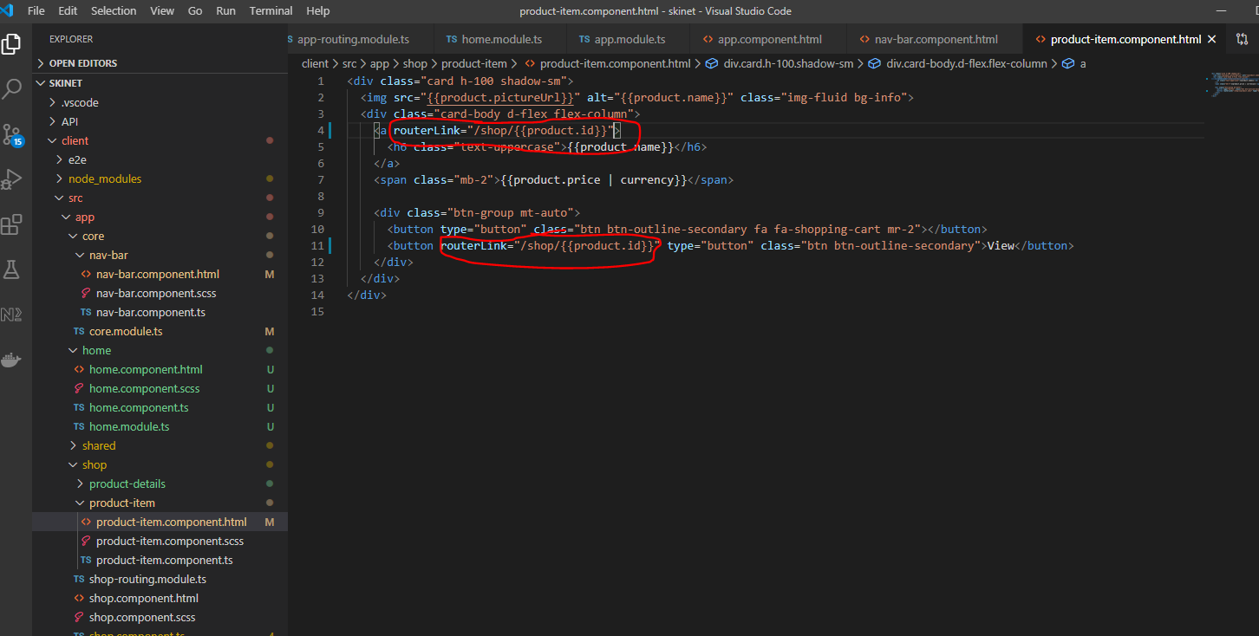

Add this:-

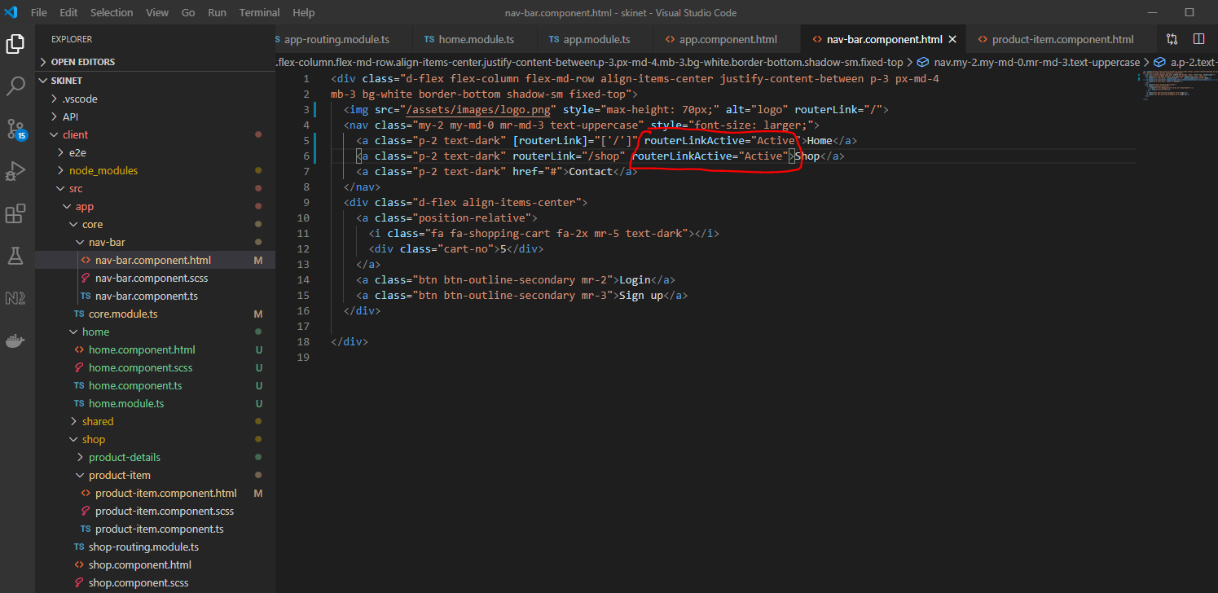

Update css:-

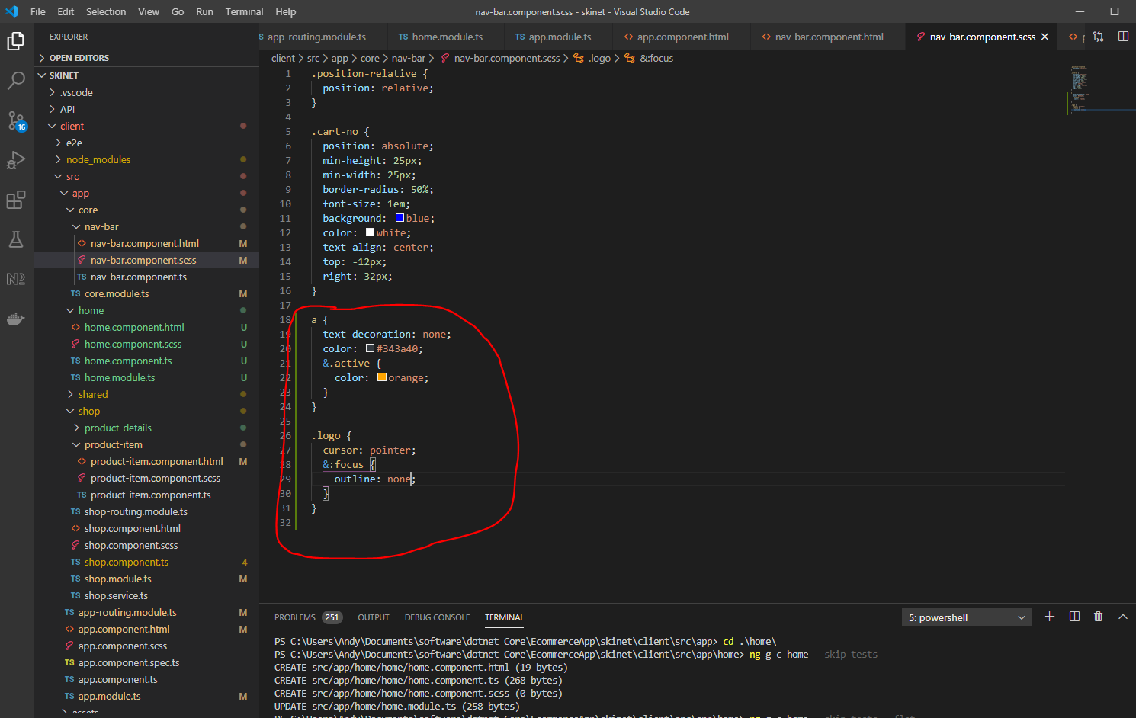

Also,

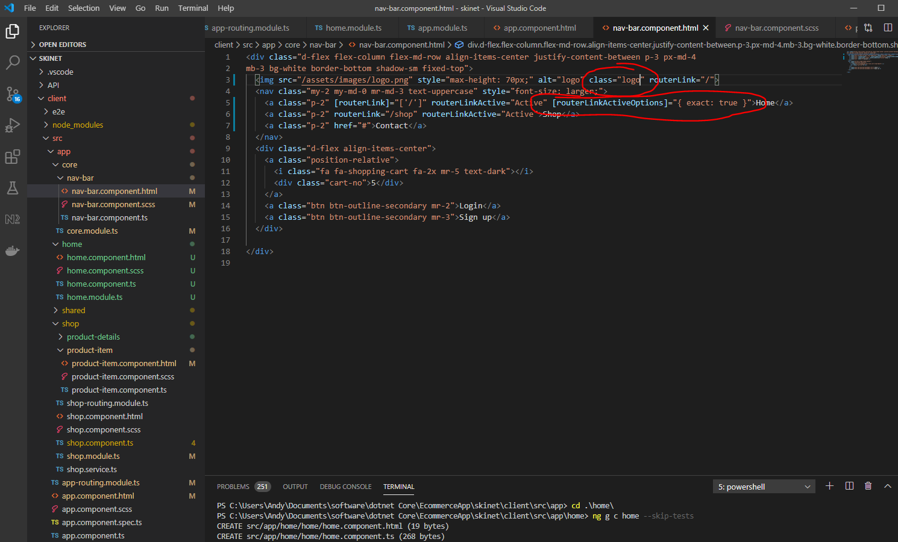

**Create a method for getting a single product in Shop.service.ts**

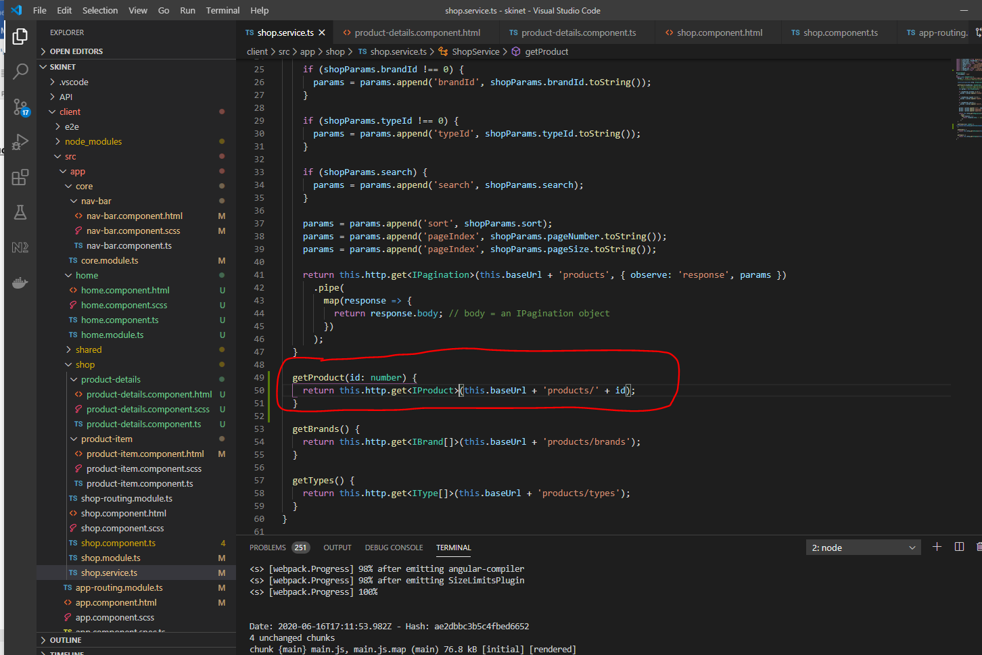

Update ‘product-details.component.ts’:-

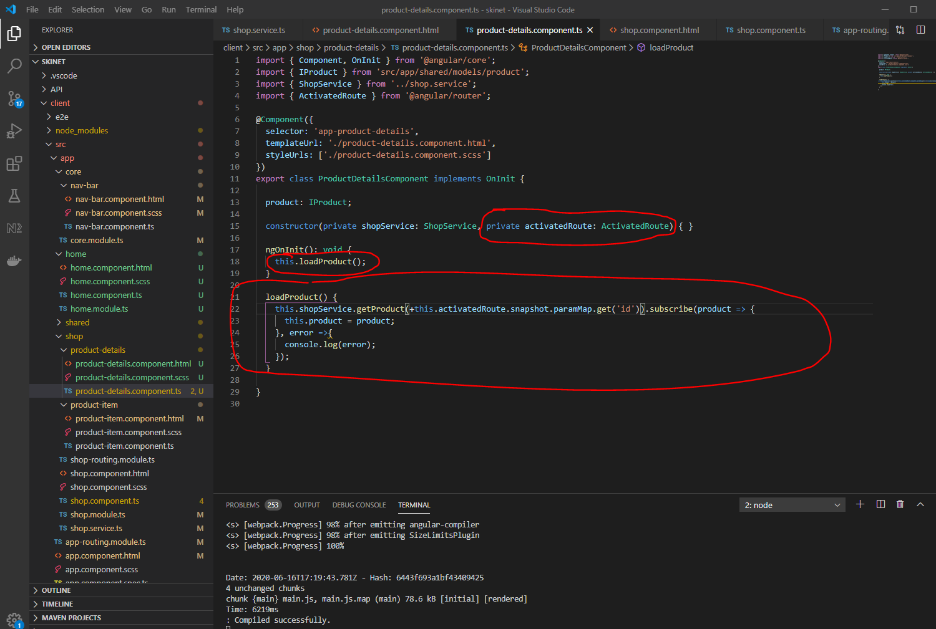

this.shopService.getProduct(+this.activatedRoute.snapshot.paramMap.get('id')).subscribe(product => {

Notice the ‘+’ in the above line. This means convert to a number.

Update product-details.component.ts:-

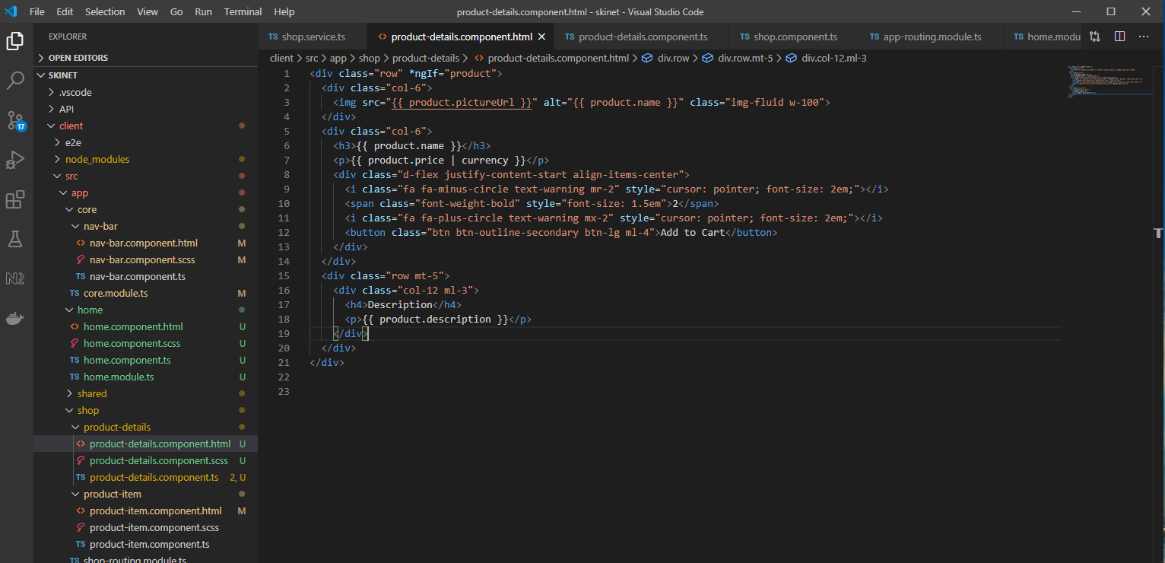

**Lazy Loading**

Only load things when you click on them. For example the shop component will not load until you click on the ‘Shop’ link in the header section.

Copy these from here:-

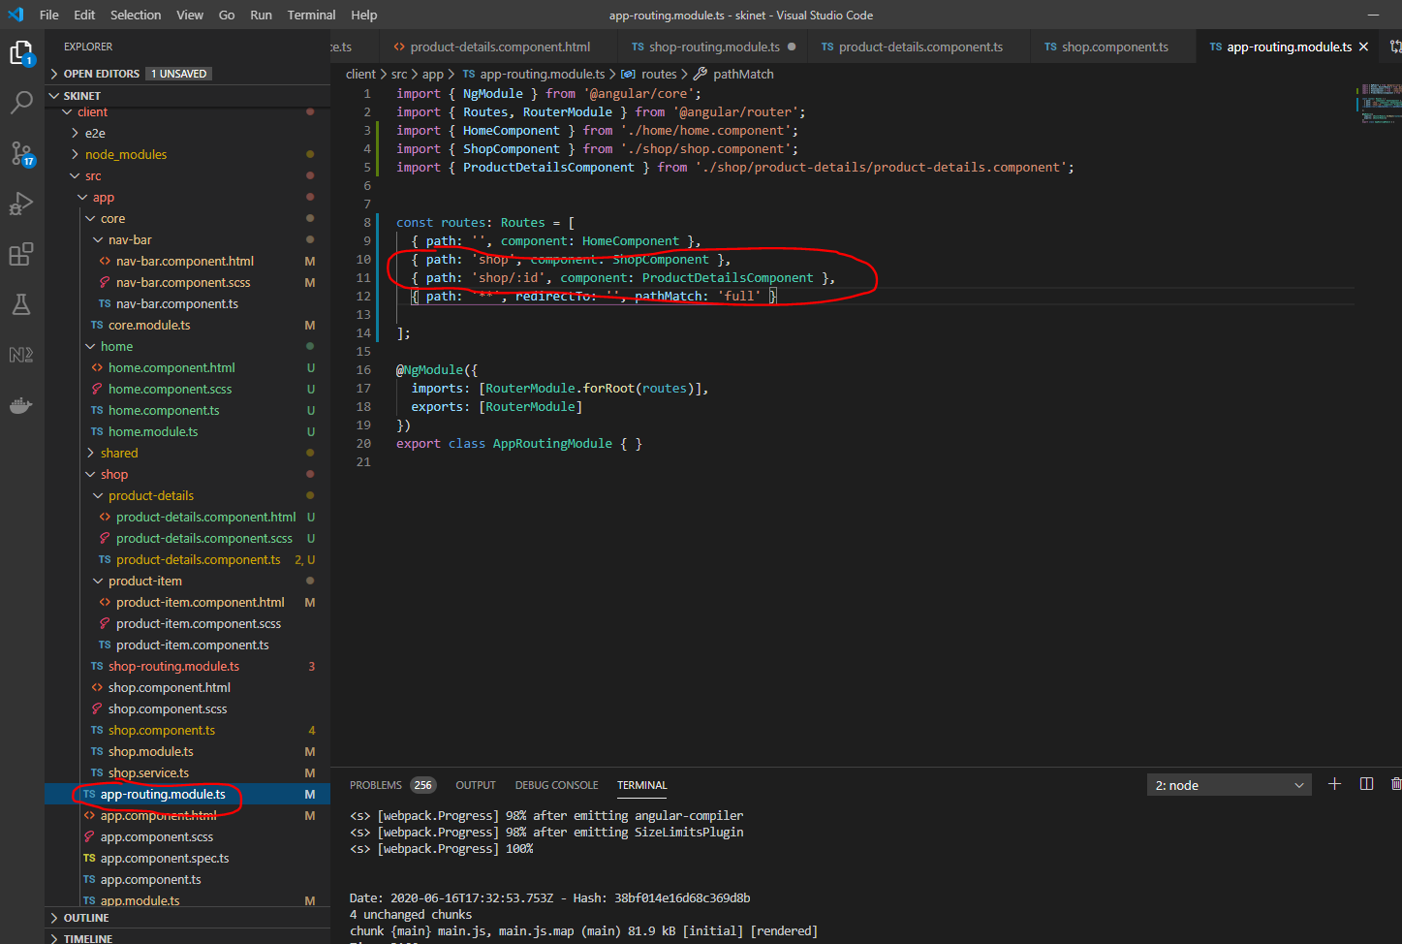

Add them to the ‘shop-routing.module.ts’:-

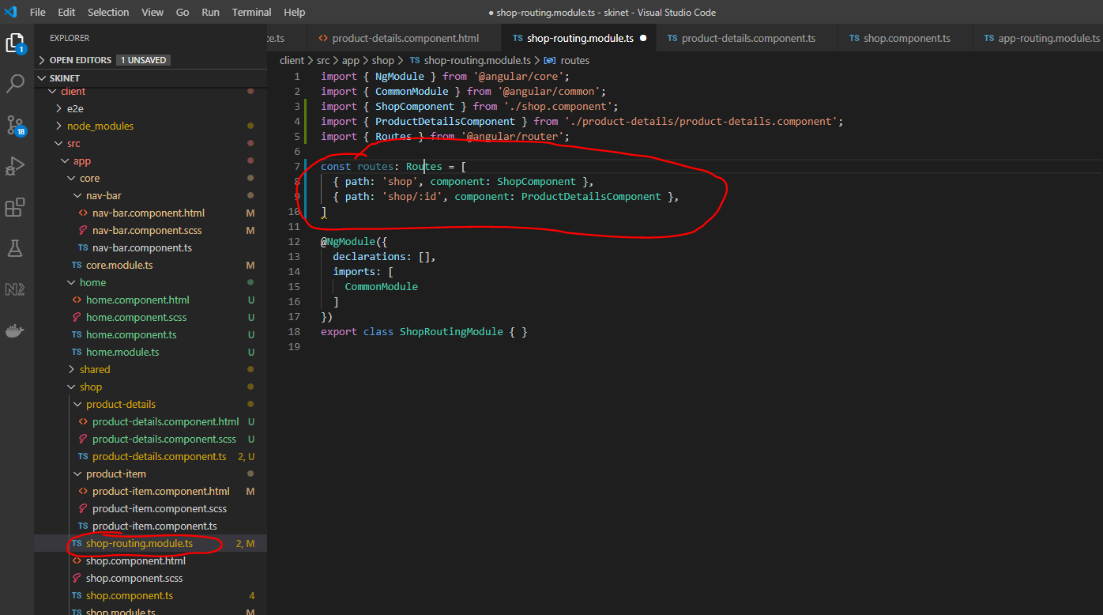

Add and change this:-

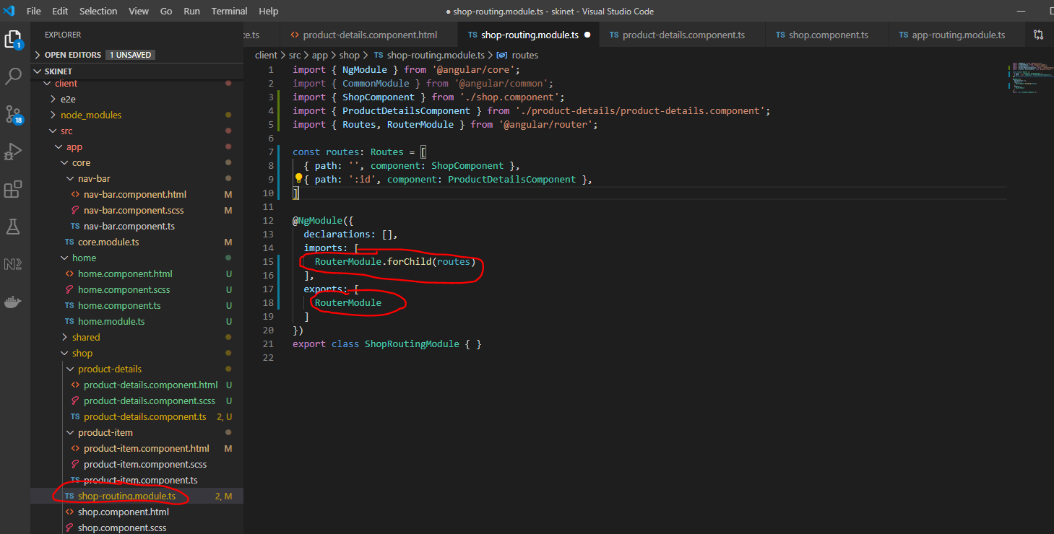

Now, update ‘shop.module.ts’:-

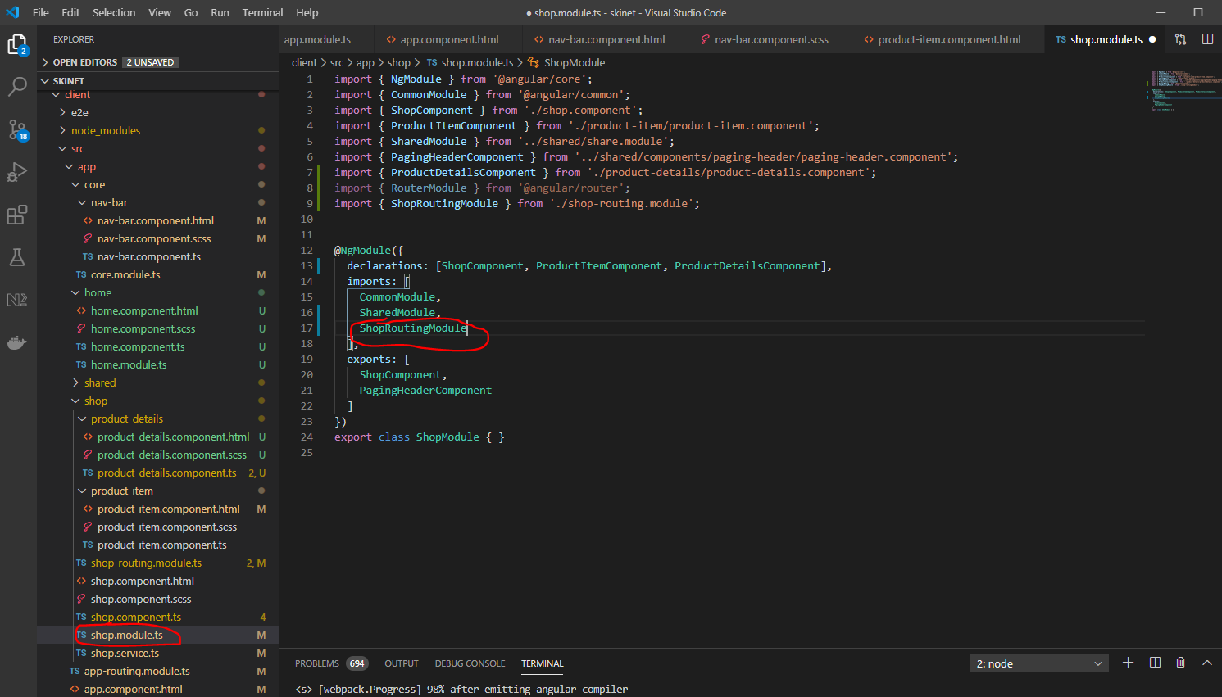

Then, update the ‘app.routing.module.ts’ file:-

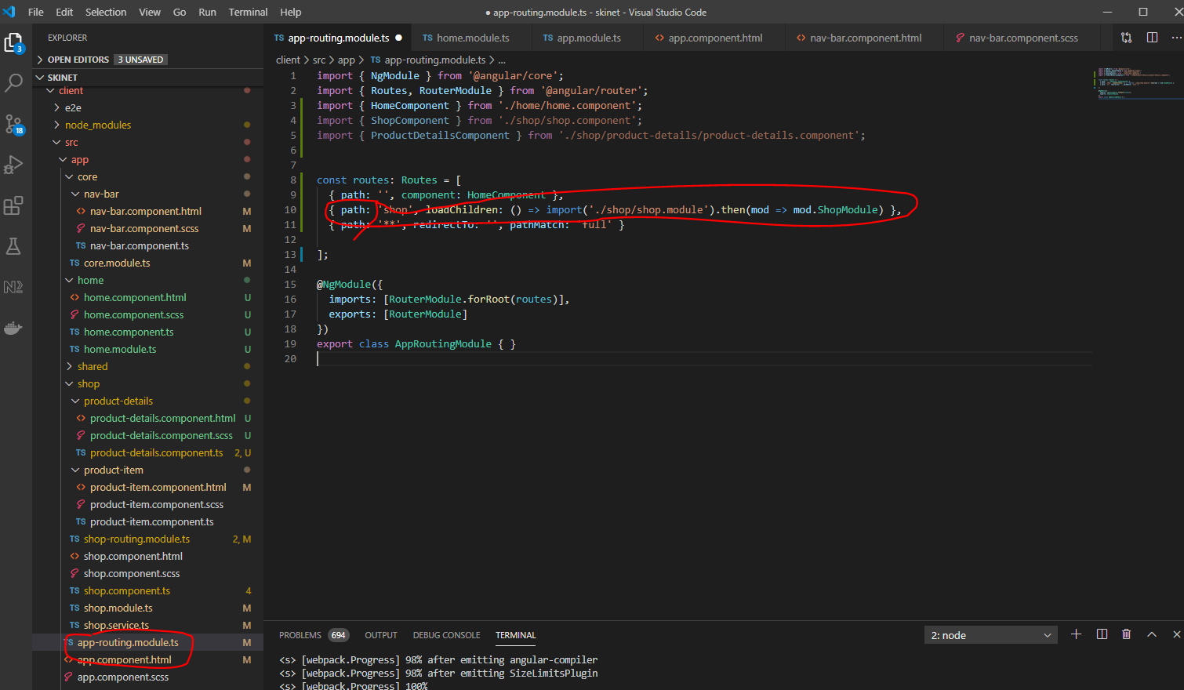

Remove the ‘ShopModule’ from the ‘app.module.ts’:-

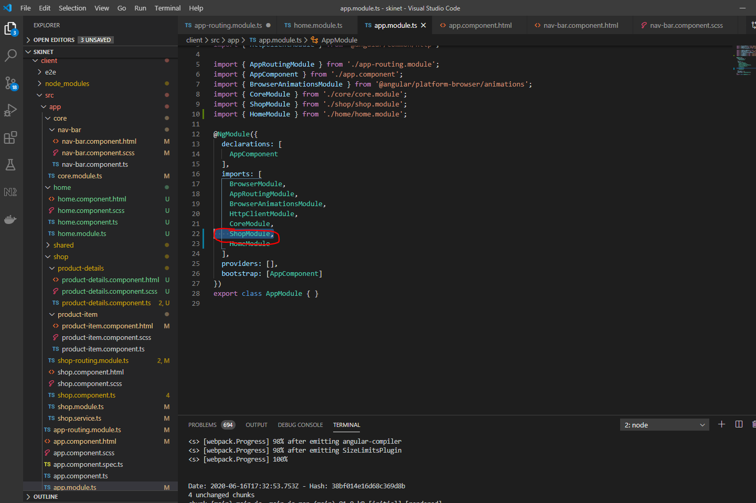

Remove the above.

Also, remove the export ‘ShopModule’ from the ‘shop.module.ts’ file:-

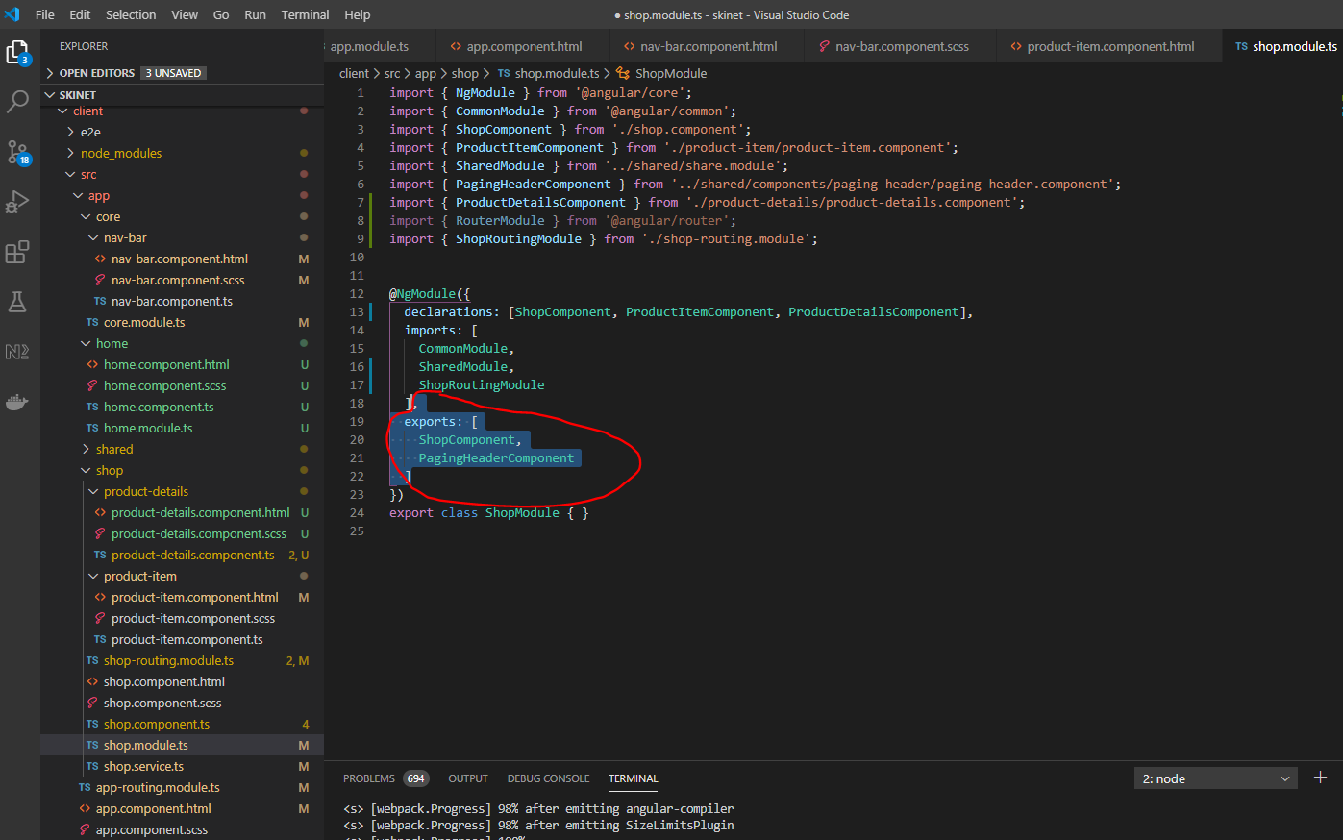

Remove the above highlighted section.

Git Push all your work.

**Error Handling**

Create test-error component here:-

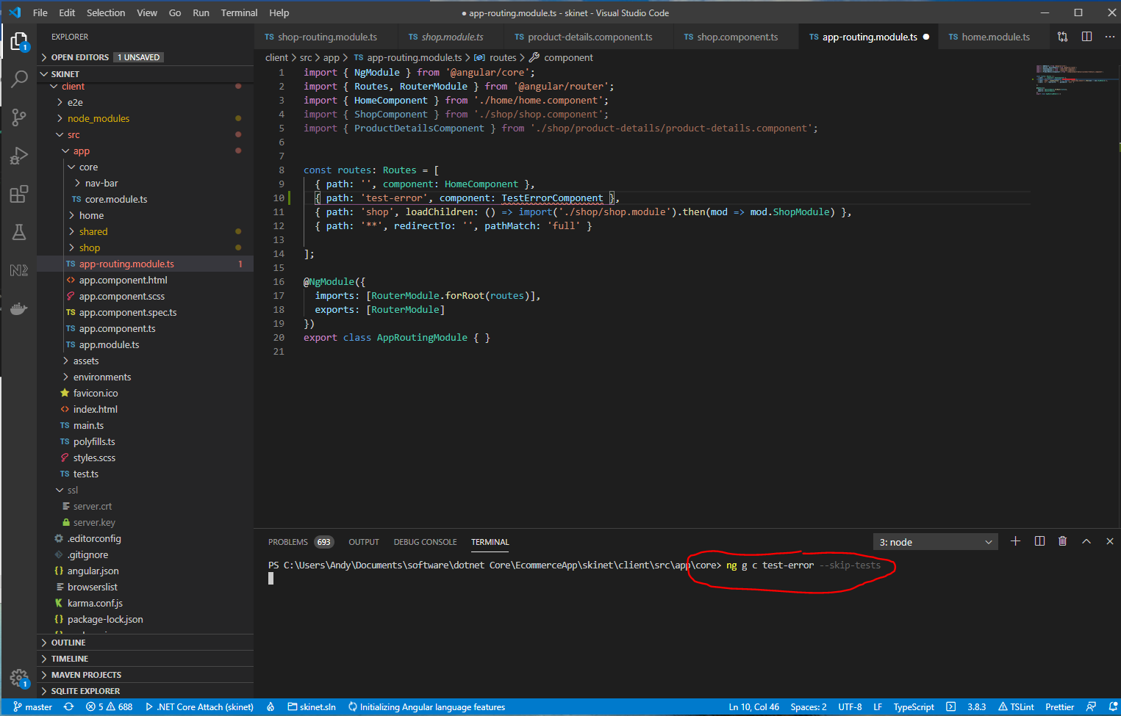

Add this:-

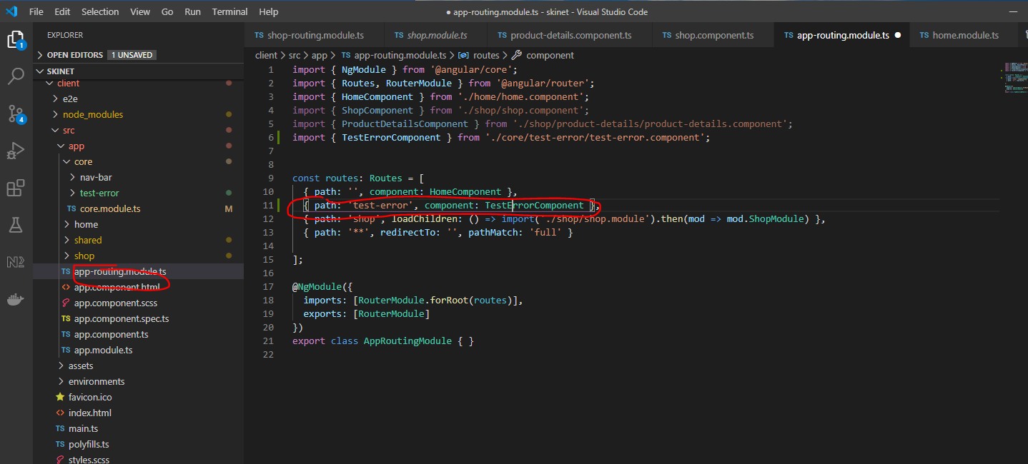

Make this temporary change to the navbar:-

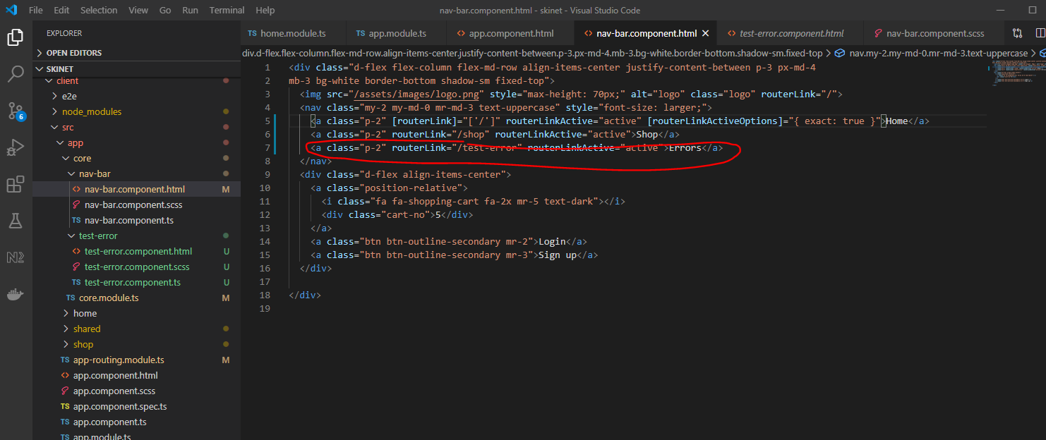

Add a setting for the development api url:-

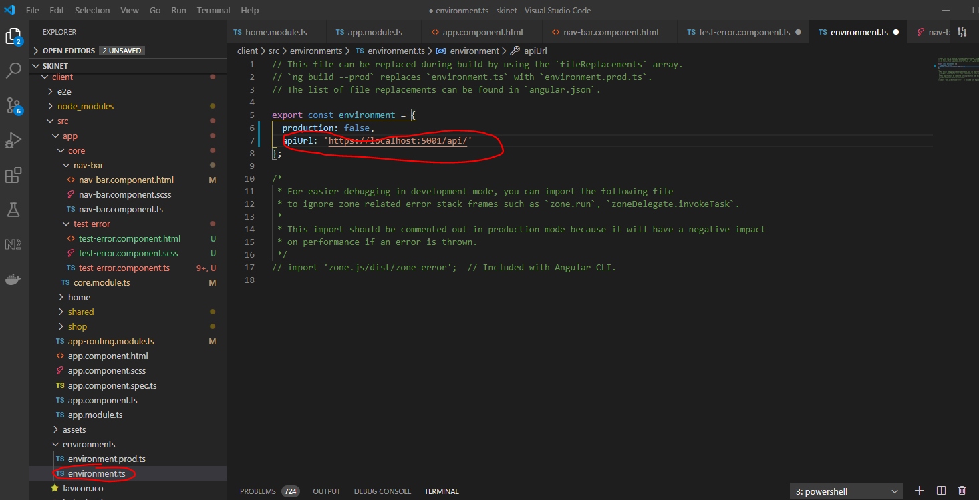

Add these methodfs to the ‘test-error.compoent.ts’:-

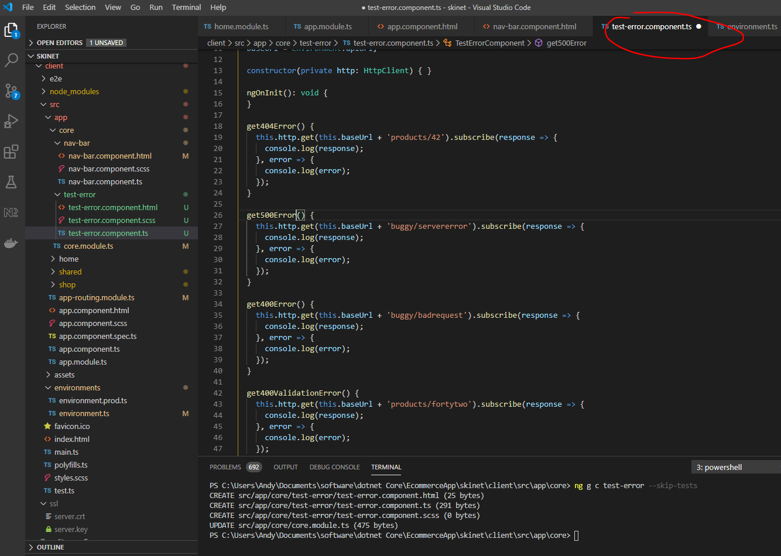

Html:-

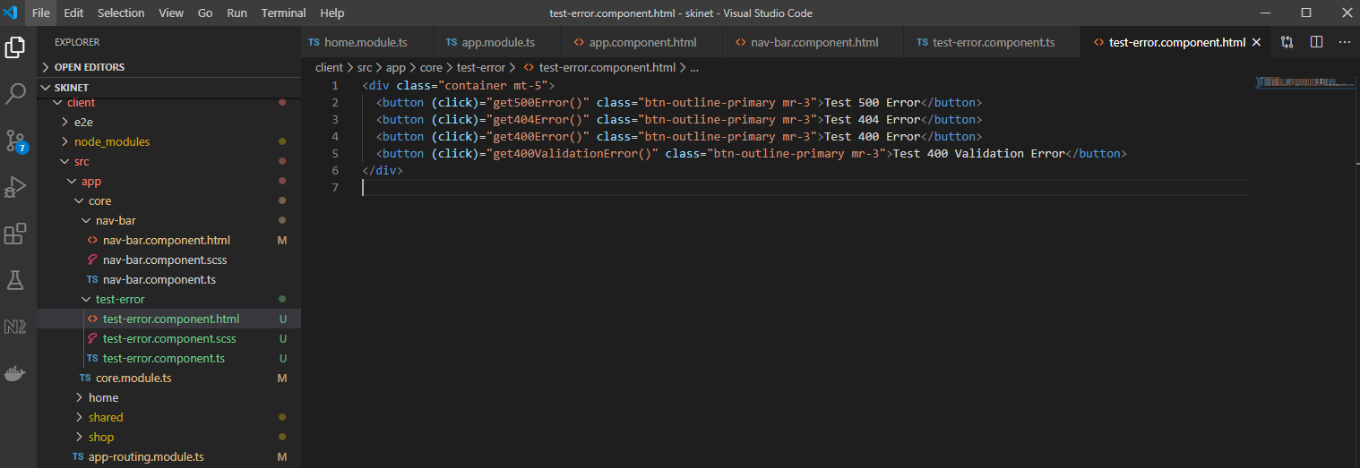

Enter devtools – F12

Check the console whilst clicking the different buttons on the error page:-

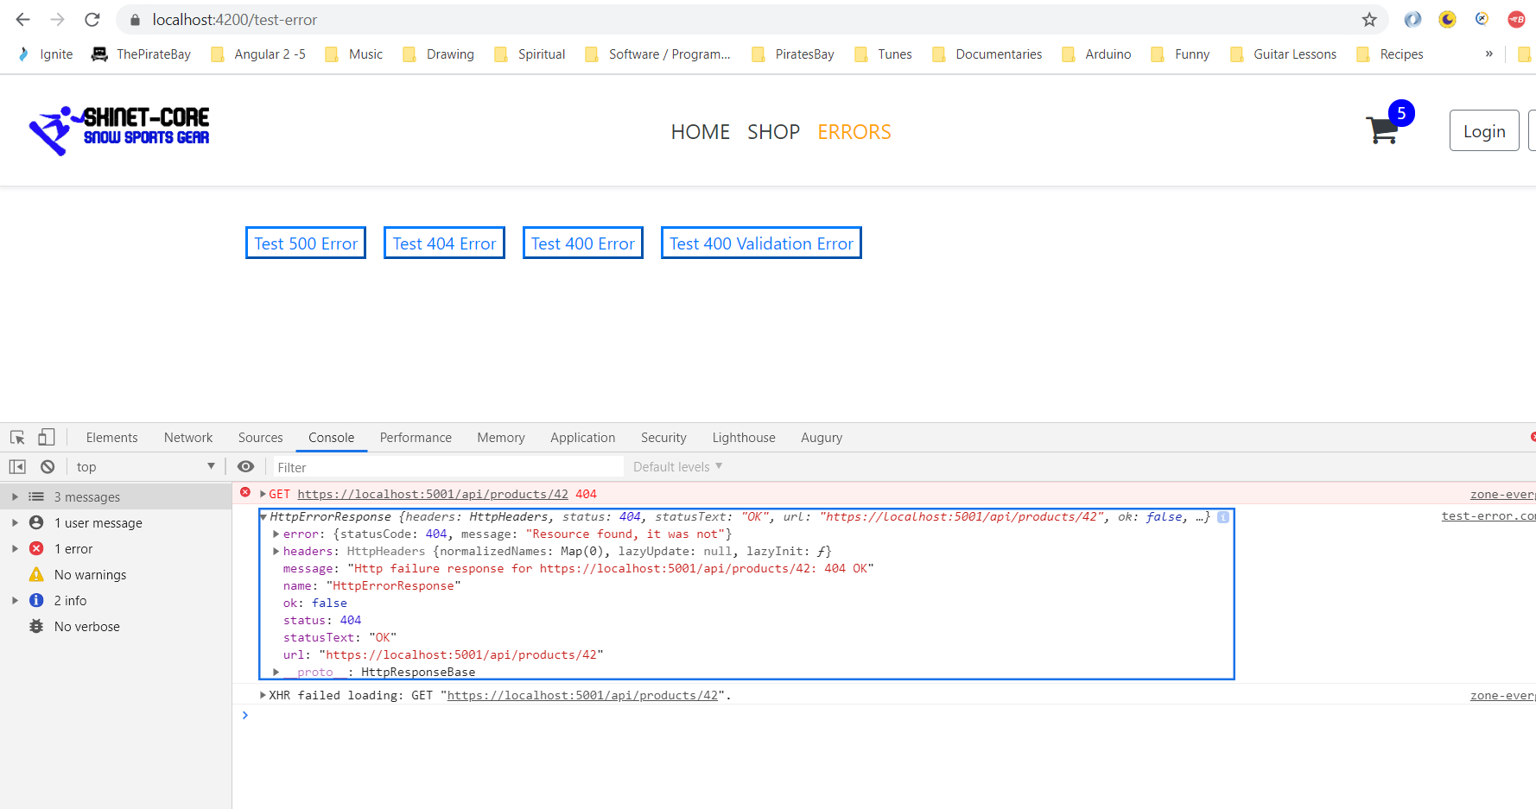

Create a new ‘not-found’ component:-

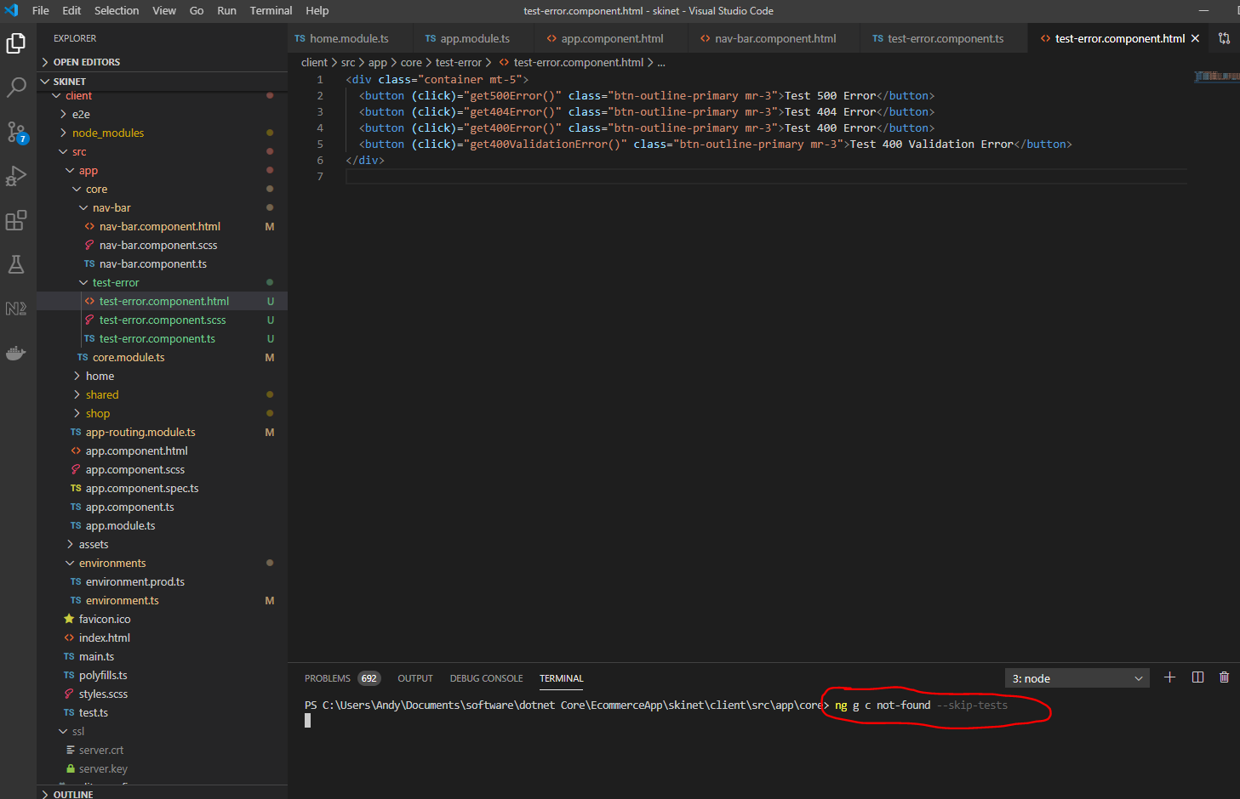

And this:-

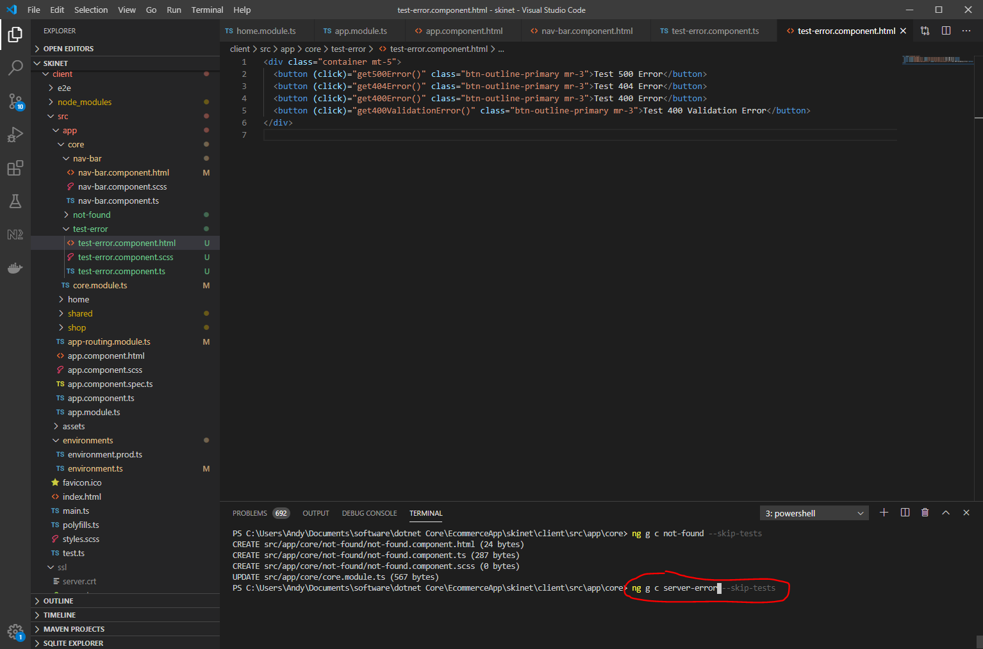

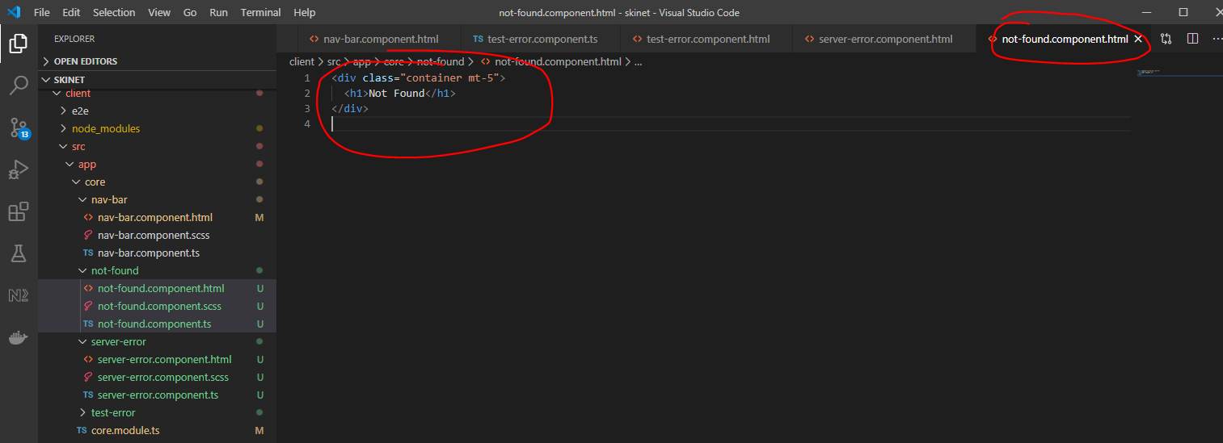

And

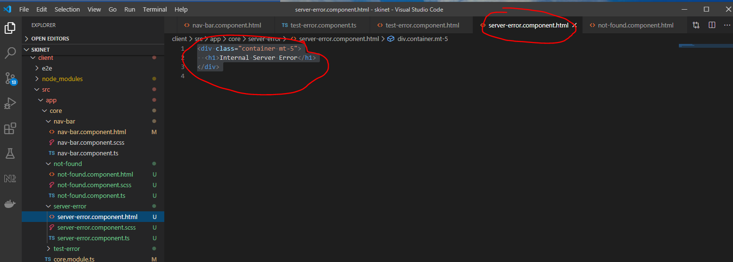

Update app-routing.module:-

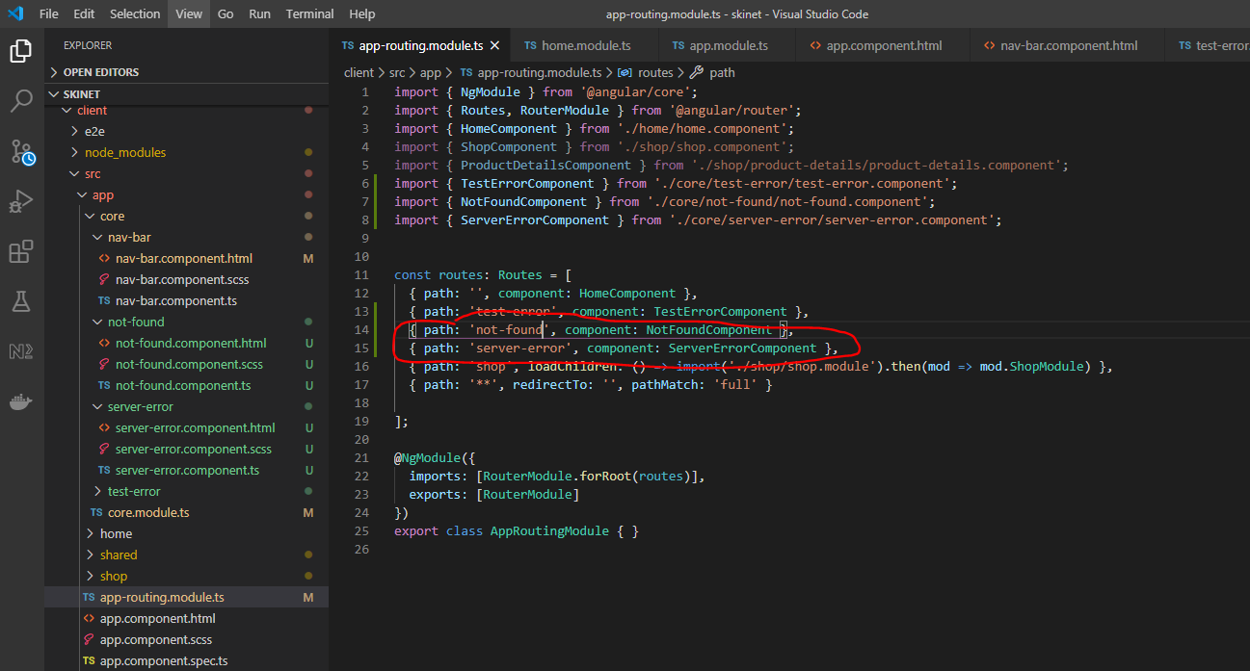

Add interceptor to intercept the response back from the server and see if the response is an error then handle the error appropriately:-

**Interceptor**

Create a new folder here:-

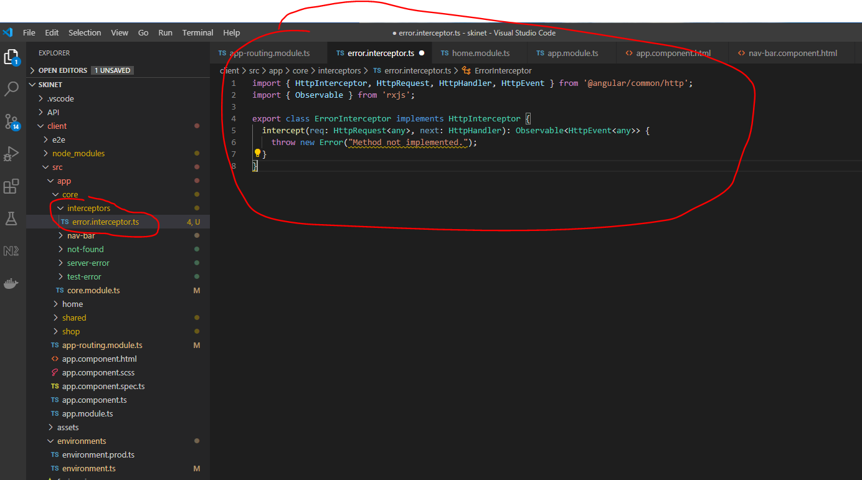

Then add the following:-

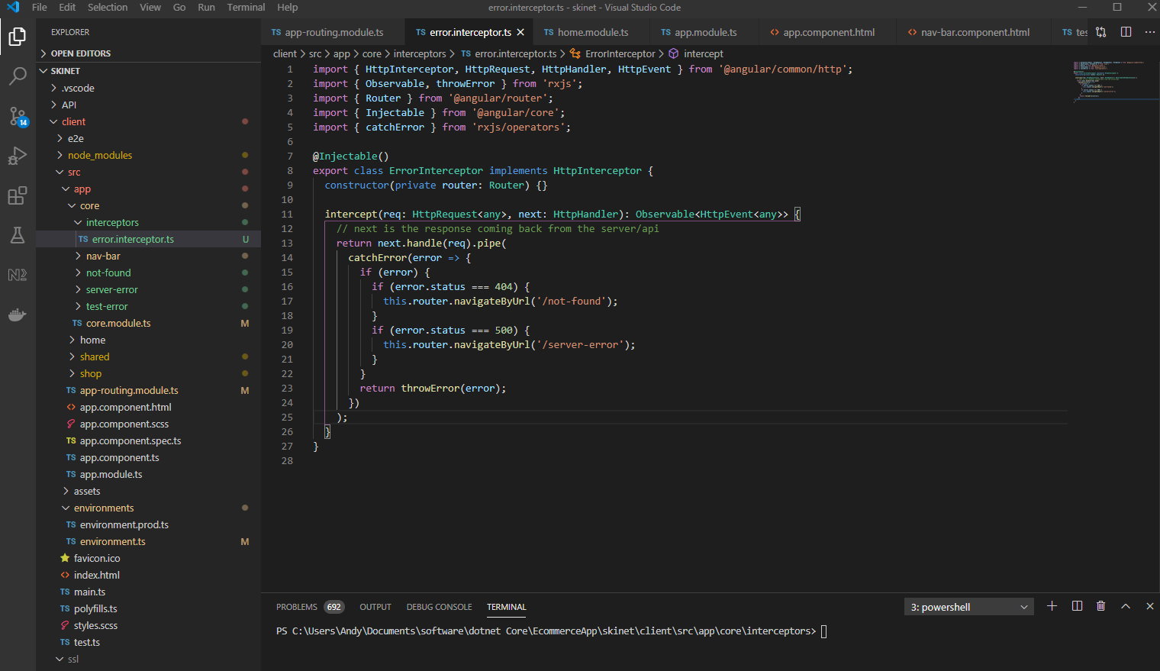

Now, update the app.module.ts file:-

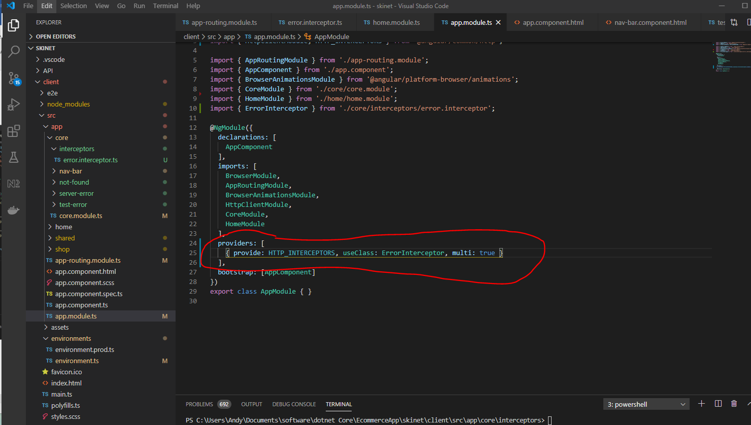

Navigate to the ‘client’ folder using the terminal then install ngx-toastr:-

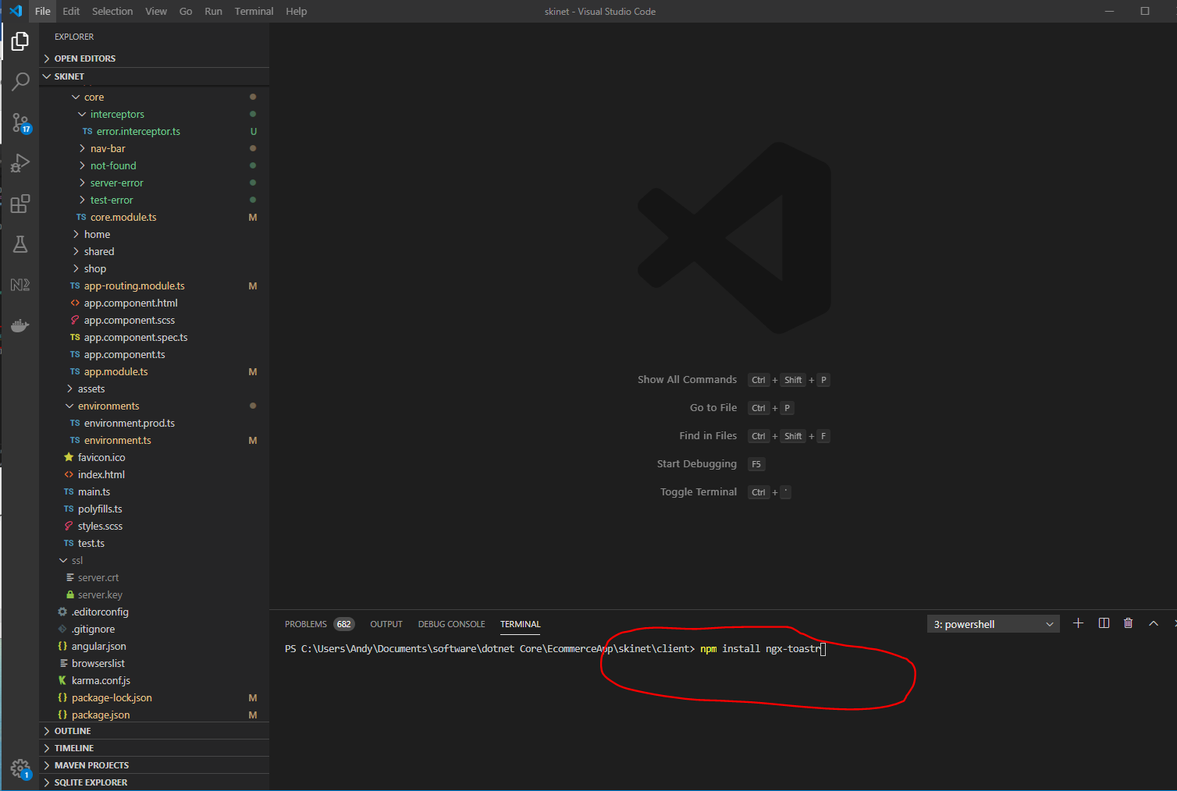

Add ToastrModule to ‘core.module.ts’:-

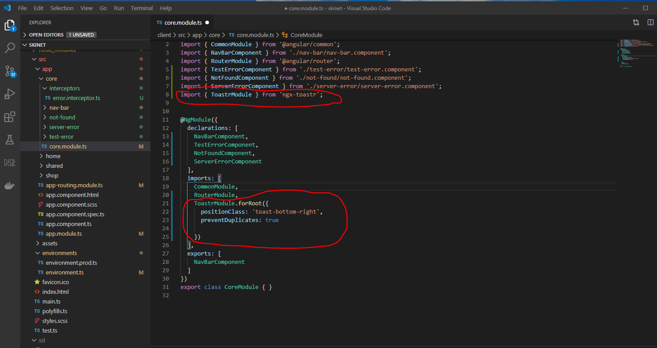

Add style sheet reference in ‘angular.json’ file:-

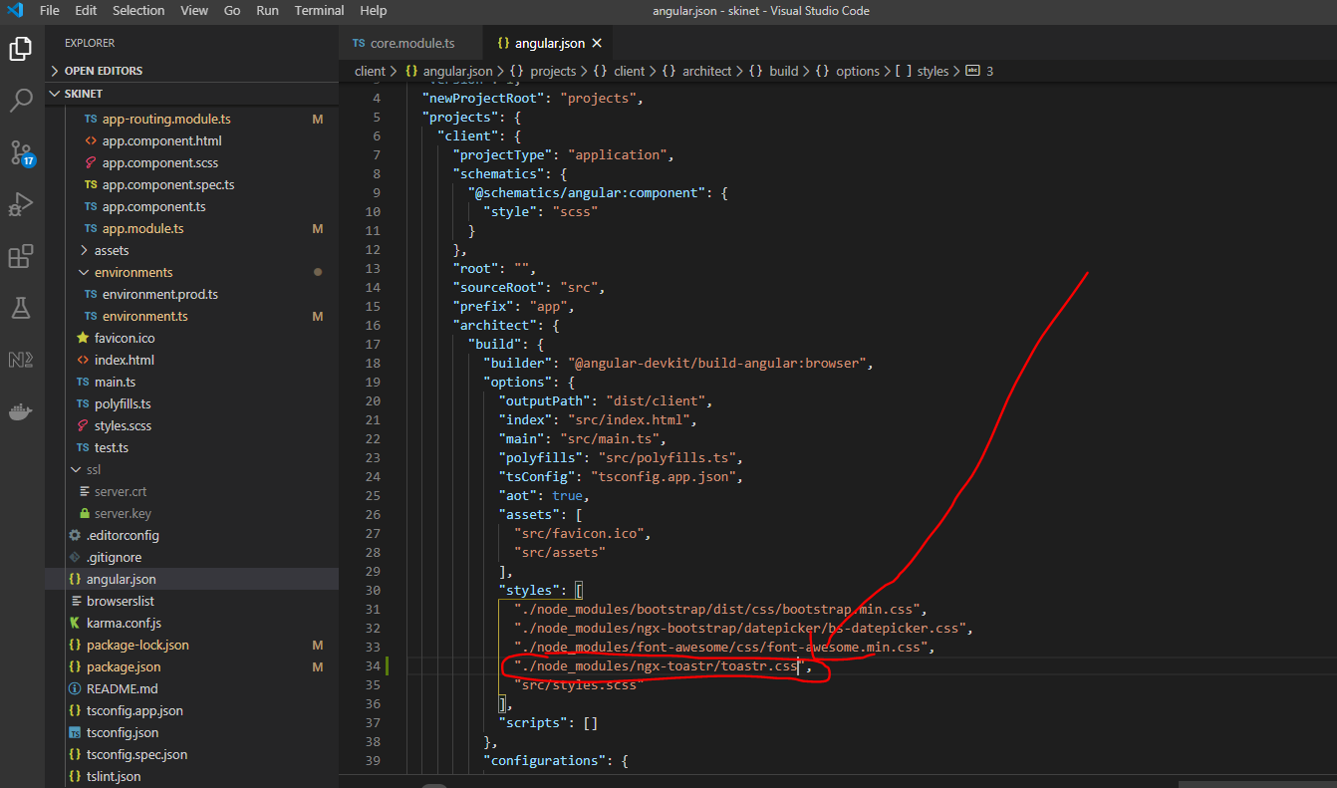

Update interceptor with 400 error:-

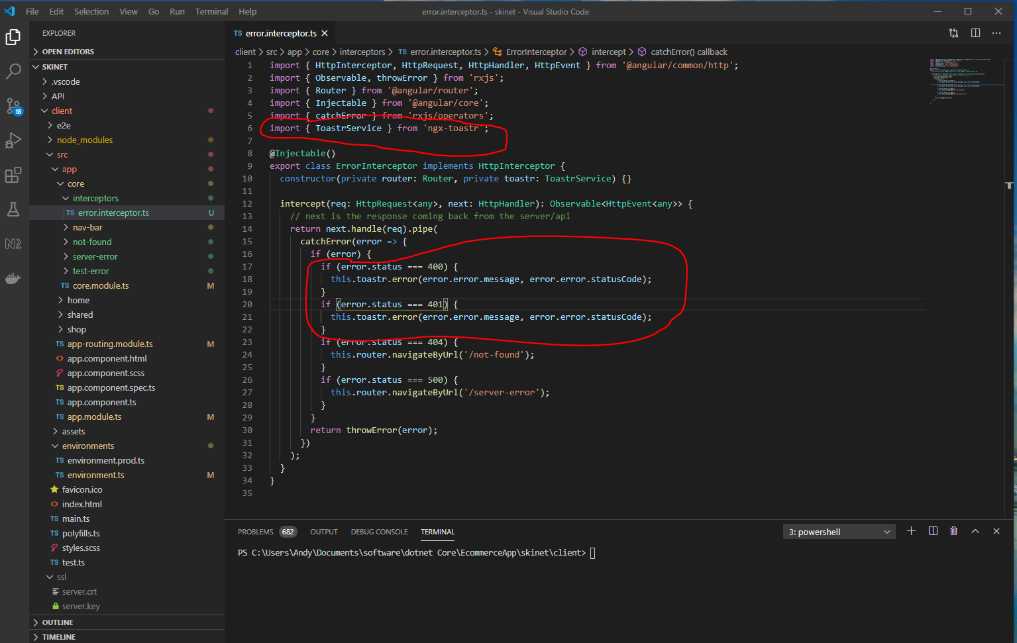

See it working:-

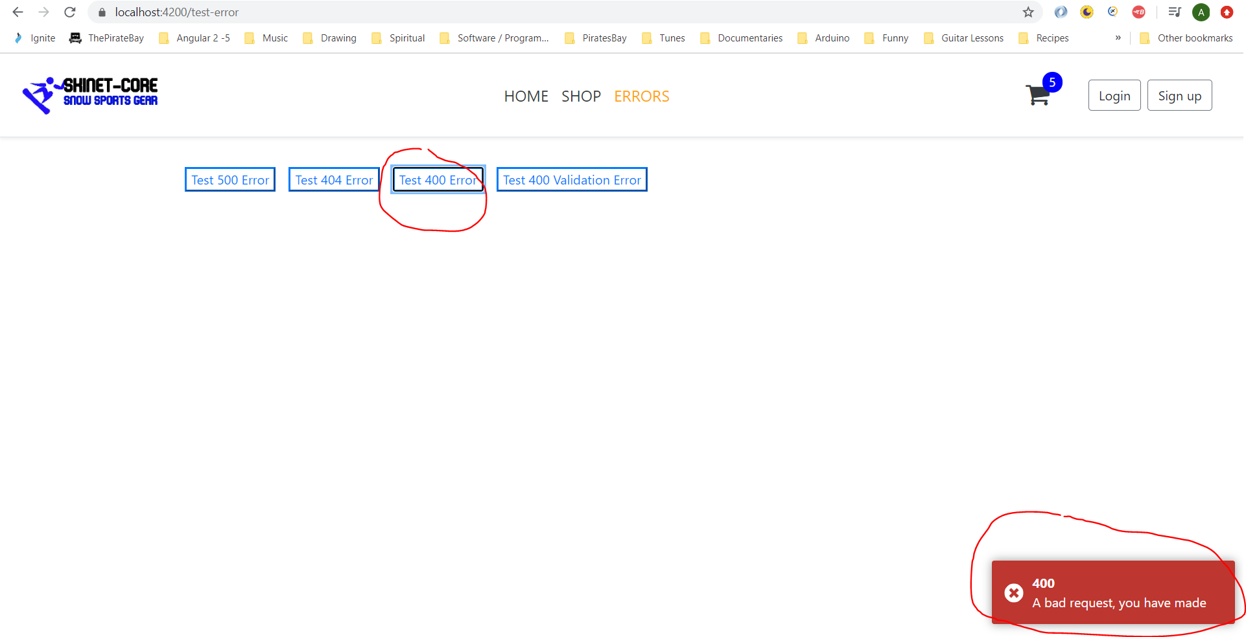

Now, deal with 400 validation error. Go to error interceptor and add this:-

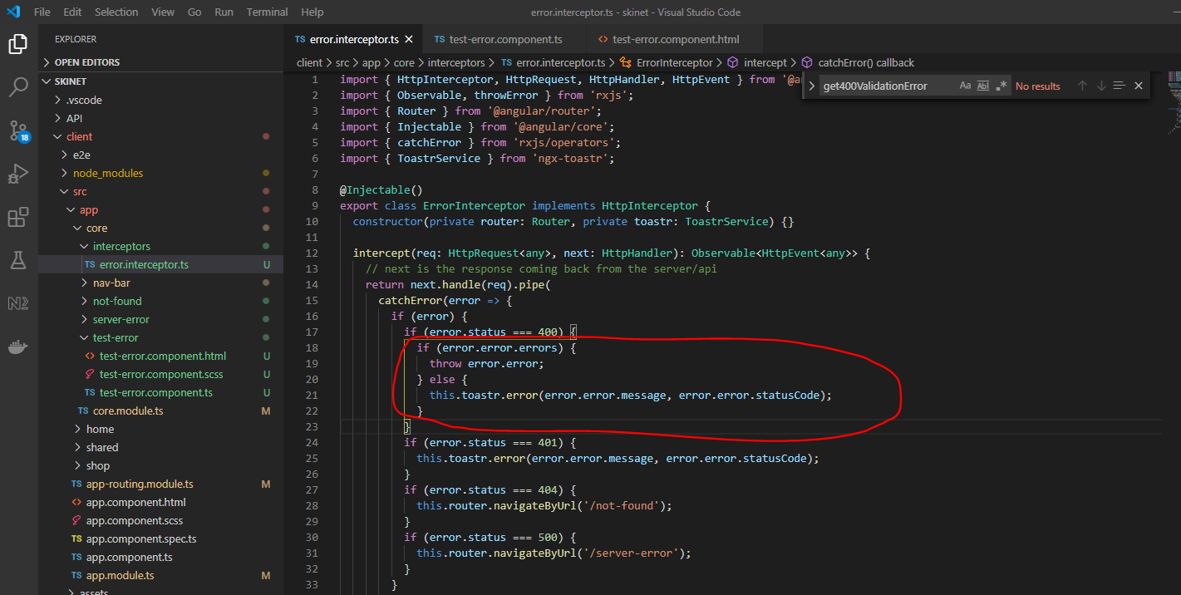

Update the ‘test-error.component.ts’ file:-

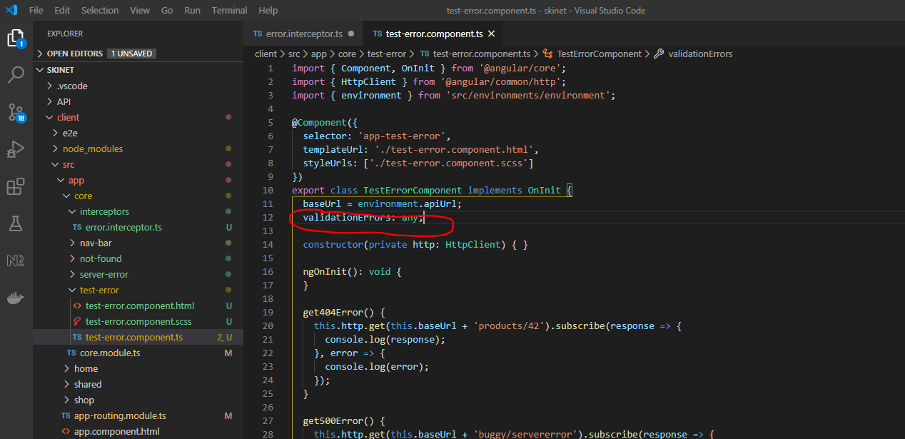

And this:-

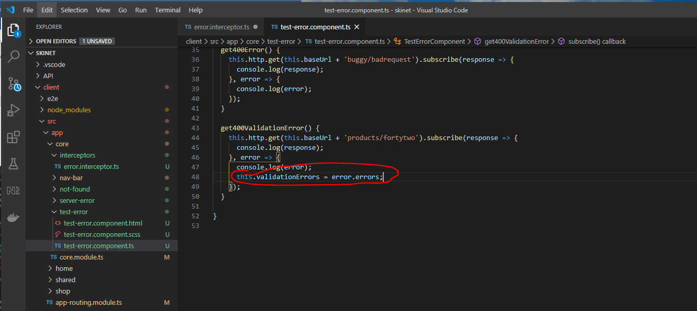

Add this to the test-error.component.html:-

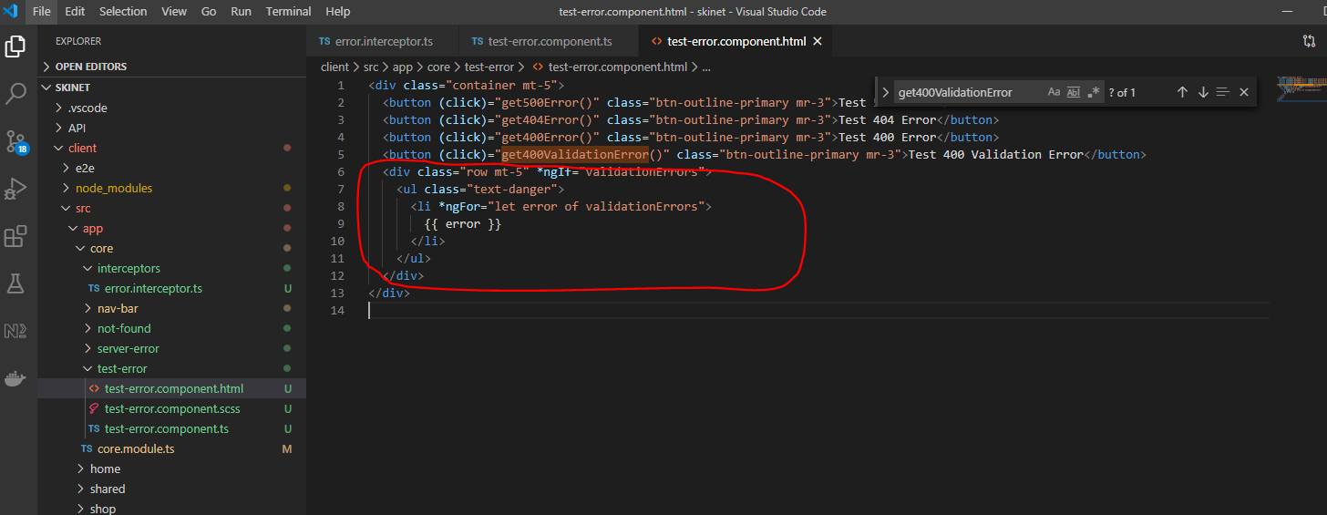

Now test this works:-

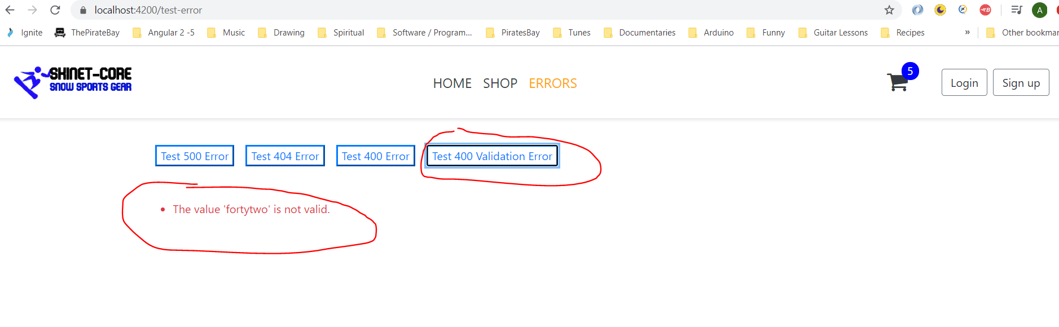

**Improving internal server error component:-**

Add this to the interceptor:-

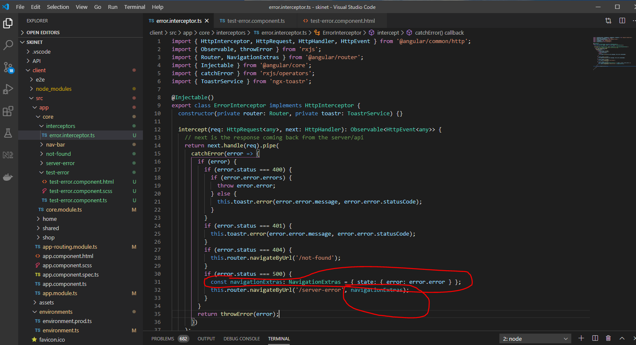

Update server-error.compoent.ts:-

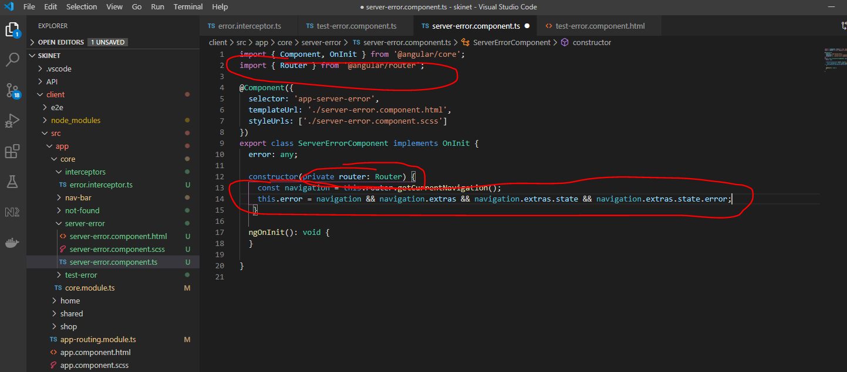

this.error = navigation && navigation.extras && navigation.extras.state && navigation.extras.state.error;

The above line will only set error if all the above states are set.

Add this to the ‘server-error.component.html file:-

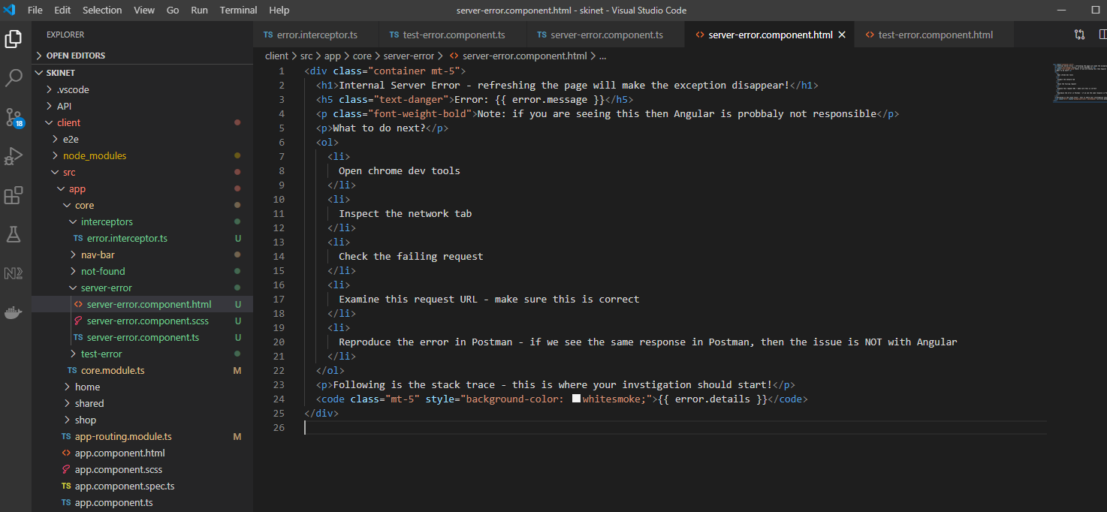

Put the above inbetween a <ng-container> tag:-

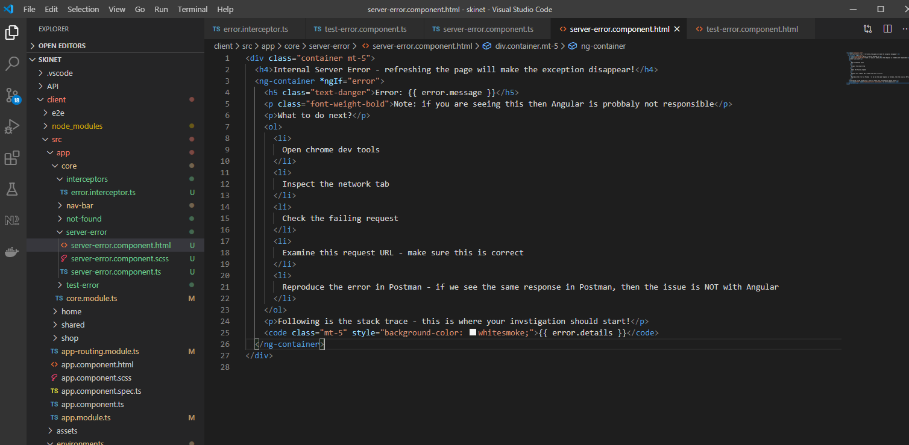

Now test:-

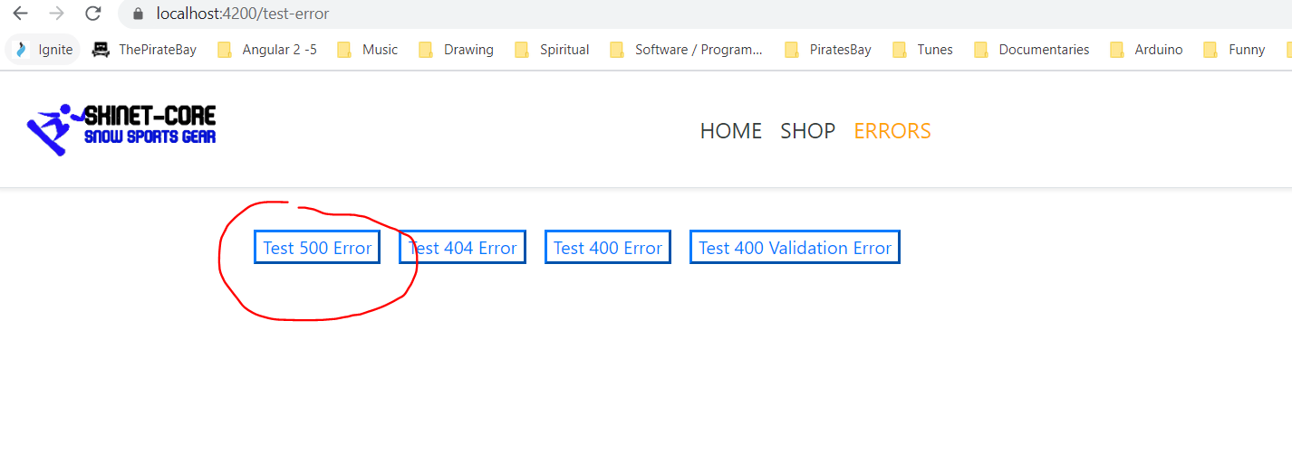

Clicking the above takes you here:-

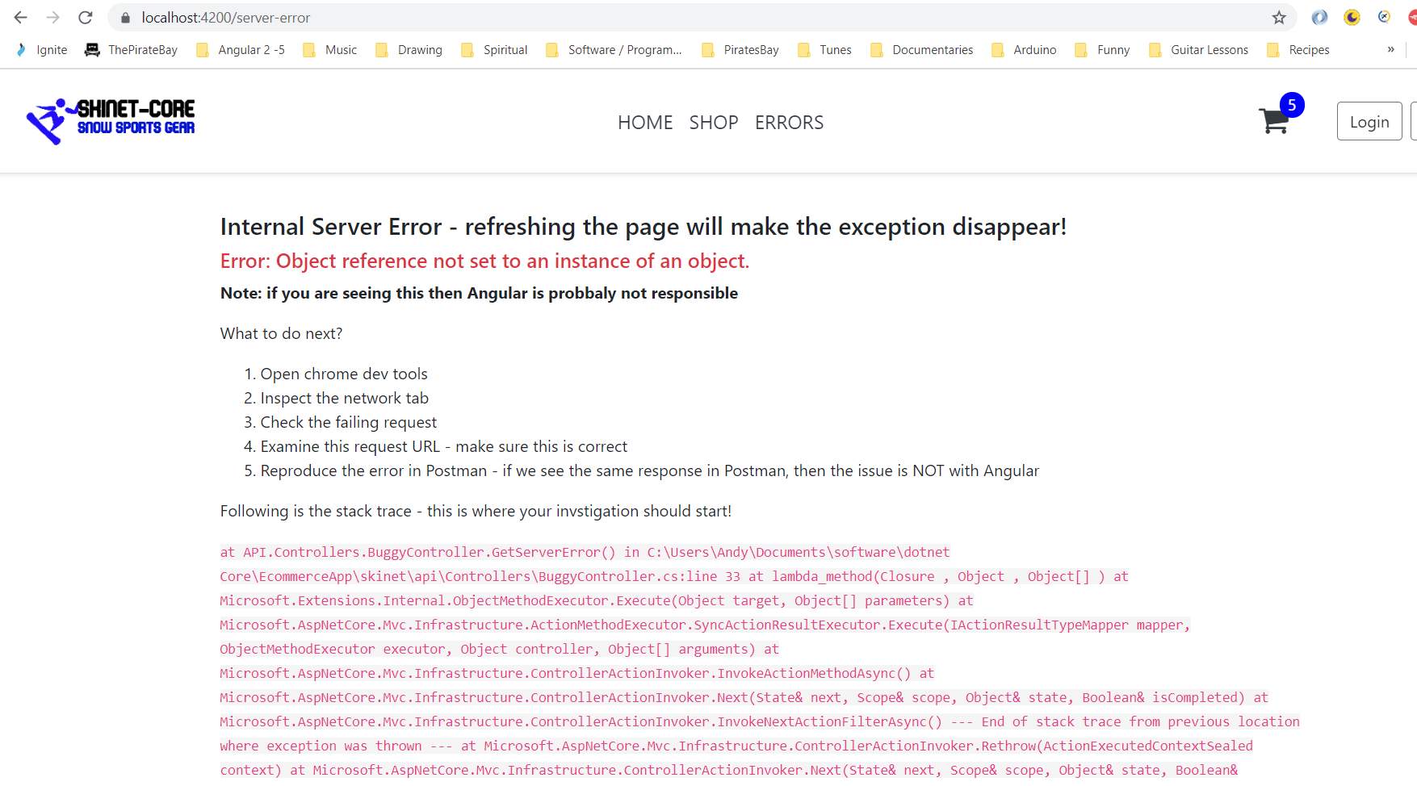

Push all changes to GitHub:-

git add .

git commit -m “Added error handling”

git push origin master

**Adding Pazazz to Client**

Header section:-

Create a new component inside of the ‘client/src/app/core’ folder:-

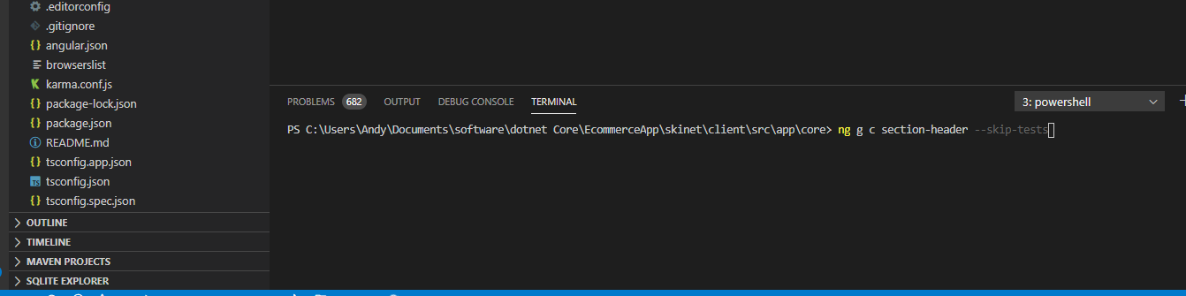

Add the following code

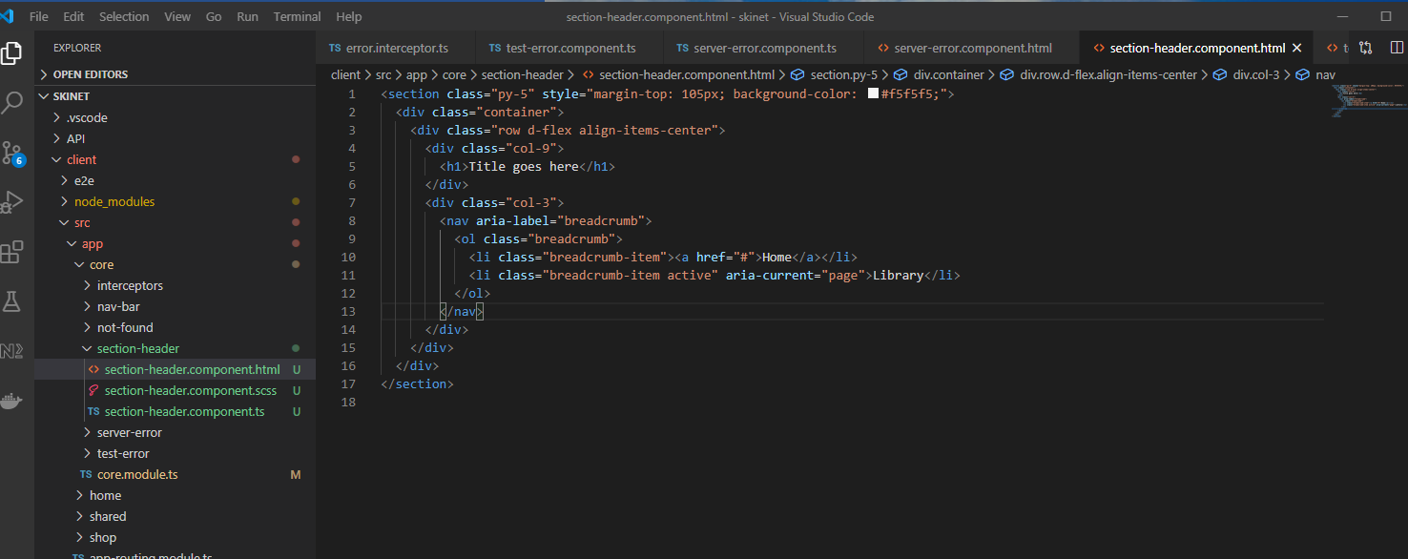

Use Bootstrap for breadcrumb styling:-

<https://getbootstrap.com/docs/4.0/components/breadcrumb/>

Export the ‘section-header’ component from ‘core.module.ts’:-

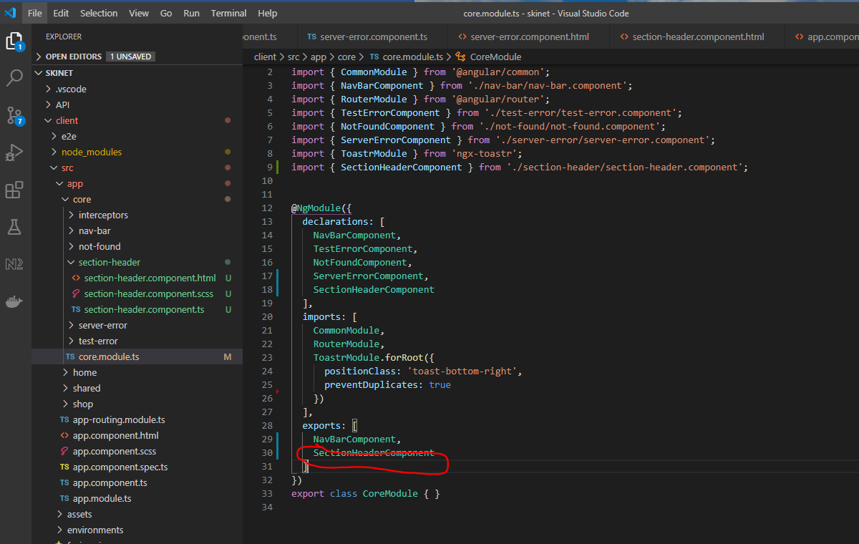

Add section-header to app.component.html:-

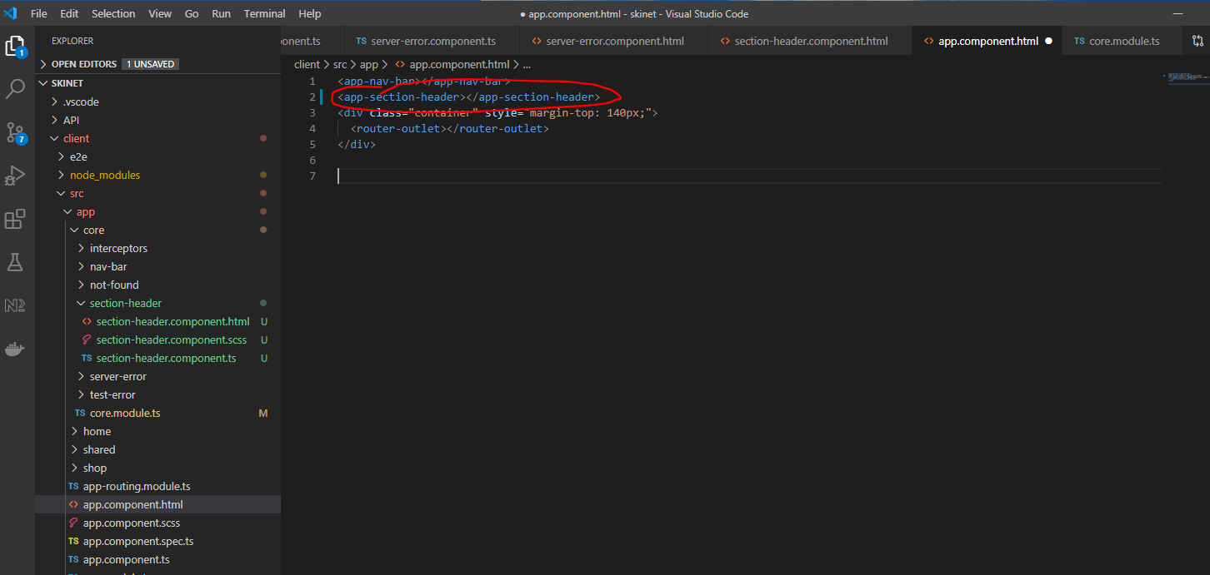

**Add breadcrumb functionality**

See breadcrumb section below:-

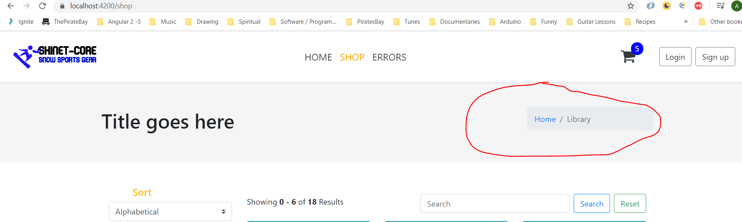

Add this package to your project:-

xng-breadcrumb

In your terminal navigate to here:-

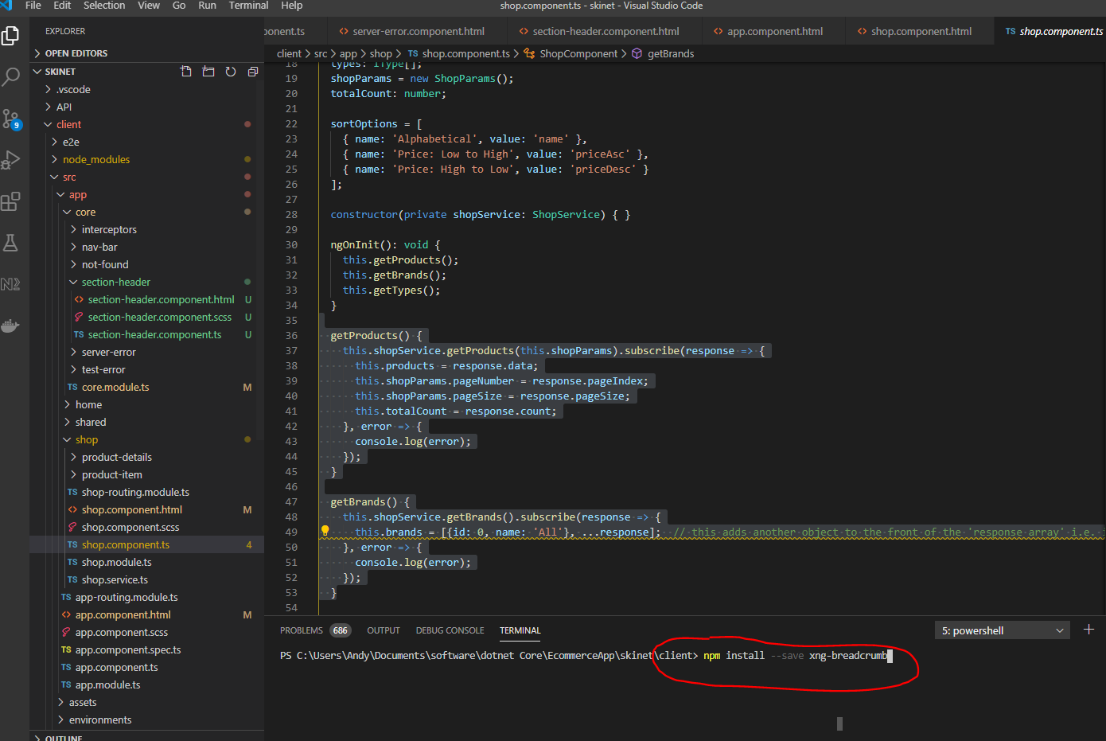

npm install --save xng-breadcrumb

Add this to the ‘core.module.ts’ file:-

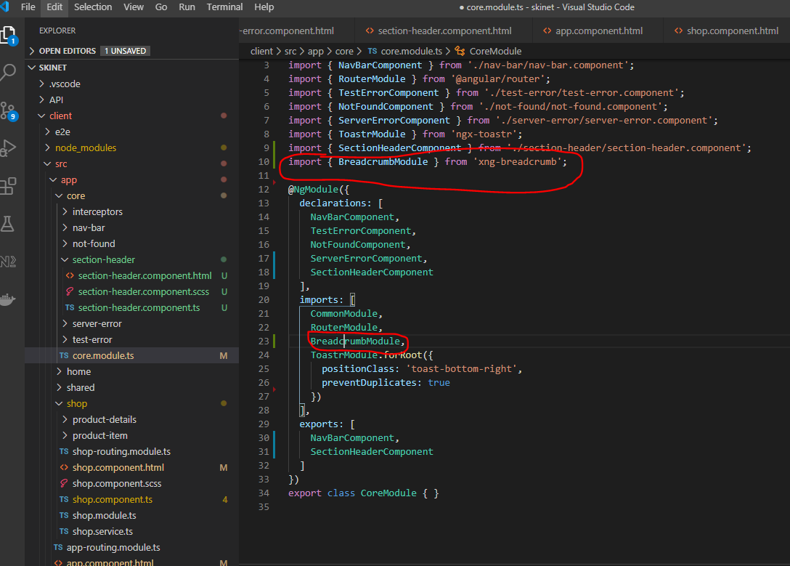

Add this into section-header.component.html:-

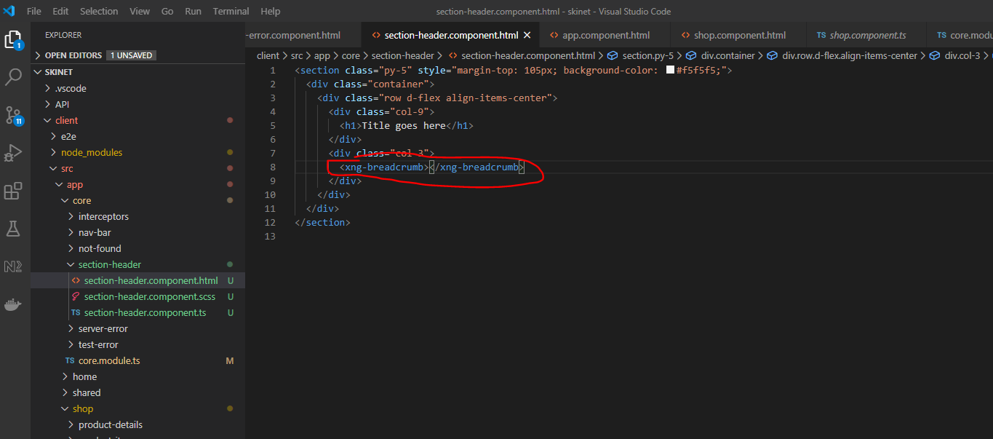

Update the app-rounting.module.ts:-

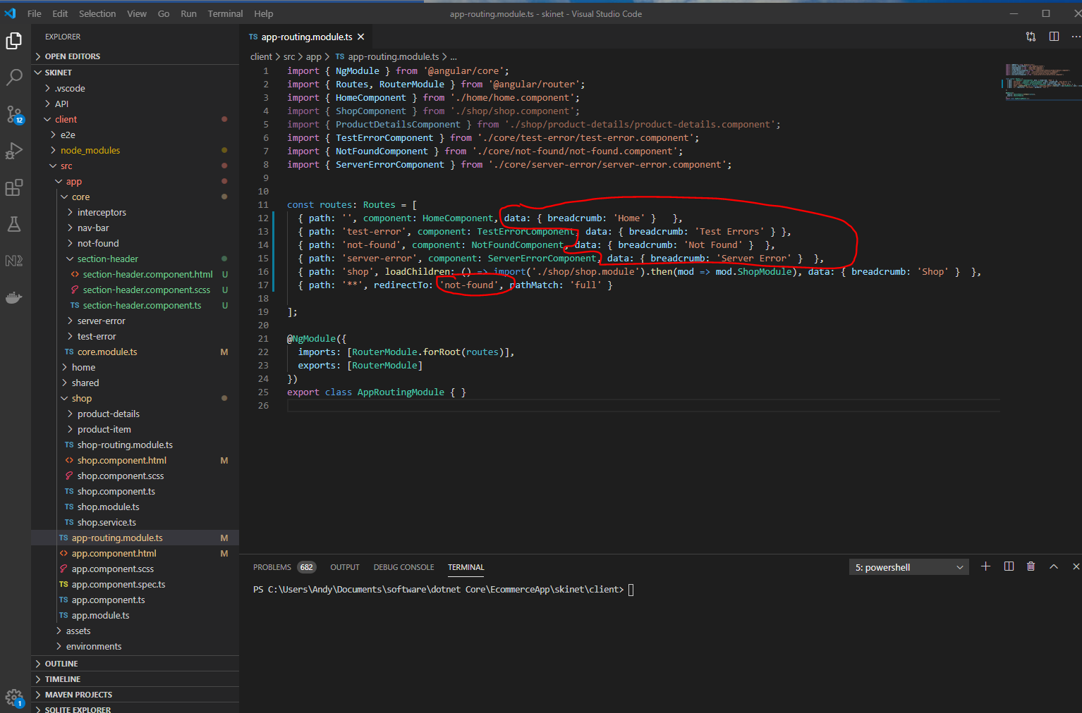

Update this file:-

shop-routing.module.ts

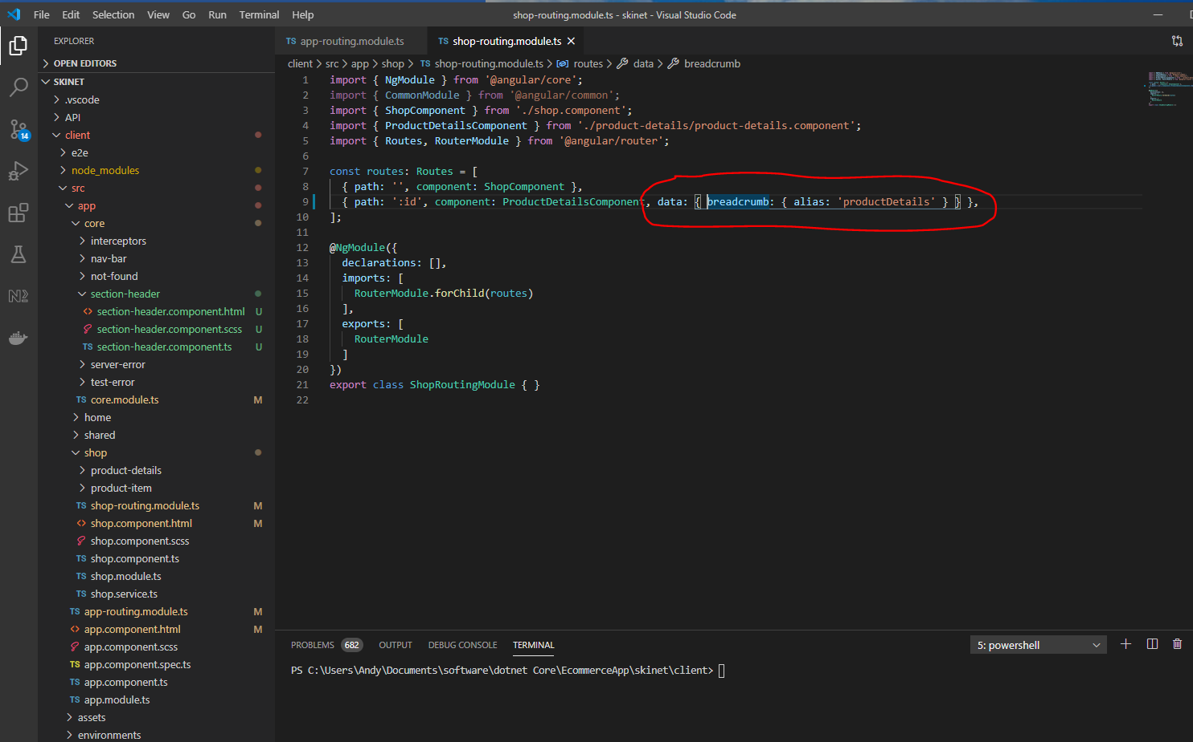

Add this to the ‘product-details.component.ts’ file:-

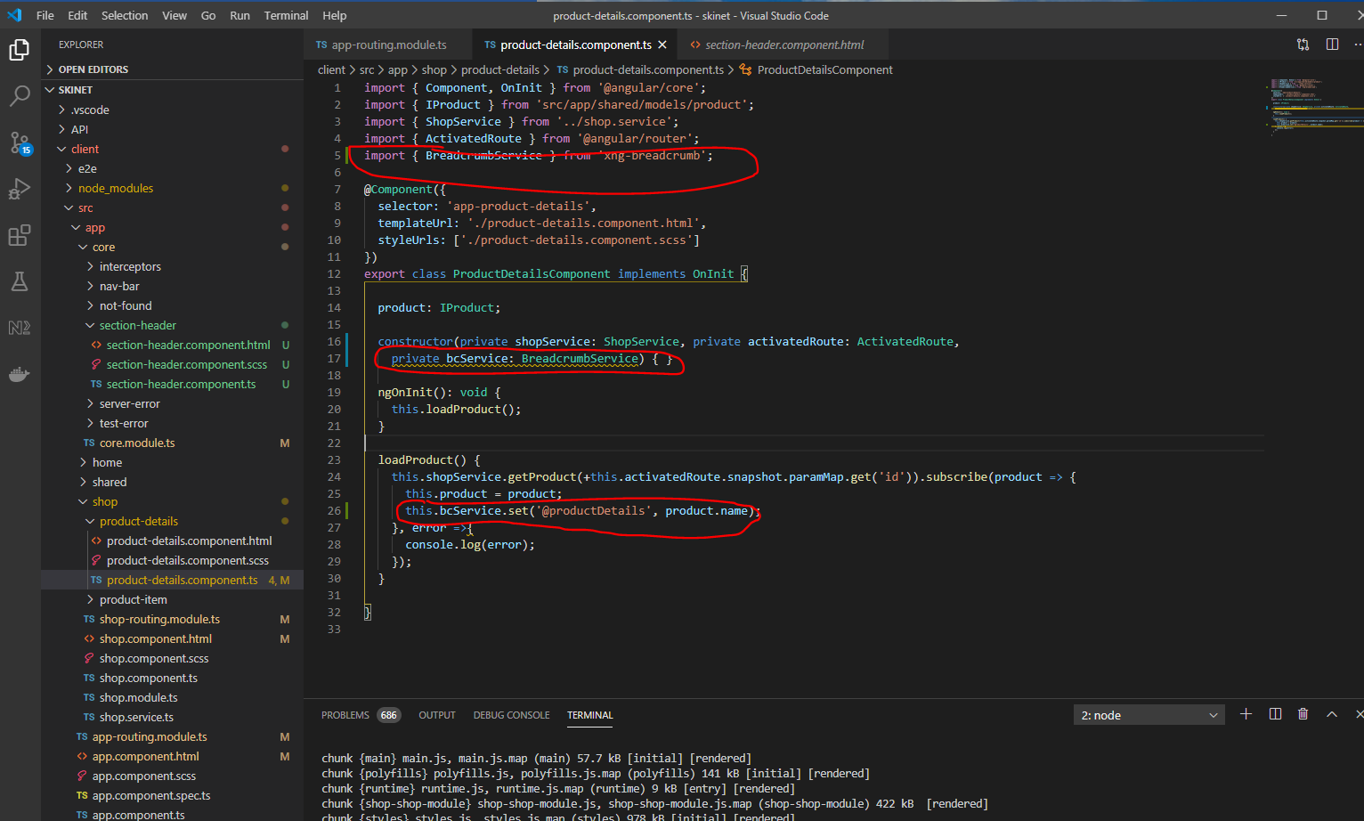

The website now has this:-

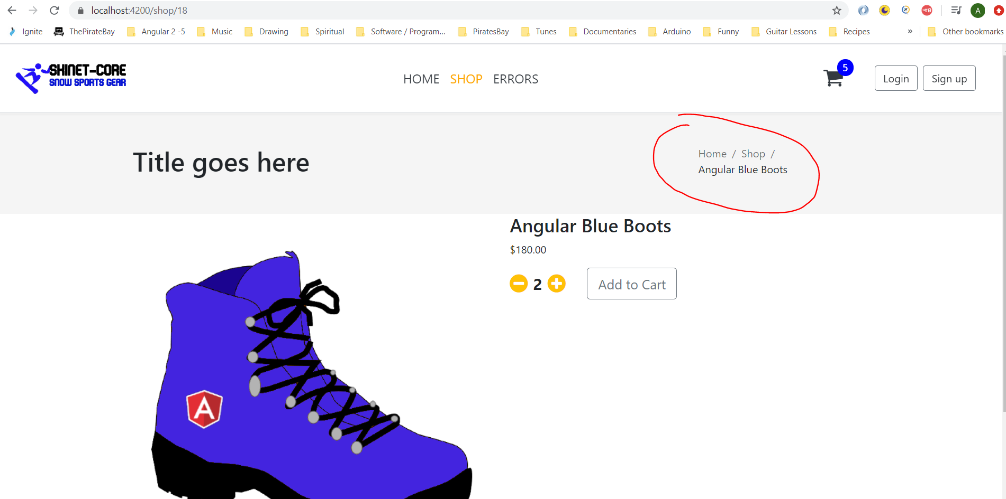

Update the styles.scscc file to tidy the above up:-

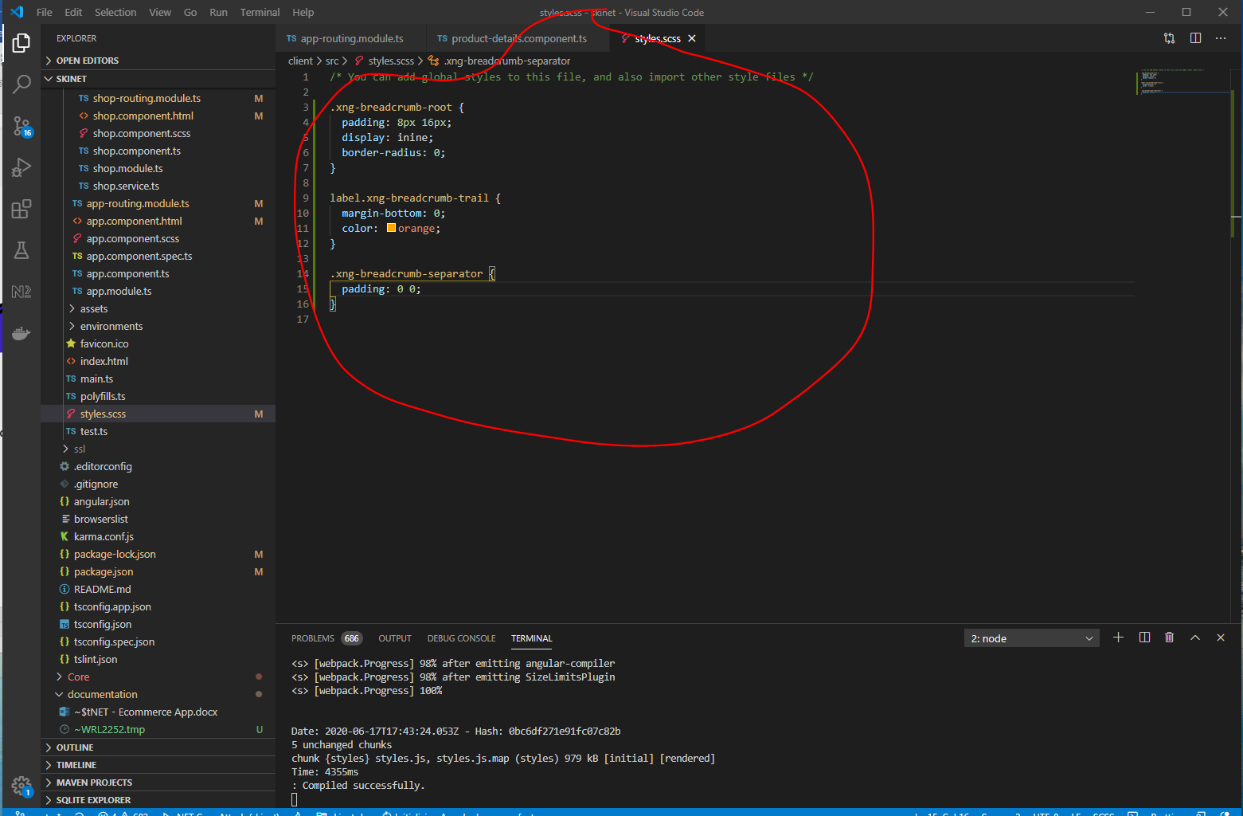

**Add title to page**

This will be dependent on which breadcrumb we have selected.

Update the section-header.compoent.ts:-

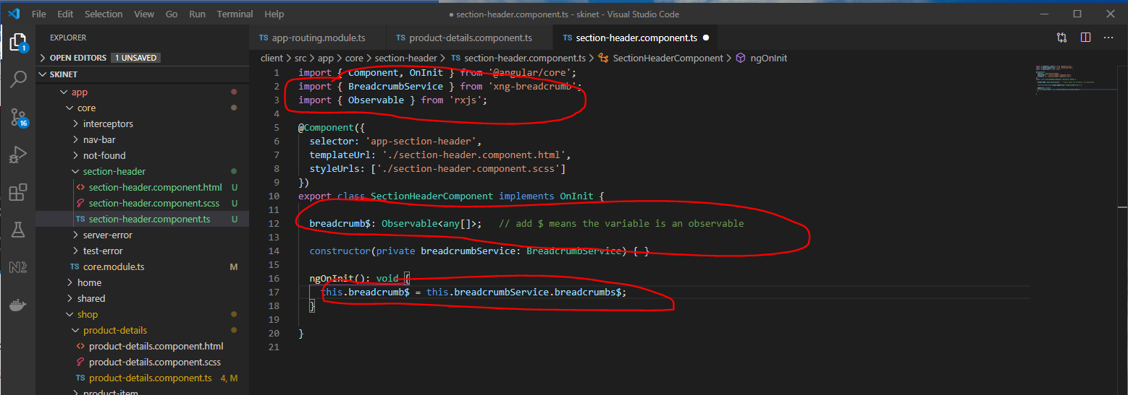

Update html:-

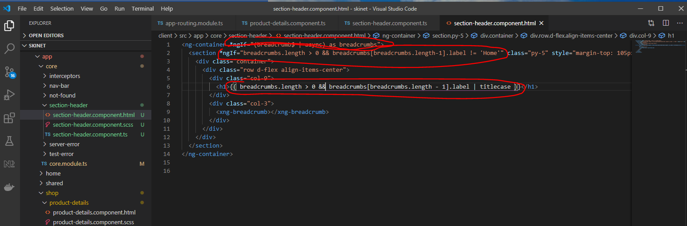

Async – this means that it will subscribe the ‘breadcrumb$’ observable. And unsubscribe when finished.

**Style Product Item**

Update ‘product-item.componet.ts’:-

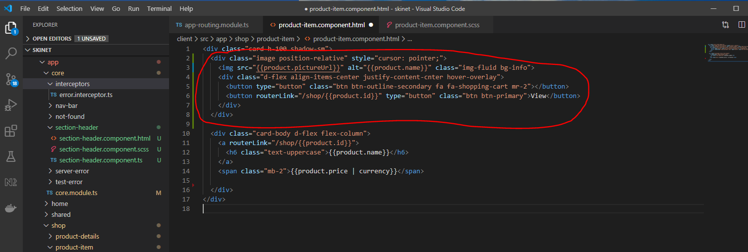

Now, update the scss:-

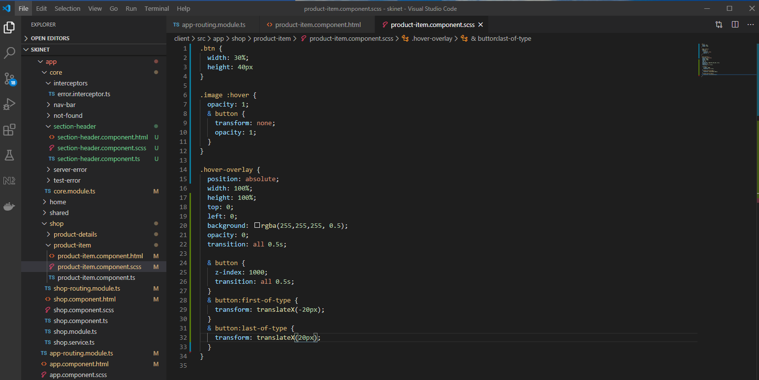

**Change Bootstrap Theme with Bootswatch**

You can look at Bootstrap theme here:-

<https://themestr.app/>

In the terminal (must be in the ‘client’ folder):-

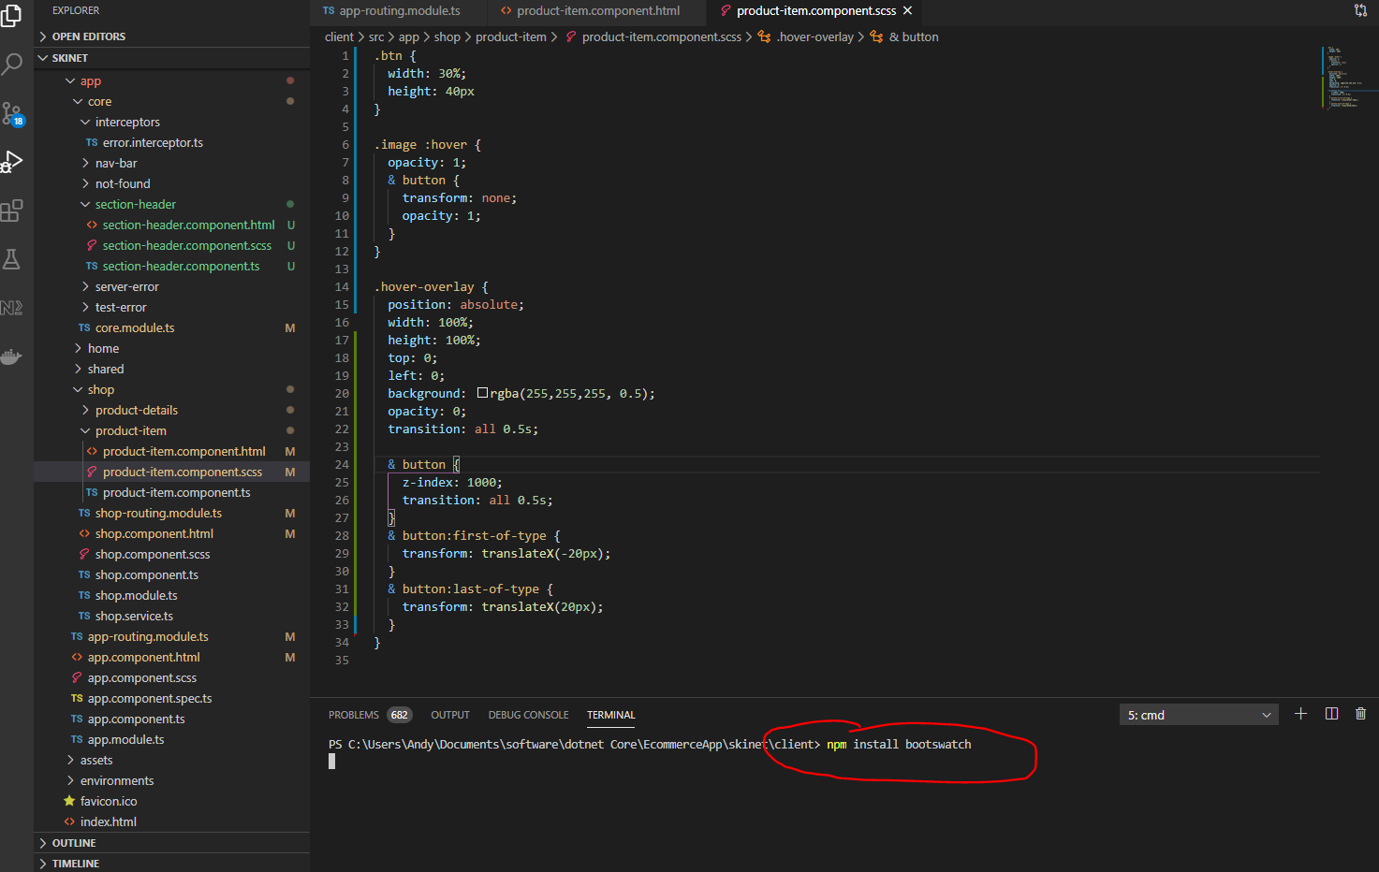

Update the ‘angular.json’ file with this:-

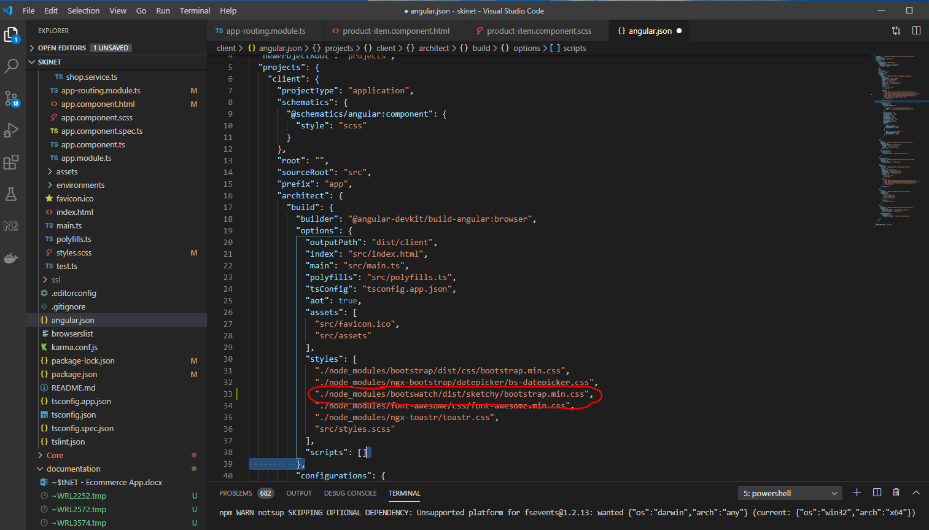

"./node_modules/bootswatch/dist/sketchy/bootstrap.min.css",

Use the above to try the ‘sketchy’ them

Try a better theme:-

‘united’

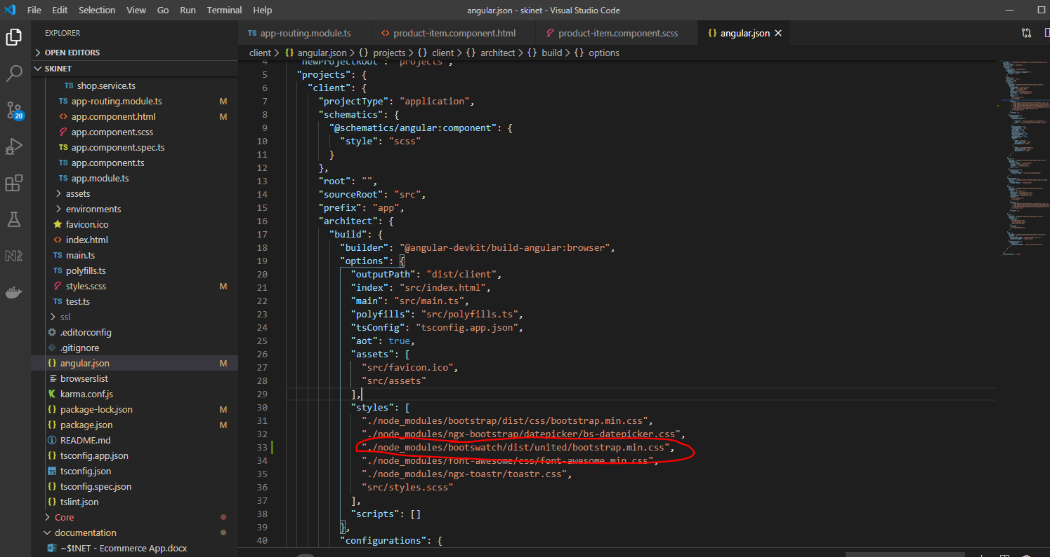

"./node_modules/bootswatch/dist/united/bootstrap.min.css",

Looks nicer:-

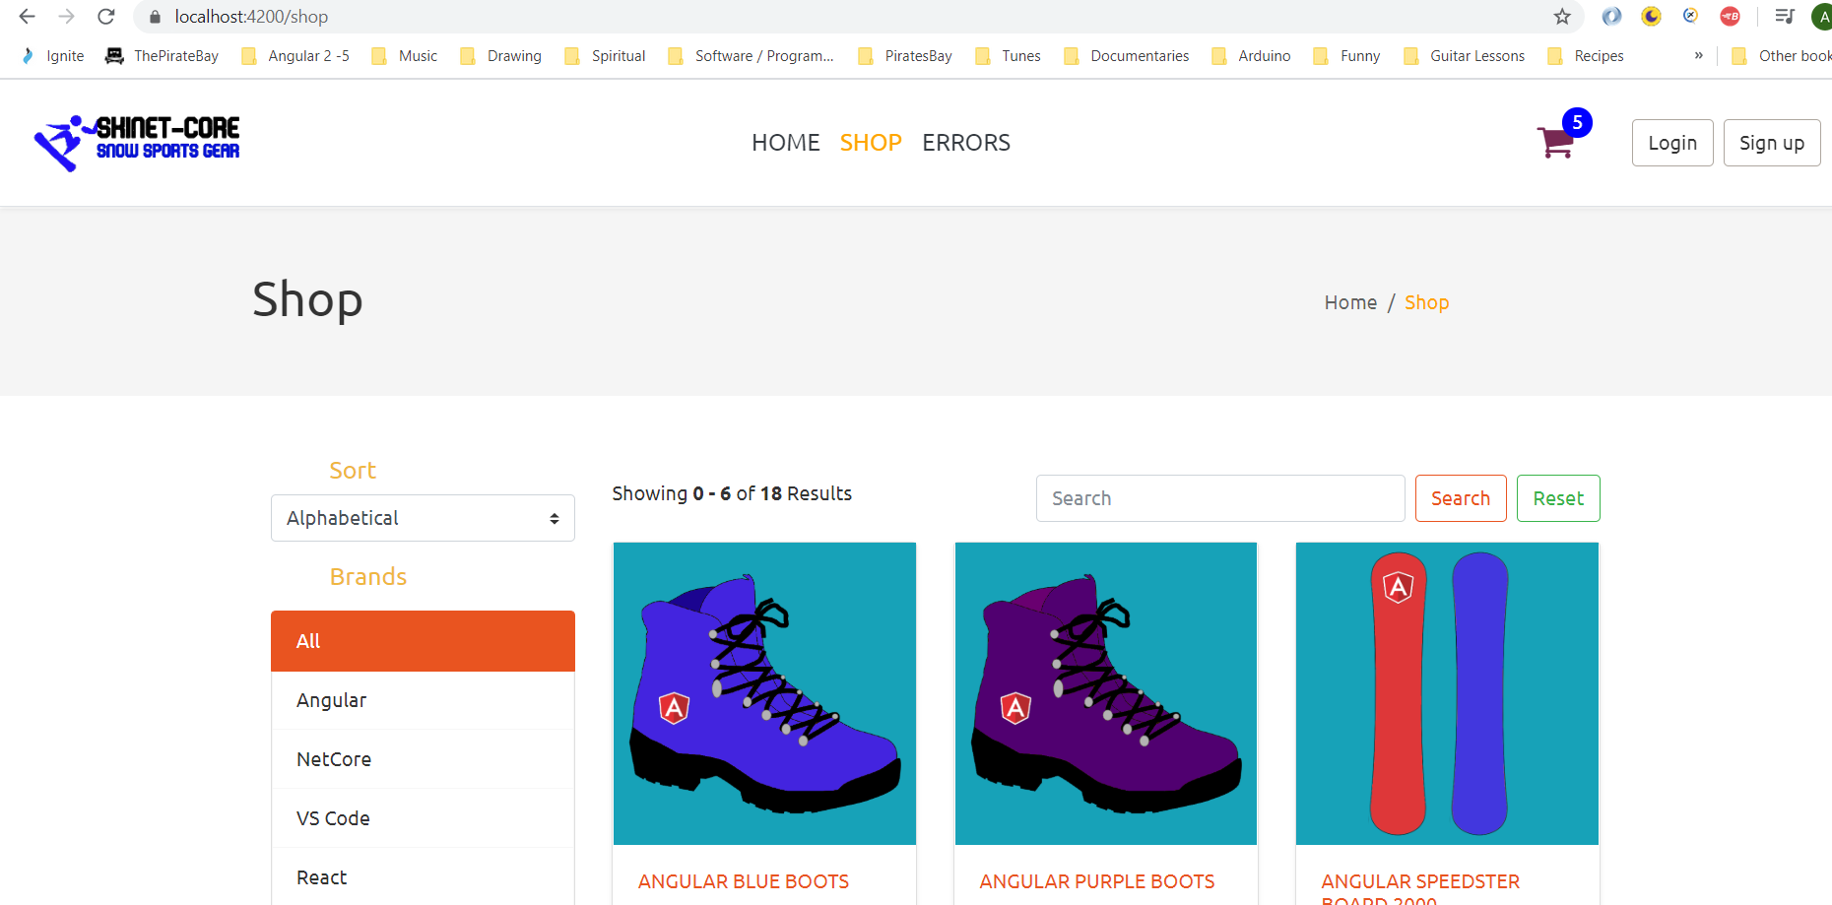

**Add loading indicator**

Add a delay into the ‘error.interceptor.ts’ class to test this:-

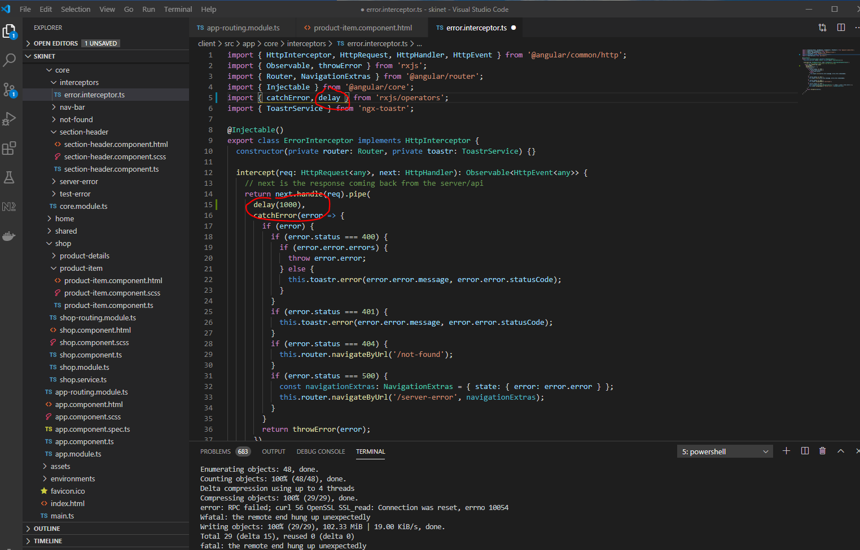

Install ngx-spinner:-

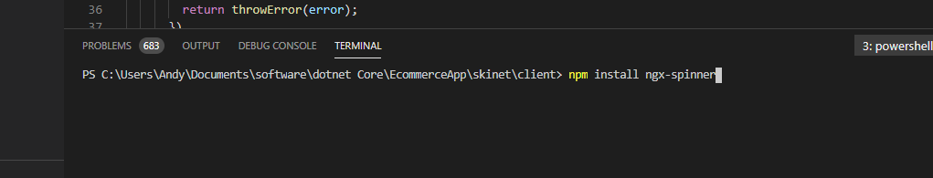

npm install ngx-spinner

Add to app.module.ts:-

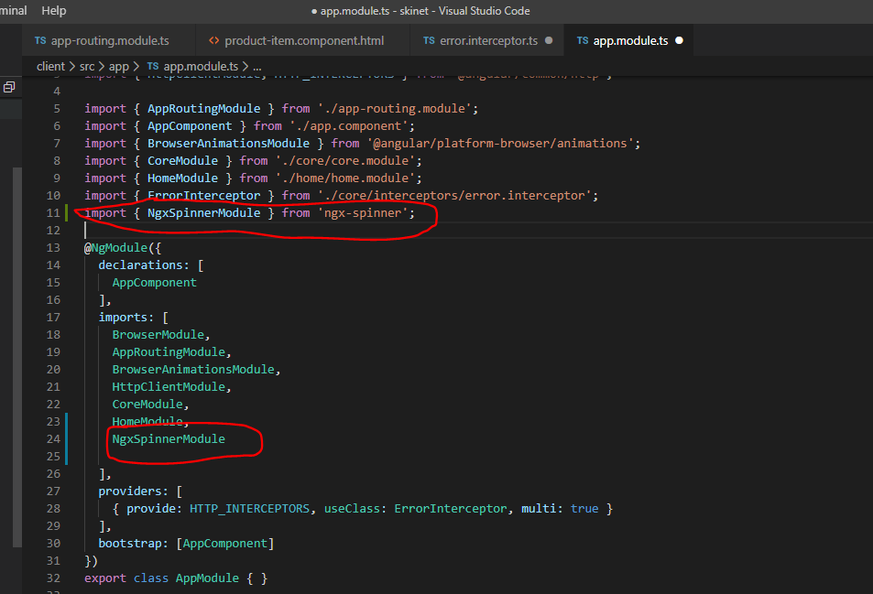

Add this:-

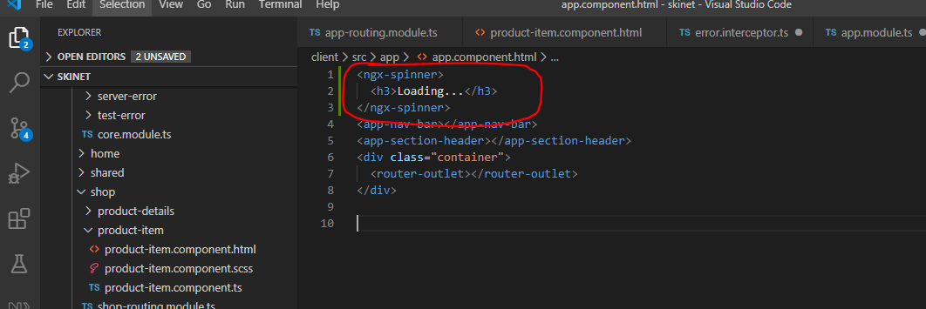

Create this folder:-

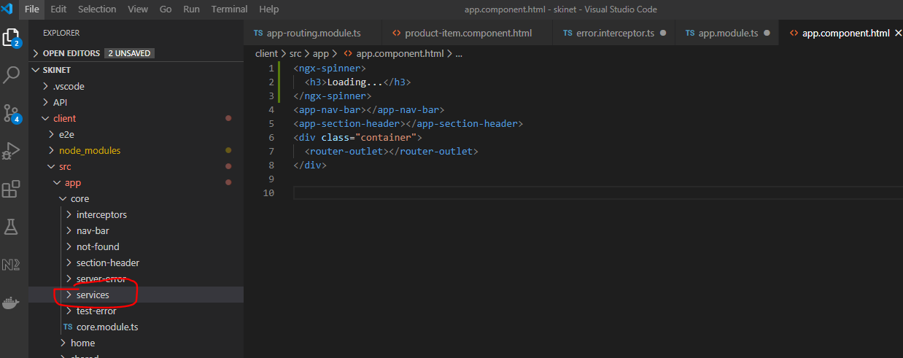

In the terminal cd into the folder and create a new service called ‘busy’:-

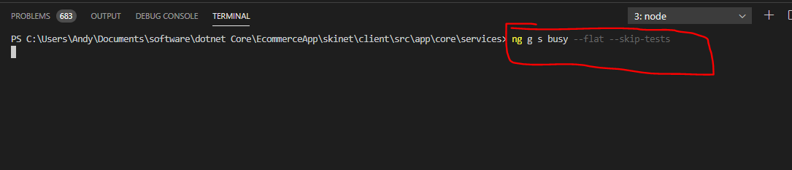

Add this code into the new service:-

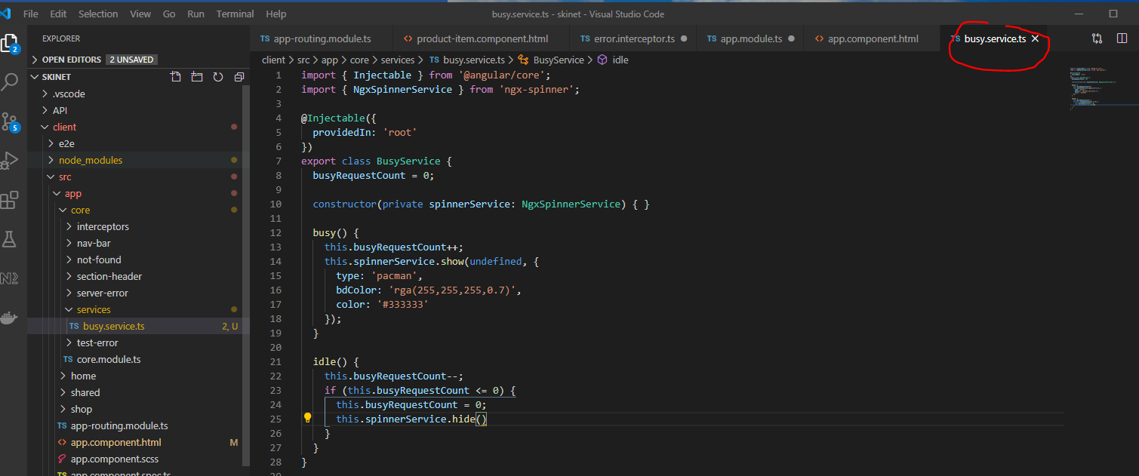

Create a new interceptor:-

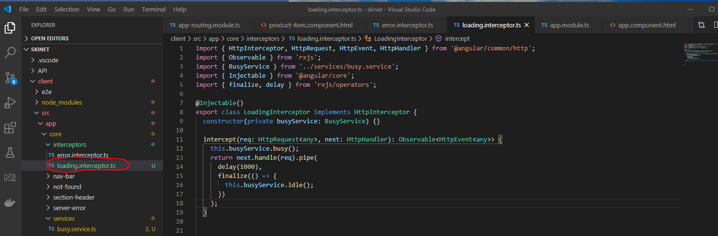

Now, remove the delay from the other interceptor:-

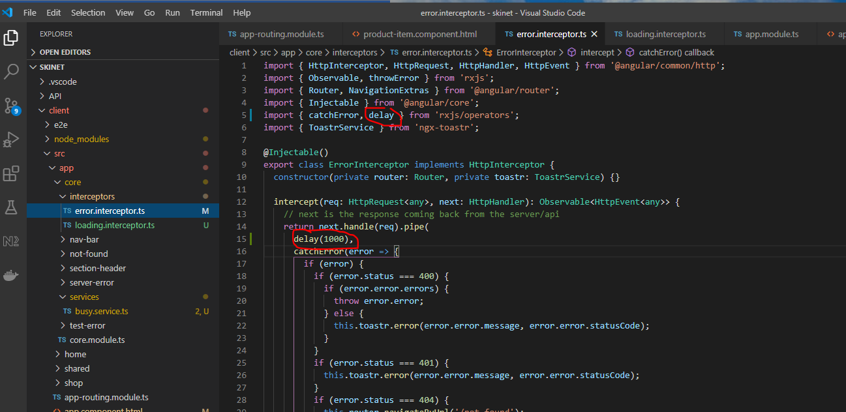

Add new interceptor to the app.module.ts:-

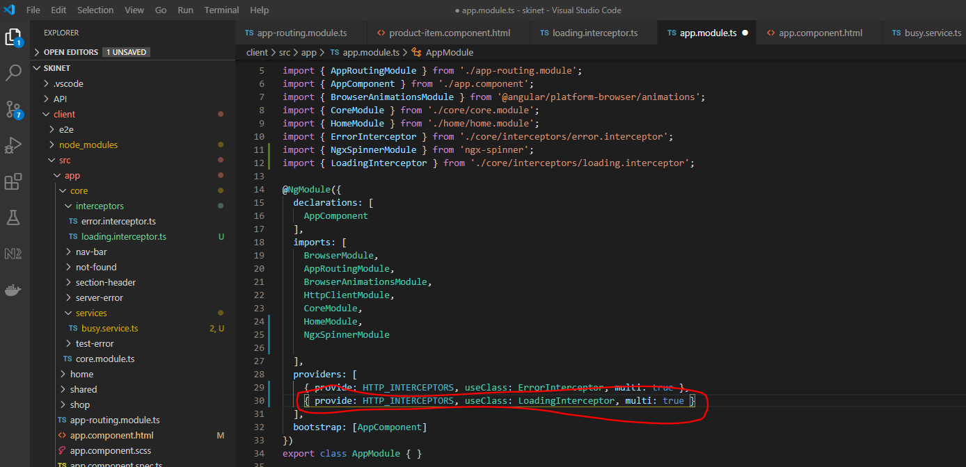

Change the spinner type here:-

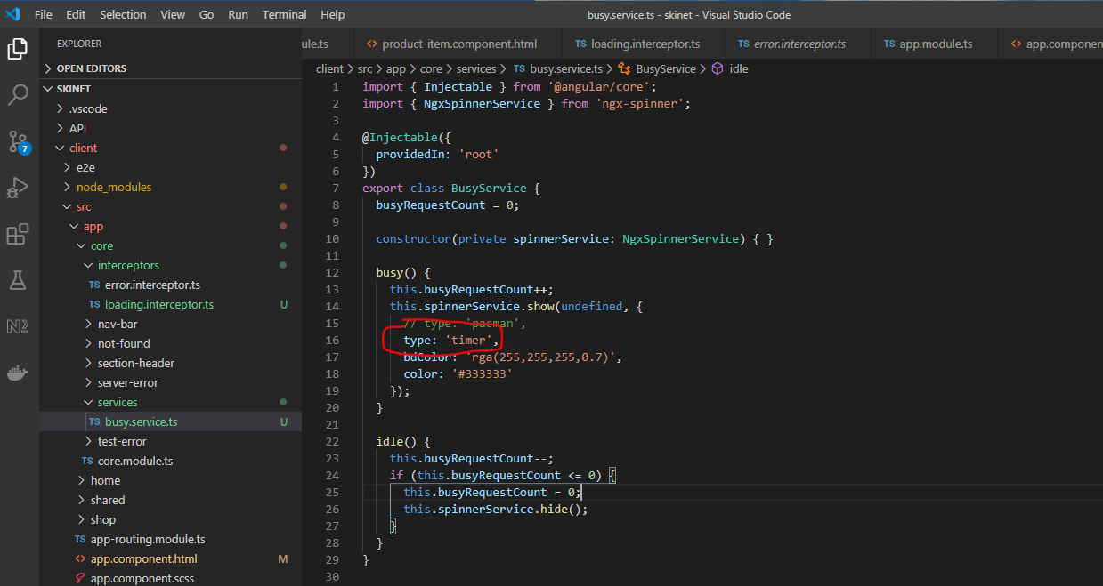

Look at this website for different spinner types:-

<https://napster2210.github.io/ngx-spinner/>

**Cleaning up Loading Issues**

To ensure that we have our brands and types returned from the server first before we display any data on the screen add this to shop.component.ts:-

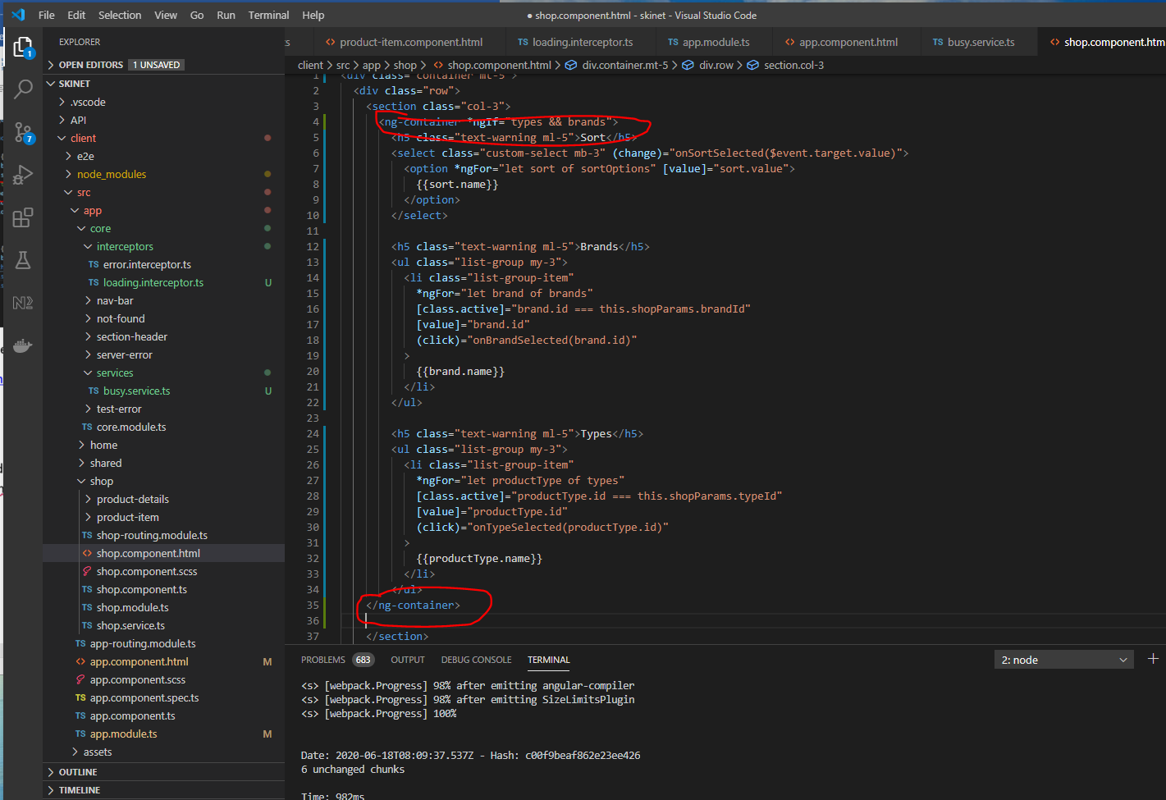

Also, make sure search section does not load before the products have loaded:-

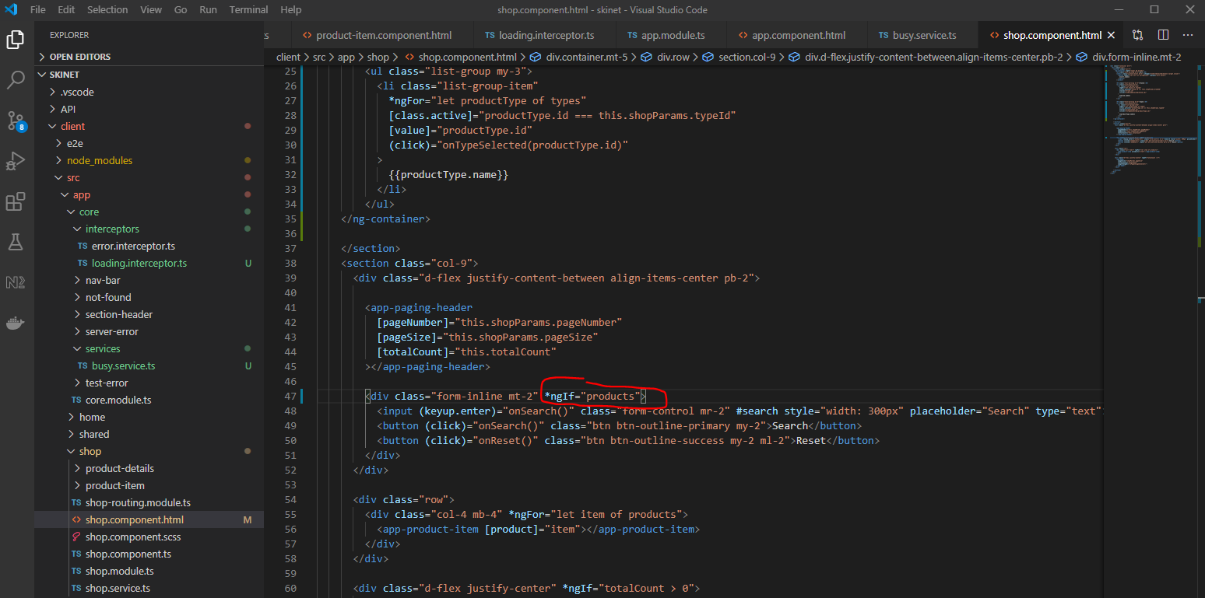

Now, we get his error when using the search box:-

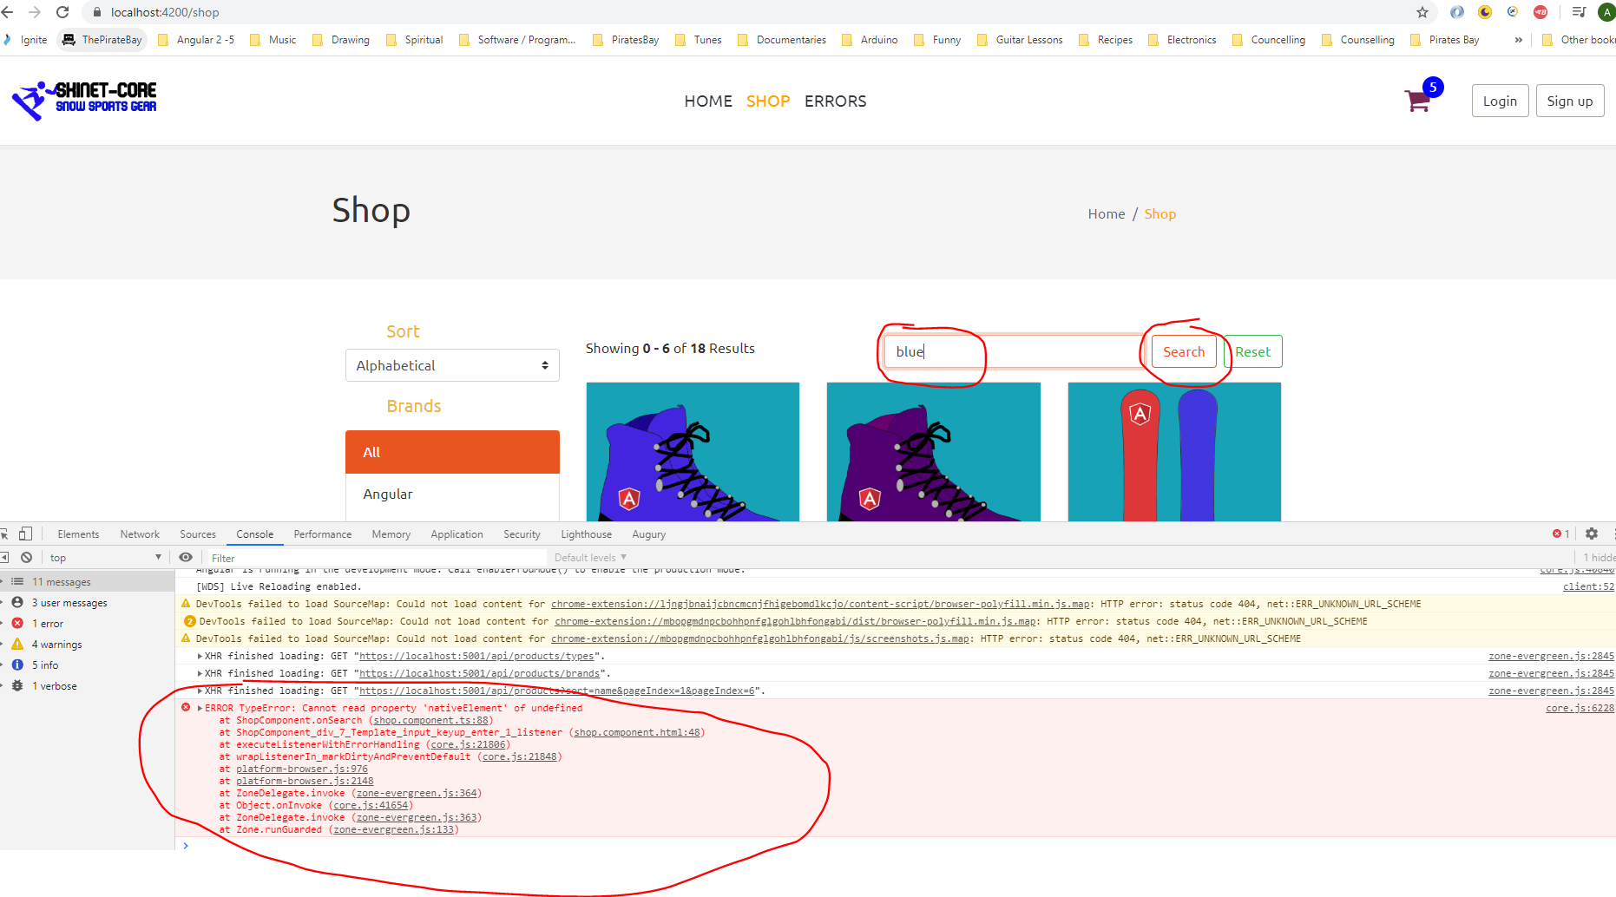

Overcome this by changing this:-

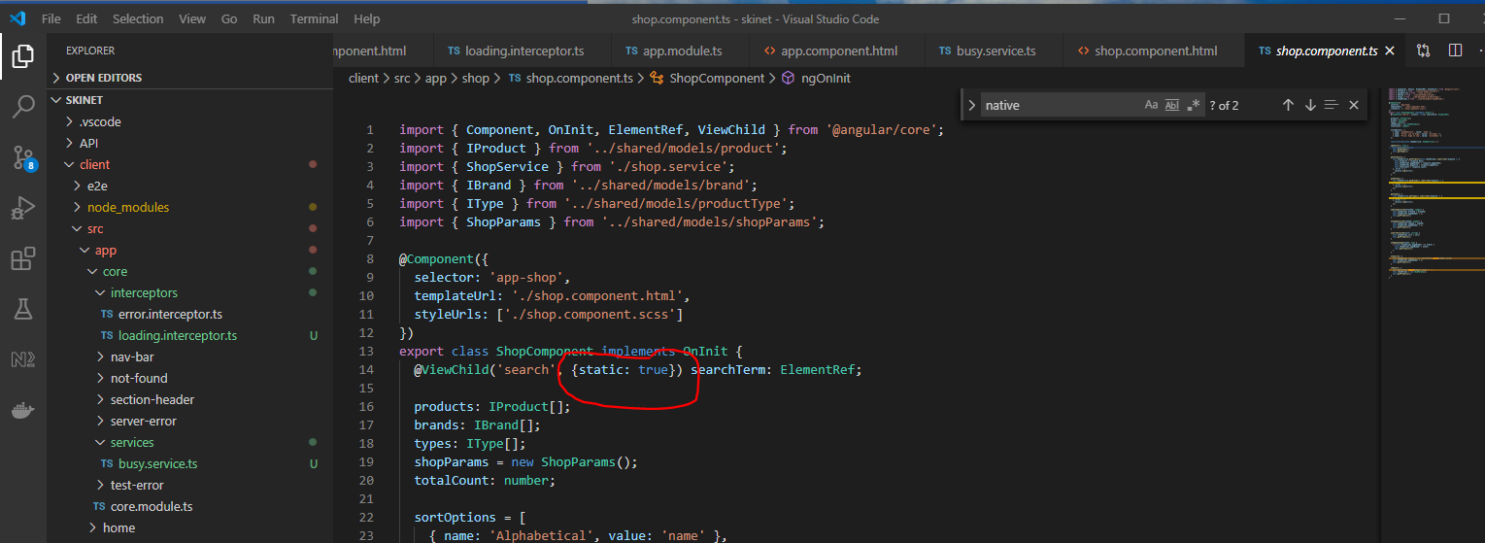

Change ‘static: true’ to ‘static: false’:-

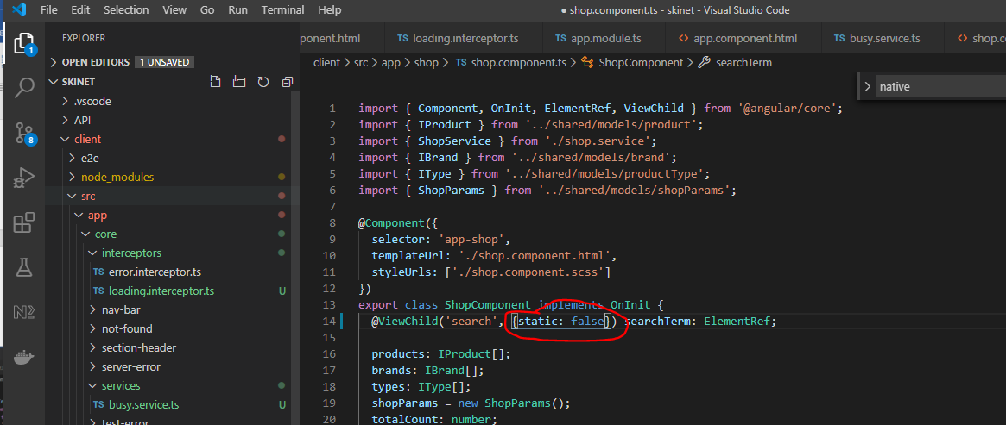

Another problem is that the product number is being loaded first in the title area. To correct this:-

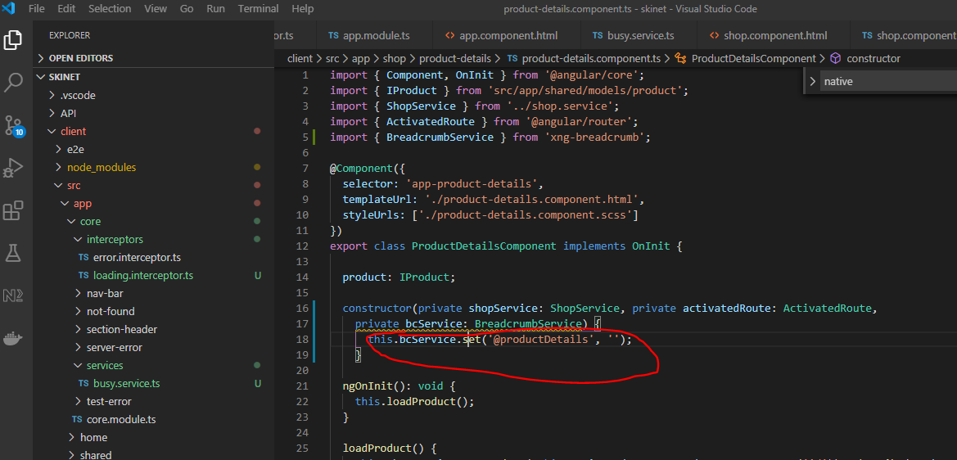

To clean up the product detail container:-

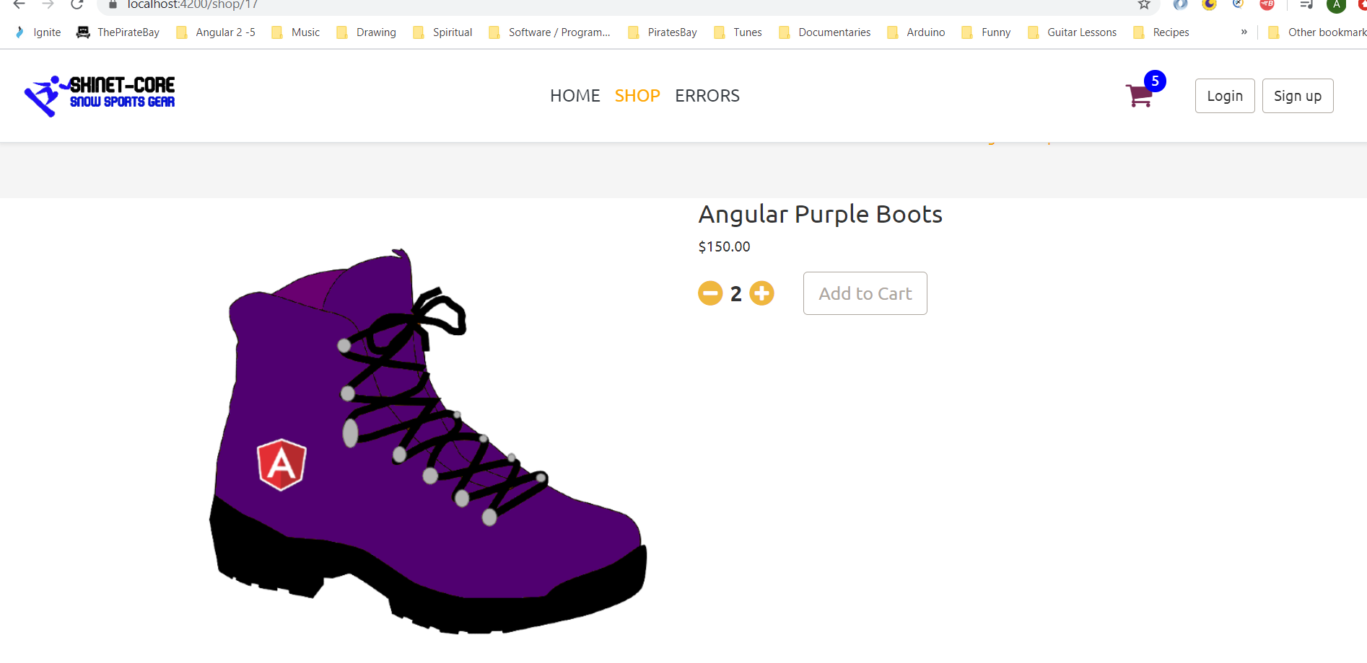

Do this:-

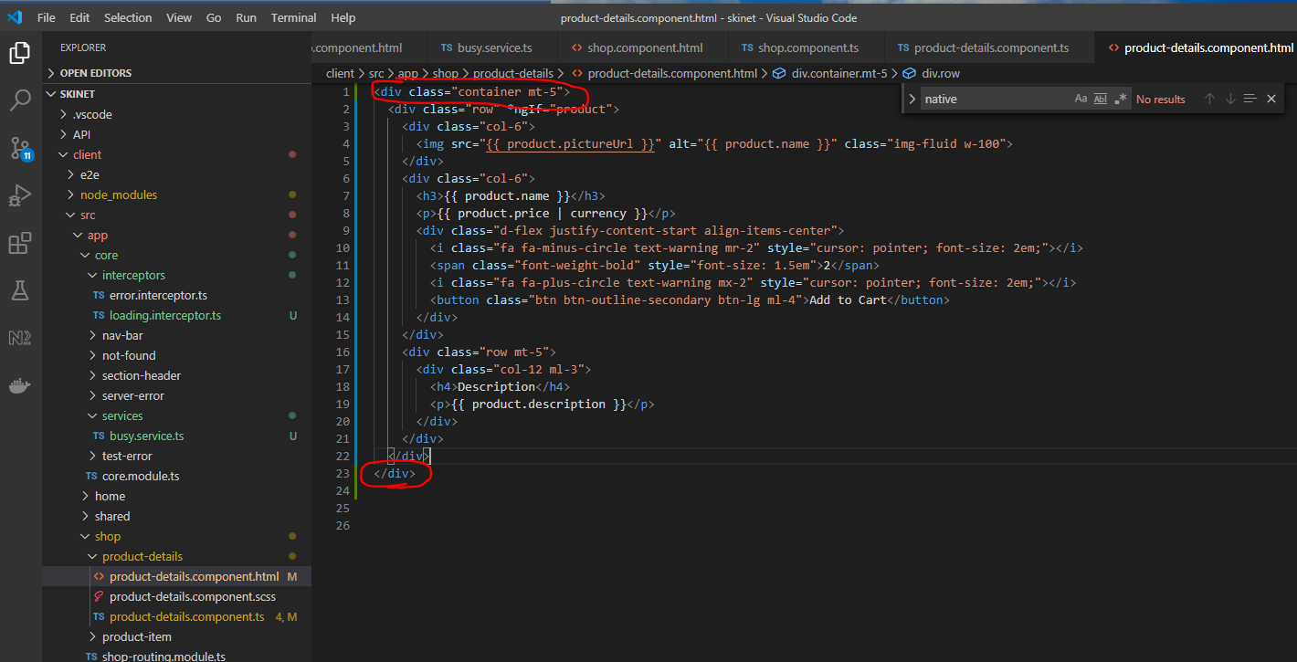

There is now more spacing:-

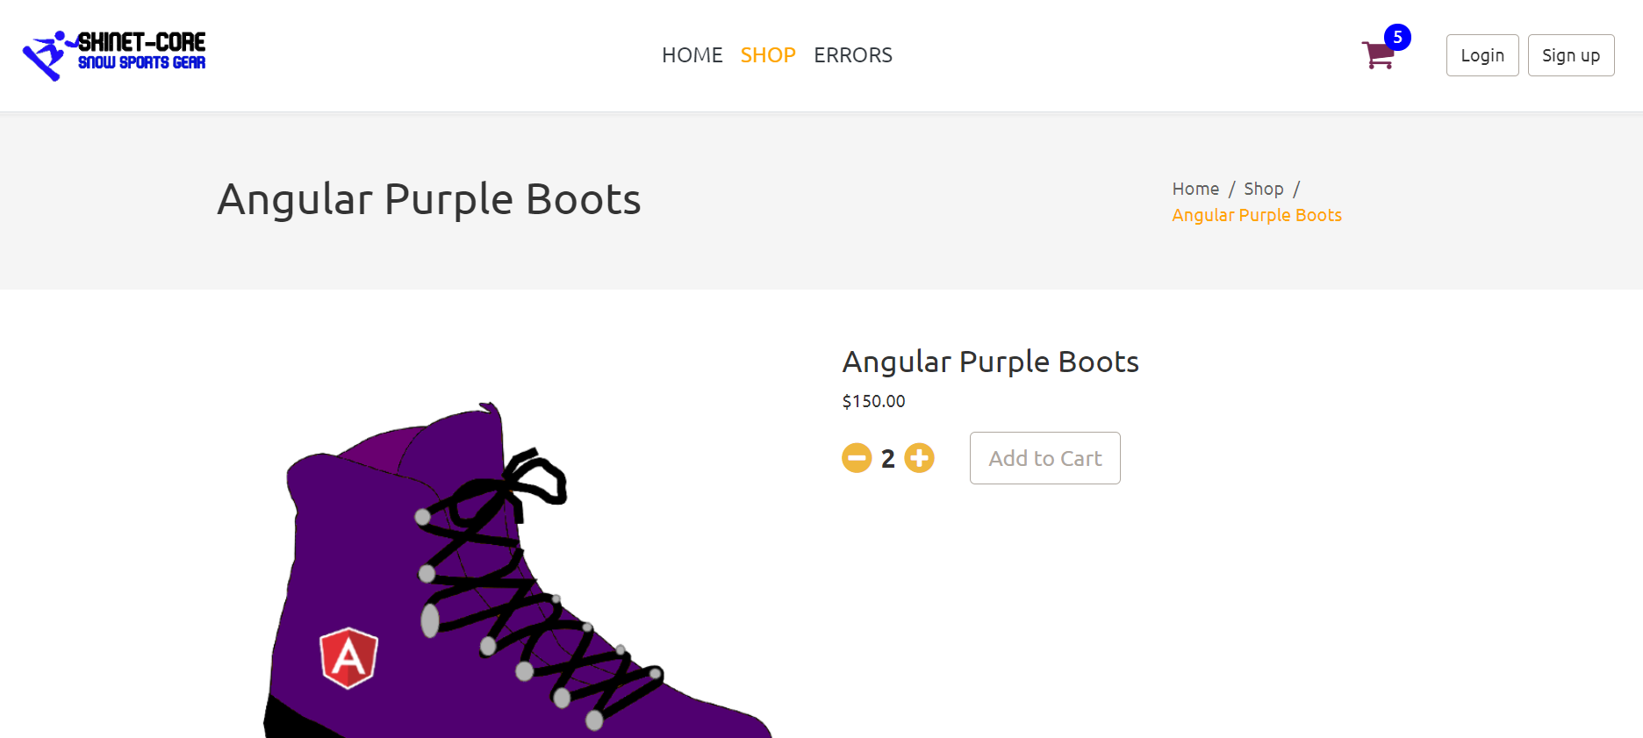

Now create Home page:-

Add a carousel with images:-

Add this to the shared.module.ts file:-

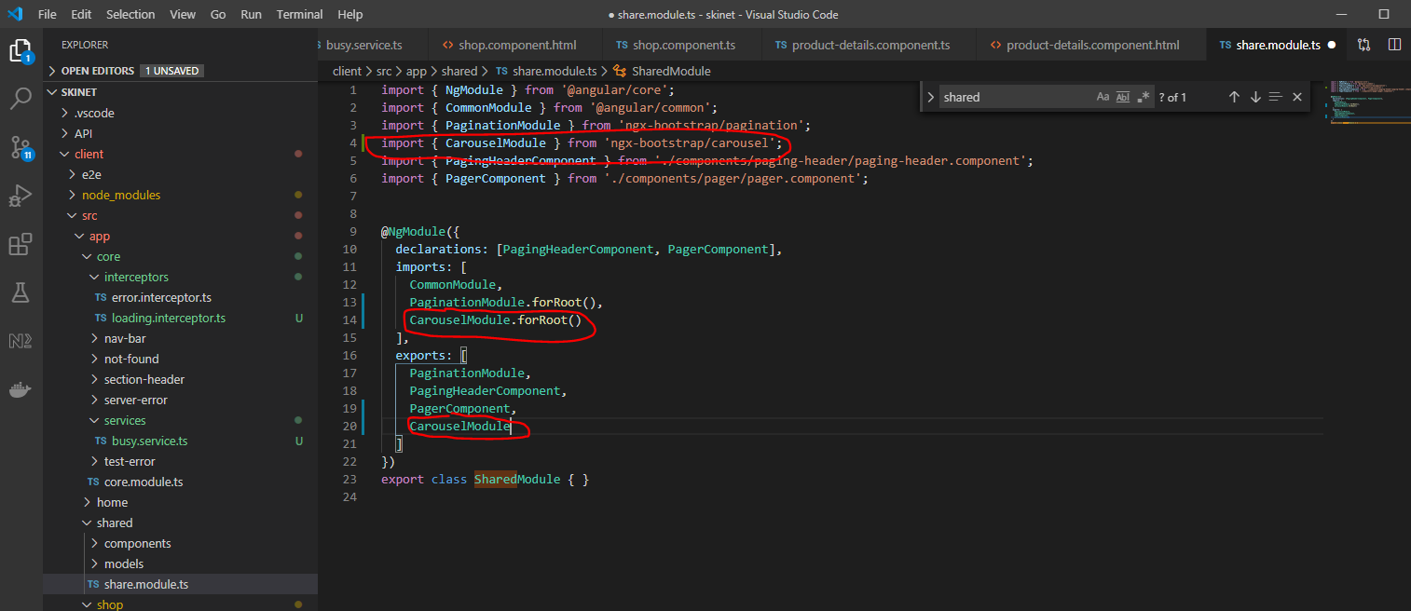

Now, import the shared module into the [home.module.ts:-](http://home.module.ts:-)

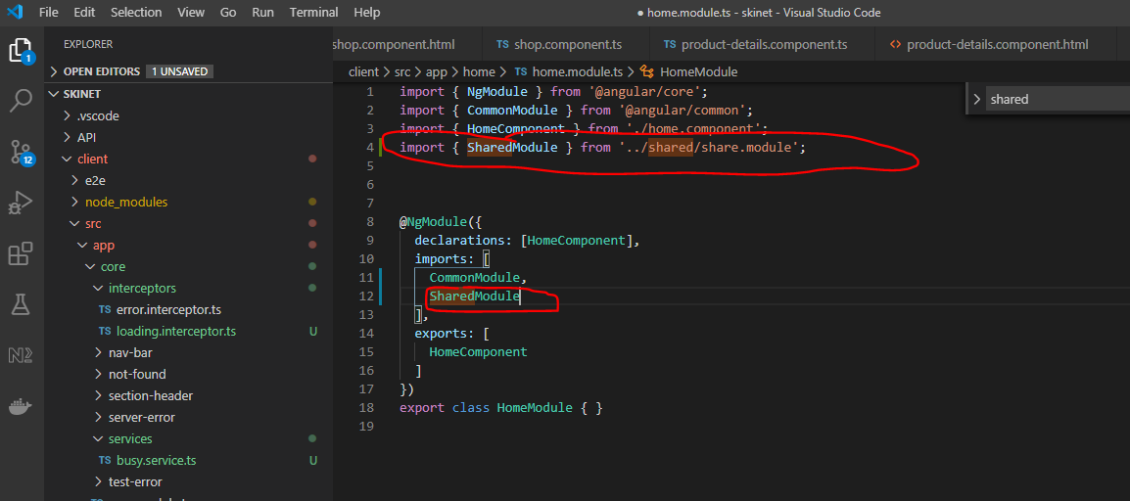

Now, add this to the [home.component.html:-](http://home.component.html:-)

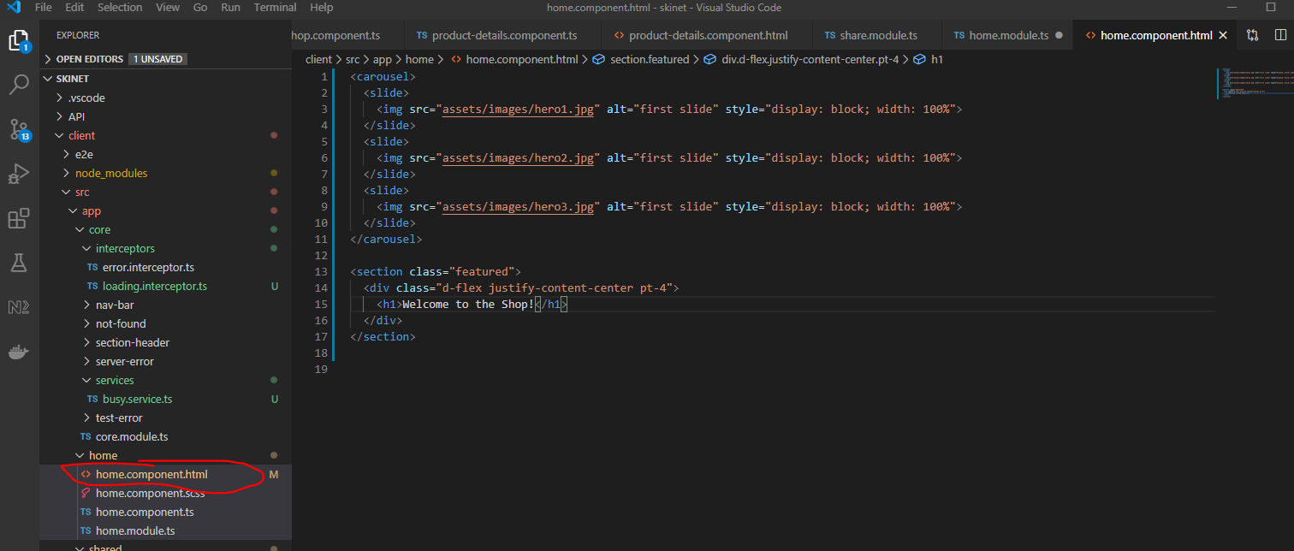

Add some scss:-

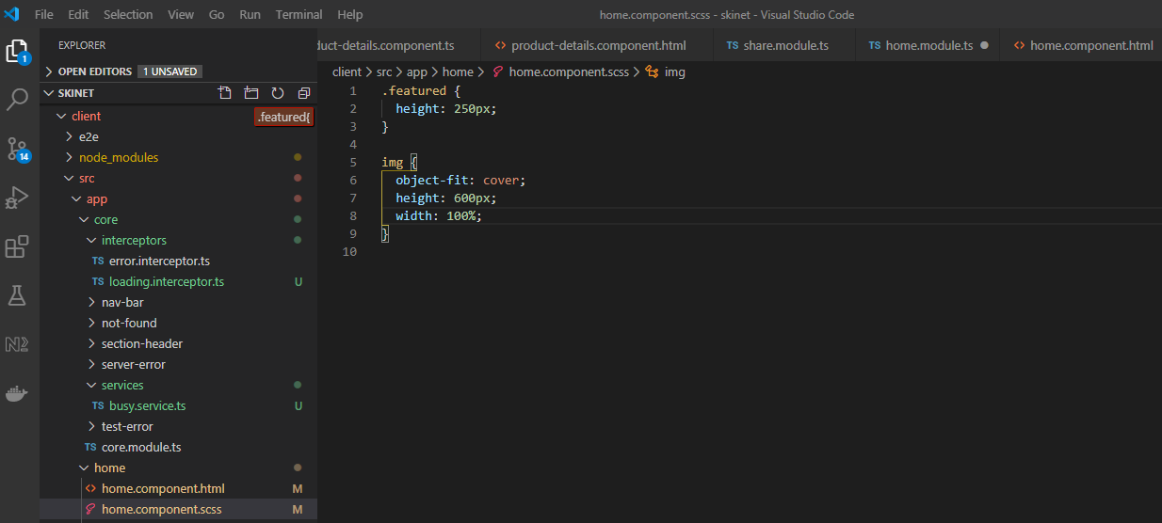

This creates this:-

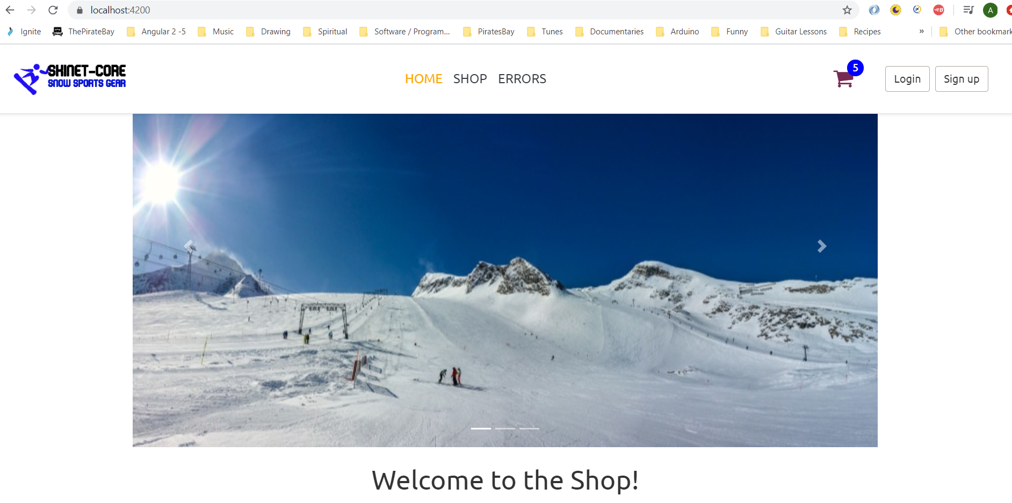

We want the carousel slider image to reach the sides of the page though, remove the container class from here:-

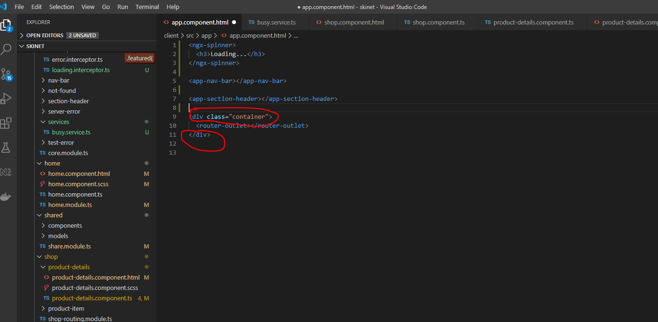

Also, remove this:-

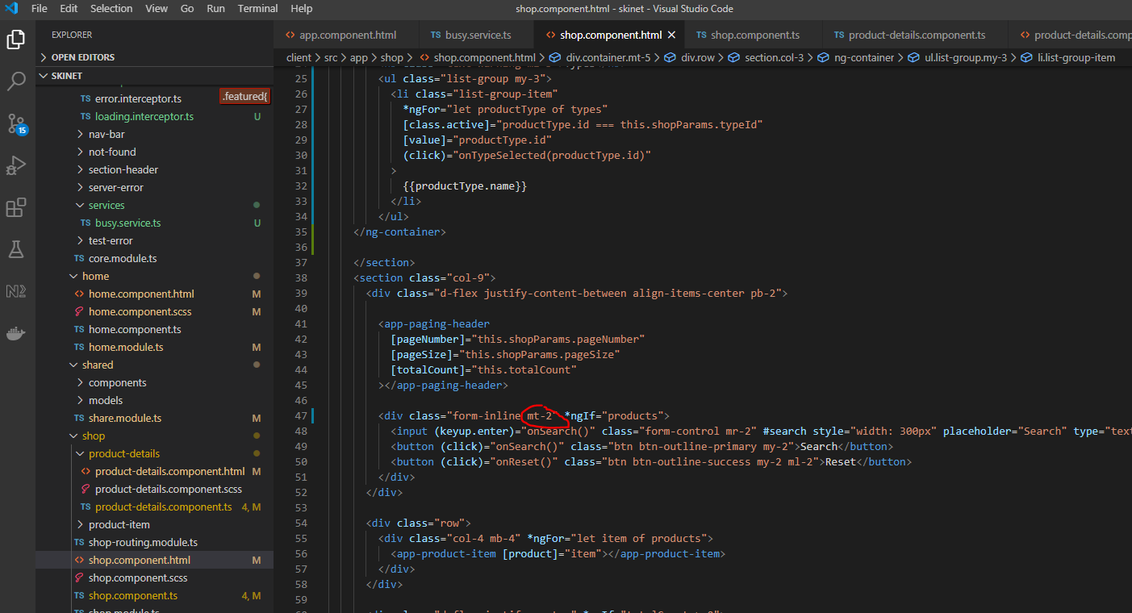

Also, change this:-

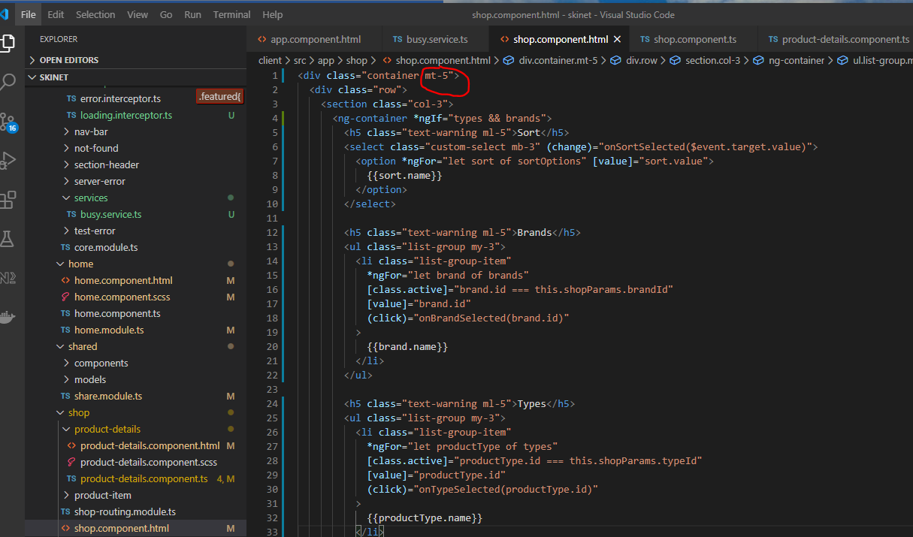

Change to mt-3.

Add this too:-

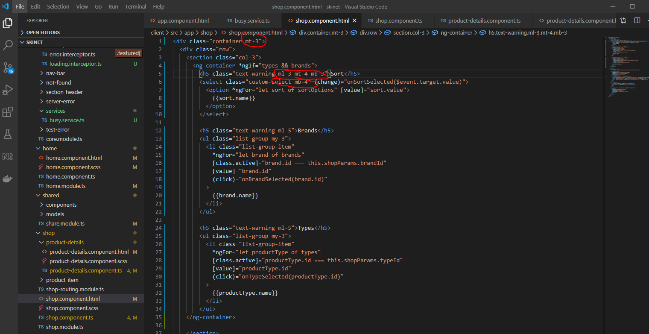

Git push.

**Basket API**

Use ‘Redis’ for storing the contents of a users basket. Redis is an in memory storage place. It is very fast. It also persists data, so data isn’t lost.

Install a new package into the ‘Infrastructure’ folder:-

*[ctrl] + [SHIFT] + p*

*nuget*

*StackExchange.Redis*

*2.0.601*

*{root}/API/API.csproj*

Add this to the startup.cs class:-

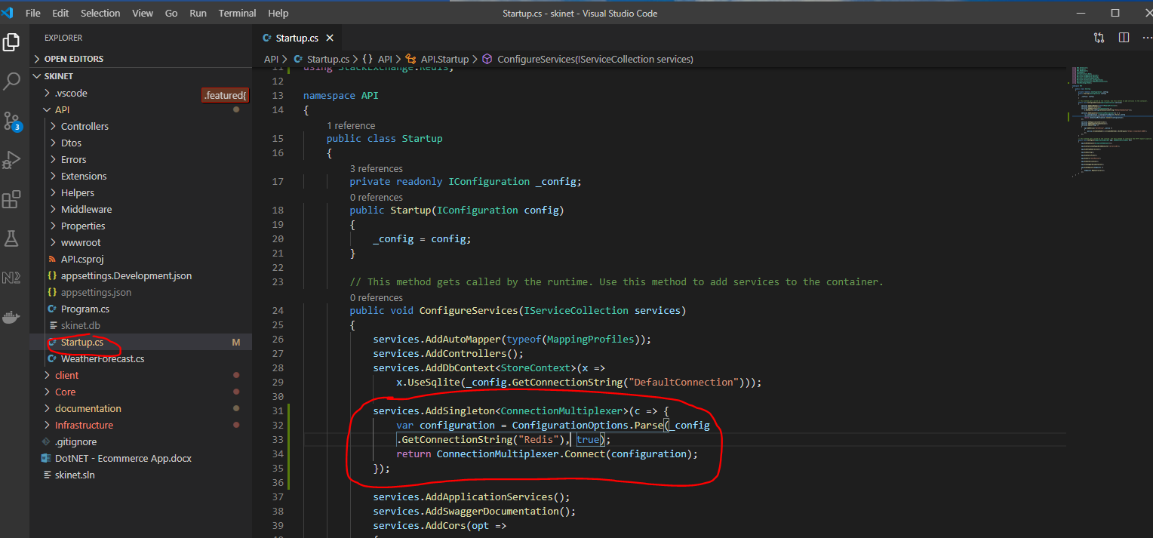

Update appsettings.Development.json file:-

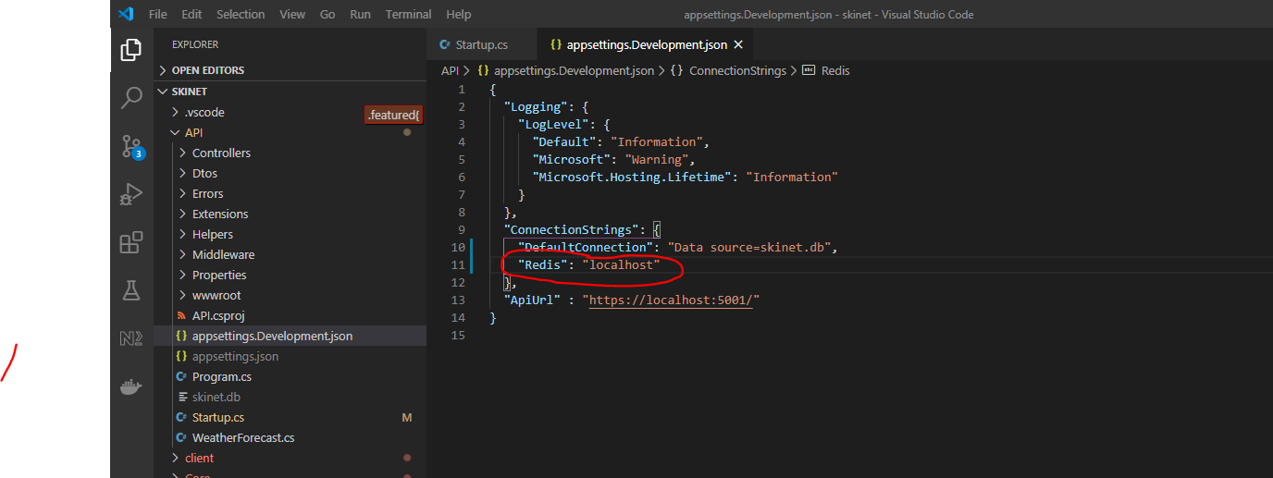

**Create classes for the basket**

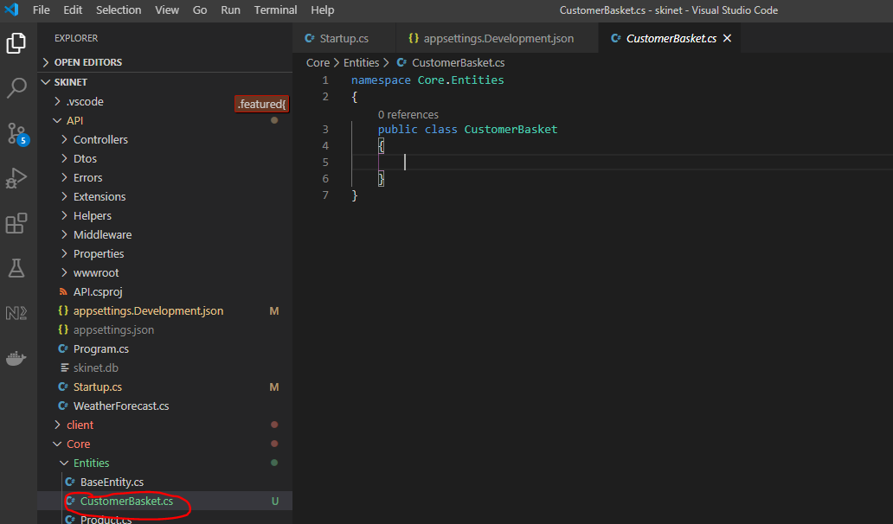

Add properties to class:-

Create the ‘BasketItem’ class:-

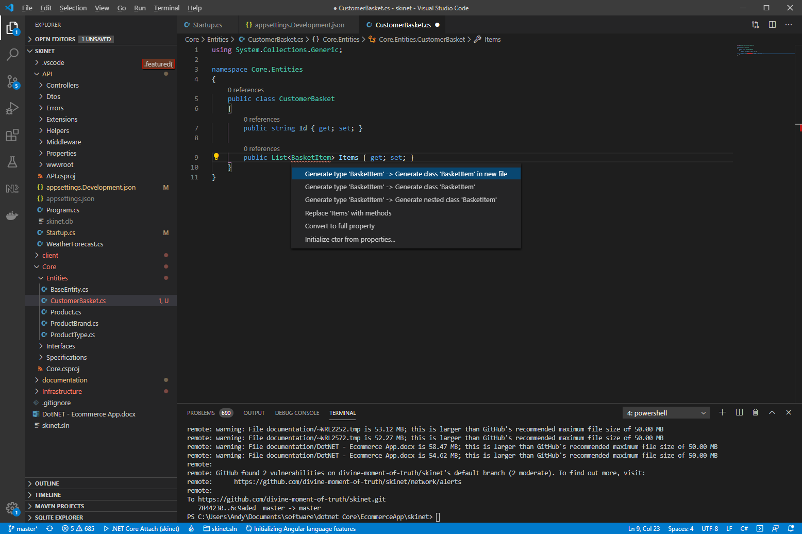

Create BasketItem class from the above:-

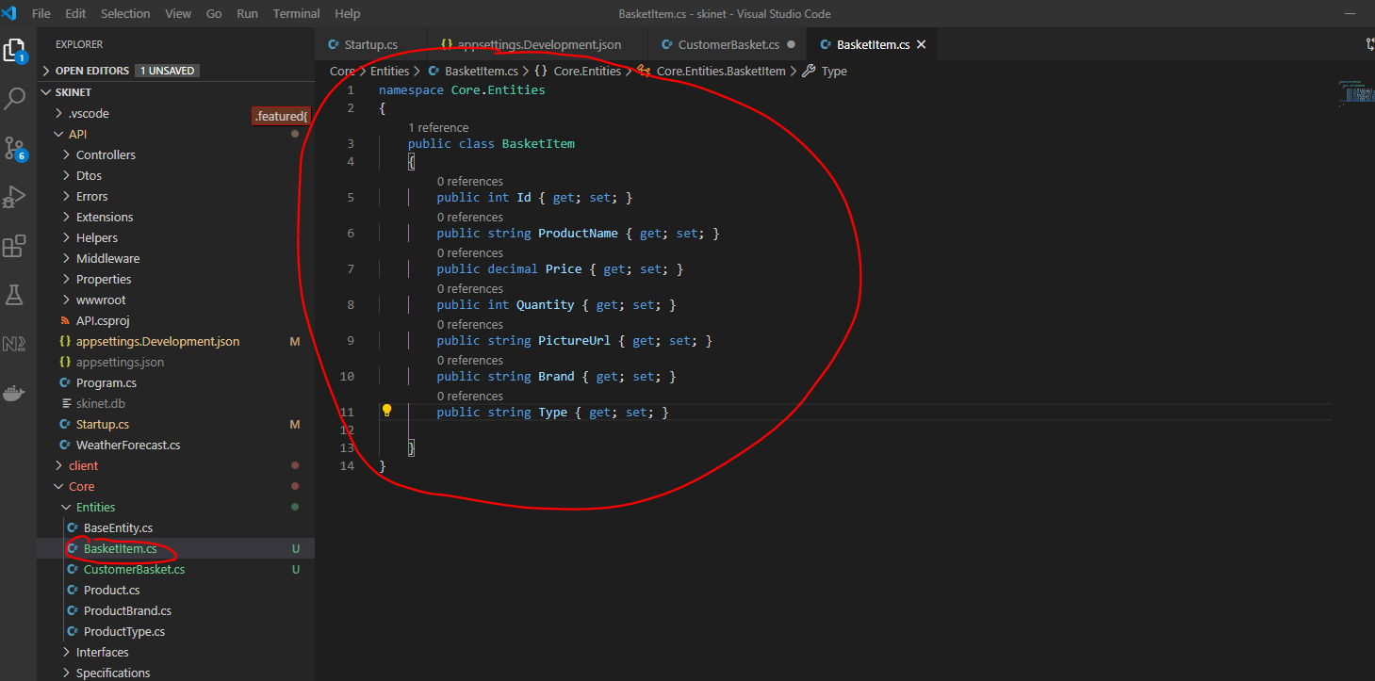

Update the ‘CustomerItem’ class:-

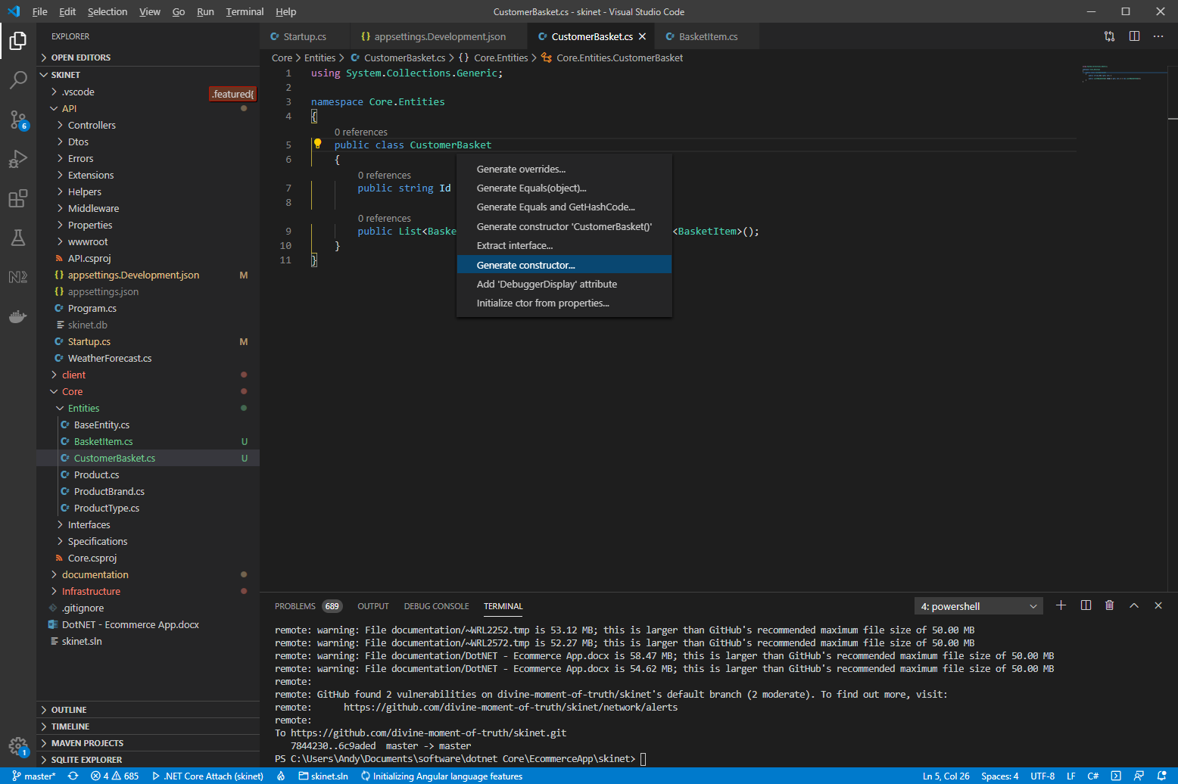

So it looks like this:-

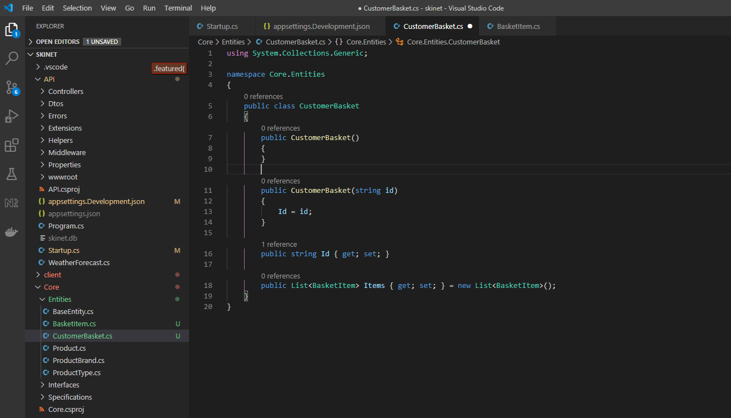

Create a repo and an interface for the basket:-

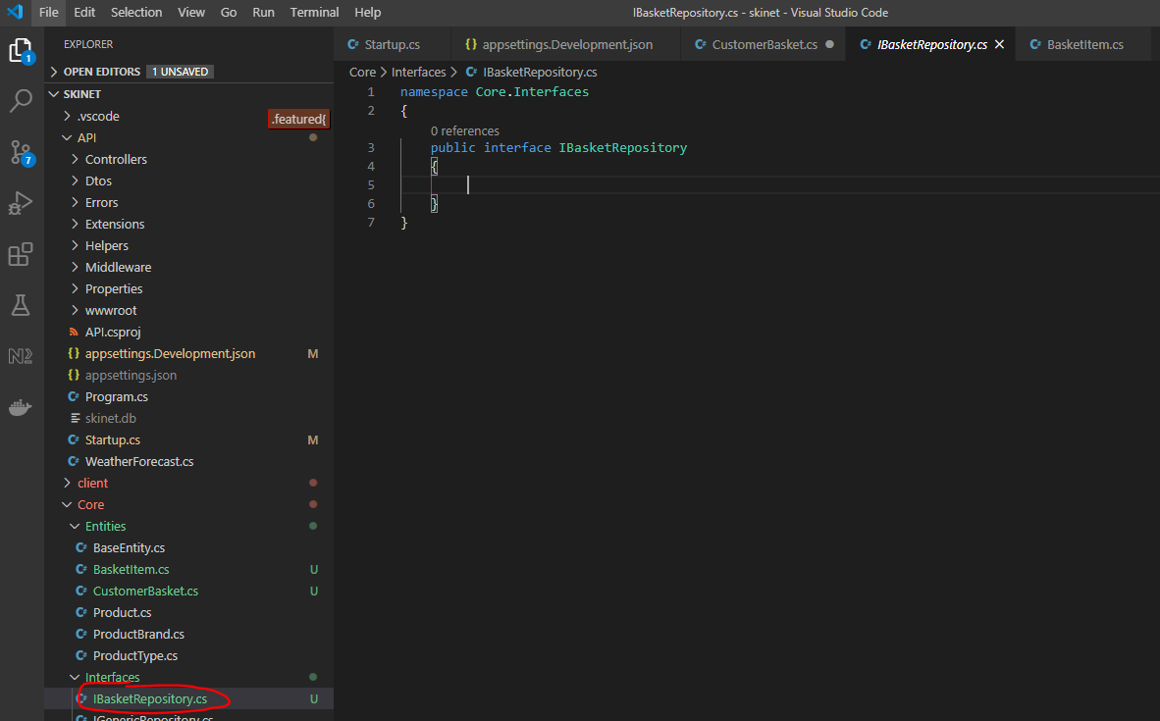

Add the following properties:-

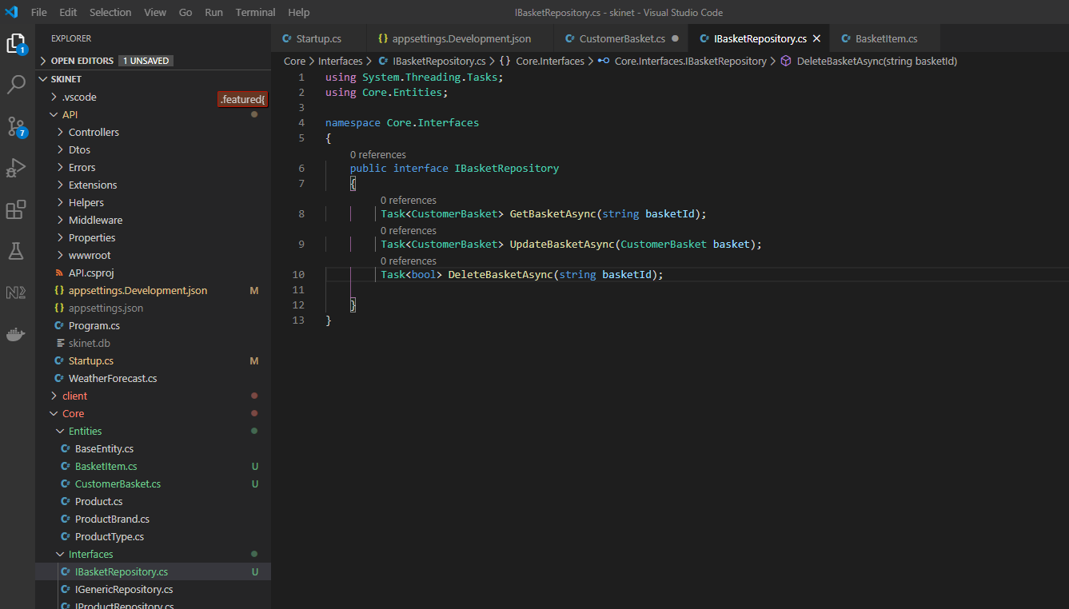

Now, create a new ‘BasketRepository’ class here:-

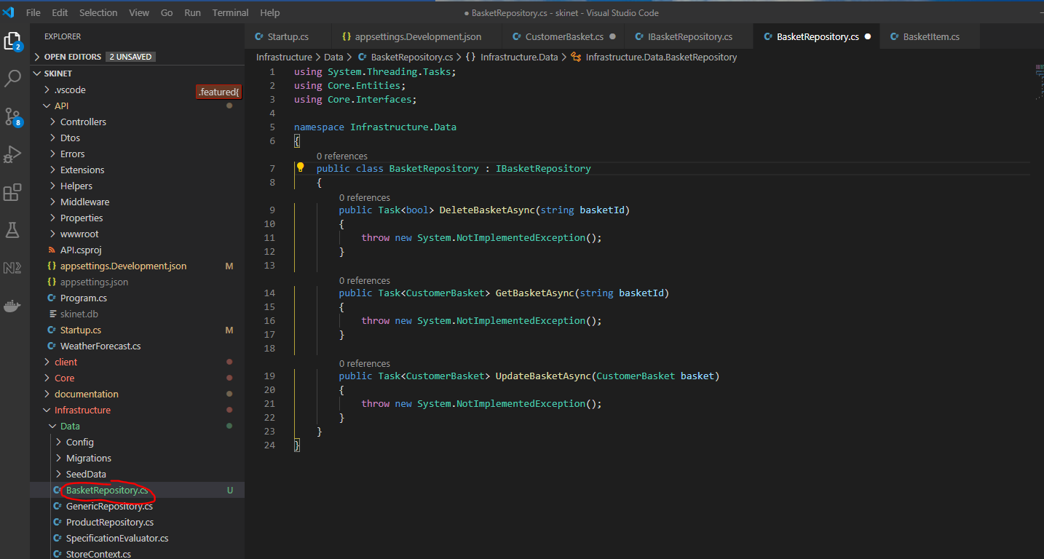

Add this service to the ‘ApplicationServiceExtensions.cs’ class:-

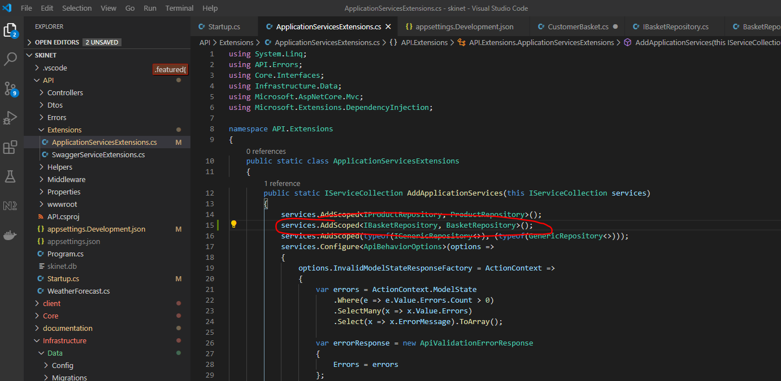

Provide implementation for the BasketRepository class:-

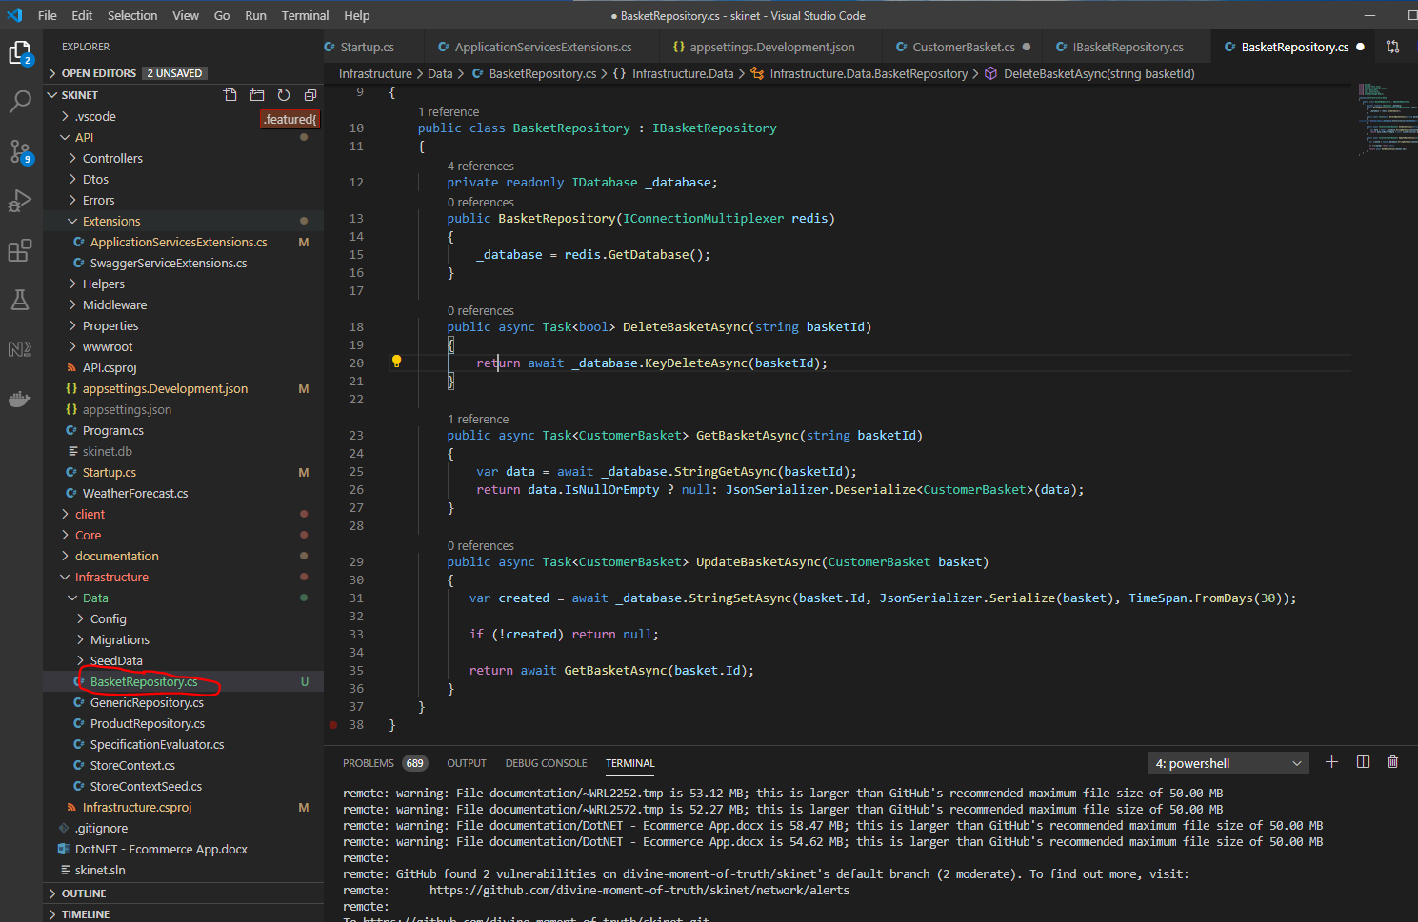

**Adding Basket Controller**

Create a new class here:-

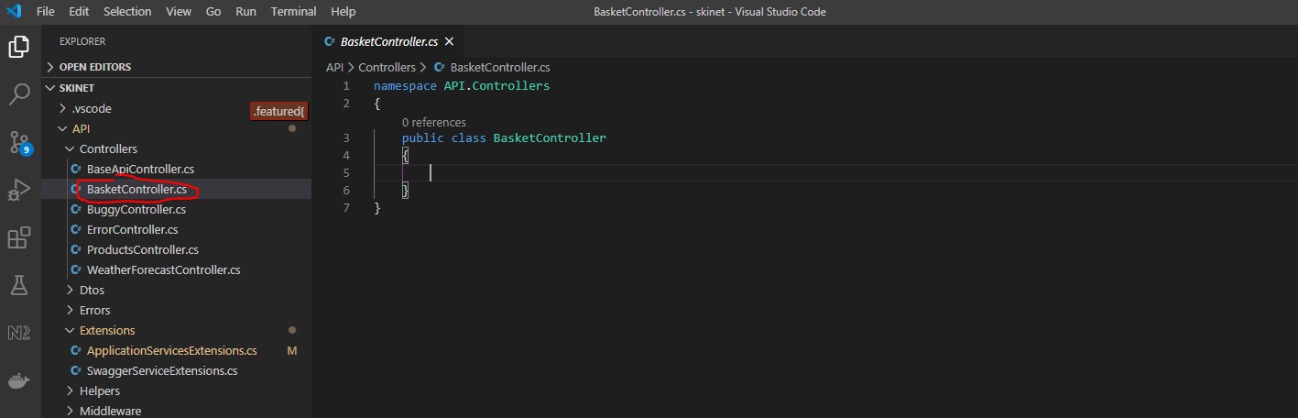

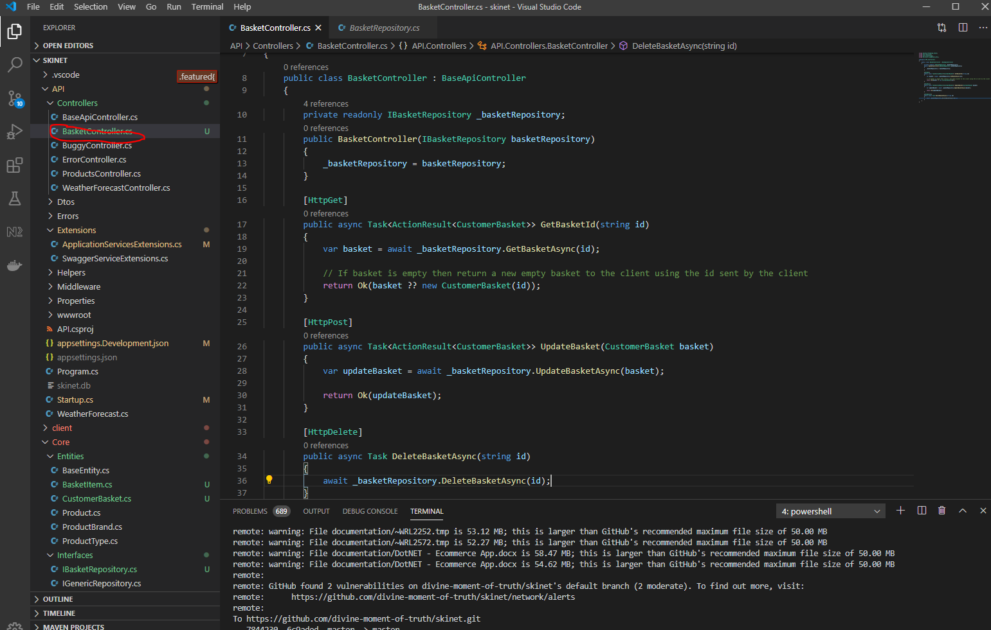

**Install a Redis server on your computer**

First download package manager –

<https://chocolatey.org/install>

You need to use Powershell to install this:-

Open Powershell as administrator

Copy this:-

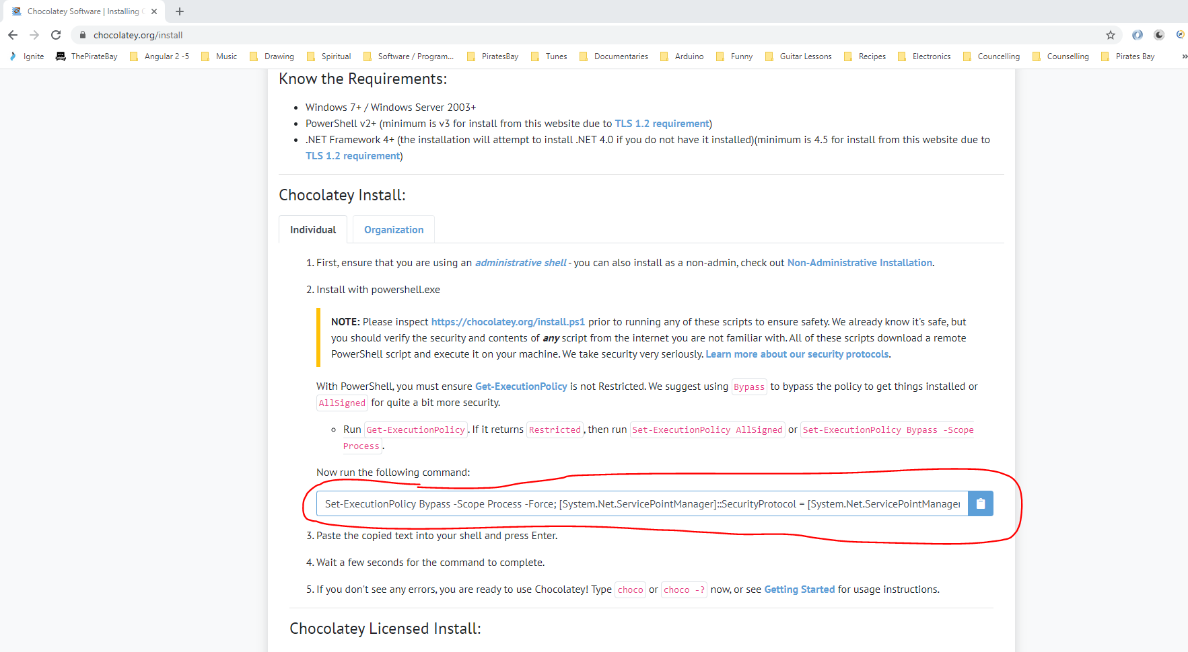

Paste into Powershell to install Chocolately:-

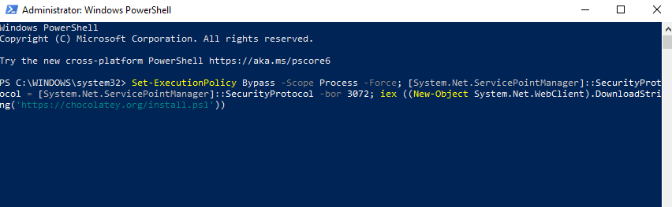

Search for Redis in Chocolatey website:-

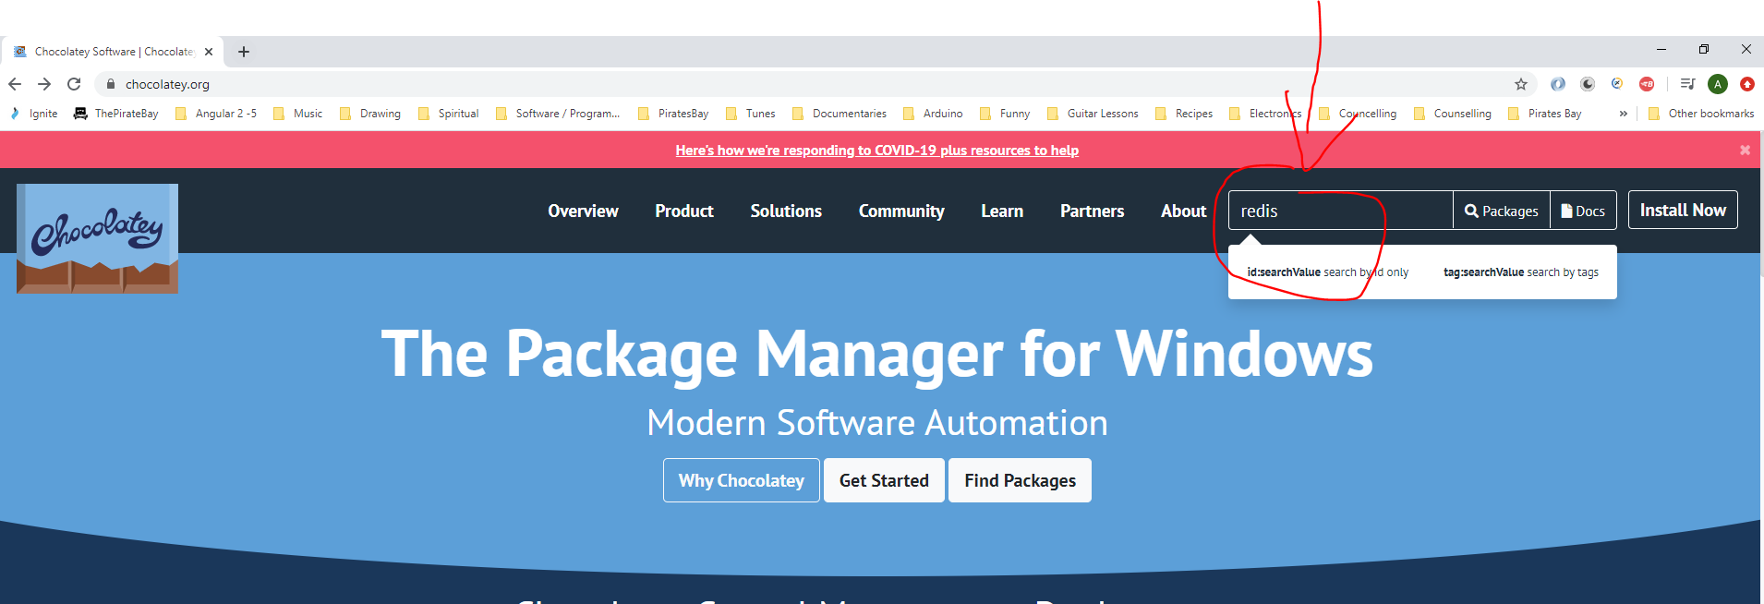

We want this version:-

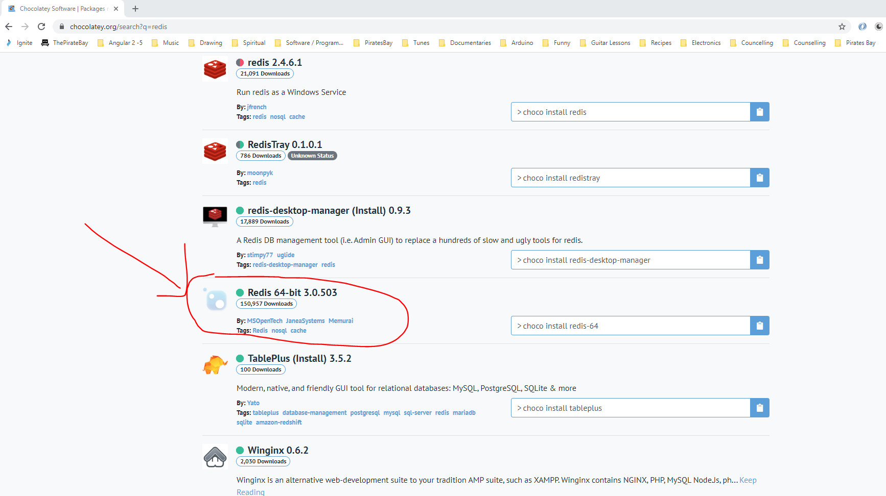

Copy this command:-

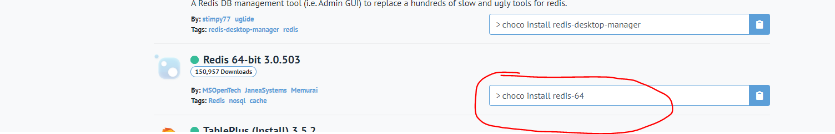

Open a new Powershell as administrator and paste the chocolatey command in here:-

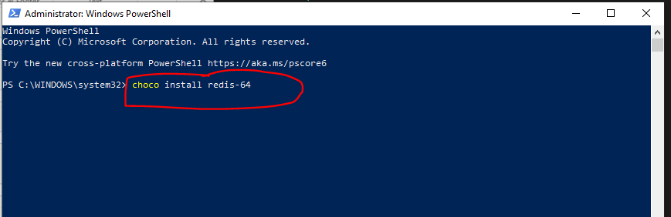

To start the Redis server open a command prompt as admin and type this:-

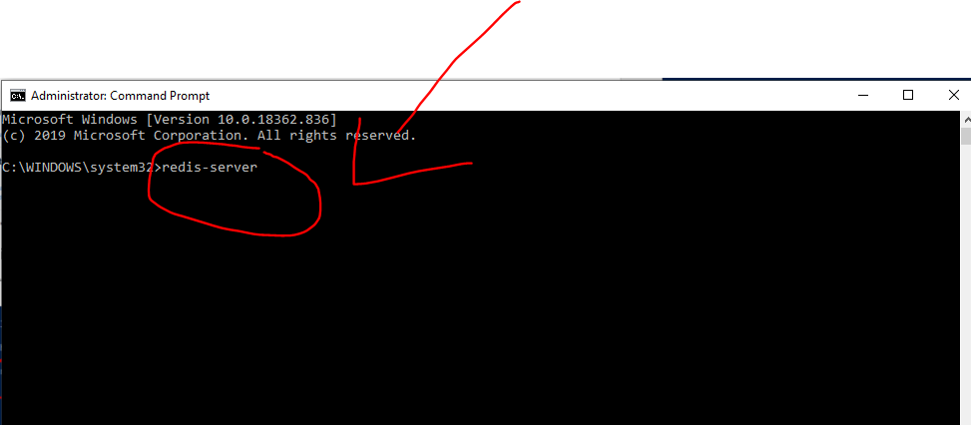

Now open a new command prompt as admin and enter this:-

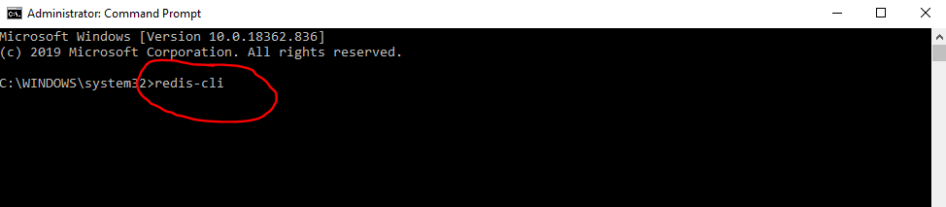

Test to see of its working typing ‘ping’:-

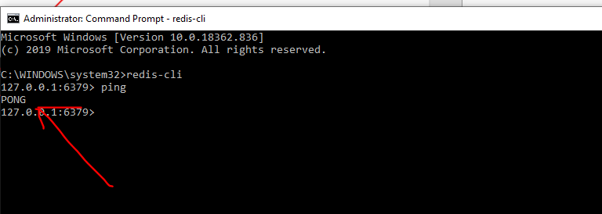

Pong response means its working.

Neil wrote some notes here:-

*Well it seems that this Redis GUI has disappeared from the internet and it is difficult to find the same kind of thing that does not require sign up or paying a fee.    Apologies.    This tool is only a "nice to have" for this course and it is only used to double check what the redis server keys are.   This can also be accomplished via the command line using the following commands:*

*When the Redis-Server is started you can open a new terminal tab and use:*

*redis-cli KEYS '*'*

*This will give you a list of the keys from the command line.*

*You can then use:*

*redis-cli GET <keyvalue>*

*Which will show you the value of the key.*

*I've added a callout to the 2 lessons regarding Redis installation with the same advice that I'm uploading now.   Apologies for the inconvenience and thanks for letting me know.*

*Neil*

**Test in Postman**

Test using this:-

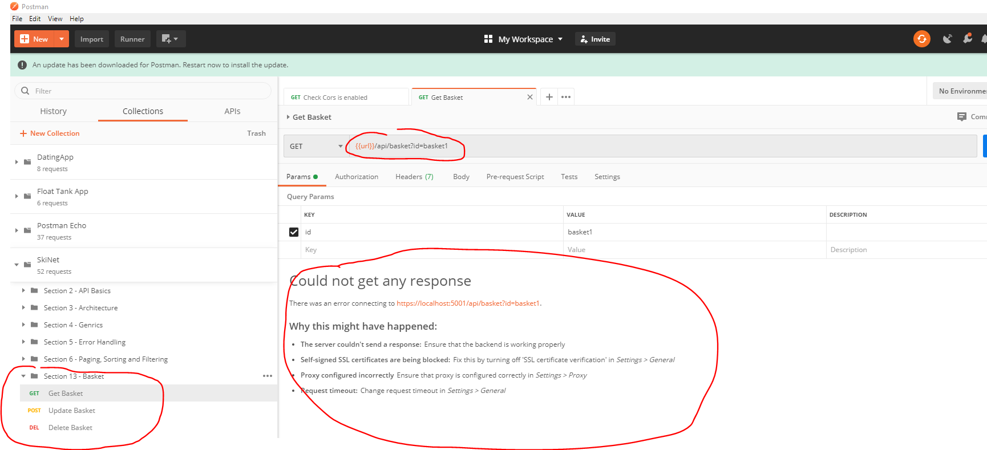

Notice that you are getting a ‘Could not get any response’.

Check the API terminal in VSCode:-

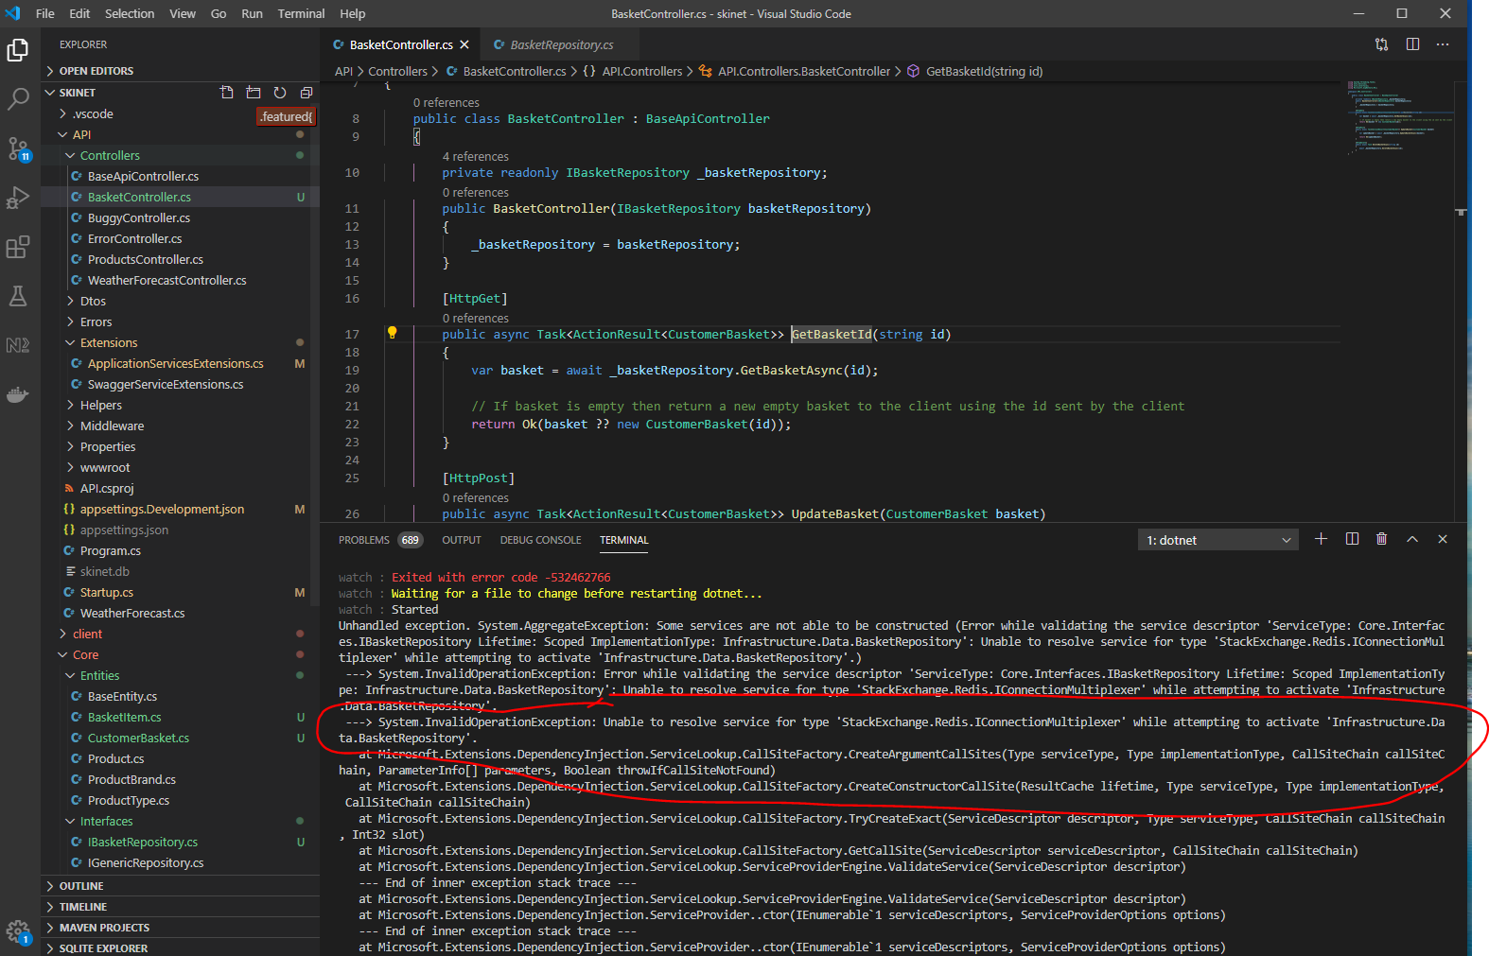

Check the code it mentions in the error message i.e. this:-

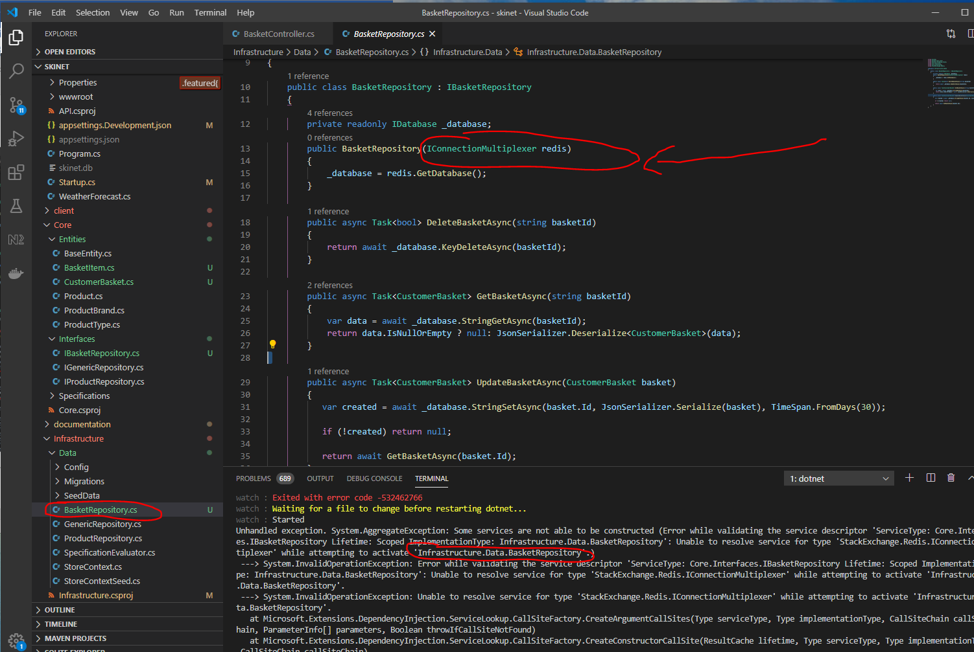

The IConnectionMultiplexer. Check the ‘Startup.cs’ class:-

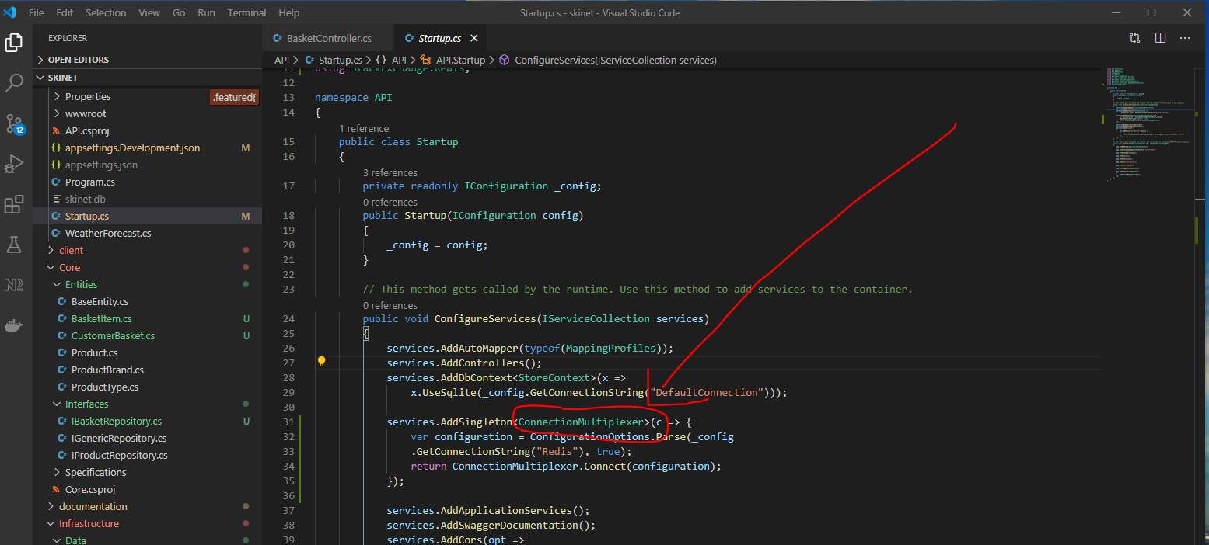

The above it the problem. It should not be ‘ConnectionMultiplexer’ is should be ‘IConnectionMultiplexer’. So Add an ‘I’, change to:-

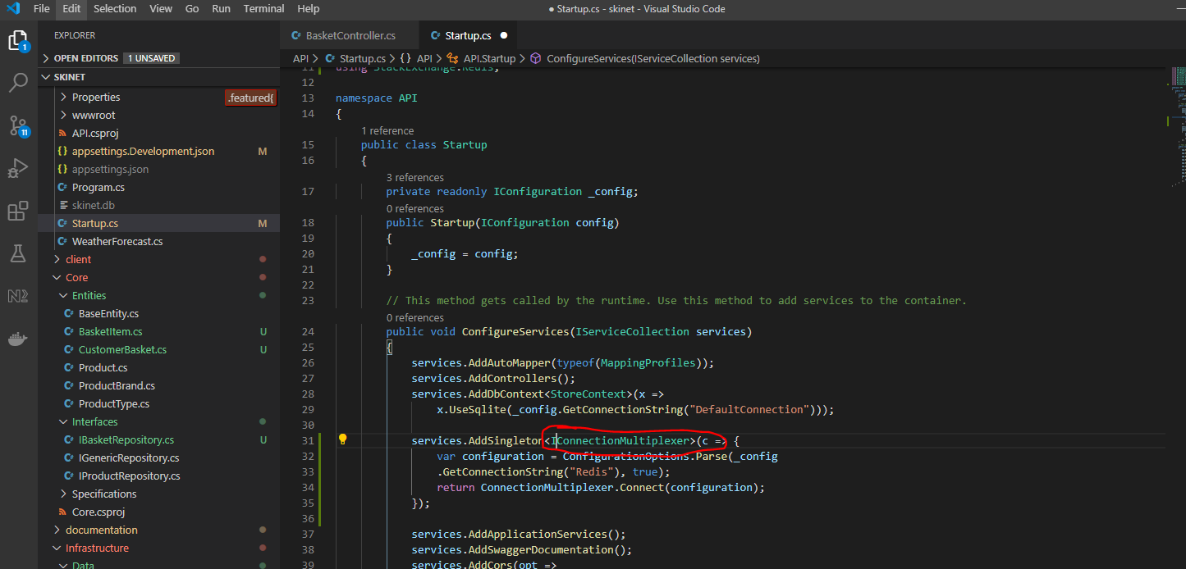

Restart API.

Try Postman again:-

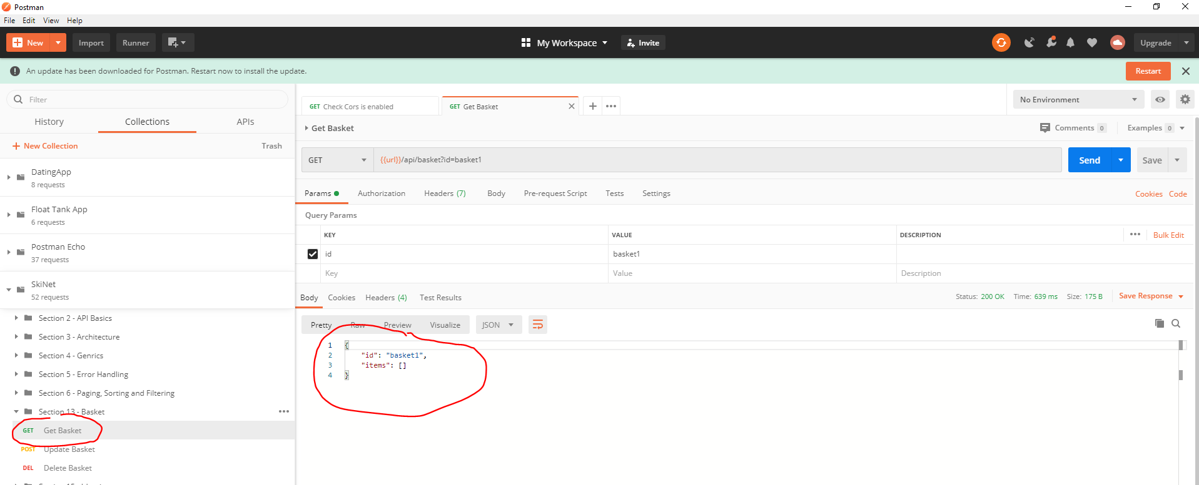

This time we get a basket.

You can stop the Redis server by typing this into the command prompt:-

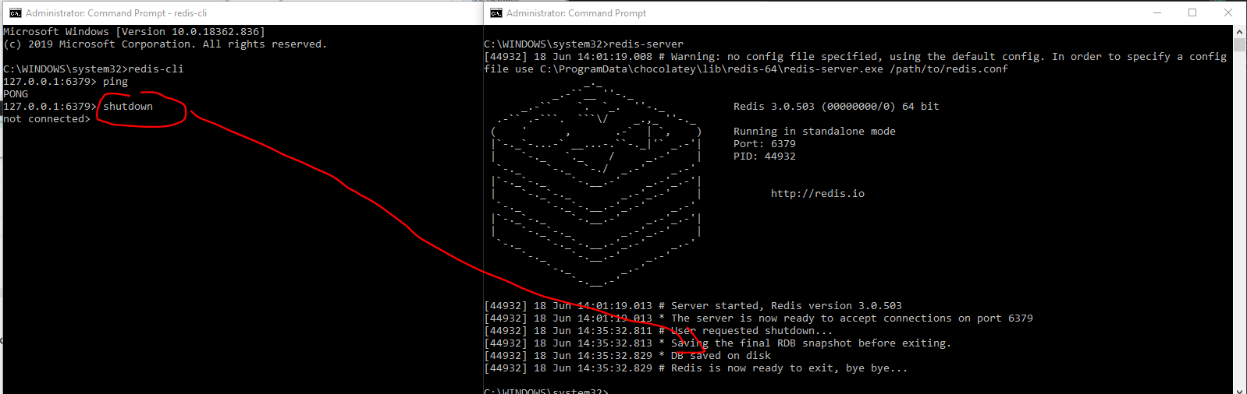

To restart again:-

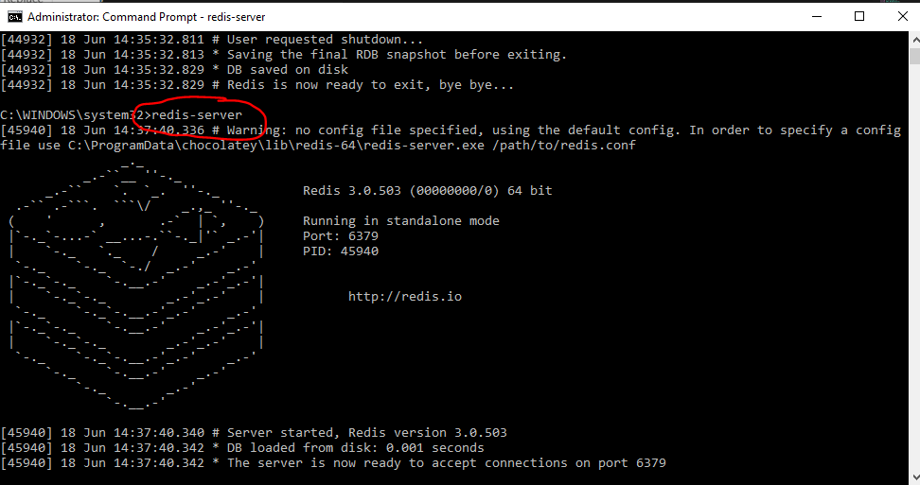

Git push changes.

**Add Client Basket**

Create a ‘basket’ module:-

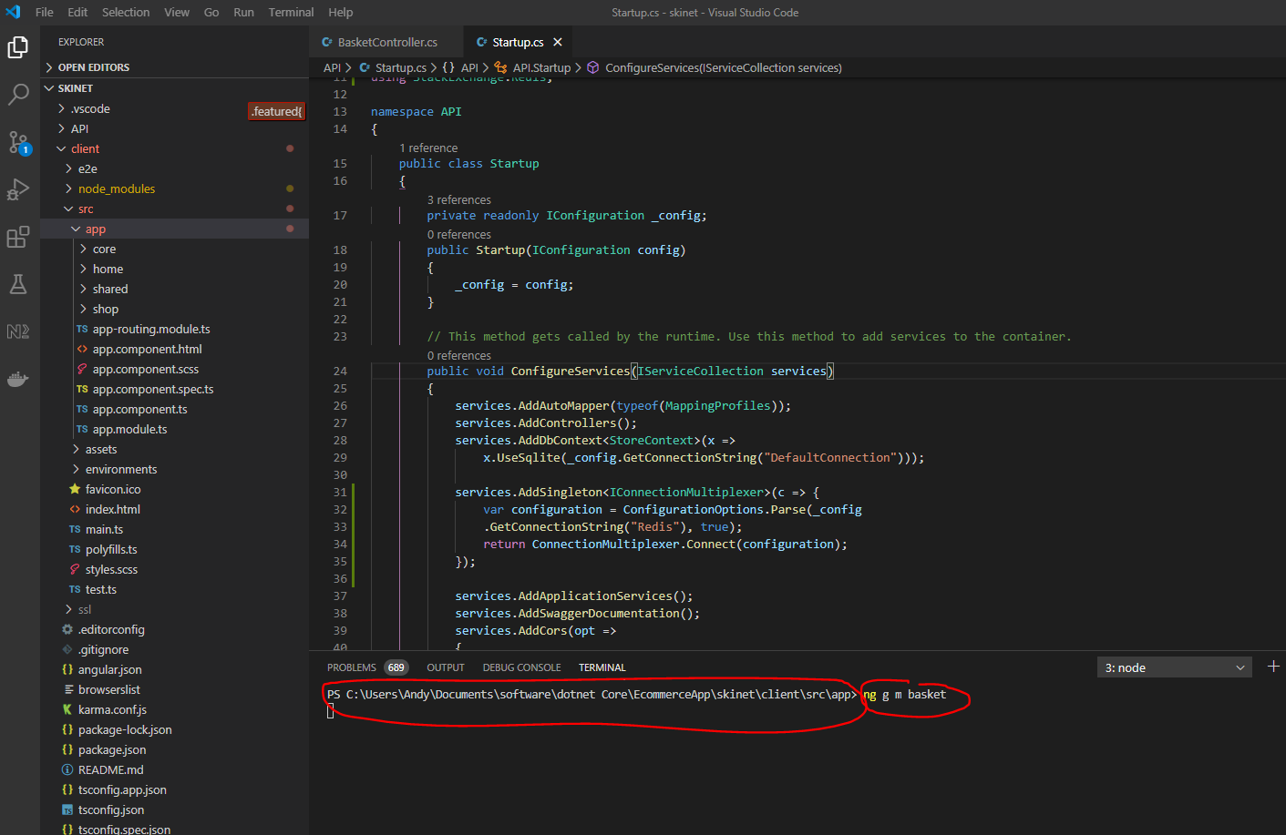

cd into ‘basket’ folder and create a routing module:-

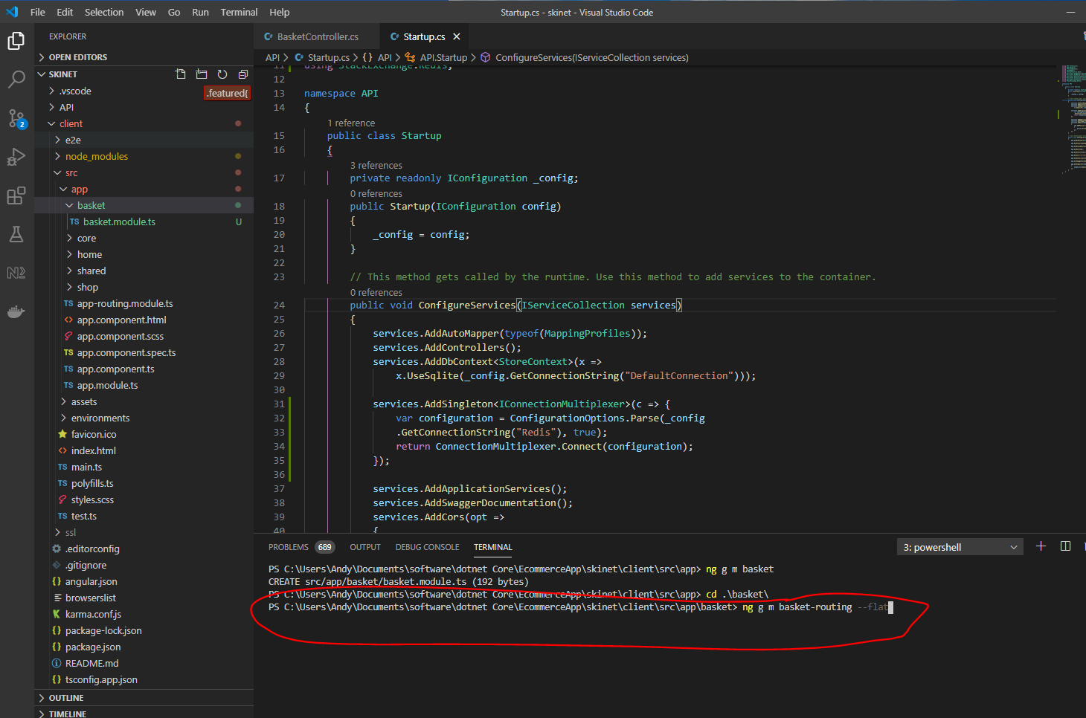

Now, generate a basket component:-

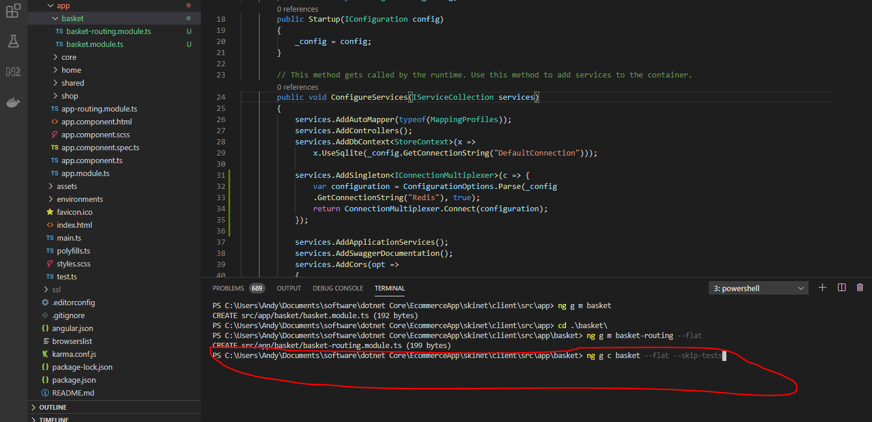

Now create a basket service:-

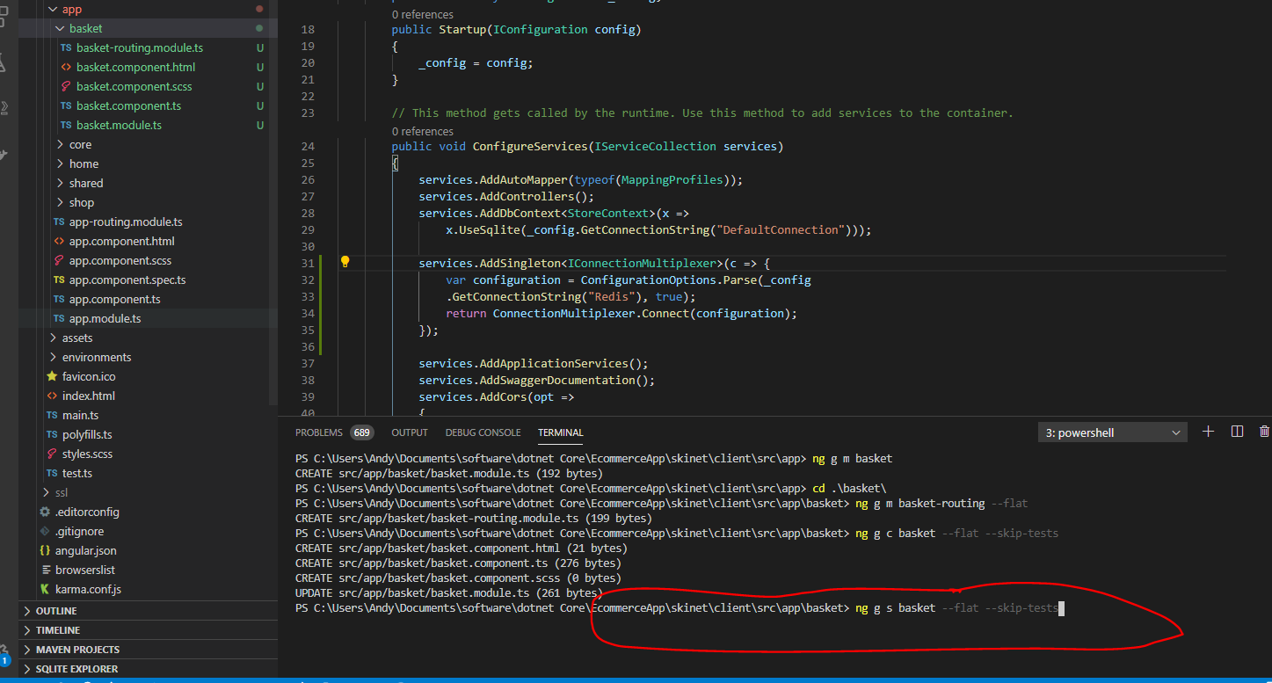

Add lazy loading, so go to the app-routing.ts file and add this:-

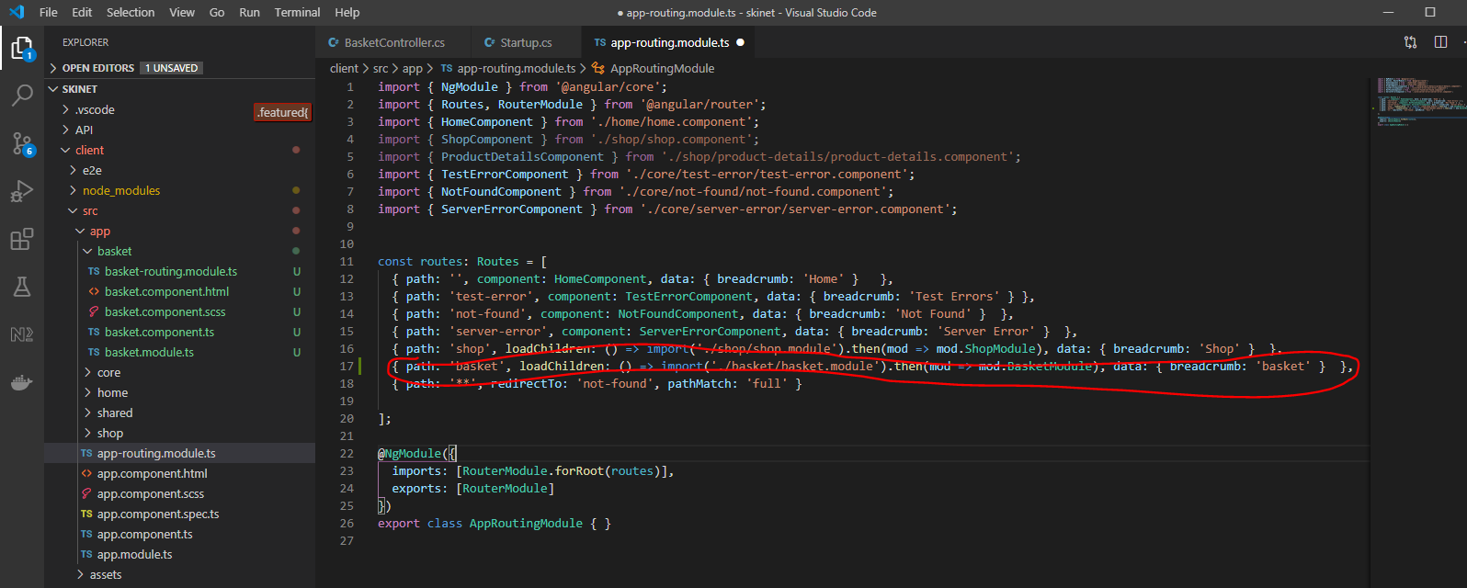

Now add this to the ‘basket-routing.module.ts’ file:-

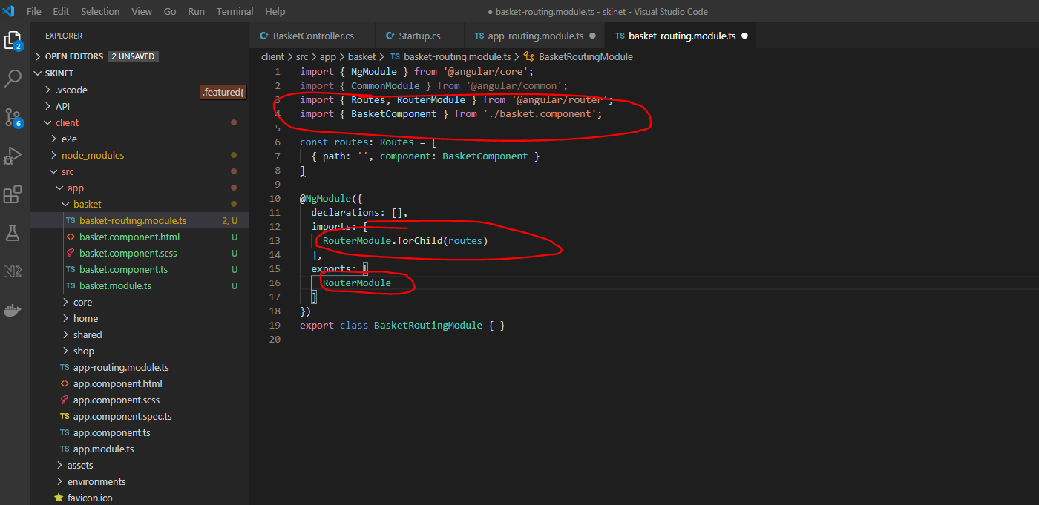

Add this to the ‘basket.module.ts’:-

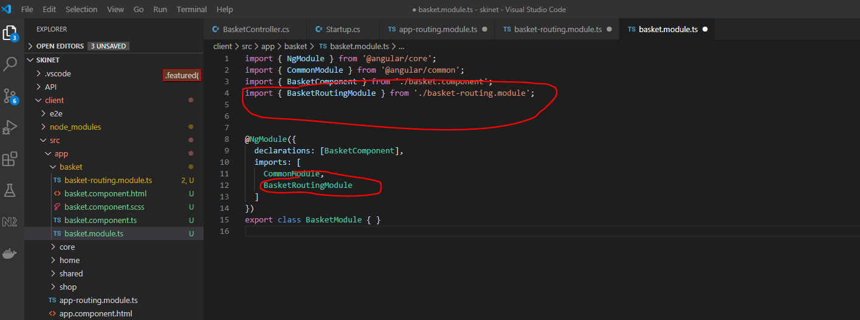

Update nav-bar.component.html to test:-

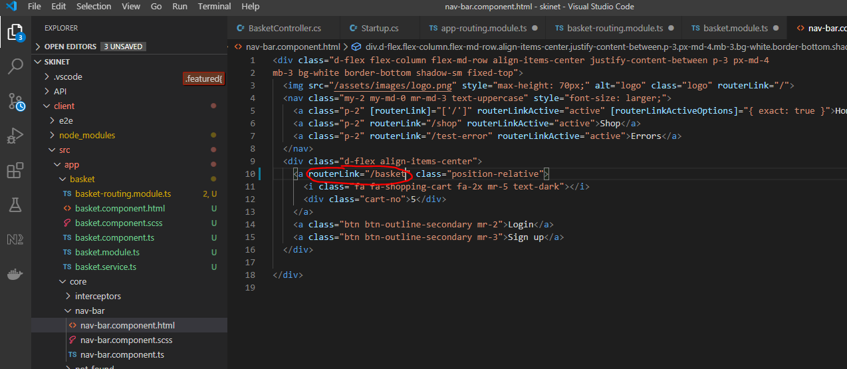

Restart the angular app and see:-

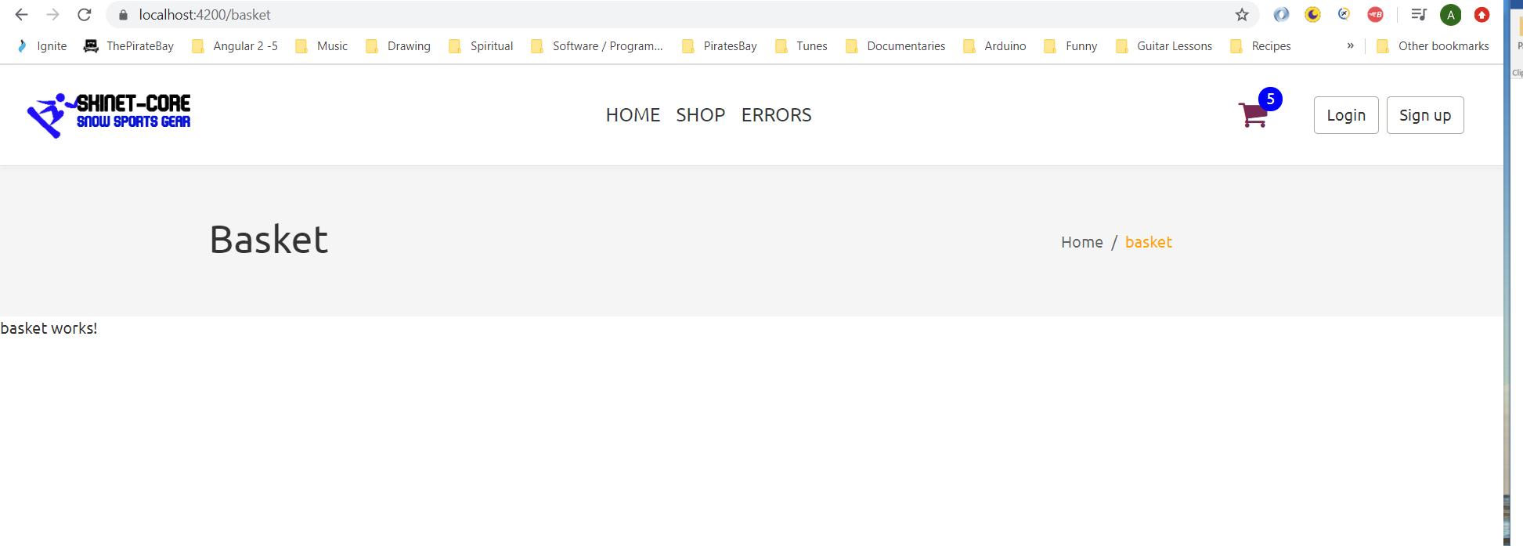

**Create Interface for Basket**

Use Swagger to get data for interface:-

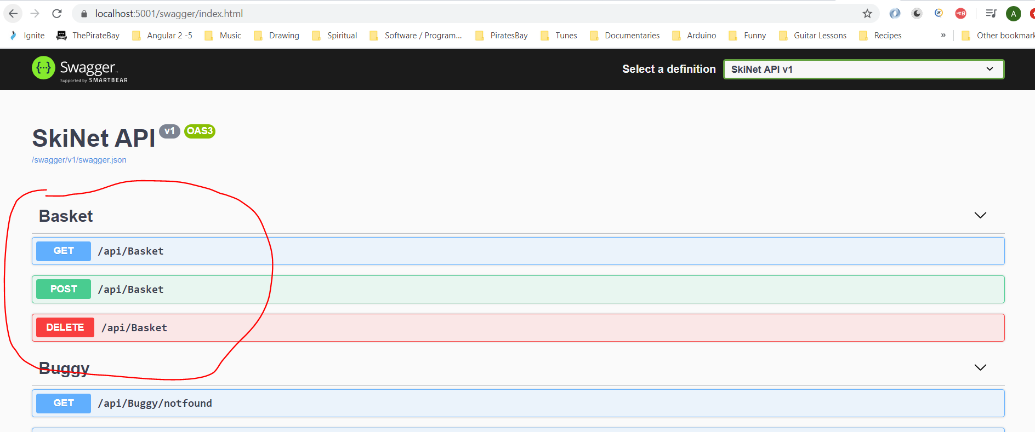

Copy this:-

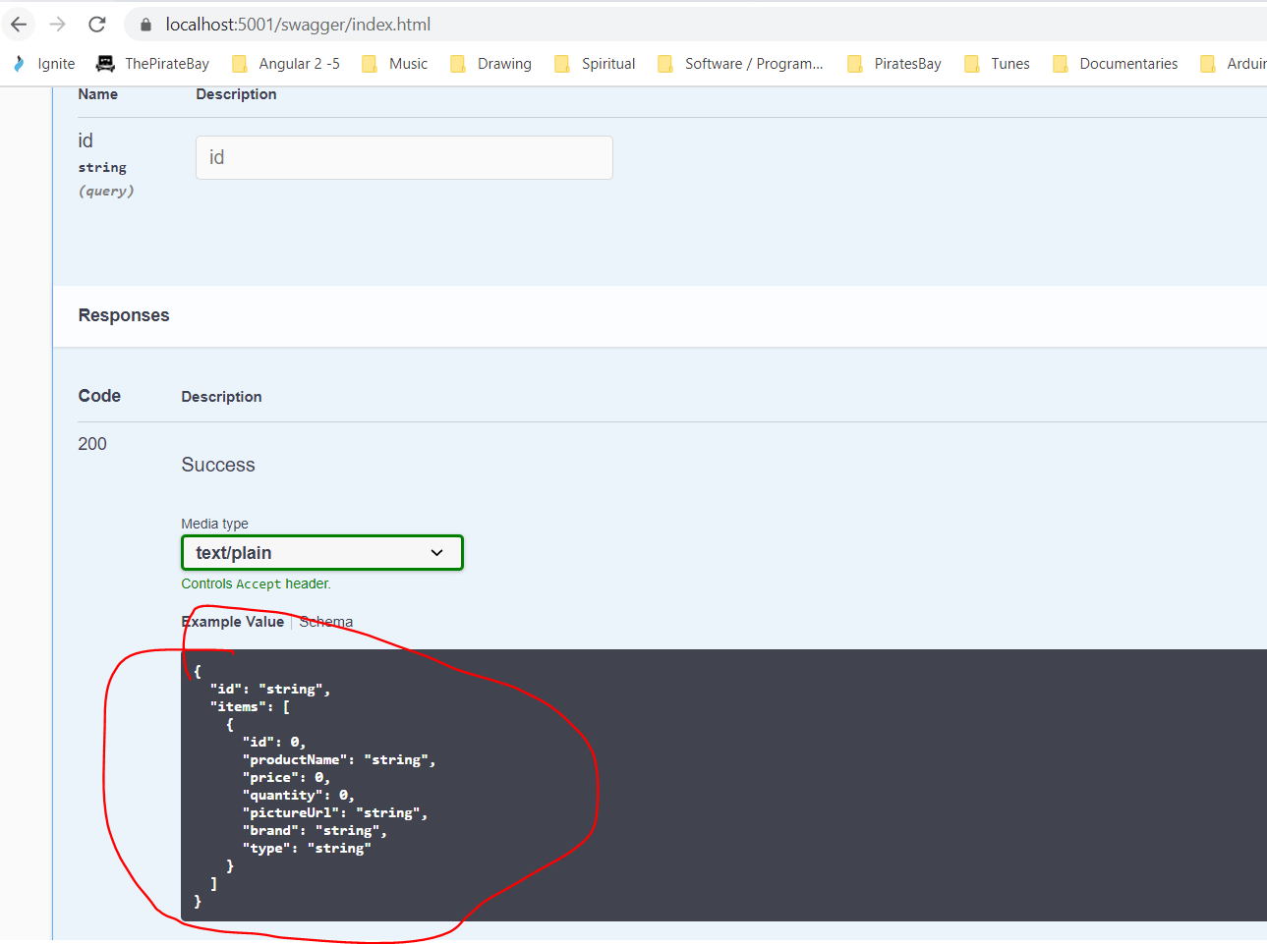

Paste into JSON to TS web app:-

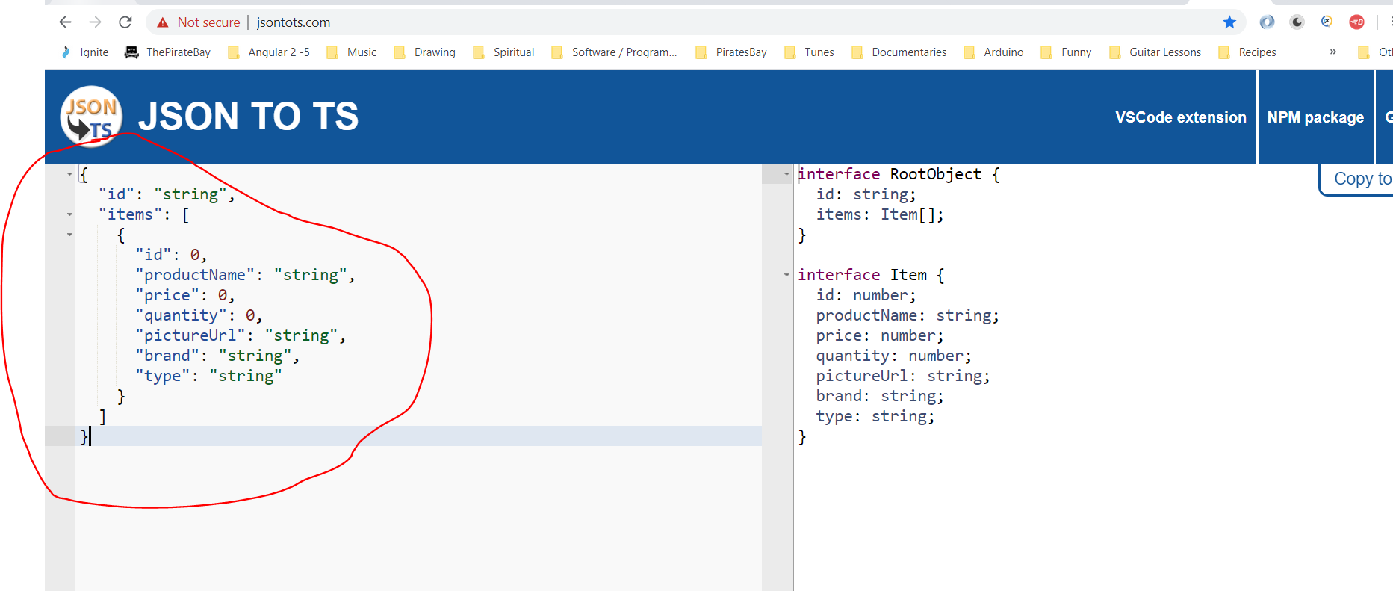

Copy right hand size into VSCode

Create a new file under ‘shared\models’:-

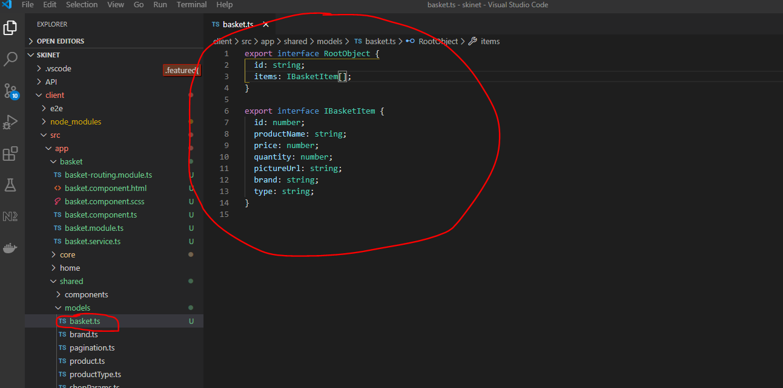

Now create a Basket class that implements IBasket:-

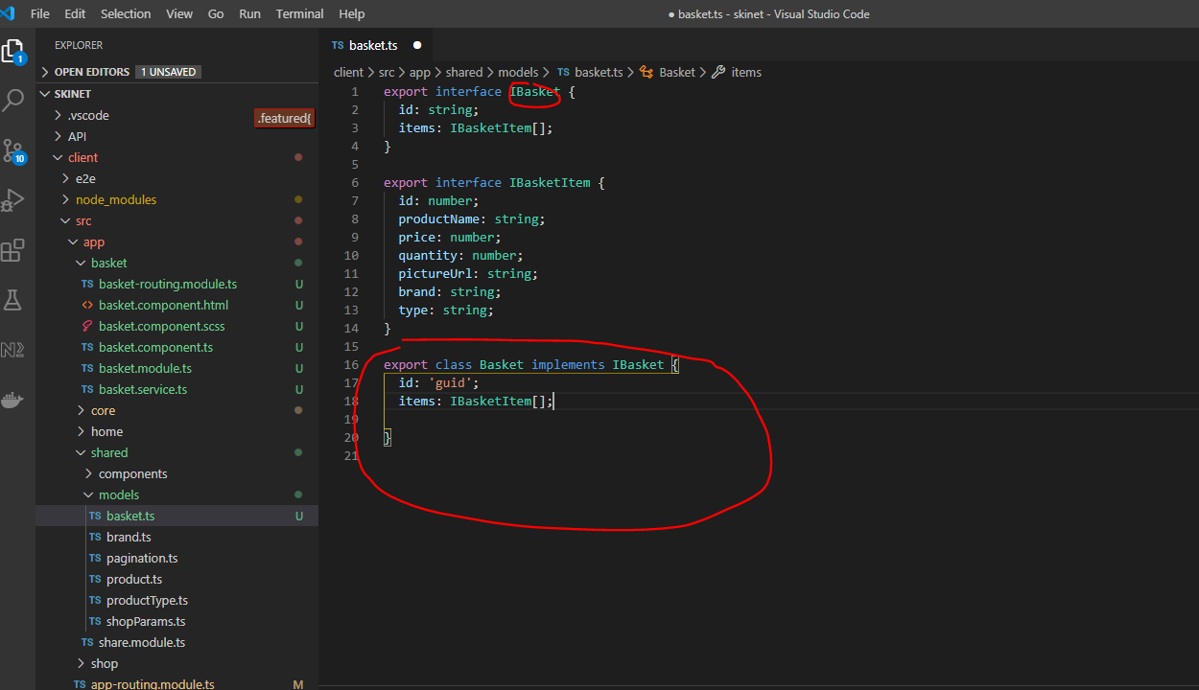

Add the following helper class – uuid. This will generate a GUID for each item. First cd into the ‘client’ folder:-

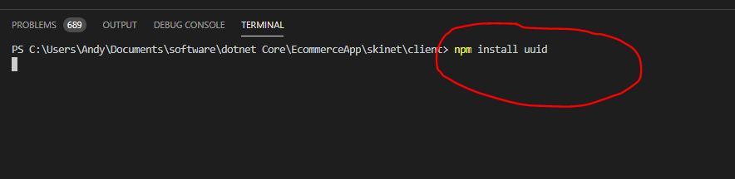

When installed add this:-

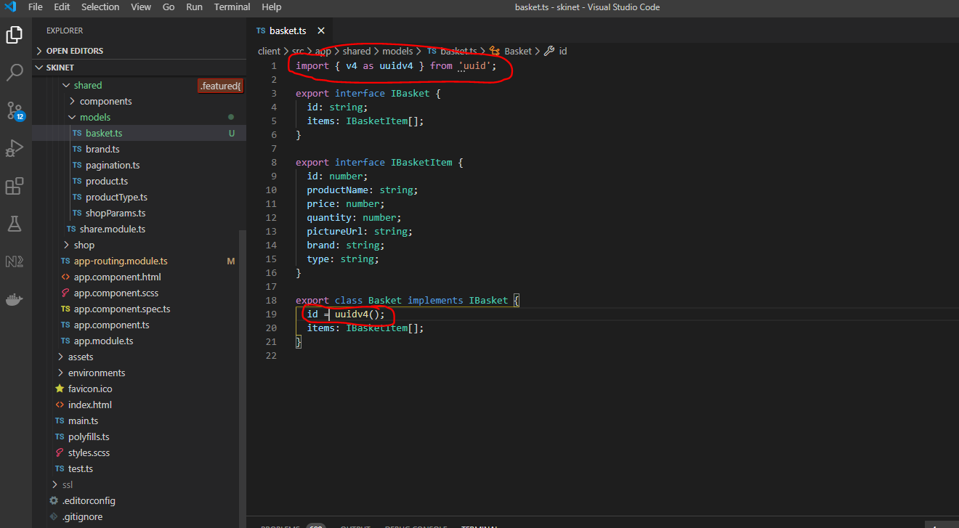

Add this to the Basket Service:-

import { Injectable } from '@angular/core';

import { environment } from 'src/environments/environment';

import { HttpClient } from '@angular/common/http';

import { BehaviorSubject } from 'rxjs';

import { IBasket, IBasketItem, Basket } from '../shared/models/basket';

import { map } from 'rxjs/operators';

import { IProduct } from '../shared/models/product';

@Injectable({

  providedIn: 'root'

})

export class BasketService {

  baseUrl = environment.apiUrl;

  private basketSource = new BehaviorSubject<IBasket>(null);

  basket$ = this.basketSource.asObservable();

  constructor(private http: HttpClient) { }

  getBasket(id: string) {

    return this.http.get(this.baseUrl + '/basket?id=' + id)

      .pipe(

        map((basket: IBasket) => {

          this.basketSource.next(basket);

        })

      );

  }

  setBasket(basket: IBasket) {

    return this.http.post(this.baseUrl + 'basket', basket).subscribe((response: IBasket) => {

      this.basketSource.next(response);

      console.log(response);

    }, error => {

      console.log(error);

    });

  }

  getCurrentBasketValue() {

    return this.basketSource.value;

  }

  addItemToBasket(item: IProduct, quantity = 1) {

    const itemToAdd: IBasketItem = this.mapProductItemToBasketItem(item, quantity);

    const basket = this.getCurrentBasketValue() ?? this.createBasket(); // if basket is null then create a basket object

    basket.items = this.addOrUpdateItem(basket.items, itemToAdd, quantity);

    this.setBasket(basket);

  }

  private addOrUpdateItem(items: IBasketItem[], itemToAdd: IBasketItem, quantity: number): IBasketItem[] {

    const index = items.findIndex(i => i.id === itemToAdd.id);

    if (index === -1) { // if not found then add to basket

      itemToAdd.quantity = quantity;

      items.push(itemToAdd);

    } else { // if found then increment quantity

      items[index].quantity += quantity;

    }

    return items;

  }

  createBasket(): IBasket {

    const basket = new Basket();

    localStorage.setItem('basket_id', basket.id);

    return basket;

  }

  private mapProductItemToBasketItem(item: IProduct, quantity: number): IBasketItem {

    return {

      id: item.id,

      productName: item.name,

      price: item.price,

      pictureUrl: item.pictureUrl,

      quantity,

      brand: item.productBrand,

      type: item.productType

    };

  }

}

Update product-item.component

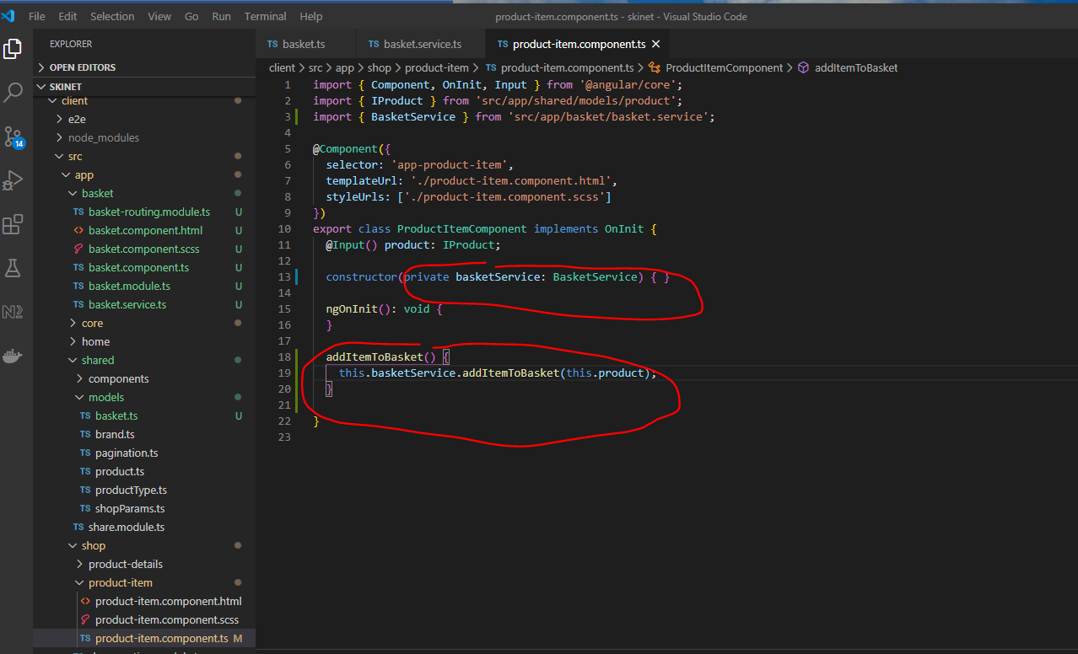

Update html:-

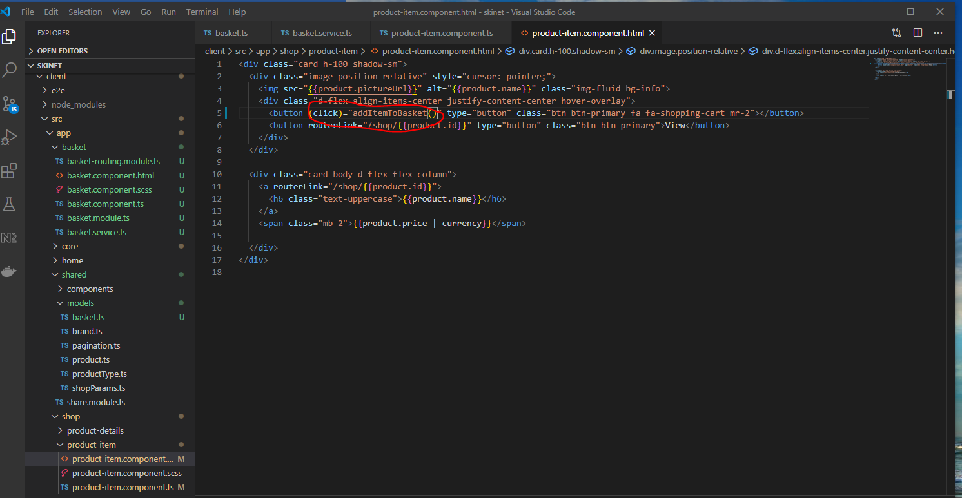

Now test that adding a product to the basket works:-

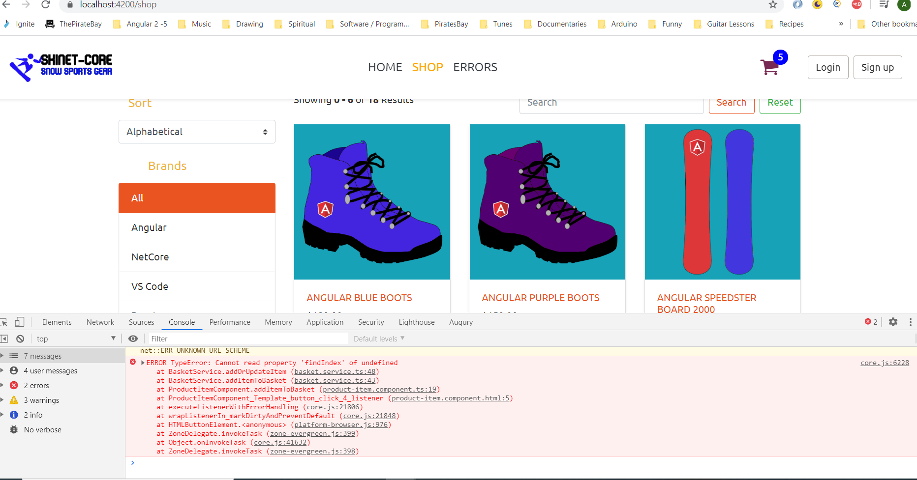

See error above.

To fix this you need to set the Basket class ‘items’ property to an empty array, see below:-

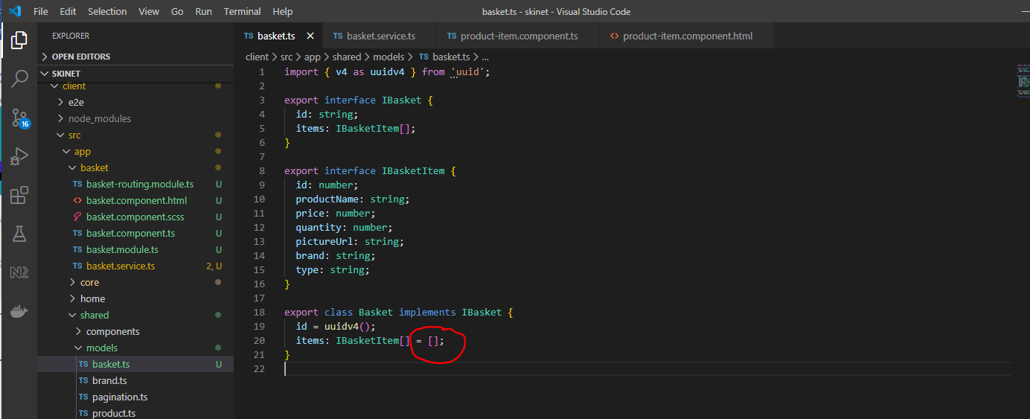

**Now add code to persist the content of the basket**

Add this code to app.component.ts:-

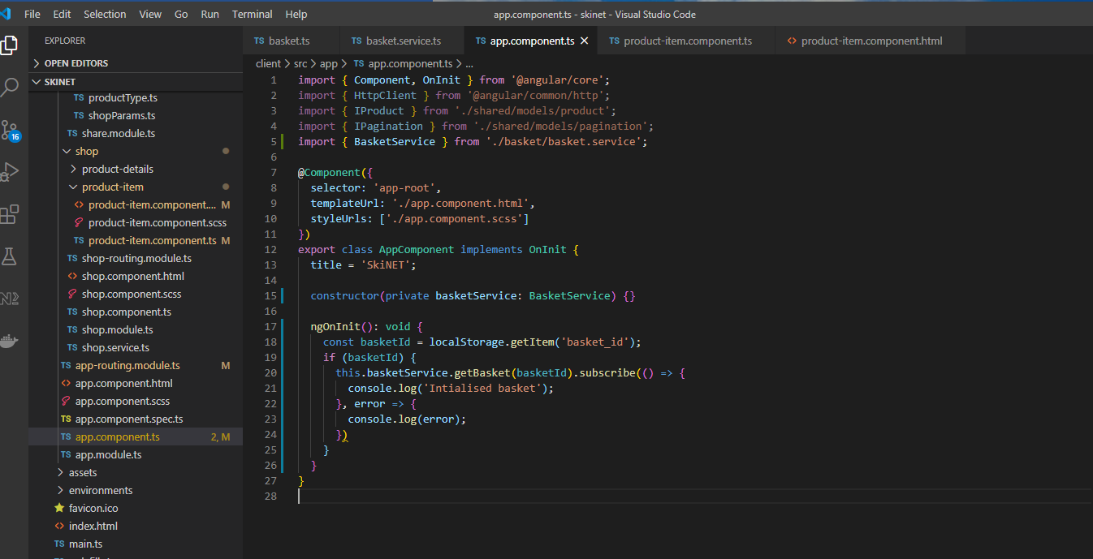

**Display basket item count in nav-bar**

Add this code to the nav-bar component:-

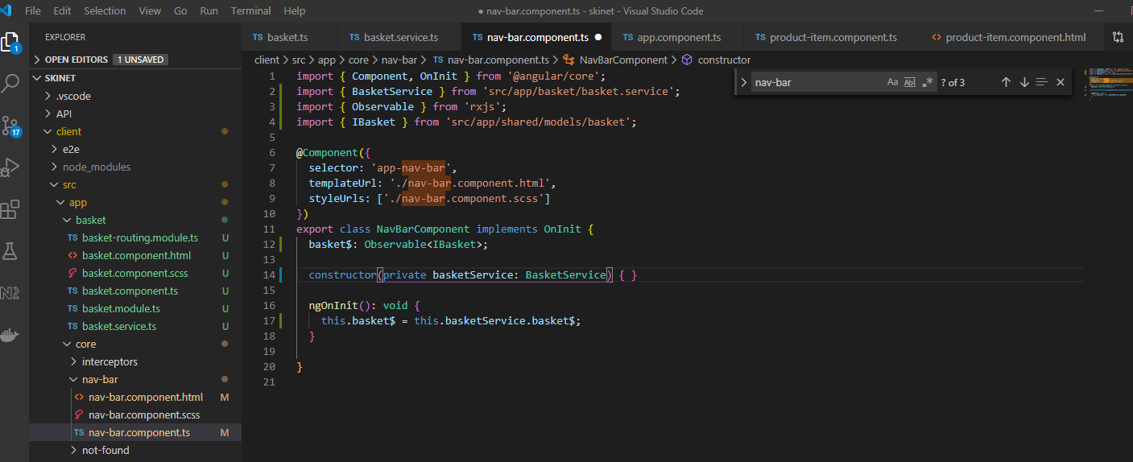

Add this html:-

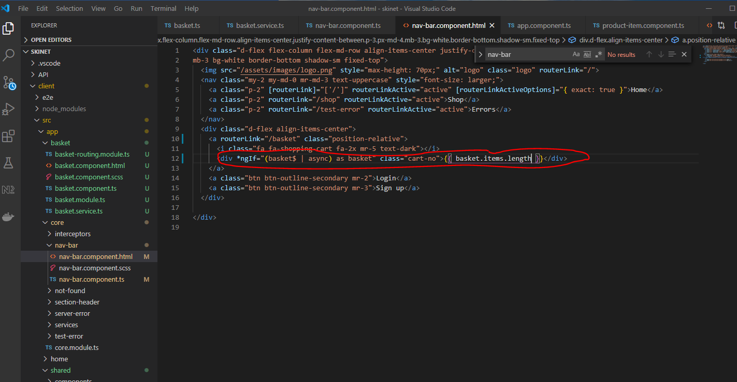

Now update basket.component.ts:-

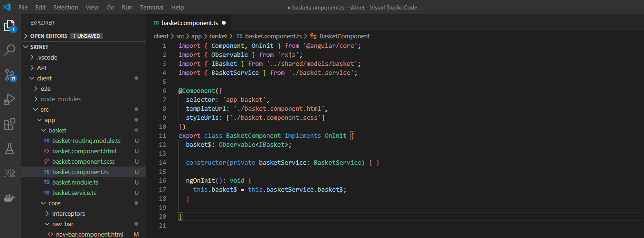

And html:-

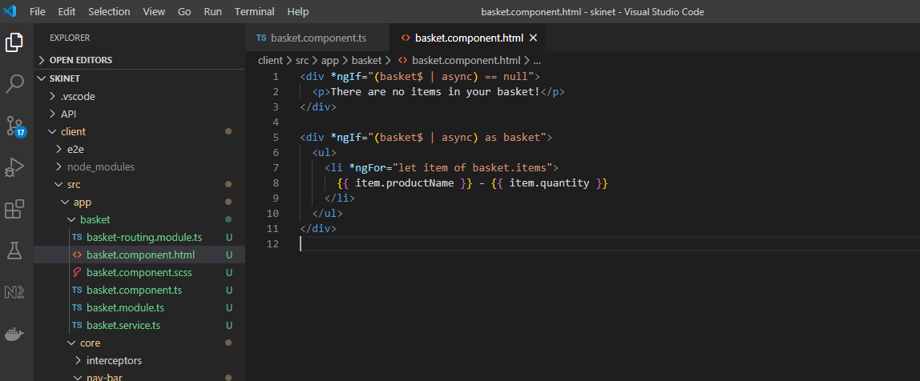

Change this:-

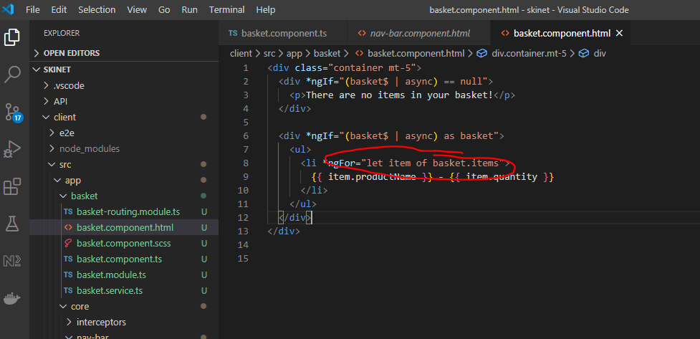

To:-

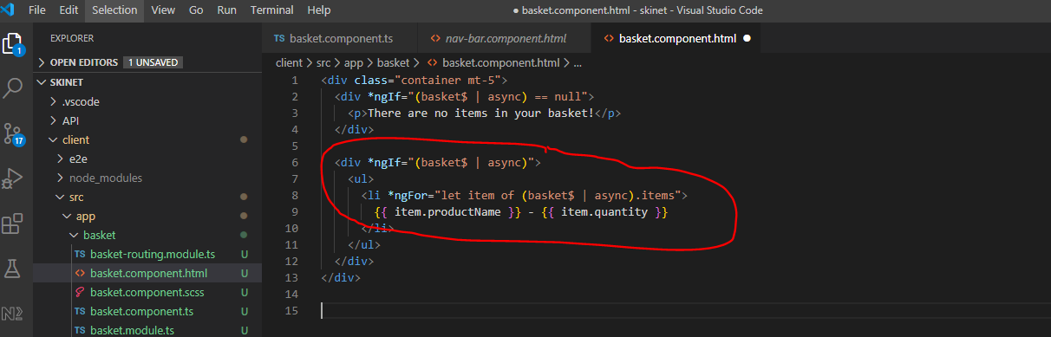

**Style the basket**

md-1 - means margin bottom

py-5 - means padding at top and bottom

p-2 - padding of 2

px-3 - padding left and right of 2

Add the following html to the ‘basket.component.html’ file:-

<div class="container mt-5">

  <div *ngIf="(basket$ | async) == null">

    <p>There are no items in your basket!</p>

  </div>

  <div *ngIf="(basket$ | async)">

    <div class="pb-5">

      <div class="container">

        <div class="row">

          <div class="col-12 py-5 mb-1">

            <div class="table-responsive">

              <table class="table">

                <thead>

                  <tr>

                    <th class="border-0 bg-light" scope="col">

                      <div class="p-2 px-3 text-uppercase">Product</div>

                    </th>

                    <th class="border-0 bg-light" scope="col">

                      <div class="py-2 text-uppercase">Price</div>

                    </th>

                    <th class="border-0 bg-light" scope="col">

                      <div class="py-2 text-uppercase">Quantity</div>

                    </th>

                    <th class="border-0 bg-light" scope="col">

                      <div class="py-2 text-uppercase">Total</div>

                    </th>

                    <th class="border-0 bg-light" scope="col">

                      <div class="py-2 text-uppercase">Remove</div>

                    </th>

                  </tr>

                </thead>

                <tbody>

                  <tr *ngFor="let item of (basket$ | async).items">

                    <th scope="row">

                      <div class="p-2">

                        <img src="{{ item.pictureUrl }}" alt="{{ item.productName }}" class="img-fluid" style="max-height: 50px">

                        <div class="ml-3 d-inline-block align-middle">

                          <h5 class="mb-0">

                            <a routerLink="/shop/{{ item.id }}" class="text-dark">{{ item.productName }}</a>

                          </h5>

                          <span class="text-muted font-weight-normal font-italic d-block">Type: {{ item.type }}</span>

                        </div>

                      </div>

                    </th>

                    <td class="align-middle"><strong>{{ item.price | currency }}</strong></td>

                    <td class="align-middle">

                      <div class="d-flex align items-center">

                        <i class="fa fa-minus-circle text-warning mr-2" style="cursor: pointer; font-size: 2em;"></i>

                        <span class="font-weight-bold" style="font-size: 1.5em">{{ item.quantity }}</span>

                        <i class="fa fa-plus-circle text-warning mx-2" style="cursor: pointer; font-size: 2em;"></i>

                      </div>

                    </td>

                    <td class="align-middle"><strong>{{ item.price * item.quantity | currency }}</strong></td>

                    <td class="align-middle text-center">

                      <a class="text-danger">

                        <i class="fa fa-trash" style="font-size: 2em;"></i>

                      </a>

                    </td>

                  </tr>

                </tbody>

              </table>

            </div>

          </div>

        </div>

      </div>

    </div>

  </div>

</div>

**Add basket totals to the service**

Create a new interface in the ‘basket.ts’:-

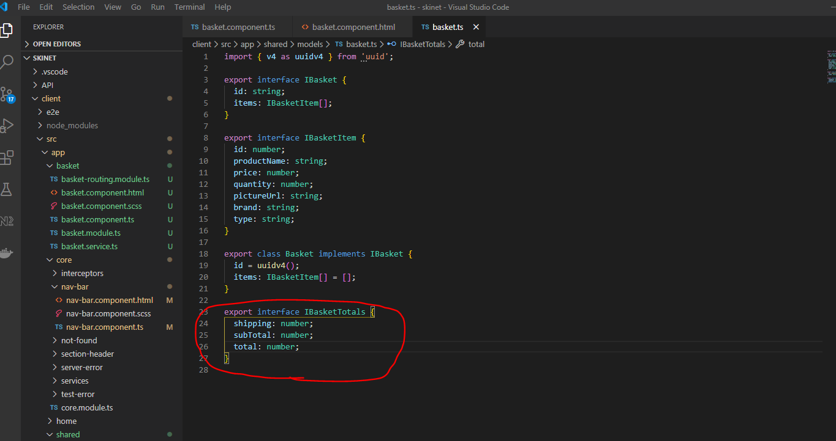

Update basket service:-

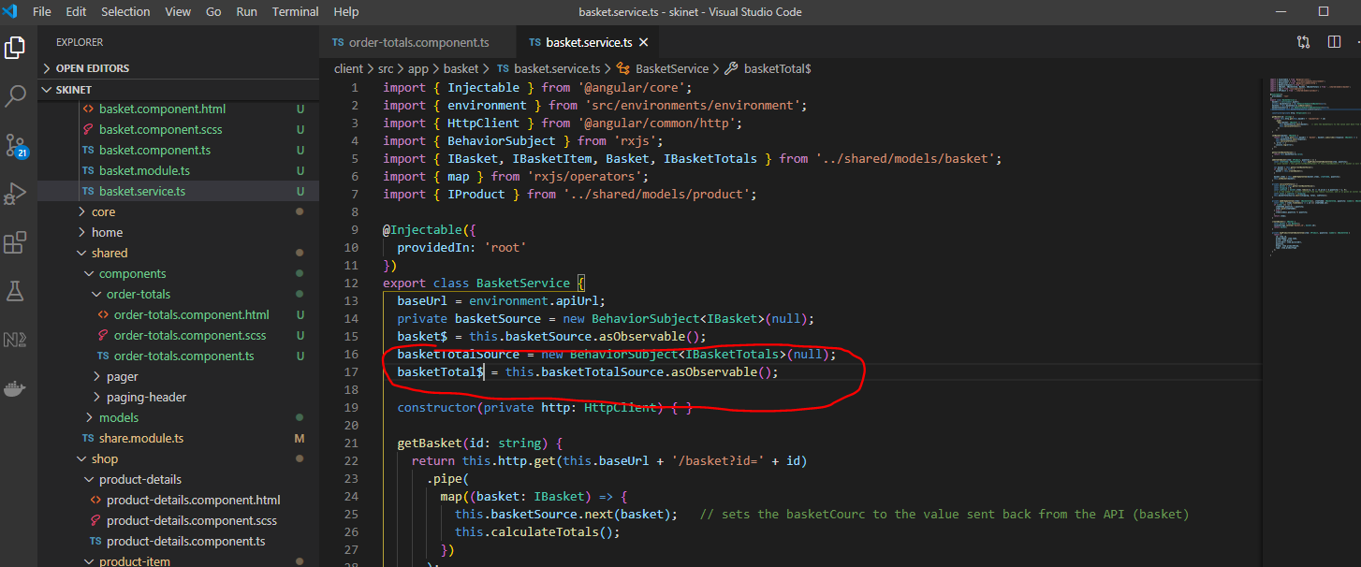

And:-

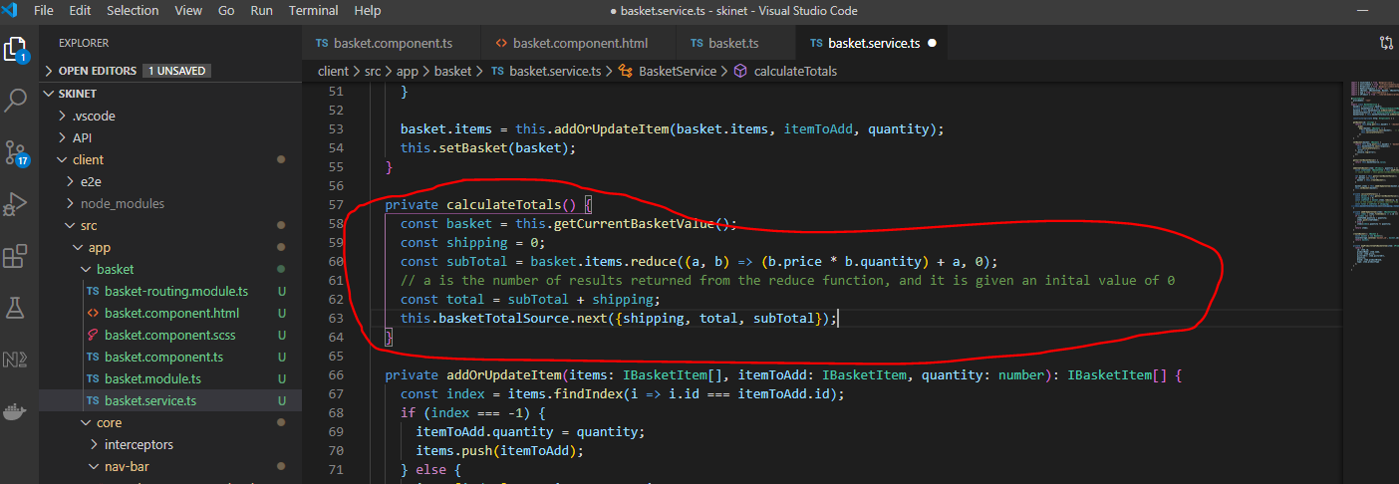

And:-

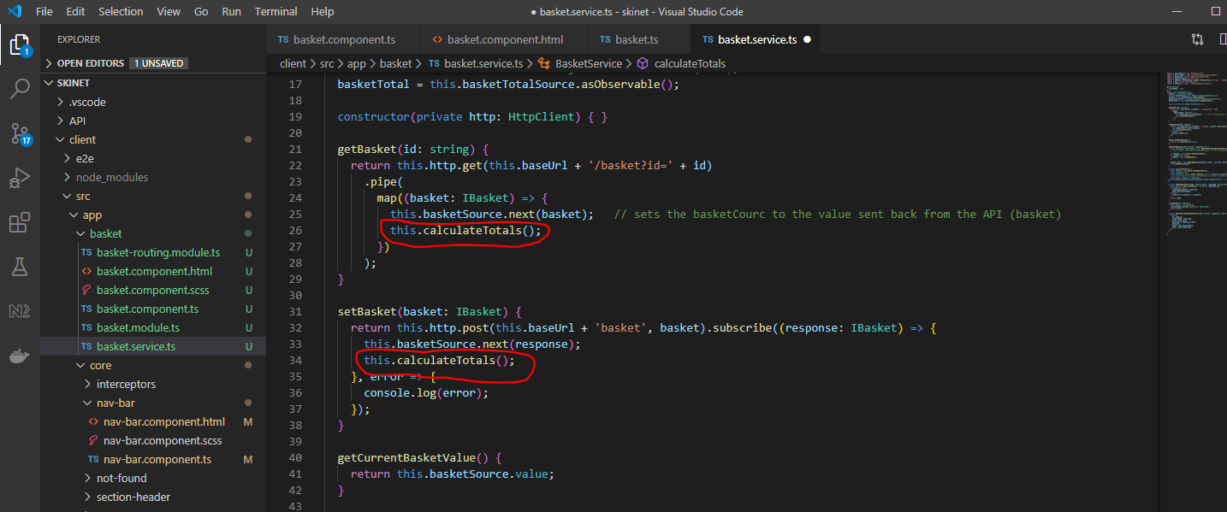

**Create a new component for the order Summary**

In the terminal cd here:-

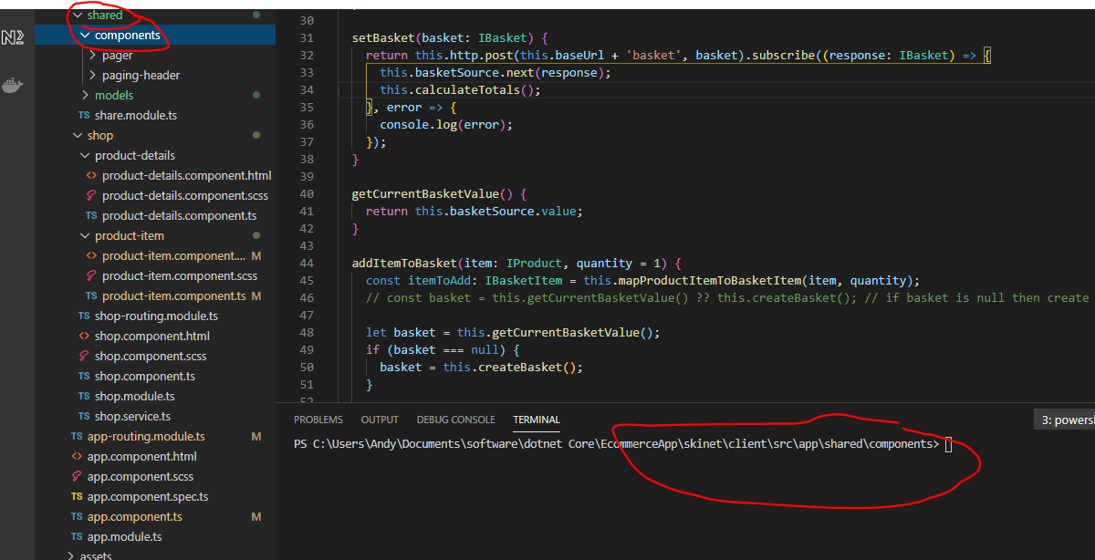

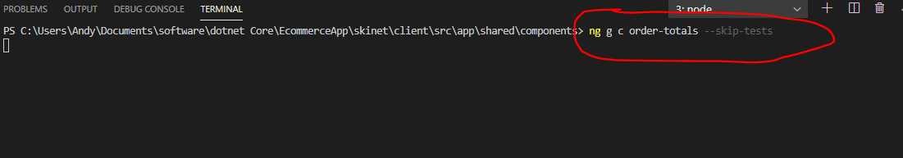

Add this to the component.ts:-

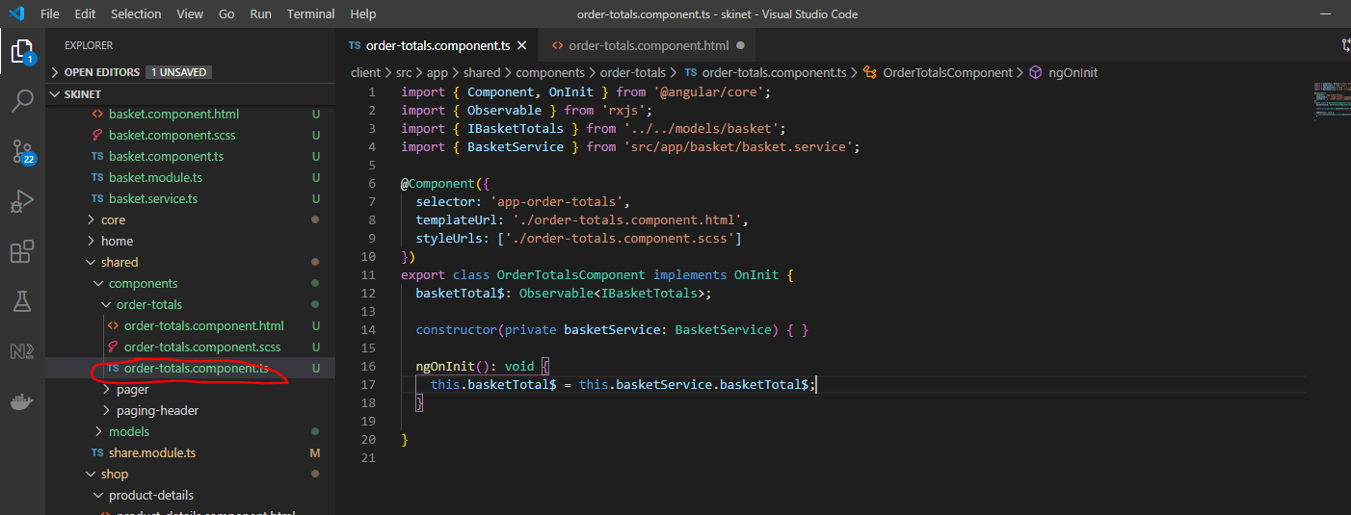

And the html:-

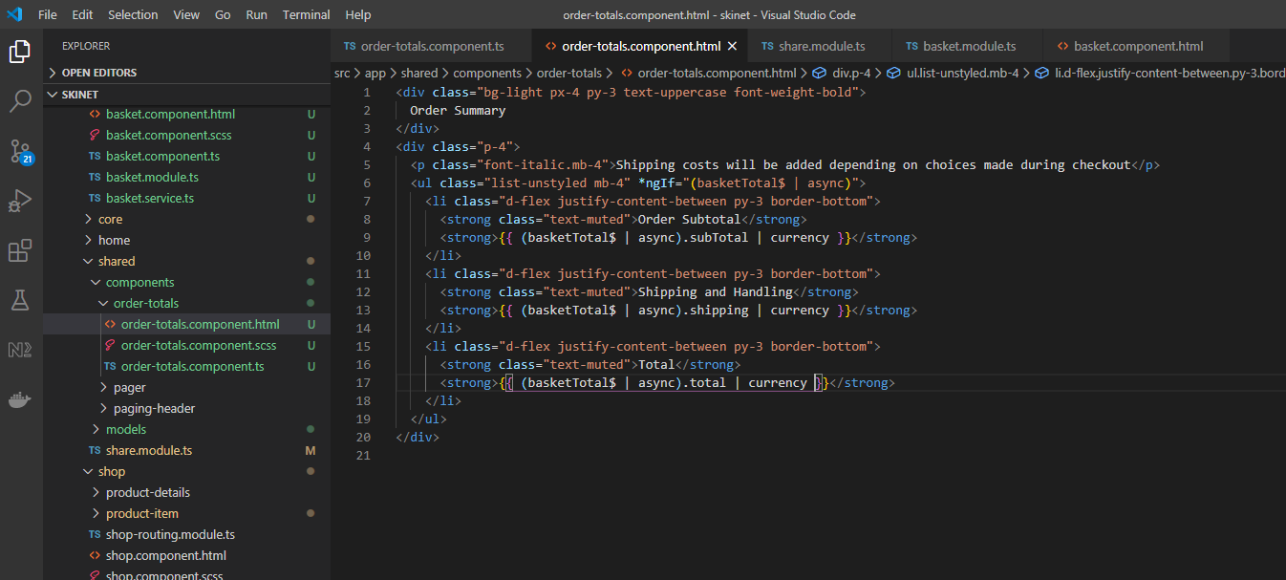

Export the above component from the ‘shared.module.ts’ file:-

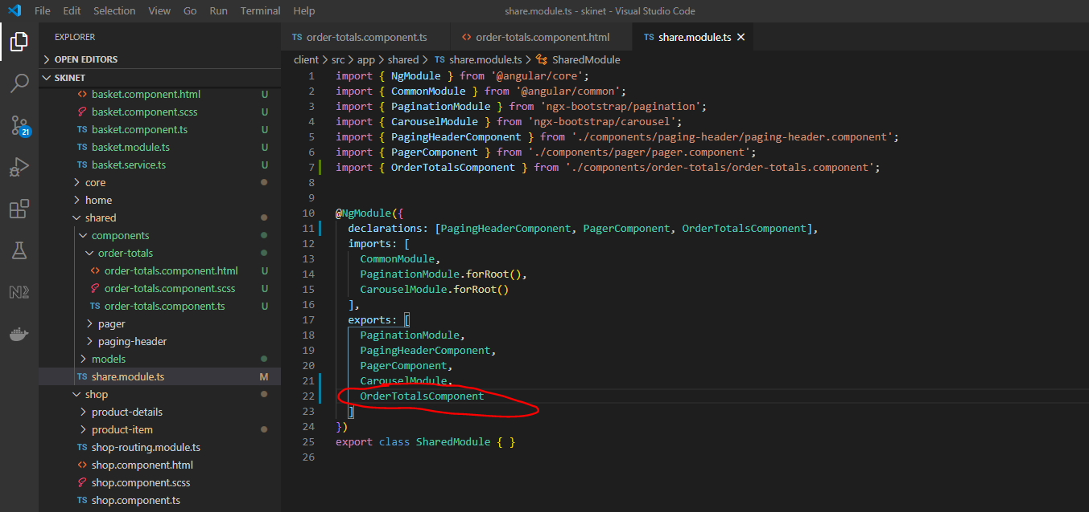

Import into basket.module.ts:-

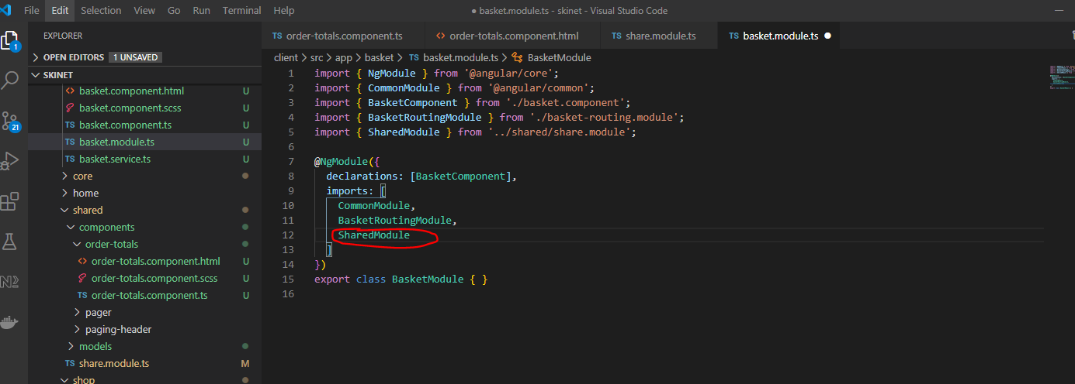

Update basket.component.html:-

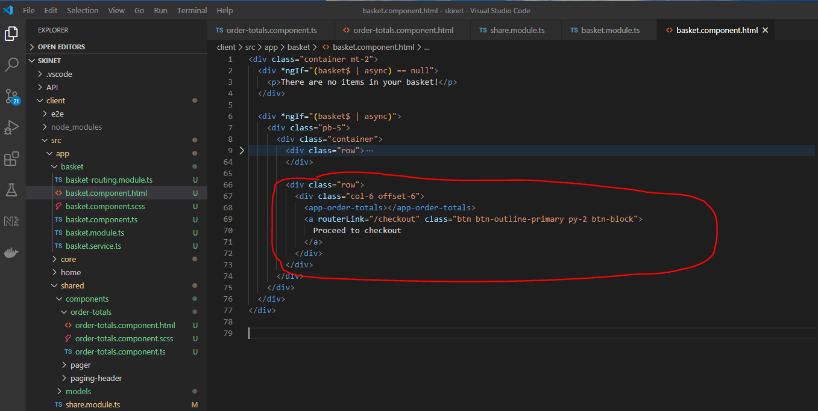

**Implement minus and plus icons on checkout page**

Add this to the basket service:-

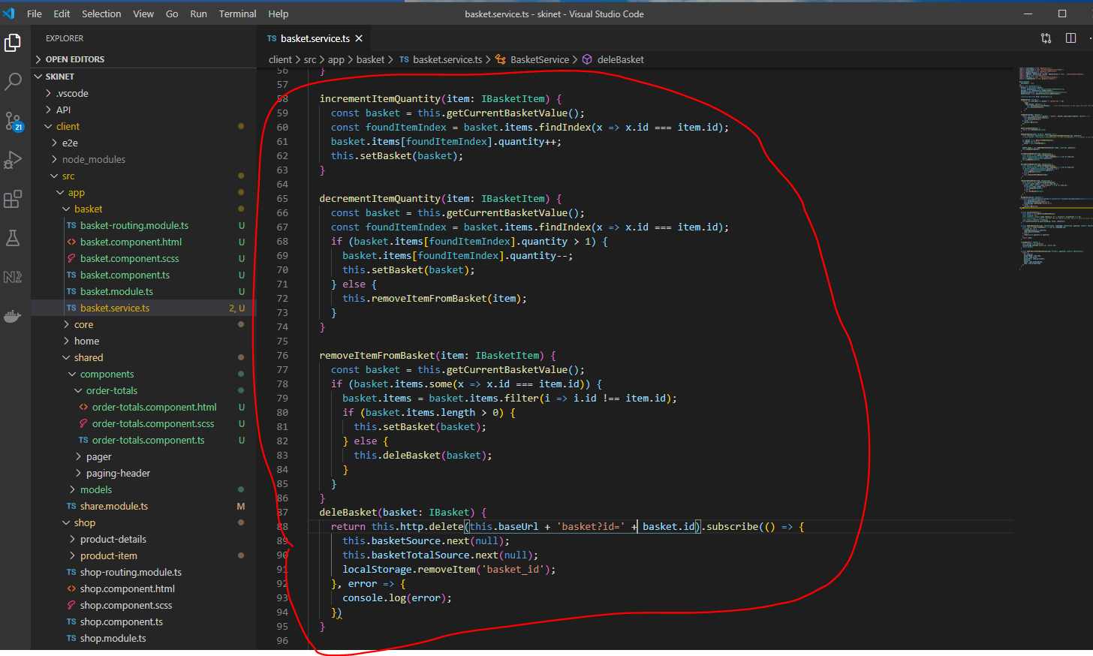

Add these methods to the ‘basket.component.ts’:-

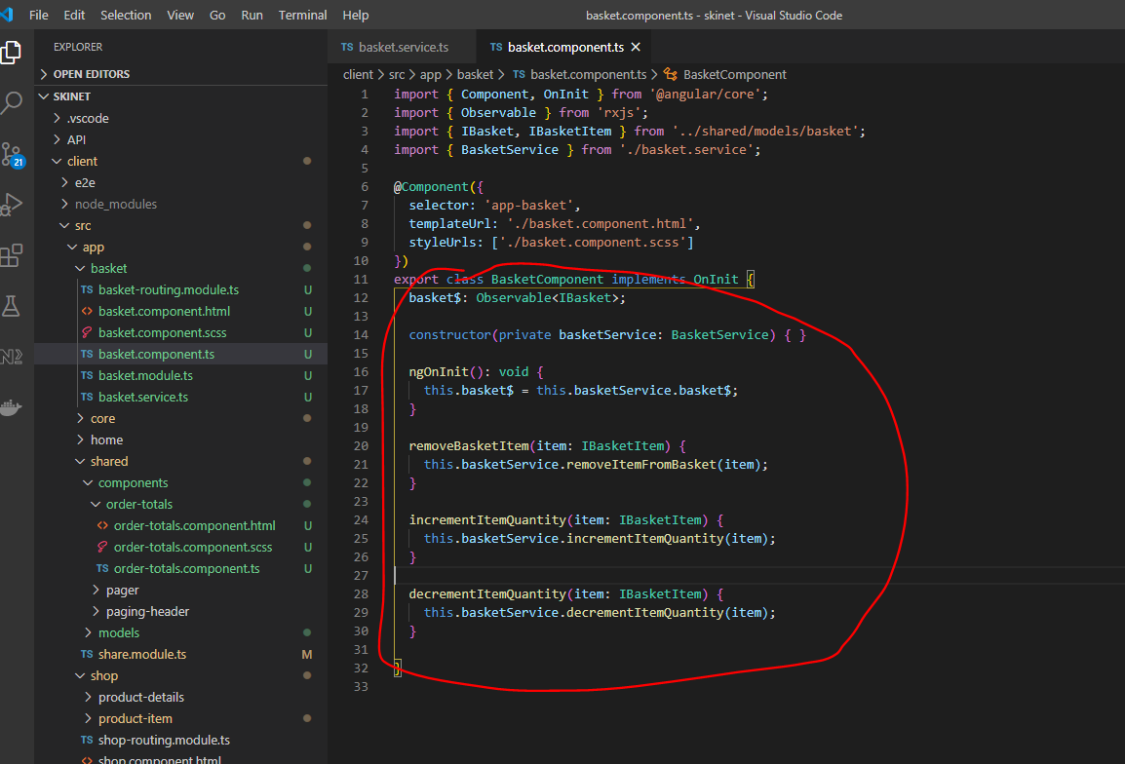

Update html:-

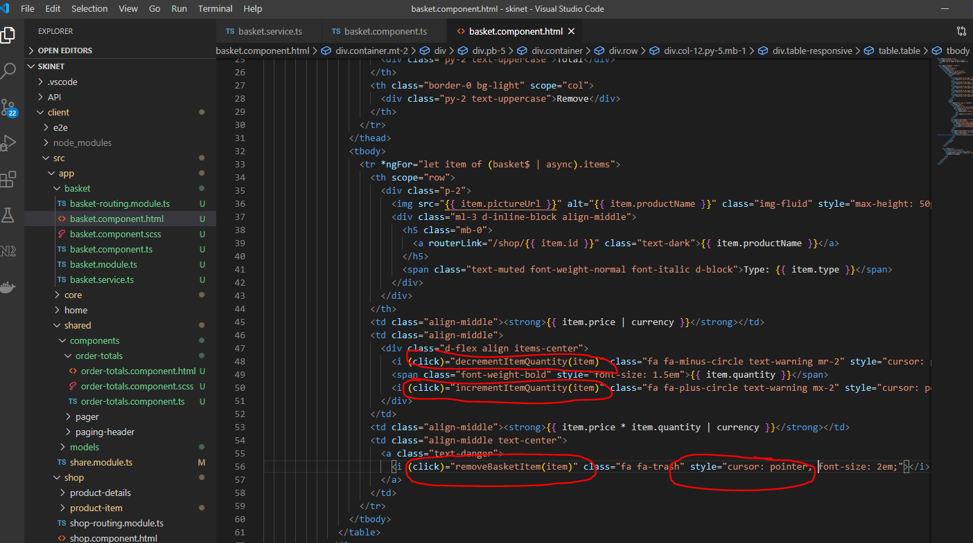

Now update the product-detail component:-

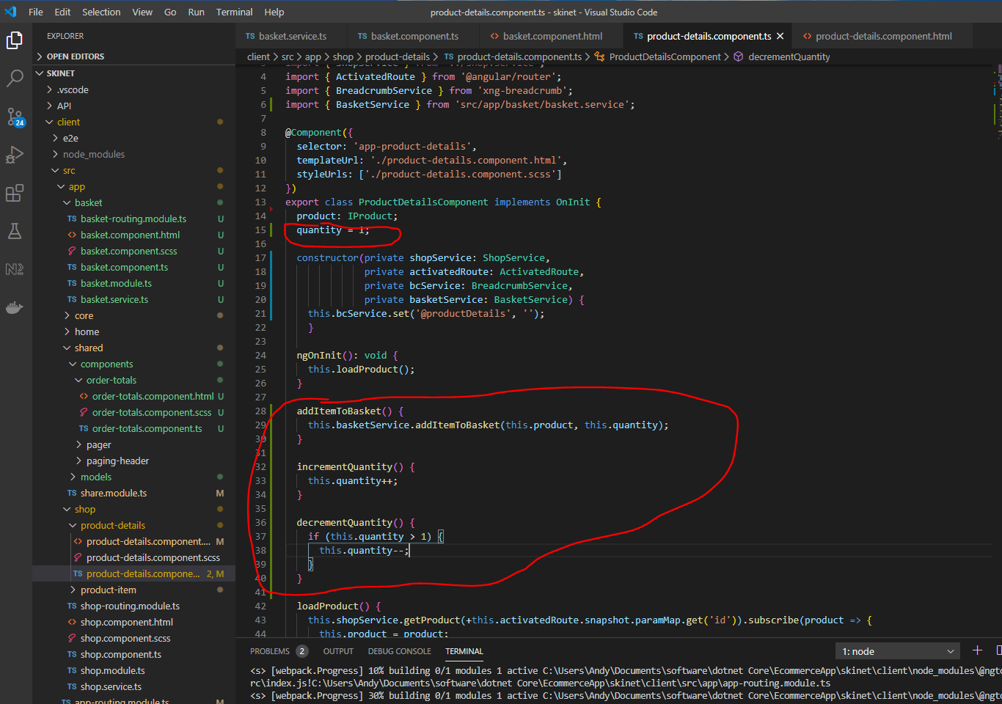

And the html:-

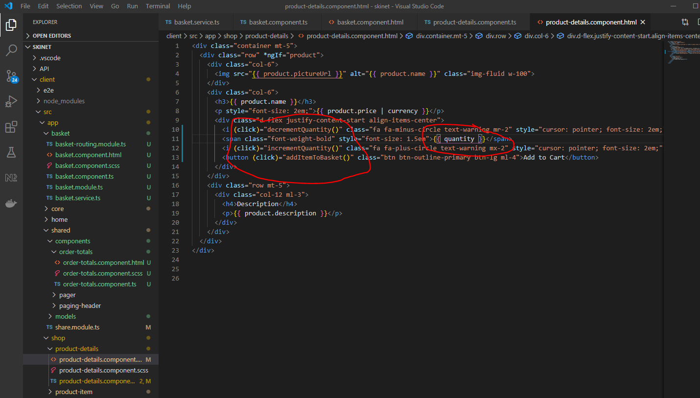

**Adding Checkout Module**

In the terminal window cd into the ‘app’ folder then create a new module:-

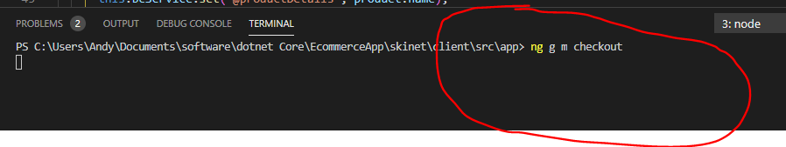

Cd into checkout folder and create a routing module:-

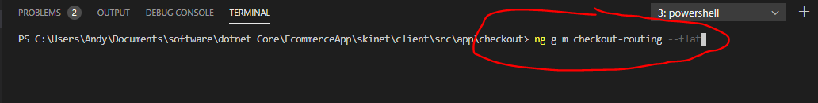

Create a service:-

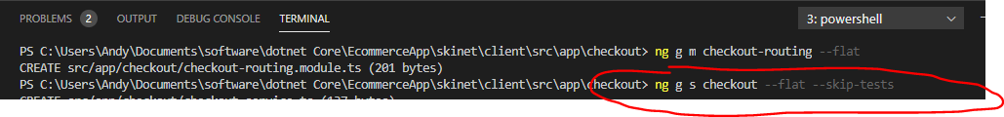

Then, create a component:-

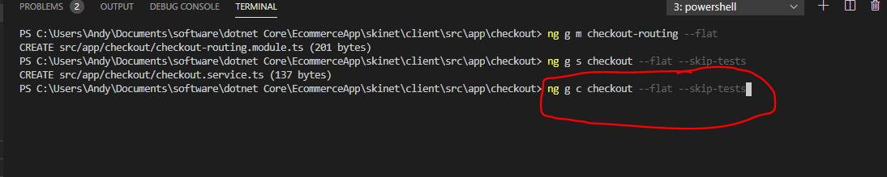

Now open the routing module and add this:-

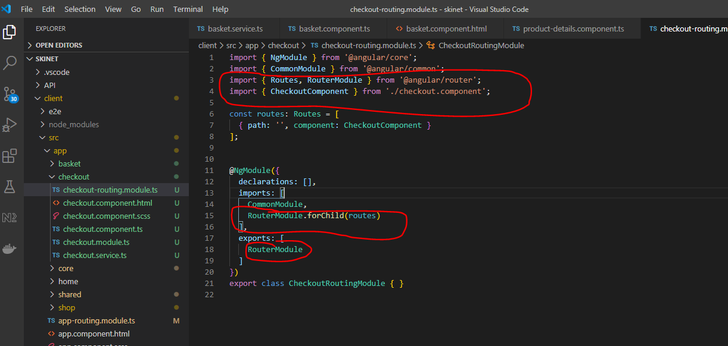

Import the CheckoutRoutingModule into the Checkout module:-

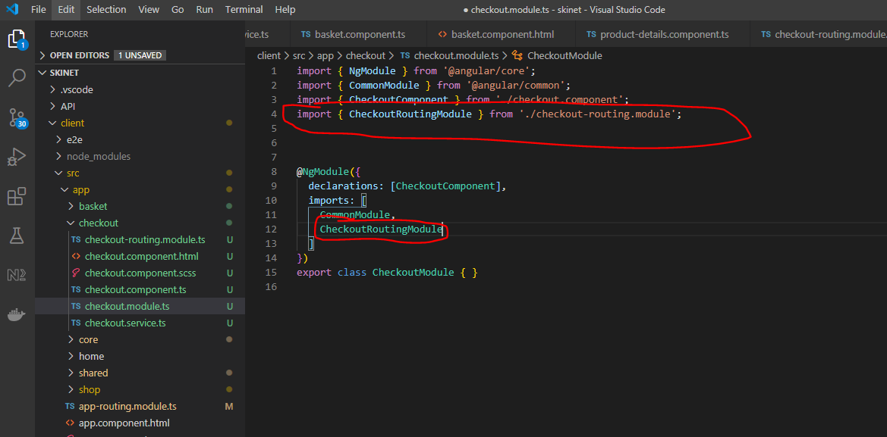

Add and entry into the app-routing.module.ts (needs to be lazy loaded):-

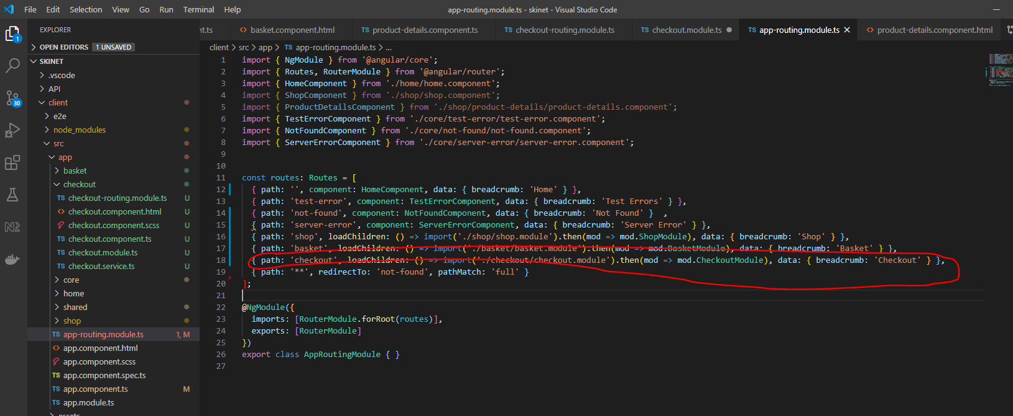

Add this to checkout component html:-

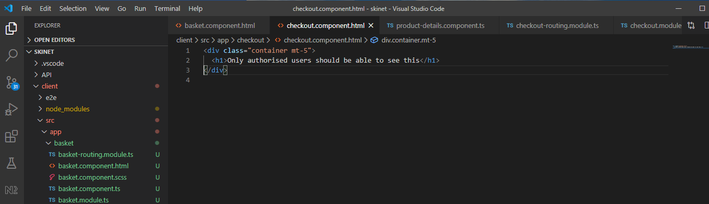

Need to add this file to the .gitignore file as we don’t want to commit this to GitHub:-

dump.rdb

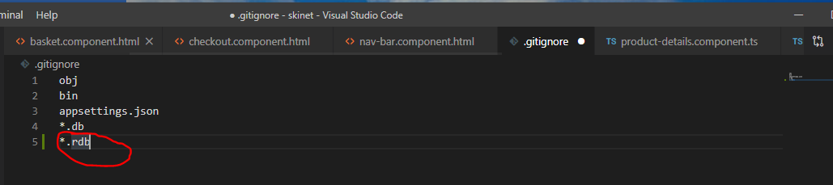

**API Identity**

**[1] Install this package:-**

[ctrl] + [shift] + p

nuget

Microsoft.AspNetCore.Identity

2.2.0

{root}/Infrastructure/Infrastructure.csproj

**[2] Install this package:-**

[ctrl] + [shift] + p

nuget

Microsoft.AspNetCore.Identity.EntityFrameworkCore

3.1.4

{root}/Infrastructure/Infrastructure.csproj

Version needs to match the version of Entity. First get the version of dotnet runtime SDK running on your machine:-

In VSCode terminal type:-

dotnet --info

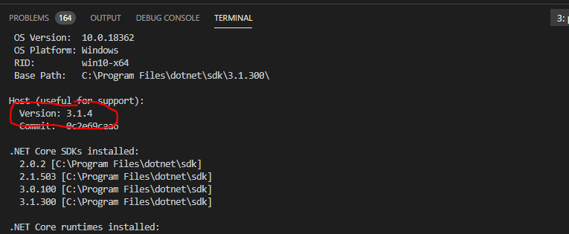

**[3] Install this package:-**

[ctrl] + [shift] + p

nuget

Microsoft.IdentityModel.Tokens

5.6.0

{root}/Infrastructure/Infrastructure.csproj

**[4] Install this package:-**

[ctrl] + [shift] + p

nuget

System.IdentityModel.Tokens.Jwt

6.6.0

{root}/Infrastructure/Infrastructure.csproj

**[5] Install this package:-**

[ctrl] + [shift] + p

nuget

Microsoft.AspNetCore.Authentication.JwtBearer

3.1.4

{root}/Api/Api.csproj

**[6] Install this package:-**

[ctrl] + [shift] + p

nuget

Microsoft.Extensions.Identity.Stores

3.1.4

{root}/Core/Core.csproj

In the terminal type:-

***dotnet restore***

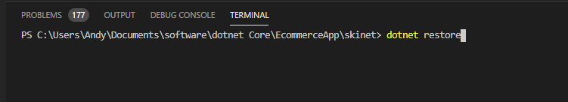

See errors:-

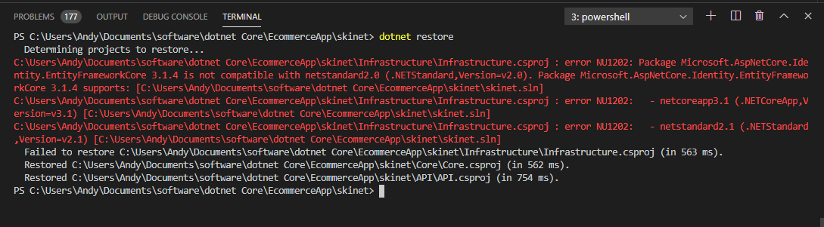

This is because:-

Package Microsoft.AspNetCore.Identity.EntityFrameworkCore 3.1.4 is not compatible with netstandard2.0 (.NETStandard,Version=v2.0)

See:-

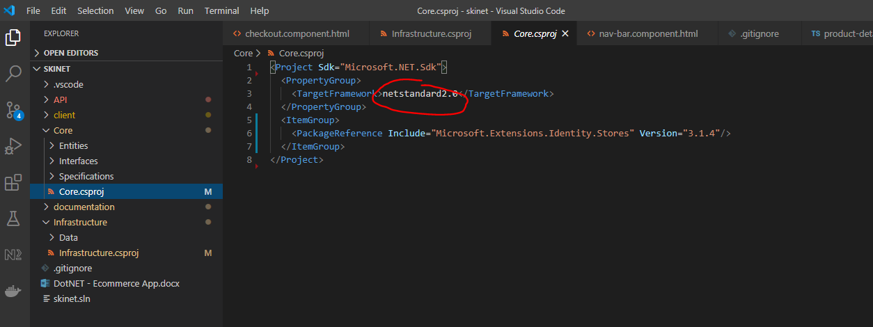

And:-

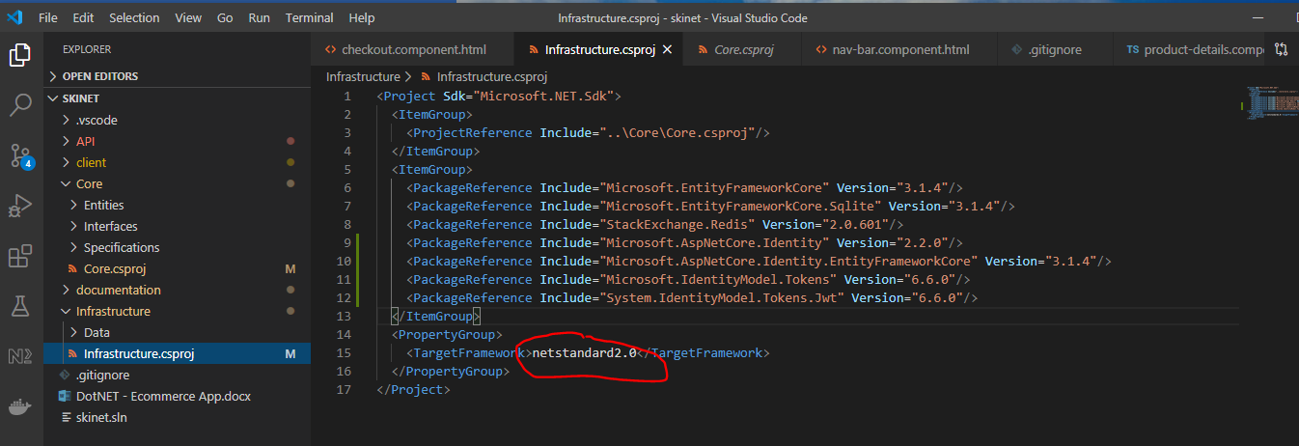

See API.csproj is using a different version:-

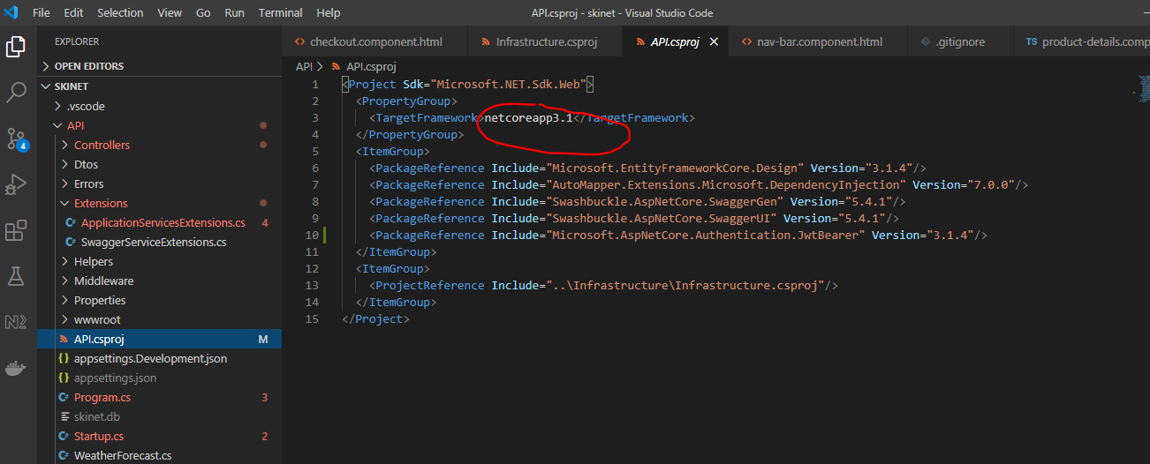

Change ‘netstand2.0’ in Core.csproj to ‘netstand2.1’:-

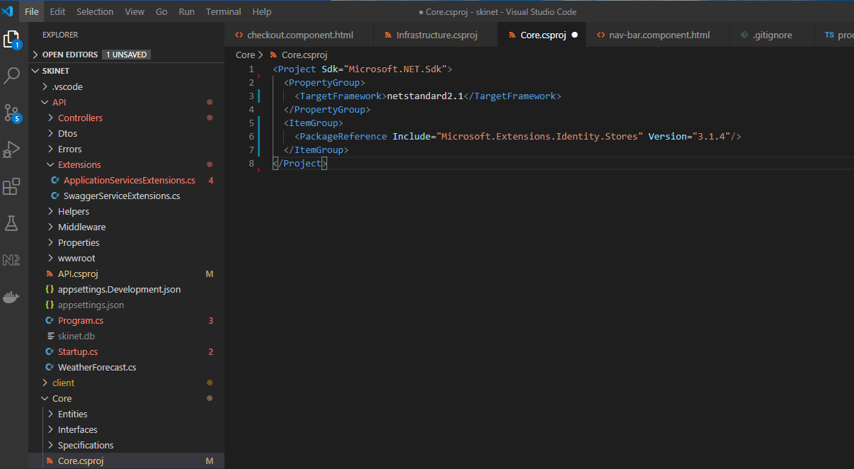

Change ‘netstand2.0’ in Infastructure.csproj to ‘netstand2.1’:-

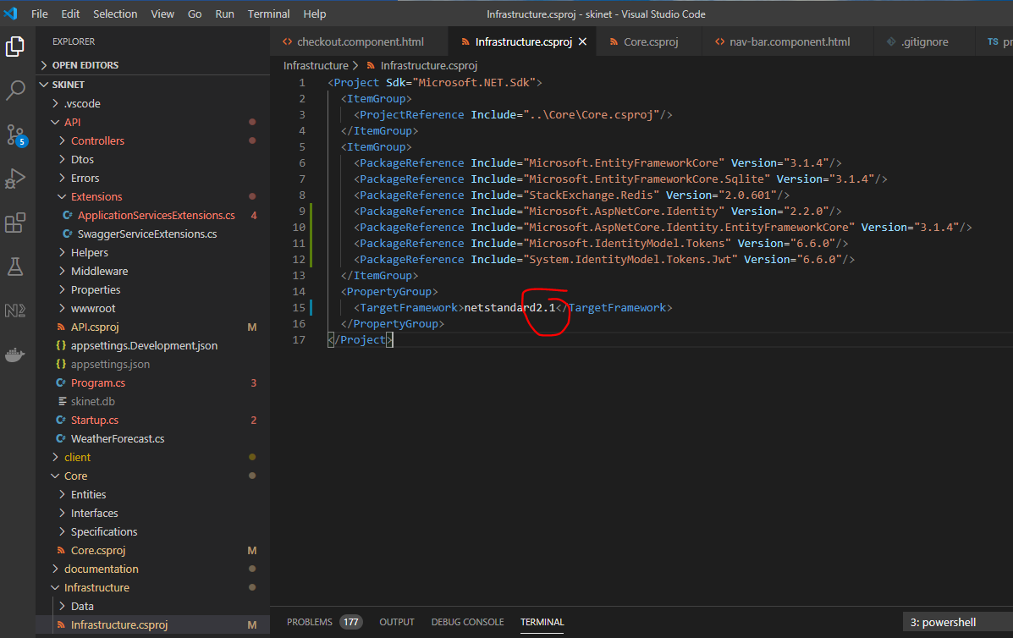

In the terminal type:-

***dotnet restore***

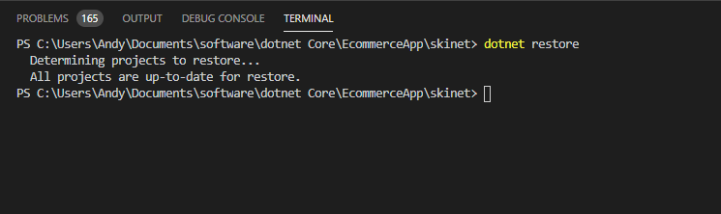

See error has now disappeared.

**Setup Identity Classes**

Create this class:-

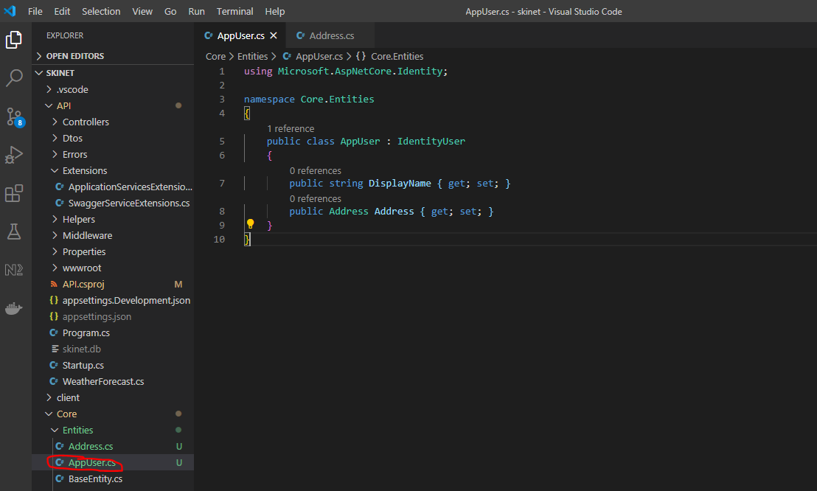

Also, create the Address entity class:-

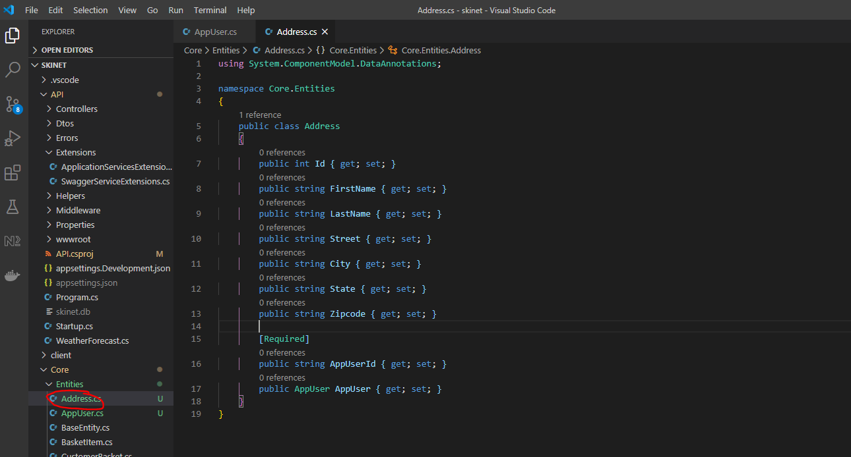

This provides a one-to-one relationship i.e. one user can have one address.

Create a new folder and more the above classes into it:-

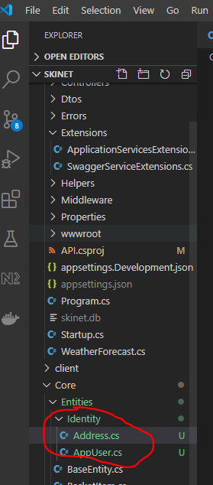

Add this to each class;-

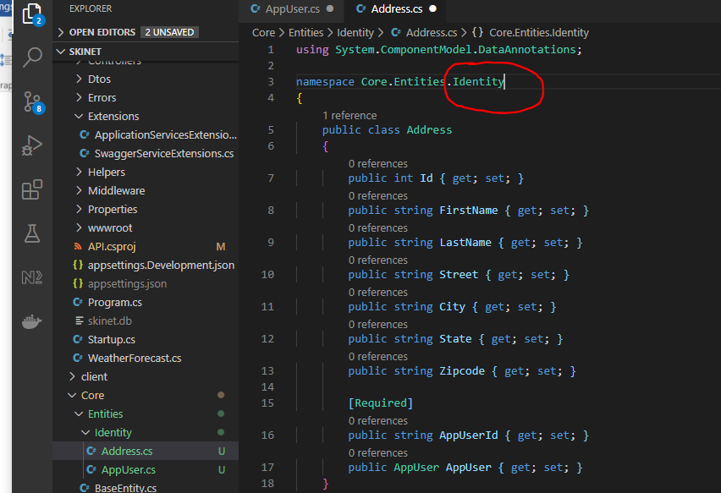

**Add IdentityDbContext**

Create a new folder:-

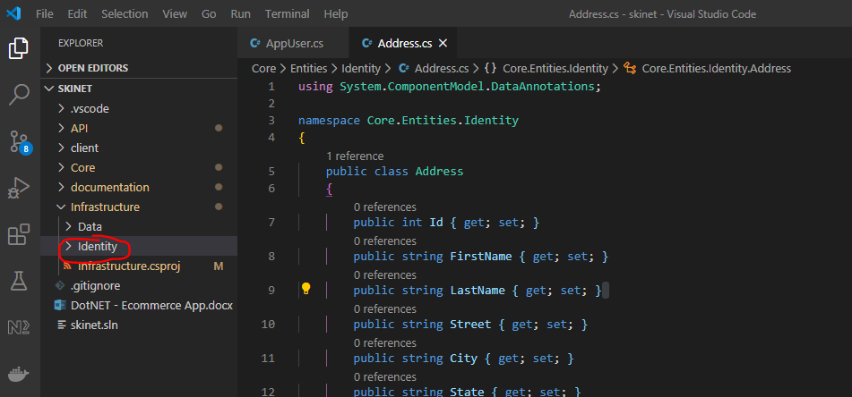

Create class in here:-

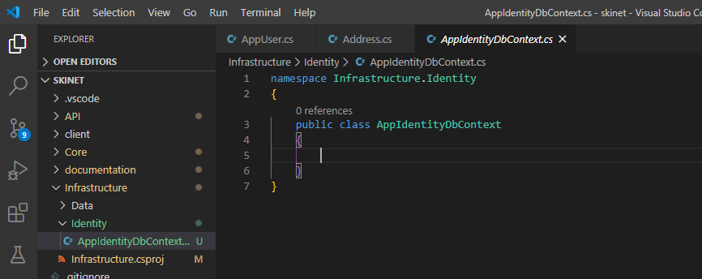

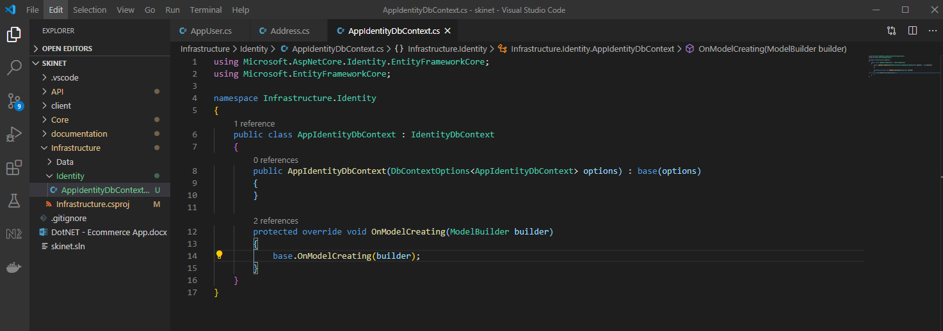

Add this to the startup.cs file

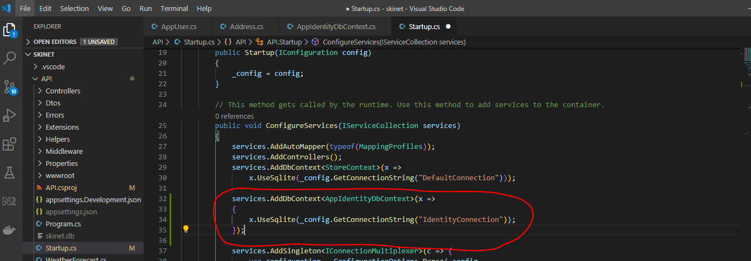

Add Identity Connection string to the ‘appsettings.Development.json’ file:-

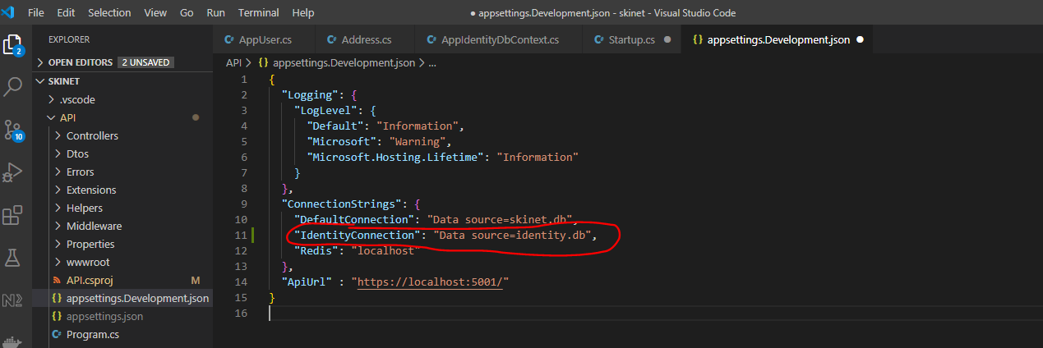

**Adding new migration**

Because we are creating an entirely different DB for the Identity section do this in the terminal:-

***dotnet ef migrations add IdentityInitial -p Infrastructure -s API -o Identity/Migrations -c AppIdentityDbContext***

This creates a DB migration here:-

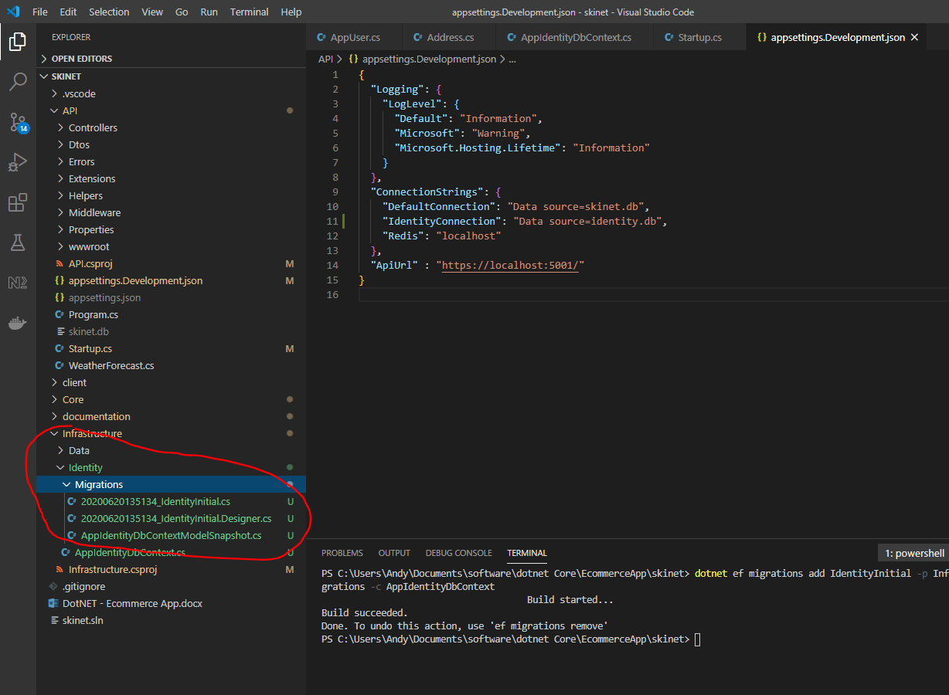

There is a problem here:-

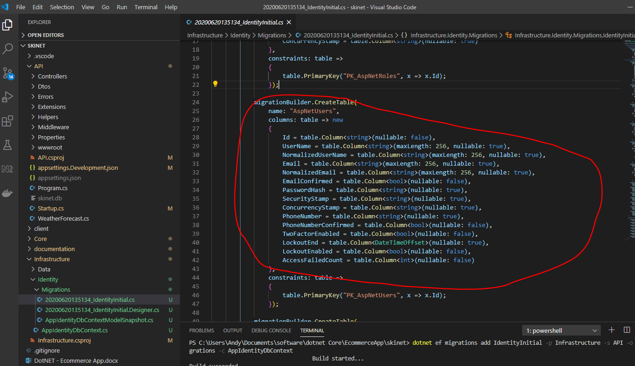

See it is missing the ‘Address’ and DisplayName. This is because we are missing this:-

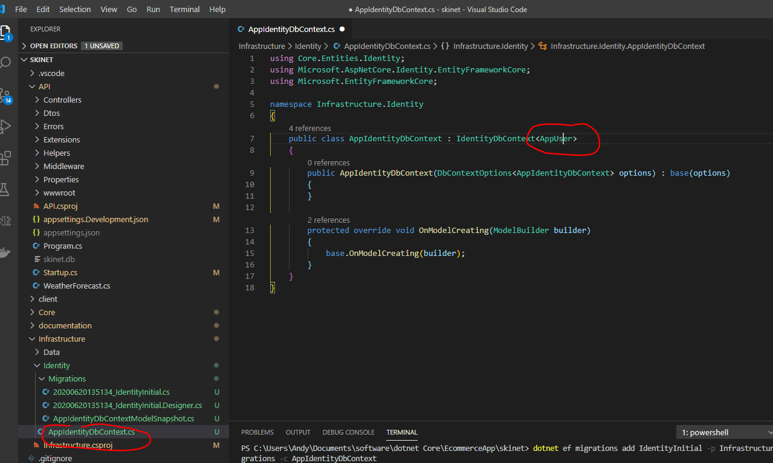

So we need to remove the last migration now:-

***dotnet ef migrations remove -p Infrastructure -s API -c AppIdentityDbContext***

Then re-create the migration:-

***dotnet ef migrations add IdentityInitial -p Infrastructure -s API -o Identity/Migrations -c AppIdentityDbContext***

Now, see there is a DisplayName:-

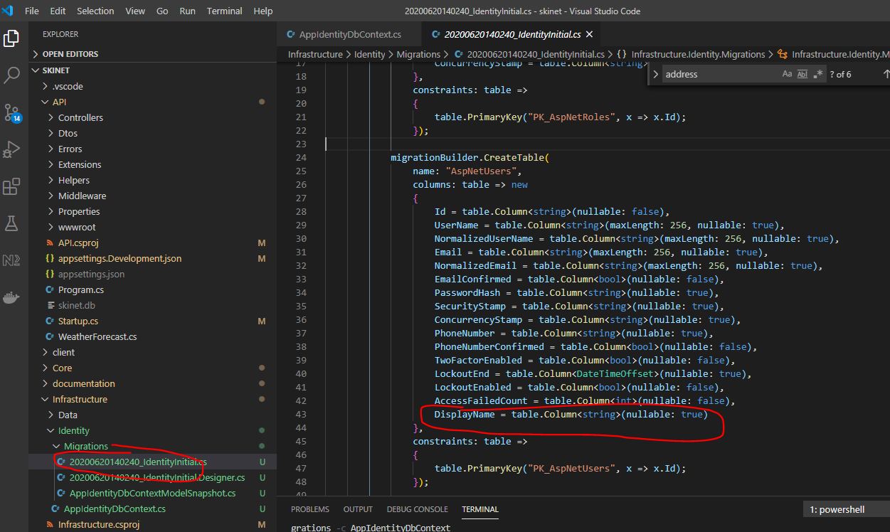

And an ‘Address’ table:-

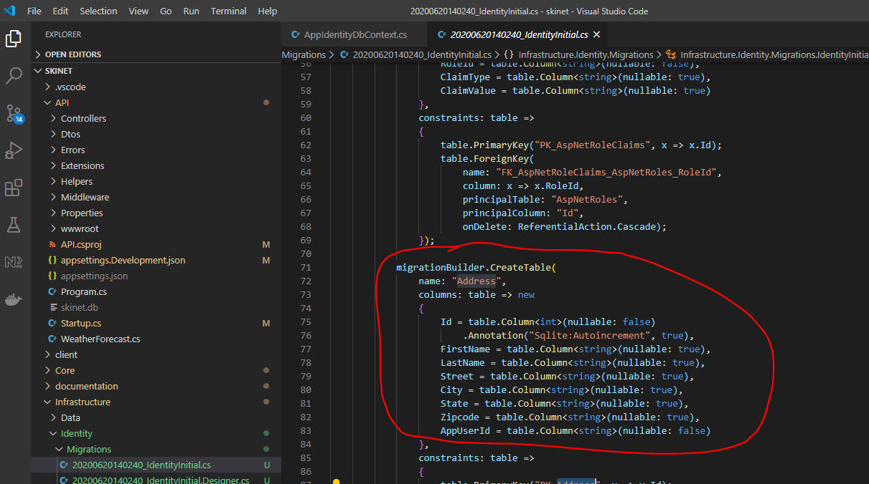

Create a seed class to seed users and address into DB:-

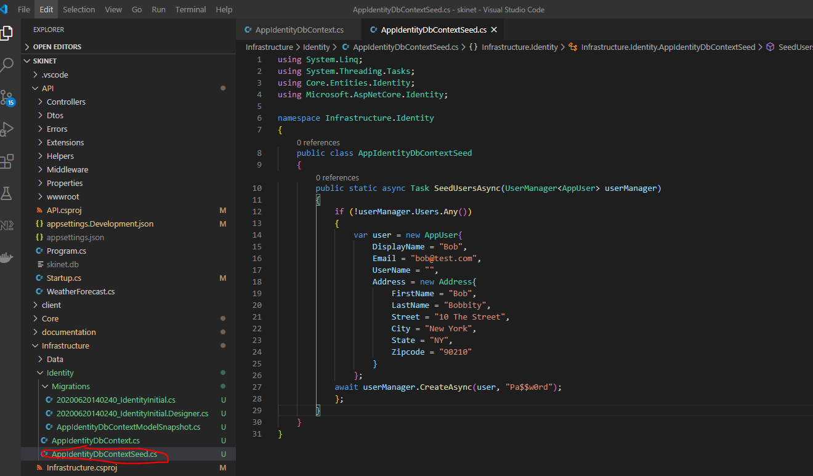

Add an entry in the ‘startup.cs’ class. To keep startup.cs file less busy create an extension method for the above:-

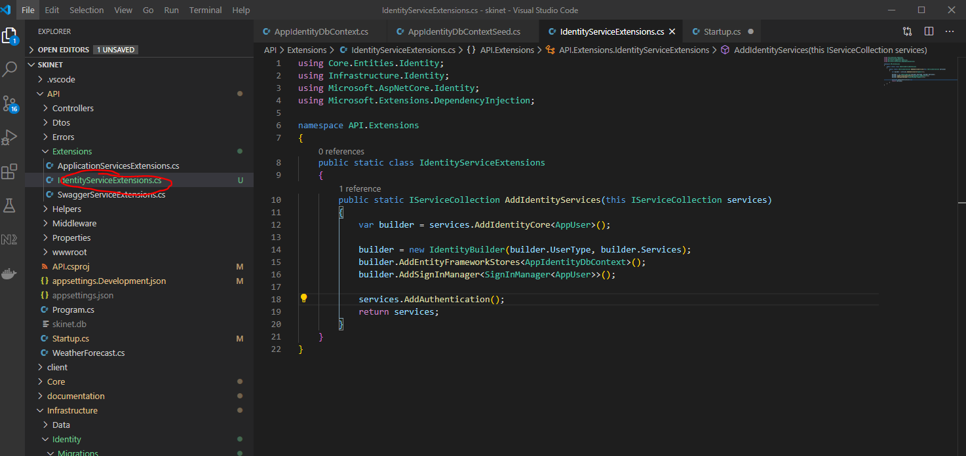

Now add this reference to ‘startup.cs’ class:-

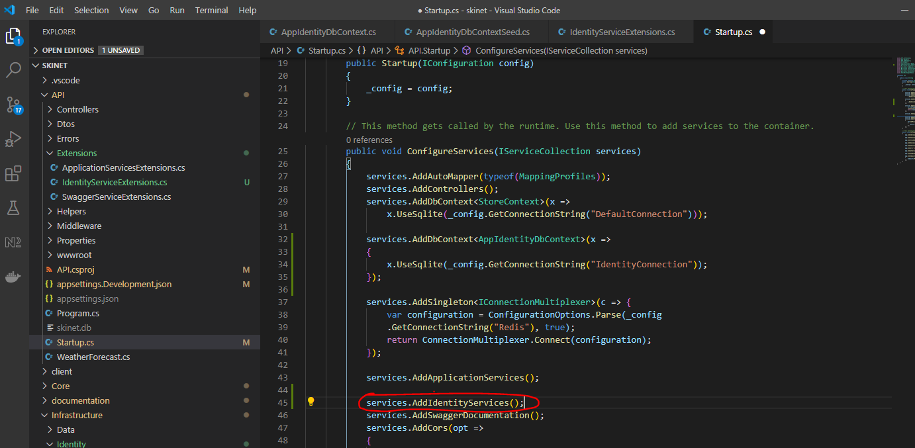

**Add Identity to program class**

Add this to the ‘program.cs’ class:-

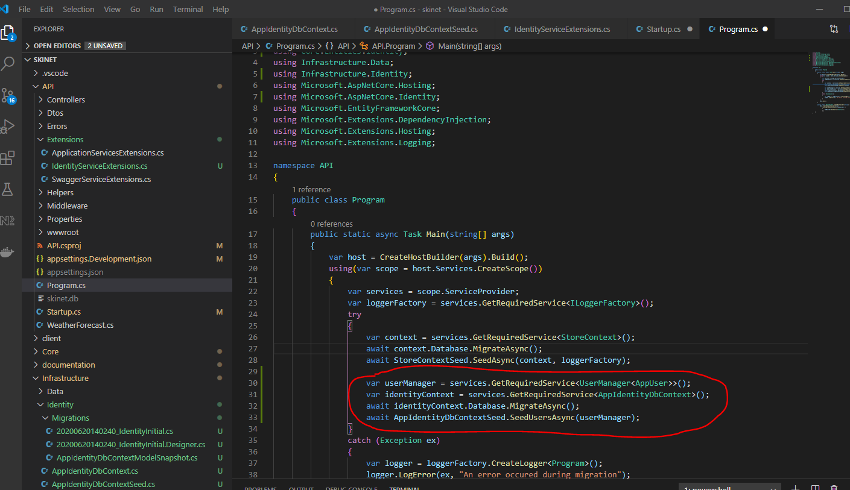

Now start API:-

***dotnet watch run***

Now check that database has been created:-

[ctrl] + [shift] + p

Sqlite: Open Database

identity.db

See database and tables below:-

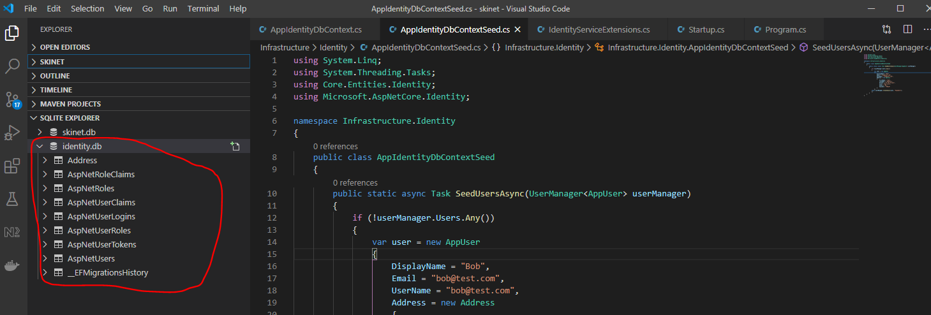

See created user – Bob:-

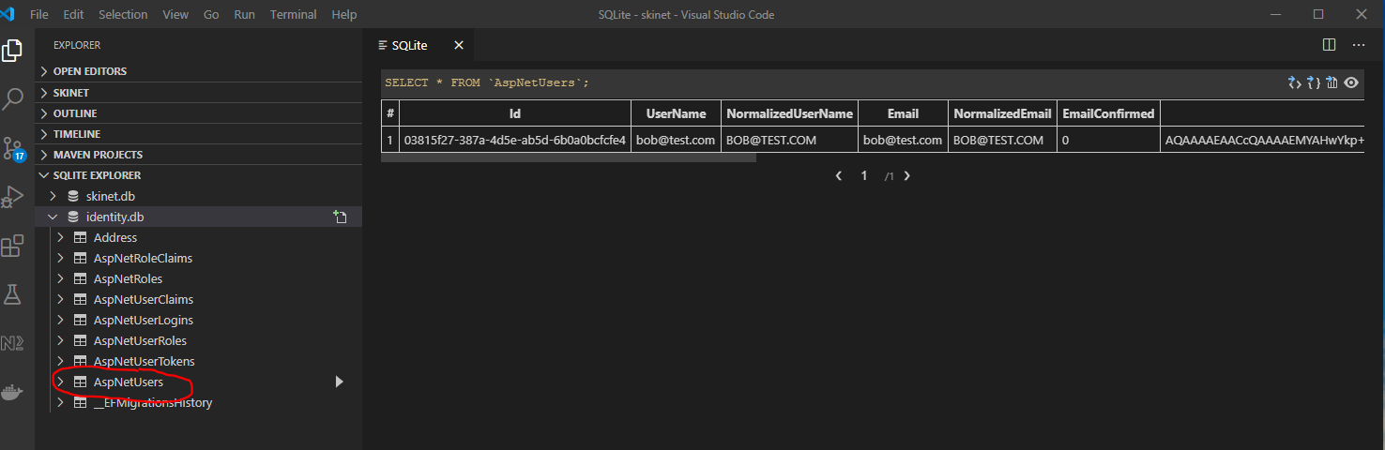

**Create Account Controller**

Create a new Controller class here:-

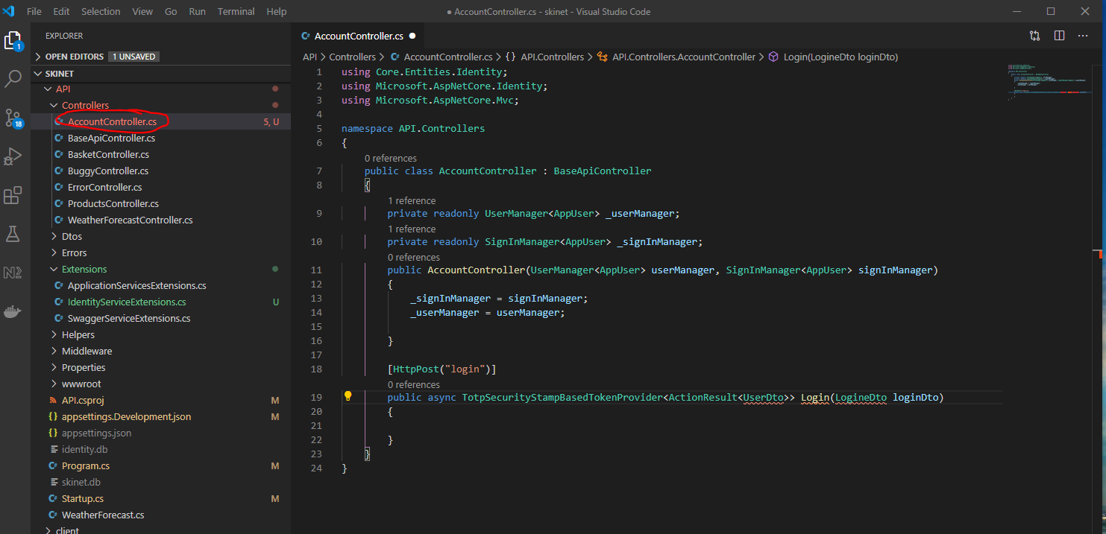

Create DTO’s for:-

**UserDto**

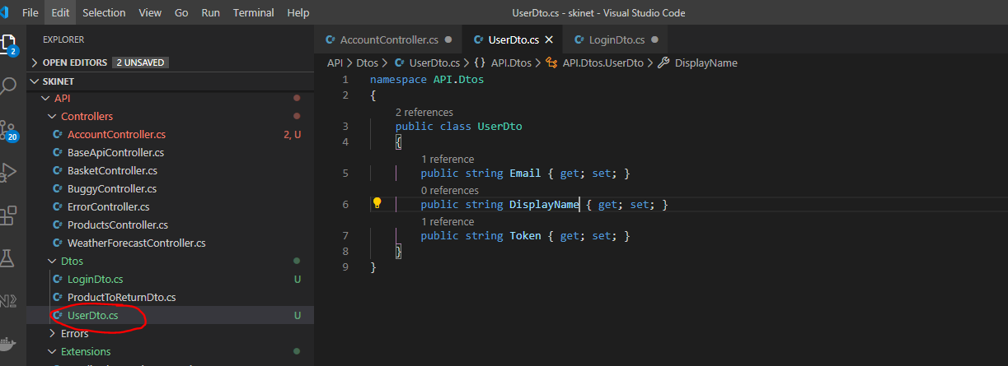

**LoginDto**

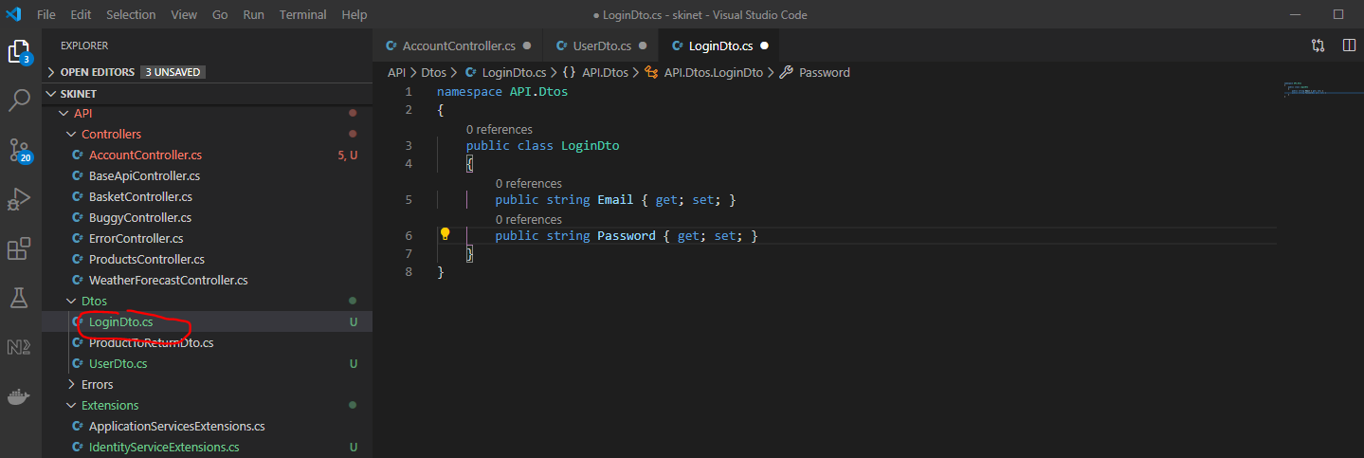

Update AccountController:-

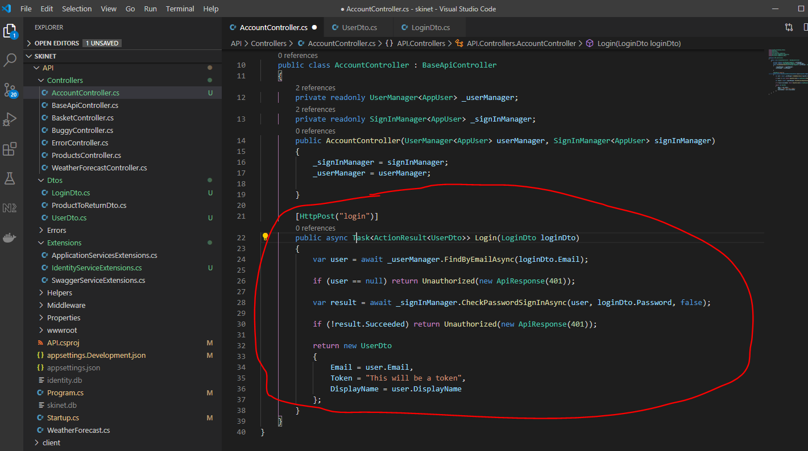

Test in Postman:-

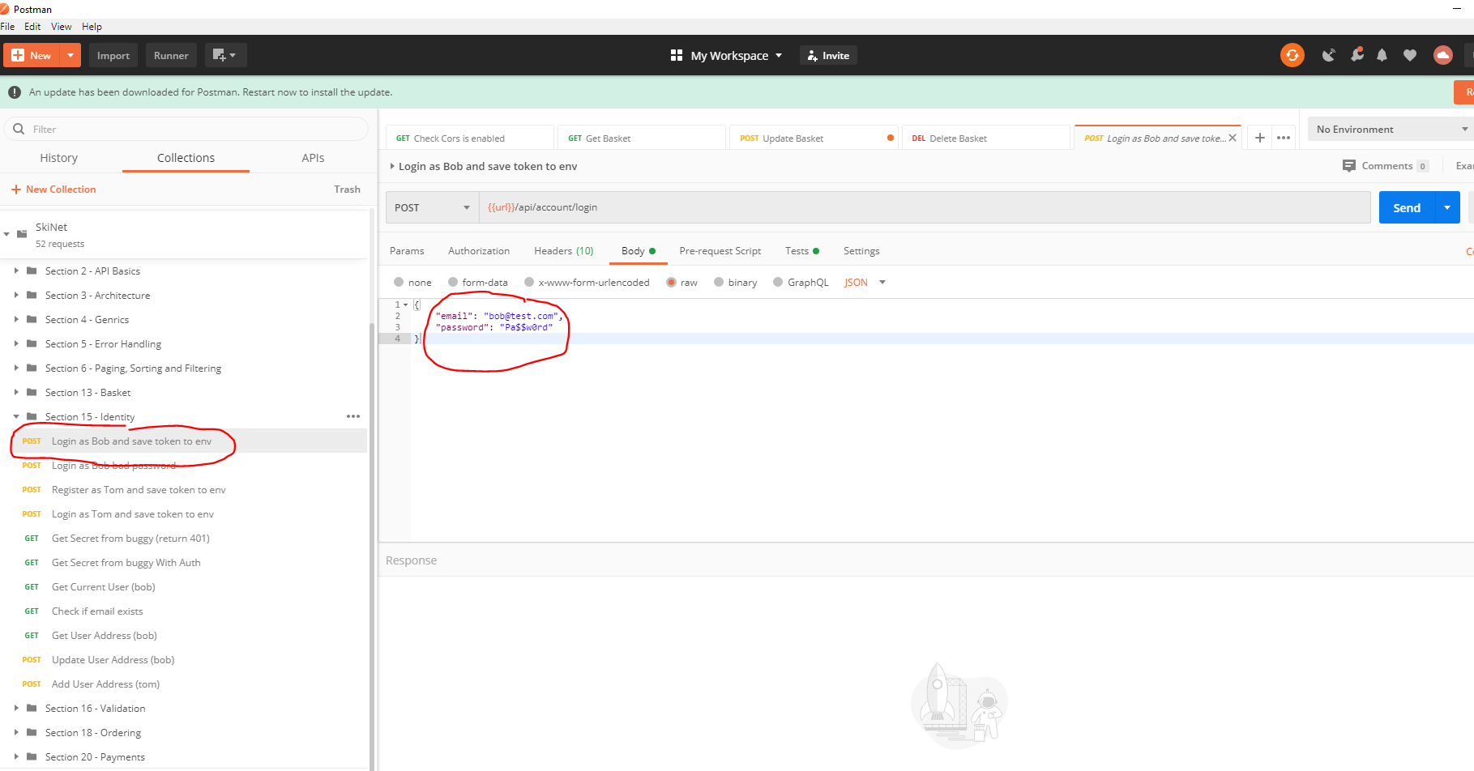

See response:-

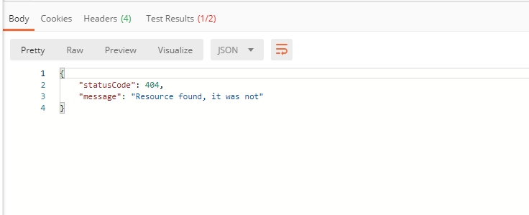

Try restarting the API, then try the Postman request again.

Now see response:-

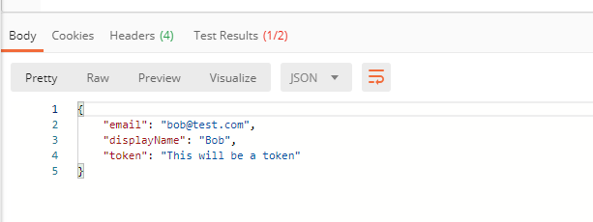

**Create User Registry**

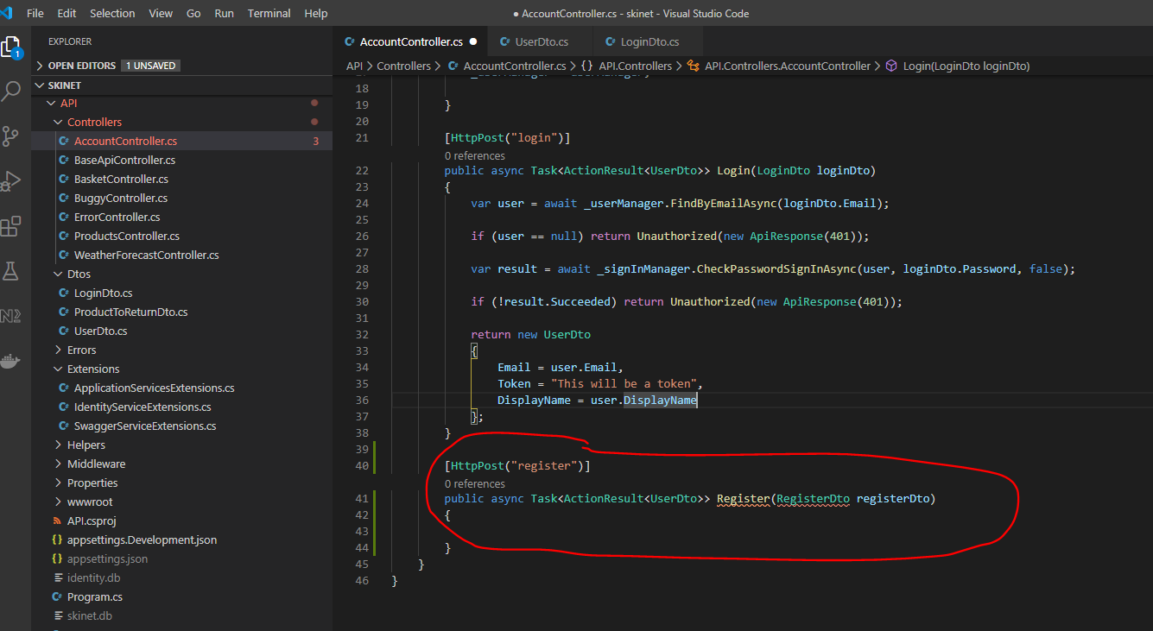

Create a new DTO – RegisterDto

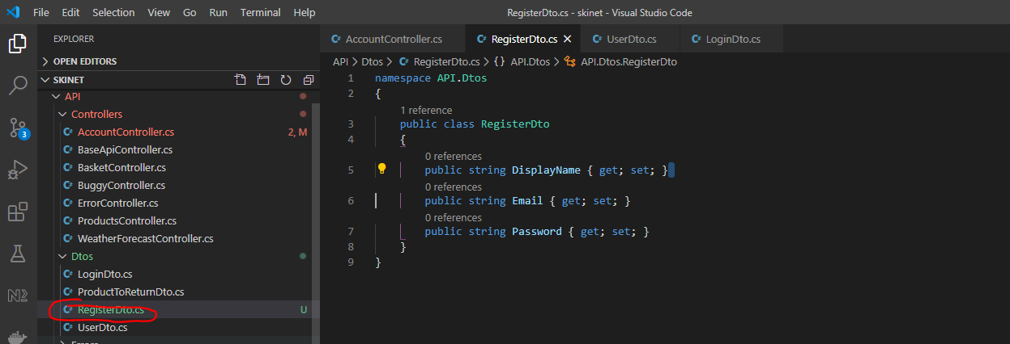

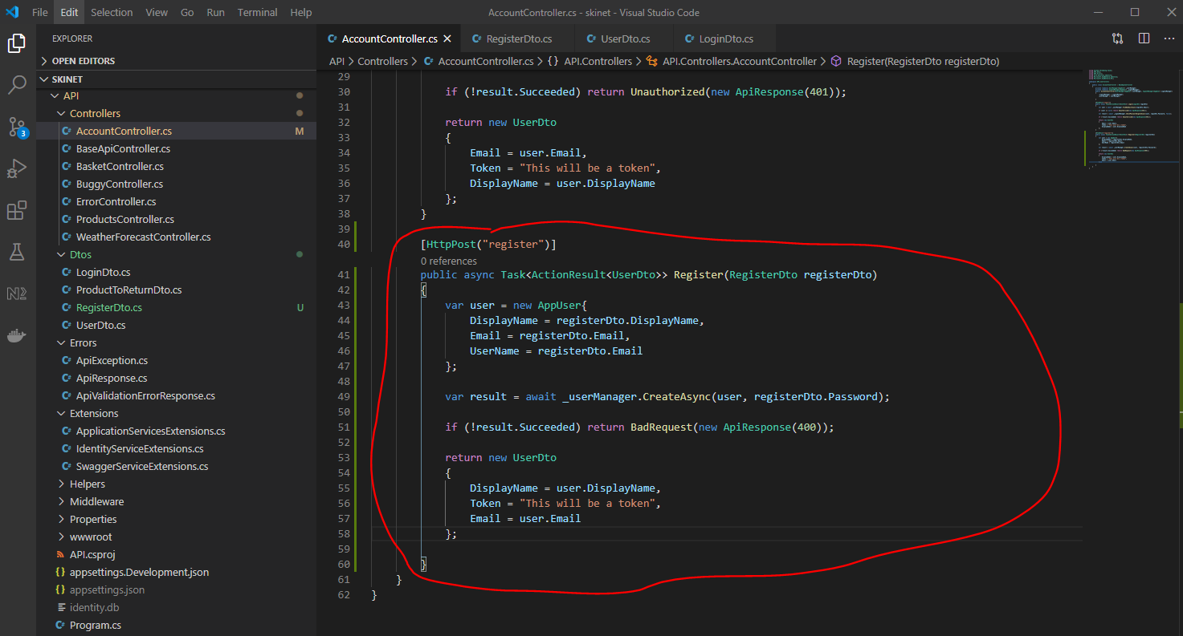

Test in Postman:-

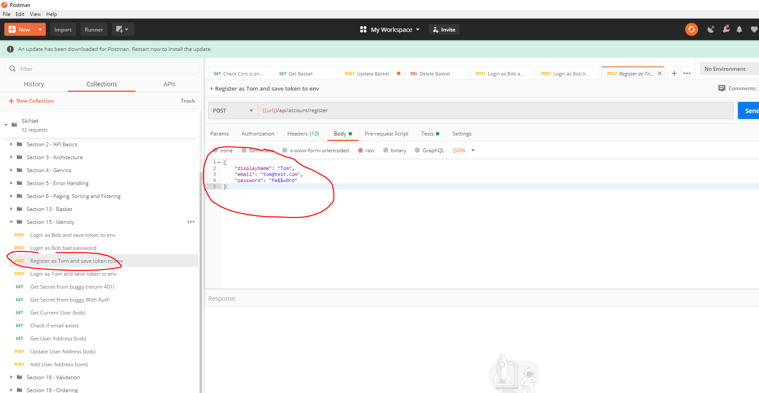

See success:-

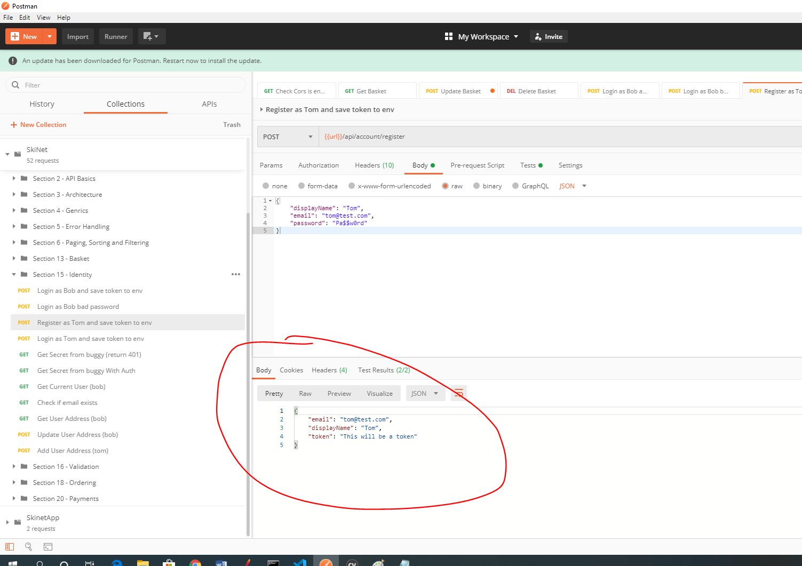

**Add a Token Generation Service**

Create a interface here:-

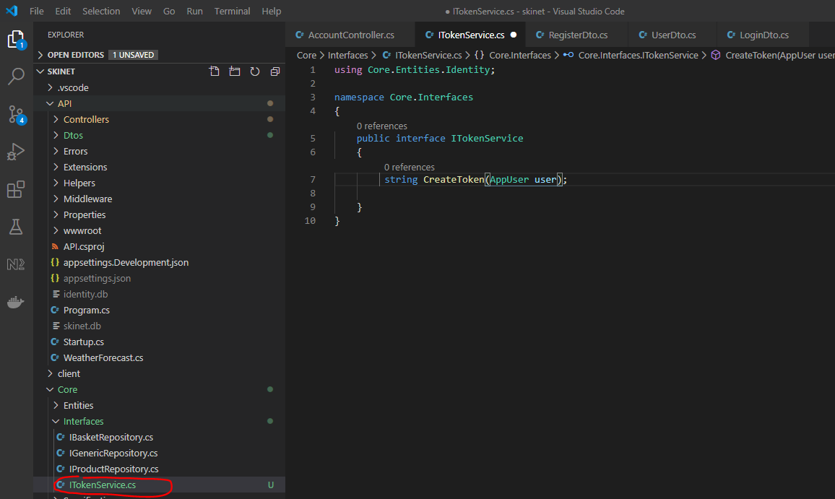

Create a folder under ‘Infrastructure’ for services:-

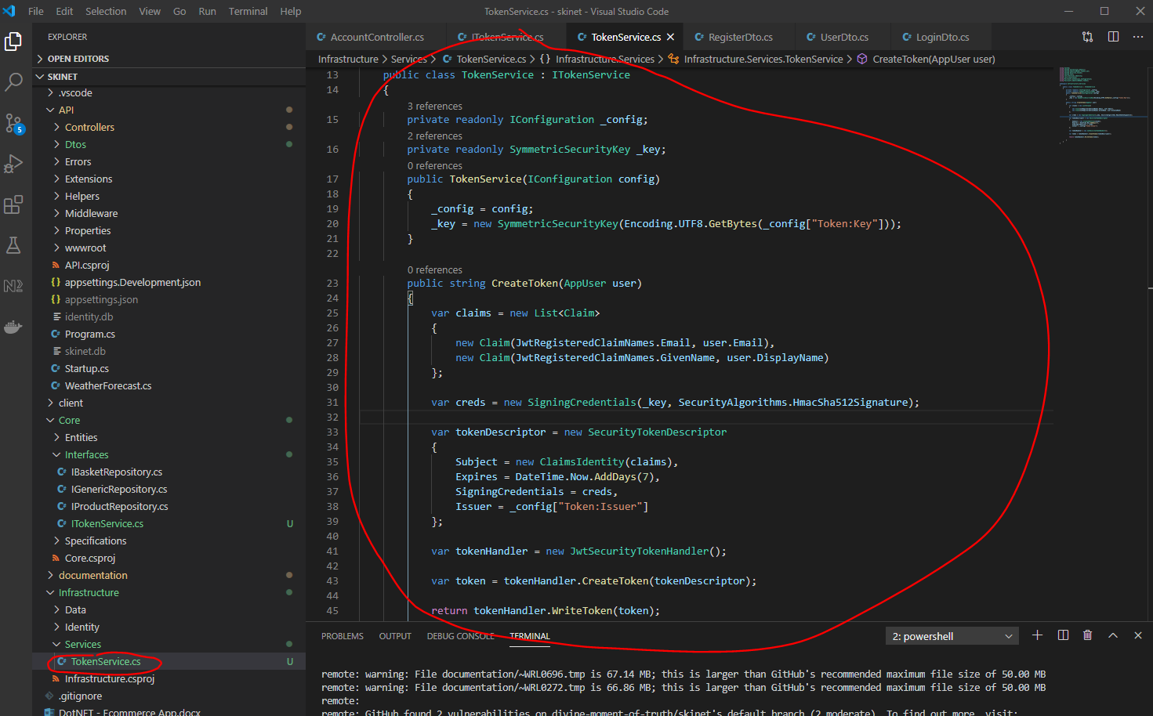

Update IdentityServiceExtensions:-

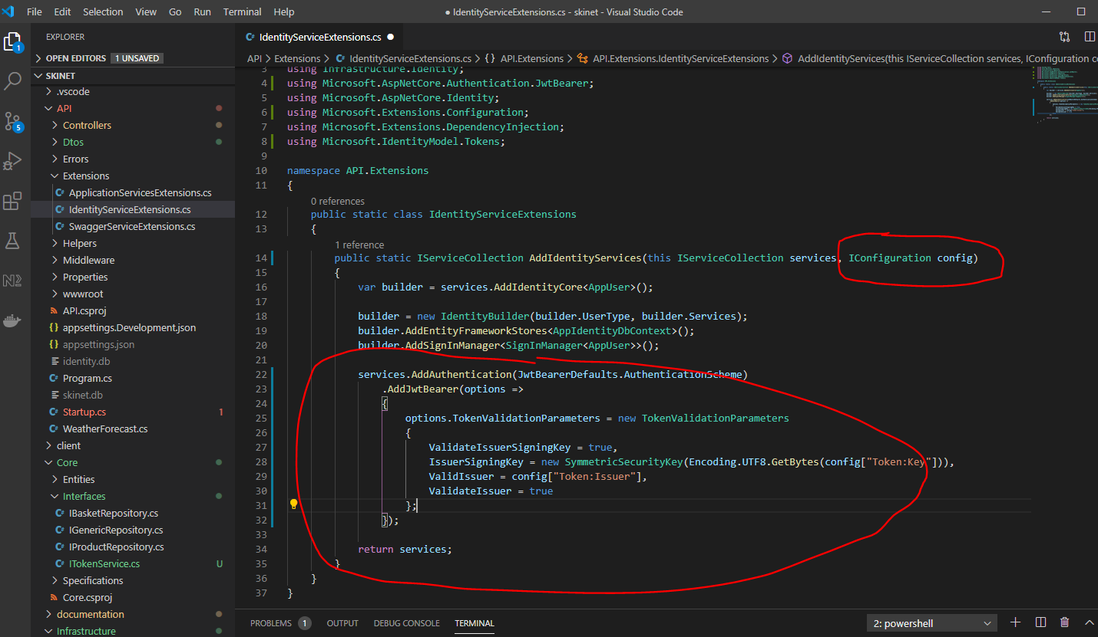

Now update the sartup.cs class:-

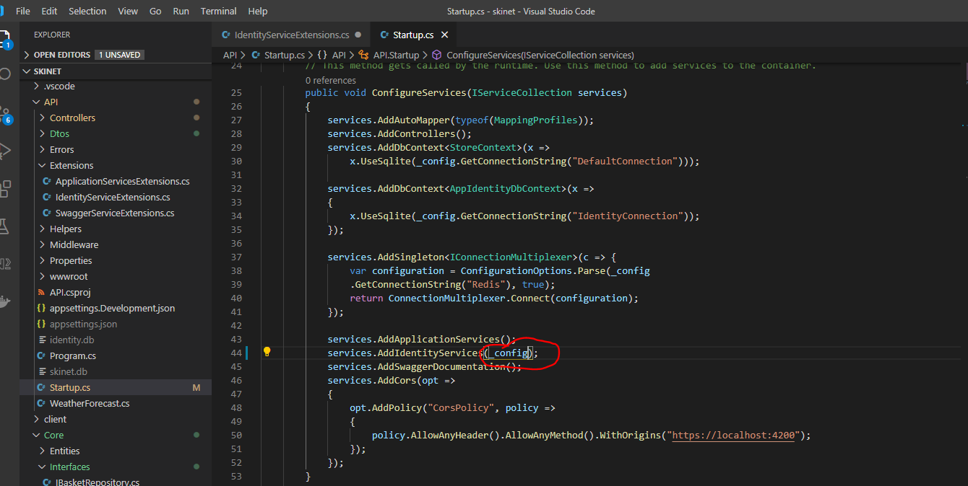

Add a key to the ‘appsettings.Development.json’ file:-

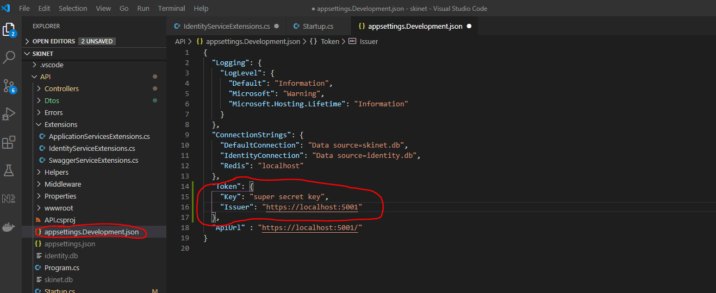

Add another entry into the ‘startup.cs’ class:-

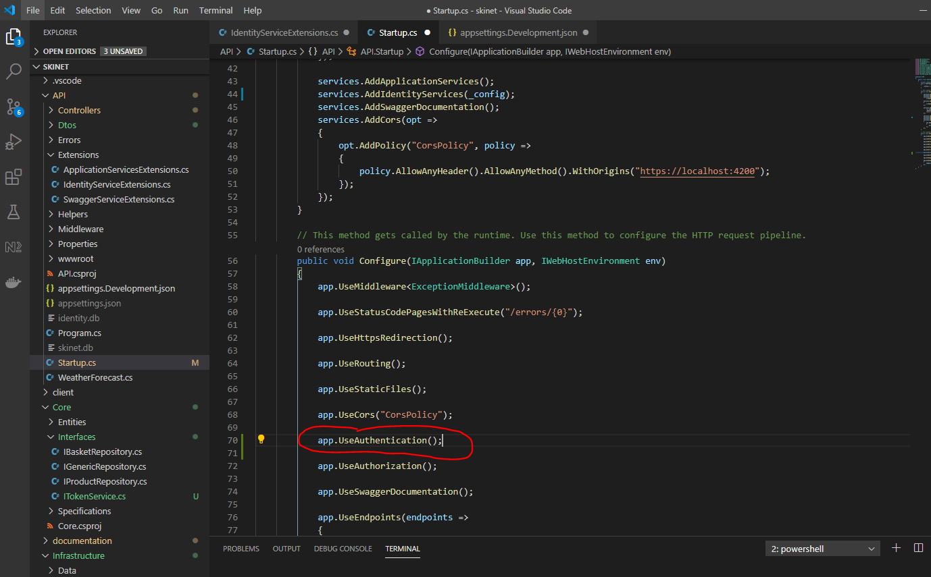

Now add an entry into the ApplicationServices.Extensions.cs class:-

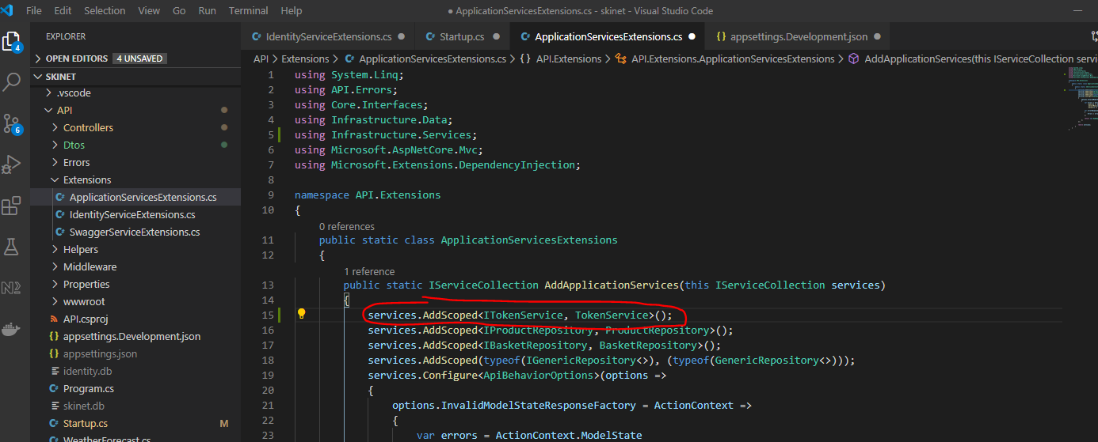

Update the AccountController:-

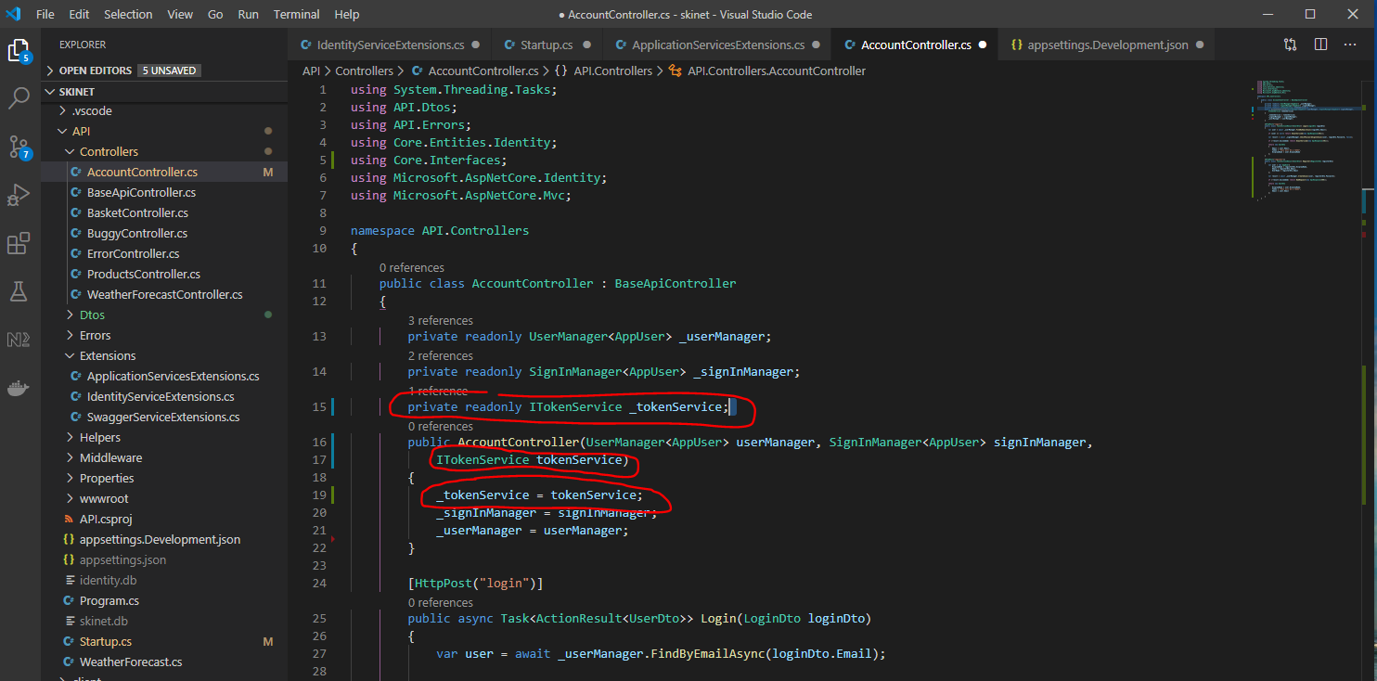

And:-

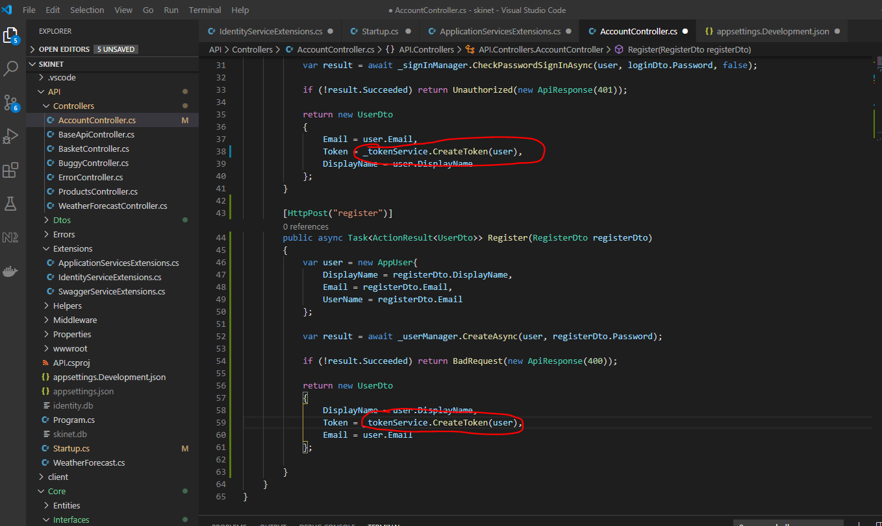

Now test in Postman, see that a token is now being returned:-

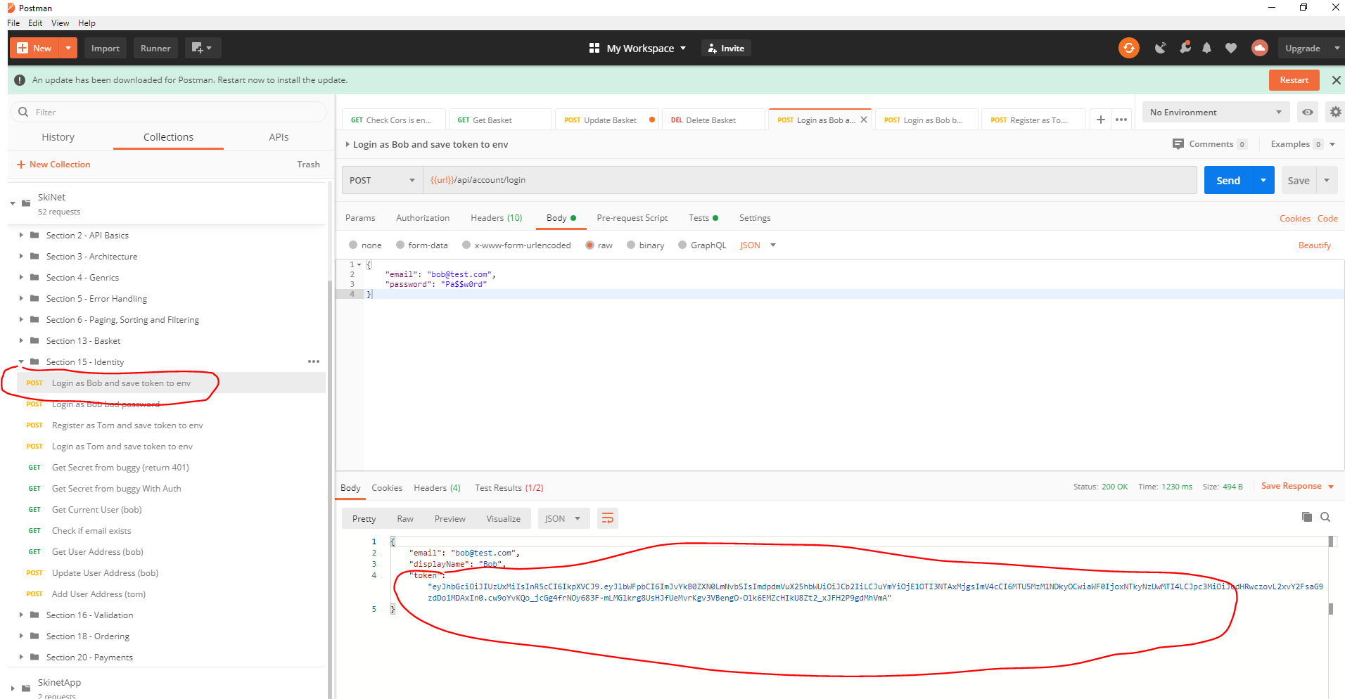

Copy the token and then head over to this website:-

<https://jwt.io/>

Paste token here:-

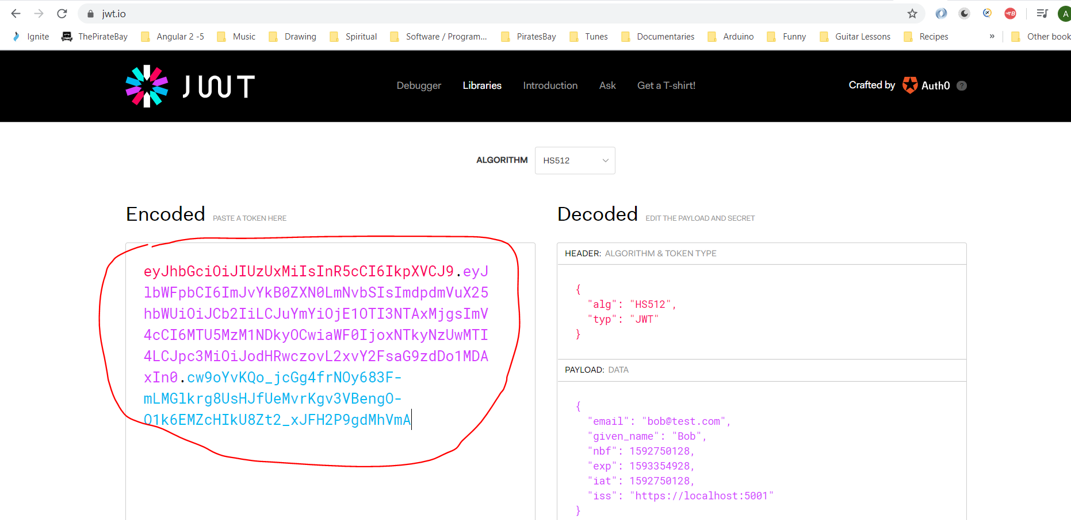

Add an entry into the ‘BuggyController’:-

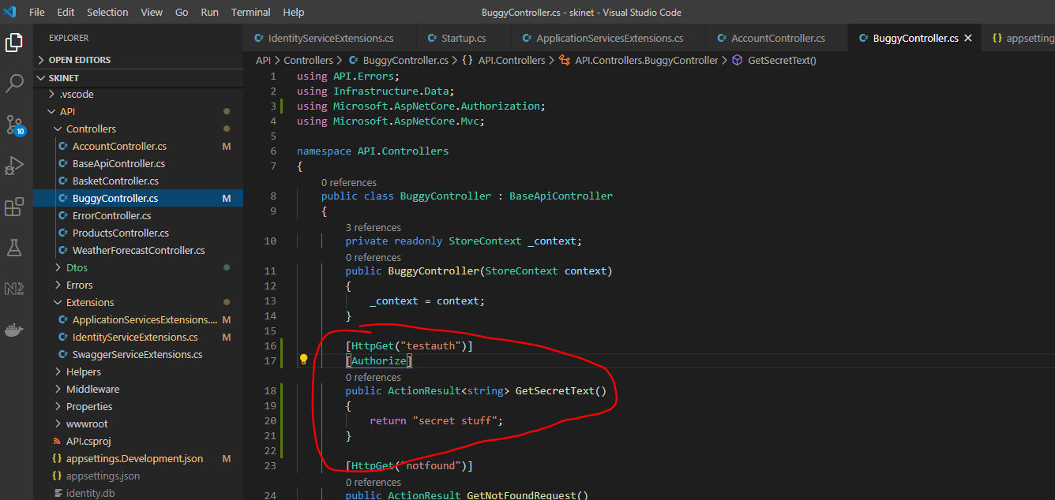

Test using Postman:-

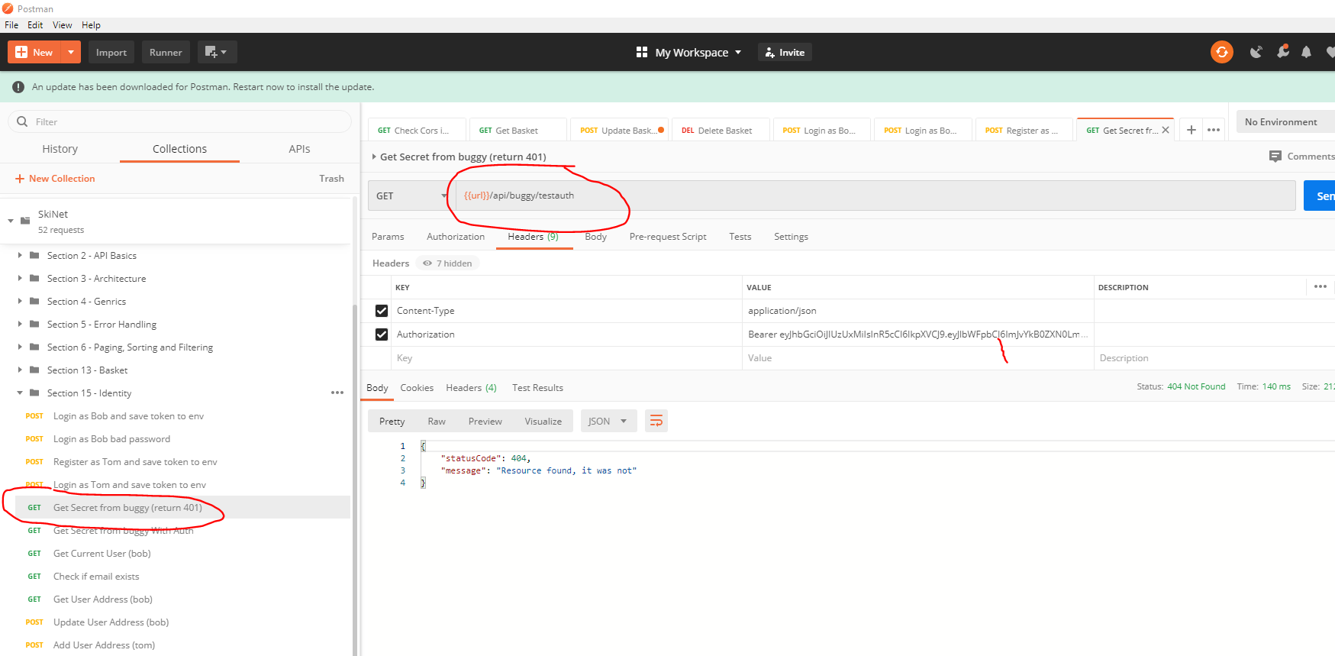

See error above.

Investigate the problem reveals:-

Change the logging levels in the ‘appsettings.Development.json’ file, change this from ‘warning’ to ‘information’:-

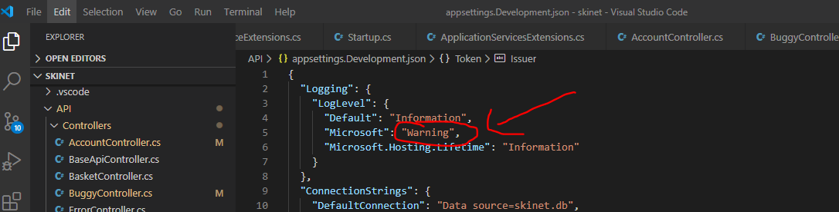

To:-

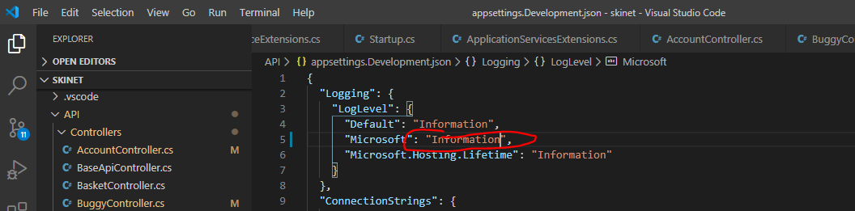

Click send in postman again and check the terminal window:-

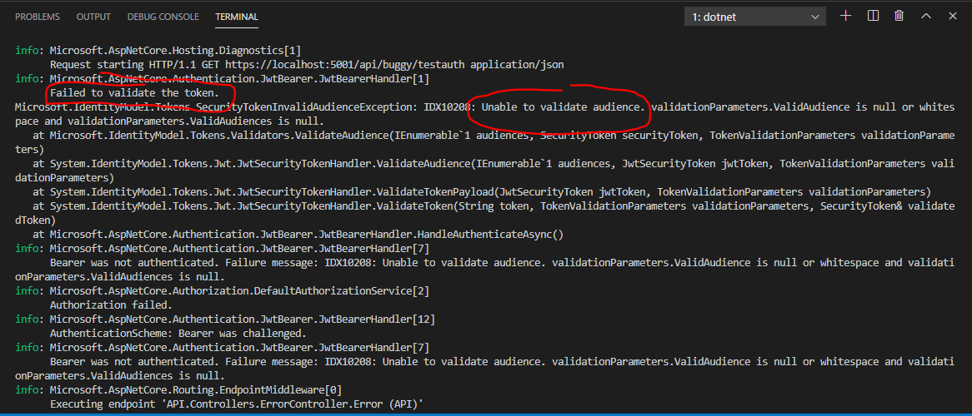

The problem is the ‘audience’ within the token. The audience is who you issue the token to. The audience would be the client.

Need to add a line to the IdentityServiceExtensions.cs file below here:-

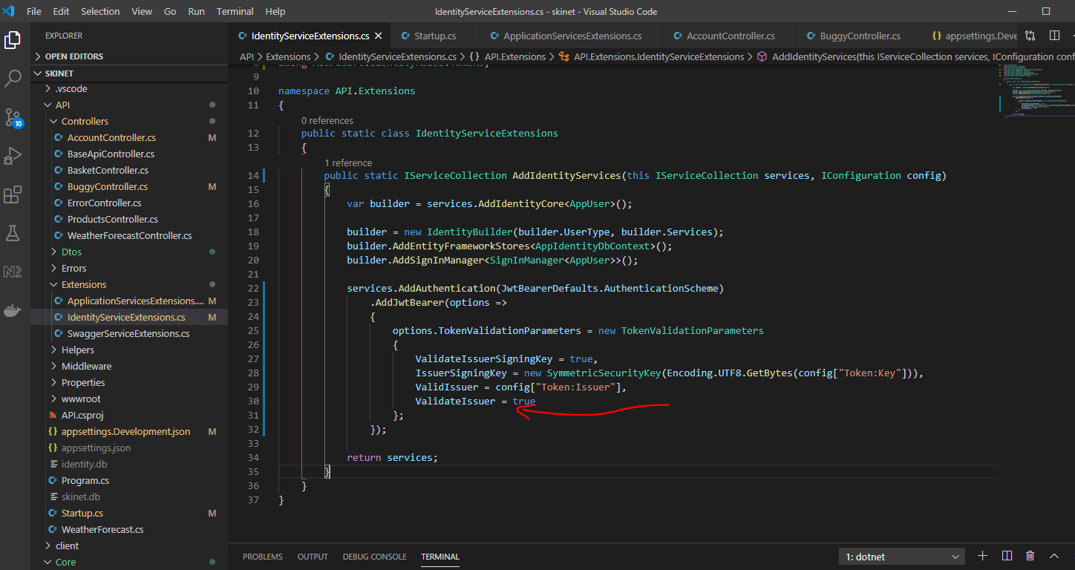

Add this:-

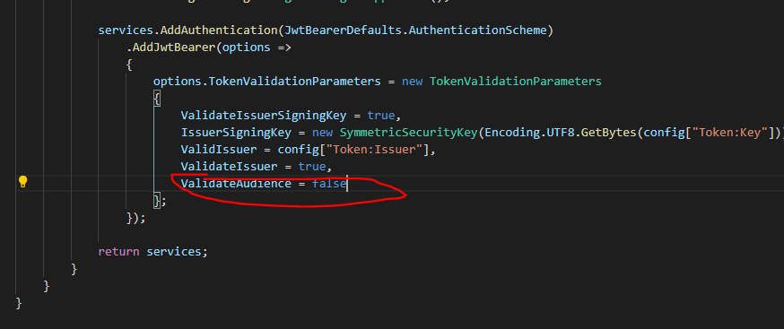

Test in Postman again:-

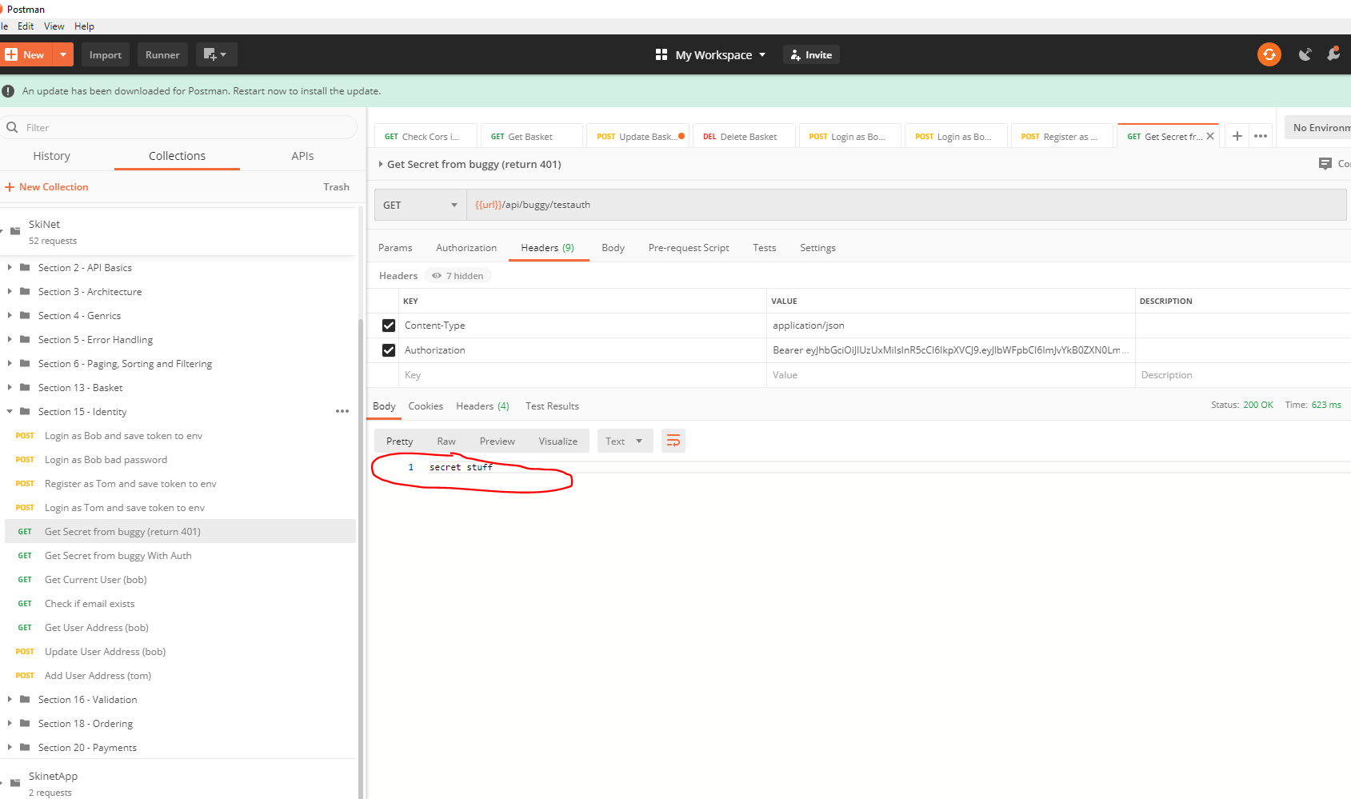

See the secret message has been returned this time.

The global variable containing the token can be found by clicking thus:-

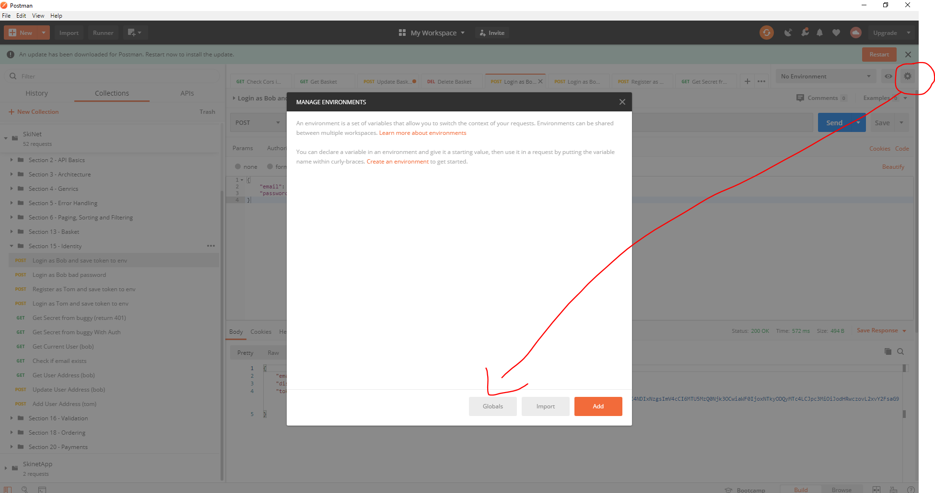

Add the following methods to the Account Controller:-

This method is used to get the currently logged in user. It will return a DtoUser:-

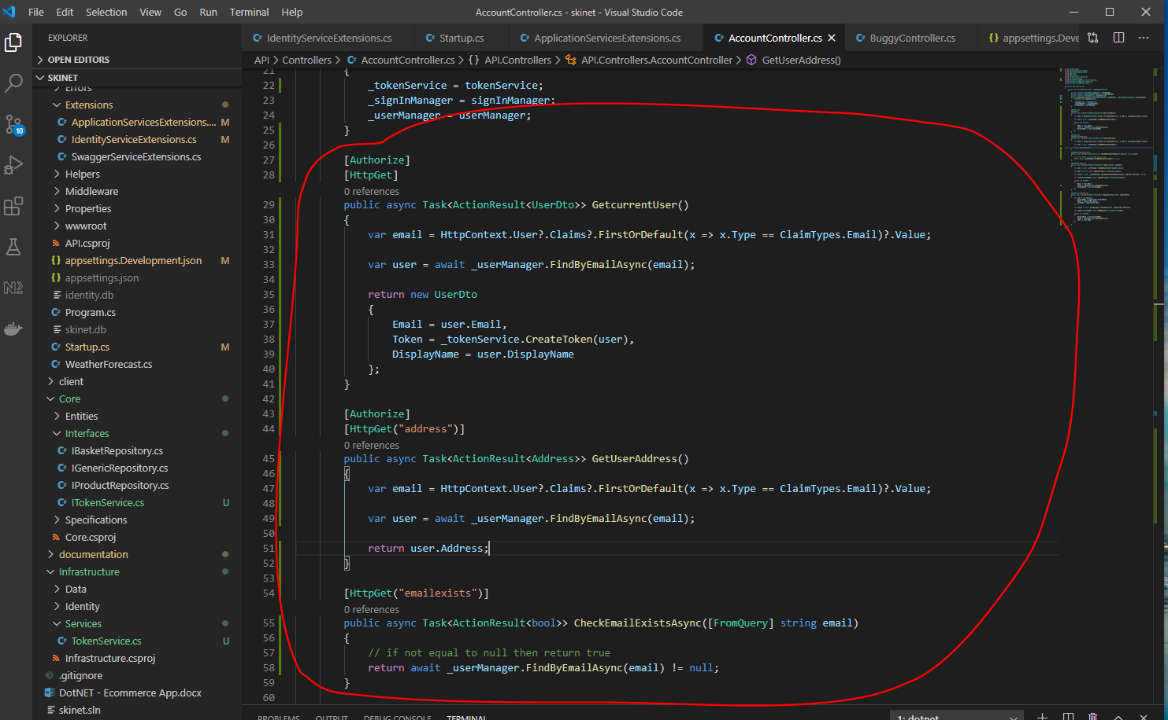

Test in Postman:-

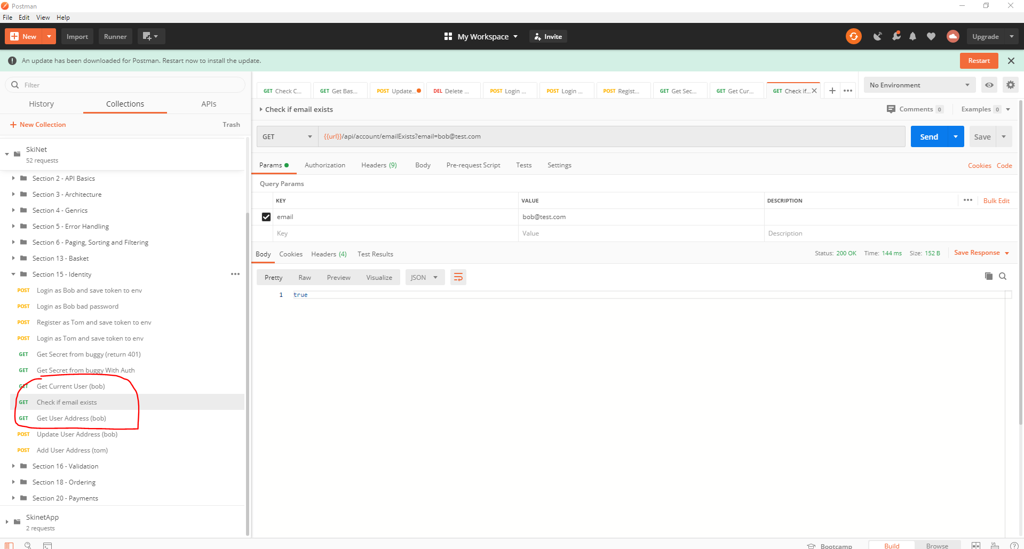

When running the ‘Get user address’ postman we get a ‘204 – no content’ message:-

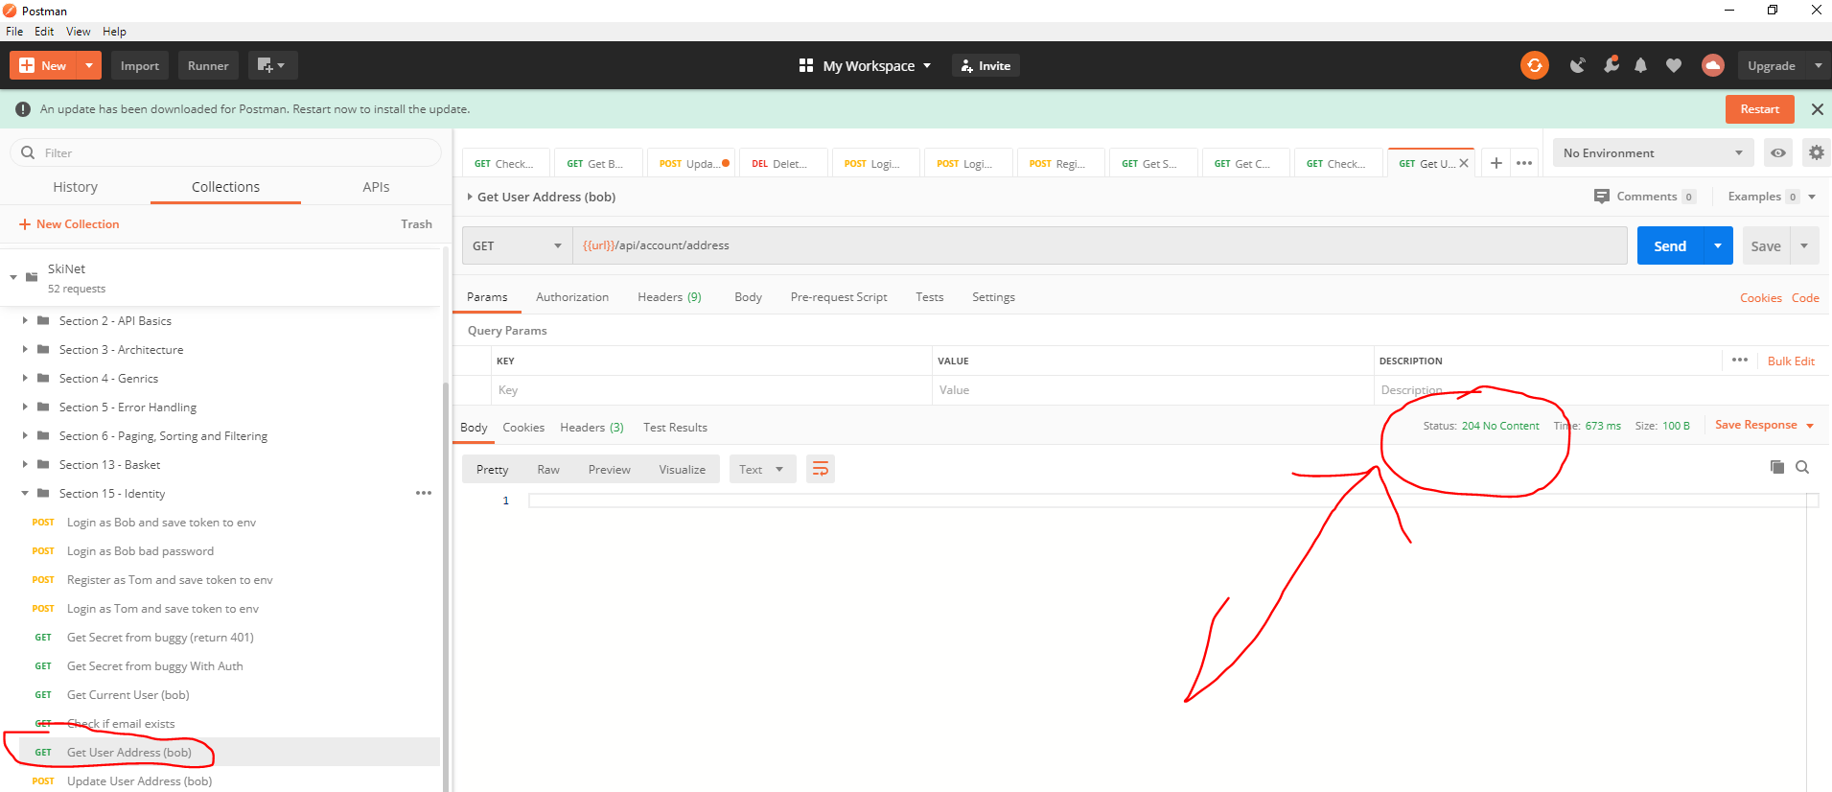

Create a new extension class to resolve the problem:-

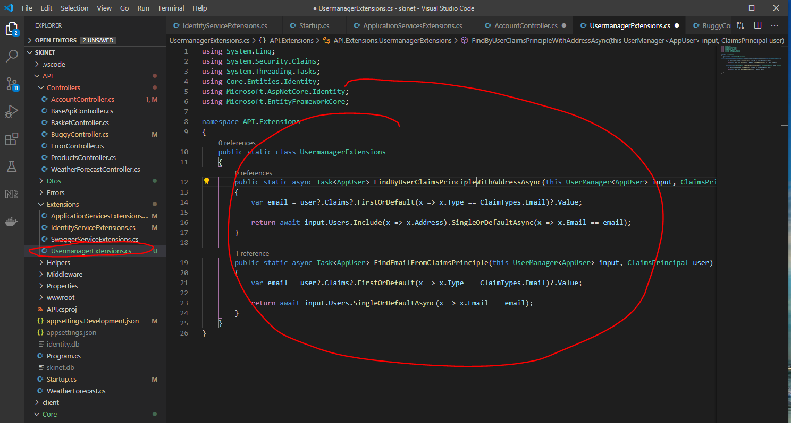

Now change the AccountController as follows:-

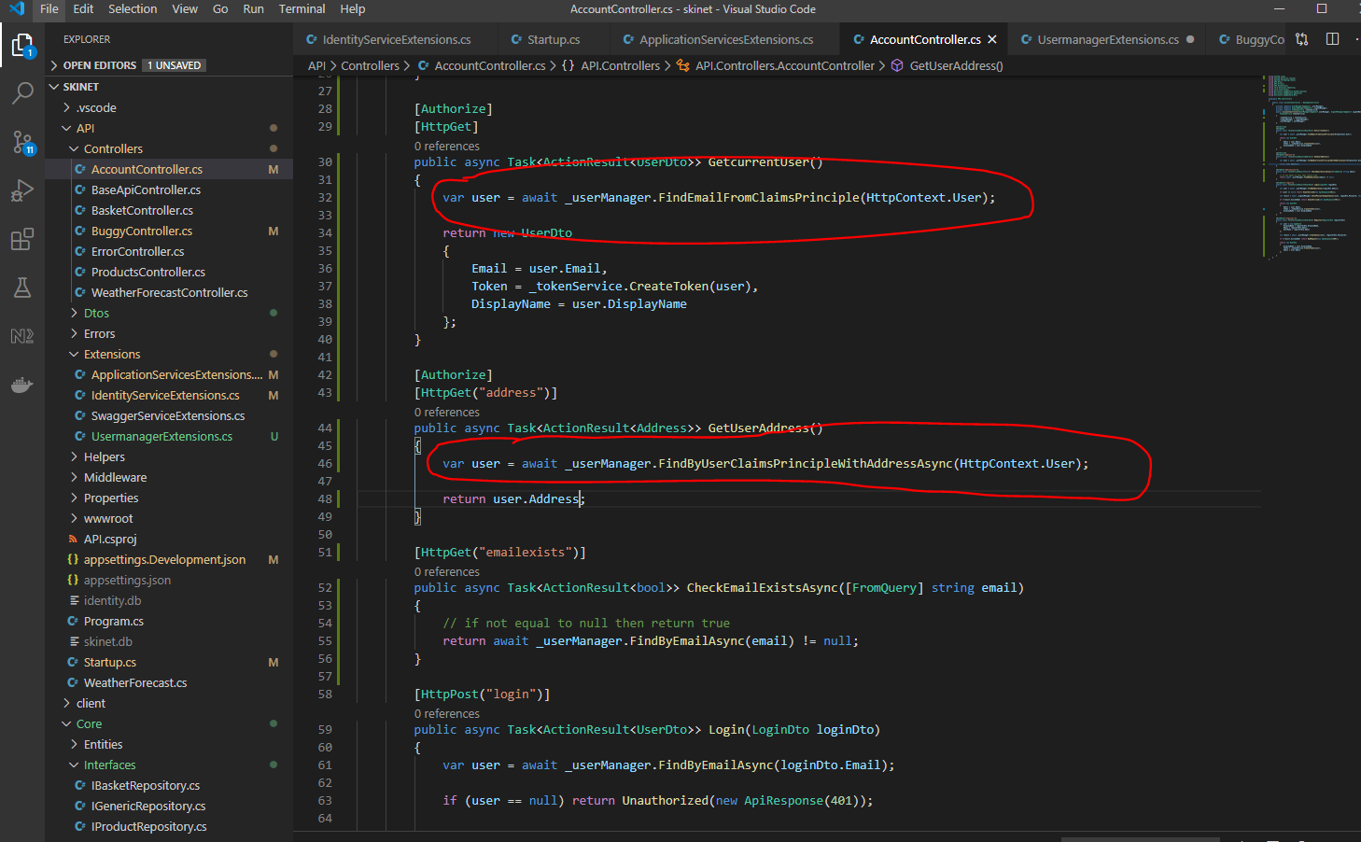

Now test in Postman again:-

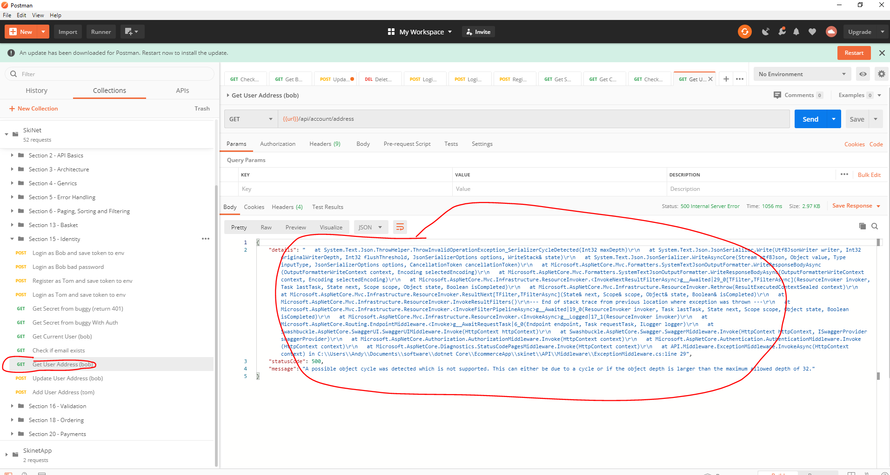

See error.

"message": "A possible object cycle was detected which is not supported. This can either be due to a cycle or if the object depth is larger than the maximum allowed depth of 32."

This is because the ‘Address’ entity class contains the ‘AppUser’:-

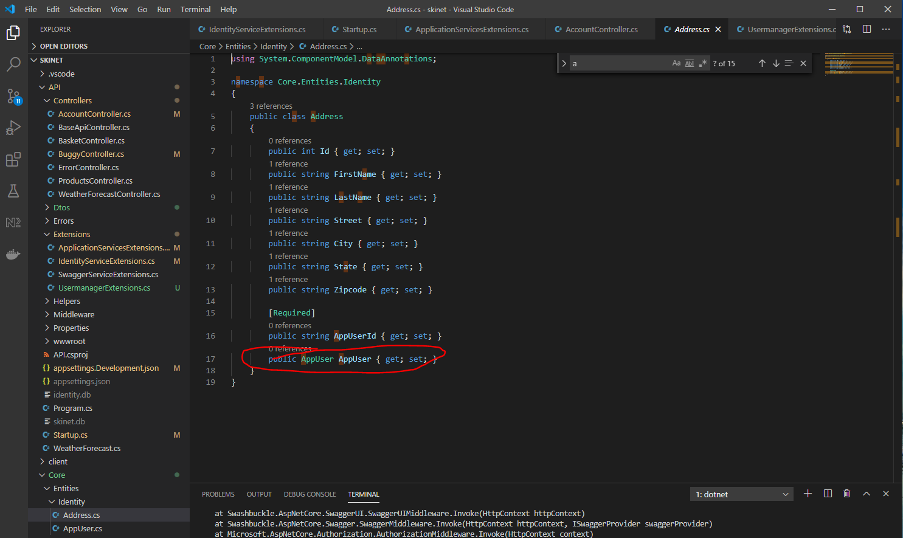

We need to create a new DTO class. First copy the following properties from the ‘Address’ entity class:-

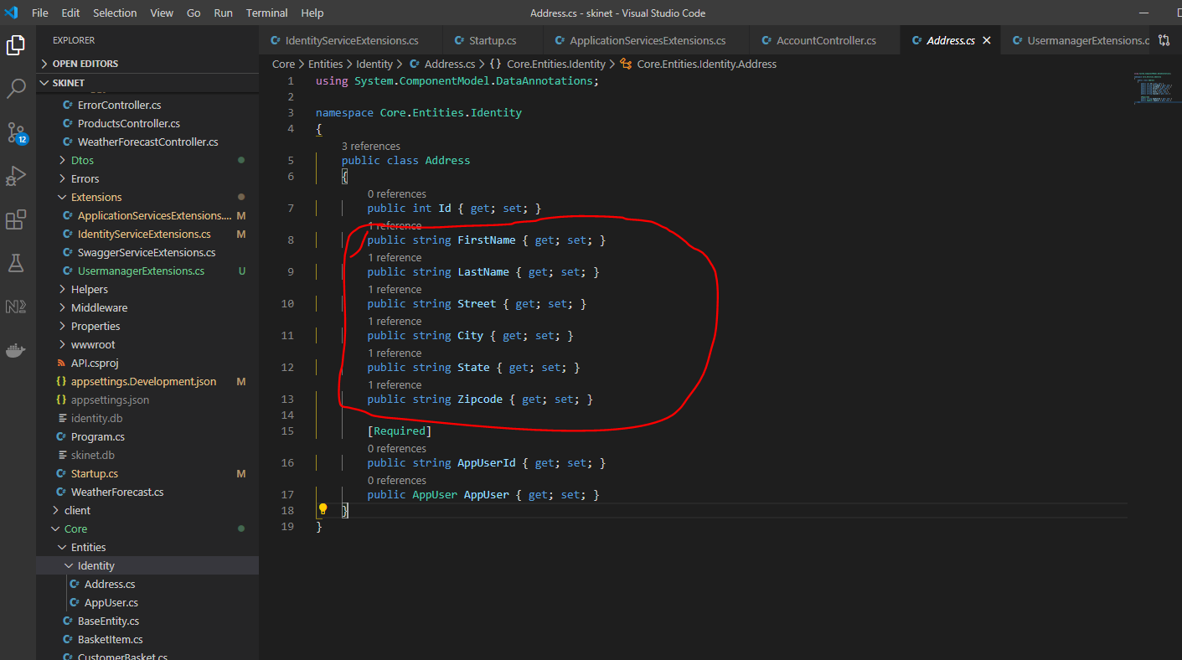

Create ‘AddressDto’ here:-

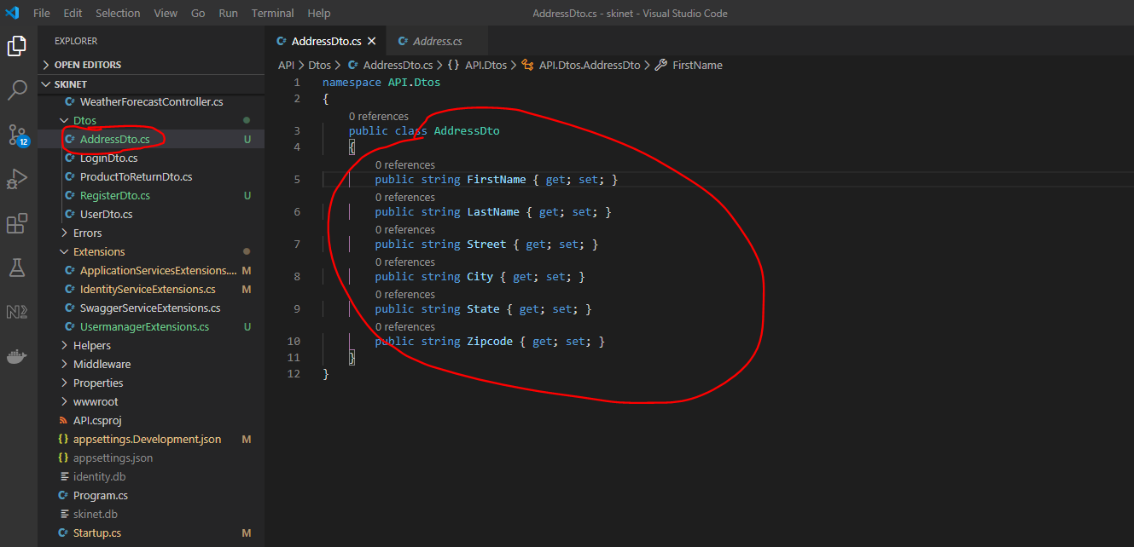

Update the ‘MappingProfiles.cs’ class as follows:-

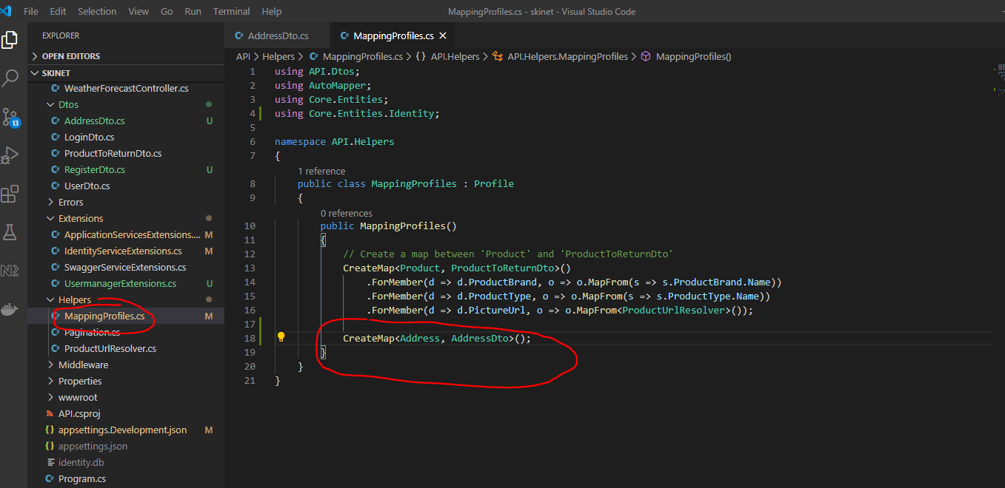

Now, update the AccountController:-

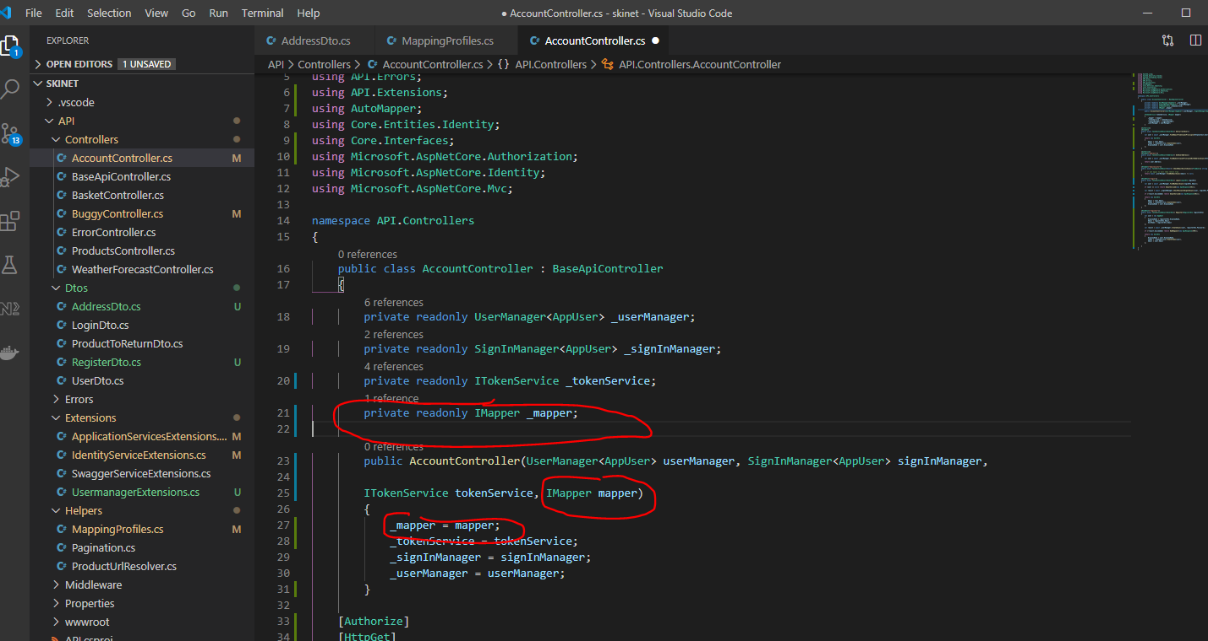

And:-

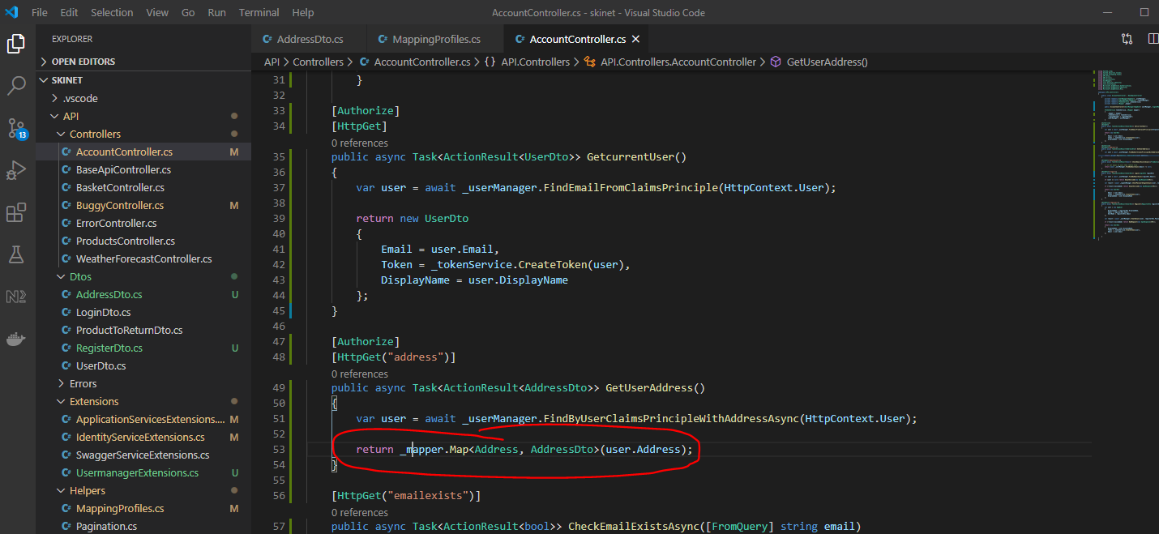

We also need a method for updating the address:-

First update this:-

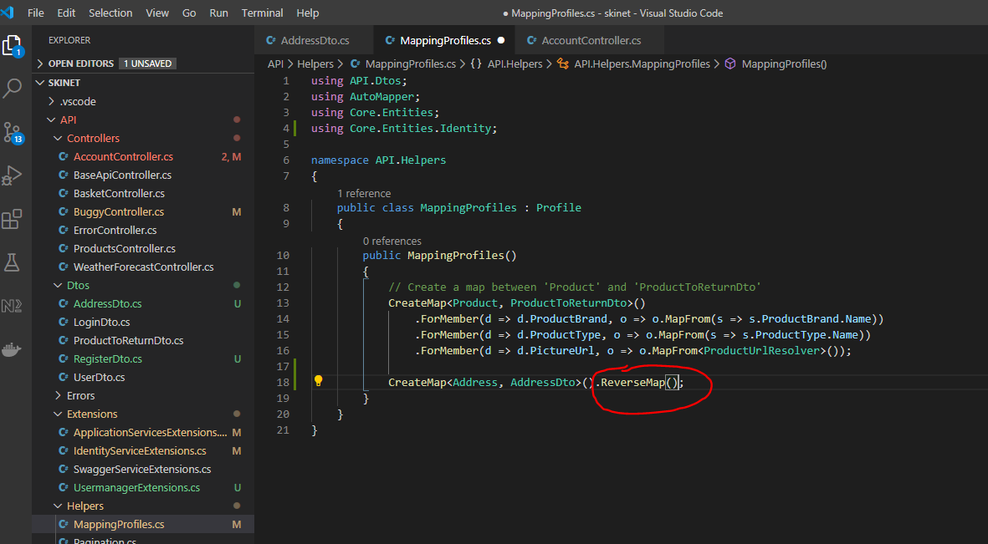

Update AcountController now:-

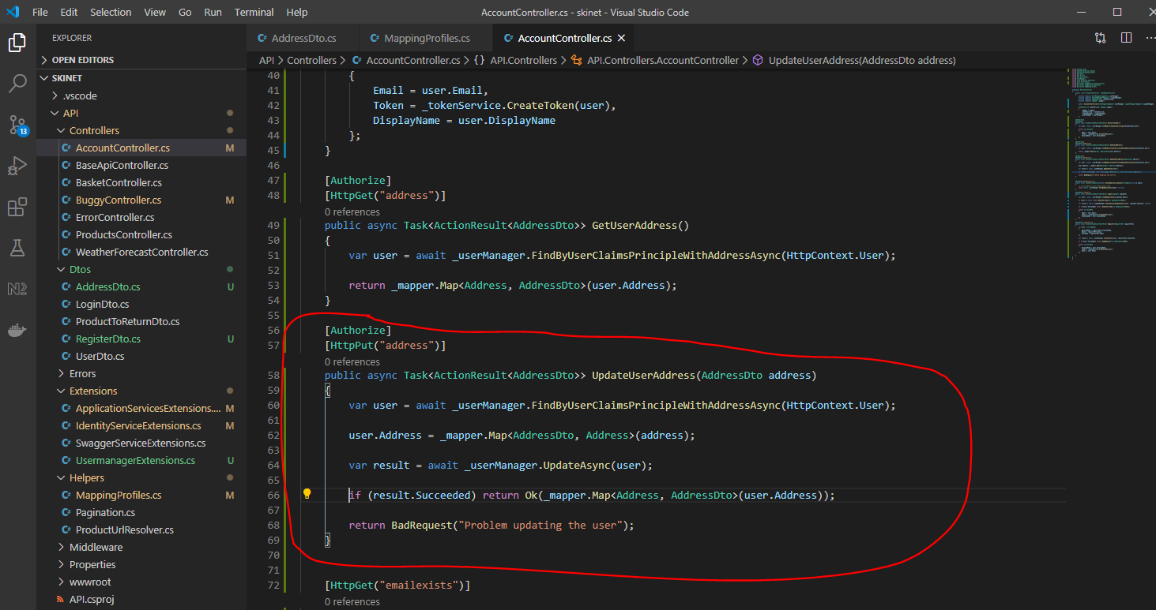

Test in Postman:-

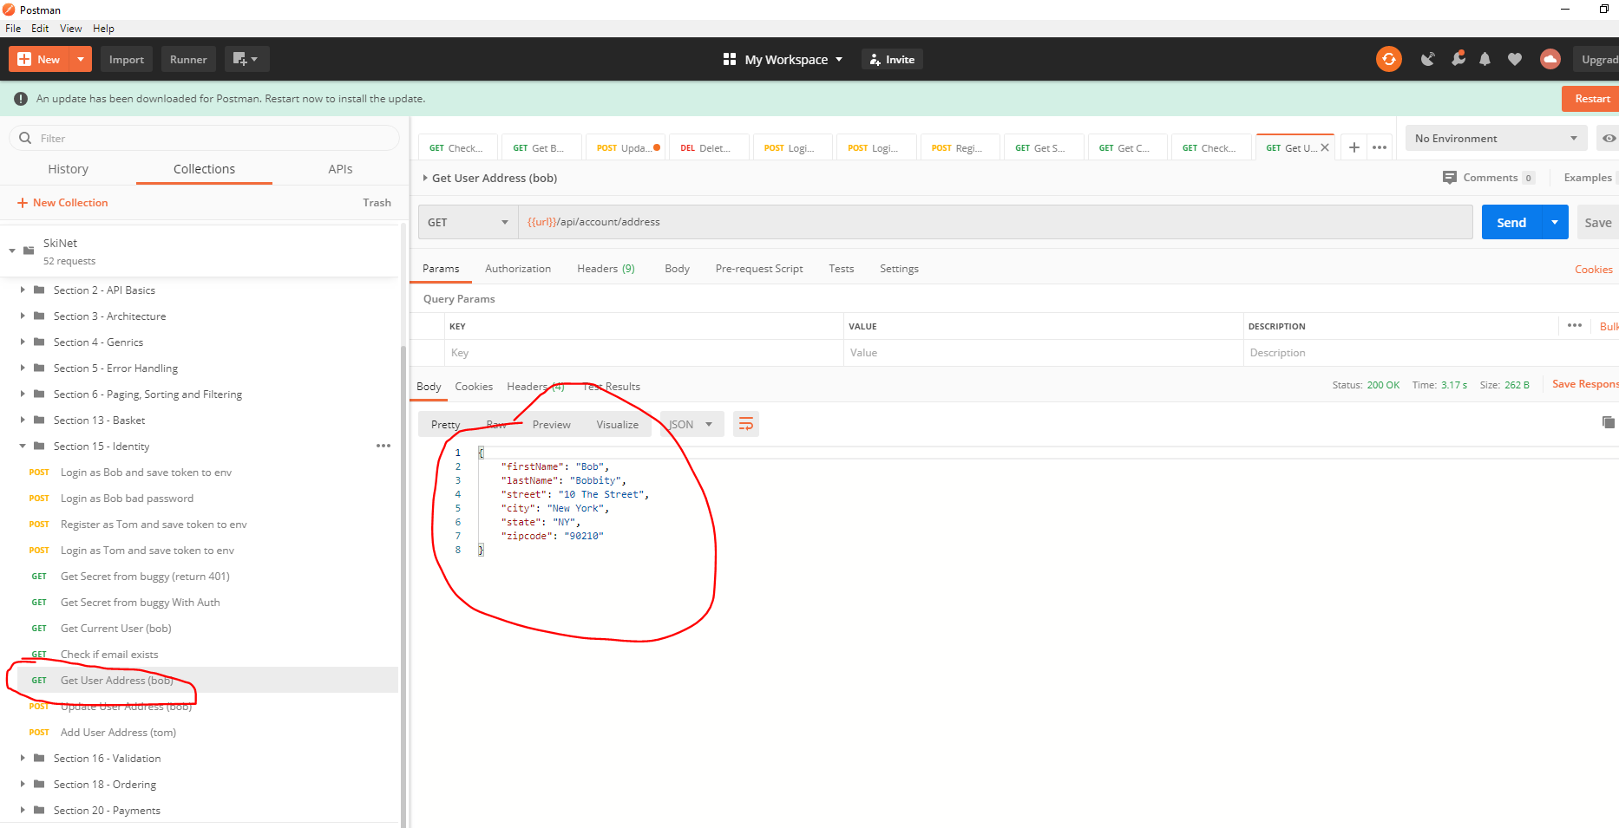

Save to GitHub